**Connecting Hive and sparksql in Tableau**

Connect ODBC data source

Download ODBC driver 32 or 64 bit and install windows system

Go to control panel and Administrative tool

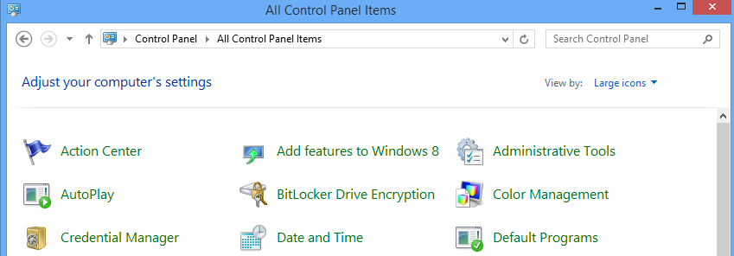

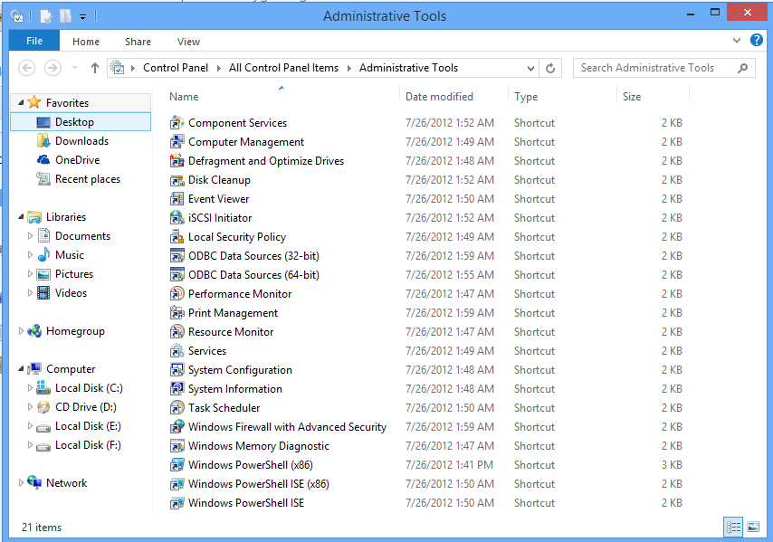

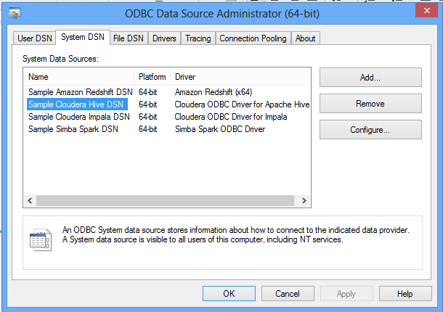

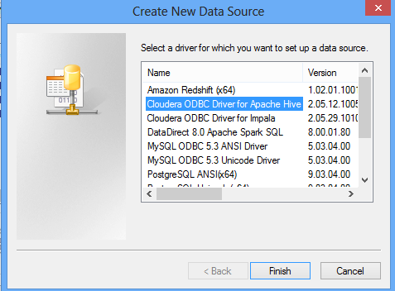

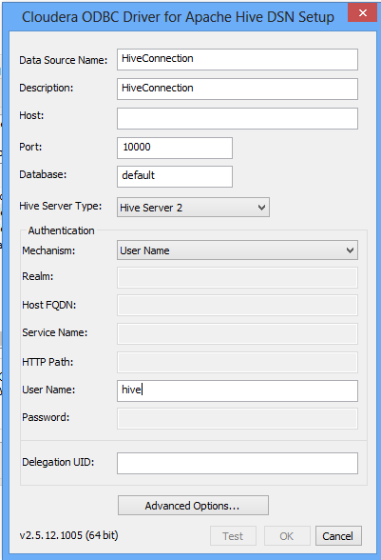

Download and Install tableau trial version

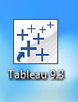

Open tableau go to More Server→ClouderaHadoop

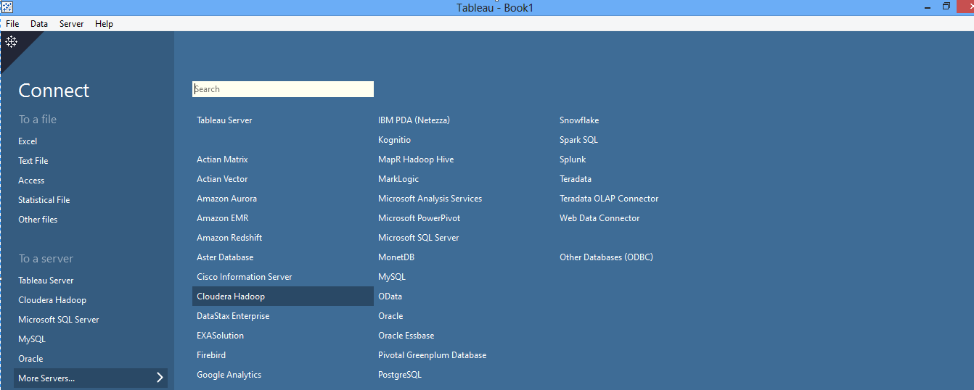

Give local host ip

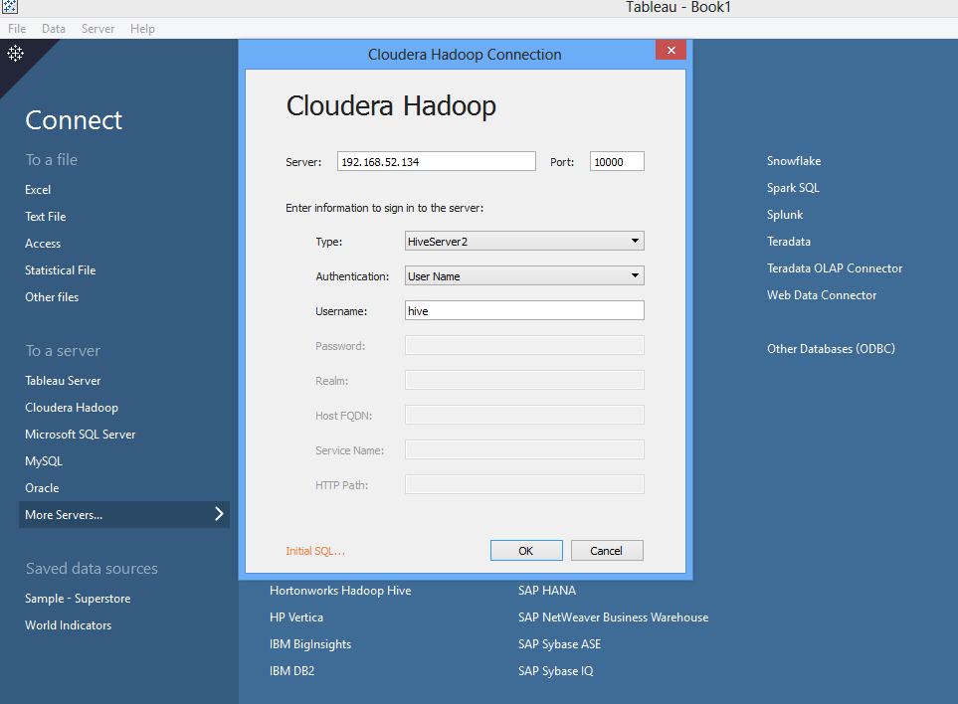

After connection you can make report in tableau

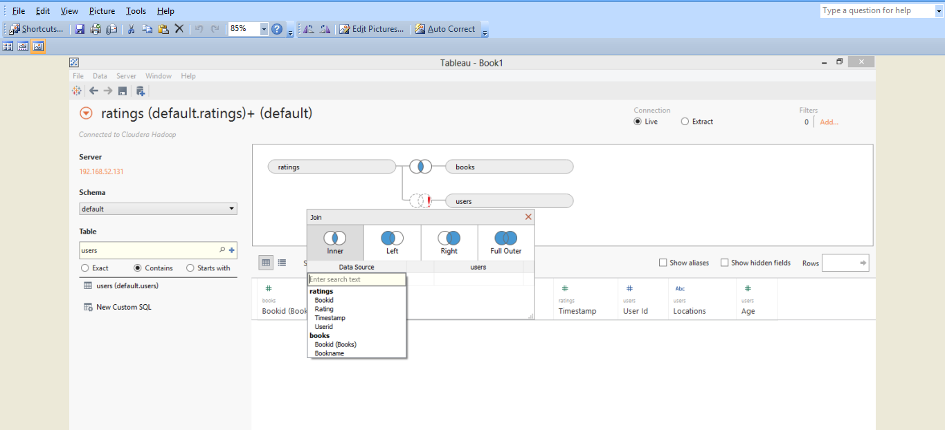

select x1.bookid,sum(x1.rating) as rating from

(select b.bookid,r.rating,r.userid from books b join ratings r on b.bookid=r.bookid

join users u on u.user_id=r.userid) x1 group by x1.bookid order by rating desc limit 10;

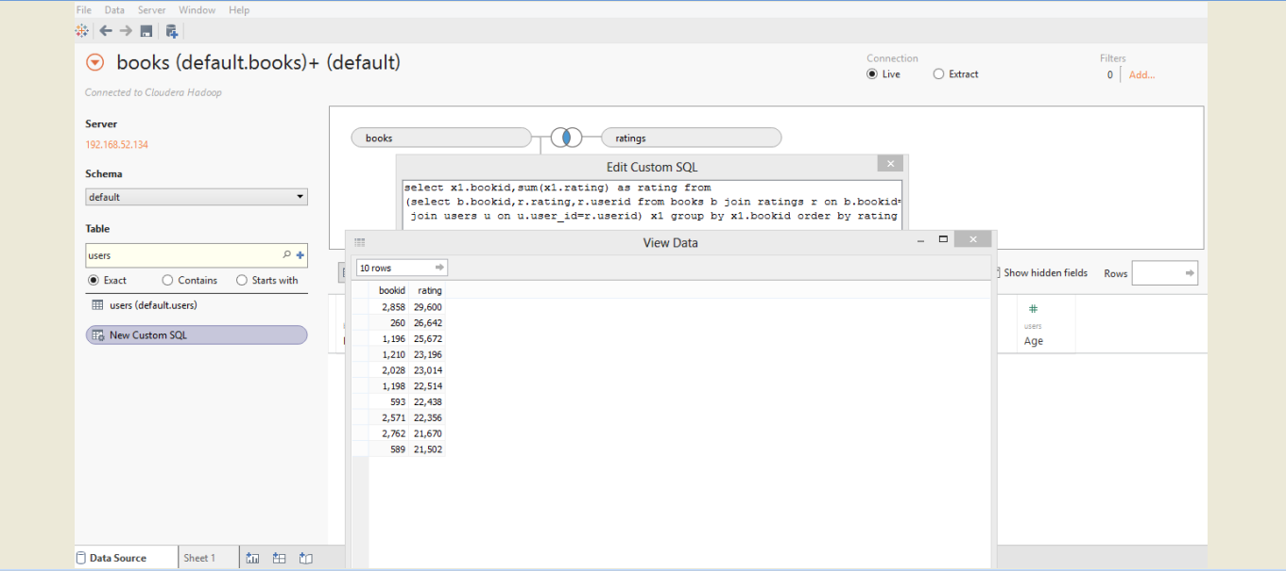

Display Recommended book

All Rated books

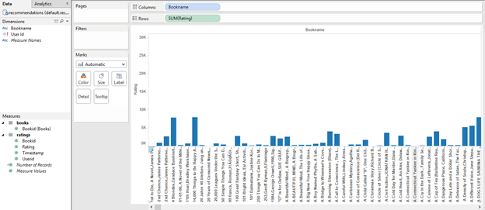

Top 10 rated book

For this we you need to inner join books and ratings table .

(Please check the our udemy course for more details for this graphic view in tableau.)

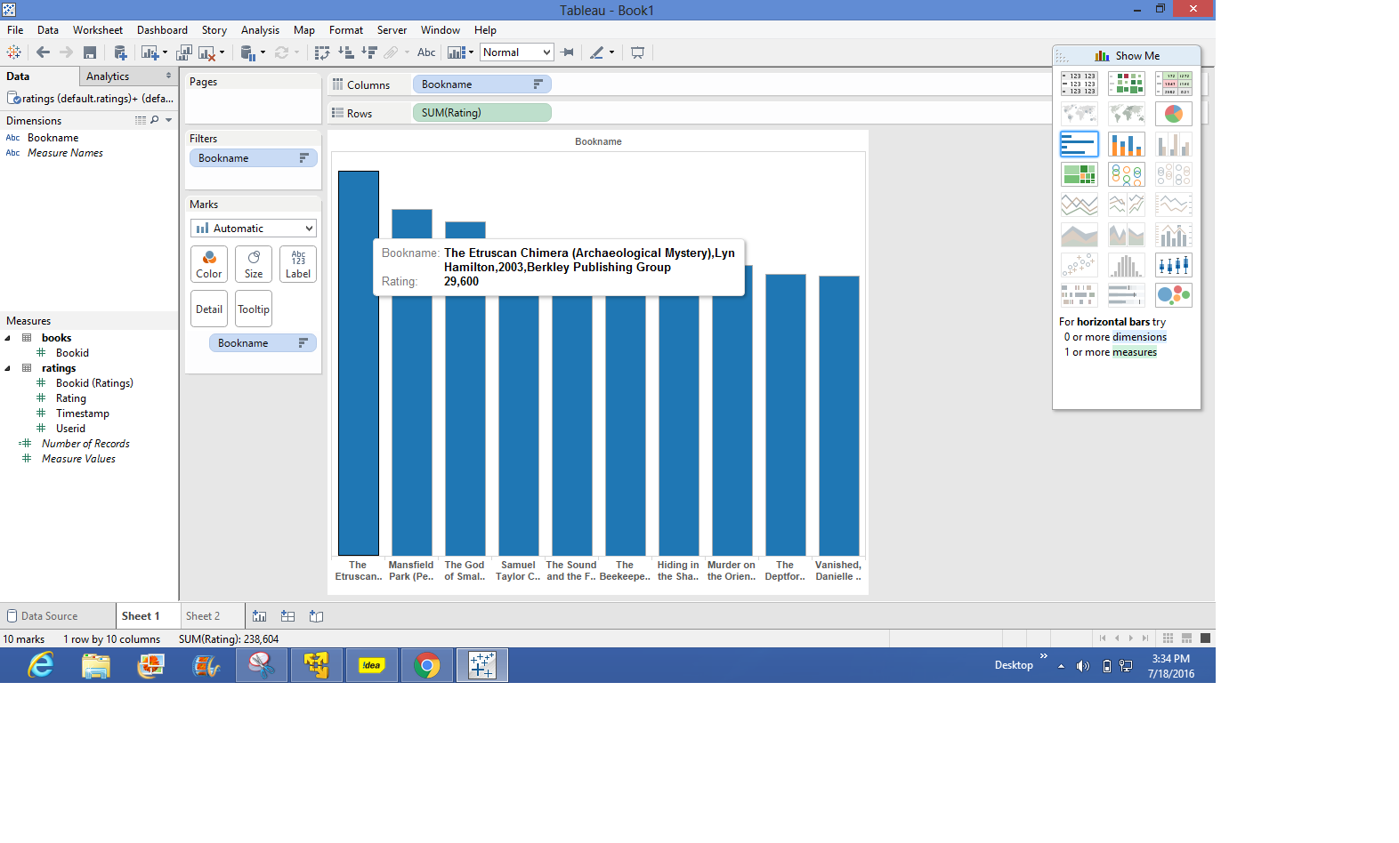

Recommended book for user id 25

