**Github Tutorial**

**Part 3**

GitHub is a Web-based revision control hosting service for software development and code sharing. It offers all the revision control and all SCM functionality of Git and can also add its own features. Git was initially designed and developed by Linus Torvalds for Linux kernel development in 2005. Initial git supports only command line system. So to overcome this GitHub was invented which provides web based and desktop both graphical interface. Another pletforms like bitbucket, source frogo, and GitLab are also available.

**Part 4**

Press enter to submit commands

> git init

Initialized empty Git repository in /.git/

Success!

$ git status

# On branch master

# Initial commit

nothing to commit (create/copy files and use "git add" to track)

Success!

$ git status

# On branch master

#

# Initial commit

#

# Untracked files:

# (use "git add <file>..." to include in what will be committed)

#

# octocat.txt

nothing added to commit but untracked files present (use "git add" to track)

Success!

$ git add octocat.txt

Nice job, you've added octocat.txt to the Staging Area

$ git status

# On branch master

#

# Initial commit

#

# Changes to be committed:

# (use "git rm --cached <file>..." to unstage)

#

# new file: octocat.txt

#

Success!

$ git commit -m "Add cute octocat story"

[master (root-commit) 20b5ccd] Add cute octocat story

1 file changed, 1 insertion(+)

create mode 100644 octocat.txt

Success!

$ git add '*.txt'

Success!

$ git commit -m 'Add all the octocat txt files'

[master 3852b4d] Add all the octocat txt files

4 files changed, 4 insertions(+)

create mode 100644 blue_octocat.txt

create mode 100644 octofamily/baby_octocat.txt

create mode 100644 octofamily/momma_octocat.txt

create mode 100644 red_octocat.txt

Success!

$ git log

commit 3852b4db1634463d0bb4d267edb7b3f9cd02ace1

Author: Try Git <try_git@github.com>

Date: Sat Oct 10 08:30:00 2020 -0500

Add all the octocat txt files

commit b652edfd888cd3d5e7fcb857d0dabc5a0fcb5e28

Author: Try Git <try_git@github.com>

Date: Sat Oct 10 08:30:00 2020 -0500

Added cute octocat story

Success!

$ git remote add origin <https://github.com/try-git/try_git.git>

Success!

$ git push -u origin master

Branch master set up to track remote branch master from origin.

Success!

$ git pull origin master

Updating 3852b4d..3e70b0f

Fast-forward

yellow_octocat.txt | 1 +

1 file changed, 1 insertion(+)

create mode 100644 yellow_octocat.txt

Success!

$ git diff HEAD

diff --git a/octocat.txt b/octocat.txt

index 7d8d808..e725ef6 100644

--- a/octocat.txt

+++ b/octocat.txt

@@ -1 +1 @@

-A Tale of Two Octocats

+[mA Tale of Two Octocats and an Octodog

Success!

$ git add octofamily/octodog.txt

Success!

$ git diff –staged

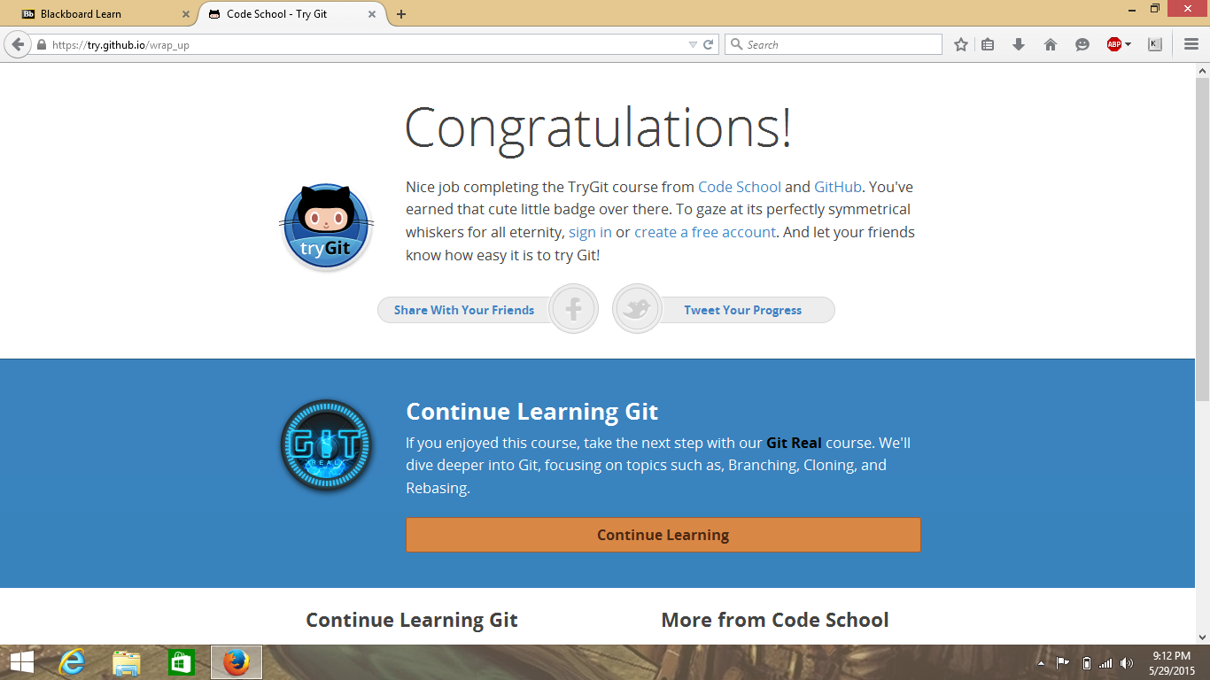

**Part 5**

Define the following terms in the context of Git :

* **Repository**: It is a storage space where any user’s project can be live. Sometimes GitHub users shorten this name to ‘repo’. In git hub by default repository name would be .git
* **Commit**: This is the command that gives Git its power. When you commit, you are taking a “snapshot” of your repository at that point in time, giving you a checkpoint to which you can reevaluate or restore your project to any previous state.
* **Push**: This command is uses to show your offline commit work online and share with other users.
* **Branch**: Branch gives freedom to work each and every user to work on a same project at a time without interrupting others. When they have done with their work they can merge their work and share it online.
* **Fork**: A fork is a copy of a repository. Forking a repository allows you to freely experiment with changes without affecting the original project. Most commonly, forks are used to either propose changes to someone else's project or to use someone else's project as a starting point for your own idea.
* **Merge**: When you’re done working on a branch, you can merge your changes back to the master branch, which is visible to all collaborators.
* **Clone**: If you need to collaborate with someone on a project, or if you want to get a copy of a project so you can look at or use the code, you will clone it. You simply run the git clone [url] command with the URL of the project you want to copy.
* **Pull**: it is used to get most up-to-date repository to for work on user’s personal computer.
* **Pull request**: pull request uses to share your work visible to others. If you made any changes in the project. This request allows other user to see what changes you have made in project.