**RSS Reader**

**Report**

**Submitted By:**

**Ritesh Pathak.**

**Hardik Patel.**

**Tianyu Wang.**

**YI Chan.**

**Introduction:**

RSS (Rich Site Summary) is a format for delivering regularly changing web content. Many news-related sites, weblogs and other online publishers syndicate their content as an RSS Feed to whoever wants it. RSS (Rich Site Summary); originally RDF Site Summary; often called Really Simple Syndication, uses a family of standard web feed formats. Create a personal news feed and read your favorite websites and blogs in a clean and intuitive format. Subscribe to as many feeds as you want and keep up on all topics and sources you care about. RSS solves a problem for people who regularly use the web. It allows you to easily stay informed by retrieving the latest content from the sites you are interested in. You save time by not needing to visit each site individually. You ensure your privacy, by not needing to join each site's email newsletter. There are number of sites which are growing enormously day by day which provides RSS feeds.

**Research:**

RSS stands for really simple syndication. RSS is an easy way to share your website updates and content with your users so that users might not have to visit your site daily for any kind of updates. Frequently, users find it's time consuming to surf websites because they have experienced so much advertisement and unwanted information at one time. RSS feeds enable publishers to syndicate data automatically. A standard XML file format ensures compatibility with many different machines/programs. RSS feeds also benefit users who want to receive timely updates from favorite websites or to aggregate data from many sites. There are many similar RSS applications right now, such as Feedly, Readability etc.

**Development:**

This project has been developed in Android Studio using many fragments, activities along with manifest files which develops automatically once the program has been generated in the android studio. We have developed the project in such a way that it would be helpful for the users to read the feeds in a nice and clear layout on their mobile devices. In this application we have proposed many technologies such as Array Adapter, List View, Parse XML in Android, HTTP Request and Show Website Content in Web View in Android. This project has been developed for making it easy to read the feeds for the users. In the development part we also have made a contribution from main program to async task support which goes to adding the user url input function and also we have used the drag and refresh option for getting maximum benefits to the users. Then we also have used a web view function for the better UI.

**Pen and Paper Design:**

This project was made into a rough presentation for checking it would run and be helpful to the users or not. We made it in the rough by drawing on a paper, this are the some images of our rough presentation.

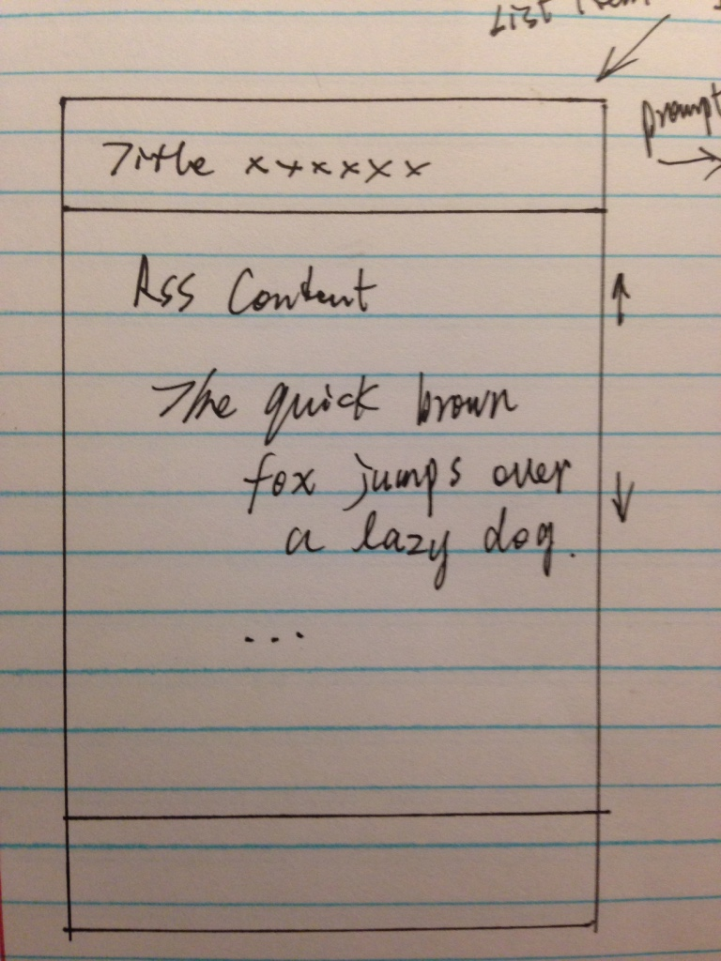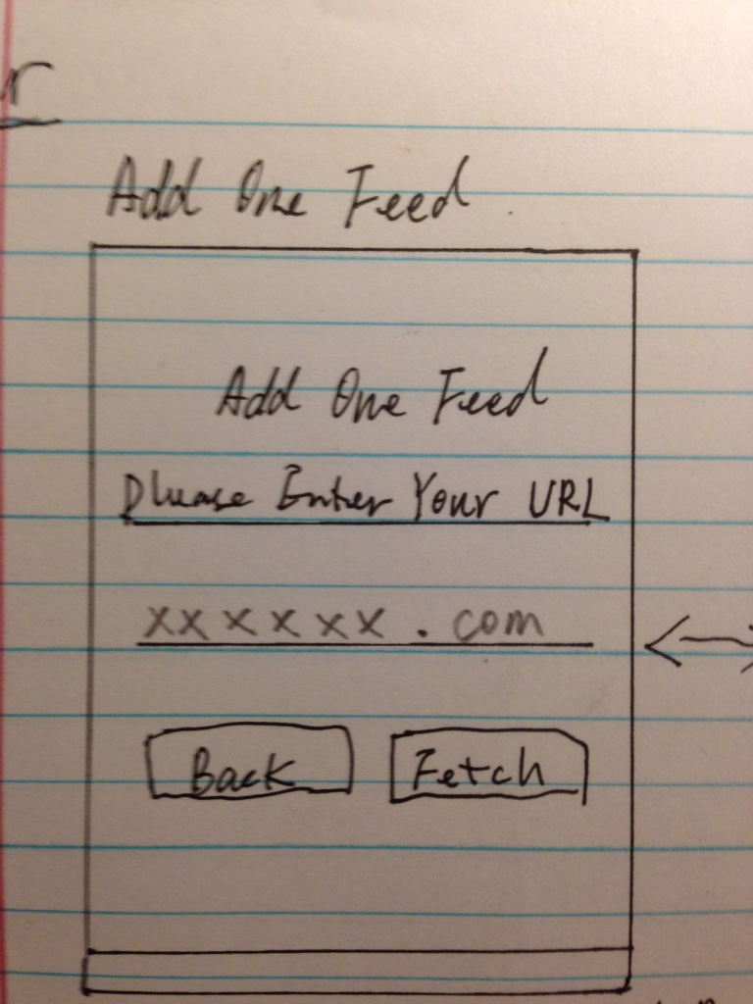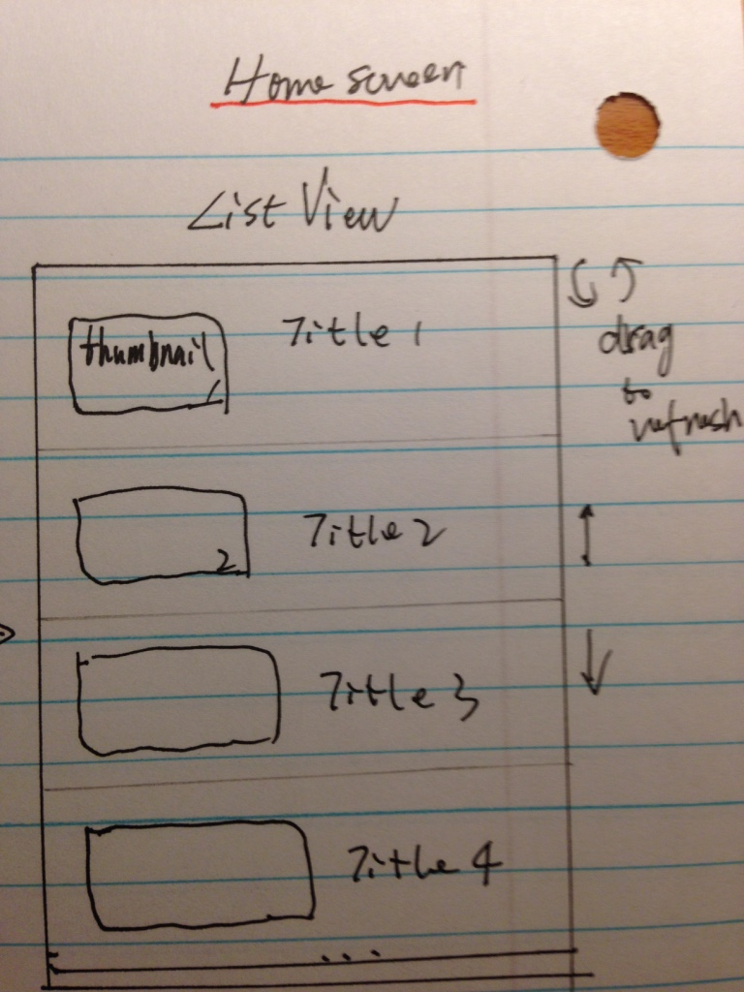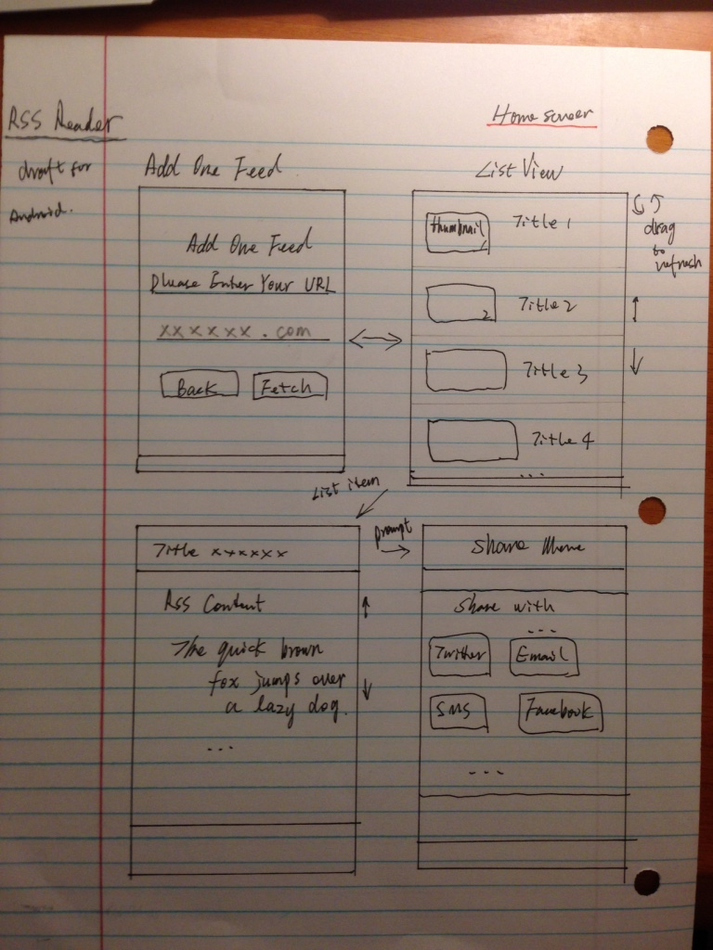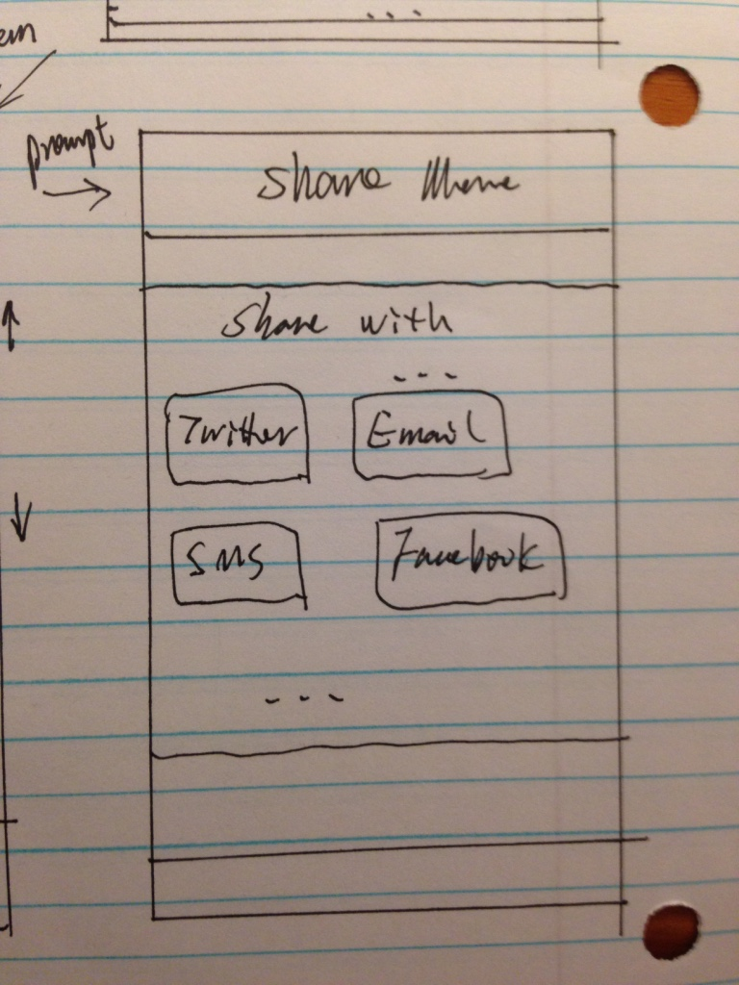

**User Description:**

This is for the users who like to read online on their favorite topics and articles, for this they just have to search a website by URL. The searching RSS feed and organizing article process will be carried out in background. It provides an easily accessible method for users to search and read articles they need, and to save time for users to look for their interest articles.

**Final Output:**

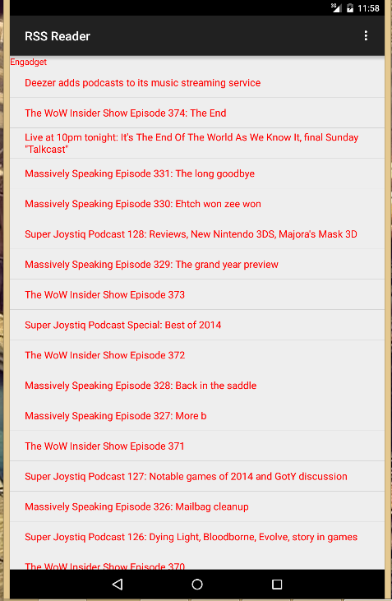

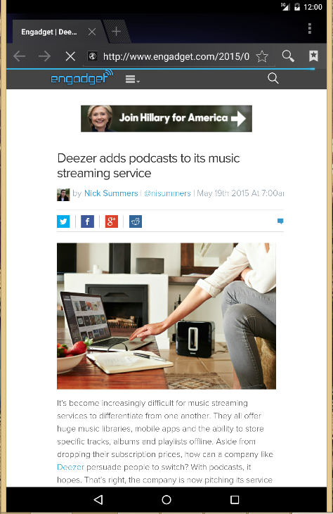

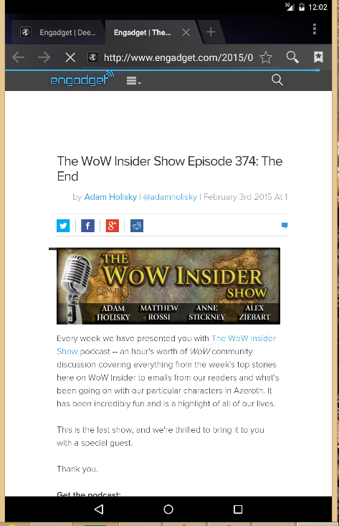

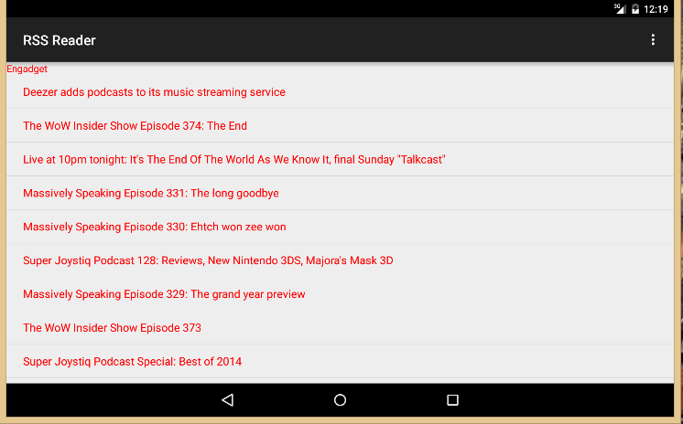

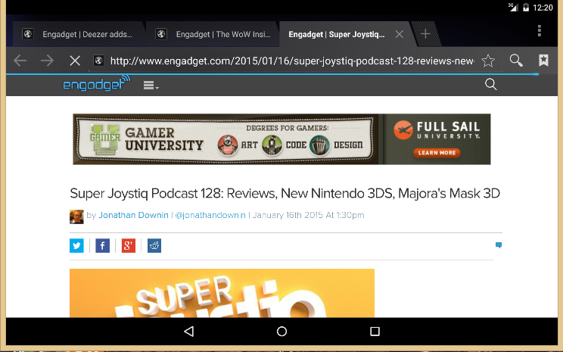

**References:**

* [**http://java.dzone.com/articles/building-rss-reader-android-0**](http://java.dzone.com/articles/building-rss-reader-android-0)
* [**https://androidresearch.wordpress.com/2013/06/01/creating-a-simple-rss-application-in-android-v2/**](https://androidresearch.wordpress.com/2013/06/01/creating-a-simple-rss-application-in-android-v2/)
* [**http://jmsliu.com/1390/rss-reader-app-android-tutorial-1-listview-and-arrayadapter.html**](http://jmsliu.com/1390/rss-reader-app-android-tutorial-1-listview-and-arrayadapter.html)