Introduction

The main motive to make this website is to give best deals of product to customers by comparing same products from different websites. Another advantage of this website is that this website is verified and no cookies will be found through this website. The best way to introduce our website is by giving answer of a question.

Why customer will use our website?

Consumers use cost-comparison sites for two reasons: either to locate the lowest possible price on a specific item from a merchant with a good reputation. Even if the item is not purchased online, the consumer will gain some [perspective](http://i.viglink.com/?key=535fb381c276aba2df16c56f4cdce13c&insertId=5b0ec4ea20b1be59&type=S&exp=60%3ACI1C55A%3A2&libId=k2so1s3u01021li9000DAc1rnvpeu&loc=https%3A%2F%2Fitstillworks.com%2Fprice-comparison-work-6685948.html&v=1&iid=5b0ec4ea20b1be59&opt=true&out=http%3A%2F%2Fwww.amazon.com%2Fgp%2Fsearch%3Fie%3DUTF8%26camp%3D1789%26creative%3D9325%26index%3Delectronics%26keywords%3Dperspective%26linkCode%3Dur2&ref=https%3A%2F%2Fwww.google.com%2F&title=How%20Does%20a%20Price%20Comparison%20Site%20Work%3F%20%7C%20It%20Still%20Works&txt=%3Cspan%3Eperspective%3C%2Fspan%3E) on whether the prices displayed in stores are good ones, factoring in what shipping costs might have been and they will gain knowledge of some new products.

The **purpose** is to attempt to find the best deal on a product. The practice of comparing **shopping** before **shopping** has the focus to achieve the best deals and pricing on merchandise/services.

**Website design**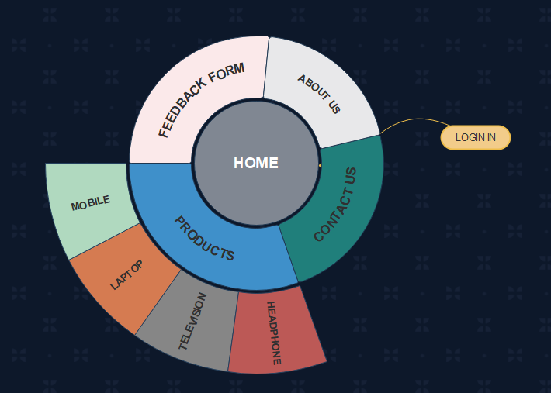

The website is divided into 4 parts:

1)Products: This section of website contains different sub sections of mobile, television, laptop and head phone. This sub sections further opens the list of different products having link showing best deal price of that product

2)Contact us: This section of website shows address, contact number and other ways to contact us

3)About us: This section provides information about the website.

4)Feedback Form: This section of website shows a form which allows user to give review or even can place complain of a product or complain against the website providing the product.

**Title of the website**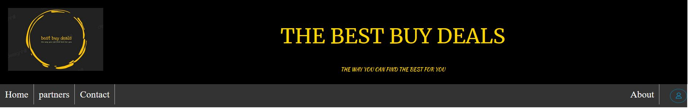

The header is the most important part of any website to make it user friendly so that user can use it properly without having any difficulty.

* The picture describes the header of the page which shows the symbol of our website, title and trademark of the website.
* The second line shown in pictures shows buttons like home, partners, contact, about and a log in button, these buttons help to open the links, for example; if a user wants to log in his/her account, the log in button is provided.
* This title page is made using CSS.

Log in Page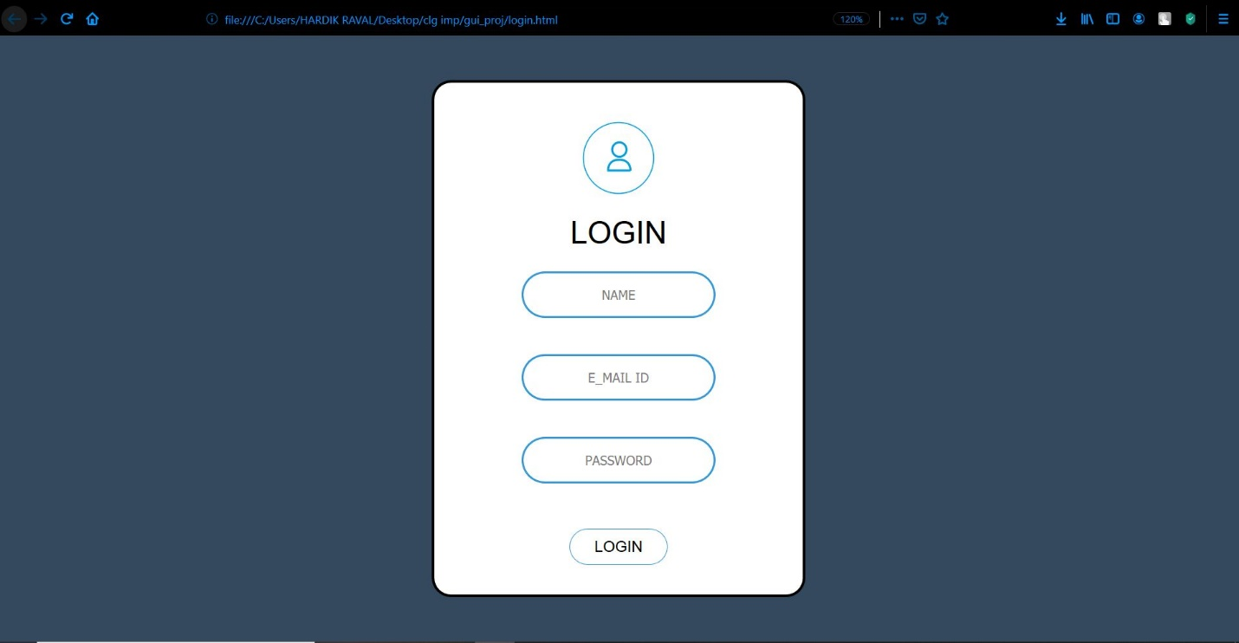

Log in page of the website is important for the website hosting as the host can collect the data so that the host can have track about number of users joining the website and to get an idea that how much traffic is there on our website.

* The login page shown in the picture will be opened when the user clicks the log in button present in the header and from this, he can register himself/herself to the website.
* This login in page is made using CSS.

**Menu Page**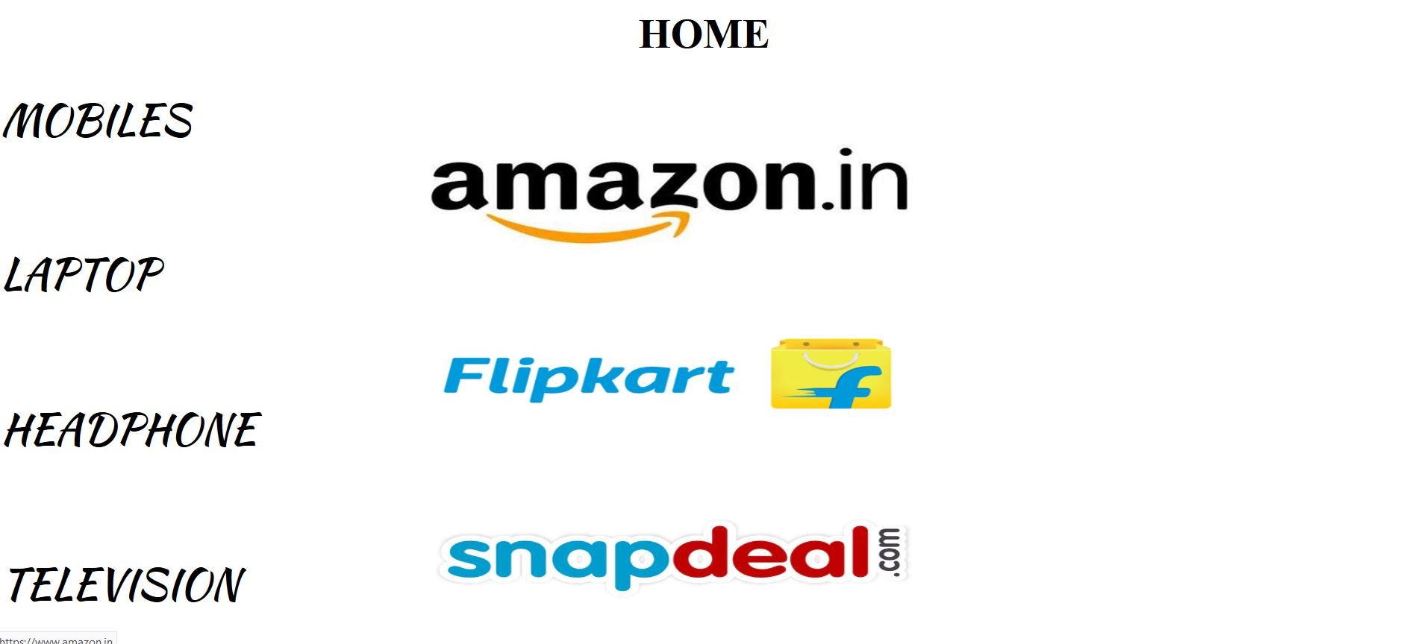

The main content of the website is shown in this section. The user can compare the products by selecting the device that he/she wants to buy.

* This section shows the partners of the website on the right side, the images of the popular online store can be opened by clicking it and on the left, options of the device are given so that user can select what he wants to buy.

**Product Page**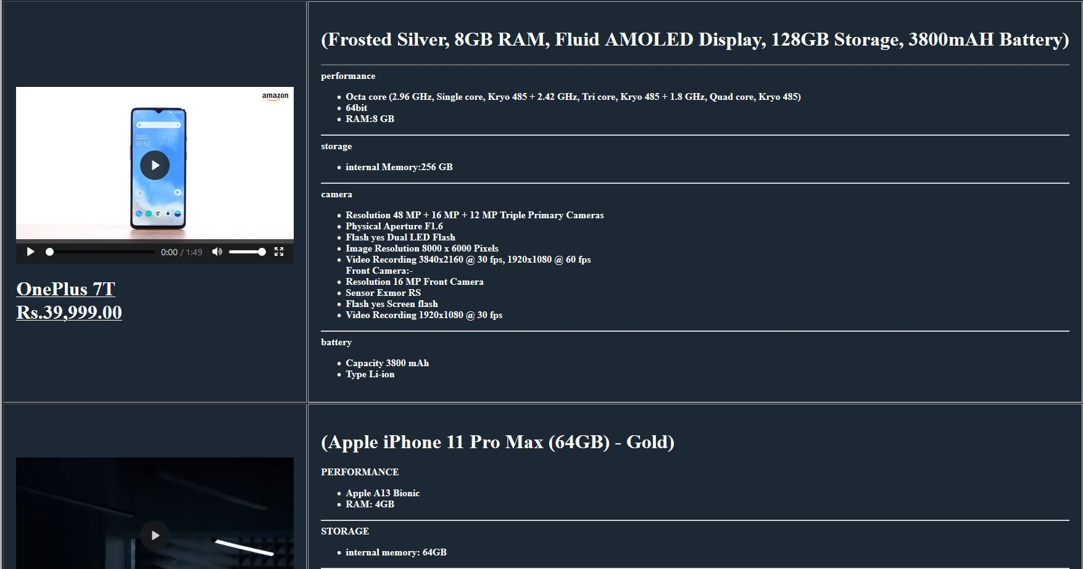

* **The product page shows the list of all the products with their description on right side containing all its technical statistics.**
* **The text present below the image or video of the product when clicked opens the direct link of the website that provides the best deal of that product with the least price compared to other websites.**

Contact us Section



* This section of the website describes the information of the address of head office, mobile number and e-mail id for users to contact them for any complain or suggestions.

Feedback Form

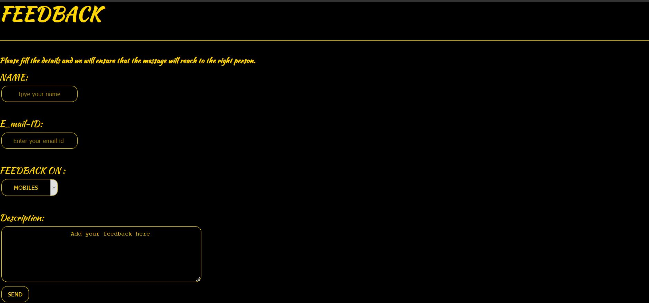

* The feedback form allows the user to give suggestion to make website more user friendly so large number of people gets attracted towards the website or to complain about the product or the website from where the product has been bought.

Footer



Footer of the website is important for the website host as we can show that the website has all the rights to show the product of other e-commerce on our website. The footer also contains other options to contact us, like Instagram-id, email id and mobile number.

Conclusion

Things that we have learnt by preparing this project:

1)This project has helped to develop our designing skills.

2)We have learnt the concept of making different user-friendly forms

3)We have also learnt to link different website and to use CSS for making the design of webpage more attractive.

4)Through this project many small concepts like creating table and inserting data in it; adjusting different fonts, images, videos using hypertext and hyperlink and many more small concepts has been cleared.

5)The most important thing that we learnt is how all the e-commerce website works, how such pricing website earn money, how such price comparison website store different products and many more.

Strengths of the website

The website is user friendly and the concept of comparing prices of different products turns to be In favor of customer as they can get best deals.

All the genuine website’s are shown in this website and no other fraud website is linked with this website.

Weakness of the website

There are many more comparison websites present in the market so to get more attention.

All the products that come into the market, cannot be shown as many unique products are assigned to a particular web store for a particular time this copyright doesn’t allow any other website to sell that product for a particular interval of time.