A
MINI PROJECT-1A REPORT
On
“SMART BILLING CART”
BY
Hardik Hemant Rawat | 125A2047
Shivraj Morde | 125A2033
Ismail Mohammed | 125A2052
Pranav Anand | 125A2062

UNDER THE GUIDANCE OF
Dr. Swati Rane

SUBMITTED IN PARTIAL FULFILLMENT FOR THE DEGREE OF
SECOND YEAR OF ENGINEERING
IN
ELECTRONICS AND TELECOMMUNICATION



DEPARTMENT OF ELECTRONICS AND TELECOMMUNICATION
SIES GRADUATE SCHOOL OF TECHNOLOGY
NERUL, NAVI MUMBAI – 400706
ACADEMIC YEAR
2026- 2027
CERTIFICATE
This is to certify that the project titled “Smart Billing Cart” carried out by following students of S.E in Electronics and Telecommunication:
Hardik Hemant Rawat | 125A2047
Shivraj Morde | 125A2033
Ismail Mohammed | 125A2052
Pranav Anand | 125A2062

The project report is submitted in partial fulfilment of second year of engineering Electronics and Telecommunication from University of Mumbai during the academic year 2026 - 2027
Dr. Swati Rane | Prof. Pratibha Joshi | Dr. Swati Rane
Internal Guide | Mini Project Coordinator | Head Of Department

We have examined this report as per university requirements at SIES Graduate School of Technology, Nerul (E), Navi Mumbai on _____________

Name of External Examiner : ______________________________________
Signature with Date : ______________________________________
Name of Internal Examiner : ______________________________________
Signature with Date :______________________________________
ABSTRACT
Billing queues are the slowest part of shopping in a store: customers wait at the counter even to pay for two or three items, and staff must check by eye that every customer leaving has paid. Smart carts described in IEEE work either need an RFID tag on every product or send the customer back to a cashier to pay.
This project presents SmartCart, a self-checkout system for a neighbourhood general store. The shopper scans the barcode already printed on each pack, or a SmartCart QR label for loose items, with their own phone. The cart, offers, budget and bill are handled by a web application built with Flask and MySQL and hosted online. The bill is paid from an in-app SmartCart Wallet that is topped up at the counter by cash or UPI using a signed, one-time top-up token that staff confirm.
Each paid bill carries an HMAC-signed, one-time exit pass shown as a QR code. A Raspberry Pi 4 with a Pi Camera v2 at the exit reads this pass and asks the server to verify it: a green LED and one beep allow the shopper to leave, while a red LED and beeps stop a screenshot, an edited code or a bill that has already been used. The Pi only makes outgoing HTTPS calls with its own device key and accepts no incoming connections.
A weight check using a 10 kg load cell and an HX711 amplifier was designed and built so that an item enters the cart only when its barcode, weight and camera colour agree. The HX711 board failed during testing, so this check is switched off in the current version. The system is live at smartcart-gkrx.onrender.com. A survey of five IEEE papers shows that SmartCart is the only one of them that needs no product tags, takes payment inside the app and verifies a signed exit pass with a camera; its main gaps are the missing weight check and the absence of measured accuracy figures, which form the future scope.
Keywords: smart cart, self-checkout, Raspberry Pi, QR code, barcode, HMAC, Flask, IoT.

ACKNOWLEDGEMENT
We express our sincere gratitude to our project guide and Head of the Department of Electronics and Telecommunication, Dr. Swati Rane, for her guidance, encouragement and support throughout this mini project.
We are thankful to our Mini Project Coordinator, Prof. Pratibha Joshi, for planning the project schedule, reviewing our progress and giving valuable suggestions at every stage.
We also thank the teaching and non-teaching staff of the Department of Electronics and Telecommunication, SIES Graduate School of Technology, for providing the laboratory, the Raspberry Pi and the other facilities needed to build and test this project.
Finally, we thank our families and friends for their constant support.

Hardik Hemant Rawat (125A2047)
Shivraj Morde (125A2033)
Ismail Mohammed (125A2052)
Pranav Anand (125A2062)

TABLE OF CONTENT

 | Abstract | i
 | Acknowledgement | ii
 | List of Table | iv
 | List of Figure | v
1 | Introduction | 1
 | 1.1 Background | 1
 | 1.2 Need of the Project | 1
 | 1.3 Objectives | 1
 | 1.4 Literature Survey | 2
2 | Working Principle | 4
 | 2.1 Methodology | 4
 | 2.2 Scanning and Cart | 4
 | 2.3 SmartCart Wallet | 5
 | 2.4 Exit Verification | 5
 | 2.5 Weight and Camera Check | 5
3 | Circuit Description | 7
 | 3.1 Block Diagram | 7
 | 3.2 Circuit Diagram | 7
4 | Component Description | 9
 | 4.1 Raspberry Pi 4 | 9
 | 4.2 Pi Camera v2 | 9
 | 4.3 Load Cell and HX711 | 10
 | 4.4 LEDs and Buzzer | 10
 | 4.5 Hardware Setup | 10
5 | Software Description | 12
 | 5.1 Server | 12
 | 5.2 Website | 12
 | 5.3 Raspberry Pi Program | 12
 | 5.4 Security | 12
 | 5.5 Results | 13
6 | Advantages | 16
7 | Disadvantages | 17
8 | Scope | 18
9 | Conclusion | 19
10 | References | 20

LIST OF TABLE

Table No. | Title | Page No.
1.1 | Comparison of the surveyed IEEE papers with SmartCart | 3
2.1 | Exit-pass results and Raspberry Pi signals | 5
3.1 | Raspberry Pi pin connections | 8
4.1 | List of components | 9
7.1 | Where SmartCart falls short of the surveyed papers | 17

LIST OF FIGURE

Fig. No. | Title | Page No.
2.1 | Methodology flowchart | 4
3.1 | System block diagram | 7
3.2 | Circuit (wiring) diagram | 8
4.1 | Raspberry Pi 4 GPIO wiring | 10
4.2 | HX711 amplifier with the load cell wires | 11
4.3 | SmartCart running on the Raspberry Pi's own display | 11
5.1 | Scanning an item and the cart | 13
5.2 | Wallet top-up token and staff wallet counter | 14
5.3 | Paid bill with exit pass and exit-gate result | 14
5.4 | Admin dashboard | 15

INTRODUCTION
1.1 Background
Retail billing in most Indian stores still depends on a cashier scanning every item at a counter. At busy hours the queue at the counter becomes the slowest part of a shopping trip, even for a customer buying only two or three items. Large chains have started trying scan-and-go systems such as Amazon Dash Cart, Instacart Caper Cart and DMart Scan & Go, but these depend on expensive carts or store infrastructure that a small store cannot afford.
SmartCart is a self-checkout system designed for a neighbourhood general store. It turns the shopper's own phone into the scanner and the payment terminal, and uses a single Raspberry Pi with a camera at the exit to check that every customer who leaves has paid. The store used in the project stocks 48 everyday items in eight sections: stationery, snacks, biscuits and chocolates, beverages, instant food, personal care, household and electronics and hobby.
1.2 Need of the Project
• Customers wait in billing queues even for a few items, and long queues make customers leave without buying.
• Manual billing needs a cashier at every counter and is open to scanning and counting mistakes.
• Checking at the exit that a customer has paid is done by eye and can be fooled by an old or copied bill.
• Smart carts in published work need an RFID tag on every product or a computer and screen on every cart, which is costly for a small store.
1.3 Objectives
1. To let shoppers scan the barcode already printed on each pack, or a QR label for loose items, with their own phone and see a running bill.
2. To take payment inside the application through a prepaid SmartCart Wallet that staff top up against cash or UPI.
3. To issue every paid bill a signed, one-time exit pass and verify it with a Raspberry Pi camera at the exit, with a green or red light and a buzzer.
4. To design a weight and camera-colour check that confirms the item put in the cart is the item scanned.
5. To give staff a wallet counter, an exit-gate screen and an admin dashboard for sales and stock.
1.4 Literature Survey
Five IEEE papers on smart shopping carts were studied. They are summarised below and compared with SmartCart in Table 1.1.
M. Kumar et al. [1], ICSTCEE 2023. A Raspberry Pi 4 trolley in which the shopper scans each item's QR code with a USB camera; the bill is shown on a 20x4 LCD and buttons add, remove or update items. A 5 kg load cell and Bluetooth are fitted, and payment is made at the counter or on a mobile phone. A second mode makes the trolley follow the shopper by tracking shirt colour. No timing or accuracy results are reported and there is no anti-theft or exit check.
N. Ibrahim et al. [2], 3SCEA 2026. A Raspberry Pi 4B cart with a Pi Camera v2 and a 7-inch touchscreen. Products are identified by barcode (OpenCV and Zbar) and by a YOLO11s object-detection model trained on 8 product classes (214 images) and run with NCNN on the Pi. It adds login, an admin panel, a store map, recipes and a budget. The receipt is still paid at the cashier, there is no anti-theft check, and the authors note that scanning failed in poor light.
M. Shahroz et al. [3], IEEE Access 2020. An Arduino Uno cart that reads RFID tags on products with an MFRC522 reader (13.56 MHz, 0-60 mm) and sends the bill over HC-06 Bluetooth to an Android app, backed by a web management system. The customer logs in with an RFID card. Every product needs a tag, there is no anti-theft check, and no measured results are given.
R. Nishitha et al. [4], RTEICT 2019. Shoppers scan barcodes with an Android phone and the bill is sent to a PC server over Wi-Fi; payment is by OTP, bank deduction or card. RFID detectors at the exit compare tags with the bill and sound a buzzer for unbilled items. About 9 items reached the server on 2G, about 30 on 3G and over 100 on 4G or 10 Mbps Wi-Fi; detection was best with the detector at 45 degrees, and one unit costs about Rs 40,000-50,000.
M. H. Walid et al. [5], ICEECE 2026. A Raspberry Pi 3B+ cart with an RC522 RFID reader (2-5 cm), a load cell with HX711, a TFT display, buzzer and RGB LED, linked to Firebase, a Telegram bot and a payment gateway. A weight mismatch raises an alert. Measured results: anti-theft accuracy 91.7%, RFID reads 93 out of 100 (98% for normal and 88% for metallic packs), and 1.37 s from a mismatch to the alert. It needs internet and is affected by metal packaging.
Table 1.1: Comparison of the surveyed IEEE papers with SmartCart
Work | Controller | Item identification | Payment | Anti-theft / exit check | Measured results
[1] Kumar 2023 | Raspberry Pi 4 | QR code, USB camera | At counter or mobile | None | None reported
[2] Ibrahim 2026 | Raspberry Pi 4B | Barcode + YOLO11s | At cashier | None | Chart only; fails in poor light
[3] Shahroz 2020 | Arduino Uno | RFID tag on each item | Android app | None | None reported
[4] Nishitha 2019 | PC + Arduino | Barcode on Android phone | OTP, bank or card | RFID gate at exit | 9 / 30 / 100+ items on 2G / 3G / 4G
[5] Walid 2026 | Raspberry Pi 3B+ | RFID tag on each item | Payment gateway link | Load-cell weight check | 91.7% anti-theft; 93/100 reads
SmartCart (this project) | Raspberry Pi 4 + web server | Shopper's phone scans existing barcode / QR label | In-app wallet, staff-confirmed top-up | Signed one-time exit pass read by Pi camera | Not yet measured

The survey shows that none of the five papers combines tag-free scanning, payment inside the application and a verified exit check. SmartCart is built around that gap; Chapters 6 and 7 compare it with the papers in detail.
WORKING PRINCIPLE
2.1 Methodology
Fig. 2.1 shows the complete flow of a shopping trip, from login to the exit gate. Each step is checked by the server, so the phone never decides a price, a balance or whether a bill is valid.
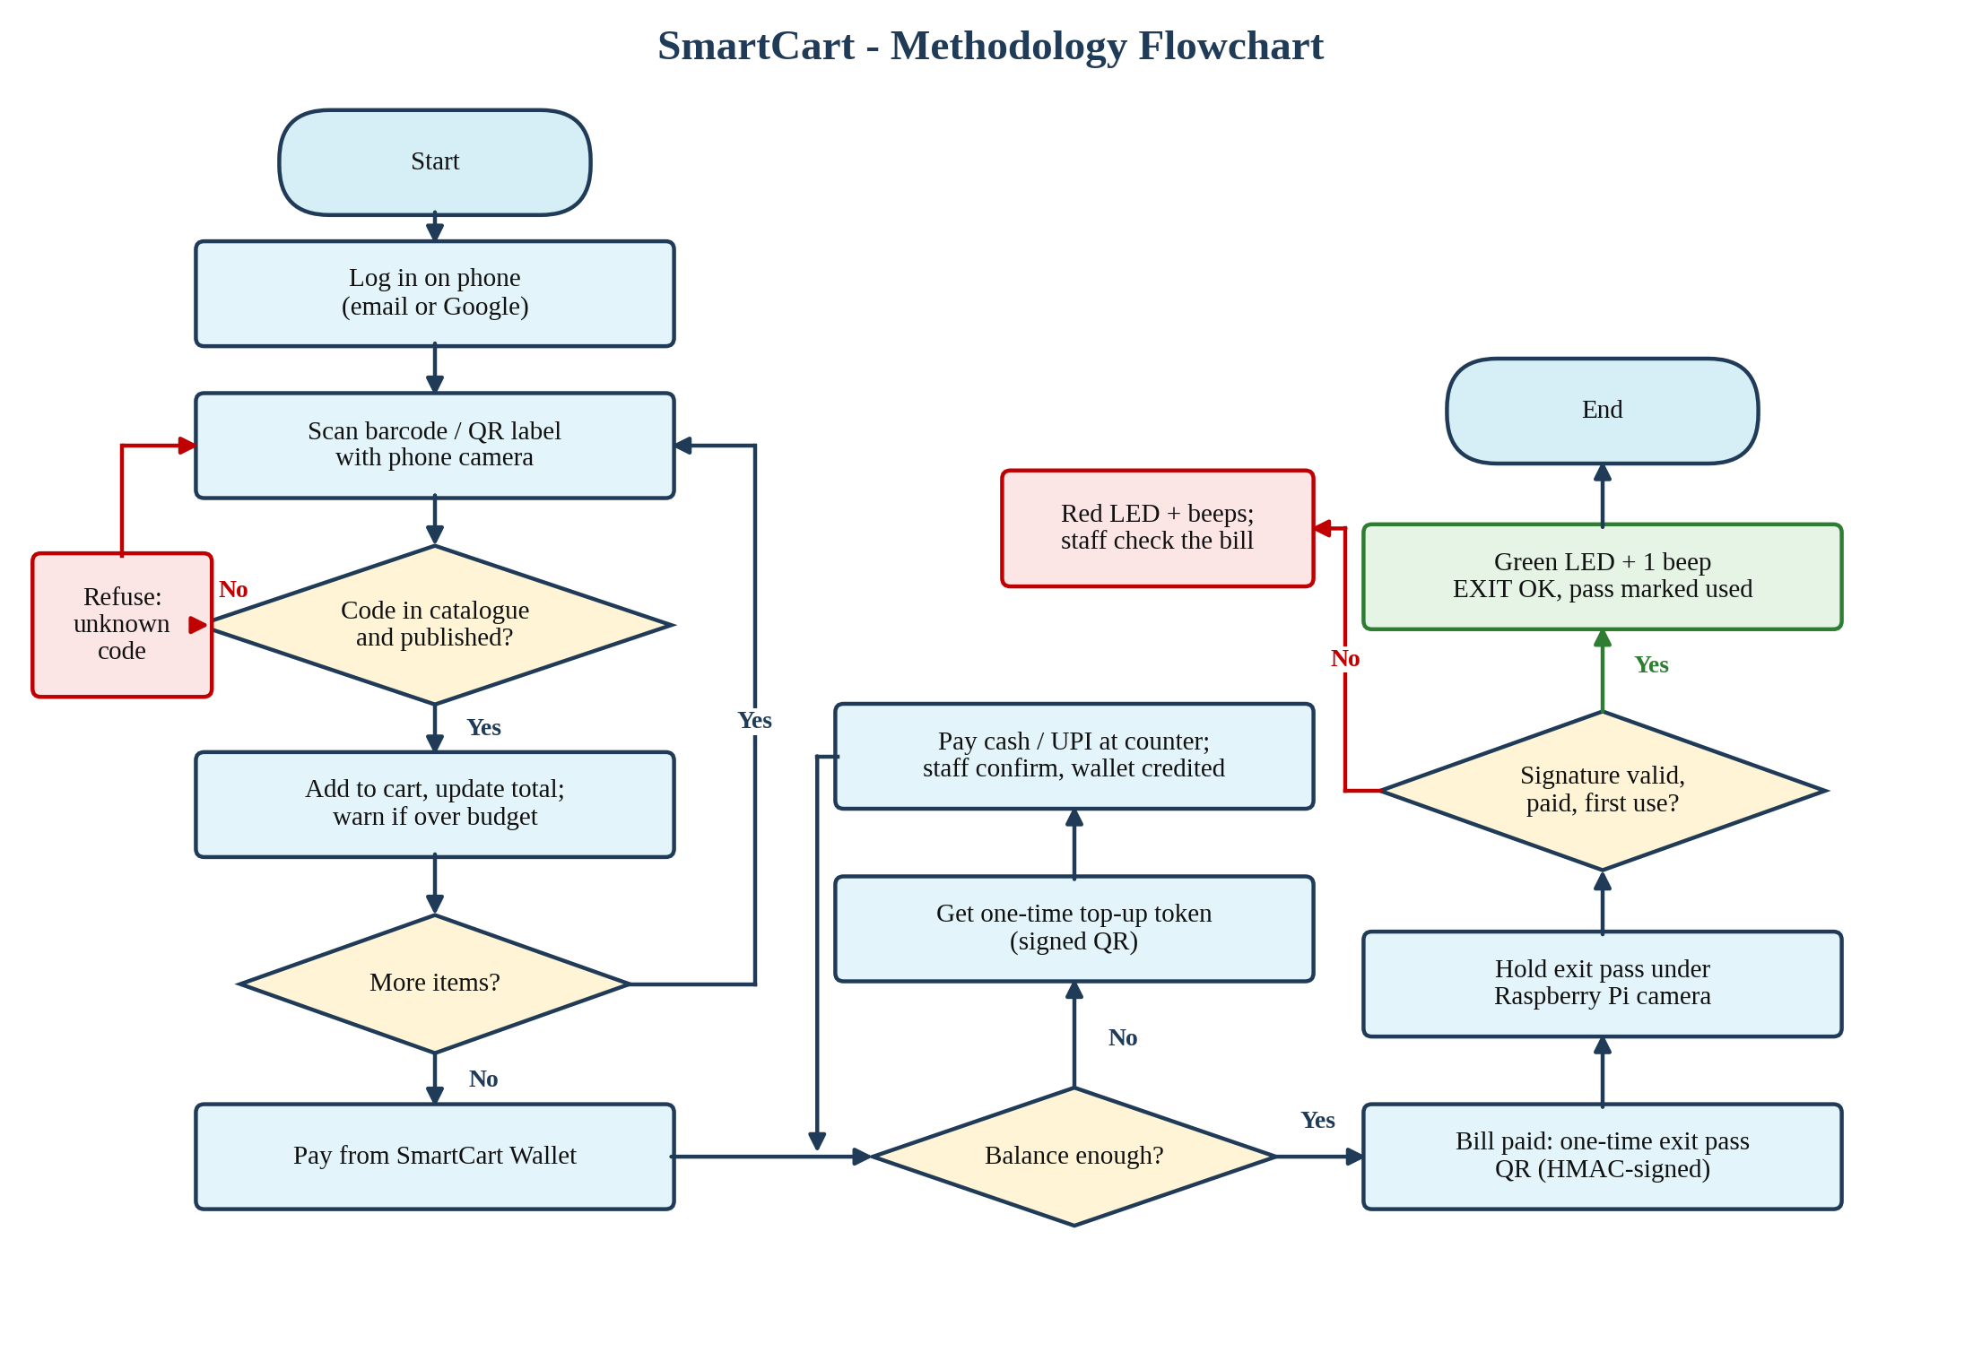
Fig. 2.1: Methodology flowchart
2.2 Scanning and Cart
The shopper logs in with an email and password or with Google sign-in and opens the Scan page. One camera scanner reads the barcode printed on a pack (EAN-13, EAN-8, UPC-A, UPC-E, Code 128 and Code 39) and SmartCart QR labels for loose items, with no mode to choose. The server looks the code up in the catalogue: a published product is added to the cart, and an unknown or mistyped code is refused because it is not in the catalogue.
The cart shows a running total, offer savings against the MRP, and a spending budget that warns when it is crossed. A wrong scan can be undone at once. A shopping list with a store map, voice search, larger text and a Call staff button are also provided.
2.3 SmartCart Wallet
Bills are paid from the shopper's SmartCart Wallet (1 token = Rs 1). To add money, the shopper chooses an amount and gets a one-time top-up token shown as a QR code. They pay that amount at the counter by cash or UPI, and staff scan the token on the Wallet Counter page (or hold it under the Pi camera) and press Cash received or UPI received. Only then is the wallet credited. Paying the bill takes the amount from the wallet; if the balance is short, the payment is refused and the cart offers a top-up. Every change is logged with the balance after it, and balances change only under a database row lock.
2.4 Exit Verification
Every paid bill carries an exit pass QR of the form SCBILL-<order>-<signature>, where the signature is an HMAC computed by the server with a secret key. At the exit the shopper holds the pass under the Raspberry Pi camera. The Pi decodes the QR and sends it to the server, which checks the signature, that the bill is paid and that the pass has not been used before. The Pi then shows the result with its LEDs and buzzer (Table 2.1). Staff can also scan the pass with a phone on the Exit Gate page, which shows every Pi result live.
Table 2.1: Exit-pass results and Raspberry Pi signals
Result | Meaning | Pi signal
EXIT OK | Genuine, paid bill used for the first time; marked as used | Green LED + 1 beep
BILL ALREADY USED | A screenshot or a second person using the same bill | Red LED + 2 beeps
INVALID BILL | Fake or edited QR, or an order number put into a QR generator | Red LED + long beep
HOLD CUSTOMER | Unresolved flagged scans, or bag weight does not match (scale on) | Red flashing + 3 beeps
Top-up token read | Token opens on the staff Wallet Counter for confirmation | Green double blink + beep

2.5 Weight and Camera Check
To stop a shopper scanning a cheap item and putting an expensive one in the cart, a weight and camera check was designed. When an item settles on the load-cell platform, the Pi sends one weight reading and one photo to the server. In weight mode the item enters the cart only if its weight is within the product's calibrated range (+-3%); in full mode its camera colour must also be close to the product's reference colour. Each reading can be used for only one scan, a mismatch is saved for staff to approve or reject, and an item placed without being scanned within 15 s raises an alert. This part is built and tested with a simulator, but the HX711 board failed, so the server currently runs with the scale switched off (SCALE_ENABLED off).
CIRCUIT DESCRIPTION
3.1 Block Diagram
Fig. 3.1 shows the four parts of the system. The shopper's phone and the staff devices talk to the SmartCart server over HTTPS. The Raspberry Pi on the cart or exit gate reads QR codes with the Pi Camera v2 and drives two LEDs and a buzzer. The Pi never accepts incoming connections: it only calls out to the server with its device key, sending exit-pass and token codes and a heartbeat every 30 s that shows it as online.
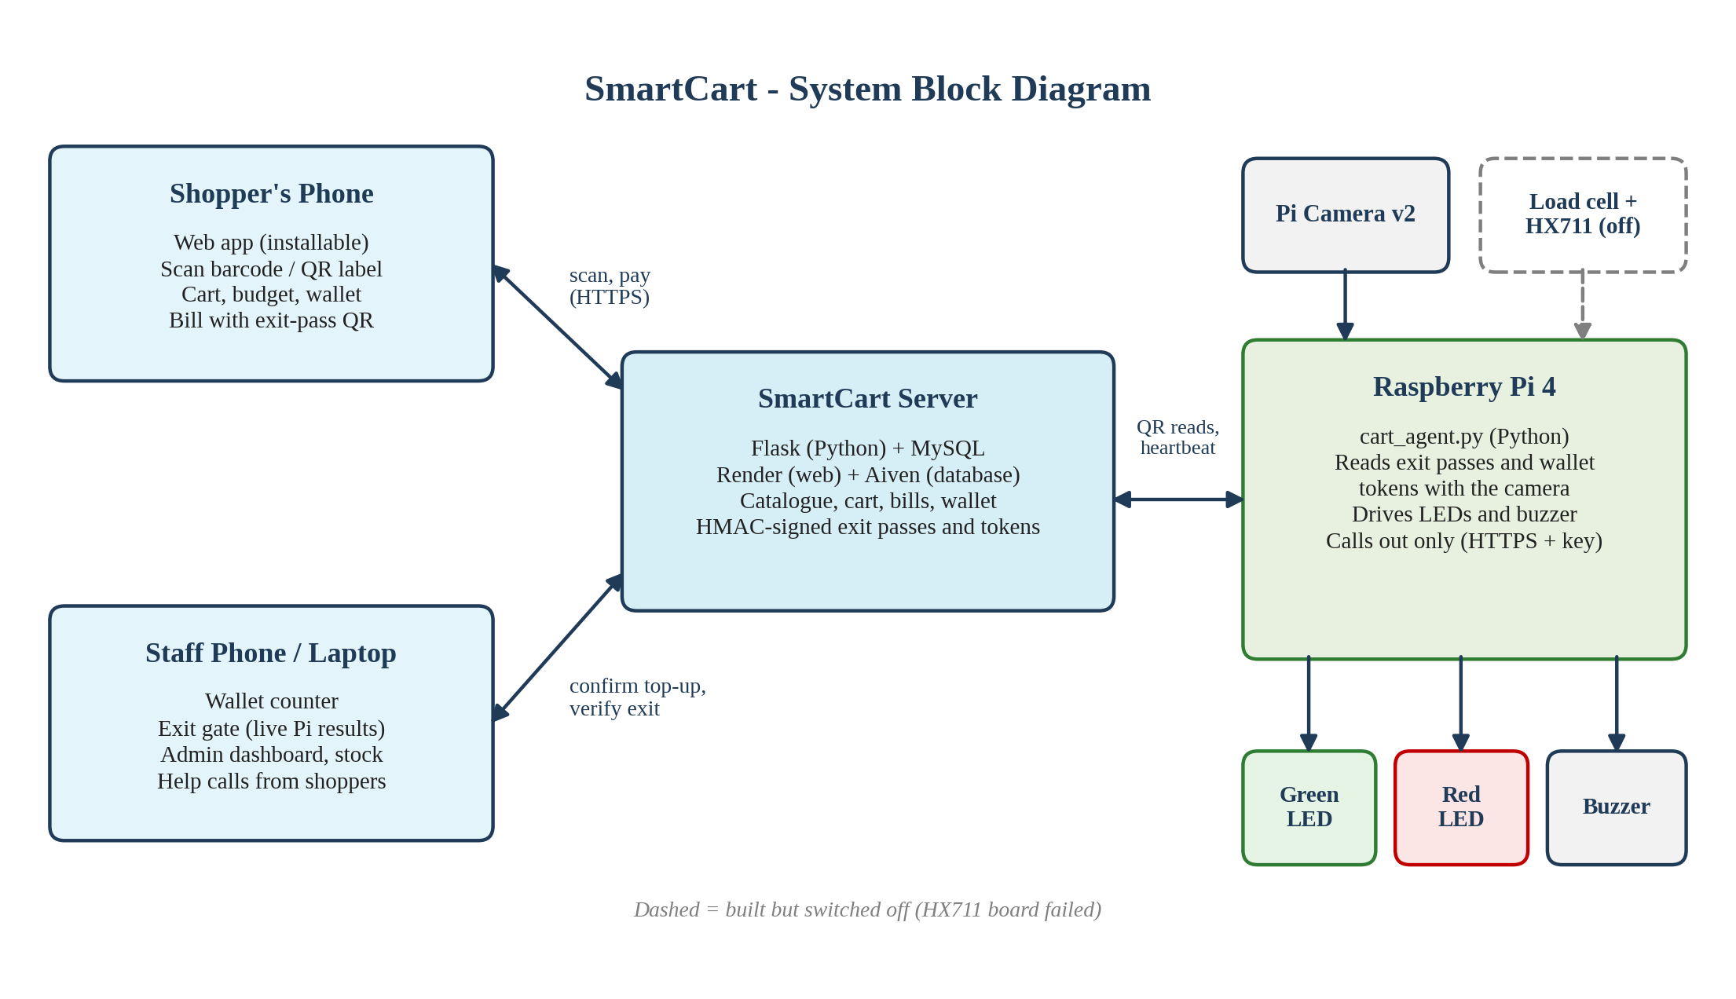
Fig. 3.1: System block diagram
3.2 Circuit Diagram
Fig. 3.2 shows the wiring. The HX711 is powered from the Pi's 3.3 V pin and its data (DT) and clock (SCK) lines go to GPIO 5 and GPIO 6. The green and red LEDs are driven from GPIO 17 and GPIO 27 through 220 ohm current-limiting resistors, and the active buzzer from GPIO 22. All grounds share one rail. The camera connects to the CSI port with a ribbon cable. Table 3.1 lists every connection by physical pin number.
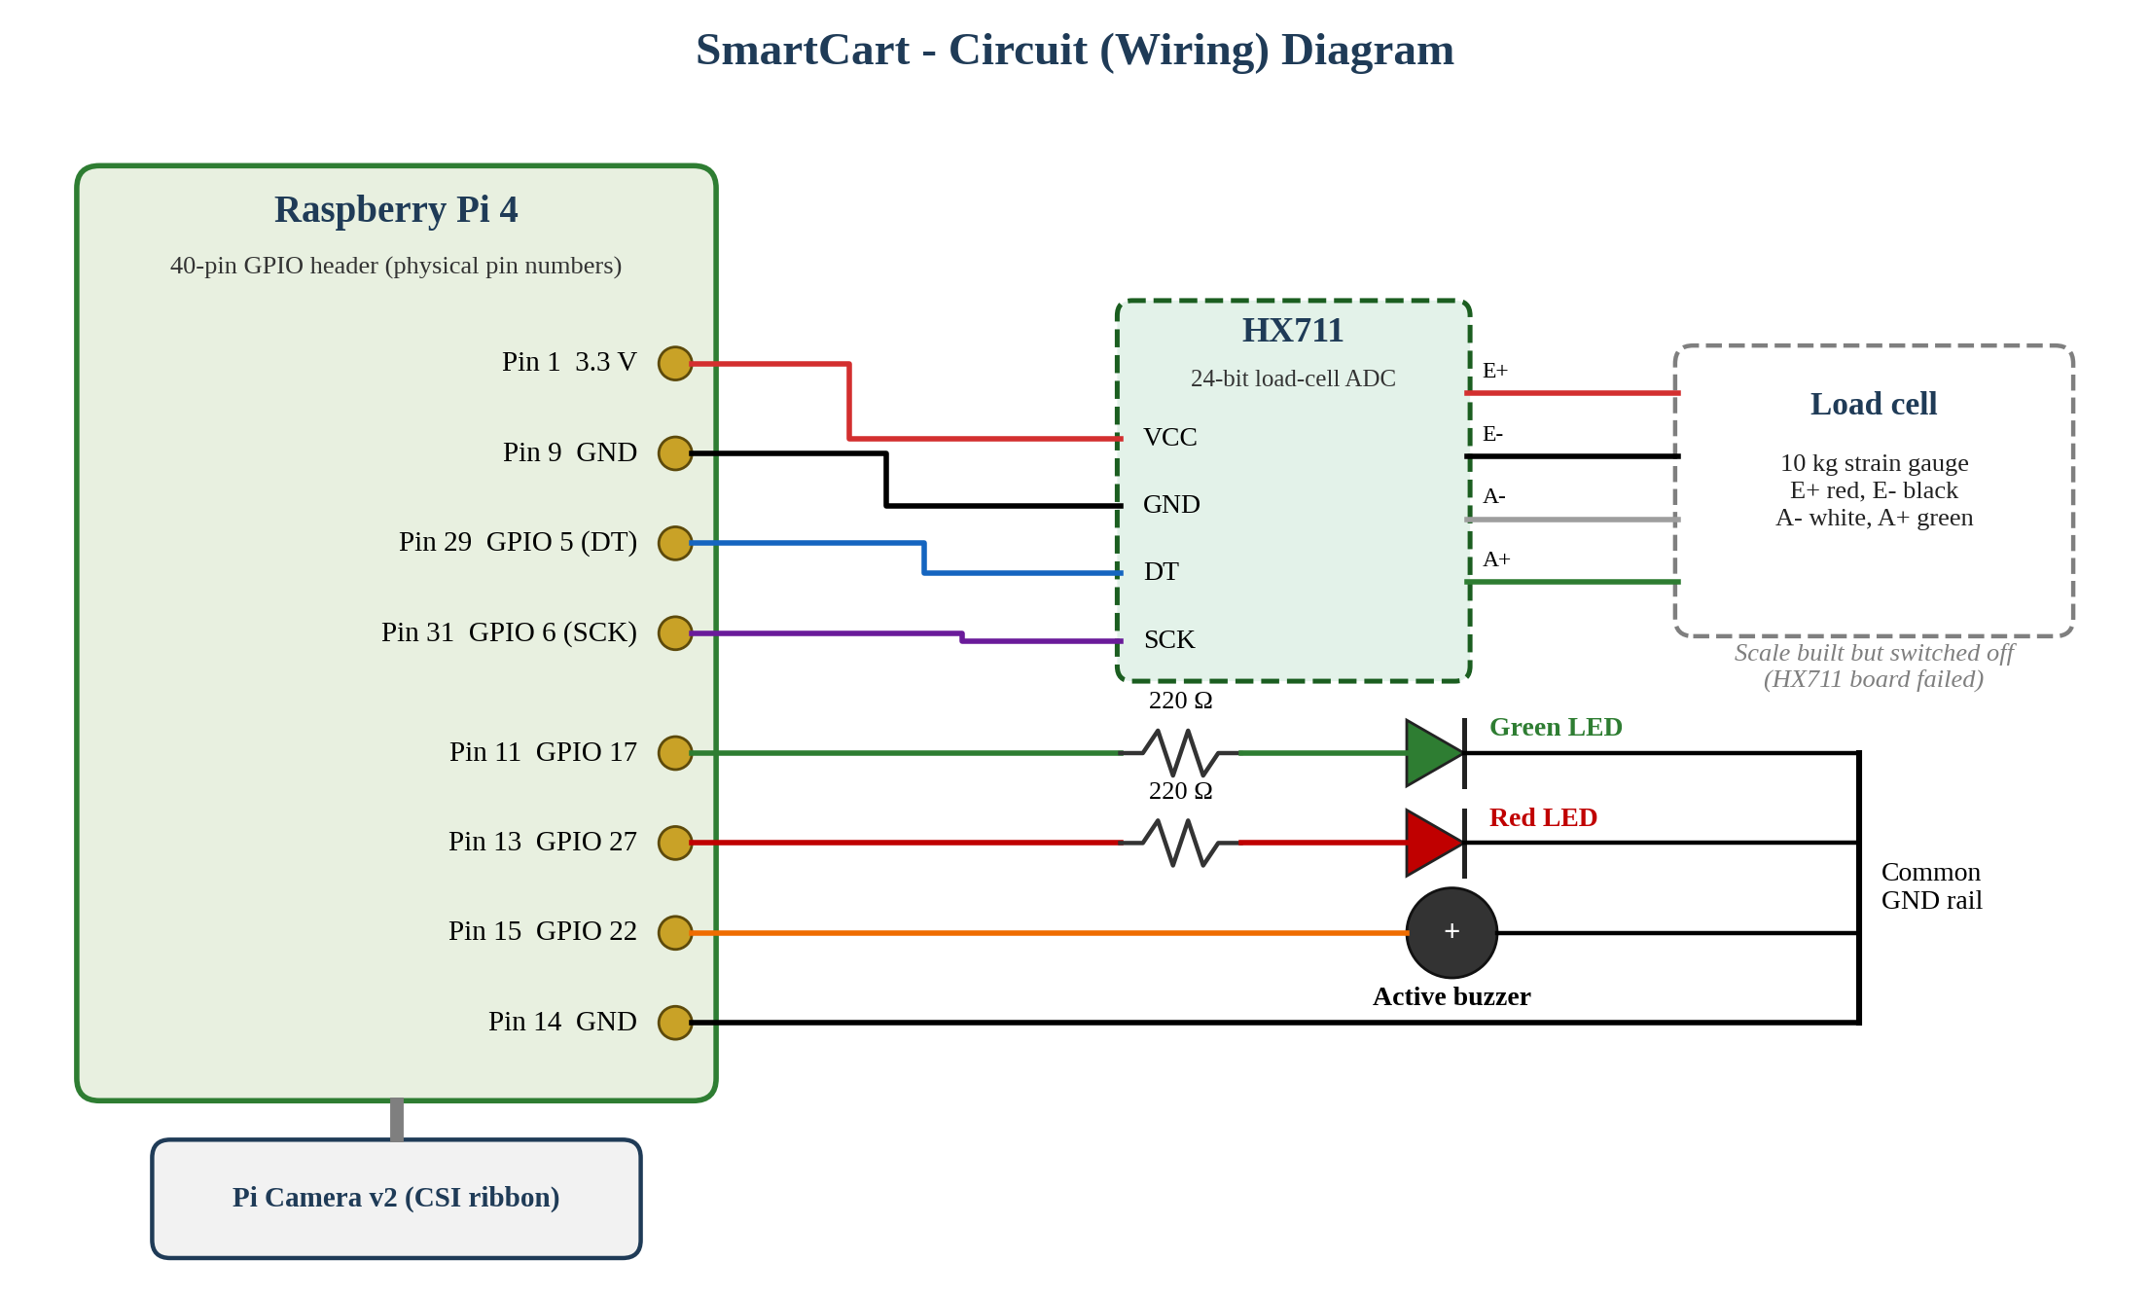
Fig. 3.2: Circuit (wiring) diagram
Table 3.1: Raspberry Pi pin connections
Part | Wire | Pi pin | Signal
HX711 | VCC | 1 | 3.3 V
HX711 | GND | 9 | Ground
HX711 | DT | 29 | GPIO 5
HX711 | SCK | 31 | GPIO 6
Green LED | Anode via 220 Ω | 11 | GPIO 17
Red LED | Anode via 220 Ω | 13 | GPIO 27
Buzzer (active) | + | 15 | GPIO 22
LEDs and buzzer | Ground | 14 | Ground
Load cell to HX711 | Red E+, black E-, white A-, green A+ | - | Bridge excitation / signal

COMPONENT DESCRIPTION
Table 4.1 lists the components used. Each is described below.
Table 4.1: List of components
Sr. No. | Component | Specification | Purpose
1 | Raspberry Pi 4 Model B | Quad-core ARM Cortex-A72, Wi-Fi, 40-pin GPIO, CSI port | Runs the cart / exit-gate program
2 | Pi Camera v2 | 8 MP Sony IMX219 sensor, CSI ribbon | Reads exit-pass and top-up token QR codes
3 | Load cell | 10 kg strain-gauge bridge | Weighs items (built, switched off)
4 | HX711 module | 24-bit ADC for load cells | Amplifies and digitises the load-cell signal
5 | LEDs | Green and red, 5 mm, 220 Ω resistors | OK / stop indication
6 | Buzzer | Active buzzer, 3.3 V | Audible OK / alert
7 | microSD card and power supply | Raspberry Pi OS; 5 V 3 A USB-C | Storage and power for the Pi
8 | Breadboard and jumper wires | - | Connections
9 | Smartphone | Camera and web browser | Shopper scans items and pays

4.1 Raspberry Pi 4
The Raspberry Pi 4 Model B is a single-board computer with a quad-core ARM Cortex-A72 processor, dual-band Wi-Fi, Bluetooth, Gigabit Ethernet, USB 3.0 ports and a 40-pin GPIO header. It runs Raspberry Pi OS and the SmartCart Pi program written in Python. The GPIO pins drive the LEDs and buzzer and read the HX711, and the CSI port connects the camera. One Pi replaced the three ESP32 boards of the first design, so the weight and the photo of an item come from one board at the same moment.
4.2 Pi Camera v2
The Pi Camera v2 uses an 8-megapixel Sony IMX219 sensor and connects to the Pi's CSI port. In SmartCart it reads the exit-pass QR code on the shopper's phone and the wallet top-up tokens, using the Picamera2 library and the pyzbar QR decoder. In full verification mode it also measures the colour of an item on the platform.
4.3 Load Cell and HX711
A load cell is a metal bar carrying strain gauges in a Wheatstone bridge; its output changes by a few millivolts with the load. The HX711 is a 24-bit analog-to-digital converter made for load cells, with a built-in programmable-gain amplifier. It sends readings to the Pi over two wires: DT (data) and SCK (clock). The scale is calibrated with an empty platform and a known weight. During testing the HX711 never pulled its DT line low on any GPIO pin, which shows that the board was unpowered or faulty, so the scale is switched off until it is replaced.
4.4 LEDs and Buzzer
A green and a red LED, each with a 220 ohm series resistor to limit the current from the 3.3 V GPIO pins, show whether a shopper may leave. An active buzzer gives one beep for OK and different beep patterns for a used bill, an invalid bill or a hold. The same signals tell staff when a top-up token has been read and when the Pi has started and connected.
4.5 Hardware Setup
Fig. 4.1 and Fig. 4.2 show the wiring of the Pi and the HX711. Fig. 4.3 shows the SmartCart Wallet Counter running in the browser on the Raspberry Pi's own display in the laboratory.
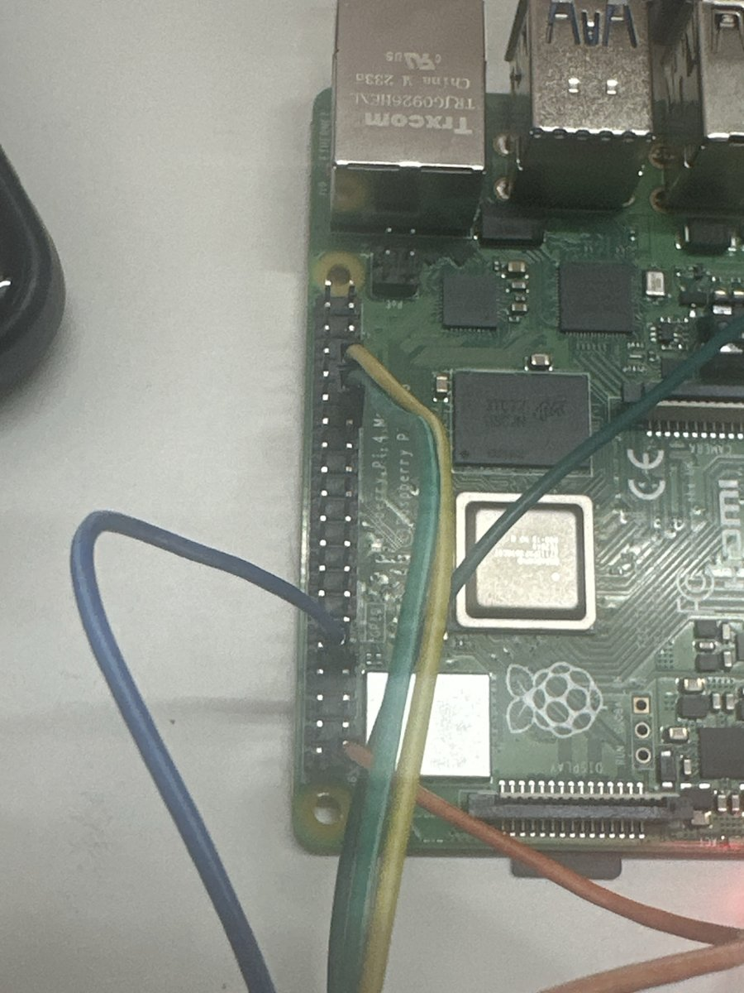
Fig. 4.1: Raspberry Pi 4 GPIO wiring
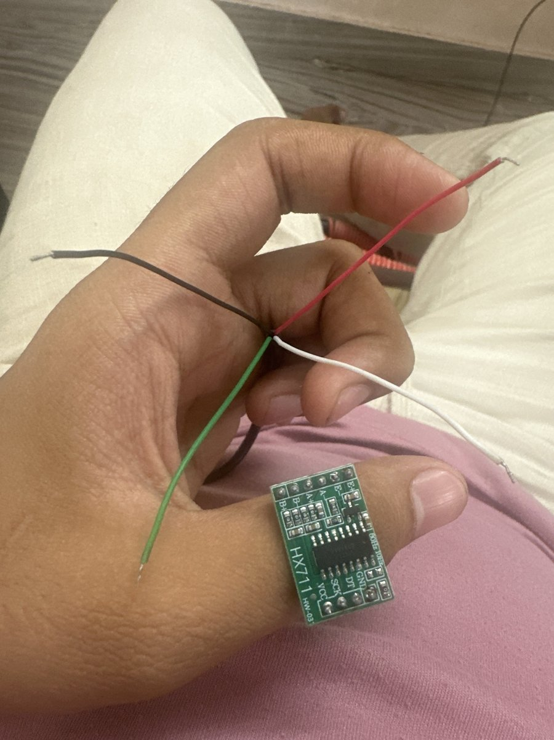
Fig. 4.2: HX711 amplifier with the load cell wires
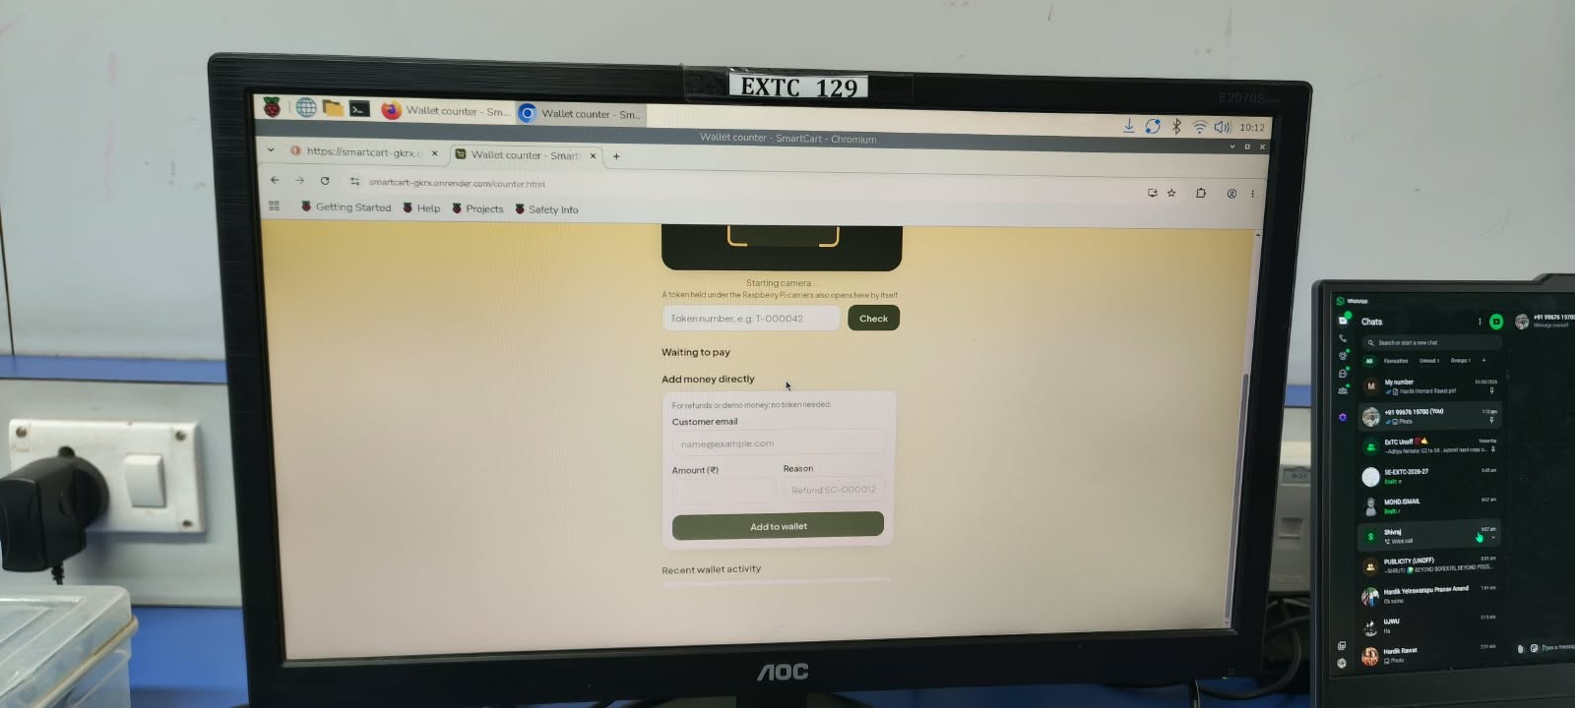
Fig. 4.3: SmartCart running on the Raspberry Pi's own display
SOFTWARE DESCRIPTION
5.1 Server
The server is written in Python with the Flask framework and SQLAlchemy, and stores its data in MySQL 8. Its main tables hold users, products, cart items, orders and order items, wallet transactions, top-up requests, hardware readings, flagged transactions, cart alerts, shopping lists and help requests. Logins use JSON Web Tokens, with optional Google sign-in. The product catalogue is kept in the server's memory, so shop pages and scans are answered without querying the database. The server is hosted on Render with the database on Aiven, and it also serves the website, so the whole system runs from one address.
5.2 Website
The website is written in plain HTML, CSS and JavaScript and can be installed on Android and iPhone as an app. Shopper pages cover the shop, scanning, cart, wallet, bills and shopping list. Staff pages are the Wallet Counter, the Exit Gate and an admin dashboard with today's sales, a 7-day chart, best sellers, low-stock items with one-tap restock, flagged scans and a sales CSV download. The camera scanner (html5-qrcode), the QR drawing library and the font are served by the site itself, so it works on campus networks that block public CDNs.
5.3 Raspberry Pi Program
The Pi program, cart_agent.py, is written in Python. It uses Picamera2 to capture frames, pyzbar to decode QR codes, and lgpio / RPi.GPIO to drive the LEDs and buzzer and read the HX711. It sends exit-pass codes, top-up tokens and a heartbeat every 30 s to the server with the header X-Device-Key, and shows the answer with its lights and buzzer. It is installed with a script, starts by itself on power-up, and can block all incoming connections with a firewall. When the server reports the scale as switched off, the program skips the scale and runs only the exit gate and token reading.
5.4 Security
• Signed codes: exit passes and top-up tokens carry an HMAC signature and work once.
• Passwords: stored only as hashes; five wrong attempts lock an account for 15 minutes.
• Rate limits: 300 requests a minute per user and 60 changes a minute, with 20 sign-ups an hour per address.
• Content-Security-Policy: only the site's own scripts run, which blocks injected scripts.
• Secrets: keys and the admin password come from the server's settings, never from the code.
• Device key: the Pi must send its key with every request and accepts no incoming connections.
5.5 Results
The system is deployed and working at smartcart-gkrx.onrender.com. Barcode and QR scanning, the cart, offers and budget, wallet top-up by cash or UPI with staff confirmation, payment from the wallet, the signed exit pass and its verification by the Raspberry Pi camera all work end to end. Figs. 5.1 to 5.4 show the main screens. The weight check is switched off because of the failed HX711 board, and timing and accuracy have not yet been measured.
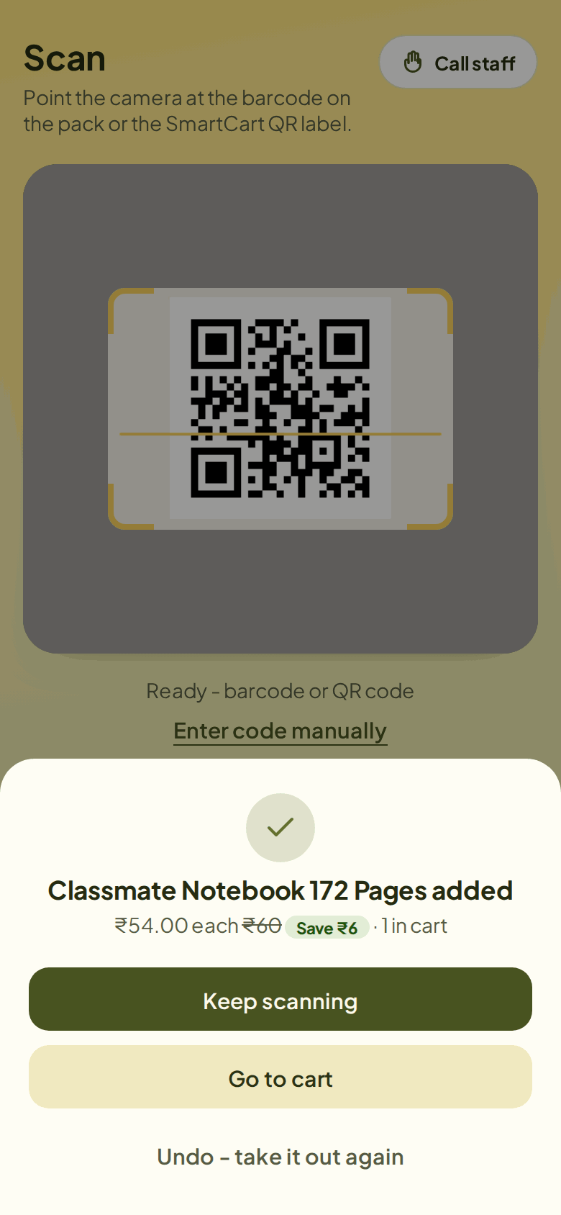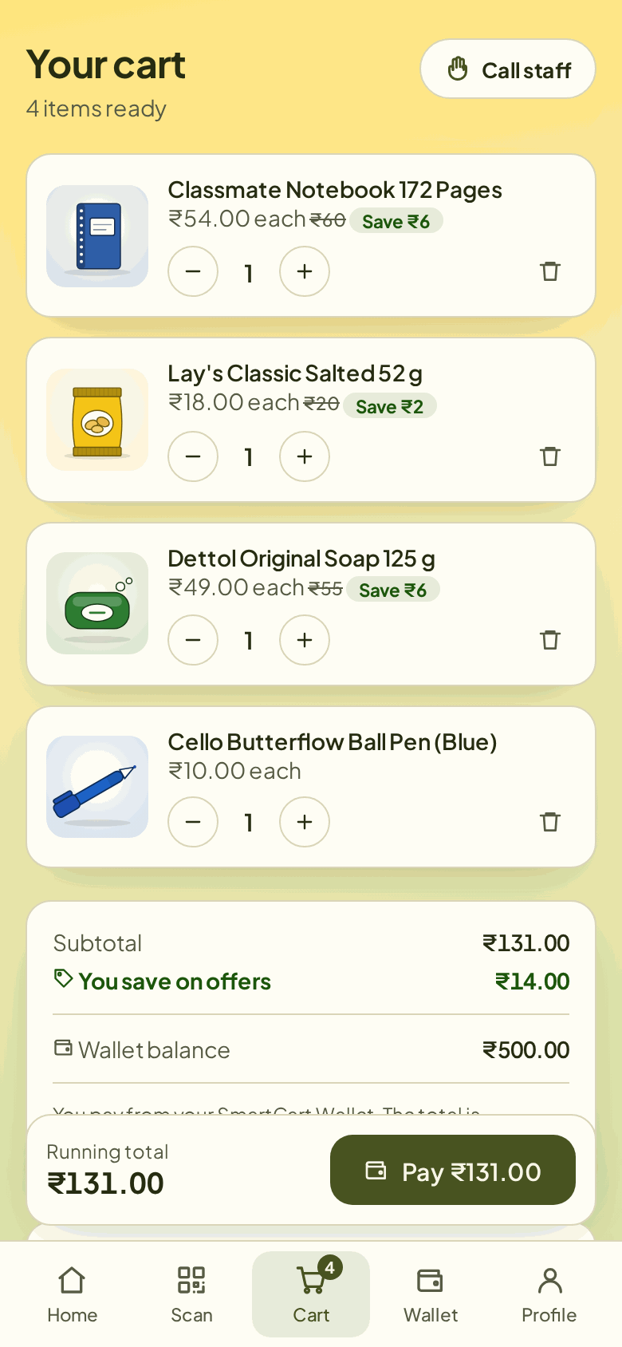
Fig. 5.1: Scanning an item and the cart
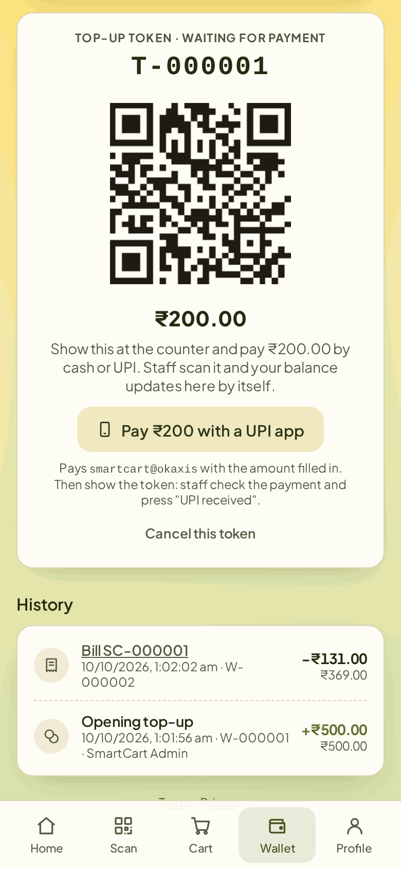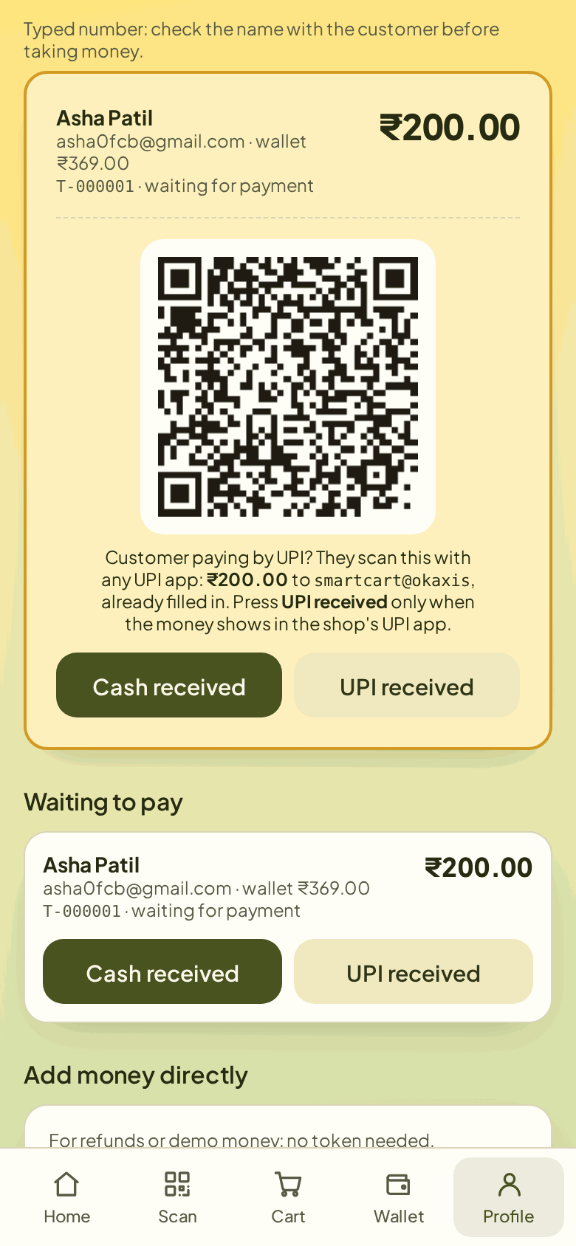
Fig. 5.2: Wallet top-up token and staff wallet counter
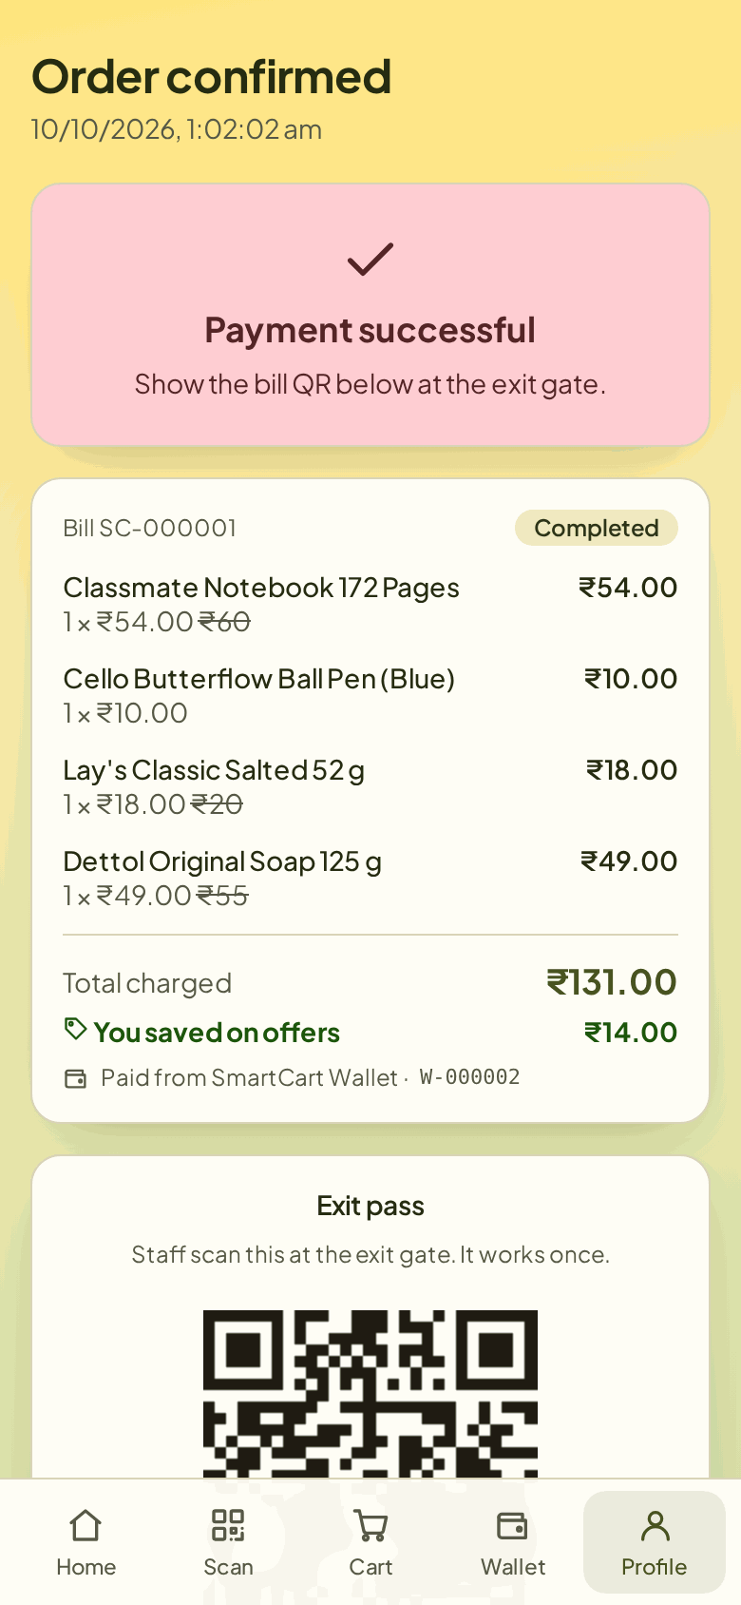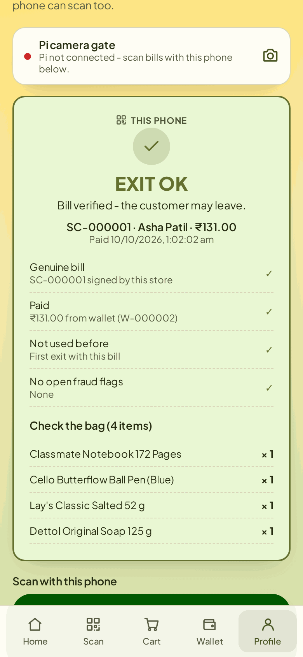
Fig. 5.3: Paid bill with exit pass and exit-gate result
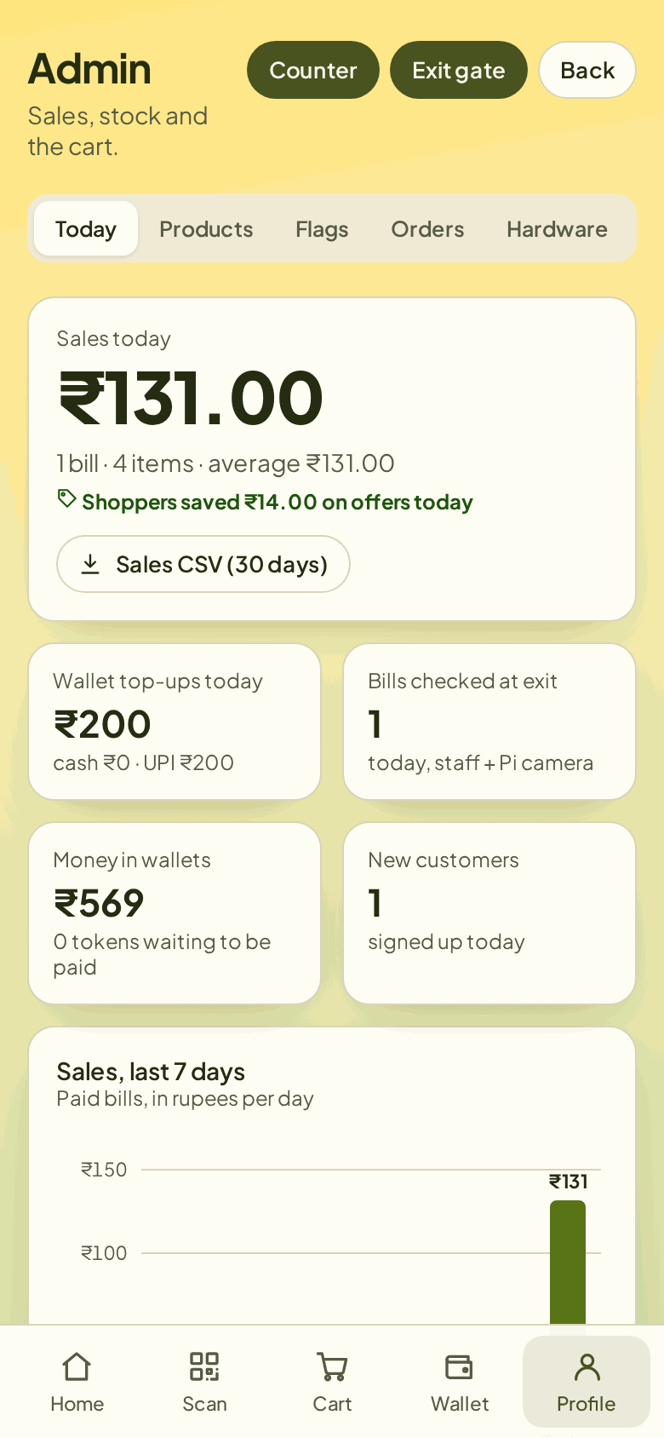
Fig. 5.4: Admin dashboard
ADVANTAGES
Compared with the five surveyed IEEE papers, SmartCart is different and better in four ways:
• No tags or extra scanners on products: papers [3], [4] and [5] need an RFID tag on every item and [1] and [2] need a camera and screen on the cart; SmartCart uses the barcodes already printed on packs and the shopper's own phone.
• Payment inside the app: papers [1] and [2] send the shopper to a cashier; SmartCart takes payment from the wallet, with top-ups added only after staff confirm the cash or UPI.
• Verified exit: only [4] (RFID gate) and [5] (weight check) try to stop theft; SmartCart's exit pass is HMAC-signed and works once, so screenshots, edited codes and reused bills are refused.
• One web app for shoppers and staff: a wallet counter, exit gate and admin dashboard with sales and stock, instead of a local screen or a single app.
Other advantages:
• Low cost: one Raspberry Pi with a camera serves the exit; no hardware is needed on every cart for scanning or payment.
• Works from any phone browser and installs as an app; no app-store download is needed.
• The Pi never accepts incoming connections, which keeps it safe on a shop network.
• Staff tools (sales CSV, low-stock alerts, help calls) come with the system.
DISADVANTAGES
SmartCart falls short of the surveyed papers in five places, listed in Table 7.1.
Table 7.1: Where SmartCart falls short of the surveyed papers
Gap | Paper that does better | Why it matters
No measured results (timings, accuracy, failure rates) | [4] reports items per network type; [5] reports 91.7% anti-theft and per-step timings | Without numbers, faster and more secure are claims, not results
Weight check switched off (HX711 failed) | [5] runs a live load-cell check with alerts | An item can go into the bag without being scanned
Exit pass proves the bill was paid, not that the bag matches it | [4] checks every tagged item at the exit | Staff must check the bag against the item list by eye
Needs the shopper's phone and internet; free hosting takes about 30 s to wake | [1], [2] work from the cart's own screen | Shoppers without a smartphone or with a weak signal cannot use it
Wallet top-up needs a staff member to confirm | [4] deducts from the bank; [5] sends a payment link | One more manual step at the counter

SCOPE
The following work would close the gaps in Chapter 7 and extend the project:
1. Turn the weight check back on: fit a working HX711, set a tolerance per product and report its accuracy as [5] does.
2. Measure and publish results: time scan-to-cart, payment and exit checks over at least 100 trials, and count how many fake, edited or reused passes are refused.
3. Check the bag at the exit: weigh the bag at the gate and compare it with the bill's expected weight.
4. Direct UPI payment: add a payment gateway so top-ups and bills clear without staff confirmation.
5. Product recognition: a small YOLO model on the Pi camera, as in [2], to catch items placed without a scan.
6. Lower-cost ESP32 version: move the cart electronics to an ESP32 and keep the camera only at the exit.
7. Paid hosting and offline queueing: remove the 30 s wake-up delay and keep scans when the network drops.
CONCLUSION
SmartCart shows that a small store can offer self-checkout without RFID tags or a computer on every cart. Shoppers scan the barcodes already printed on packs with their own phone, pay from a SmartCart Wallet topped up by cash or UPI, and leave after a Raspberry Pi camera verifies a signed, one-time exit pass. The system is live online and works end to end with the Raspberry Pi 4, Pi Camera v2, LEDs and buzzer.
Among the five IEEE papers surveyed, SmartCart is the only one that combines tag-free scanning, payment inside the application and a verified exit. Its weaknesses are equally clear: the weight check is switched off after the HX711 board failed, the exit pass does not prove that the bag matches the bill, and accuracy and timing are not yet measured. Fixing the scale and running measured trials are the next steps.
REFERENCES
[1] M. Kumar et al., “Intelligent Shopping Trolley with Automated Billing using Raspberry Pi,” in Proc. 4th Int. Conf. Smart Technologies in Computing, Electrical and Electronics (ICSTCEE), Bengaluru, India, 2023, doi: 10.1109/ICSTCEE60504.2023.10585242.
[2] N. Ibrahim et al., “Smart Shopping Cart: A Raspberry Pi-Based System for Reducing Supermarket Checkout Delays,” in Proc. IEEE Int. Conf. Smart Sustainable Systems for Computer and Engineering Applications (3SCEA), 2026, pp. 1100–1109, doi: 10.1109/3SCEA68071.2026.11602934.
[3] M. Shahroz, M. F. Mushtaq, M. Ahmad, S. Ullah, A. Mehmood and G. S. Choi, “IoT-Based Smart Shopping Cart Using Radio Frequency Identification,” IEEE Access, vol. 8, pp. 68426–68438, 2020, doi: 10.1109/ACCESS.2020.2986681.
[4] R. Nishitha, S. S. Naik, V. Raksha and U. Kulsum, “IoT Based Automatic Billing System Using Barcode Scanner by Android Device and Monitoring Unregistered Barcode by RFID,” in Proc. 4th Int. Conf. Recent Trends on Electronics, Information, Communication & Technology (RTEICT), Bangalore, India, 2019, pp. 15–20, doi: 10.1109/RTEICT46194.2019.9016698.
[5] M. H. Walid et al., “The Smart Cart with Automatic Billing and Anti-Theft,” in Proc. IEEE Int. Conf. Electrical, Electronic and Computer Engineering (ICEECE), 2026, doi: 10.1109/ICEECE71300.2026.11709931.
[6] Raspberry Pi Ltd., “Raspberry Pi 4 Model B,” product documentation. [Online]. Available: https://www.raspberrypi.com/products/raspberry-pi-4-model-b/
[7] Pallets Projects, “Flask documentation.” [Online]. Available: https://flask.palletsprojects.com/
[8] SmartCart project source code and live demo. [Online]. Available: https://github.com/hardikrawat910-byte/smart-billing-cart and https://smartcart-gkrx.onrender.com

