A
MINI PROJECT-1A REPORT
On
“CARTLESS CHECKOUT: SELF-BILLING USING YOUR OWN PHONE”
BY
Hardik Hemant Rawat | 125A2047
Shivraj Morde | 125A2033
Mohammed Ismail | 125A2052
Pranav Anand | 125A2062

UNDER THE GUIDANCE OF
Dr. Swati Rane

SUBMITTED IN PARTIAL FULFILLMENT FOR THE DEGREE OF
SECOND YEAR OF ENGINEERING
IN
ELECTRONICS AND TELECOMMUNICATION



DEPARTMENT OF ELECTRONICS AND TELECOMMUNICATION
SIES GRADUATE SCHOOL OF TECHNOLOGY
NERUL, NAVI MUMBAI – 400706
ACADEMIC YEAR
2026- 2027
CERTIFICATE
This is to certify that the project titled “CartLess Checkout: Self-Billing Using Your Own Phone” carried out by following students of S.E in Electronics and Telecommunication:
Hardik Hemant Rawat | 125A2047
Shivraj Morde | 125A2033
Ismail Mohammed | 125A2052
Pranav Anand | 125A2062

The project report is submitted in partial fulfilment of second year of engineering Electronics and Telecommunication from University of Mumbai during the academic year 2026 - 2027
Dr. Swati Rane | Prof. Pratibha Joshi | Dr. Swati Rane
Internal Guide | Mini Project Coordinator | Head Of Department

We have examined this report as per university requirements at SIES Graduate School of Technology, Nerul (E), Navi Mumbai on _____________

Name of External Examiner : ______________________________________
Signature with Date : ______________________________________
Name of Internal Examiner : ______________________________________
Signature with Date :______________________________________
ABSTRACT
Billing queues are the slowest part of shopping in a store: customers wait at the counter even to pay for two or three items, and staff must check by eye that every customer leaving has paid. Smart carts described in IEEE work either need an RFID tag on every product or send the customer back to a cashier to pay.
This project presents CartLess Checkout, a self-checkout system for a neighbourhood general store. The shopper scans the barcode already printed on each pack, or a CartLess QR label for loose items, with their own phone. The cart, offers, budget and bill are handled by a web application built with Flask and MySQL and hosted online. The bill is paid from an in-app CartLess Wallet that is topped up at the counter by cash or UPI using a signed, one-time top-up token that staff confirm.
Each paid bill carries an HMAC-signed, one-time exit pass shown as a QR code. A Raspberry Pi 4 with a Pi Camera v2 at the exit reads this pass and asks the server to verify it: a green LED and one beep allow the shopper to leave, while a red LED and beeps stop a screenshot, an edited code or a bill that has already been used. The Pi only makes outgoing HTTPS calls with its own device key and accepts no incoming connections.
A weight check using a 10 kg load cell and an HX711 amplifier was designed and built so that an item enters the cart only when its barcode, weight and camera colour agree. The HX711 has been fixed and the scale calibrated with 1 kg and 2 kg reference weights up to 4 kg; the check is now to be switched on in the software. The system is live at smartcart-gkrx.onrender.com. A survey of five IEEE papers shows that CartLess Checkout is the only one of them that needs no product tags, takes payment inside the app and verifies a signed exit pass with a camera. Timing and accuracy have been measured and are reported in the results; a store trial and weight-check accuracy across products form the future scope.
Keywords: smart cart, self-checkout, Raspberry Pi, QR code, barcode, HMAC, Flask, IoT.

ACKNOWLEDGEMENT
We express our sincere gratitude to our project guide and Head of the Department of Electronics and Telecommunication, Dr. Swati Rane, for her guidance, encouragement and support throughout this mini project.
We are thankful to our Mini Project Coordinator, Prof. Pratibha Joshi, for planning the project schedule, reviewing our progress and giving valuable suggestions at every stage.
We also thank the teaching and non-teaching staff of the Department of Electronics and Telecommunication, SIES Graduate School of Technology, for providing the laboratory, the Raspberry Pi and the other facilities needed to build and test this project.
Finally, we thank our families and friends for their constant support.

Hardik Hemant Rawat (125A2047)
Shivraj Morde (125A2033)
Ismail Mohammed (125A2052)
Pranav Anand (125A2062)

TABLE OF CONTENT

 | Abstract | i
 | Acknowledgement | ii
 | List of Table | iv
 | List of Figure | v
1 | Introduction | 1
 | 1.1 Background | 1
 | 1.2 Need of the Project | 1
 | 1.3 Objectives | 1
 | 1.4 Literature Survey | 2
2 | Working Principle | 4
 | 2.1 Methodology | 4
 | 2.2 Scanning and Cart | 4
 | 2.3 CartLess Wallet | 5
 | 2.4 Exit Verification | 5
 | 2.5 Weight and Camera Check | 5
3 | Circuit Description | 7
 | 3.1 Block Diagram | 7
 | 3.2 Circuit Diagram | 7
4 | Component Description | 9
 | 4.1 Raspberry Pi 4 | 9
 | 4.2 Pi Camera v2 | 10
 | 4.3 Load Cell and HX711 | 10
 | 4.4 LEDs and Buzzer | 11
 | 4.5 Hardware Setup | 11
5 | Software Description | 14
 | 5.1 Server | 14
 | 5.2 Website | 14
 | 5.3 Raspberry Pi Program | 14
 | 5.4 Security | 14
 | 5.5 Languages, Versions and System Requirements | 15
 | 5.6 Results | 16
6 | Advantages | 20
7 | Disadvantages | 21
8 | Scope | 22
9 | Conclusion | 23
10 | References | 24

LIST OF TABLE

Table No. | Title | Page No.
1.1 | Comparison of survey papers | 3
2.1 | Exit-pass results and Raspberry Pi signals | 5
3.1 | Raspberry Pi pin connections | 8
4.1 | List of components | 9
4.2 | Boards of the first design and how the Raspberry Pi 4 replaced them | 10
4.3 | Load cell and scale specifications | 11
5.1 | Languages used | 15
5.2 | Systems the software was run on | 15
5.3 | Minimum requirements and URL | 16
5.4 | Weight calibration results | 16
5.5 | Server test results | 17
6.1 | Advantages over the surveyed papers | 20
7.1 | Where CartLess Checkout falls short of the surveyed papers | 21

LIST OF FIGURE

Fig. No. | Title | Page No.
2.1 | Methodology flowchart | 4
3.1 | System block diagram | 7
3.2 | Circuit (wiring) diagram | 8
4.1 | Raspberry Pi 4 GPIO wiring | 12
4.2 | HX711 amplifier with the load cell wires | 13
4.3 | CartLess Checkout running on the Raspberry Pi's own display | 13
5.1 | Scanning an item and the cart | 17
5.2 | Wallet top-up token and staff wallet counter | 18
5.3 | Paid bill with exit pass and exit-gate result | 18
5.4 | Admin dashboard | 19

1. INTRODUCTION
1.1 Background
Retail billing in most Indian stores still depends on a cashier scanning every item at a counter. At busy hours the queue at the counter becomes the slowest part of a shopping trip, even for a customer buying only two or three items. Large chains have started trying scan-and-go systems such as Amazon Dash Cart, Instacart Caper Cart and DMart Scan & Go, but these depend on expensive carts or store infrastructure that a small store cannot afford.
CartLess Checkout is a self-checkout system designed for a neighbourhood general store. It turns the shopper's own phone into the scanner and the payment terminal, and uses a single Raspberry Pi with a camera at the exit to check that every customer who leaves has paid. The store used in the project stocks 48 everyday items in eight sections: stationery, snacks, biscuits and chocolates, beverages, instant food, personal care, household and electronics and hobby.
1.2 Need of the Project
- Customers wait in billing queues even for a few items, and long queues make customers leave without buying.
- Manual billing needs a cashier at every counter and is open to scanning and counting mistakes.
- Checking at the exit that a customer has paid is done by eye and can be fooled by an old or copied bill.
- Smart carts in published work need an RFID tag on every product or a computer and screen on every cart, which is costly for a small store.
1.3 Objectives
- To let shoppers scan the barcode already printed on each pack, or a QR label for loose items, with their own phone and see a running bill.
- To take payment inside the application through a prepaid CartLess Wallet that staff top up against cash or UPI.
- To issue every paid bill a signed, one-time exit pass and verify it with a Raspberry Pi camera at the exit, with a green or red light and a buzzer.
- To design a weight and camera-colour check that confirms the item put in the cart is the item scanned.
- To give staff a wallet counter, an exit-gate screen and an admin dashboard for sales and stock.
1.4 Literature Survey
Five IEEE papers on smart shopping carts were studied. They are summarised below and compared with CartLess Checkout in Table 1.1.
M. Kumar et al., ICSTCEE 2023. A Raspberry Pi 4 trolley in which the shopper scans each item's QR code with a USB camera; the bill is shown on a 20x4 LCD and buttons add, remove or update items. A 5 kg load cell and Bluetooth are fitted, and payment is made at the counter or on a mobile phone. A second mode makes the trolley follow the shopper by tracking shirt colour. No timing or accuracy results are reported and there is no anti-theft or exit check.
N. Ibrahim et al., 3SCEA 2026. A Raspberry Pi 4B cart with a Pi Camera v2 and a 7-inch touchscreen. Products are identified by barcode (OpenCV and Zbar) and by a YOLO11s object-detection model trained on 8 product classes (214 images) and run with NCNN on the Pi. It adds login, an admin panel, a store map, recipes and a budget. The receipt is still paid at the cashier, there is no anti-theft check, and the authors note that scanning failed in poor light.
M. Shahroz et al., IEEE Access 2020. An Arduino Uno cart that reads RFID tags on products with an MFRC522 reader (13.56 MHz, 0-60 mm) and sends the bill over HC-06 Bluetooth to an Android app, backed by a web management system. The customer logs in with an RFID card. Every product needs a tag, there is no anti-theft check, and no measured results are given.
R. Nishitha et al., RTEICT 2019. Shoppers scan barcodes with an Android phone and the bill is sent to a PC server over Wi-Fi; payment is by OTP, bank deduction or card. RFID detectors at the exit compare tags with the bill and sound a buzzer for unbilled items. About 9 items reached the server on 2G, about 30 on 3G and over 100 on 4G or 10 Mbps Wi-Fi; detection was best with the detector at 45 degrees, and one unit costs about Rs 40,000-50,000.
M. H. Walid et al., ICEECE 2026. A Raspberry Pi 3B+ cart with an RC522 RFID reader (2-5 cm), a load cell with HX711, a TFT display, buzzer and RGB LED, linked to Firebase, a Telegram bot and a payment gateway. A weight mismatch raises an alert. Measured results: anti-theft accuracy 91.7%, RFID reads 93 out of 100 (98% for normal and 88% for metallic packs), and 1.37 s from a mismatch to the alert. It needs internet and is affected by metal packaging.
Table 1.1: Comparison of Survey Papers
Author | Microcontroller | Methodology used | Payment | Anti-theft / exit check | Measured result (IEEE authors) | Measure taken in CartLess Checkout
Kumar et al. (2023) | Raspberry Pi 4 | QR code read by a USB camera on the trolley | At counter or mobile | None | None reported | Item scan processed by the server in a median 9.8 ms (300 scans)
Ibrahim et al. (2026) | Raspberry Pi 4B | Barcode + YOLO11s object detection | At cashier | None | Detection chart only; scanning failed in poor light | Phone camera reads the printed barcode; 300 of 300 unknown or mistyped codes refused
Shahroz et al. (2020) | Arduino Uno | RFID tag on each item | Android app | None | None reported | No tags needed; exit pass verified in a median 10.2 ms (90 passes)
Nishitha et al. (2019) | PC + Arduino | Barcode scanned on an Android phone | OTP, bank or card | RFID gate at exit | About 9 / 30 / 100+ items reached the server on 2G / 3G / 4G | Wallet checkout in a median 19.1 ms (90 bills); network time not yet measured
Walid et al. (2026) | Raspberry Pi 3B+ | RFID tag on each item + load-cell weight | Payment gateway link | In-cart weight check | 91.7% anti-theft accuracy; 93/100 RFID reads | 360 of 360 forged or edited exit passes and 90 of 90 reused passes refused
CartLess Checkout (this project) | Raspberry Pi 4 Model B + web server | Shopper's phone scans the existing barcode / QR label; HX711 weight check | In-app wallet, staff-confirmed top-up | Signed one-time exit pass read by the Pi camera | Server-side tests (see the last column) | –

The survey shows that none of the five papers combines tag-free scanning, payment inside the application and a verified exit check. CartLess Checkout is built around that gap; Chapters 6 and 7 compare it with the papers in detail.
2. WORKING PRINCIPLE
2.1 Methodology
Fig. 2.1 shows the complete flow of a shopping trip, from login to the exit gate. Each step is checked by the server, so the phone never decides a price, a balance or whether a bill is valid.
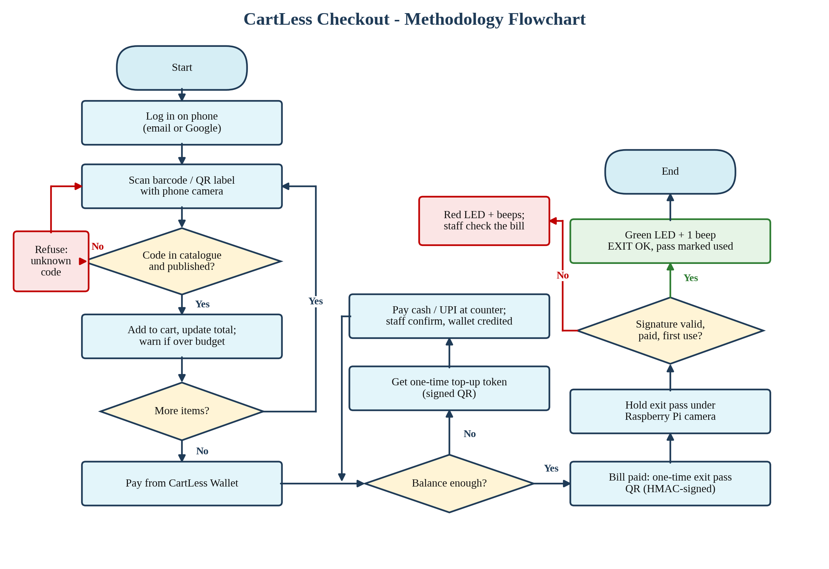
Fig. 2.1: Methodology flowchart
2.2 Scanning and Cart
The shopper logs in with an email and password or with Google sign-in and opens the Scan page. One camera scanner reads the barcode printed on a pack (EAN-13, EAN-8, UPC-A, UPC-E, Code 128 and Code 39) and CartLess QR labels for loose items, with no mode to choose. The server looks the code up in the catalogue: a published product is added to the cart, and an unknown or mistyped code is refused because it is not in the catalogue.
The cart shows a running total, offer savings against the MRP, and a spending budget that warns when it is crossed. A wrong scan can be undone at once. A shopping list with a store map, voice search, larger text and a Call staff button are also provided.
2.3 CartLess Wallet
Bills are paid from the shopper's CartLess Wallet (1 token = Rs 1). To add money, the shopper chooses an amount and gets a one-time top-up token shown as a QR code. They pay that amount at the counter by cash or UPI, and staff scan the token on the Wallet Counter page (or hold it under the Pi camera) and press Cash received or UPI received. Only then is the wallet credited. Paying the bill takes the amount from the wallet; if the balance is short, the payment is refused and the cart offers a top-up. Every change is logged with the balance after it, and balances change only under a database row lock.
2.4 Exit Verification
Every paid bill carries an exit pass QR of the form SCBILL-<order>-<signature>, where the signature is an HMAC computed by the server with a secret key. At the exit the shopper holds the pass under the Raspberry Pi camera. The Pi decodes the QR and sends it to the server, which checks the signature, that the bill is paid and that the pass has not been used before. The Pi then shows the result with its LEDs and buzzer (Table 2.1). Staff can also scan the pass with a phone on the Exit Gate page, which shows every Pi result live.
Table 2.1: Exit-pass results and Raspberry Pi signals
Result | Meaning | Pi signal
EXIT OK | Genuine, paid bill used for the first time; marked as used | Green LED + 1 beep
BILL ALREADY USED | A screenshot or a second person using the same bill | Red LED + 2 beeps
INVALID BILL | Fake or edited QR, or an order number put into a QR generator | Red LED + long beep
HOLD CUSTOMER | Unresolved flagged scans, or bag weight does not match (scale on) | Red flashing + 3 beeps
Top-up token read | Token opens on the staff Wallet Counter for confirmation | Green double blink + beep

2.5 Weight and Camera Check
To stop a shopper scanning a cheap item and putting an expensive one in the cart, a weight and camera check was designed. When an item settles on the load-cell platform, the Pi sends one weight reading and one photo to the server. In weight mode the item enters the cart only if its weight is within the product's calibrated range (+-3%); in full mode its camera colour must also be close to the product's reference colour. Each reading can be used for only one scan, a mismatch is saved for staff to approve or reject, and an item placed without being scanned within 15 s raises an alert. The HX711 has now been fixed and the scale calibrated in hardware with 1 kg and 2 kg reference weights, up to 4 kg; the check is to be switched on in the software (SCALE_ENABLED) next.
3. CIRCUIT DESCRIPTION
3.1 Block Diagram
Fig. 3.1 shows the four parts of the system. The shopper's phone and the staff devices talk to the CartLess Checkout server over HTTPS. The Raspberry Pi on the cart or exit gate reads QR codes with the Pi Camera v2 and drives two LEDs and a buzzer. The Pi never accepts incoming connections: it only calls out to the server with its device key, sending exit-pass and token codes and a heartbeat every 30 s that shows it as online.
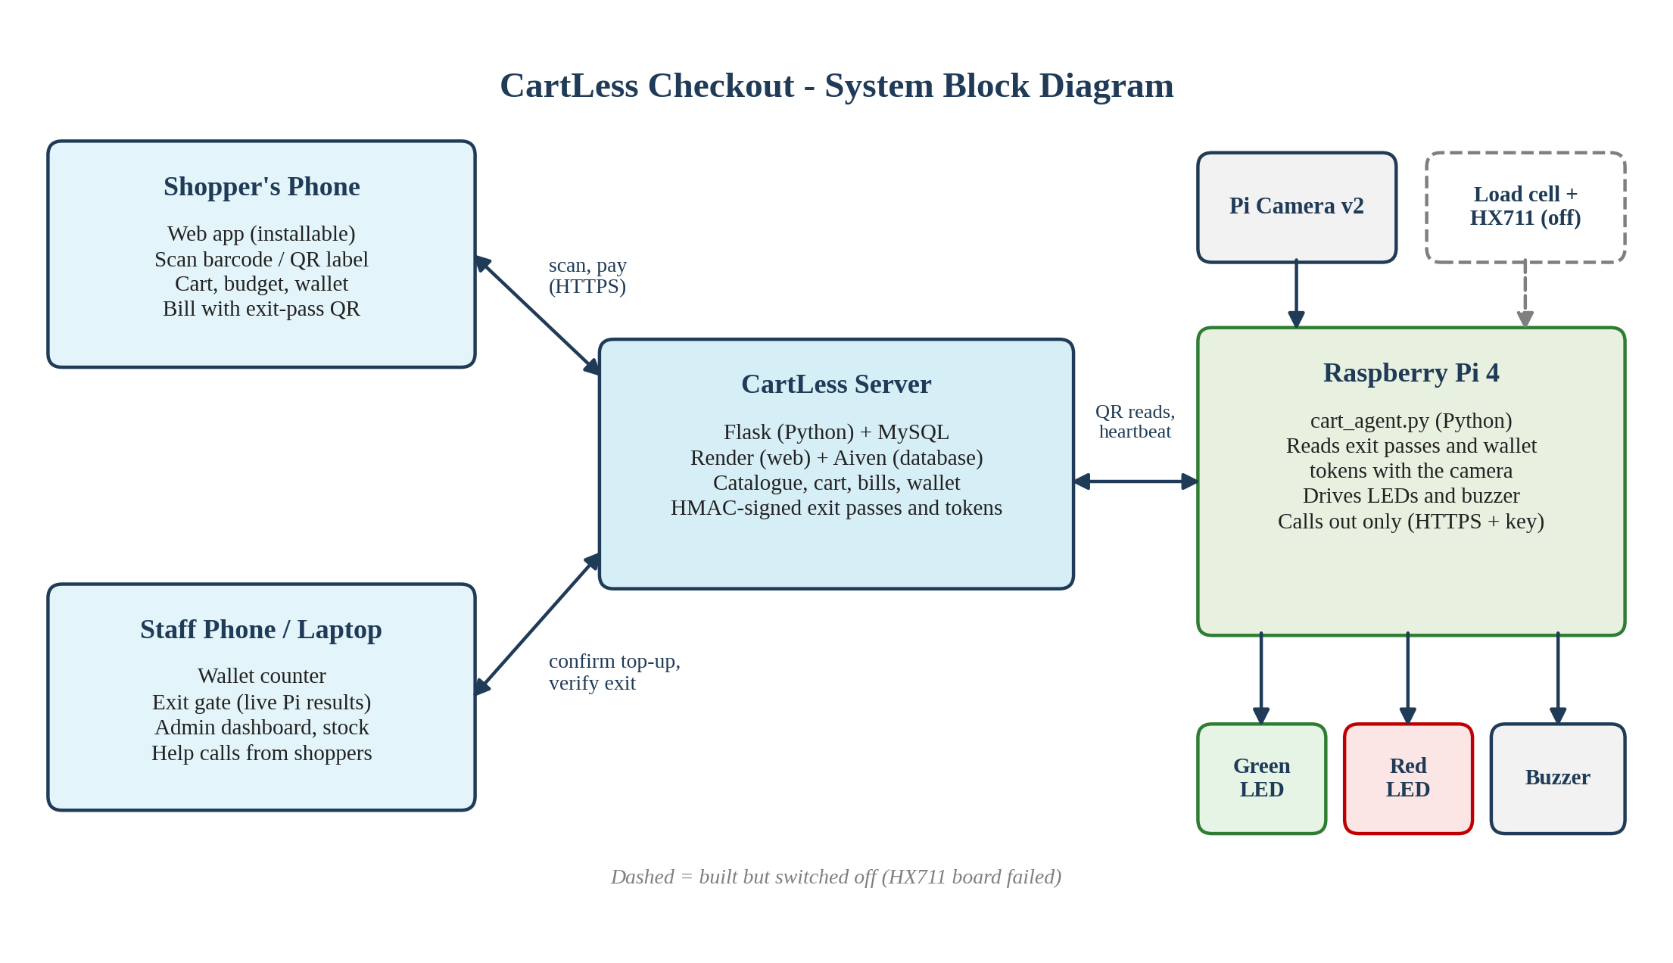
Fig. 3.1: System block diagram
3.2 Circuit Diagram
Fig. 3.2 shows the wiring. The HX711 is powered from the Pi's 3.3 V pin and its data (DT) and clock (SCK) lines go to GPIO 5 and GPIO 6. The green and red LEDs are driven from GPIO 17 and GPIO 27 through 220 ohm current-limiting resistors, and the active buzzer from GPIO 22. All grounds share one rail. The camera connects to the CSI port with a ribbon cable. Table 3.1 lists every connection by physical pin number.
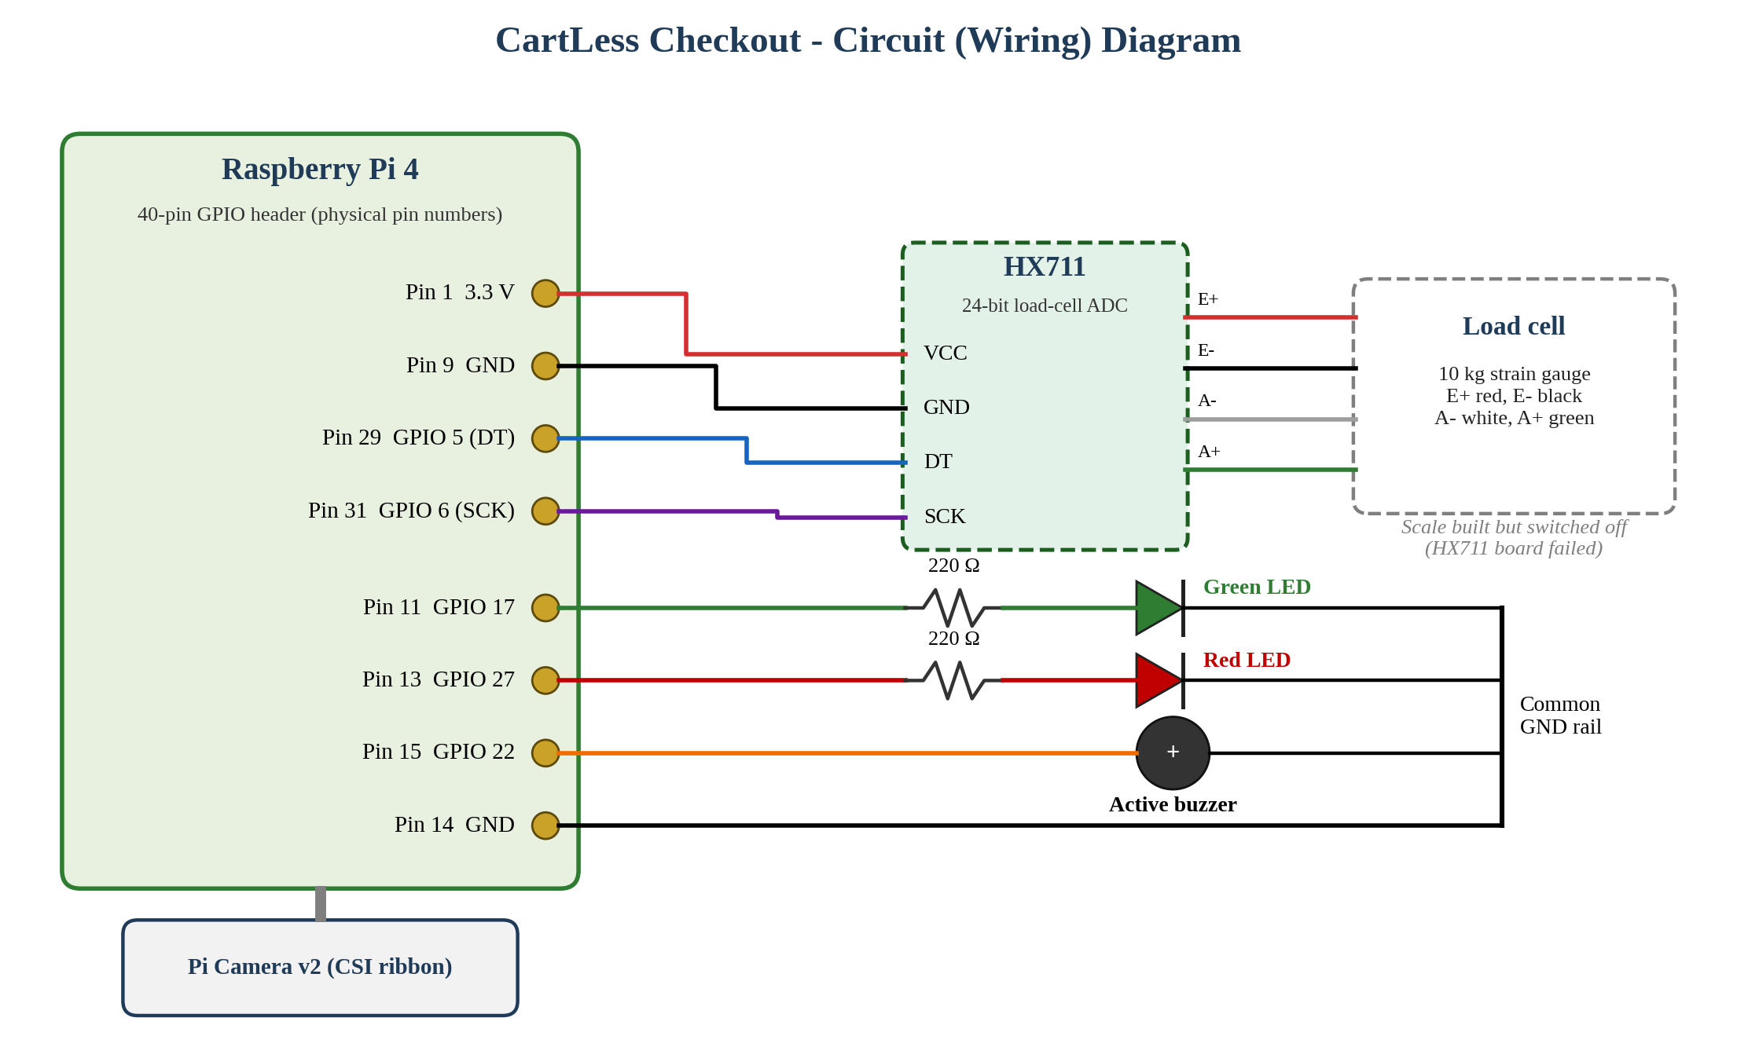
Fig. 3.2: Circuit (wiring) diagram
Table 3.1: Raspberry Pi pin connections
Part | Wire | Pi pin | Signal
HX711 | VCC | 1 | 3.3 V
HX711 | GND | 9 | Ground
HX711 | DT | 29 | GPIO 5
HX711 | SCK | 31 | GPIO 6
Green LED | Anode via 220 Ω | 11 | GPIO 17
Red LED | Anode via 220 Ω | 13 | GPIO 27
Buzzer (active) | + | 15 | GPIO 22
LEDs and buzzer | Ground | 14 | Ground
Load cell to HX711 | Red E+, black E-, white A-, green A+ | - | Bridge excitation / signal

4. COMPONENT DESCRIPTION
Table 4.1 lists the components used. Each is described below.
Table 4.1: List of components
Sr. No. | Component | Specification | Purpose
1 | Raspberry Pi 4 Model B (8 GB) | 64-bit quad-core Cortex-A72, 8 GB LPDDR4 RAM, 802.11ac Wi-Fi, Bluetooth 5.0, 40-pin GPIO, CSI port | Runs the cart / exit-gate program
2 | Raspberry Pi Camera Module 2 | Sony IMX219 8 MP sensor, fixed focus, 3280 × 2464 stills, 1080p30 video, CSI ribbon | Reads exit-pass and top-up token QR codes; item colour
3 | Load cell | 10 kg strain-gauge load cell (4-wire full bridge) | Weighs each item on the platform
4 | HX711 load-cell amplifier module | 24-bit ADC, channel A, gain 128 | Amplifies and digitises the load-cell signal
5 | LEDs | Green and red, 5 mm, 220 Ω resistors | OK / stop indication
6 | Buzzer | Active buzzer, 3.3 V | Audible OK / alert
7 | microSD card and USB-C power supply | Raspberry Pi OS; 5 V / 3 A USB-C | Storage and power for the Pi
8 | Breadboard and jumper wires | - | Connections
9 | Smartphone | Camera and web browser | Shopper scans items and pays

4.1 Raspberry Pi 4
The Raspberry Pi 4 Model B used in this project has a 64-bit quad-core Cortex-A72 processor, 8 GB of LPDDR4 RAM, 802.11b/g/n/ac Wi-Fi, Bluetooth 5.0, Gigabit Ethernet, two USB 3.0 and two USB 2.0 ports, two micro-HDMI ports and a 40-pin GPIO header, and needs a 5 V / 3 A USB-C supply. It runs Raspberry Pi OS and the CartLess Checkout Pi program written in Python. The GPIO pins drive the LEDs and buzzer and read the HX711, and the CSI port connects the camera.
The first design (September 2026) planned three separate boards on the cart: two ESP32 development boards and one ESP32-CAM. Table 4.2 shows what each board was meant to do and how the single Raspberry Pi 4 now does the same work.

Table 4.2: Boards of the first design and how the Raspberry Pi 4 replaced them
Board in the first design | Its job | How it talked to the others | How the Raspberry Pi 4 does it now
ESP32 #1 – Weight node | Read the load cell through the HX711 and get a stable weight | Sent each weight over Wi-Fi as an HTTP POST to ESP32 #2 | The HX711 DT and SCK lines go straight to GPIO 5 and GPIO 6; cart_agent.py reads and filters the weight
ESP32 #2 – Coordinator | Receive the weight from ESP32 #1 and forward it to the Flask server | Wi-Fi to ESP32 #1 and to the server | The same program sends the weight to the server over HTTPS; no relay board is needed
ESP32-CAM – Vision node | Photograph the item and send the JPEG to the server | Its own Wi-Fi connection straight to the server (flashed with an FTDI programmer) | Raspberry Pi Camera Module 2 on the CSI port; the same program takes the photo and also reads exit-pass QR codes

With three boards, the weight and the photo of one item reached the server from two different devices at slightly different times, and the server had to guess which photo belonged to which weight. Each board also needed its own firmware, Wi-Fi connection and power supply. On the Raspberry Pi 4 one program reads the weight, waits until it settles, takes the photo and sends both one after the other, so they always belong to the same item. There is one program to maintain instead of three, and the Pi also runs the exit gate.
4.2 Pi Camera v2
The Pi Camera v2 uses an 8-megapixel Sony IMX219 sensor and connects to the Pi's CSI port. In CartLess Checkout it reads the exit-pass QR code on the shopper's phone and the wallet top-up tokens, using the Picamera2 library and the pyzbar QR decoder. In full verification mode it also measures the colour of an item on the platform.
4.3 Load Cell and HX711
A load cell is a metal bar carrying strain gauges in a Wheatstone bridge; its output changes by a few millivolts with the load. The HX711 is a 24-bit analog-to-digital converter made for load cells, with a built-in programmable-gain amplifier. It sends readings to the Pi over two wires: DT (data) and SCK (clock). The scale is calibrated with an empty platform and a known weight. An earlier HX711 board did not respond during testing; the module has now been fixed and the scale calibrated with 1 kg and 2 kg reference weights, up to 4 kg.
4.4 LEDs and Buzzer
A green and a red LED, each with a 220 ohm series resistor to limit the current from the 3.3 V GPIO pins, show whether a shopper may leave. An active buzzer gives one beep for OK and different beep patterns for a used bill, an invalid bill or a hold. The same signals tell staff when a top-up token has been read and when the Pi has started and connected.
4.5 Hardware Setup
Fig. 4.1 and Fig. 4.2 show the wiring of the Pi and the HX711. Fig. 4.3 shows the CartLess Wallet Counter running in the browser on the Raspberry Pi's own display in the laboratory.
Load cell and weight capacity
The HX711 module has been fixed and the scale calibrated in hardware; the weight check is to be switched on in the software next. The load cell is a 10 kg strain-gauge cell wired as a full Wheatstone bridge (red E+, black E-, white A-, green A+). The HX711 excites the bridge, amplifies its small output with a gain of 128 on channel A and converts it with a 24-bit analog-to-digital converter. Table 4.3 lists the scale's figures as used in the Pi program.
Table 4.3: Load cell and scale specifications
Parameter | Value
Load cell rated capacity | 10 kg (10,000 g)
Calibrated range | Up to 4 kg, using 1 kg and 2 kg reference weights (5 kg and 10 kg not used, to avoid overloading the cell)
Smallest item counted | 2 g (lighter changes are treated as noise)
Amplifier / converter | HX711, channel A, gain 128, 24-bit signed output
Supply to the HX711 | 3.3 V from Pi pin 1
Settling rule | 5 readings in a row within 2 g (or 1% of the weight) count as one stable weight
Readings per item | Exactly one weight is sent for each item placed on the platform
Item acceptance band | Within ±3% of the product's calibrated weight
Calibration result | scale_factor stored in cart_agent.ini (raw counts per gram)

The scale is calibrated with the Pi program in three steps:
- With the platform empty, run python3 cart_agent.py calibrate; the program averages 15 readings and stores this as zero (tare).
- Place a known reference weight (1 kg or 2 kg in our calibration) on the platform and type its weight in grams. Combinations of the two weights were used to check readings up to 4 kg.
- The program computes scale_factor = (loaded reading – zero reading) / known grams, saves it to cart_agent.ini and reads the object back to confirm. python3 cart_agent.py test-scale then shows live grams.
Every product is then calibrated once from the admin page: only that product is placed on the platform and its real weight range (±3%) is saved, which the server uses to accept or flag each scanned item.
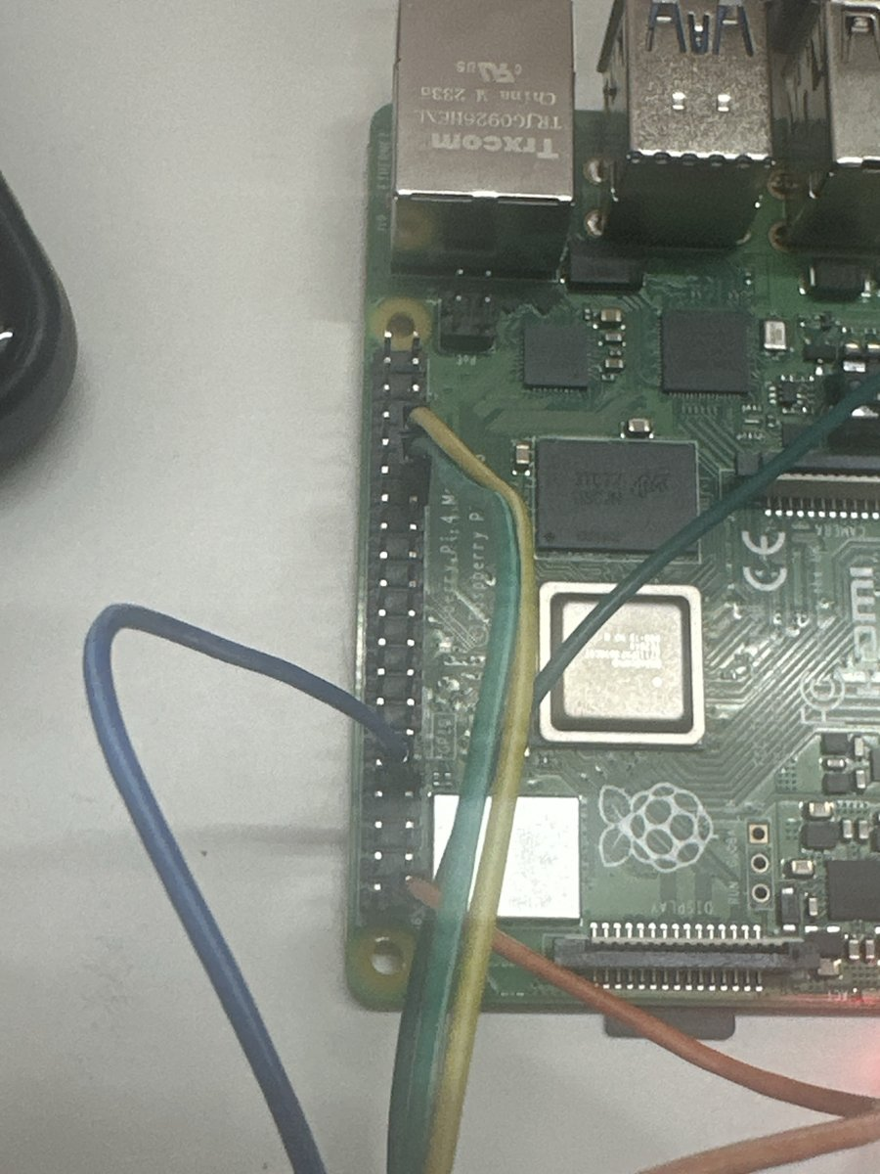
Fig. 4.1: Raspberry Pi 4 GPIO wiring
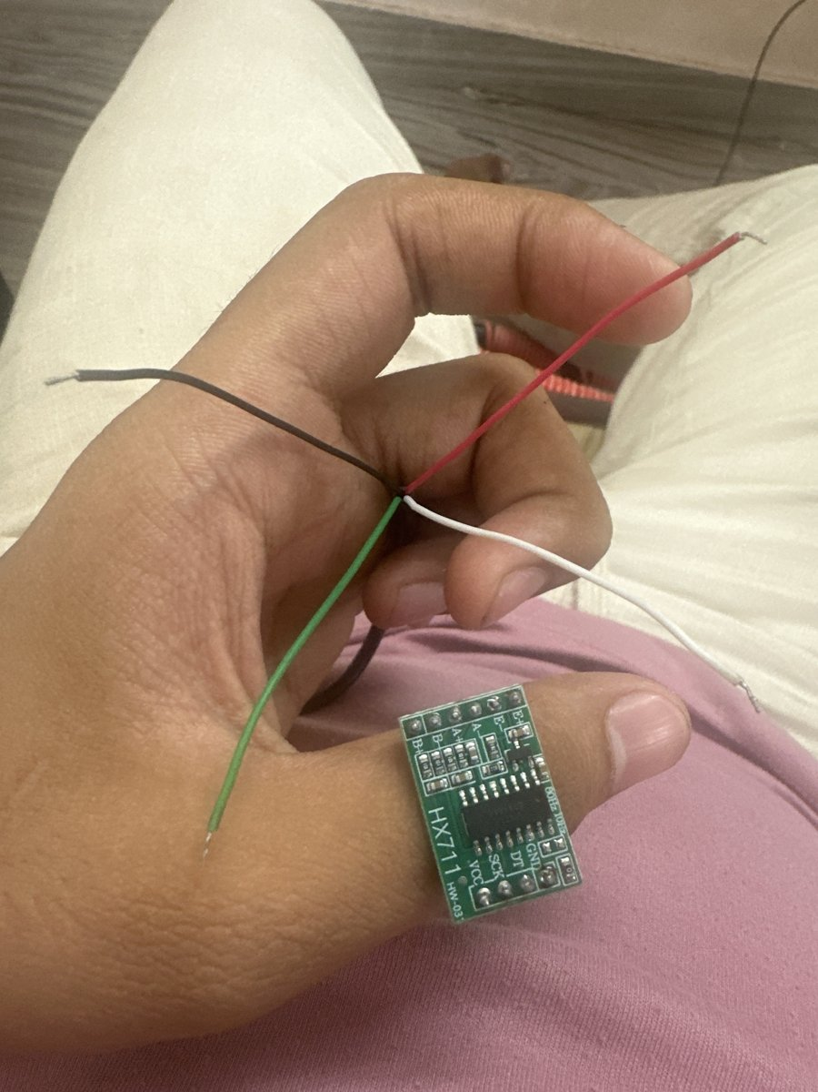
Fig. 4.2: HX711 amplifier with the load cell wires
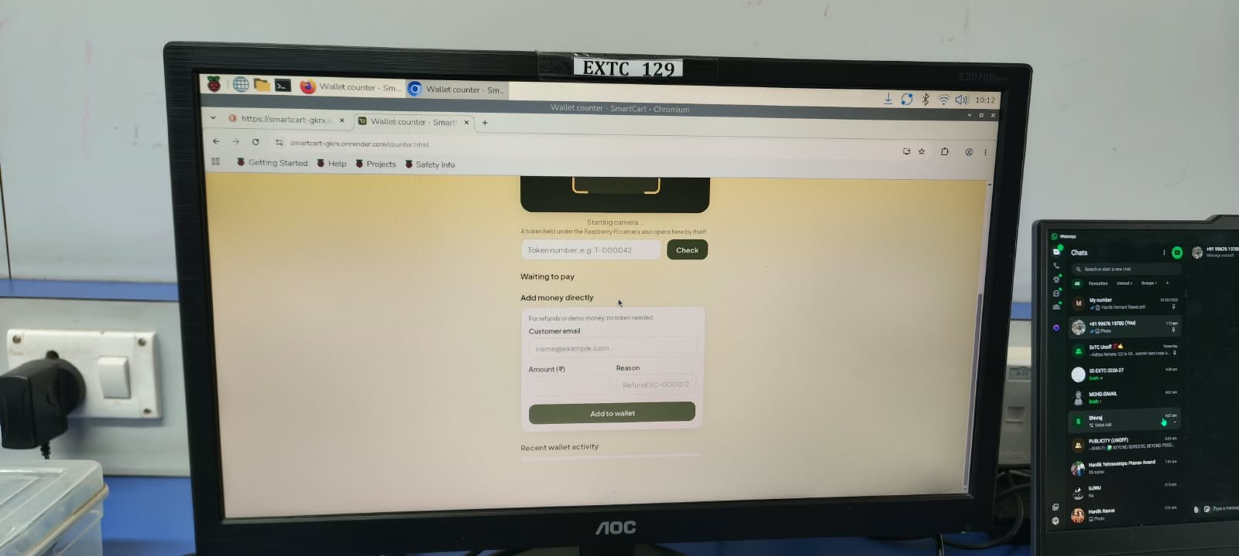
Fig. 4.3: CartLess Checkout running on the Raspberry Pi's own display
5. SOFTWARE DESCRIPTION
5.1 Server
The server is written in Python with the Flask framework and SQLAlchemy, and stores its data in MySQL 8. Its main tables hold users, products, cart items, orders and order items, wallet transactions, top-up requests, hardware readings, flagged transactions, cart alerts, shopping lists and help requests. Logins use JSON Web Tokens, with optional Google sign-in. The product catalogue is kept in the server's memory, so shop pages and scans are answered without querying the database. The server is hosted on Render with the database on Aiven, and it also serves the website, so the whole system runs from one address.
5.2 Website
The website is written in plain HTML, CSS and JavaScript and can be installed on Android and iPhone as an app. Shopper pages cover the shop, scanning, cart, wallet, bills and shopping list. Staff pages are the Wallet Counter, the Exit Gate and an admin dashboard with today's sales, a 7-day chart, best sellers, low-stock items with one-tap restock, flagged scans and a sales CSV download. The camera scanner (html5-qrcode), the QR drawing library and the font are served by the site itself, so it works on campus networks that block public CDNs.
5.3 Raspberry Pi Program
The Pi program, cart_agent.py, is written in Python. It uses Picamera2 to capture frames, pyzbar to decode QR codes, and lgpio / RPi.GPIO to drive the LEDs and buzzer and read the HX711. It sends exit-pass codes, top-up tokens and a heartbeat every 30 s to the server with the header X-Device-Key, and shows the answer with its lights and buzzer. It is installed with a script, starts by itself on power-up, and can block all incoming connections with a firewall. The weight reading code is ready; until the weight check is switched on in the server (SCALE_ENABLED), the program skips the scale and runs only the exit gate and token reading.
5.4 Security
- Signed codes: exit passes and top-up tokens carry an HMAC signature and work once.
- Passwords: stored only as hashes; five wrong attempts lock an account for 15 minutes.
- Rate limits: 300 requests a minute per user and 60 changes a minute, with 20 sign-ups an hour per address.
- Content-Security-Policy: only the site's own scripts run, which blocks injected scripts.
- Secrets: keys and the admin password come from the server's settings, never from the code.
- Device key: the Pi must send its key with every request and accepts no incoming connections.
5.5 Languages, Versions and System Requirements
Table 5.1 lists the languages used and why, Table 5.2 the systems the software has been run on, and Table 5.3 the minimum requirements to use or run it.
Table 5.1: Languages used
Language | Version | Where it is used | Why we chose it
Python | 3.11 (needs 3.10 or newer) | Server (Flask 3.1.3, SQLAlchemy 2.1.1) and the Raspberry Pi program | One language for the server and the Pi; ready libraries for web, database, camera (Picamera2) and QR decoding (pyzbar)
HTML5 | HTML Living Standard | All website pages | Runs in every phone browser, so shoppers need no app download
CSS3 | CSS3 | Layout, colours, phone-first design | Pages adapt to any screen size without a separate app
JavaScript | ES2017+, no framework | Camera scanner (html5-qrcode 2.3.8), cart, wallet and staff pages | Gives camera access in the browser and needs no build step
SQL | MySQL 8.0 | Database of users, products, orders and the wallet ledger | Transactions and row locks keep wallet money correct

Table 5.2: Systems the software was run on
System | Exact component / service | Capability
Live web server | Render free web service, Python 3, Gunicorn 26.2.0 | 0.1 CPU, 512 MB RAM; sleeps after 15 minutes without visitors and takes about a minute to wake
Database | Aiven for MySQL, free plan | 1 CPU, 1 GB RAM, 1 GB storage, up to 76 connections
Exit gate | Raspberry Pi 4 Model B (8 GB LPDDR4) with Raspberry Pi Camera Module 2 | 64-bit quad-core Cortex-A72; Raspberry Pi OS; runs cart_agent.py and the browser
Test machine | 2-core Intel Xeon 2.1 GHz, MySQL 8.0, Python 3.11 | Used for the server tests reported in Table 1.1
Browsers used | Google Chrome and Mozilla Firefox; Chromium and Firefox on the Pi | Shopper and staff pages

Table 5.3: Minimum requirements and URL
To… | Minimum requirement
Use the website (shopper) | Smartphone with a rear camera, an up-to-date Chrome, Firefox or Safari browser, and an internet connection; the site must be opened over https for the camera to work
Use the staff pages | Any phone, laptop or the Raspberry Pi with a modern browser
Run the server yourself | Python 3.10+, MySQL 8.0.16+ and about 512 MB of RAM (the free Render plan is enough)
Run the exit gate | Raspberry Pi with a CSI camera (Camera Module 2), Raspberry Pi OS with Picamera2 and python3-lgpio, 5 V / 3 A supply, Wi-Fi
Open the live system | https://smartcart-gkrx.onrender.com
Get the source code | https://github.com/hardikrawat910-byte/smart-billing-cart

5.6 Results
The system is deployed and working at smartcart-gkrx.onrender.com. Barcode and QR scanning, the cart, offers and budget, wallet top-up by cash or UPI with staff confirmation, payment from the wallet, the signed exit pass and its verification by the Raspberry Pi camera all work end to end. Figs. 5.1 to 5.4 show the main screens. Timing and accuracy have been measured. Table 5.4 gives the weight calibration of the scale and Table 5.5 the server tests.
Table 5.4: Weight calibration results
Reference weight placed | Scale reading (g) | Error (g) | Error (%)
None (empty platform, tare) | 0 gm | 0 gm | 0.00%
1 kg (1,000 g) | 986 gm | 14 gm | 1.40%
2 kg (2,000 g) | 2025 gm | 25 gm | 1.25%
1 kg + 2 kg (3,000 g) | 2957 gm | 43 gm | 1.43%
4 kg (4,000 g) | 4070 gm | 70 gm | 1.72%

Table 5.5: Server test results
Test (server, 2-core test machine) | Result
Item scans accepted | 300 of 300; median 9.8 ms, 95th percentile 13.3 ms
Unknown or mistyped codes refused | 300 of 300; median 2.4 ms
Wallet checkouts | 90 paid; median 19.1 ms, 95th percentile 25.1 ms
Genuine exit pass, first use | 90 of 90 accepted; median 10.2 ms
Same exit pass used again | 90 of 90 refused
Forged or edited exit passes | 360 of 360 refused
Edited top-up tokens | 50 of 50 refused; each genuine token credited once

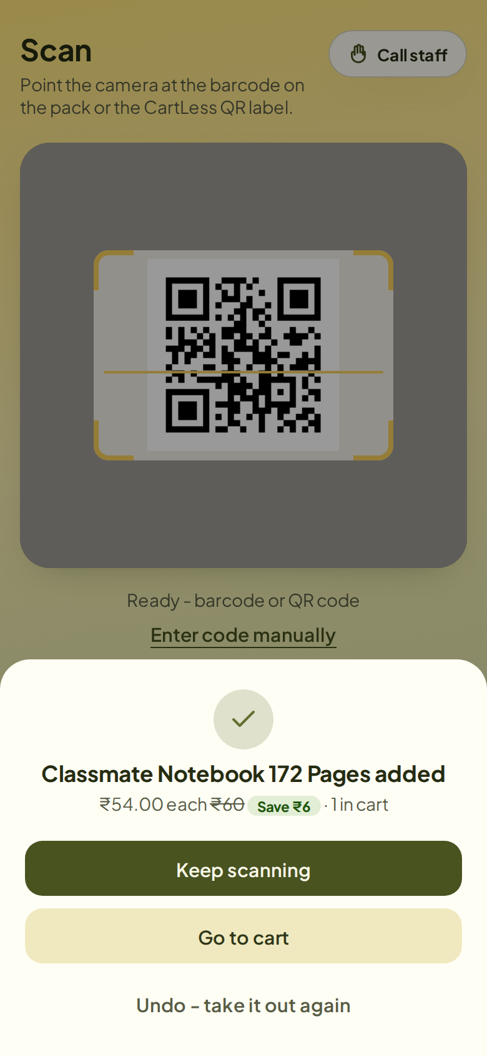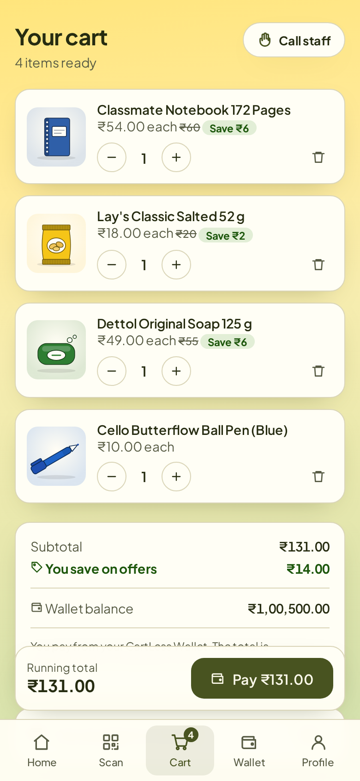
Fig. 5.1: Scanning an item and the cart
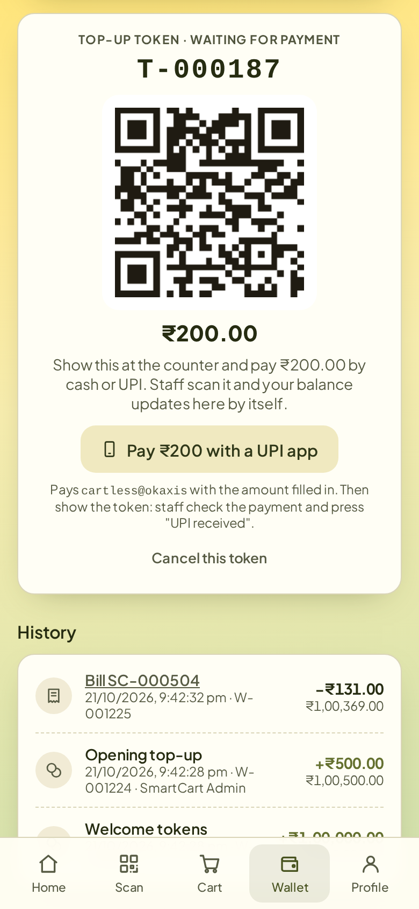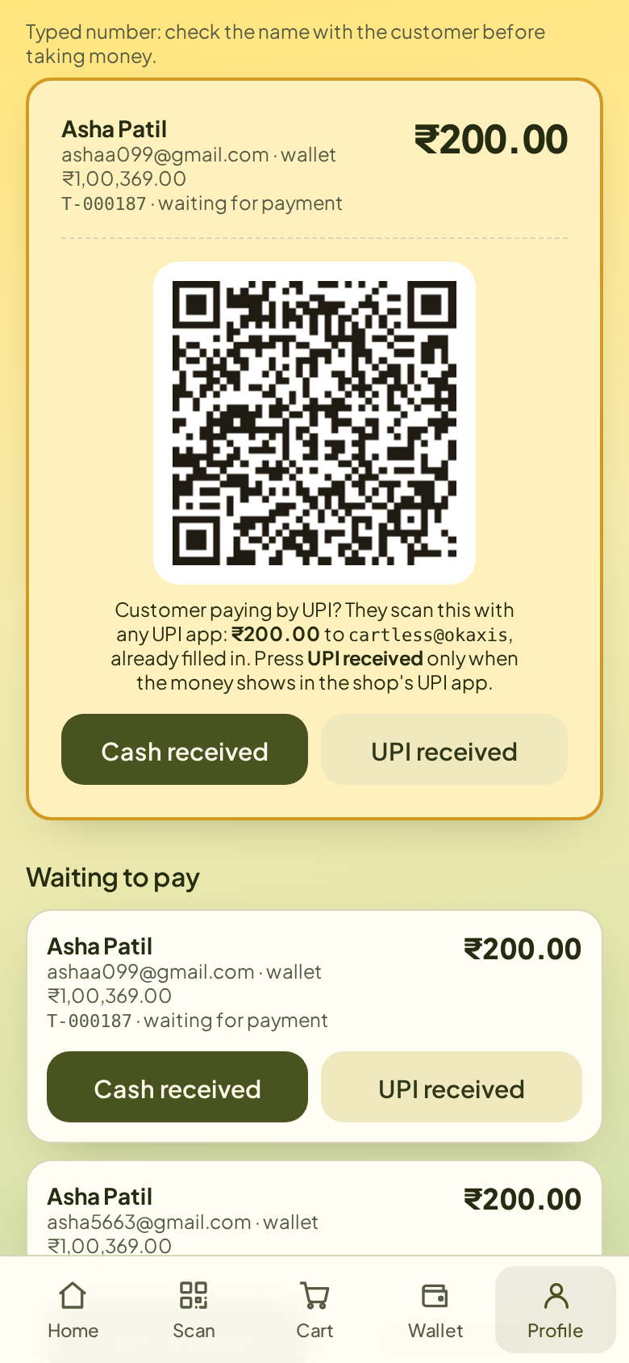
Fig. 5.2: Wallet top-up token and staff wallet counter
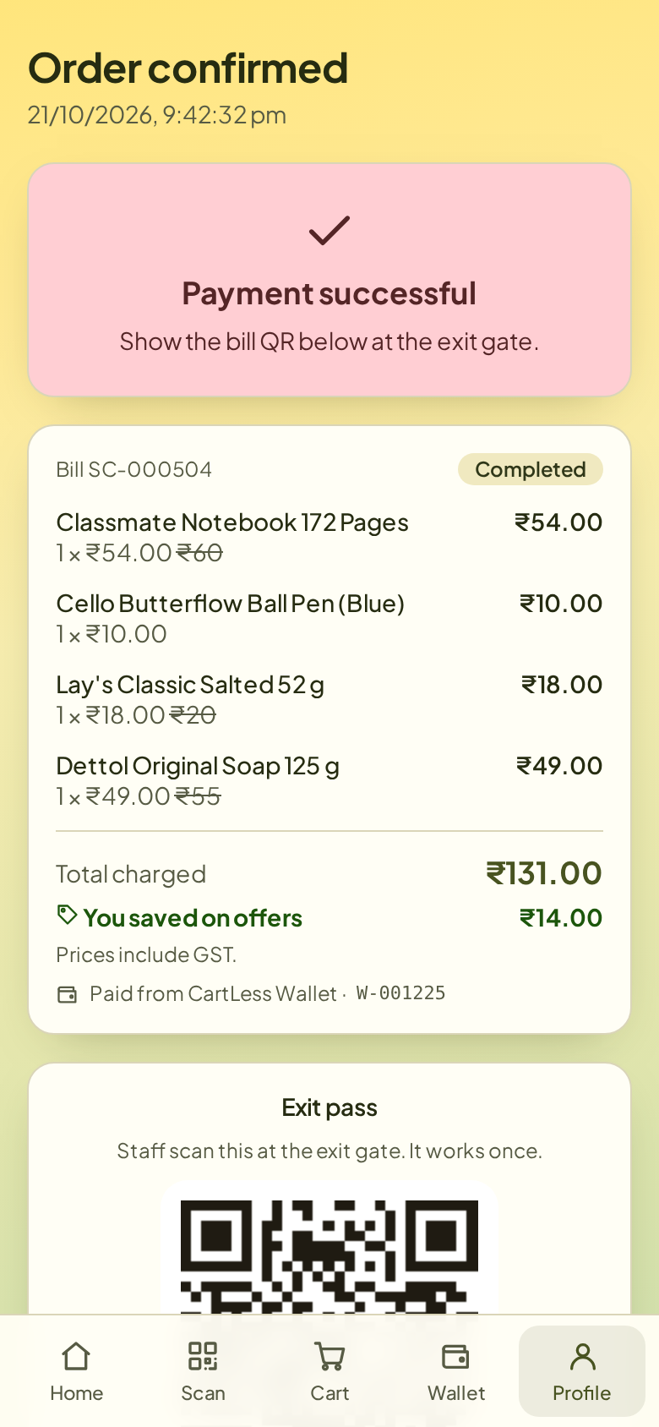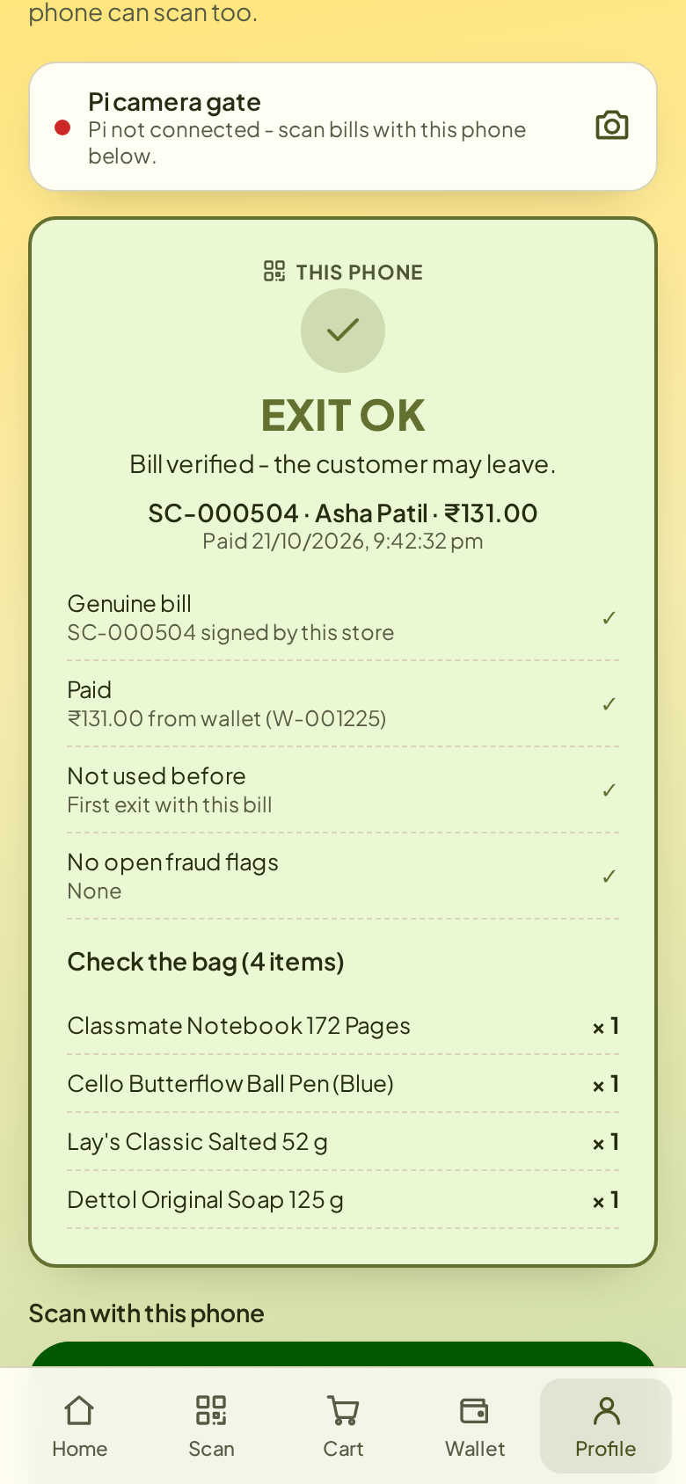
Fig. 5.3: Paid bill with exit pass and exit-gate result
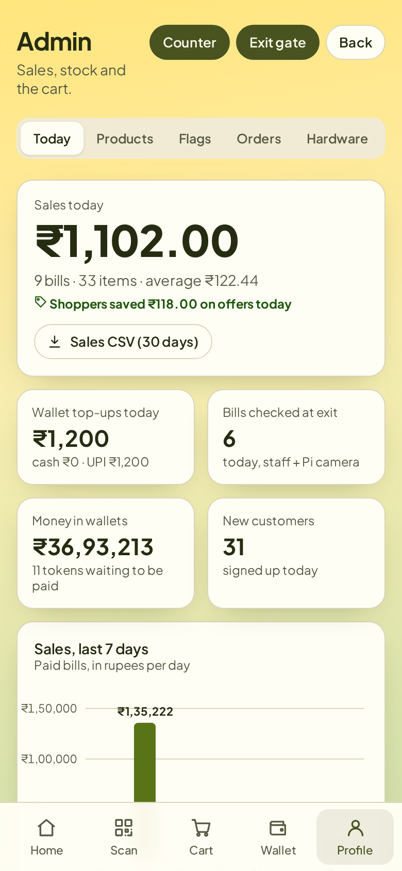
Fig. 5.4: Admin dashboard
6. ADVANTAGES
6.1 Advantages over the Surveyed Papers
Table 6.1: Advantages over the surveyed papers
Area | Surveyed papers | CartLess Checkout
Identifying items | Shahroz et al., Nishitha et al. and Walid et al. need an RFID tag on every item; Kumar et al. and Ibrahim et al. need a camera and screen on every cart | Scans the barcode already printed on each pack with the shopper's own phone; no tags, no hardware on the cart
Paying | Kumar et al. and Ibrahim et al. send the shopper to a cashier | Pays inside the app from a wallet; top-ups are added only after staff confirm the cash or UPI
Stopping theft at the exit | Only Nishitha et al. check at the exit (RFID gate) | HMAC-signed, one-time exit pass checked by the Pi camera; edited, copied and reused bills are refused
Staff tools | A local screen or a single app | Wallet counter, exit gate and admin dashboard in one web app

6.2 Other Advantages
- Low cost: one Raspberry Pi with a camera serves the exit; carts need no electronics for scanning or paying.
- No app download: works in any phone browser and can be installed as an app.
- Safe on a shop network: the Pi never accepts incoming connections; it only calls out to the server.
- Ready for staff: sales CSV, low-stock alerts and help calls come with the system.
7. DISADVANTAGES
CartLess Checkout still falls short of the surveyed papers in five places, listed in Table 7.1.
Table 7.1: Where CartLess Checkout falls short of the surveyed papers
Gap | Paper that does better | Why it matters
Results come from a test server, not from a store trial with shoppers | Walid et al. report 91.7% anti-theft accuracy and per-step timings on their hardware | Speed and security are proven on the server, not yet in a real shop
Weight check is fixed and calibrated in hardware only up to 4 kg, and is not yet switched on in the software | Walid et al. run a live load-cell check and report its accuracy | Without a measured accuracy, how often a wrong item slips through is unknown
The exit pass proves the bill was paid, not that the bag matches the bill | Nishitha et al. check every tagged item at the exit gate | Staff still compare the bag with the item list by eye
Needs the shopper's phone and internet; the free server takes about a minute to wake | Kumar et al. and Ibrahim et al. work from the cart's own screen | Shoppers without a smartphone or with a weak signal cannot use it
Wallet top-up needs a staff member to confirm the payment | Nishitha et al. deduct from the bank; Walid et al. send a payment link | One more manual step at the counter

8. SCOPE
With the scale now calibrated, the next steps are to prove the system in a real shop and to remove the manual steps that remain. They are listed in the order we plan to take them up:
- Store trial: run CartLess Checkout in a real shop with at least 100 shoppers and compare the time from first scan to leaving the shop with the time taken at a billing counter.
- Weight check in software: switch on the weight check in the server (SCALE_ENABLED), extend calibration above 4 kg, calibrate every product, then measure how often a wrong or unscanned item is caught and how often a correct item is wrongly flagged, as Walid et al. did.
- Bag check at the exit: add a second load cell at the exit gate to weigh the bag and compare it with the expected weight of the bill, so staff no longer check the bag by eye.
- Direct UPI payment: connect a UPI payment gateway so wallet top-ups are credited automatically, without staff confirmation.
- Product recognition: add a small on-device detection model on the Pi camera, as Ibrahim et al. did, to recognise items placed without a scan.
- Low-cost ESP32 cart node: build a cheaper cart unit with an ESP32 and the HX711 for weighing, keeping the Raspberry Pi only at the exit gate (semester 4 project).
- Offline working: keep scans on the phone when the network drops and move to paid hosting so the server never sleeps.
- Store analytics: use the sales data already collected to forecast demand and suggest restock quantities.
9. CONCLUSION
CartLess Checkout shows that a small store can offer self-checkout without RFID tags or a computer on every cart. Shoppers scan the barcodes already printed on packs with their own phone, pay from a CartLess Wallet topped up by cash or UPI, and leave after a Raspberry Pi camera verifies a signed, one-time exit pass. The system is live online and works end to end with the Raspberry Pi 4, Pi Camera v2, LEDs and buzzer.
Among the five IEEE papers surveyed, CartLess Checkout is the only one that combines tag-free scanning, payment inside the application and a verified exit. Its weaknesses are equally clear: the weight check is calibrated in hardware up to 4 kg but not yet switched on in the software, and the exit pass does not prove that the bag matches the bill. Switching on the weight check and a trial in a real shop are the next steps.
10.REFERENCES
- M. Kumar et al., “Intelligent Shopping Trolley with Automated Billing using Raspberry Pi,” in Proc. 4th Int. Conf. Smart Technologies in Computing, Electrical and Electronics (ICSTCEE), Bengaluru, India, 2023, doi: 10.1109/ICSTCEE60504.2023.10585242.
- N. Ibrahim et al., “Smart Shopping Cart: A Raspberry Pi-Based System for Reducing Supermarket Checkout Delays,” in Proc. IEEE Int. Conf. Smart Sustainable Systems for Computer and Engineering Applications (3SCEA), 2026, pp. 1100–1109, doi: 10.1109/3SCEA68071.2026.11602934.
- M. Shahroz, M. F. Mushtaq, M. Ahmad, S. Ullah, A. Mehmood and G. S. Choi, “IoT-Based Smart Shopping Cart Using Radio Frequency Identification,” IEEE Access, vol. 8, pp. 68426–68438, 2020, doi: 10.1109/ACCESS.2020.2986681.
- R. Nishitha, S. S. Naik, V. Raksha and U. Kulsum, “IoT Based Automatic Billing System Using Barcode Scanner by Android Device and Monitoring Unregistered Barcode by RFID,” in Proc. 4th Int. Conf. Recent Trends on Electronics, Information, Communication & Technology (RTEICT), Bangalore, India, 2019, pp. 15–20, doi: 10.1109/RTEICT46194.2019.9016698.
- M. H. Walid et al., “The Smart Cart with Automatic Billing and Anti-Theft,” in Proc. IEEE Int. Conf. Electrical, Electronic and Computer Engineering (ICEECE), 2026, doi: 10.1109/ICEECE71300.2026.11709931.
- Raspberry Pi Ltd., “Raspberry Pi 4 Model B,” product documentation. [Online]. Available: https://www.raspberrypi.com/products/raspberry-pi-4-model-b/
- Pallets Projects, “Flask documentation.” [Online]. Available: https://flask.palletsprojects.com/
- CartLess Checkout project source code and live demo. [Online]. Available: https://github.com/hardikrawat910-byte/smart-billing-cart and https://smartcart-gkrx.onrender.com

