**Proposal for CIS 602(Data Visualization)**

**By Hardik Sankhla (01617980) and Sujoy Kar (01577342)**

I am working on my project with “**Sujoy Kar”** that is on “**Dota Statisctics**”.

**Description: -** The link provided below contains the steamWebAPI datasets of the following game Dota 2 which contains different datasets about “match History”, “player game history”, “Player profile summary", etc. We can retrieve the match history and match details in JSON or XML format for use.

**URL:-**

<http://dev.dota2.com/showthread.php?t=58317>

<http://steamwebapi.azurewebsites.net/>

**Examples:-**

1. The following link provides the live datasets of recent 100 games played by players in JSON format.

<https://api.steampowered.com/IDOTA2Match_570/GetMatchHistory/V001/?key=3E11DA346FDD004A984BB5C028DED83B>

1. The following link provides the datasets of recent 100 games played by a particular player “Ser Onion” (steam Profile: http://steamcommunity.com/profiles/76561198013496371) whose account_id is “76561198013496371” in JSON format.

<https://api.steampowered.com/IDOTA2Match_570/GetMatchHistory/V001/?key=3E11DA346FDD004A984BB5C028DED83B&account_id=76561198013496371>

1. The following link provides the datasets of a particular match played by 10 players which contains different stats of each player for that particular match which is in JSON format.

<https://api.steampowered.com/IDOTA2Match_570/GetMatchDetails/v001/?key=3E11DA346FDD004A984BB5C028DED83B&match_id=2255238031>

**Questions we plan to answer in our project?**

**Q.1** Where the game is most played on world Map?

**Q.2** Did a player improve or degrade with every update changes brought in the game?

**Q.3** Were there significant changes by players all over the world for choosing a particular Game Character (Hero) in a specific Patch Update (6.73a patch update or 6.85b patch update)? (Trends of Hero Popularity)

**Q.4** Was the game successful in a particular area to gain the interest of new players in to playing it?

**Q.5** Who are the gamers who play Dota for a living (gaming as a sport – eSports) and where do they reside?

**Q.6** How new players have been attracted towards Dota because of constant increase in Prize pool for Dota 2 Tournament (The International) as how Dota is just not a game but source of money, showing one’s talent and a way of meeting new people via online gaming.

**Initial design for your visualization**

1. Profile of a Professional Player (Dendi) with the record of his all GamesPlayed till date.

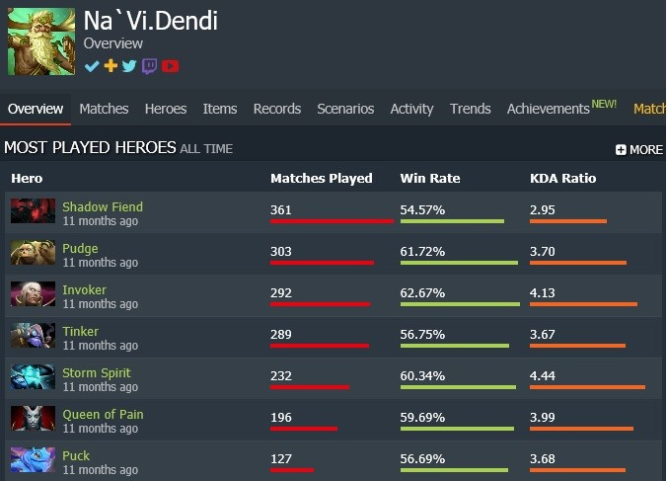

1. Line Chart of XPM (Experience per Minute) and Kills of a particular game. (How a player performed)

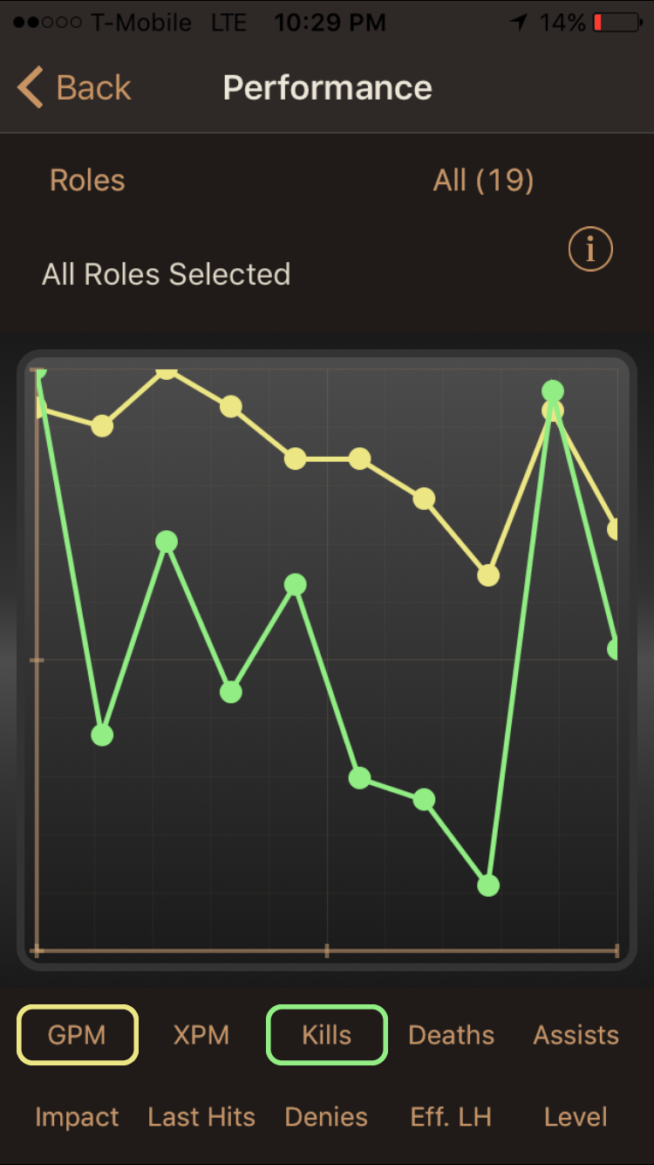

1. Bar Chart representing games played (Wins – Loss) during a patch update of the game and how he/she has developed in game over the years.

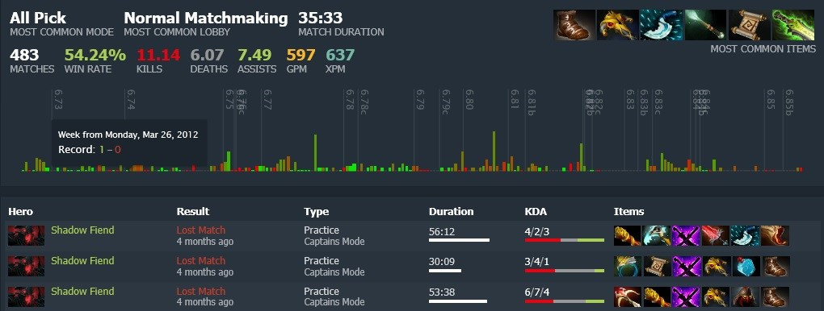

1. The image below displays the searching trends for League of legends (game similar to dota) but taking this as an idea to represent the Population, Density of gamers in a particular area and where the top professional players play in different countries according to their Match Making Ranking (MMR).

