Machine Learning Assessment of El Niño Teleconnections and Crop Value Added in India

Prof. Pankaj Deshmukh
Dept. of Artificial Intelligence and Data Science
K. J. Somaiya Institute of Technology
Mumbai, India
pankaj@somaiya.edu
Altair Patel
Dept. of Artificial Intelligence and Data Science
K. J. Somaiya Institute of Technology
Mumbai, India
altair.patel@somaiya.edu
Hardik Sedani
Dept. of Artificial Intelligence and Data Science
K. J. Somaiya Institute of Technology
Mumbai, India
hardik.sedani@somaiya.edu

Abstract—This study examines whether annual climate variables and state identity can estimate crop gross state value added (GSVA) across India. A panel of 385 complete observations covers 28 states from financial year 2011–12 to 2024–25. Daily gridded rainfall and temperature from the India Meteorological Department are aligned with the Oceanic Niño Index and RBI/NSO crop GSVA at constant 2011–12 prices. Five regressors are trained on 280 observations through 2020–21 and evaluated on 105 later observations. Ordinary least squares produces the lowest test root mean squared error among the fitted models, at INR 17,410.41 crore, with R² = 0.8783. However, carrying forward each state's final training-year GSVA reduces the error to INR 10,890.73 crore. Permuting climate inputs produces small changes in linear-model error, suggesting limited additional predictive information in this specification. A working web application exposes the harmonized panel, model comparisons, predictions, and conditional scenarios. The results establish a reproducible state-level assessment while showing that strong pooled fit does not establish reliable climate attribution or improvement over a simple persistence benchmark.
Keywords—El Niño, Indian agriculture, crop GSVA, panel data, machine learning, chronological evaluation

Introduction
Climate variability affects agricultural production through water availability, temperature exposure, and the timing of crop development. Evidence from India links agricultural outcomes to seasonal climate, but the relationship depends on the crop, region, and period studied [1]. The El Niño–Southern Oscillation (ENSO) adds a large-scale source of variation: Pacific sea-surface temperature anomalies are associated with changes in Indian rainfall [2]. This association has varied over time [3], and the location and evolution of Pacific warming matter for interpreting monsoon failure [4]. A state-level economic application therefore needs to test its own predictive performance rather than assume that an ENSO signal automatically translates into accurate estimates of crop value added.
The Indian monsoon contains substantial spatial and temporal variability [5]. Indian Ocean conditions can modify the monsoon–ENSO association [6], while the Indian Ocean Dipole provides a distinct source of climate variability [7]. Different Pacific warming patterns also have different teleconnections [8]. These findings motivate the inclusion of local rainfall and temperature alongside an ENSO index. They also caution against assigning every low-output year to El Niño. In the present model, rainfall, temperature, and the Oceanic Niño Index (ONI) are explanatory inputs to a prediction system; none is treated as an experimentally isolated cause.
The economic outcome considered here is crop gross state value added, expressed in INR crore at constant 2011–12 prices. This measure differs from crop yield, farm profit, household income, and the value of all agriculture and allied activities. It provides a common monetary scale for comparing state observations, while retaining large differences in the size and composition of their crop sectors. These differences make state identity useful for pooled prediction, but they also create a risk: a model can obtain a high R² by separating large and small state economies without accurately tracking changes within a state.
This study addresses three questions. First, how do a linear model and four tree ensembles compare on a later-period holdout? Second, do these models improve on state-specific historical benchmarks? Third, how much does the fitted linear model depend on the climate inputs when state identity is held fixed? The work combines official-data harmonization, a reproducible comparison of saved models, and an application that makes the results inspectable. The central finding is that the linear model leads the five fitted regressors, yet a simple last-observed-value benchmark performs substantially better. This result determines the limits placed on the application's prediction and scenario outputs.

Related Work

ENSO and Agricultural Outcomes
Research on ENSO and the monsoon supplies physical context, but the choice of index remains consequential. Work on ENSO indices in a warming climate shows why index definitions and background warming require attention [9]. The present analysis retains the historical ONI series used by the implemented pipeline. It does not substitute a relative index after model fitting or equate an annual ONI average with a categorical declaration of an El Niño episode. Such a substitution would alter the inputs and require a new training and evaluation cycle.
Climate–crop studies also show why annual averages can be restrictive. Global production research connects changes in climate with crop output [10], while work on nonlinear temperature exposure identifies effects that a mean temperature cannot fully represent [11]. Indian wheat research examines extreme heat during senescence [12], and rice research considers monsoon and temperature relationships [13]. These studies motivate better seasonal features for subsequent versions of the system. They do not supply numerical loss coefficients for the current GSVA model, whose outcome, spatial scale, and input construction differ.
Economic research using weather variation distinguishes statistical association from the identification of an economic response [14]. The distinction is especially relevant when output trends, irrigation, crop choice, and technology are incompletely observed. The goal here is a transparent comparison of predictive specifications. The fitted relationships are not interpreted as causal damage functions, and a model-generated difference between two weather inputs is not presented as an observed economic loss.

Drought Vulnerability and Spatial Assessment
Drought research distinguishes meteorological deficits from agricultural and socioeconomic consequences [15]. Agricultural vulnerability assessments consider the systems exposed to a hazard, including their sensitivity and capacity to respond [16]. Survey evidence from Maharashtra documents farmers' experiences of drought impacts and adaptation [17]. District-scale studies further examine how exposure, sensitivity, and adaptive capacity vary across Maharashtra [18]. This literature explains why rainfall alone is an incomplete indicator of agricultural harm.
Several Indian studies combine indicators into spatial vulnerability assessments. Analytical hierarchy methods have been applied to disaster vulnerability [19] and, in fuzzy form, to drought vulnerability in Odisha [20]. Composite assessments have also been developed for Tamil Nadu [21], agricultural drought mapping [22], and hazard-specific evaluation under the IPCC framework [23]. A study of Vidarbha provides a regional example of drought vulnerability assessment [24]. These approaches address relative vulnerability rather than prediction of a monetary outcome. Their mapped categories should therefore not be treated as labels for the regression task used in this paper.
The broader conceptual literature emphasizes that vulnerability depends on the system, stressor, and assessment objective [25], [26], [27]. Principal component analysis has supported information-rich vulnerability mapping [28], but its role is to summarize variation in the input matrix [29]. Research on composite indicators also emphasizes sensitivity analysis when assessing the reliability of rankings [30]. This project does not compute a PCA vulnerability index. It retains the useful emphasis on traceable inputs and clear interpretation while evaluating predicted crop GSVA directly against held-out economic observations.

Machine Learning and Evaluation
Reviews of agricultural machine learning document varied tasks, input types, and modeling approaches [31], [32]. The present comparison uses established ensemble families: Random Forest [33], Extra Trees [34], gradient boosting [35], and XGBoost [36]. Their flexibility permits interactions and nonlinear splits, but the relatively small panel does not ensure that this flexibility improves performance. Ordinary least squares is therefore included as a transparent comparator.
Time-structured data require evaluation designs that respect their dependence structure [37], [38]. Error estimates can also become optimistic when model selection and performance assessment use the same data repeatedly [39]. Accordingly, the reported split places earlier financial years in training and later years in testing. The comparison uses the saved configurations, without claiming an exhaustive hyperparameter search. The holdout establishes a retrospective comparison for known states; it does not establish transfer to unseen states, future ENSO events, or a real-time forecast made before weather observations are available.

Study Area and Data

Spatial and Temporal Scope
The study covers 28 Indian states over 14 financial years, from 2011–12 through 2024–25. A financial year is identified by its starting calendar year and runs from April to March. The candidate panel therefore contains 392 state-year combinations. Seven lack an economic target, leaving 385 complete observations. Union territories are outside the model's state vocabulary. The panel includes diverse crop economies, but each state is represented by a single weather sampling location rather than an area-weighted climate surface.
The excluded economic observations are Goa for 2024–25, Gujarat for 2023–24 and 2024–25, and Manipur, Mizoram, Nagaland, and Sikkim for 2024–25. Missing labels are not filled with model predictions or assumed zeros. Consequently, the final two test years have fewer states than the earlier test years. The coverage pattern is shown in Fig. 2 and must be considered when comparing annual errors: changes in the evaluated state mix accompany changes in the year.
The panel is balanced during training, with ten observations for every state. Its incompleteness is concentrated in the evaluation period: the test set contains 105 of 112 possible state-years. This distinction matters because the fitted state indicators are learned from equal numbers of training years, while pooled test metrics weight states according to their available observations. Gujarat contributes two test rows and five other states contribute three, compared with four for the remaining states. No weighting correction is applied to make these contributions equal. The reported metrics therefore describe the observed complete-case holdout, with its actual coverage.

Climate and Economic Sources
Daily rainfall is taken from the IMD 0.25° gridded product, whose development is documented by Pai et al. [40]. Daily maximum and minimum temperatures use the IMD 1° gridded product, with the gridded-temperature methodology described by Srivastava et al. [41]. For each state, the pipeline selects the nearest cell to a configured representative coordinate. Rainfall and temperature can therefore use different grid-cell centers. Their coordinates and valid-day counts remain in the prepared panel for audit.
The target comes from the locally retained RBI table titled “Gross State Value Added by Economic Activity—Agriculture (Constant Prices),” Table 30, pages 85–86, based on NSO/MoSPI data. Its note specifies that the data pertain to crops. The source reports INR lakh at the 2011–12 price base; the pipeline divides values by 100 to obtain INR crore. Older price-base tables are not concatenated with this series. Keeping a single base avoids treating a change in accounting units as an economic change, although revisions and differences in underlying state estimates can still affect comparability.
Historical NOAA Climate Prediction Center ONI observations provide the ENSO input. Within each financial year, the pipeline averages the ten three-month seasons fully contained between April and March, from AMJ through JFM. These overlapping seasons summarize the same evolving Pacific phenomenon and are not ten independent observations. The financial-year ONI value is shared by all states in that year. Table I summarizes the variables; Fig. 1 shows their path through the system.
TABLE I
VARIABLES AND SOURCE ALIGNMENT
Variable | Source and construction | Unit
Rainfall | IMD daily 0.25° grid; FY sum | mm
Temperature | IMD daily 1° grid; FY mean | °C
ONI | NOAA; 10 complete seasons per FY | °C
Crop GSVA | RBI/NSO Table 30; 2011–12 prices | INR crore
State | 28 one-hot indicators | Binary
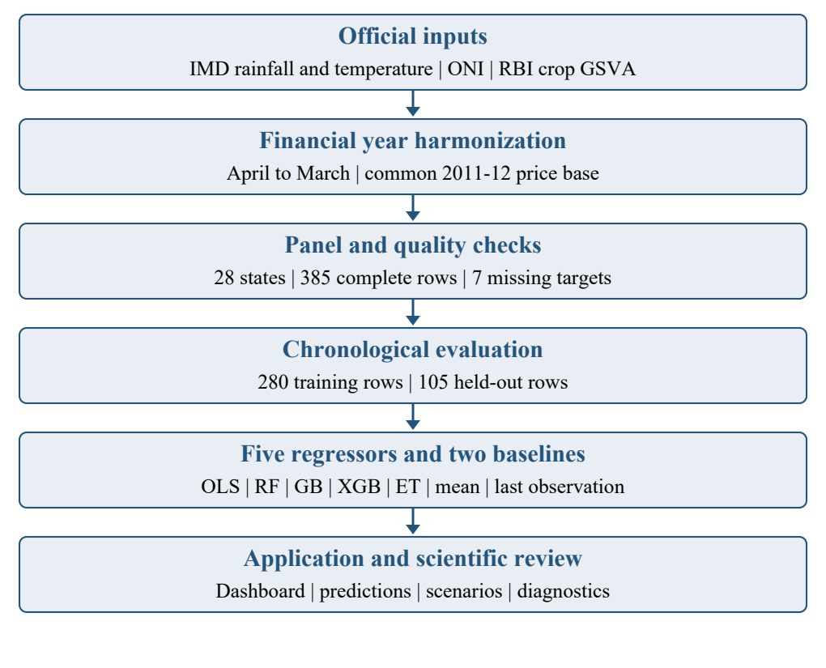
Fig. 1. Data preparation, chronological evaluation, and application workflow.

Harmonization and Quality Control
Annual rainfall is the sum of available valid daily observations in the financial year. Daily mean temperature is calculated from the maximum and minimum temperatures, and those daily means are averaged over the year. A 95% daily-coverage criterion screens the climate aggregates. The retained row records rainfall coverage, temperature coverage, expected days, and the selected cells. This design makes missingness visible rather than hiding it behind an annual number.
$Rₛᵧ = Σ Pₛd , Tₛᵧ = (1 / |D|) Σ (Tmaxₛd + Tminₛd) / 2 (1)$
In (1), D denotes valid days, P is daily rainfall, and Tmax and Tmin are daily temperatures. The rainfall total is a sum over valid days, not an automatic rescaling to compensate for every missing day. A high coverage threshold reduces that discrepancy but cannot guarantee that missing observations are meteorologically random. Likewise, a representative point may differ materially from the climate experienced across an entire state, particularly where elevation, coastlines, or rainfall gradients are pronounced.
The complete panel has rainfall values from 188.53 to 4,301.28 mm and mean temperatures from 19.182 to 29.854 °C. Financial-year ONI ranges from −0.720 to 1.945 °C. Crop GSVA ranges from INR 729.65 to 214,070.82 crore. Quality flags retained for Assam in 2022–23, Manipur in 2017–18, and Telangana in 2019–20 remain available for inspection. They are not silently deleted to improve reported accuracy. The current results use the complete-case panel with those flags retained; a flag-exclusion sensitivity analysis has not been used to claim robustness.
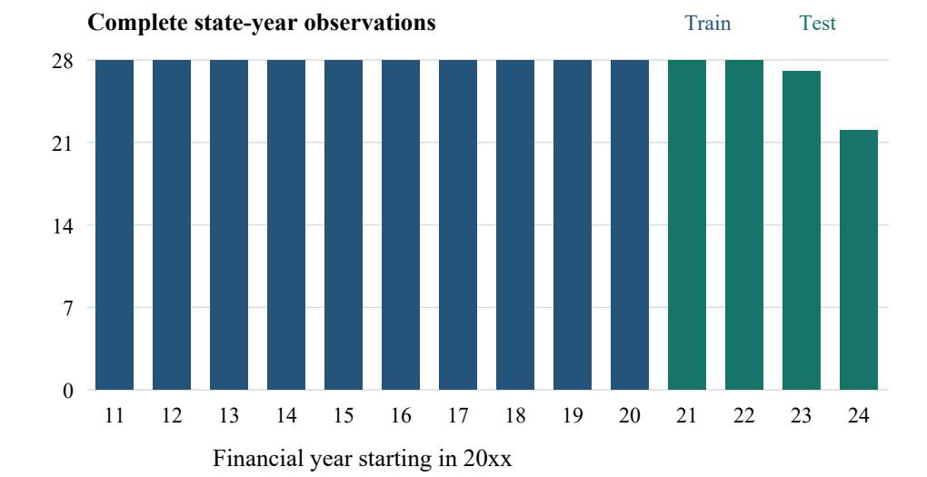
Fig. 2. Complete observations by financial year. The final four years form the holdout.

Methodology

Feature Representation and Chronological Split
Each observation contains rainfall, mean temperature, ONI, and a one-hot state vector. The final input has 31 columns: three climate variables and 28 state indicators. The year is used to construct the split but is not itself a predictive feature. All states present in the test set occur in training. The first ten financial years, 2011–12 through 2020–21, supply 280 training rows. The final four years, 2021–22 through 2024–25, supply 105 test rows. No random redistribution of state-years is used for the reported comparison.
The linear specification can be written as (2), where a state-specific level and three common climate slopes describe the prediction. The stored implementation uses an intercept and all 28 indicator columns. This representation is redundant, so individual intercept and dummy coefficients are not uniquely interpretable as separate structural effects. Predictions remain the quantities evaluated. In addition, the shared slopes assume the same linear response across states, an assumption that may be restrictive for different crop mixes and irrigation systems.
$ŷₛᵧ = αₛ + βR Rₛᵧ + βT Tₛᵧ + βO ONIᵧ (2)$
The split uses observed climate from the held-out years. It therefore evaluates retrospective estimation conditional on realized weather, not an operational forecast issued before those years begin. A usable advance forecast would require weather and ENSO inputs available at the issue date, together with a treatment of their uncertainty. This distinction prevents a chronological split from being mistaken for proof that the full information set was available in advance.

Model Configurations
Random Forest and Extra Trees each contain 150 trees, with maximum depth 10, minimum split size 3, and minimum leaf size 2. Random Forest uses bootstrap sampling; Extra Trees does not. Gradient Boosting and XGBoost use 150 estimators, learning rate 0.08, maximum depth 4, and row subsampling of 0.85. XGBoost additionally uses column subsampling of 0.85 and a squared-error regression objective. Stochastic configurations use random seed 42. Table II records the principal settings of the saved run.
TABLE II
SAVED MODEL CONFIGURATIONS
Model | Principal settings
OLS | Intercept; 31 input columns
Random Forest | 150 trees; depth 10; split 3; leaf 2; bootstrap
Extra Trees | 150 trees; depth 10; split 3; leaf 2; no bootstrap
Gradient Boosting | 150 stages; depth 4; rate 0.08; subsample 0.85
XGBoost | 150 trees; depth 4; rate 0.08; row/column sampling 0.85
These configurations provide a controlled comparison of the implemented model families. They are not presented as the optimal configurations for every state or time period. No scaling is applied to the input features. For tree models, state indicators and continuous weather variables offer different kinds of partitions; for the linear model, coefficient magnitudes also depend on the units in which those inputs are expressed. Consequently, raw coefficient size and tree impurity reduction are not directly comparable measures of climate influence.
The different learning rules also suggest different failure modes. Bagged trees combine partitions learned from resampled observations, while extremely randomized trees introduce additional randomness in split selection. Boosting adds successive corrections to the fitted function. In this small panel, a flexible method can fit state–weather combinations that occur only a few times in training. Conversely, the common slopes of the linear specification may miss a localized or threshold response. The evaluation does not assume either behavior in advance. It compares their resulting predictions on exactly the same later observations, using a common economic unit and consistent feature order.

Baselines and Error Measures
Two additional benchmarks test whether model complexity adds value. The state-mean baseline predicts each state's average GSVA over the training period. The persistence baseline predicts the state's final training-year value, from 2020–21, for every held-out year. Both use training data only. Persistence is deliberately fixed across the full four-year holdout and is not updated using newly observed test targets. This makes the comparison conservative with respect to a practical rolling forecast that could incorporate additional annual observations.
$ŷmeanₛᵧ = μₛ , ŷlastₛᵧ = yₛ,₂₀₂₀ (3)$
In (3), μs is the training mean for state s and ys,2020 is its last training observation. The benchmarks capture different features of the target: the mean represents a long-run state level, whereas persistence preserves the most recent known level. Their comparison helps reveal whether a fitted model is mainly reproducing historical differences between states or improving on the recent state trajectory.
MAE, RMSE, R², and MAPE are calculated over the same held-out rows. MAE and RMSE retain the INR-crore scale; RMSE gives more weight to large errors. The literature discusses complementary reasons to report both rather than rely on one summary alone [42], [43]. MAPE provides a relative-error view, but can give small-valued observations disproportionate influence [44]. No near-zero correction is needed for the positive targets in this panel, although large differences in state scale remain important.
$MAE = Σ |yᵢ − ŷᵢ| / n ; RMSE = √[Σ (yᵢ − ŷᵢ)² / n] (4)$
The pooled R² denominator uses the mean of all held-out targets. It therefore includes the large between-state variation in GSVA. A high pooled value does not imply equally strong performance within each state. The report supplements pooled metrics with annual errors and a predicted-versus-observed plot. It does not average unstable state-level R² estimates based on only two to four observations into a claim about national forecasting skill.

Climate Diagnostic and Reproducibility
Impurity-based importance can be affected by predictor characteristics and the fitting procedure [45]. Permutation provides another way to examine dependence on an input [46]. Here, the saved linear model is evaluated after separately shuffling rainfall or temperature within each state's test observations. ONI is permuted by test year, with the same reassigned annual value applied to every state in that year. This preserves its shared annual structure. State identity is unchanged, and each diagnostic uses 20 repeats with seed 42.
$ΔRMSEⱼ = meanᵦ[RMSE(y, f(Xpermⱼᵦ))] − RMSE(y, f(X)) (5)$
Equation (5) defines the average change in RMSE after permutation. A positive value means that disrupting the input worsens error; a negative value means the disrupted values happen to improve it. The diagnostic is descriptive. It does not establish causality, and correlated predictors can substitute for one another. With only four held-out years, the ONI result is based on a particularly small set of distinct annual values. Confidence intervals and significance tests are therefore not inferred from the sign of these changes.
The evaluated run is identified as run_20261001_192910_2ff9dde9. Its stored metadata records the split, feature order, target definition, panel hash, and hashes of the five serialized model artifacts. Recomputing predictions from those artifacts reproduces the saved RMSE values to their reported precision. The baseline and permutation diagnostics use the same panel and held-out rows. These checks connect the numerical results to a specific dataset and fitted model set, rather than to an unrecorded rerun with altered inputs.

Application Architecture and Scenarios
The application combines a Next.js/React frontend with a FastAPI backend. The interface exposes historical state-year records, charts, model comparisons, prediction forms, and conditional climate scenarios. Backend services assemble compatible features, load trained artifacts, and return results with their model context. SQLite and local files support the local configuration; Firestore and cloud storage are optional integrations. The scientific evaluation concerns the saved model run and is separate from the availability of these deployment options.
A scenario changes selected climate inputs while retaining the chosen state. Its model-implied difference is defined in (6), where x represents the baseline inputs and x* the altered inputs. The percentage change is relative to the model's baseline prediction, not necessarily to an observed GSVA value. Such output describes the response of the fitted function to a specified input change. It does not establish how rainfall, temperature, and ENSO would jointly evolve in the physical climate system.
$Δŷ = f(x*) − f(x) , Δ\% = 100 Δŷ / f(x) (6)$
Prediction and explanation answer different questions [47]. In particular, setting ONI to a stronger warm anomaly while holding rainfall fixed does not reconstruct the full pathway through which ENSO may influence a monsoon. The system is therefore suitable for conditional model exploration and inspection of assumptions. Using its scenario differences as crop-insurance payouts, causal loss estimates, or state budget requirements would require further validation and a design appropriate to those decisions.

Results and Discussion

Comparison of the Five Regressors
Table III reports the reproduced holdout metrics. Ordinary least squares gives the lowest RMSE of the five fitted regressors, at INR 17,410.41 crore, followed by Gradient Boosting, Extra Trees, XGBoost, and Random Forest. Its MAE is INR 10,049.97 crore and its pooled R² is 0.8783. The performance ordering is specific to the saved configurations, feature set, target scale, and chronological split. It does not imply that linear regression will dominate every expanded climate or agricultural dataset.
TABLE III
MODEL ERRORS ON 105 HELD-OUT ROWS
Model | MAE¹ | RMSE¹ | R² | MAPE %
OLS | 10,049.97 | 17,410.41 | 0.8783 | 33.51
Random Forest | 12,556.09 | 21,343.40 | 0.8172 | 60.82
Gradient Boosting | 11,023.36 | 18,086.89 | 0.8687 | 62.83
XGBoost | 11,267.99 | 18,752.05 | 0.8589 | 70.74
Extra Trees | 12,105.21 | 18,388.83 | 0.8643 | 71.66
¹ Monetary errors are in INR crore.
The four ensembles do not obtain a clear advantage from their additional flexibility. Random Forest has the largest RMSE, while Extra Trees has a lower RMSE than XGBoost but a higher MAPE. These differences illustrate why a ranking based on one error metric is incomplete. Large states contribute strongly to squared error, whereas smaller states can dominate relative error. A model intended for state-specific use should be assessed against the relevant error tolerance rather than chosen solely from the pooled leaderboard.

What the Baselines Reveal
The state-mean benchmark has RMSE of INR 17,552.79 crore, only slightly above the linear model. The linear model's RMSE improvement over that benchmark is approximately 0.81%, and its MAE is slightly worse. The persistence benchmark is substantially stronger: RMSE is INR 10,890.73 crore, MAE is INR 5,343.19 crore, and R² is 0.9524. Its RMSE is approximately 37.45% lower than the linear model's. Table IV and Fig. 3 place the model results beside these benchmarks.
TABLE IV
TRAINING-ONLY HISTORICAL BENCHMARKS
Predictor | MAE¹ | RMSE¹ | R²
State mean | 9,911.99 | 17,552.79 | 0.8763
Last value | 5,343.19 | 10,890.73 | 0.9524
OLS comparison | 10,049.97 | 17,410.41 | 0.8783
¹ Monetary errors are in INR crore.
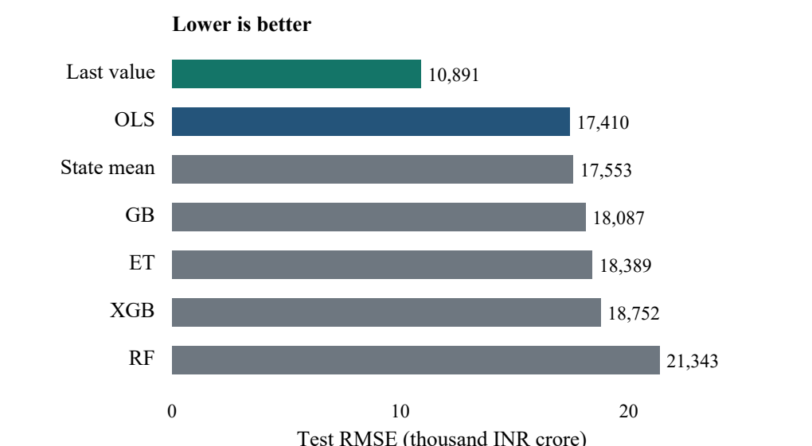
Fig. 3. RMSE comparison including training-only baselines. Last value denotes fixed persistence from FY 2020–21.
This comparison changes the interpretation of the apparent model fit. The climate-and-state regressors capture much of the difference between states, but they do not outperform the latest known state level. Historical averages can lag a changing economic series; a recent observation may therefore provide more useful information than the present weather features. This is consistent with the result, but the experiment does not isolate the contribution of technological change, cropping patterns, or other omitted economic drivers.
The persistence result is also relevant to application design. “Best model” in the stored five-model comparison means the lowest RMSE within that particular candidate list. Once an additional benchmark is evaluated, the label must not be generalized into “best available forecast.” A subsequent model-selection protocol should include persistence as a formal candidate and reserve a new evaluation period if the current results are used to guide feature or hyperparameter changes.
The advantage of persistence is not confined to one unusually large state. Comparing squared errors separately within each state shows lower persistence RMSE than OLS RMSE in 26 of the 28 states. Each comparison uses only that state's available test observations, so it remains descriptive rather than a statistical test. Even so, this broad pattern strengthens the practical case for retaining the benchmark. The result is also visible in relative error: persistence has pooled MAPE of 9.93%, compared with 16.56% for the training mean and 33.51% for OLS. The benchmark comparison is therefore informative on both the absolute and relative scales.

Temporal and State-Level Error Patterns
Figure 4 compares the linear model's predictions with observed GSVA. The wide range of state economic levels accounts for much of the visual spread. Large-state underprediction contributes substantial absolute error: over the held-out observations, Uttar Pradesh has MAE of approximately INR 59,135.75 crore, Madhya Pradesh INR 43,012.03 crore, and Maharashtra INR 27,432.86 crore. These are prediction errors, not measured climate losses. Differences in scale mean that a smaller state's lower absolute error need not indicate a better relative prediction.
Together, these three states account for approximately 79.63% of the linear model's total squared error across the holdout. The linear predictions fall below the observed target in 78 of 105 rows, with mean signed error, defined as prediction minus observation, of −INR 9,289.18 crore. This indicates a substantial downward bias in the evaluated period. The bias is not a universal statement about every state, nor does it reveal the cause of the missed growth. It identifies a concrete weakness that aggregate R² alone would conceal and that a future model should address explicitly.
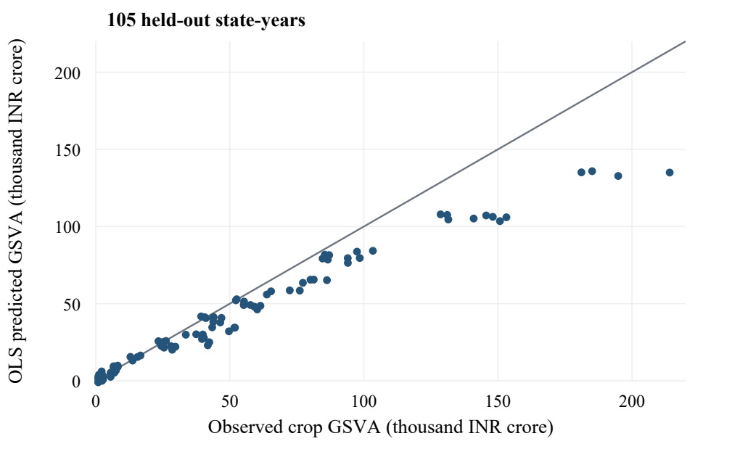
Fig. 4. Observed and predicted crop GSVA for the linear model. The diagonal represents exact prediction.
Annual linear-model RMSE rises from INR 13,072.53 crore in 2021–22 to INR 23,158.59 crore in 2024–25. Table V and Fig. 5 show the progression. Increasing error with distance from the training period is consistent with a model that does not fully track evolving output levels. However, the state composition also changes: the final year contains 22 observations rather than 28. The annual comparison therefore cannot attribute all deterioration to elapsed time alone.
TABLE V
ANNUAL HELD-OUT PERFORMANCE OF OLS
FY | n | MAE¹ | RMSE¹ | R²
2021–22 | 28 | 7,034.36 | 13,072.53 | 0.9237
2022–23 | 28 | 9,439.80 | 15,284.48 | 0.9022
2023–24 | 27 | 10,863.91 | 17,953.27 | 0.8686
2024–25 | 22 | 13,665.68 | 23,158.59 | 0.8130
¹ Monetary errors are in INR crore.
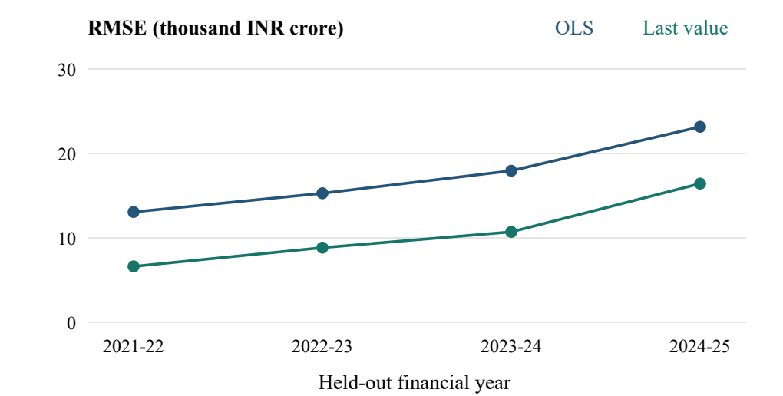
Fig. 5. Annual RMSE for OLS and fixed persistence on the same available observations.
Persistence RMSE also increases across the test period, from INR 6,621.89 crore in 2021–22 to 8,842.09 in 2022–23, 10,710.27 in 2023–24, and 16,431.36 in 2024–25. Thus, the most recent training observation becomes less accurate as it is carried farther forward, but it remains better than OLS in every evaluated year. The experiment does not establish whether a trend extrapolation, a lagged-output regression, or a seasonal climate model would be superior. It establishes the benchmark those alternatives should beat under the same information constraints before additional complexity is treated as an improvement.
The pooled R² remains above 0.8 in each test year, even as absolute errors grow. This combination is possible because the model still separates higher- and lower-GSVA states reasonably well. It should not be interpreted as evidence that most annual economic changes are explained by climate. The distinction between level prediction and change prediction is central to deciding whether the model can support monitoring, forecasting, or an assessment of exposure to ENSO.

Dependence on Climate Inputs
The permutation diagnostic gives RMSE changes of +2.07 crore for rainfall, +14.52 crore for mean temperature, and −13.50 crore for ONI. These values are small compared with the unpermuted RMSE of INR 17,410.41 crore. Table VI and Fig. 6 summarize the calculation. In the present linear specification, the retained climate variables provide limited additional predictive information on the held-out observations once state identity is fixed.
TABLE VI
LINEAR-MODEL CLIMATE PERMUTATION DIAGNOSTIC
Permuted input | Mean ΔRMSE¹ | Procedure
Rainfall | +2.07 | Within state
Temperature | +14.52 | Within state
ONI | −13.50 | Shared test year
¹ INR crore; 20 repeats; baseline RMSE = 17,410.41.
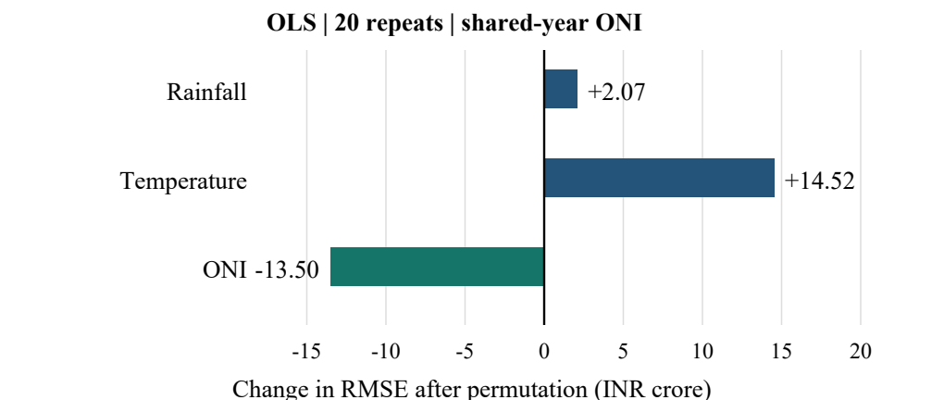
Fig. 6. Mean change in linear-model RMSE after separate climate permutations. Small magnitudes limit substantive interpretation.
The negative ONI value does not show that El Niño benefits agriculture. It shows that one particular perturbation procedure slightly improves one fitted model's prediction error on a short test window. Conversely, a small positive temperature value does not quantify the economic damage caused by heat. The result concerns the sensitivity of the model's performance to its inputs. Aggregation, correlated predictors, shared annual variation, and a short record all constrain the interpretation.
The diagnostic also discourages interpreting normalized absolute linear coefficients as percentage contributions to the economy. Those coefficients combine millimeters, degrees Celsius, and binary indicators, so their relative magnitudes depend on units. Tree importances describe the fitted splitting rules and face different limitations. Permutation is useful here because it assesses prediction error on held-out rows, but it still cannot replace a causal design or recover information removed by annual aggregation.

Limitations
The first limitation is spatial representation. A single nearest grid point cannot characterize the full distribution of weather across a large state. Area-weighted climate extraction over administrative boundaries, preferably weighted by cultivated area or crop distribution where justified, would provide a closer match to the state-level economic target. The current approach is computationally simple and auditable, but it should not be described as a state-wide rainfall measurement.
The second limitation is temporal resolution. Financial-year rainfall and temperature averages can obscure monsoon breaks, planting dates, flowering-stage heat, and crop-specific exposure. The same annual total can arise from different rainfall sequences. ONI is also shared across states, yielding only 14 annual values across the panel and only four in the test period. Hundreds of state-year rows therefore do not supply hundreds of independent ENSO histories.
The third limitation concerns model inputs and validation. The feature set omits lagged GSVA, irrigation, crop area, crop composition, soil conditions, policy, and technology. The strong persistence benchmark makes lagged economic information a priority for future assessment. The current single chronological holdout does not measure stability across alternative cutoffs, and the reported model ranking has not been validated on a second untouched period. Repeatedly redesigning the system around the present test results would weaken their status as an independent evaluation.
Finally, the outcome is an aggregate economic measure at a constant price base. It cannot directly establish household welfare, crop-specific yield loss, or district drought vulnerability. Scenario outputs inherit the model's limitations and may involve implausible combinations of inputs. Transparent models and clearly stated decision boundaries are particularly valuable when predictions could influence consequential choices [48]. At its present stage, the application supports exploratory analysis and reproducible comparison, with predictive uncertainty and economic attribution remaining open research problems.
Data publication timing introduces another constraint for future deployment. The analysis uses the retained economic table and prepared weather observations as a research dataset, without reconstructing the exact vintage available at each historical issue date. Economic revisions can change targets after initial publication, and an annual climate aggregate cannot be known before the year ends. A prospective evaluation should preserve dated input snapshots, record forecast issue times, and distinguish preliminary targets from revised ones. These records would make it possible to assess operational performance without accidentally giving a historical model information that became available only later.

Conclusion and Future Work
The project integrates IMD weather observations, historical ONI, and RBI/NSO crop GSVA into a 385-row state-year panel and a working analytical application. Under a chronological split, ordinary least squares achieves the lowest RMSE among five fitted regressors. However, a fixed last-observed-value benchmark performs substantially better, and climate permutation produces only small changes in linear-model error. The evidence supports a useful baseline for further research rather than a validated estimate of ENSO-induced economic loss.
The next evaluation should add lagged target information, distinguish economic levels from annual growth, and test seasonal or crop-stage weather features. Spatial aggregation should move from representative points to documented state or crop-area summaries. Rolling-origin validation would show whether improvements persist across forecast origins, while a separate state-transfer experiment could assess generalization beyond the fitted state vocabulary. Each extension should be compared with persistence using data available at the intended prediction date. This sequence would strengthen the connection between the application's outputs and the agricultural questions it is intended to support.

Acknowledgment
The authors acknowledge K. J. Somaiya Institute of Technology for the academic setting of this project and the public data providers whose climate and economic records enable reproducible assessment.

References
- K. Krishna Kumar, K. Rupa Kumar, R. G. Ashrit, N. R. Deshpande, and J. W. Hansen, “Climate impacts on Indian agriculture,” International Journal of Climatology, vol. 24, no. 11, pp. 1375–1393, 2004, doi: 10.1002/joc.1081.
- E. M. Rasmusson and T. H. Carpenter, “The Relationship Between Eastern Equatorial Pacific Sea Surface Temperatures and Rainfall over India and Sri Lanka,” Monthly Weather Review, vol. 111, no. 3, pp. 517–528, 1983, doi: 10.1175/1520-0493(1983)111<0517:trbeep>2.0.co;2.
- K. K. Kumar, B. Rajagopalan, and M. A. Cane, “On the Weakening Relationship Between the Indian Monsoon and ENSO,” Science, vol. 284, no. 5423, pp. 2156–2159, 1999, doi: 10.1126/science.284.5423.2156.
- K. K. Kumar, B. Rajagopalan, M. Hoerling, G. Bates, and M. Cane, “Unraveling the Mystery of Indian Monsoon Failure During El Niño,” Science, vol. 314, no. 5796, pp. 115–119, 2006, doi: 10.1126/science.1131152.
- S. Gadgil, “The Indian Monsoon and Its Variability,” Annual Review of Earth and Planetary Sciences, vol. 31, no. 1, pp. 429–467, 2003, doi: 10.1146/annurev.earth.31.100901.141251.
- K. Ashok, Z. Guan, and T. Yamagata, “Impact of the Indian Ocean dipole on the relationship between the Indian monsoon rainfall and ENSO,” Geophysical Research Letters, vol. 28, no. 23, pp. 4499–4502, 2001, doi: 10.1029/2001gl013294.
- N. H. Saji, B. N. Goswami, P. N. Vinayachandran, and T. Yamagata, “A dipole mode in the tropical Indian Ocean,” Nature, vol. 401, no. 6751, pp. 360–363, 1999, doi: 10.1038/43854.
- K. Ashok, S. K. Behera, S. A. Rao, H. Weng, and T. Yamagata, “El Niño Modoki and its possible teleconnection,” Journal of Geophysical Research: Oceans, vol. 112, no. C11, 2007, doi: 10.1029/2006jc003798.
- G. J. van Oldenborgh et al., “Defining El Niño indices in a warming climate,” Environmental Research Letters, vol. 16, no. 4, Art. no. 044003, 2021, doi: 10.1088/1748-9326/abe9ed.
- D. B. Lobell, W. Schlenker, and J. Costa-Roberts, “Climate Trends and Global Crop Production Since 1980,” Science, vol. 333, no. 6042, pp. 616–620, 2011, doi: 10.1126/science.1204531.
- W. Schlenker and M. J. Roberts, “Nonlinear temperature effects indicate severe damages to U.S. crop yields under climate change,” Proceedings of the National Academy of Sciences, vol. 106, no. 37, pp. 15594–15598, 2009, doi: 10.1073/pnas.0906865106.
- D. B. Lobell, A. Sibley, and J. Ivan Ortiz-Monasterio, “Extreme heat effects on wheat senescence in India,” Nature Climate Change, vol. 2, no. 3, pp. 186–189, 2012, doi: 10.1038/nclimate1356.
- M. Auffhammer, V. Ramanathan, and J. R. Vincent, “Climate change, the monsoon, and rice yield in India,” Climatic Change, vol. 111, no. 2, pp. 411–424, 2012, doi: 10.1007/s10584-011-0208-4.
- M. Dell, B. F. Jones, and B. A. Olken, “What Do We Learn from the Weather? The New Climate-Economy Literature,” Journal of Economic Literature, vol. 52, no. 3, pp. 740–798, 2014, doi: 10.1257/jel.52.3.740.
- A. K. Mishra and V. P. Singh, “A review of drought concepts,” Journal of Hydrology, vol. 391, no. 1-2, pp. 202–216, 2010, doi: 10.1016/j.jhydrol.2010.07.012.
- O. V. Wilhelmi and D. A. Wilhite, “Assessing Vulnerability to Agricultural Drought: A Nebraska Case Study,” Natural Hazards, vol. 25, no. 1, pp. 37–58, 2002, doi: 10.1023/a:1013388814894.
- P. Udmale, Y. Ichikawa, S. Manandhar, H. Ishidaira, and A. S. Kiem, “Farmers׳ perception of drought impacts, local adaptation and administrative mitigation measures in Maharashtra State, India,” International Journal of Disaster Risk Reduction, vol. 10, pp. 250–269, 2014, doi: 10.1016/j.ijdrr.2014.09.011.
- D. Swami and D. Parthasarathy, “Dynamics of exposure, sensitivity, adaptive capacity and agricultural vulnerability at district scale for Maharashtra, India,” Ecological Indicators, vol. 121, Art. no. 107206, 2021, doi: 10.1016/j.ecolind.2020.107206.
- A. Chakraborty and P. K. Joshi, “Mapping disaster vulnerability in India using analytical hierarchy process,” Geomatics, Natural Hazards and Risk, vol. 7, no. 1, pp. 308–325, 2016, doi: 10.1080/19475705.2014.897656.
- S. Saha et al., “Spatial assessment of drought vulnerability using fuzzy-analytical hierarchical process: a case study at the Indian state of Odisha,” Geomatics, Natural Hazards and Risk, vol. 12, no. 1, pp. 123–153, 2021, doi: 10.1080/19475705.2020.1861114.
- G. Balaganesh et al., “Development of composite vulnerability index and district level mapping of climate change induced drought in Tamil Nadu, India,” Ecological Indicators, vol. 113, Art. no. 106197, 2020, doi: 10.1016/j.ecolind.2020.106197.
- C. S. Murthy, B. Laxman, and M. V. R. Sesha Sai, “Geospatial analysis of agricultural drought vulnerability using a composite index based on exposure, sensitivity and adaptive capacity,” International Journal of Disaster Risk Reduction, vol. 12, pp. 163–171, 2015, doi: 10.1016/j.ijdrr.2015.01.004.
- J. Sharma and N. H. Ravindranath, “Applying IPCC 2014 framework for hazard-specific vulnerability assessment under climate change,” Environmental Research Communications, vol. 1, no. 5, Art. no. 051004, 2019, doi: 10.1088/2515-7620/ab24ed.
- S. C. Nair and A. Mirajkar, “Drought vulnerability assessment across Vidarbha region, Maharashtra, India,” Arabian Journal of Geosciences, vol. 15, no. 4, Art. no. 355, 2022, doi: 10.1007/s12517-022-09623-0.
- S. L. Cutter, B. J. Boruff, and W. L. Shirley, “Social Vulnerability to Environmental Hazards ,” Social Science Quarterly, vol. 84, no. 2, pp. 242–261, 2003, doi: 10.1111/1540-6237.8402002.
- W. N. Adger, “Vulnerability,” Global Environmental Change, vol. 16, no. 3, pp. 268–281, 2006, doi: 10.1016/j.gloenvcha.2006.02.006.
- H. M. Füssel, “Vulnerability: A generally applicable conceptual framework for climate change research,” Global Environmental Change, vol. 17, no. 2, pp. 155–167, 2007, doi: 10.1016/j.gloenvcha.2006.05.002.
- D. J. Abson, A. J. Dougill, and L. C. Stringer, “Using Principal Component Analysis for information-rich socio-ecological vulnerability mapping in Southern Africa,” Applied Geography, vol. 35, no. 1-2, pp. 515–524, 2012, doi: 10.1016/j.apgeog.2012.08.004.
- I. T. Jolliffe and J. Cadima, “Principal component analysis: a review and recent developments,” Philosophical Transactions of the Royal Society A: Mathematical, Physical and Engineering Sciences, vol. 374, no. 2065, Art. no. 20150202, 2016, doi: 10.1098/rsta.2015.0202.
- M. Saisana, A. Saltelli, and S. Tarantola, “Uncertainty and sensitivity analysis techniques as tools for the quality assessment of composite indicators,” Journal of the Royal Statistical Society: Series A (Statistics in Society), vol. 168, no. 2, pp. 307–323, 2005, doi: 10.1111/j.1467-985X.2005.00350.x.
- K. Liakos, P. Busato, D. Moshou, S. Pearson, and D. Bochtis, “Machine Learning in Agriculture: A Review,” Sensors, vol. 18, no. 8, pp. 2674, 2018, doi: 10.3390/s18082674.
- T. van Klompenburg, A. Kassahun, and C. Catal, “Crop yield prediction using machine learning: A systematic literature review,” Computers and Electronics in Agriculture, vol. 177, Art. no. 105709, 2020, doi: 10.1016/j.compag.2020.105709.
- L. Breiman, “Random Forests,” Machine Learning, vol. 45, no. 1, pp. 5–32, 2001, doi: 10.1023/a:1010933404324.
- P. Geurts, D. Ernst, and L. Wehenkel, “Extremely randomized trees,” Machine Learning, vol. 63, no. 1, pp. 3–42, 2006, doi: 10.1007/s10994-006-6226-1.
- J. H. Friedman, “Greedy function approximation: A gradient boosting machine,” The Annals of Statistics, vol. 29, no. 5, 2001, doi: 10.1214/aos/1013203451.
- T. Chen and C. Guestrin, “XGBoost: A scalable tree boosting system,” Proceedings of the 22nd ACM SIGKDD International Conference on Knowledge Discovery and Data Mining, pp. 785–794, 2016, doi: 10.1145/2939672.2939785.
- C. Bergmeir and J. M. Benítez, “On the use of cross-validation for time series predictor evaluation,” Information Sciences, vol. 191, pp. 192–213, 2012, doi: 10.1016/j.ins.2011.12.028.
- D. R. Roberts et al., “Cross‐validation strategies for data with temporal, spatial, hierarchical, or phylogenetic structure,” Ecography, vol. 40, no. 8, pp. 913–929, 2017, doi: 10.1111/ecog.02881.
- S. Varma and R. Simon, “Bias in error estimation when using cross-validation for model selection,” BMC Bioinformatics, vol. 7, no. 1, Art. no. 91, 2006, doi: 10.1186/1471-2105-7-91.
- D. S. Pai, M. Rajeevan, O. P. Sreejith, B. Mukhopadhyay, and N. S. Satbha, “Development of a new high spatial resolution (0.25° × 0.25°) long period (1901-2010) daily gridded rainfall data set over India and its comparison with existing data sets over the region,” MAUSAM, vol. 65, no. 1, pp. 1–18, 2014, doi: 10.54302/mausam.v65i1.851.
- A. K. Srivastava, M. Rajeevan, and S. R. Kshirsagar, “Development of a high resolution daily gridded temperature data set (1969–2005) for the Indian region,” Atmospheric Science Letters, vol. 10, no. 4, pp. 249–254, 2009, doi: 10.1002/asl.232.
- C. Willmott and K. Matsuura, “Advantages of the mean absolute error (MAE) over the root mean square error (RMSE) in assessing average model performance,” Climate Research, vol. 30, pp. 79–82, 2005, doi: 10.3354/cr030079.
- T. Chai and R. R. Draxler, “Root mean square error (RMSE) or mean absolute error (MAE)? – Arguments against avoiding RMSE in the literature,” Geoscientific Model Development, vol. 7, no. 3, pp. 1247–1250, 2014, doi: 10.5194/gmd-7-1247-2014.
- R. J. Hyndman and A. B. Koehler, “Another look at measures of forecast accuracy,” International Journal of Forecasting, vol. 22, no. 4, pp. 679–688, 2006, doi: 10.1016/j.ijforecast.2006.03.001.
- C. Strobl, A. L. Boulesteix, A. Zeileis, and T. Hothorn, “Bias in random forest variable importance measures: Illustrations, sources and a solution,” BMC Bioinformatics, vol. 8, no. 1, Art. no. 25, 2007, doi: 10.1186/1471-2105-8-25.
- A. Altmann, L. Toloşi, O. Sander, and T. Lengauer, “Permutation importance: a corrected feature importance measure,” Bioinformatics, vol. 26, no. 10, pp. 1340–1347, 2010, doi: 10.1093/bioinformatics/btq134.
- G. Shmueli, “To Explain or to Predict?,” Statistical Science, vol. 25, no. 3, pp. 289–310, 2010, doi: 10.1214/10-sts330.
- C. Rudin, “Stop explaining black box machine learning models for high stakes decisions and use interpretable models instead,” Nature Machine Intelligence, vol. 1, no. 5, pp. 206–215, 2019, doi: 10.1038/s42256-019-0048-x.

