Timbre Vocal Affect Classification
A Speaker Disjoint Comparison of Gaussian Hidden Markov Models and Classical Baselines
Hardik Sharma
Timbre Machine Learning Research Project
2 October 2026

Research report covering the project question, baseline selection, methodology, experimental design, results, individual reflection, originality review, and oral assessment preparation

Abstract
This study tests whether explicit temporal sequence modelling improves six-class vocal-affect classification over fixed-length classical baselines. The main method extracts 20 mel-frequency cepstral coefficients, root-mean-square energy, fundamental frequency, and voiced proportion from short acoustic frames. A training-only StandardScaler and principal component analysis transform the 23 inputs to eight dimensions. Six three-state diagonal Gaussian hidden Markov models then produce length-normalized scores through a hand-written Viterbi decoder. A validation-fitted multinomial calibrator converts those scores to class probabilities and sets an abstention threshold.
The frozen corpus contains 10,890 accepted recordings. RAVDESS and CREMA-D provide speaker-disjoint training, validation, and in-domain test partitions; TESS is reserved as an external test. Logistic regression and random forest baselines receive seven summary statistics for each of the same 23 acoustic features. All models share the same 5,848 training recordings, 1,324 in-domain test recordings, label space, and seed.
The temporal hypothesis was not supported. Logistic regression achieved 49.92% in-domain accuracy and 49.68% macro-F1, compared with 38.97% and 37.42% for the calibrated HMM. Random forest achieved the strongest TESS result, but only 32.54% accuracy and 30.80% macro-F1. The HMM's validation-selected abstention rule raised retained-set accuracy in-domain, yet retained every TESS recording and therefore did not identify the external shift. Training-only reverberation also reduced HMM performance. These results show that sequence structure alone does not compensate for limited features, class-conditional modelling assumptions, label ambiguity, and dataset shift.
The intended contribution is a reproducible and leakage-aware experiment that combines dataset harmonization, a hand-written decoder, calibrated uncertainty, explicit abstention, and external-domain evaluation. The report treats the negative comparison as the main finding and limits claims to vocal affect rather than a person's internal emotional state.
Keywords speech emotion recognition, vocal affect, hidden Markov model, Viterbi decoding, calibration, domain shift

Contents
Rubric Coverage
1 Research Question Motivation and Contribution
2 Baselines and Methodology
3 Experimental Design and Data
4 Results
5 Analysis and Discussion
6 Limitations and Threats to Validity
7 Conclusion
8 Turnitin Quality and Originality Review
References
Appendix A Individual Analysis and Reflection Hardik Sharma
Appendix B Individual Question and Answer Preparation
Appendix C Reproducibility and Evidence Map

Rubric Coverage
The report addresses each assessed element directly. The Turnitin row distinguishes a completed originality self-check from the institution-generated similarity report, which can only be produced after upload.
Rubric area | Report coverage | Primary evidence
Research question motivation and contribution | Section 1 defines a falsifiable temporal-model comparison, explains the application relevance, and states the intended technical contribution. | Frozen model comparison and external-domain result
Baseline and methodology | Section 2 justifies logistic regression and random forest, then specifies features, PCA, HMM training, hand-written Viterbi scoring, calibration, and abstention. | Model metadata and training scripts
Experimental design and data | Section 3 defines the target, inputs, dataset roles, splits, metrics, fair settings, data-quality risks, and leakage controls. | Manifest, split file, and cache validation
Individual analysis and reflection | Appendix A is a named one-page analysis organized around claim, evidence, reasoning, trade-off, and limitations. | Measured in-domain and TESS results
Turnitin quality and originality | Section 8 gives source attribution, evidence traceability, authorship guidance, and a pre-submission originality review without inventing a similarity score. | References and artifact map
Individual question and answer | Appendix B provides concise answers covering methodology, design, results, limitations, and individual analysis. | Twelve viva-style questions

1 Research Question Motivation and Contribution

1.1 Research Question
Research question On a six-class vocal-affect task with speaker-disjoint evaluation, does a bank of class-conditional Gaussian hidden Markov models scored by hand-written Viterbi decoding outperform logistic regression and random forest baselines that summarize the same acoustic inputs, and do its calibrated confidence and abstention behaviour remain useful under a TESS domain shift?
This question is specific because it fixes the prediction target, data roles, model families, scoring method, and evaluation setting. It is testable through accuracy, balanced accuracy, macro-F1, expected calibration error, multiclass Brier score, coverage, covered accuracy, and latency on the frozen partitions. The primary directional hypothesis is that preserving frame order will improve balanced accuracy and macro-F1 over clip-summary baselines. The calibration hypothesis is that a validation-fitted mapping and threshold will produce useful probability estimates and reject uncertain recordings without relying on test labels.

1.2 Real World Motivation
Timbre is a prototype voice companion that adapts its response to acoustic cues in speech. In that setting, a wrong confident prediction can be more harmful than a cautious estimate because a system may respond inappropriately to sadness, anger, fear, or neutral speech. The project therefore evaluates both discrimination and uncertainty. A model should identify useful vocal patterns, indicate when confidence is weak, and fail visibly when the recording domain differs from development data.
The output is described as vocal affect rather than true emotion. RAVDESS, CREMA-D, and TESS contain acted or annotated categories, while the model observes only acoustics. It cannot see the speaker's context, intent, culture, self-report, or mental state. The model is therefore unsuitable for diagnosis, high-stakes decisions, surveillance, or any claim that it knows how a person actually feels. Its defensible use is a low-stakes interaction signal with an explicit uncertainty path.

1.3 Intended Contribution
The project does not claim to invent MFCCs, PCA, Gaussian HMMs, logistic regression, or random forests. Its intended contribution is the design and implementation of a coherent experiment around those methods. The main components are a canonical six-class manifest across three datasets, speaker-disjoint partitions, audio-quality and duplicate screening, a shared frame-feature contract, a training-only scaler and PCA stage, six class-conditional sequence models, hand-written log-space Viterbi decoding, validation-only probability calibration and abstention, and a common evaluation harness that reports in-domain and external performance.
This contribution matters even when the proposed method loses. A reproducible negative result identifies the limits of the modelling assumption and prevents an application demo from being mistaken for scientific evidence. The experiment also exposes two deployment-relevant failures: probability quality can change sharply across datasets, and a threshold selected in-domain may retain every out-of-domain recording.

2 Baselines and Methodology

2.1 Why These Baselines
The baselines ask whether temporal modelling adds value beyond the same underlying acoustic measurements. Each recording is converted to 161 fixed-length values by taking the mean, standard deviation, median, minimum, maximum, 25th percentile, and 75th percentile of each of the 23 frame features. This deliberately removes frame order while preserving level and distribution. The comparison therefore isolates the central design choice more cleanly than a baseline built from unrelated inputs.
Scaled multinomial logistic regression is the interpretable linear baseline. It tests whether approximately linear class boundaries in the summary representation are already sufficient. Class weights reduce the influence of the smaller neutral class. Random forest is the nonlinear baseline described by Breiman (2001). Its 300 trees can capture interactions and thresholds without requiring feature scaling, while balanced subsampling addresses class imbalance. A uniform six-class guess gives 16.67% expected accuracy, and the largest in-domain class represents 17.22% of that test set; these are references rather than trained competitors.
Model | Input | Purpose | Key settings
Logistic regression | 161 clip-summary values | Linear discriminative baseline | StandardScaler, balanced classes, 2,000 iterations
Random forest | 161 clip-summary values | Nonlinear discriminative baseline | 300 trees, balanced subsamples, fixed seed
Gaussian HMM bank | Ordered 8-dimensional frame sequence | Proposed temporal method | Six class models, three diagonal-Gaussian states each

2.2 Acoustic Inputs
Every recording is loaded as mono audio at 16 kHz. MFCC and energy features use centered 25 ms windows with a 10 ms stride. Fundamental frequency uses a 50 ms YIN analysis window on the same hop grid and is set to zero when voiced proportion is below 0.2. The resulting frame matrix has 23 columns. These inputs capture complementary properties of the speech signal without using transcript content or demographic metadata.
Input | Width | Information represented | Main risk
MFCC | 20 | Short-term spectral envelope and vocal-tract-related shape | Sensitive to channel and speaker characteristics
RMS energy | 1 | Frame-level amplitude | Affected by microphone gain and distance
Fundamental frequency | 1 | Pitch contour in voiced regions | YIN errors and speaker-dependent pitch range
Voiced proportion | 1 | Share of voiced samples in the frame | Simple activity estimate rather than learned VAD

2.3 Proposed Sequence Method
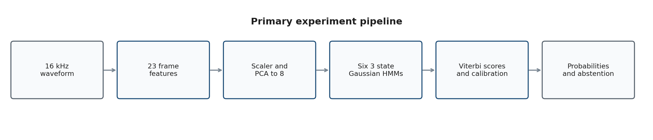
Figure 1 Implemented path from waveform to calibrated probabilities
A StandardScaler first standardizes the incompatible units of MFCC, energy, pitch, and voiced proportion. PCA then reduces each frame from 23 to eight dimensions. Both transformations are fitted on 1,580,436 training frames and reused unchanged for validation, test, TESS, and live inference. Fitting them only on training frames prevents test-distribution information from entering the representation.
The method trains one three-state diagonal Gaussian HMM for each of the six vocal-affect classes. The hidden states represent within-class acoustic regimes, not the six class labels. The hmmlearn library estimates transition and emission parameters with Baum-Welch for up to 100 iterations. At prediction time, every class model scores the same reduced sequence. The project's hand-written Viterbi implementation performs log-space dynamic programming with backpointers and returns the best hidden-state path score. Dividing by the number of frames prevents longer utterances from receiving more negative scores only because they contain more observations. Rabiner (1989) provides the standard HMM formulation, while Viterbi (1967) introduced the decoding principle.

2.4 Calibration and Abstention
Six length-normalized HMM scores are standardized and mapped to probabilities by multinomial logistic regression fitted on the 1,318 validation recordings. This calibrator is part of the final HMM pipeline rather than a separate baseline. Calibration is evaluated with expected calibration error and the multiclass Brier score because a useful confidence value should reflect the frequency of correct predictions, not merely rank classes (Guo et al., 2017). The validation workflow selected a maximum-probability threshold of 0.2358 while requiring at least 80% coverage. Predictions below the threshold are treated as abstentions.
Classification fairness and probability fairness require separate interpretations. All three models use the same training recordings, test recordings, labels, seed, and underlying acoustic features. However, only the HMM receives a validation-fitted post-hoc calibrator and abstention threshold. Accuracy and macro-F1 remain direct method comparisons; ECE and Brier comparisons are descriptive because the baseline probabilities were not given symmetric post-hoc calibration.

3 Experimental Design and Data

3.1 Prediction Target and Dataset Roles
The target is a single categorical label for each recording: neutral, happy, sad, angry, fearful, or disgust. These six classes are shared by all three corpora. RAVDESS calm and surprise and TESS pleasant surprise are excluded so that class identity does not reveal the source dataset. An unknown outcome is implemented through abstention rather than trained as a seventh class because silence, corruption, domain shift, and a close decision boundary do not form one coherent acoustic category.
Dataset | Accepted recordings | Speakers | Role | Reason for role
CREMA-D | 7,435 | 91 | Development | Largest six-class corpus with actor and agreement metadata
RAVDESS | 1,055 | 24 | Development | Validated acted speech with controlled lexical material
TESS | 2,400 | 2 | External test only | Different speakers, carrier phrases, and collection conditions
Total | 10,890 | 117 | All roles | Eight integrity exclusions after six-class filtering

RAVDESS contains professional actors performing lexically matched North American English expressions (Livingstone & Russo, 2018). CREMA-D contains 7,442 original clips from 91 actors and preserves crowd-derived voice agreement information (Cao et al., 2014). TESS contains 2,800 recordings from two actresses across seven categories; this experiment uses the 2,400 clips in the shared six-class space (Pichora-Fuller & Dupuis, 2020). Dataset descriptions justify their roles but do not remove their acted-speech and demographic limitations.

3.2 Frozen Data Splits
Partition | Clips | Development speakers | Permitted use
Training | 5,848 | 79 | Fit baselines, scaler, PCA, and HMM parameters
Validation | 1,318 | 18 | Fit HMM score calibration and choose abstention threshold
In-domain test | 1,324 | 18 | Final RAVDESS and CREMA-D comparison
External test | 2,400 | 2 TESS speakers | Final cross-dataset generalization check

Speakers are partitioned independently inside each development dataset. CREMA-D contributes 63 training, 14 validation, and 14 test speakers; RAVDESS contributes 16, 4, and 4. No development speaker crosses partitions. TESS is locked to external_test. The split document records seed 42, exact clip identifiers, speaker groups, and the manifest SHA-256 value 2e59f4c0a7447516c09dd2fac6564087fe27aca54e809750c8853f3f79545e1a.

3.3 Evaluation Metrics
Metric | Question answered | Why needed
Accuracy | How often is the top label correct | Direct overall result
Balanced accuracy | What is mean recall across classes | Reduces the effect of class imbalance
Macro precision recall F1 | Does performance hold across every class | Exposes class collapse hidden by accuracy
Confusion matrix | Which labels are confused | Supports substantive failure analysis
ECE | Do confidence bins match empirical correctness | Measures probability reliability with binning sensitivity
Multiclass Brier | How far are probabilities from one-hot targets | Proper score that penalizes confident error
Coverage and covered accuracy | What fraction is retained and how accurate is it | Evaluates the abstention trade-off
Median p90 p95 latency | Can the perception path meet the 300 ms budget | Connects research output to interactive use

3.4 Fair Comparison Settings
A fair comparison holds constant the properties that are not under study. The three model families use the same six labels, original training recordings, frozen test sets, seed, and 23 base acoustic measurements. The HMM sees the ordered frame sequence after training-only PCA; baselines see seven fixed summary statistics per feature. Training-only reverberation is evaluated as a separate ablation and never mixed into the primary baseline comparison. Hyperparameters are not selected from the final test or TESS labels.
Control | Implementation | Residual limitation
Common data | Same manifest, train clips, label mapping, seed, and test clips | Model capacities and input dimensionalities differ by design
Speaker independence | Disjoint speakers within RAVDESS and CREMA-D | TESS has only two speakers and is a domain test
Feature lineage | Same 23 frame measurements feed every model | Baselines aggregate to 161 values while HMM uses PCA sequences
Calibration | HMM calibration and threshold use validation only | Baseline probabilities are not post-hoc calibrated
Model selection | Primary settings declared before final evaluation | Later v2 work cannot reuse observed v1 test as a clean selection set

3.5 Data Quality and Leakage Risks
The manifest screens every candidate for decode failure, non-finite samples, duration below 0.2 seconds, RMS below 0.0001, at least 98% silent frames, and clipping above 5%. Audio SHA-256 values identify exact duplicates. The final corpus excludes six clips from three conflicting-label duplicate pairs, one same-label duplicate, and one nearly silent clip. The cache contains one finite feature matrix for every accepted row, and the current data-readiness check confirms 10,890 valid caches.
Risk | Control | Remaining concern
Speaker leakage | All clips from one development speaker share one partition | Speaker-disjoint lab data still differs from spontaneous users
Exact audio leakage | SHA-256 duplicate detection before split | Near-duplicates and repeated lexical content may remain
Transformation leakage | Scaler and PCA fit on training frames only | Large correlated frame counts can dominate the PCA objective
Selection leakage | Calibration and threshold use validation only; tests are final | Observed v1 test results cannot be used to promote v2 without a new holdout
Augmentation leakage | Reverberation is generated for training rows only | One room-response family does not cover real noise variation
Label quality | Conflicting exact duplicates are removed and CREMA agreement is retained | Acted intent and perceived affect can disagree
Domain shortcut | Independent datasets occur in every development split | CREMA-D supplies 88% of training clips and recording cues may dominate
Cache staleness | Audio hash and label are validated on load | The current loader does not re-check the serialized feature contract during data-ready

3.6 Reproducibility
The primary model metadata records seed 42, Python 3.11.9, hmmlearn 0.3.3, librosa 0.11.0, NumPy 2.4.6, scikit-learn 1.9.0, SciPy 1.17.1, SoundFile 0.14.0, the complete feature contract, and code commit e5f4c1b. The experiment JSON stores the model commit and manifest hash. Current verification passes data-ready, Ruff, 150 automated tests, and git diff checking. One release gap remains: the accepted standardized calibration correction is represented in the present working tree and artifact metadata, while the trained-model commit field still points to e5f4c1b. A submission archive should bind the exact final code state, metrics, and model metadata to one immutable revision.

4 Results

4.1 Validation Calibration
The standardized multinomial calibrator was fitted on 1,318 validation recordings. Validation accuracy was 39.23%, ECE was 0.0455, and the multiclass Brier score was 0.7229 compared with 0.8215 for the uncalibrated softmax reference. The selected threshold of 0.2358 retained 80.20% of validation clips and reached 42.95% accuracy on the retained subset. These values describe fitting and threshold selection on validation data and are not final generalization results.

4.2 Frozen In Domain Test
Model | Accuracy | Balanced accuracy | Macro F1 | ECE | Brier | Coverage | Covered accuracy
Calibrated HMM | 38.97% | 39.45% | 37.42% | 0.0739 | 0.7376 | 74.92% | 42.54%
Logistic regression | 49.92% | 50.19% | 49.68% | 0.1006 | 0.6618 | 100% | 49.92%
Random forest | 48.64% | 49.14% | 47.65% | 0.0896 | 0.6549 | 100% | 48.64%

Logistic regression is the strongest in-domain model by accuracy, balanced accuracy, and macro-F1. It exceeds the HMM by 10.95 percentage points in accuracy and 12.27 points in macro-F1. Random forest is close to logistic regression and has the best in-domain Brier score. The HMM is above chance but does not support the hypothesis that explicit frame-order modelling improves classification. Its median scoring latency is 9.94 ms and p95 is 14.66 ms, so the method meets the 300 ms perception budget on cached features; this timing excludes audio decode and feature extraction.
Calibration materially improves the HMM relative to raw softmaxed Viterbi scores. Raw accuracy is 26.96%, macro-F1 is 21.55%, ECE is 0.1022, and Brier score is 0.8139. The calibrated values are 38.97%, 37.42%, 0.0739, and 0.7376. Calibration changes the decision boundary because it is a multinomial mapping over all six scores; it is not merely a confidence rescaling.
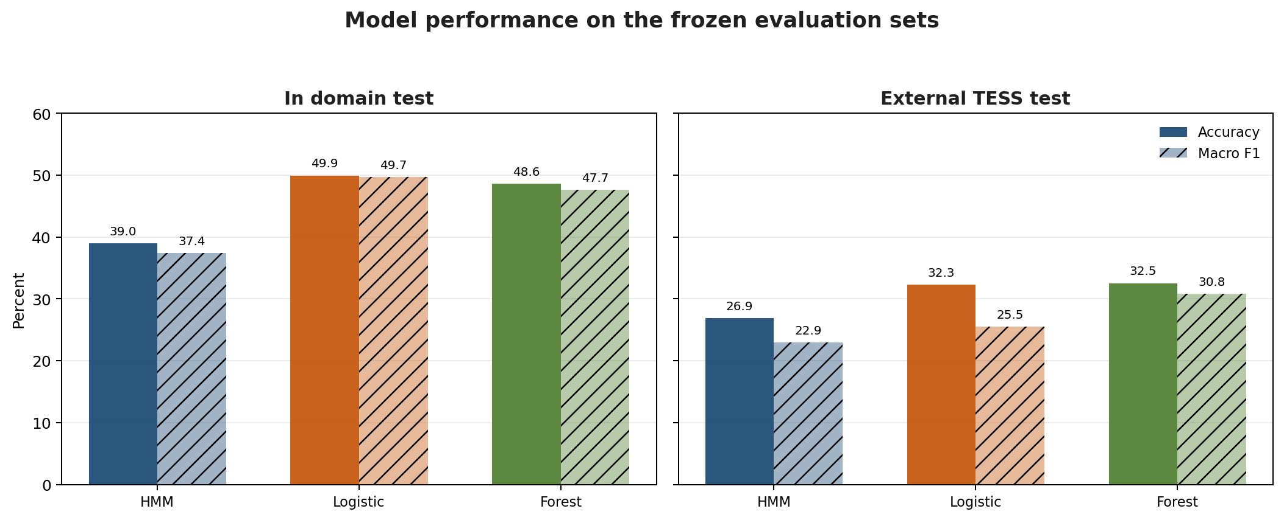
Figure 2 Accuracy and macro F1 on the in domain and external evaluation sets

4.3 Class Level Error Pattern
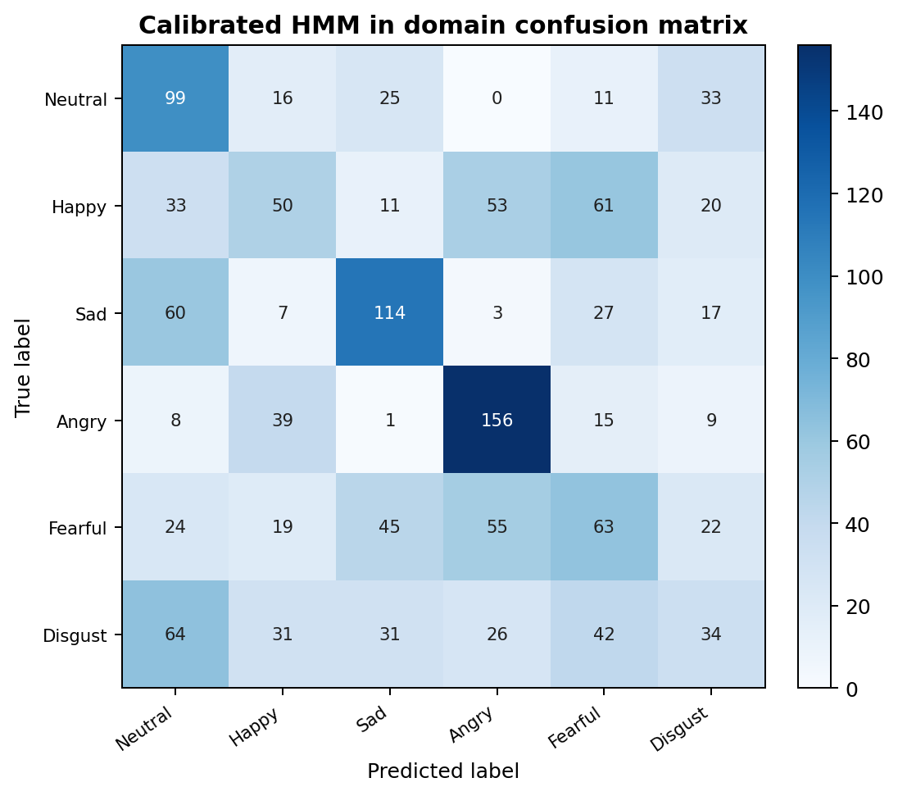
Figure 3 In domain confusion matrix for the calibrated HMM
Angry is the HMM's strongest in-domain class with 59.88% F1. Sad follows at 50.11%. Disgust is weakest at 18.73% F1, and happy and fearful are also difficult. The matrix shows several systematic errors: happy and fearful often become angry, fearful is split among sad, angry, and fearful, and disgust often becomes neutral. These errors imply that the HMM bank has not formed class-specific temporal likelihoods that separate the most acoustically overlapping categories.

4.4 External TESS Test
Model | Accuracy | Balanced accuracy | Macro F1 | ECE | Brier | Coverage
Calibrated HMM | 26.88% | 26.88% | 22.94% | 0.1662 | 0.7960 | 100%
Logistic regression | 32.29% | 32.29% | 25.50% | 0.4954 | 1.1080 | 100%
Random forest | 32.54% | 32.54% | 30.80% | 0.0280 | 0.7547 | 100%

Every method drops sharply on TESS. Random forest has the highest external accuracy and macro-F1, but 32.54% accuracy remains modest. Logistic regression retains similar accuracy but becomes severely miscalibrated, with ECE 0.4954 and Brier score 1.1080. Random forest's low ECE should not be mistaken for high predictive quality because its accuracy and Brier score remain limited; ECE can also look small when confidence is consistently low.
The HMM threshold retains 74.92% of in-domain test recordings and improves retained accuracy to 42.54%, but it retains all 2,400 TESS recordings. The validation-derived confidence threshold therefore does not detect the external domain shift. On TESS the HMM almost never recognizes sad or disgust, reaching 1.49% and 0% F1 for those classes. This is the strongest evidence against using its probability output as a general uncertainty signal.

4.5 Reverberation Ablation and Exploratory Development
A training-only RIRS reverberation ablation doubled the HMM training sequences without changing validation, test, or TESS inputs. In-domain accuracy fell from 38.97% to 37.61% and external accuracy fell from 26.88% to 25.33%. The ablation is rejected because it adds one type of acoustic variation but does not improve the emotion decision boundary.
After the v1 tests were observed, a separate training-only exploratory search added delta, acceleration, slope, duration, and four normalized temporal segments to produce a 691-value clip representation. The five-fold speaker-grouped finalist achieved 54.55% mean validation accuracy and 54.06% mean validation macro-F1, but mean training macro-F1 was 91.03%, leaving a 36.97-point gap. This is promising development evidence, not a final result. Because the v1 test has already influenced analysis, promotion requires a newly sealed speaker or dataset holdout.

5 Analysis and Discussion

5.1 Answer to the Research Question
The answer is no for the frozen v1 experiment. The calibrated HMM does not outperform either clip-summary baseline on in-domain accuracy, balanced accuracy, or macro-F1, and it also trails random forest on TESS. The temporal hypothesis is therefore rejected for this implementation and data contract. Calibration improves the HMM substantially relative to its raw score mapping, but the resulting confidence and abstention behaviour do not transfer reliably to the external dataset.

5.2 Why the Temporal Model Lost
First, the three-state diagonal Gaussian assumption is restrictive. Each class model must represent different speakers, phrases, intensities, and datasets with only three acoustic regimes and independent covariance dimensions. Emotion-related trajectories need not follow the same state ordering across speakers. A poor generative fit reduces the value of the Viterbi path even when frame order is preserved.
Second, PCA optimizes global variance rather than emotion separation. The scaler and PCA are leakage-safe, but the eight retained dimensions may preserve speaker, recording, or phonetic variance more strongly than class information. Because CREMA-D supplies 5,145 of 5,848 training recordings, its conditions also dominate the frame distribution used to fit PCA and the HMMs.
Third, the summary baselines may already capture the strongest cues in these acted corpora. Pitch level, energy, spectral distribution, and their spread can separate high-arousal expressions without requiring temporal state transitions. Logistic regression's win suggests that the decisive information is reasonably accessible in the 161 summary values. The later dynamic representation improves grouped validation by preserving movement and coarse contour while avoiding a rigid HMM state model, which supports this interpretation.
Fourth, the calibrator repairs score scale but cannot repair the underlying class likelihoods. Its improvement shows that raw class-specific scores are not directly comparable. The remaining confusion pattern shows that a discriminative mapping over six scores cannot recover information that the HMM bank failed to encode.

5.3 Domain Shift and Uncertainty
TESS differs in speakers, carrier phrases, recording setup, and performance style. All models lose accuracy, which means the development corpus does not define a stable representation of vocal affect across collection conditions. This limitation is more important than a small in-domain ranking difference. A companion used with spontaneous multilingual speech would face a wider shift than TESS, including accents, code-switching, microphones, rooms, background noise, and less exaggerated expressions.
The abstention failure is especially informative. A maximum-probability threshold measures uncertainty under the fitted mapping, not distance from the training distribution. The HMM can remain confident when every class model is wrong in a similar way. A deployment-oriented system would need explicit out-of-distribution checks, data from the target population, and threshold evaluation on multiple external domains. Low ECE alone cannot demonstrate safety, especially with only one external corpus and a small number of speakers.

5.4 Recommended Next Experiment
The next experiment should freeze the 691-value dynamic representation and choose a regularized model through speaker-grouped cross-validation on training speakers only. Model selection should consider mean macro-F1, fold spread, the train-validation gap, and dataset-specific out-of-fold performance. Calibration should then use the existing validation speakers. A final claim requires a new sealed speaker or domain holdout that has not influenced v1 or v2 decisions. The evaluation should add a reliability diagram, class-conditional calibration, and an explicit domain detector or energy-based rejection rule.

6 Limitations and Threats to Validity
Threat | Effect on interpretation | Required mitigation
Acted English speech | Results may overestimate transfer to spontaneous multilingual conversation | Collect consented target-domain speech and keep it sealed until final evaluation
Dataset imbalance | CREMA-D may dominate the representation and decision boundary | Use dataset-aware weighting or balanced speaker-grouped sampling
Only two TESS speakers | External result measures one corpus shift and has weak speaker diversity | Add another external corpus and a local target-population study
Categorical label noise | Intended labels may not match perceived or self-reported affect | Use agreement weighting, multi-rater labels, or dimensional valence and arousal
HMM specification | Three diagonal states may underfit varied trajectories | Compare more states, full or tied covariance, mixture emissions, and discriminative sequence models through grouped validation
Calibration asymmetry | Baseline and HMM ECE/Brier are not a symmetric post-hoc comparison | Calibrate every finalist on the same validation protocol
Test reuse | The observed v1 test is no longer clean for v2 selection | Declare a new sealed holdout before promoting a v2 result
Artifact revision gap | Recorded model commit does not fully bind the accepted local calibration correction | Commit the final code and regenerate metadata or archive the exact patch
Cache contract check | Data-ready can accept a cache whose feature settings changed if hash and label did not | Validate the serialized feature contract and sample rate on every cache load
No causal interpretation | Predicted acoustic class cannot establish internal emotion or explain behaviour | Limit output language and prohibit high-stakes use

The findings are valid for the frozen corpus, code path, and recorded artifacts. They do not demonstrate performance on live microphone input, spontaneous conversation, Arabic speech, clinical populations, or production hardware. The model latency values cover cached feature scoring, not the full waveform-to-response path. These boundaries should remain explicit in presentation and oral assessment.

7 Conclusion
Timbre provides a complete classical machine-learning experiment for six-class vocal-affect classification. Its strongest scientific result is negative: the proposed class-conditional HMM bank does not beat logistic regression or random forest summaries on unseen development speakers, and every method generalizes poorly to TESS. The finding is supported by a frozen manifest, speaker-disjoint splits, common features, held-out evaluation, calibration metrics, confusion matrices, and a training-only augmentation ablation.
The experiment still contributes useful engineering and research evidence. The hand-written Viterbi path is tested, score calibration improves the HMM, the data pipeline detects exact duplicate and quality problems, and the external test reveals that in-domain confidence is not a domain-shift detector. The next defensible step is to select a less rigid temporal summary model through grouped validation and evaluate it once on a newly sealed holdout. Until then, the system should be described as an experimental vocal-affect estimator rather than a reliable emotion detector.

8 Turnitin Quality and Originality Review

8.1 Institutional Report Status
An institutional Turnitin similarity report cannot be generated from this local repository. No similarity percentage or submission identifier is claimed in this document. After the university upload, the official report should be attached to the submission and reviewed for matched reference entries, common technical phrases, dataset names, and any unexpectedly long passages. Inventing a percentage before upload would be inaccurate.

8.2 Originality and Evidence Self Check
Check | Status | Evidence or action
Research question is project-specific | Complete | It names the six-class task, temporal HMM, two baselines, speaker-disjoint test, calibration, and TESS transfer
Results are traceable | Complete | Every reported number maps to the primary or augmented experiment JSON and the frozen manifest hash
External ideas are attributed | Complete | Datasets, HMM/Viterbi background, random forests, calibration, Librosa, and scikit-learn appear in References
Direct quotation | None used | Dataset and paper descriptions are paraphrased and cited
Library and project work are separated | Complete | The report identifies library-backed training and the hand-written decoder plus project integration
Negative findings are preserved | Complete | The HMM loss, TESS collapse, abstention failure, and rejected augmentation are reported
AI assistance is handled honestly | Student review required | This draft was prepared with AI-assisted code inspection and drafting; Hardik must verify it, make it reflect his own understanding, and disclose assistance under course policy
Official Turnitin evidence | Pending external upload | Attach the institution-generated report and resolve any unattributed matching before final submission

Before submission, Hardik should read the entire report aloud, reproduce the key calculations from the JSON artifacts, and remove any sentence he cannot explain without notes. This is both an originality safeguard and preparation for the individual oral assessment. Reference-list matches and standard model names are expected; unexplained copied prose is not.

References
Breiman, L. (2001). Random forests. Machine Learning, 45, 5-32. https://doi.org/10.1023/A:1010933404324
Cao, H., Cooper, D. G., Keutmann, M. K., Gur, R. C., Nenkova, A., and Verma, R. (2014). CREMA-D: Crowd-sourced emotional multimodal actors dataset. IEEE Transactions on Affective Computing, 5(4), 377-390. https://doi.org/10.1109/TAFFC.2014.2336244
Guo, C., Pleiss, G., Sun, Y., and Weinberger, K. Q. (2017). On calibration of modern neural networks. Proceedings of the 34th International Conference on Machine Learning, 70, 1321-1330. https://proceedings.mlr.press/v70/guo17a.html
Livingstone, S. R., and Russo, F. A. (2018). The Ryerson Audio-Visual Database of Emotional Speech and Song RAVDESS. PLOS ONE, 13(5), e0196391. https://doi.org/10.1371/journal.pone.0196391
McFee, B., Raffel, C., Liang, D., Ellis, D. P. W., McVicar, M., Battenberg, E., and Nieto, O. (2015). librosa: Audio and music signal analysis in Python. Proceedings of the 14th Python in Science Conference, 18-25. https://doi.org/10.25080/Majora-7b98e3ed-003
Pedregosa, F., Varoquaux, G., Gramfort, A., Michel, V., Thirion, B., Grisel, O., and others. (2011). Scikit-learn: Machine learning in Python. Journal of Machine Learning Research, 12, 2825-2830. https://jmlr.org/papers/v12/pedregosa11a.html
Pichora-Fuller, M. K., and Dupuis, K. (2020). Toronto emotional speech set TESS Version 1.0. Borealis. https://doi.org/10.5683/SP2/E8H2MF
Rabiner, L. R. (1989). A tutorial on hidden Markov models and selected applications in speech recognition. Proceedings of the IEEE, 77(2), 257-286. https://doi.org/10.1109/5.18626
Viterbi, A. J. (1967). Error bounds for convolutional codes and an asymptotically optimum decoding algorithm. IEEE Transactions on Information Theory, 13(2), 260-269. https://doi.org/10.1109/TIT.1967.1054010
Timbre Project. (2026a). Canonical six-class manifest summary and split contract. data/manifests/summary.json and data/splits/six_class_v1.json.
Timbre Project. (2026b). Primary six-class held-out evaluation. experiments/six_class_v1/metrics_20260929-154227.json.
Timbre Project. (2026c). Training-only reverberation ablation. experiments/six_class_v1_augmented/metrics_20260929-155613.json.

Appendix A Individual Analysis and Reflection Hardik Sharma
Substantive finding The temporal HMM failed to beat simpler clip-summary baselines, and its confidence threshold failed to detect the TESS domain shift.

Claim
My claim is that the current HMM architecture adds temporal complexity without adding enough class-discriminative information. Calibration makes its scores more useful in-domain, but the model is not ready to support adaptive conversation across recording domains.

Supporting Evidence
Evidence | Calibrated HMM | Best comparison | Difference
In-domain accuracy | 38.97% | 49.92% logistic | HMM lower by 10.95 points
In-domain macro F1 | 37.42% | 49.68% logistic | HMM lower by 12.27 points
TESS accuracy | 26.88% | 32.54% forest | HMM lower by 5.67 points
Abstention coverage | 74.92% in-domain | 100% on TESS | Threshold rejected no TESS clips

Reasoning
The comparison is meaningful because every model uses the same six labels, training recordings, test recordings, seed, and base acoustic measurements. The baseline summaries discard order, so their win directly weakens the hypothesis that the implemented HMM's state sequence is useful. The HMM assumptions are probably too rigid: three diagonal-Gaussian states per class must represent different speakers, phrases, intensities, and corpora. PCA also preserves large global variance, which may reflect speakers or channels more than affect.
The calibration result changes my interpretation of uncertainty. On the in-domain test, calibration raises HMM accuracy from 26.96% to 38.97% and improves its Brier score. Yet the same threshold accepts every TESS recording. Maximum class probability therefore indicates certainty inside the learned score mapping; it does not prove that a recording resembles the training distribution.

Design Trade Off and Reflection
The HMM remains valuable as an interpretable sequence experiment and demonstrates hand-written Viterbi decoding. It should not remain the preferred classifier merely because it is more elaborate. I would retain it as a research baseline, promote the 691-value dynamic representation only after grouped selection, calibrate every finalist symmetrically, and require a new sealed holdout. The most important lesson is that a negative result can improve the project when the comparison is fair and the failure changes the next design decision.

Limitations of This Analysis
This explanation is plausible rather than causal. The experiment does not isolate HMM state count, covariance type, PCA width, or dataset weighting one at a time. TESS has only two speakers, the corpora are acted English speech, and baseline calibration is asymmetric. A controlled ablation and a new external holdout are needed before concluding that temporal modelling is generally unhelpful for vocal affect.

Appendix B Individual Question and Answer Preparation
These answers are written for oral delivery. Each answer separates measured evidence from interpretation and can be expanded by naming the corresponding artifact or source file.
1 What exactly is your research question
I test whether preserving frame order with class-conditional Gaussian HMMs and hand-written Viterbi scoring improves six-class vocal-affect classification over logistic regression and random forest summaries of the same acoustic inputs. I also test whether HMM confidence calibration and abstention remain useful on external TESS data.
2 Why did you choose logistic regression and random forest
Logistic regression is a simple linear reference after feature scaling, while random forest is a nonlinear reference that captures feature interactions. Both receive 161 summary values derived from the same 23 frame features. If the HMM wins, temporal order is a plausible reason; if it loses, complexity alone is not justified.
3 What is the prediction target
One label per recording from neutral, happy, sad, angry, fearful, and disgust. I call these vocal-affect labels because audio does not reveal a person's private internal emotion. Unknown is an abstention outcome, not a seventh trained class.
4 What are the model inputs
Audio is mono at 16 kHz. Every 25 ms frame, with a 10 ms hop, produces 20 MFCC values, RMS energy, F0, and voiced proportion. The HMM receives the ordered sequence after a training-only scaler and PCA reduce 23 values to eight. Baselines receive seven distribution summaries of each feature, for 161 inputs.
5 How did you prevent speaker leakage
Each speaker belongs to exactly one development partition within its dataset. CREMA-D has 63 train, 14 validation, and 14 test speakers; RAVDESS has 16, 4, and 4. The split file records the exact speakers and clips, and TESS is permanently external_test.
6 What is hand written and what uses libraries
The log-space Viterbi decoder with dynamic programming and backpointers is hand-written. Project code also handles manifest construction, duplicate screening, leakage controls, normalized scoring, calibration integration, abstention selection, and evaluation. Librosa computes acoustic features, scikit-learn provides scaling, PCA, logistic regression, random forest, and calibration, and hmmlearn fits HMM parameters.
7 What is the main result
The HMM did not beat the baselines. In-domain accuracy was 38.97% for the HMM, 49.92% for logistic regression, and 48.64% for random forest. Macro-F1 showed the same ranking. On TESS, random forest was best at 32.54% accuracy, but all models were weak.
8 Did calibration help
Yes, within the HMM pipeline. In-domain accuracy rose from 26.96% with raw softmaxed Viterbi scores to 38.97% after the validation-fitted score calibrator. ECE improved from 0.1022 to 0.0739 and Brier score from 0.8139 to 0.7376. Calibration repaired score comparability, but it did not solve domain shift.
9 What failed about abstention
The threshold of 0.2358 was selected on validation with at least 80% coverage. It retained about 75% of the in-domain test and improved retained accuracy, but it retained 100% of TESS. Maximum probability was not an out-of-distribution detector.
10 What data quality problems did you find
The manifest excluded six files involved in conflicting-label exact duplicates, one same-label duplicate, and one nearly silent clip. Remaining risks include acted labels, rater disagreement, repeated phrases, corpus imbalance, microphone cues, and limited external speaker diversity.
11 What would you change next
I would freeze the dynamic 691-value representation, select a regularized classifier through speaker-grouped cross-validation, calibrate all finalists symmetrically, add explicit domain rejection, and evaluate once on a newly sealed holdout. I would also make cache loading validate the complete feature contract.
12 What was your individual analysis contribution
My appendix analyzes the central negative finding: the temporal HMM loses to simpler summaries and its abstention rule misses external shift. I connect the measured gaps to the model assumptions, explain why calibration helps without detecting domain shift, and turn that evidence into a concrete next experimental design. I also state the limits of that explanation rather than presenting it as causal proof.

Appendix C Reproducibility and Evidence Map

Reproduction Commands
make data-ready
make train-all
make test-models
make augmentation-ablation WORKERS=4
make ci
The primary report values were not regenerated during report authoring. Existing frozen artifacts were inspected, the complete cache was validated, and the repository quality suite was rerun. On 2 October 2026, data-ready confirmed 10,890 caches and make ci completed Ruff plus 150 tests.

Evidence Map
Evidence | Repository path | Use in this report
Canonical corpus summary | data/manifests/summary.json | Dataset counts, exclusions, quality thresholds, hash
Recording inventory | data/manifests/all_clips.csv | Speaker, label, split, audio quality, license, and SHA-256 per clip
Frozen split | data/splits/six_class_v1.json | Exact clip and speaker partitions
Model metadata | models/meta.json | Feature contract, PCA, HMM settings, environment, code revision
Baseline metadata | models/baselines/meta.json | Summary statistics, feature width, training data, environment
Calibration metadata | models/calibration.json | Validation metrics and abstention threshold
Primary evaluation | experiments/six_class_v1/metrics_20260929-154227.json | All in-domain and TESS results
Augmentation ablation | experiments/six_class_v1_augmented/metrics_20260929-155613.json | Rejected reverberation comparison
Dynamic finalist | experiments/dynamic_finalist_v2/summary.json | Exploratory grouped-validation result only
Implementation | src/timbre and scripts | Feature extraction, HMM, Viterbi, calibration, metrics, and data controls

Verification Snapshot
Check | Result | Scope
Data readiness | Passed | 5,848 train, 1,318 validation, 1,324 test, and 2,400 external caches
Static analysis | Ruff passed | src, scripts, and tests
Automated tests | 150 passed | Data, features, models, evaluation, API, frontend runtime, and workflows
Patch formatting | Passed | No whitespace errors in current diff

