Steps to run person JPA application in intellij idea.

Create a new project from existing source

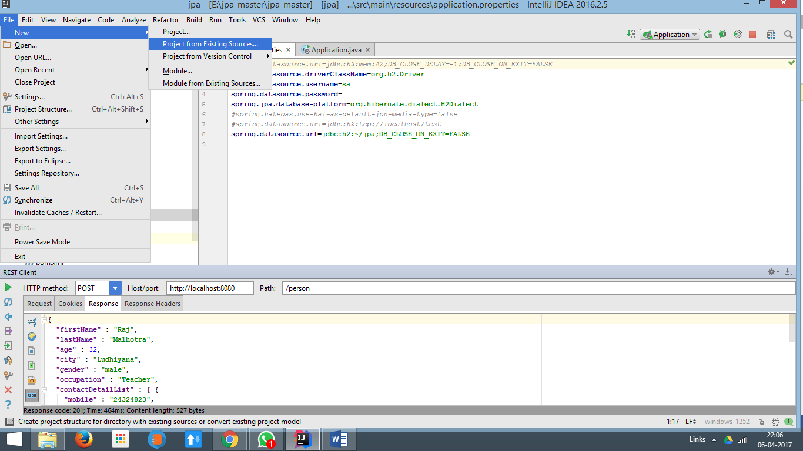

Path to pom.xml file in next step.

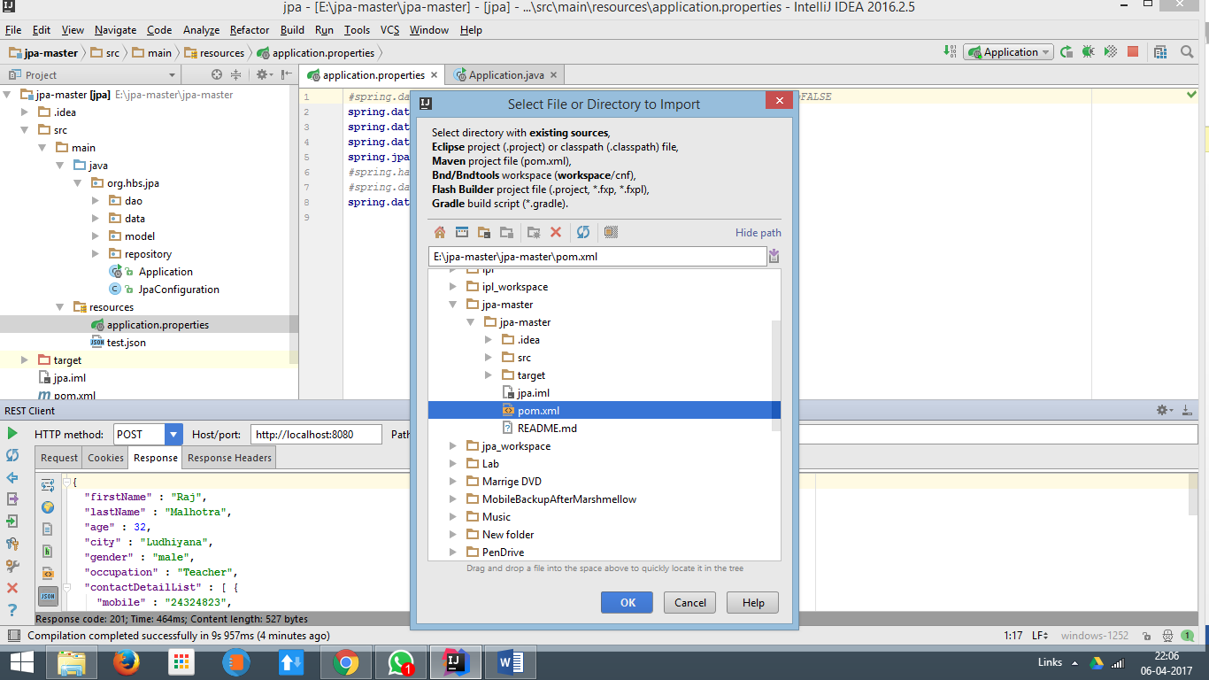

Run application from Application.java

For GET Request GET localhost:8080/person

For POST request POST localhost:8080/person

Content-type needs to be set to application/json

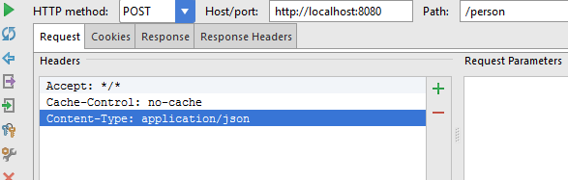

For post request object test.json can be used from project.

For connecting to H2 database,

Can go to browser and type <http://localhost:8080/console>

As database url provide

