7 AI Tools – Professional Aviation Prompts
Generated airport visuals and ready-to-use prompts
This document contains seven professional prompts designed for different AI image-generation tools, along with the generated aviation-themed visuals. The prompts focus on modern airports, young travellers, airline marketing, social-media campaigns and presentation materials.

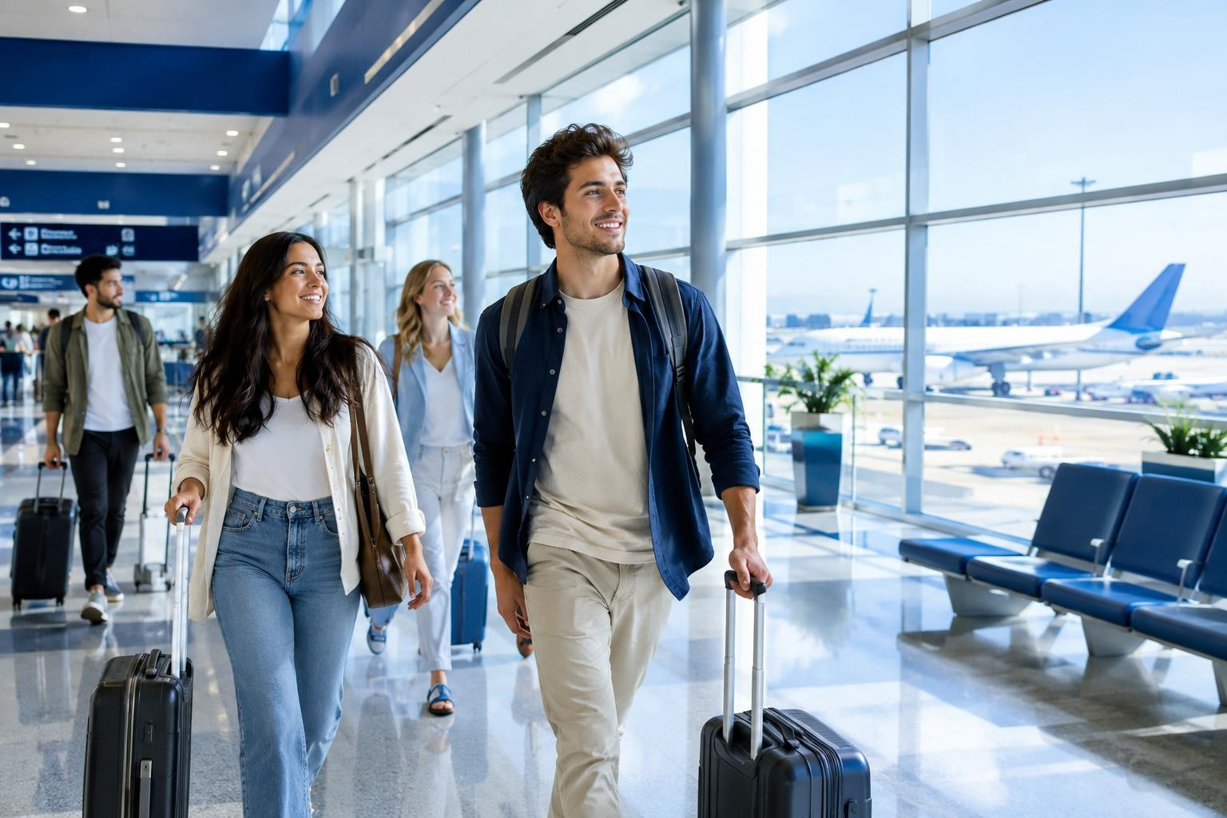
ChatGPT Images

Generated aviation visual

Professional Prompt:

Create a professional promotional photograph of young international travellers walking through a modern airport terminal. Show realistic passengers with carry-on luggage, large glass windows, aircraft visible in the background, elegant blue-and-white interior design, natural daylight, clean premium atmosphere, realistic photography, cinematic composition, high detail, suitable for an airline marketing campaign. No airline logos, no brand names, no watermark.

Midjourney
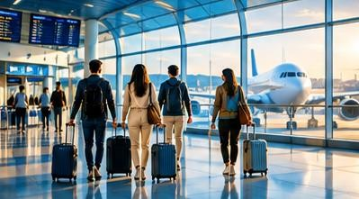

Generated aviation visual

Professional Prompt:

Luxury modern airport terminal, diverse young travellers with stylish carry-on luggage walking toward departure gates, panoramic glass architecture, aircraft visible through windows, sophisticated blue and white interior, soft natural sunlight, premium aviation advertising photography, cinematic lighting, realistic skin and clothing textures, dynamic composition, shallow depth of field, ultra-detailed, commercial campaign aesthetic --ar 16:9

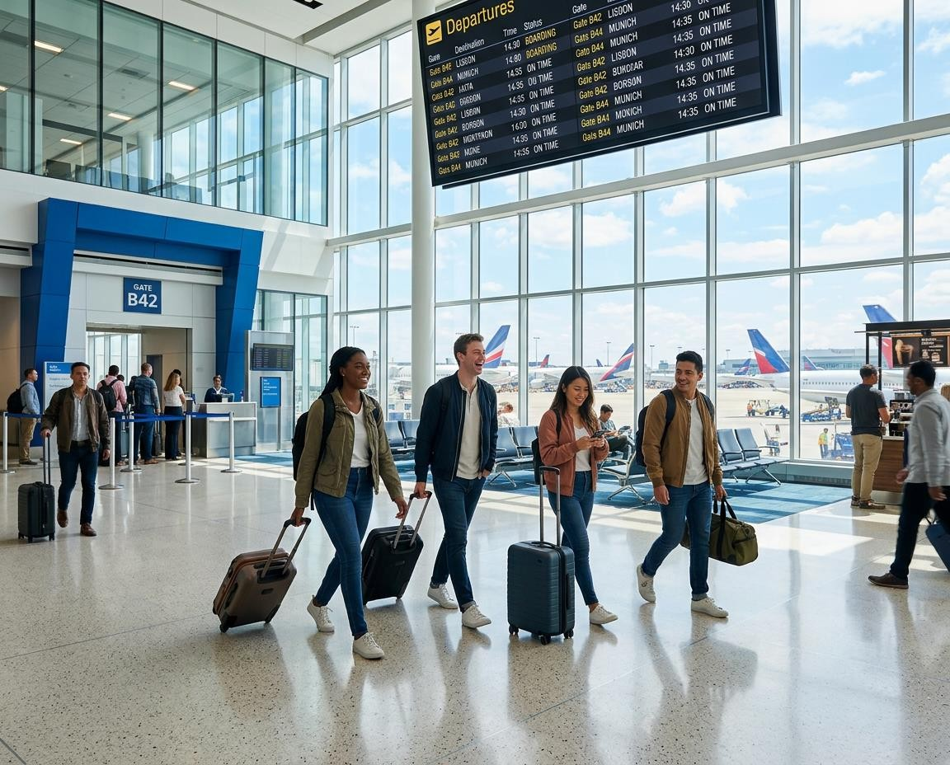
Adobe Firefly

Generated aviation visual

Professional Prompt:

Generate a photorealistic airline marketing image showing young travellers inside a spacious contemporary airport terminal. Include diverse passengers, luggage, digital departure screens without readable brand names, aircraft outside large windows, blue-and-white architectural elements, bright natural lighting, polished floors and a welcoming premium atmosphere. Professional commercial photography, clean composition, realistic details, suitable for an airport social-media campaign. No logos or watermark.

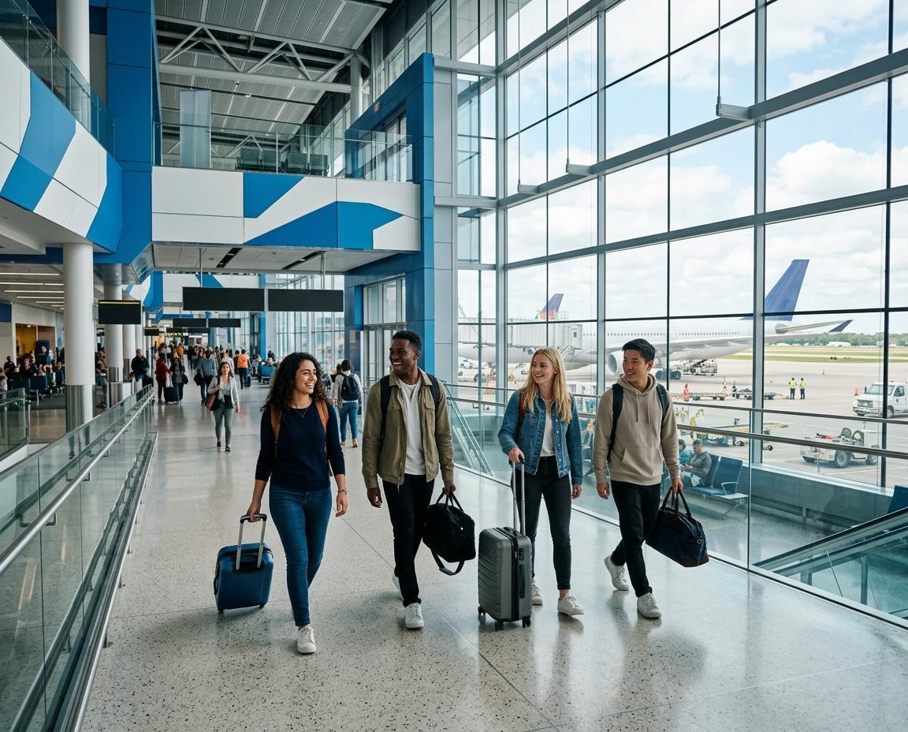
Leonardo AI

Generated aviation visual

Professional Prompt:

Create a high-end photorealistic aviation promotional scene inside a modern international airport. Show 4–5 young adult travellers from different backgrounds carrying backpacks and small suitcases, walking confidently through a bright terminal. Use contemporary blue-and-white architecture, large glass windows, subtle reflections, aircraft parked outside, realistic natural daylight, professional travel photography, balanced composition, crisp details, premium brand campaign style. Avoid logos, text and watermarks.

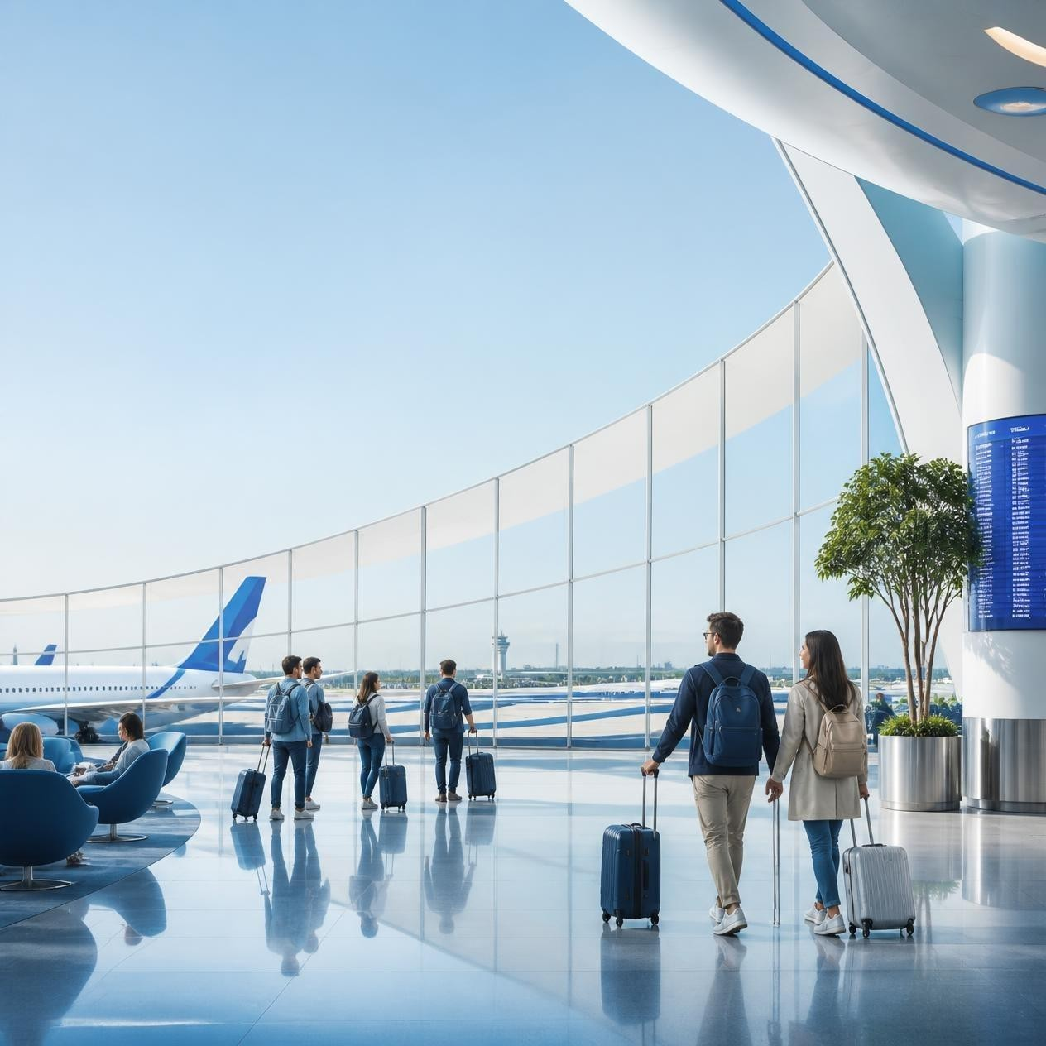
Ideogram

Generated aviation visual

Professional Prompt:
Design a professional airport travel campaign poster featuring young international travelers in a futuristic but realistic airport terminal. Show elegant blue-and-white architecture, aircraft visible through panoramic windows, natural daylight, luggage and subtle aviation elements. Leave clean negative space at the top for a headline and at the bottom for campaign information. Premium corporate photography, realistic people, polished composition, high detail, modern travel advertising aesthetic. Do not add random text, logos or watermarks.

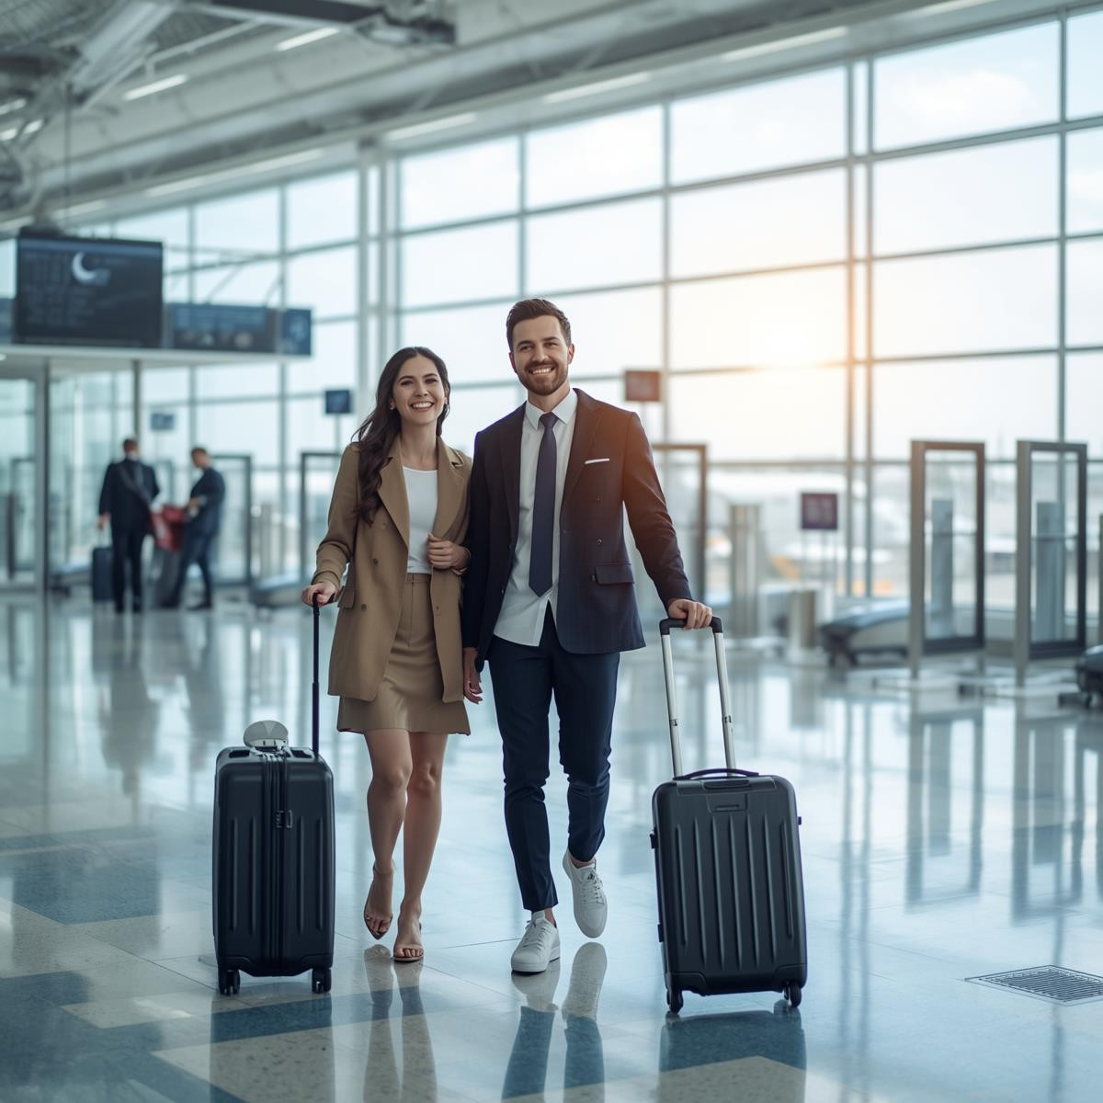
Canva

Generated aviation visual

Professional Prompt:
Create a clean professional aviation social-media promotional visual showing happy young travellers inside a modern international airport. Use a blue-and-white colour palette, bright natural lighting, glass architecture, departure gates and an aircraft visible in the background. Keep the composition uncluttered with generous empty space for adding campaign text later. Modern corporate travel aesthetic, realistic photography, premium and welcoming mood, suitable for an Instagram post or presentation slide. No logos or watermark.

Google Gemini

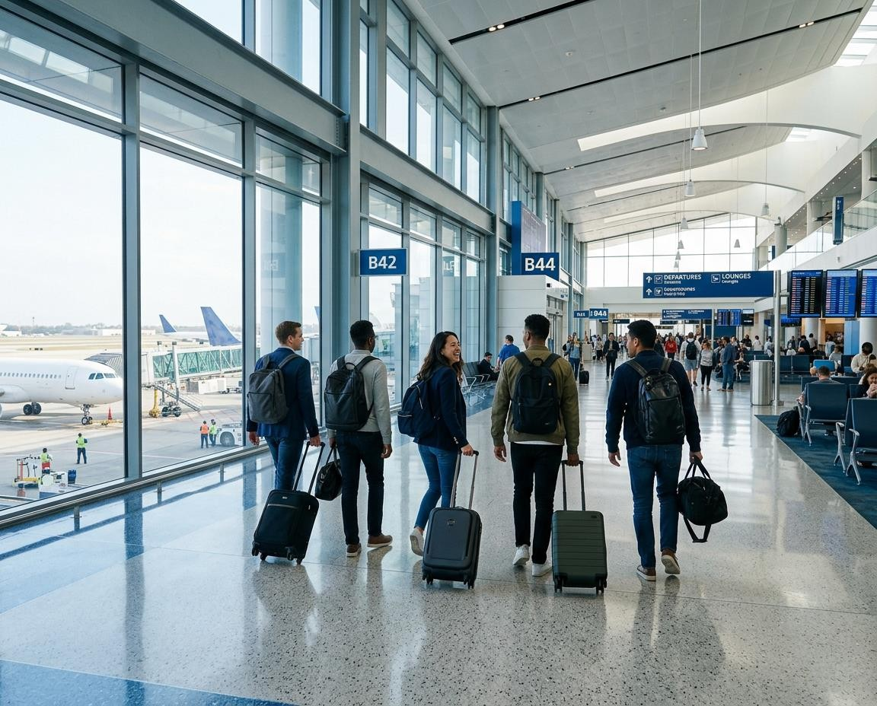
Generated aviation visual

Professional Prompt:

Create a realistic professional promotional image for the aviation industry. Show a group of young travellers arriving at a spacious modern international airport terminal with carry-on luggage. Include large windows overlooking commercial aircraft, contemporary blue-and-white interiors, natural morning light and subtle reflections. The scene should communicate travel, comfort, technology and excitement while remaining realistic and professional. Use a wide landscape composition suitable for an airline presentation. Exclude airline logos, brand names, unnecessary text and watermarks.

