DVB Subtitle Explorer

Overview
This is a very niche application to allow you to examine a DVB Compliant Transport stream for DVB Bitmap subtitles. It is born out of a need to try to work out why some subtitles were not working on specific set top boxes on a project I was working on. We were able to use DVB Analyser from DVB Control and it was incredibly useful but that’s a bit expensive so I wanted to try to write something, and in the process, learn more about how the subtitles work.
The code is entirely based up on the excellent Subtitle Edit source code from https://www.nikse.dk/ which, in my opinion, is up there with Media Info and VLC in the playout engineers open source toolkit (sitting on top of Notepad++).
The application references the DVB Subtitle specification document from
https://dvb.org/wp-content/uploads/2019/12/a009_dvb_bitmap_subtitles_nov_2017.pdf

Usage
Click the “Open File” button. If you wish to create a basic HTML report for each PID, ensure that the “Create HTML Report Files” checkbox before you open the file – the report files will be created in the same folder as the source file.
Once you select a file, the application will read it all and populate all the Subtitle PIDs in the tree view.
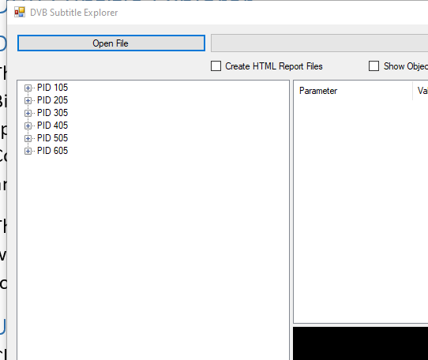
You can expand out each PID to see all subtitle PES packets with their Presentation Time Stamp, clicking on one of the Packets will show the subtitle rendered;
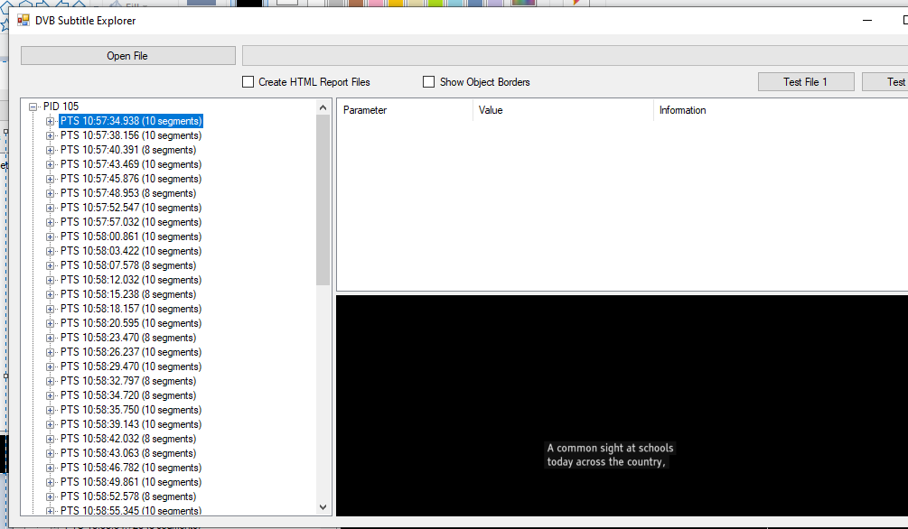
If you expand out the PES packet in the tree view, you can view the segments sent to construct the subtitle. These will vary depending on the specifics of the subtitling playout. For example, in the packet below, there are 10 segments
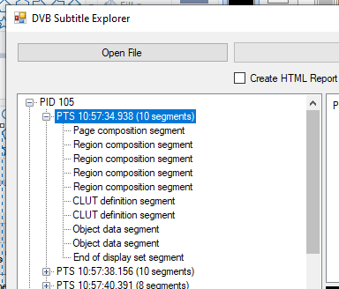
With 4 regions, 2 Colour Lookup Tables and 2 Objects defined, but other packets may have more or less. For example, most playouts send a clear screen with only 2 segments (just the page composition segment and the end of display set);
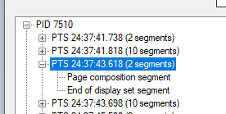

Exploring the Segments
If you click on a segment in the tree view, more information will be populated in the right hand panes. Additionally note that the Information column shows a shortened version of the notes in the DVB specification, clicking on a row will show the full shortened version in the box below;
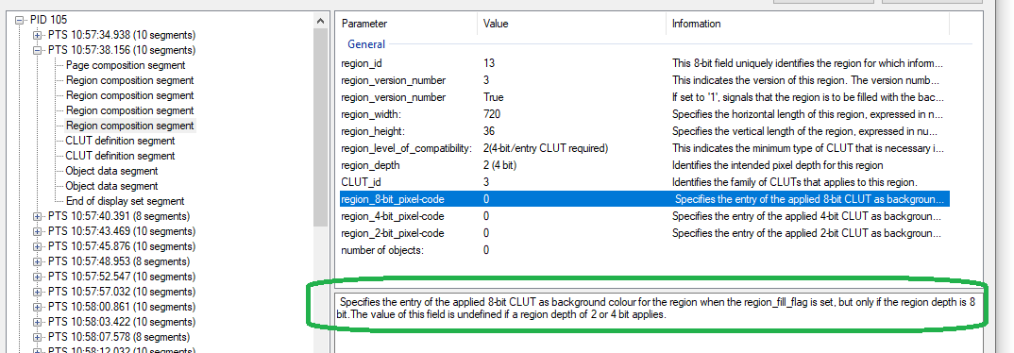

Page Composition Segment;
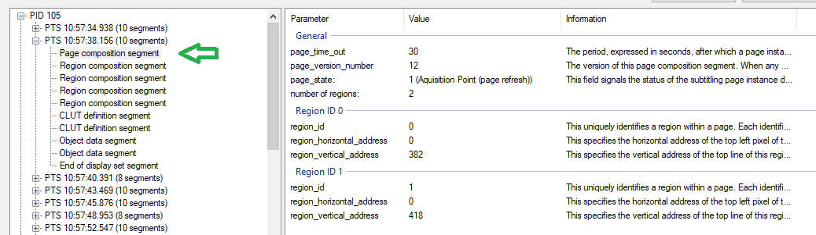
Note that this page defines 2 regions with their position set at (X/Y) 0/382 and 0/418 – i.e. the two lines of text. The region IDs refer to the region composition segments below.

Region Composition segment;
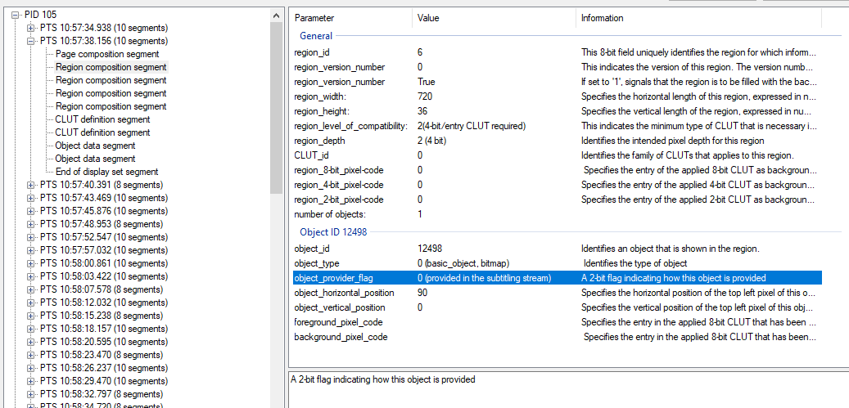
Note that this region references an Object (which is defined later) and that the region height and width are set. The position of this region on the page was already set in the page composition segment. Note also that there are 4 regions defined but the page composition segment only referenced the first 2. The last 2 are not used and also do not contain any objects either.

CLUT definition segment;
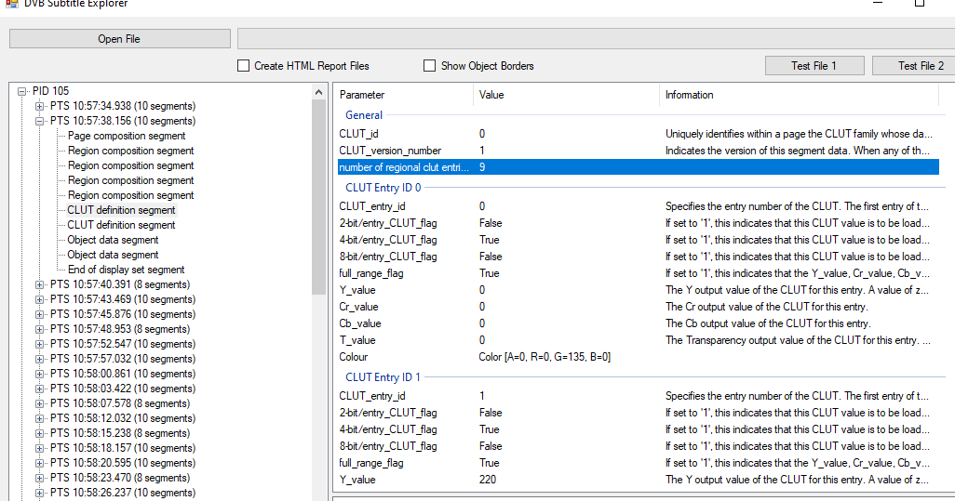
The Colour Lookup Table is a pallet of colours and here, 2 are defined.

Object data segment;
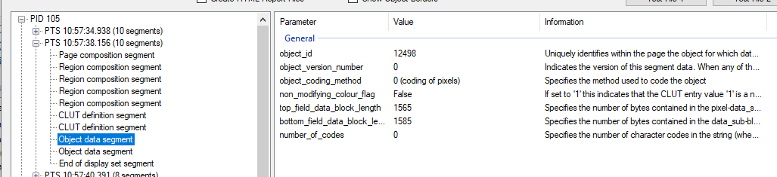
The object data segment holds the actual bitmap data. There’s not too much metadata and the raw data is not shown in the GUI.

End of Display set segment
The End of Display set segment contains no data and is just a marker.

“Show Object Borders”
If you check this checkbox, it will add a border to each object to allow you to better see how it sits in the region, e.g. here 4 objects are used…
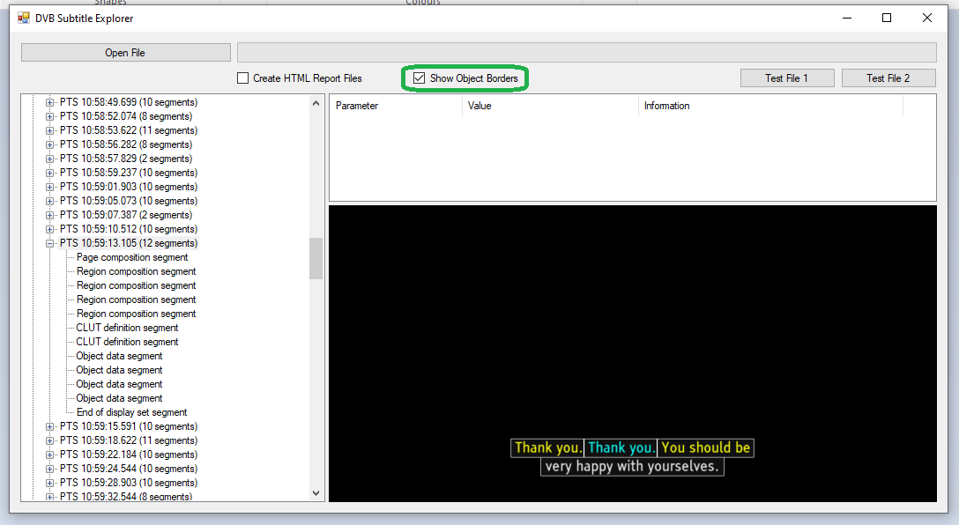
You can also see that this page was constructed from 2 (active) regions, one for each line. The first region holds 3 of the objects;
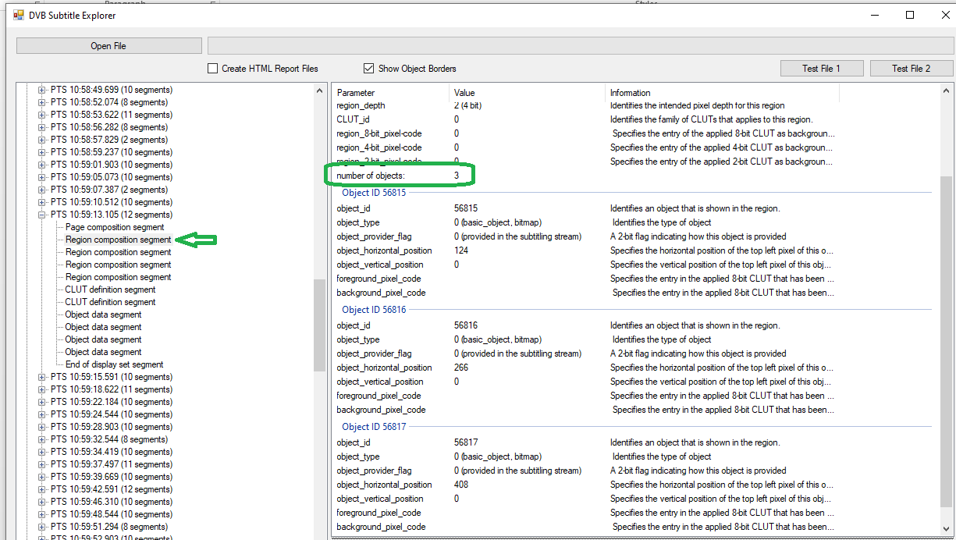
With the 2nd Region holding the last object;
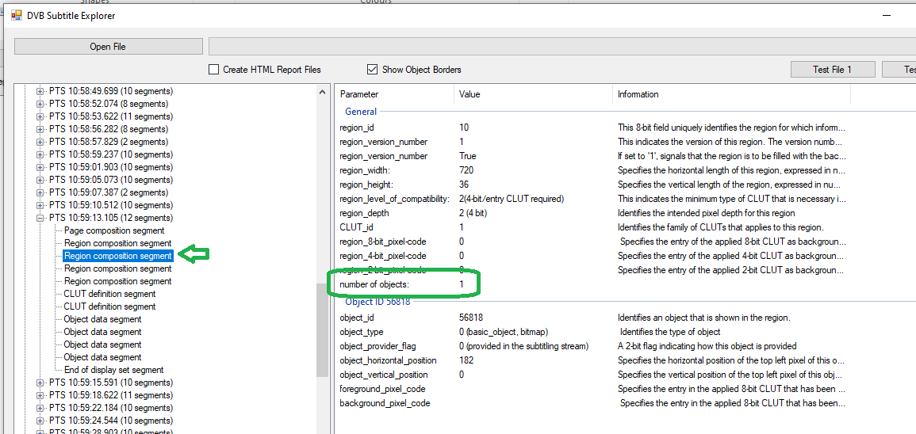
The remaining 2 regions carry no objects;
