参考：
https://github.com/JessYanCoding/MVPArms/wiki#1.6
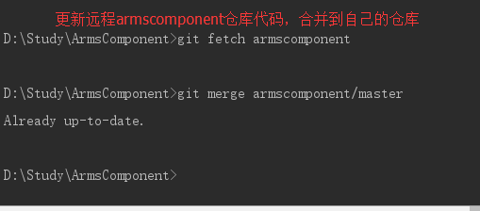

git remote add armscomponent https://github.com/JessYanCoding/ArmsComponent.git

git remote -v

git fetch armscomponent

git merge armscomponent/master --allow-unrelated-histories

