C:\>npm install -g cordova
(如果不能找到npm，则需配置环境变量。C:\Users\username\AppData\Roaming\npm)

Create the App
Go to the directory where you maintain your source code, and run a command such as the following:
$ cordova create hello com.example.hello HelloWorld

Add Platforms
All subsequent commands need to be run within the project's directory, or any subdirectories within its scope:
$ cd hello
Before you can build the project, you need to specify a set of target platforms. Your ability to run these commands depends on whether your machine supports each SDK, and whether you have already installed each SDK. Run any of these from a Mac:
$ cordova platform add ios
$ cordova platform add amazon-fireos
$ cordova platform add android
$ cordova platform add blackberry10
$ cordova platform add firefoxos
Run any of these from a Windows machine, where wp refers to different versions of the Windows Phone operating system:
$ cordova platform add wp8
$ cordova platform add windows
$ cordova platform add amazon-fireos
$ cordova platform add android
$ cordova platform add blackberry10
$ cordova platform add firefoxos
Run this to check your current set of platforms:
$ cordova platforms ls
Run either of the following synonymous commands to remove a platform:
$ cordova platform remove blackberry10
$ cordova platform rm amazon-fireos
$ cordova platform rm android
Run the following command to iteratively build the project:
$ cordova build
This generates platform-specific code within the project's platforms subdirectory. You can optionally limit the scope of each build to specific platforms:
$ cordova build ios
The cordova build command is a shorthand for the following, which in this example is also targeted to a single platform:
$ cordova prepare ios
$ cordova compile ios

Test the App on an Emulator or Device
SDKs for mobile platforms often come bundled with emulators that execute a device image, so that you can launch the app from the home screen and see how it interacts with many platform features. Run a command such as the following to rebuild the app and view it within a specific platform's emulator:
$ cordova emulate android
Alternately, you can plug the handset into your computer and test the app directly:
$ cordova run android

Use plugin ls (or plugin list, or plugin by itself) to view currently installed plugins. Each displays by its identifier:
$ cordova plugin ls # or 'plugin list'
[ 'cordova-plugin-console' ]
To remove a plugin, refer to it by the same identifier that appears in the listing. For example, here is how you would remove support for a debug console from a release version:
$ cordova plugin rm cordova-plugin-console
$ cordova plugin remove cordova-plugin-console # same
You can batch-remove or add plugins by specifying more than one argument for each command:
$ cordova plugin add cordova-plugin-console cordova-plugin-device

If the plugin is not registered at registry.cordova.io but is located in another git repository, you can specify an alternate URL:
$ cordova plugin add https://github.com/apache/cordova-plugin-console.git

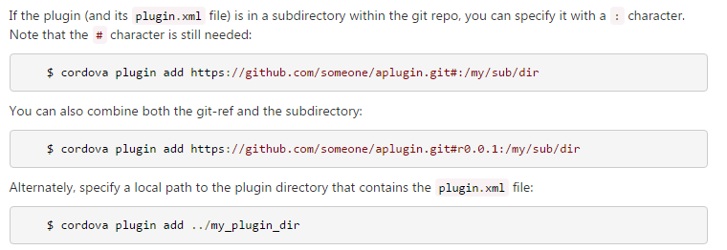Updating Cordova and Your Project
After installing the cordova utility, you can always update it to the latest version by running the following command:
$ sudo npm update -g cordova
Use this syntax to install a specific version:
$ sudo npm install -g cordova@3.1.0-0.2.0

Build the Project
If you are using the CLI in development, the project directory's top-level www directory contains the source files. Run any of these within the project directory to rebuild the app:
$ cordova build # build all platforms that were added
$ cordova build android # build debug for only Android
$ cordova build android --debug # build debug for only Android
$ cordova build android --release # build release for only Android

