**HW1**

姓名：張名翔

學號：r10631026

ER Diagram Software：TerraER

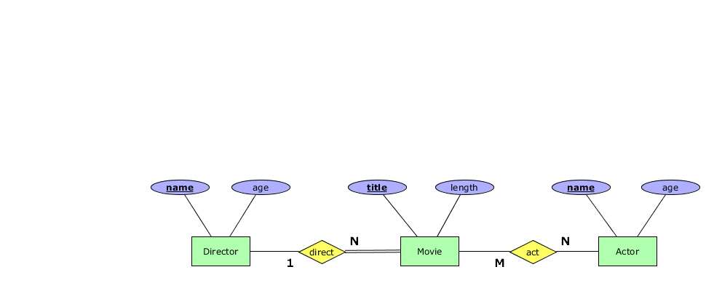

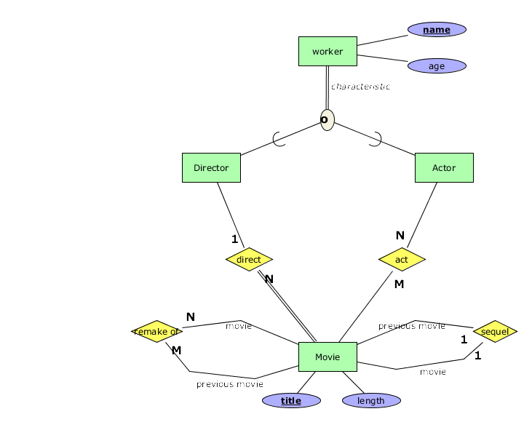

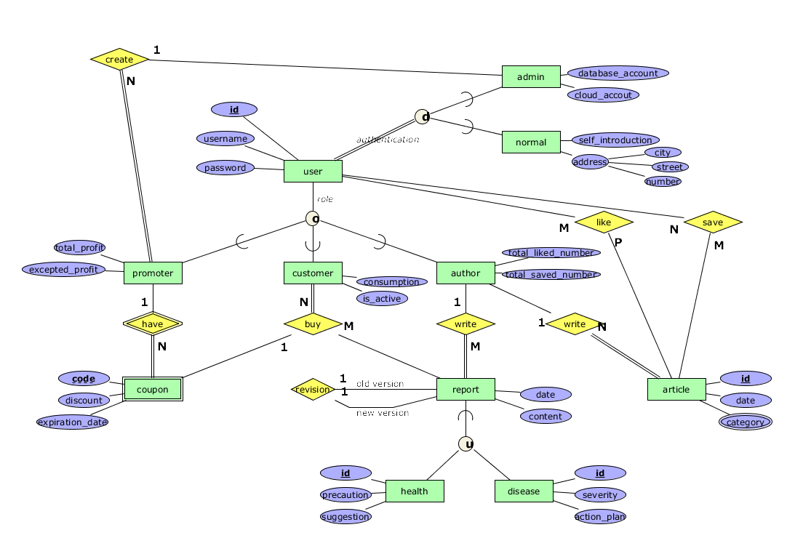

Database name: Healthy

The database is builded to manage an APP with some report and article created by expert.

* + Entity and Attribute
    - The user has id, username and password. The id is key attribute.
    - The promoter has id, username, password, total profit and excepted profit. The id is key attribute.
    - The customer has id, username, password, consumption and whether it is active. The id is key attribute.
    - The author has id, username, password, total liked number, total saved number. The id is key attribute.
    - The cupon has code, discount, expiration date. The code is partial key attribute.
    - The report has id and date, content. The id is key attribute.
    - The article has id, date and category. The category might have multiple value. The id is key attribute.
    - The admin has id, username, password, database account and cloud account. The id is key attribute.
    - The normal has id, username, password, self introduction and address which including city, street and number. The id is key attribute.
    - The health has id, precaution and suggestion. The id is key attribute.
    - The disease has id, severity and action plan. The id is key attribute.
  + Relationship
    - The user could like and save multiple articles.
    - The article could be liked and saved by multiple users.
    - The author could write multiple articles and multiple reports.
    - The article and report can be written by an author.
    - The report might be the revision of a previous report. (Recursive)
    - The customer can buy multiple reports and able to use a coupon to have a discount.
    - The report can be bought by mutiple customer.
    - The promoter might have multiple coupon.
    - The coupon belong to single promoter.
    - The admin can create multiple promoters.
    - The promoter is created by an admin.
  + Specialization
    - The user could either have three type of roles, which are promoter, customer and author.
    - The user have one of the authentications, which are admin or normal.
  + Union
    - The report is the union of health and report.
  + Constraints
    - The coupon can only been identified by which promoter have it and its code. (weakly entity)
    - The customer must buy report.
    - The report and article must been writen by author.
    - The user must have the authentication.
    - The promoter must created by an admin.