### Text-Analytics

The Purpose of the tool is to create application which will compare the Map available against the provided EDI guidelines document.

It must generate the difference report which will tell segments/fields to be added/deleted from the map provided.

###Getting Started:

Download the zip znd files of the project from the clone or download option.

###Prerequisites:

1)Spyder:

Below is the link for step-by-step downloading of Anaconda fo this.

2)Any modern browser.

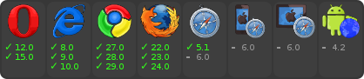

###Installing:

1)First try to run xmltojsonfin.py file on spyder.You will get a json file.

2)Then run pdftojson(fin).py .Another json file will be created.

3)After that download the zip folder and extract it named jsoncompare.

4)A video demo for running the comparison and mapping of two files(json) has been step by step demonstrated.

5)Some pdf files and xml files has also been uploaded .You can use them for running our code.