Trigger Engine Illustrated User Guide
A simple picture guide to help you understand what each screen does and why it matters.
What this app is: Think of it like a smart market helper. It watches many clues at once, scores ideas, explains why they look strong or weak, and helps you focus your attention.

How to use this guide
- Look at the screenshot first.
- Read the short explanation under it.
- Use the “Why it matters” note to understand the value of that feature.
- Remember: the app helps you make decisions, but it does not guarantee a winning trade.

1. Main Scanner Home Page
This is the first screen to check. It shows the market regime, your live status, and the ranked setups that the scanner believes are most important right now.
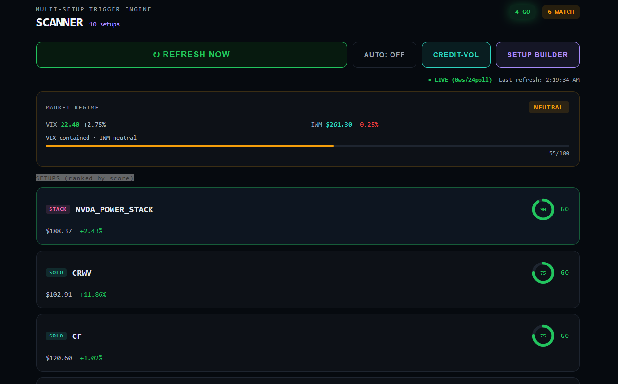
Home page of the Trigger Engine. The top section gives status and controls. The middle shows market regime. The setup cards below are ranked by score.
What to look at first
- Refresh Now / Auto: use these to update the scanner.
- LIVE badge: tells you whether the app is receiving fresh market data.
- Market Regime: shows if conditions are stronger, neutral, or weaker.
- Top setup cards: start with the highest scores first.
Why it matters: This page saves time. Instead of checking many names one by one, the scanner brings the strongest ideas to the top.

2. Setup Cards and Ranking
Each setup card is like a report card. It tells you which symbol is being watched, what kind of setup it is, and how strong it looks right now.
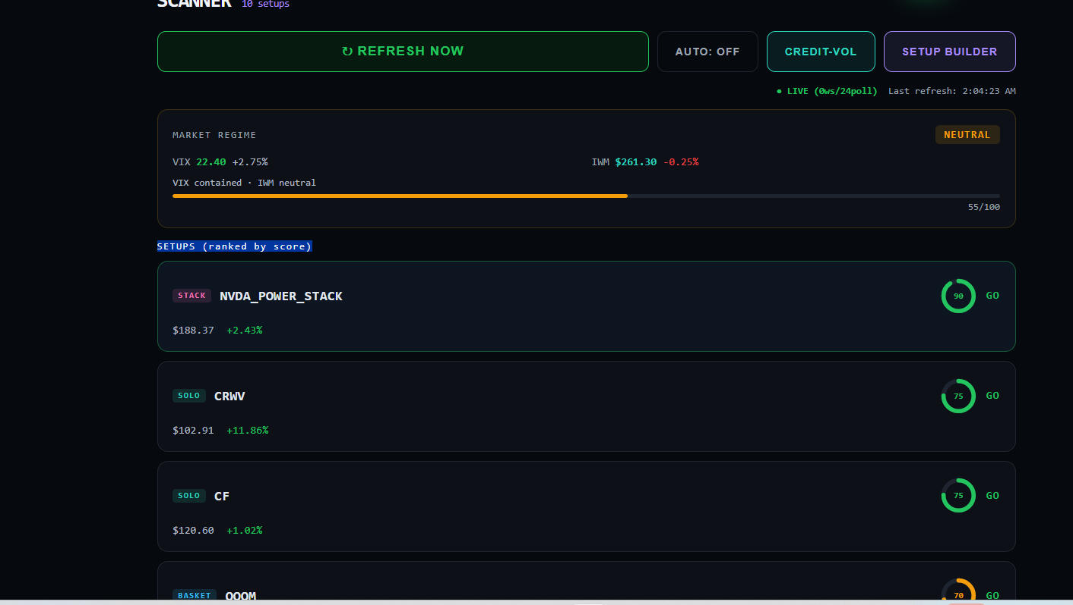
The setup list ranked by score. Higher scores are usually more interesting, but you should still click into the details before acting.
How to read a setup card
- Score ring: higher usually means more positive signals are lined up.
- GO / WATCH / NO TRADE: tells you whether the setup looks actionable or only worth monitoring.
- Price and daily move: shows where the symbol is now and how it has moved today.
- Setup tag: tells you the setup family, such as STACK, SOLO, or BASKET.
Why it matters: Ranking helps you compare ideas quickly. You do not have to treat every symbol the same.

3. Detail View and Chart
When you open a setup, the detail page gives the bigger story. You can see the chart, the score, the signal blocks, and the condition gates that explain why the setup got its result.
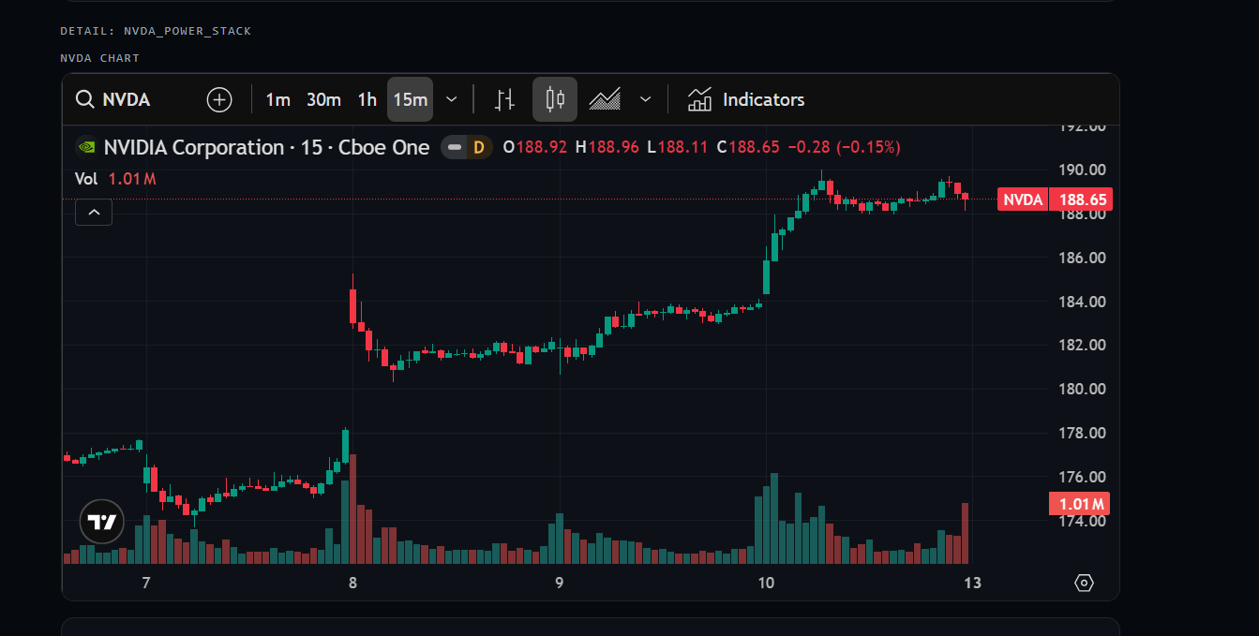
A detail page with the TradingView chart at the top. This lets you see what price is doing right now before you read the rules below.
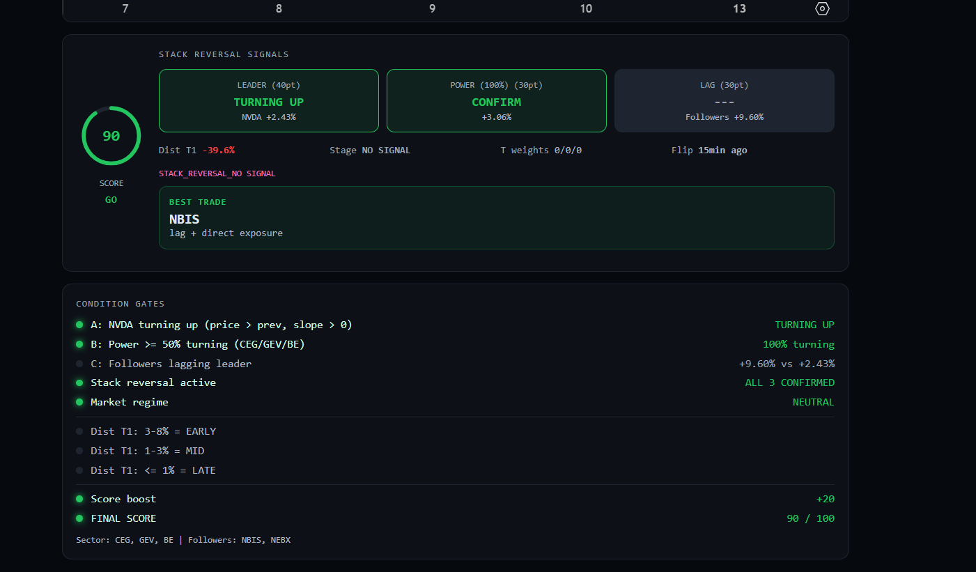
The stack-reversal detail section. The score, leader, power, lag, best trade, and condition gates explain what the engine is seeing.
How to use the detail page
- Chart: use it to see whether price looks calm, stretched, or reversing.
- Leader / Power / Lag: these boxes show which parts of the setup are confirming and which are not.
- Best Trade: shows the strongest follower or exposure choice the engine prefers.
- Condition Gates: this is the checklist of rules the setup must pass.
Why it matters: The detail page turns a score into an explanation. You can see what is helping the setup and what is holding it back.

4. Condition Gates and Score
The condition gates are one of the most important parts of the app. They show the exact rules behind the signal. If a gate is missing, the setup may look weaker even when the score is high.
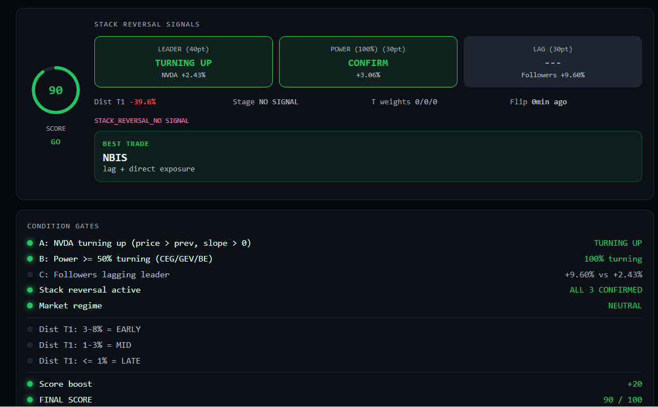
The signal and condition-gate section for a stack reversal setup. Green items are confirming. Gray items are not yet confirmed.
Simple way to think about gates
- Green means a rule is passing.
- Gray means the rule is not active yet.
- The final score combines many of these checks together.
- A setup can look exciting, but the gates show whether it is actually lined up the right way.
Why it matters: Gates help stop guessing. Instead of “I like the chart,” you can ask, “Which rules are actually confirmed?”

5. Alert Log
Alerts are the app’s way of tapping you on the shoulder. They are useful because they let you know when something deserves attention without staring at the screen all day.
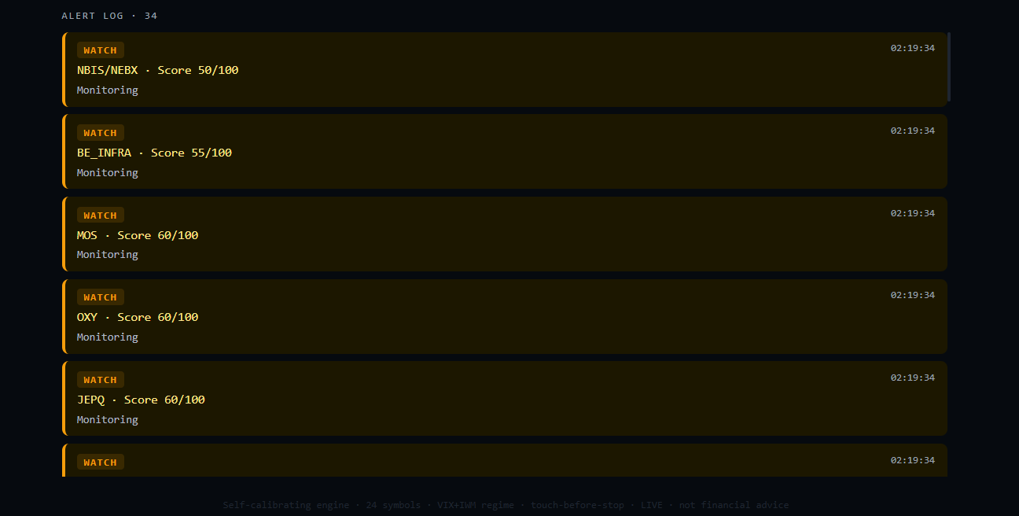
The alert log. Each entry tells you the symbol or setup, the score, and the time the alert happened.
How to use alerts
- WATCH means “monitor this.”
- A higher score usually means the app sees more things lining up.
- Use alerts to decide what to inspect next, not as blind trade commands.
- Check whether the same symbol keeps appearing. That may tell you a trend is building.
Why it matters: Alerts save attention. They help the app work like a helper instead of just a static report.

6. Premium Scanner (Credit-Vol Page)
This page is built for premium-selling ideas. It checks if options are rich enough, if risk looks manageable, and whether the setup fits a premium strategy such as selling puts.
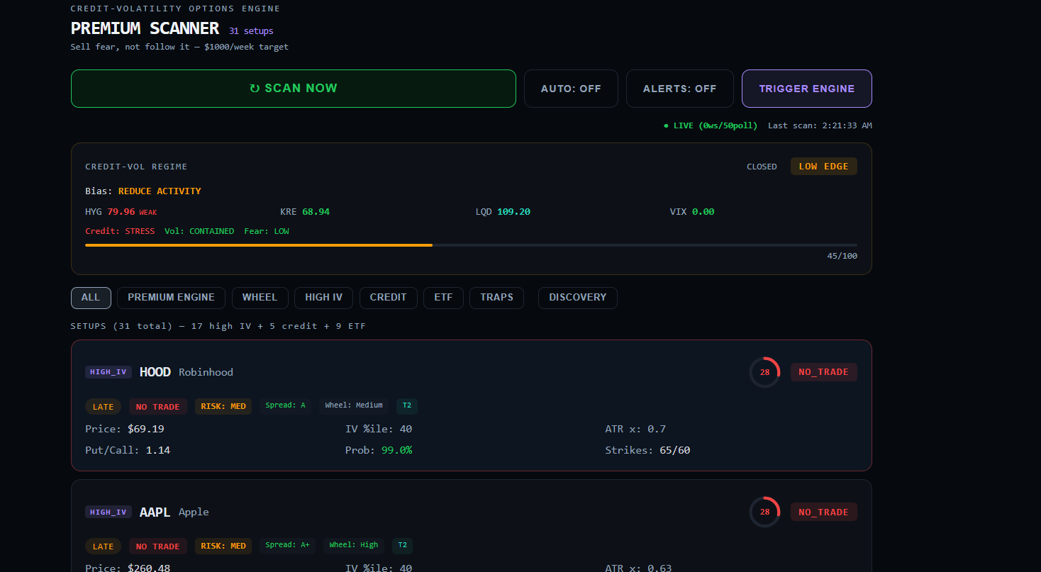
The Premium Scanner page. At the top you see the credit-vol regime. Below that are filters and option setup cards.
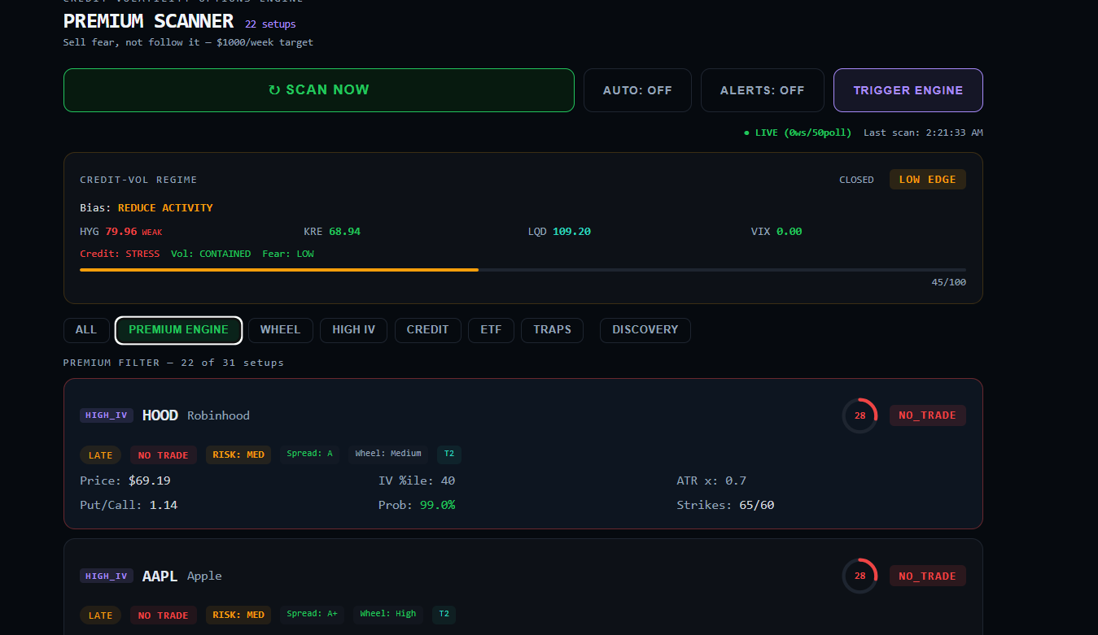
A filtered Premium Scanner view. This helps you narrow the page to Premium Engine, Wheel, High IV, Credit, ETF, Traps, or Discovery.
What to look at on this page
- Credit-Vol Regime: tells you if the premium environment looks strong or weak.
- Filters: help you narrow the scanner to the style you want.
- Setup cards: show risk level, IV percentile, probability, ATR, and strikes.
- NO TRADE does not mean bad stock forever — it means the setup is not attractive right now.
Why it matters: This page helps you avoid taking premium trades just because the percentage looks high. It adds context about risk and trade quality.

7. Premium Scanner Detail Panel
The right-side detail panel gives the explanation for the selected option setup. It shows the recommendation, probability layer, put ladder, diagnostics, and score trace.
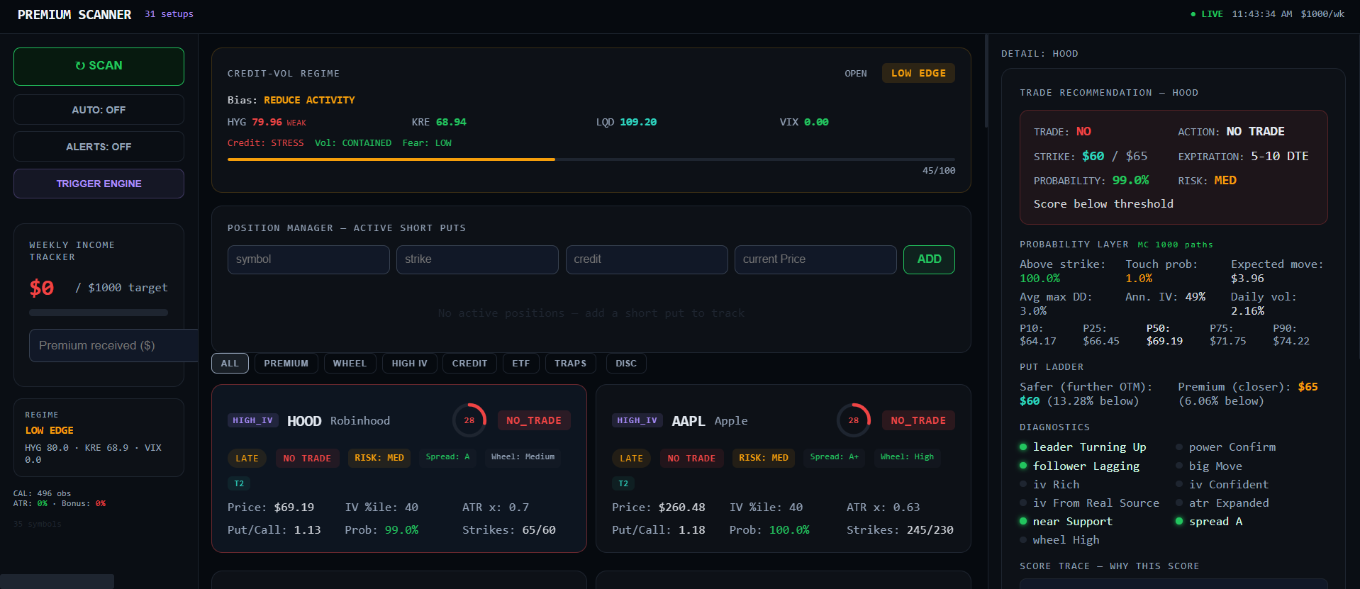
Premium Scanner with the detail panel open. The right side explains the selected symbol in more depth while the middle area still shows the full scanner.
Best items to read in the detail panel
- Trade Recommendation: quick answer for trade, action, strike, expiration, and risk.
- Probability Layer: shows above-strike odds, touch probability, expected move, and drawdown.
- Put Ladder: compares a safer farther-out strike with a closer premium strike.
- Diagnostics and Score Trace: explain what helped or hurt the setup.
Why it matters: This panel helps you understand why an idea is being rejected or accepted before you place a trade.

8. Quick Tips and Simple Definitions
Term | Simple meaning
GO | The setup looks strong enough to consider acting on.
WATCH | Interesting, but not strong enough yet.
NO TRADE | The app thinks this is not a good setup right now.
IV Rank / IV %ile | Shows whether options are cheap or expensive compared with normal.
Touch Probability | Chance price may hit a danger level before expiration.
Drawdown | How painful the trade could feel while it is open.
Support | A price area where buyers may appear.
Resistance | A price area where sellers may appear.

A safe way to use the app
- Start on the main scanner.
- Click the strongest setup.
- Read the detail page and condition gates.
- Use alerts to save time.
- Use the Premium Scanner only when you want premium-selling ideas.
- Remember that the app is a helper, not a guarantee.
Final reminder: The best way to use the app is to let it narrow your choices, then use the details and charts to decide whether the setup really fits your plan.

