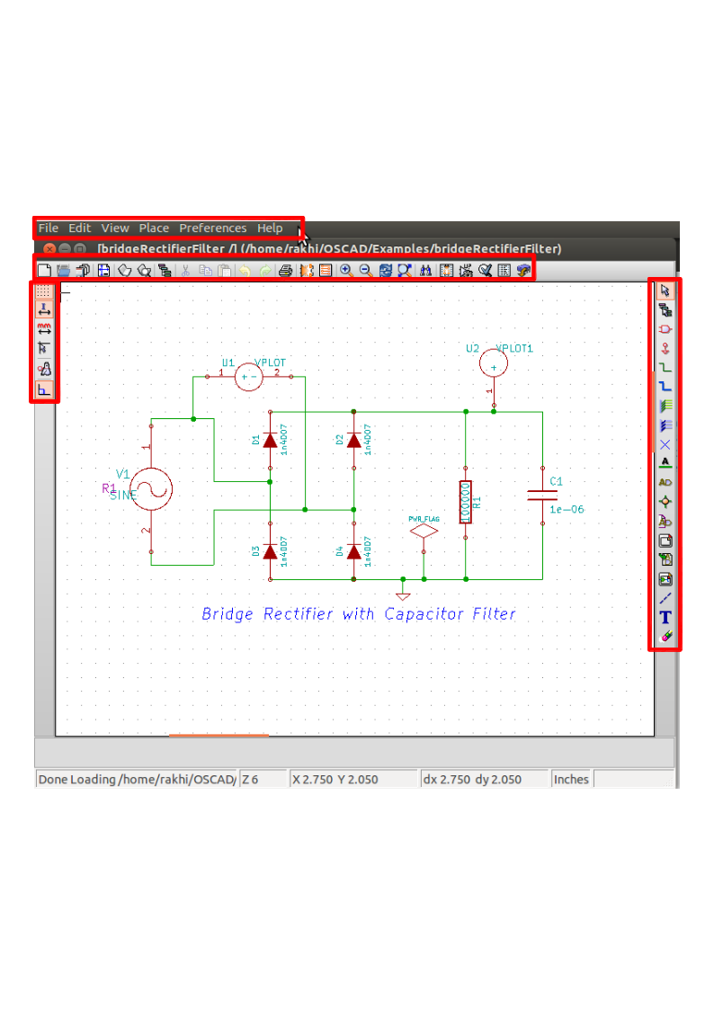
Toolbar on left
Toolbar on right
Toolbar on top
Schematic editor
Top menu bar

