**LAB NO.5: HTML DOM**

**TASKS:**

1. **Using the Shopping List files from the previous videos update the shopping list app to do the following:  
   A. If you click on the list item, it toggles the .done  class on and off.  
   B. Add buttons next to each list item to delete the item when clicked on its corresponding delete button.  
   C. BONUS: When adding a new list item, it automatically adds the delete button next to it (*hint: be sure to check if new items are clickable too!*)**

**CSS:**

body{margin:0;min-width:300px}.header{background-color:teal;padding:30px 40px;alignitems:center;textalign:center}.header:after{content:"";display:table;clear:both}input{width:85%;padding:10px 15px;margin:8px 0;display:inline-block;border:1px solid #ccc;border-radius:3px 0 0 3px;float:left;font-size:16px}.addbtn{padding:10px;width:15%;background-color:#a1c5c5;color:#000;float:left;border:1px solid #a1c5c5;margin:8px 0;text- align:center;font-size:16px;cursor:pointer;transition:.3s;border-radius:0 3px 3px 0}.addbtn:hover{background-color:#e6e6fa}ul{margin:0;padding:0}ul li{cursor:pointer;position:relative;padding:12px 8px 12px 50px;list-style-type:none;background:#eee;font-size:18px;transition:.2s;-webkit-user-select:none;-moz-user-select:none;-ms-user-select:none;user-select:none}ul li:nth-child(odd){background:#e6e6fa}ul li:hover{background:#a1c5c5}ul li.checked{background:#6d9c9c;color:#fff;text-decoration:line-through}ul li.checked::before{content:'';position:absolute;border-color:#fff;border-style:solid;border-width:0 2px 2px 0;top:10px;left:16px;transform:rotate(45deg);height:15px;width:7px}.close{position:absolute;right:0;top:0;padding:12px 16px 12px 16px}.close:hover{background-color:#e6e6fa;color:#000}

1. **Write a JavaScript program to calculate the volume of a sphere.**

**CSS:**

|  |
| --- |
| div{border:1px solid #000;border-radius:4px;width:fit-content;margin:100px;padding:30px;font-family:'century gothic';margin-left:32%}input[type=text]{width:50%;padding:8px 10px;margin:10px 0;display:inline-block;border:1px solid #008b8b;border-radius:2px;box-sizing:border-box}.btn{width:30%;padding:8px 15px;margin:7px 0;border:1px solid #008b8b;background-color:#008b8b;color:#fff;border-radius:2px;box-sizing:border-box} |

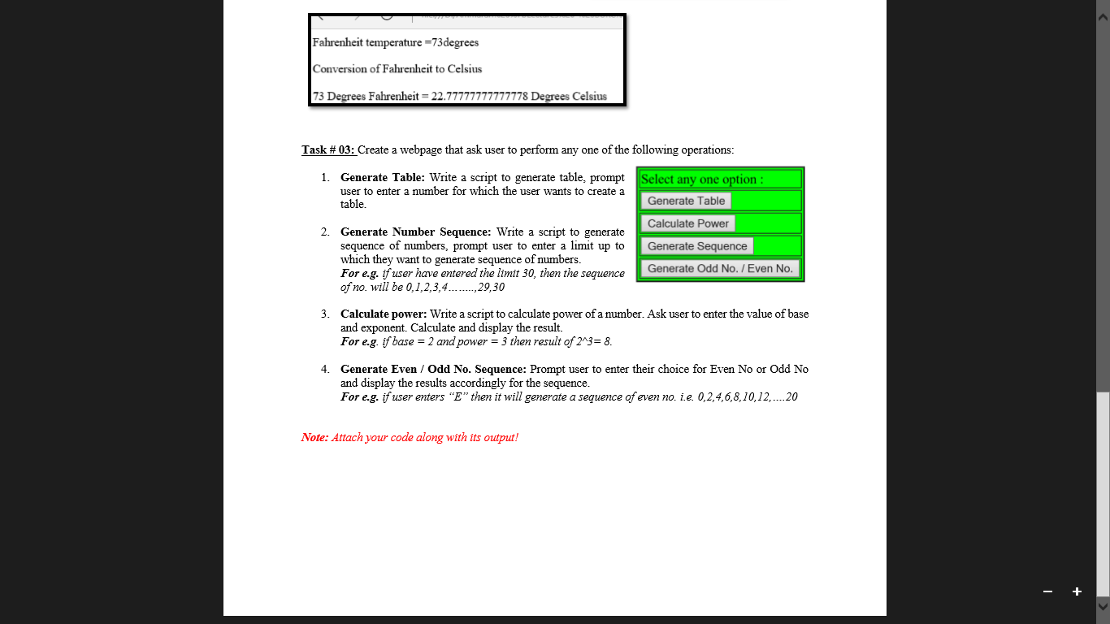

**GENERATE TABLE:**

**CSS:**

body{font-family:'century gothic';font-size:large;display:flex;flex-wrap:wrap}.container{width:400px;height:400px;margin-top:50px;margin-left:450px;border-radius:10px;background-color:#9cc09c}#btn{width:80px;padding:8px 20px;margin:20px;border:1px solid #2e2e41;background-color:#2e2e41;border-radius:5px;color:#fff;box-sizing:border-box}input{width:200px;padding:8px 20px;margin:20px;border:1px solid #ccc;background-color:#eee6e6;border-radius:5px;box-sizing:border-box}.tableprint{padding-left:150px;padding-top:30px}

**GENERATE POWER:**

**CSS:**

body{font-family:'century gothic';font-size:large;display:flex;flex-wrap:wrap}.container{width:400px;height:300px;margin-top:100px;margin-left:450px;border-radius:10px;background-color:#9cc09c}input[type=button]{width:80px;padding:8px 20px;margin-left:px;border:1px solid #2e2e41;background-color:#2e2e41;border-radius:5px;color:#fff;font-family:'century gothic';box-sizing:border-box}input{width:200px;padding:8px 15px;border:1px solid #ccc;background-color:#eee6e6;border-radius:5px;box-sizing:border-box}.children{margin-left:100px}

**GENERATE SEQUENCE:**

**CSS:**

body{font-family:'century gothic';font-size:large;display:flex;flex-wrap:wrap}.container{width:600px;height:300px;margin-top:100px;margin-left:370px;border-radius:10px;background-color:#9cc09c}input[type=button]{width:80px;padding:8px 20px;margin-left:px;border:1px solid #2e2e41;background-color:#2e2e41;border-radius:5px;color:#fff;font-family:'century gothic';box-sizing:border-box}input{width:200px;padding:8px 15px;border:1px solid #ccc;background-color:#eee6e6;border-radius:5px;box-sizing:border-box}.children{margin-left:190px}textarea[type=number]{width:97%;padding:8px 20px;margin:10px;display:inline-block;border:1px solid #ccc;background-color:#eee6e6;border-radius:2px;box-sizing:border-box}

**GENERATE EVEN/ODD SEQUENCE:**

**CSS:**

body{font-family:'century gothic';font-size:large;display:flex;flex-wrap:wrap}.container{width:600px;height:300px;margin-top:100px;margin-left:370px;border-radius:10px;background-color:#9cc09c}input[type=button]{width:80px;padding:8px 20px;margin-left:px;border:1px solid #2e2e41;background-color:#2e2e41;border-radius:5px;color:#fff;font-family:'century gothic';box-sizing:border-box}input{width:200px;padding:8px 15px;border:1px solid #ccc;background-color:#eee6e6;border-radius:5px;box-sizing:border-box}.children{margin-left:190px}textarea[type=number]{width:97%;padding:8px 20px;margin:10px;display:inline-block;border:1px solid #ccc;background-color:#eee6e6;border-radius:2px;box-sizing:border-box}

1. **Create a document with multiple tabs with background color. Upon hover background color of the document is changed accordingly.**

**CSS:**

.box{width:100px;height:100px}.container{padding-left:350px;padding-top:100px;display:flex;height:400px;flex-wrap:wrap}#h{border-radius:15px 0 0 15px}#m{border-radius:0 15px 15px 0}h1{color:#fff;padding-left:35px;padding-top:10px}.btn{background-color:#4c588d;padding:8px;width:100px;border:1px solid #4c588d;border-radius:4px;box-shadow:2px 2px 5px #9cc0c2}a{text-decoration:none;color:#fff}.back{margin-left:600px;margin-top:20px;width:fit-content;display:flex}

