**Hareen Patel**

**ECE 3220 Lab 6**

**March 16, 2017**

**https://github.com/hareenpatel/ECE-3220**

**Objective:**

The purpose of this lab was to familiarize our self with the C++ environment. Also another objective of the lab was to work with constructors and destructors.

**Results**

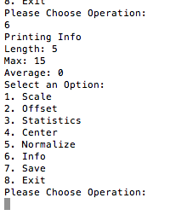

**I am printing the info of the document**

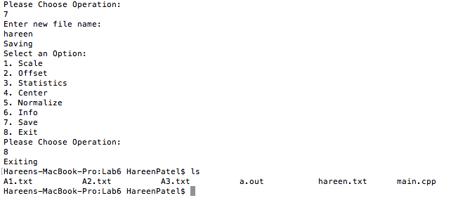

**showing the save feature is working along with new names.**

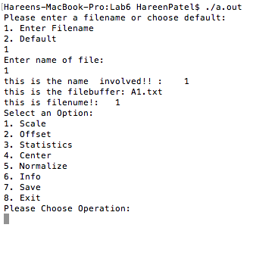

**showing the default case.**

**Discussion:**

This lab became very difficult at one point. I was getting a Seg fault but then I realized the problem. The problem was a very simple and not difficult to fix but it was causing the whole program to seg fault. The command line arguments seem to not want to work for some reason, the code was copied directly over from the previous lab and worked fine on there but doesn’t seem to work on here.

**Conclusion:**

Overall the lab was very helpful with learning how to code in C++ and getting an introduction to contractors and destructors.