<http://www.interviewquestionspdf.com/2017/01/top-95-aws-vpc-interview-questions.html>

**(MUST on VPC)**

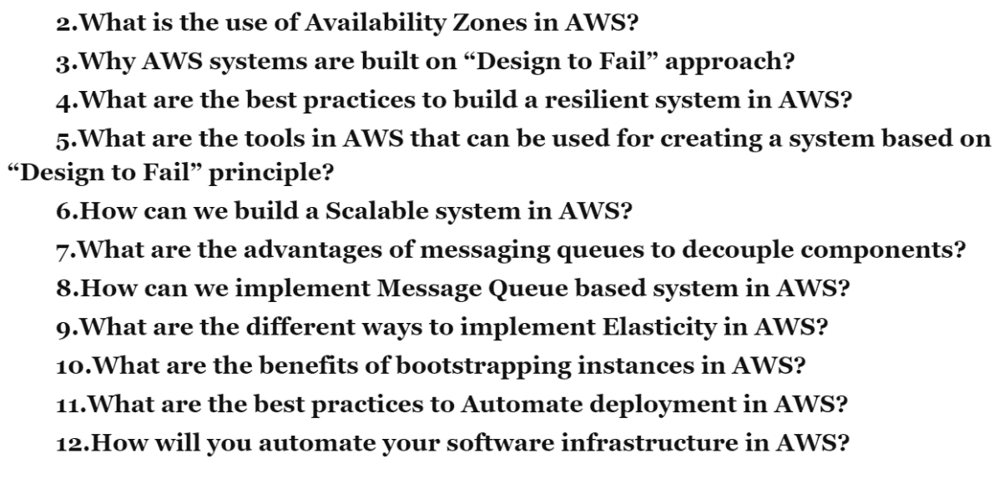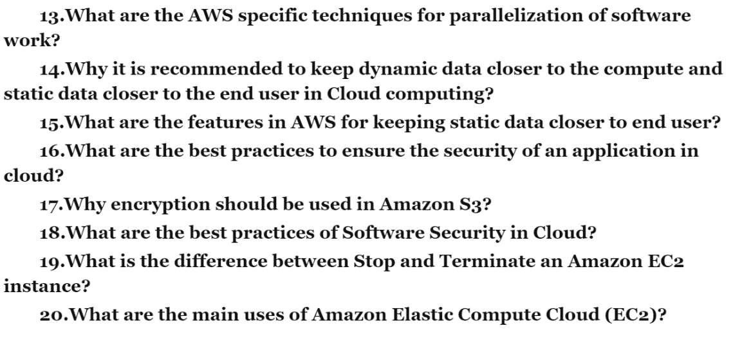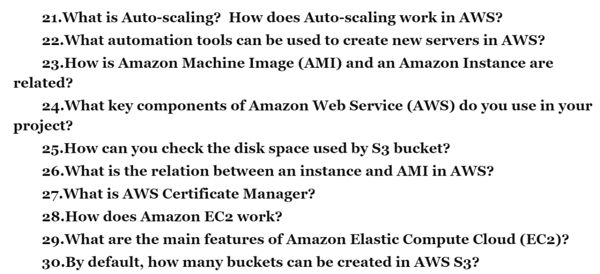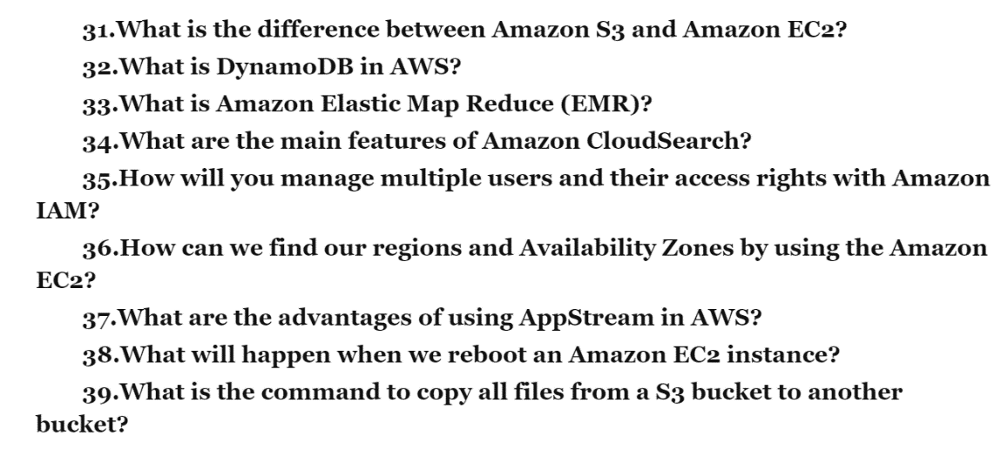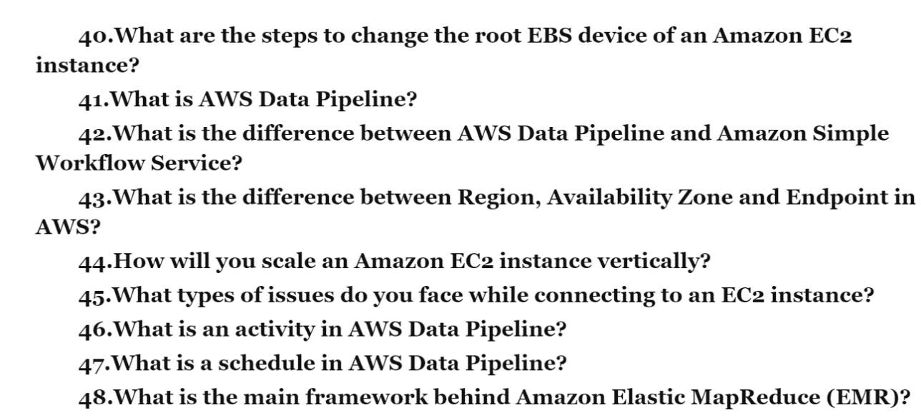

In this article, you will find all Amazon web services interview questions and answer:

Q. Explain what is AWS?  
AWS stands for Amazon Web Service; it is a collection of remote computing services also known as cloud computing platform. This new realm of cloud computing is also known as IaaS or Infrastructure as a Service.

Q. Mention what are the key components of AWS?  
The key components of AWS are  
• Route 53: A DNS web service  
• Simple E-mail Service: It allows sending e-mail using RESTFUL API call or via regular SMTP  
• Identity and Access Management: It provides enhanced security and identity management for your AWS account  
• Simple Storage Device or (S3): It is a storage device and the most widely used AWS service  
• Elastic Compute Cloud (EC2): It provides on-demand computing resources for hosting applications. It is very useful in case of unpredictable workloads  
• Elastic Block Store (EBS): It provides persistent storage volumes that attach to EC2 to allow you to persist data past the lifespan of a single EC2  
• CloudWatch: To monitor AWS resources, It allows administrators to view and collect key Also, one can set a notification alarm in case of trouble.

Q. Explain what is S3?  
S3 stands for Simple Storage Service. You can use S3 interface to store and retrieve any amount of data, at any time and from anywhere on the web. For S3, the payment model is “pay as you go”.

Q. Explain what is AMI?  
AMI stands for Amazon Machine Image. It’s a template that provides the information (an operating system, an application server, and applications) required to launch an instance, which is a copy of the AMI running as a virtual server in the cloud. You can launch instances from as many different AMIs as you need.

Q. Mention what is the relation between an instance and AMI?  
From a single AMI, you can launch multiple types of instances. An instance type defines the hardware of the host computer used for your instance. Each instance type provides different compute and memory capabilities. Once you launch an instance, it looks like a traditional host, and we can interact with it as we would with any computer.

Q. What does an AMI include?  
An AMI includes the following things  
• A template for the root volume for the instance  
• Launch permissions decide which AWS accounts can avail the AMI to launch instances  
• A block device mapping that determines the volumes to attach to the instance when it is launched

Q. How can you send a request to Amazon S3?  
Amazon S3 is a REST service, you can send a request by using the REST API or the AWS SDK wrapper libraries that wrap the underlying Amazon S3 REST API.

Q. What is Amazon EC2 service  
Amazon Elastic Compute Cloud (Amazon EC2) is a web service that provides resizable (scalable) computing capacity in the cloud. You can use Amazon EC2 to launch as many virtual servers you need. In Amazon EC2 you can configure security and networking as well as manage storage.Amazon EC2 service also helps in obtaining and configuring capacity using minimal friction.

Q. What are the features of the Amazon EC2 service?  
• As the Amazon EC2 service is a cloud service so it has all the cloud features. Amazon EC2 provides the following features:  
• The virtual computing environment (known as instances)  
• Pre-configured templates for your instances (known as Amazon Machine Images – AMIs)  
• Amazon Machine Images (AMIs) is a complete package that you need for your server (including the operating system and additional software)  
• Amazon EC2 provides various configurations of CPU, memory, storage and networking capacity for your instances (known as instance type)  
• Secure login information for your instances using key pairs (AWS stores the public key and you can store the private key in a secure place)  
• Storage volumes of temporary data are deleted when you stop or terminate your instance (known as instance store volumes)  
• Amazon EC2 provides persistent storage volumes (using Amazon Elastic Block Store – EBS)  
• A firewall that enables you to specify the protocols, ports, and source IP ranges that can reach your instances using security groups  
• Static IP addresses for dynamic cloud computing (known as Elastic IP address)  
• Amazon EC2 provides metadata (known as tags)  
• Amazon EC2 provides virtual networks that are logically isolated from the rest of the AWS cloud, and that you can optionally connect to your own network (known as virtual private clouds – VPCs)

Q. What is Amazon Machine Image and what is the relation between Instance and AMI?  
Amazon Web Services provides several ways to access Amazon EC2, like web-based interface, AWS Command Line Interface (CLI) and Amazon Tools for Windows Powershell. First, you need to sign up for an AWS account and you can access Amazon EC2.  
Amazon EC2 provides a Query API. These requests are HTTP or HTTPS requests that use the HTTP verbs GET or POST and a Query parameter named Action.

Q. What is Amazon Machine Image (AMI)?  
An Amazon Machine Image (AMI) is a template that contains a software configuration (for example, an operating system, an application server, and applications). From an AMI, we launch an instance, which is a copy of the AMI running as a virtual server in the cloud. We can even launch multiple instances of an AMI.

Q. What is the relation between Instance and AMI?  
We can launch different types of instances from a single AMI. An instance type essentially determines the hardware of the host computer used for your instance. Each instance type offers different compute and memory capabilities.  
After we launch an instance, it looks like a traditional host, and we can interact with it as we would do with any computer. We have complete control of our instances; we can use sudo to run commands that require root privileges.

Q. Explain storage for Amazon EC2 instance.  
Amazon EC2 provides many data storage options for your instances. Each option has a unique combination of performance and durability. These storages can be used independently or in combination to suit your requirements.  
There are mainly four types of storages provided by AWS.  
Amazon EBS: Its durable, block-level storage volumes can attach to running Amazon EC2 instance. The Amazon EBS volume persists independently from the running life of an Amazon EC2 instance. After an EBS volume is attached to an instance, you can use it like any other physical hard drive. Amazon EBS encryption feature supports encryption feature.  
Amazon EC2 Instance Store: Storage disk that is attached to the host computer is referred to as instance store. The instance storage provides temporary block-level storage for Amazon EC2 instances. The data on an instance store volume persists only during the life of the associated Amazon EC2 instance; if you stop or terminate an instance, any data on instance store volumes is lost.  
Amazon S3: Amazon S3 provides access to reliable and inexpensive data storage infrastructure. It is designed to make web-scale computing easier by enabling you to store and retrieve any amount of data, at any time, from within Amazon EC2 or anywhere on the web.  
Adding Storage: Every time you launch an instance from an AMI, a root storage device is created for that instance. The root storage device contains all the information necessary to boot the instance. You can specify storage volumes in addition to the root device volume when you create an AMI or launch an instance using block device mapping.

Q. What are the Security Best Practices for Amazon EC2?  
There are several best practices for secure Amazon EC2. Following are few of them.  
• Use AWS Identity and Access Management (AM) to control access to your AWS resources.  
• Restrict access by only allowing trusted hosts or networks to access ports on your instance.  
• Review the rules in your security groups regularly and ensure that you apply the principle of least  
• Privilege — only open up permissions that you require.  
• Disable password-based logins for instances launched from your AMI. Passwords can be found or cracked, and are a security risk.

Q. Explain Stopping, Starting, and Terminating an Amazon EC2 instance?  
Stopping and Starting an instance: When an instance is stopped, the instance performs a normal shutdown and then transitions to a stopped state. All of its Amazon EBS volumes remain attached, and you can start the instance again at a later time. You are not charged for additional instance hours while the instance is in a stopped state.  
Terminating an instance: When an instance is terminated, the instance performs a normal shutdown, then the attached Amazon EBS volumes are deleted unless the volume’s deleteOnTermination attribute is set to false. The instance itself is also deleted, and you can’t start the instance again at a later time.

Q. Explain Elastic Block Storage? What type of performance can you expect? How do you back it up? How do you improve performance?  
EBS is a virtualized SAN or storage area network. That means it is RAID storage to start with, so it’s redundant and faults tolerant. If disks die in that RAID you don’t lose data. Great! It is also virtualized, so you can provision and allocate storage, and attach it to your server with various API calls. No calling the storage expert and asking him or her to run specialized commands from the hardware vendor.  
Performance on EBS can exhibit variability. That is, it can go above the SLA performance level, then drop below it. The SLA provides you with an average disk I/O rate you can expect. This can frustrate some folks, especially performance experts who expect reliable and consistent disk throughout on a server. Traditional physically hosted servers behave that way. Virtual AWS instances do not.  
Backup EBS volumes by using the snapshot facility via API call or via a GUI interface like elasticfox.  
Improve performance by using Linux software raid and striping across four volumes.

Q. What is S3? What is it used for? Should encryption be used?  
S3 stands for Simple Storage Service. You can think of it like FTP storage, where you can move files to and from there, but not mount it like a filesystem. AWS automatically puts your snapshots there, as well as AMIs there. Encryption should be considered for sensitive data, as S3 is a proprietary technology developed by Amazon themselves, and as yet unproven vis-a-vis a security standpoint.

Q. What is an AMI? How do I build one?  
>> AMI stands for Amazon Machine Image. It is effectively a snapshot of the root filesystem. Commodity hardware, servers have a bios that points the master boot record of the first block on a disk. A disk image, though can sit anywhere physically on a disk, so Linux can boot from an arbitrary location on the EBS storage network.  
>> Build a new AMI by first spinning up and instance from a trusted AMI. Then adding packages and components as required. Be wary of putting sensitive data onto an AMI. For instance, your access credentials should be added to an instance after spinup with a database, mount an outside volume that holds your MySQL data after spinup as well.

Q. Can I vertically scale an Amazon instance? How?  
Yes. This is an incredible feature of AWS and cloud virtualization. Spin up a new larger instance than the one you are currently running. Pause that instance and detach the root ebs volume from this server and discard. Then stop your live instance, detach its root volume. Note down the unique device ID and attach that root volume to your new server. And then start it again. Voila, you have scaled vertically in-place!!

Q. What is auto-scaling? How does it work?  
Autoscaling is a feature of AWS which allows you to configure and automatically provision and spin up new instances without the need for your intervention. You do this by setting thresholds and metrics to monitor. When those thresholds are crossed, a new instance of your choosing will be spun up, configured, and rolled into the load balancer pool. Voila, you’ve scaled horizontally without any operator intervention!

Q. What automation tools can I use to spin up servers?  
The most obvious way is to roll-your-own scripts and use the AWS API tools. Such scripts could be written in bash, Perl or another language or your choice. The next option is to use a configuration management and provisioning tools like puppet or better it’s successor Opscode Chef. You might also look towards a tool like Scalr. Lastly, you can go with a managed solution such as RightScale.

Q. What is configuration management? Why would I want to use it with cloud provisioning of resources?  
>> Configuration management has been around for a long time in web operations and systems administration. Yet the cultural popularity of it has been limited. Most systems administrators configure machines as the software was developed before version control – that is manually making changes on servers. Each server can then and usually is slightly different. Troubleshooting though is straightforward as you login to the box and operate on it directly. Configuration management brings a large automation tool in the picture, managing servers like strings of a puppet. This forces standardization, best practices, and reproducibility as all configs are versioned and managed. It also introduces a new way of working which is the biggest hurdle to its adoption.  
>> Enter the cloud, then configuration management becomes even more critical. That’s because virtual servers such as amazons EC2 instances are much less reliable than physical ones. You absolutely need a mechanism to rebuild them as-is at any moment. This pushes best practices like automation, reproducibility and disaster recovery into center stage.

Q. Explain how you would simulate perimeter security using the Amazon Web Services model?  
Traditional perimeter security that we’re already familiar with using firewalls and so forth is not supported in the Amazon EC2 world. AWS supports security groups. One can create a security group for a jump box with ssh access – only port 22 open. From there a web server group and database group are created. The web server group allows 80 and 443 from the world, but port 22 *only* from the jump box group. Further, the database group allows port 3306 from the web server group and port 22 from the jump box group. Add any machines to the web server group and they can all hit the database. No one from the world can, and no one can directly ssh to any of your boxes.

Q. How to use Amazon SQS?  
Amazon SQS (Simple Queue Service) is a message passing mechanism that is used for communication between different connectors that are connected with each other. It also acts as a communicator between various components of Amazon. It keeps all the different functional components together. This functionality helps different components to be loosely coupled, and provide an architecture that is more failure resilient system.

**1. I have some private servers on my premises, also I have distributed some of my workload on the public cloud, what is this architecture called?**

1. Virtual Private Network
2. Private Cloud
3. Virtual Private Cloud
4. Hybrid Cloud

**Answer D.**

**Explanation:**This type of architecture would be a hybrid cloud. Why? Because we are using both, the public cloud, and your on premises servers i.e the private cloud. To make this hybrid architecture easy to use, wouldn’t it be better if your private and public cloud were all on the same network(virtually). This is established by including your public cloud servers in a virtual private cloud, and connecting this virtual cloud with your on premise servers using a VPN(Virtual Private Network).

**Section 2: Amazon EC2 Interview Questions**

For a detailed discussion on this topic, please refer our [**EC2 AWS**](https://www.edureka.co/blog/ec2-aws-tutorial-elastic-compute-cloud/) blog.

**2. What does the following command do with respect to the Amazon EC2 security groups?**

**ec2-create-group CreateSecurityGroup**

1. Groups the user created security groups into a new group for easy access.
2. Creates a new security group for use with your account.
3. Creates a new group inside the security group.
4. Creates a new rule inside the security group.

**Answer B.**

**Explanation:**A Security group is just like a firewall, it controls the traffic in and out of your instance. In AWS terms, the inbound and outbound traffic. The command mentioned is pretty straight forward, it says create security group, and does the same. Moving along, once your security group is created, you can add different rules in it. For example, you have an RDS instance, to access it, you have to add the public IP address of the machine from which you want access the instance  in its security group.

**3. You have a video trans-coding application. The videos are processed according to a queue. If the processing of a video is interrupted in one instance, it is resumed in another instance. Currently there is a huge back-log of videos which needs to be processed, for this you need to add more instances, but you need these instances only until your backlog is reduced. Which of these would be an efficient way to do it?**

You should be using an **On Demand** instance for the same. Why? First of all, the workload has to be processed now, meaning it is urgent, secondly you don’t need them once your backlog is cleared, therefore Reserved Instance is out of the picture, and since the work is urgent, you cannot stop the work on your instance just because the spot price spiked, therefore Spot Instances shall also not be used. Hence On-Demand instances shall be the right choice in this case.

**4. You have a distributed application that periodically processes large volumes of data across multiple Amazon EC2 Instances. The application is designed to recover gracefully from Amazon EC2 instance failures. You are required to accomplish this task in the most cost effective way.**

**Which of the following will meet your requirements?**

1. Spot Instances
2. Reserved instances
3. Dedicated instances
4. On-Demand instances

**Answer: A**

**Explanation:**Since the work we are addressing here is not continuous, a reserved instance shall be idle at times, same goes with On Demand instances. Also it does not make sense to launch an On Demand instance whenever work comes up, since it is expensive. Hence Spot Instances will be the right fit because of their low rates and no long term commitments.

**5. How is stopping and terminating an instance different from each other?**

Starting, stopping and terminating are the three states in an EC2 instance, let’s discuss them in detail:

* **Stopping and Starting** an instance: When an instance is stopped, the instance performs a normal shutdown and then transitions to a stopped state. All of its Amazon EBS volumes remain attached, and you can start the instance again at a later time. You are not charged for additional instance hours while the instance is in a stopped state.
* **Terminating** an instance: When an instance is terminated, the instance performs a normal shutdown, then the attached Amazon EBS volumes are deleted unless the volume’s *deleteOnTermination* attribute is set to false. The instance itself is also deleted, and you can’t start the instance again at a later time.

**6. If I want my instance to run on a single-tenant hardware, which value do I have to set the instance’s tenancy attribute to?**

1. Dedicated
2. Isolated
3. One
4. Reserved

**Answer A.**

**Explanation:**The Instance tenancy attribute should be set to Dedicated Instance. The rest of the values are invalid.

**7. When will you incur costs with an Elastic IP address (EIP)?**

1. When an EIP is allocated.
2. When it is allocated and associated with a running instance.
3. When it is allocated and associated with a stopped instance.
4. Costs are incurred regardless of whether the EIP is associated with a running instance.

**Answer C.**

**Explanation:**You are not charged, if only one Elastic IP address is attached with your running instance. But you do get charged in the following conditions:

* When you use more than one Elastic IPs with your instance.
* When your Elastic IP is attached to a stopped instance.
* When your Elastic IP is not attached to any instance.

**8. How is a Spot instance different from an On-Demand instance or Reserved Instance?**

First of all, let’s understand that Spot Instance, On-Demand instance and Reserved Instances are all models for pricing. Moving along, spot instances provide the ability for customers to purchase compute capacity with no upfront commitment, at hourly rates usually lower than the On-Demand rate in each region. Spot instances are just like bidding, the bidding price is called Spot Price. The Spot Price fluctuates based on supply and demand for instances, but customers will never pay more than the maximum price they have specified. If the Spot Price moves higher than a customer’s maximum price, the customer’s EC2 instance will be shut down automatically. But the reverse is not true, if the Spot prices come down again, your EC2 instance will not be launched automatically, one has to do that manually.  In Spot and On demand instance, there is no commitment for the duration from the user side, however in reserved instances one has to stick to the time period that he has chosen.

**9. Are the Reserved Instances available for Multi-AZ Deployments?**

1. Multi-AZ Deployments are only available for Cluster Compute instances types
2. Available for all instance types
3. Only available for M3 instance types
4. D. Not Available for Reserved Instances

**Answer B.**

**Explanation:** Reserved Instances is a pricing model, which is available for all instance types in EC2.

**10. How to use the processor state control feature available on the  c4.8xlarge instance?**

The processor state control consists of 2 states:

* The C state – Sleep state varying from c0 to c6. C6 being the deepest sleep state for a processor
* The P state – Performance state p0 being the highest and p15 being the lowest possible frequency.

Now, why the C state and P state. Processors have cores, these cores need thermal headroom to boost their performance. Now since all the cores are on the processor the temperature should be kept at an optimal state so that all the cores can perform at the highest performance.

Now how will these states help in that? If a core is put into sleep state it will reduce the overall temperature of the processor and hence other cores can perform better. Now the same can be  synchronized with other cores, so that the processor can boost as many cores it can by timely putting other cores to sleep, and thus get an overall performance boost.

Concluding, the C and P state can be customized in some EC2 instances like the c4.8xlarge instance and thus you can customize the processor according to your workload.

How to do it? You can refer this [tutorial](http://docs.aws.amazon.com/AWSEC2/latest/UserGuide/processor_state_control.html) for the same.

**11. What kind of network performance parameters can you expect when you launch instances in cluster placement group?**

The network performance depends on the instance type and network performance specification, if launched in a placement group you can expect up to

* 10 Gbps in a single-flow,
* 20 Gbps in multiflow i.e full duplex
* Network traffic outside the placement group will be limited to 5 Gbps(full duplex).

**12. To deploy a 4 node cluster of Hadoop in AWS which instance type can be used?**

First let’s understand what actually happens in a Hadoop cluster, the Hadoop cluster follows a master slave concept. The master machine processes all the data, slave machines store the data and act as data nodes. Since all the storage happens at the slave, a higher capacity hard disk would be recommended and since master does all the processing, a higher RAM and a much better CPU is required. Therefore, you can select the configuration of your machine depending on your workload. For e.g. – In this case c4.8xlarge will be preferred for master machine whereas for slave machine we can select i2.large instance. If you don’t want to deal with configuring your instance and installing hadoop cluster manually, you can straight away launch an Amazon EMR (Elastic Map Reduce) instance which automatically configures the servers for you. You dump your data to be processed in S3, EMR picks it from there, processes it, and dumps it back into S3.

**13. Where do you think an AMI fits, when you are designing an architecture for a solution?**

AMIs(Amazon Machine Images) are like templates of virtual machines and an instance is derived from an AMI. AWS offers pre-baked AMIs which you can choose while you are launching an instance, some AMIs are not free, therefore can be bought from the AWS Marketplace. You can also choose to create your own custom AMI which would help you save space on AWS. For example if you don’t need a set of software on your installation, you can customize your AMI to do that. This makes it cost efficient, since you are removing the unwanted things.

**14. How do you choose an Availability Zone?**

Let’s understand this through an example, consider there’s a company which has user base in India as well as in the US.

Let us see how we will choose the region for this use case :

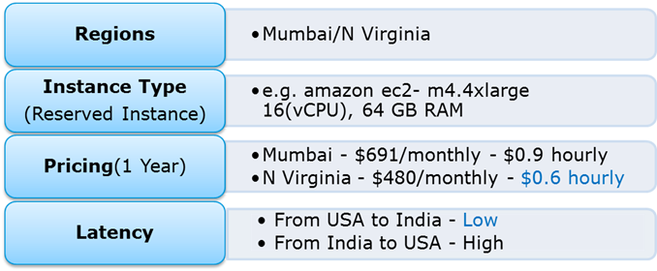

So, with reference to the above figure the regions to choose between are, Mumbai and North Virginia. Now let us first compare the pricing, you have hourly prices, which can be converted to your per month figure. Here North Virginia emerges as a winner. But, pricing cannot be the only parameter to consider. Performance should also be kept in mind hence, let’s look at latency as well. Latency basically is the time that a server takes to respond to your requests i.e the response time. North Virginia wins again!

So concluding, North Virginia should be chosen for this use case.

**15. Is one Elastic IP address enough for every instance that I have running?**

Depends! Every instance comes with its own private and public address. The private address is associated exclusively with the instance and is returned  to Amazon EC2 only when it is stopped or terminated. Similarly, the public address is associated exclusively with the instance until it is stopped or terminated. However, this can be replaced by the Elastic IP address, which stays with the instance as long as the user doesn’t manually detach it. But what if you are hosting multiple websites on your EC2 server, in that case you may require more than one Elastic IP address.

**16. What are the best practices for Security in Amazon EC2?**

There are several best practices to secure Amazon EC2. A few of them are given below:

* Use AWS Identity and Access Management (IAM) to control access to your AWS resources.
* Restrict access by only allowing trusted hosts or networks to access ports on your instance.
* Review the rules in your security groups regularly, and ensure that you apply the principle of least
* Privilege – only open up permissions that you require.
* Disable password-based logins for instances launched from your AMI. Passwords can be found or cracked, and are a security risk.

[**Learn To Use AWS Tools**](https://www.edureka.co/cloudcomputing)

**Section 3: Amazon Storage**

**17. You need to configure an Amazon S3 bucket to serve static assets for your public-facing web application. Which method will ensure that all objects uploaded to the bucket are set to public read?**

1. Set permissions on the object to public read during upload.
2. Configure the bucket policy to set all objects to public read.
3. Use AWS Identity and Access Management roles to set the bucket to public read.
4. Amazon S3 objects default to public read, so no action is needed.

**Answer B.**

**Explanation:** Rather than making changes to every object, its better to set the policy for the whole bucket. IAM is used to give more granular permissions, since this is a website, all objects would be public by default.

**18. A customer wants to leverage Amazon Simple Storage Service (S3) and Amazon Glacier as part of their backup and archive infrastructure. The customer plans to use third-party software to support this integration. Which approach will limit the access of the third party software to only the Amazon S3 bucket named “company-backup”?**

1. A custom bucket policy limited to the Amazon S3 API in three Amazon Glacier archive “company-backup”
2. A custom bucket policy limited to the Amazon S3 API in “company-backup”
3. A custom IAM user policy limited to the Amazon S3 API for the Amazon Glacier archive “company-backup”.
4. A custom IAM user policy limited to the Amazon S3 API in “company-backup”.

**Answer D.**

**Explanation:** Taking queue from the previous questions, this use case involves more granular permissions, hence IAM would be used here.

**19. Can S3 be used with EC2 instances, if yes, how?**

Yes, it can be used for instances with root devices backed by local instance storage. By using Amazon S3, developers have access to the same highly scalable, reliable, fast, inexpensive data storage infrastructure that Amazon uses to run its own global network of web sites. In order to execute systems in the Amazon EC2 environment, developers use the tools provided to load their Amazon Machine Images (AMIs) into Amazon S3 and to move them between Amazon S3 and Amazon EC2.

Another use case could be for websites hosted on EC2 to load their static content from S3.

For a detailed discussion on S3, please refer our [**S3 AWS**](https://www.edureka.co/blog/s3-aws-amazon-simple-storage-service/)blog.

**20. A customer implemented AWS Storage Gateway with a gateway-cached volume at their main office. An event takes the link between the main and branch office offline. Which methods will enable the branch office to access their data?**

1. Restore by implementing a lifecycle policy on the Amazon S3 bucket.
2. Make an Amazon Glacier Restore API call to load the files into another Amazon S3 bucket within four to six hours.
3. Launch a new AWS Storage Gateway instance AMI in Amazon EC2, and restore from a gateway snapshot.
4. Create an Amazon EBS volume from a gateway snapshot, and mount it to an Amazon EC2 instance.

**Answer C.**

**Explanation:**The fastest way to do it would be launching a new storage gateway instance. Why? Since time is the key factor which drives every business, troubleshooting this problem will take more time. Rather than we can just restore the previous working state of the storage gateway on a new instance.

**21. When you need to move data over long distances using the internet, for instance across countries or continents to your Amazon S3 bucket, which method or service will you use?**

1. Amazon Glacier
2. Amazon CloudFront
3. Amazon Transfer Acceleration
4. Amazon Snowball

**Answer C.**

**Explanation:** You would not use Snowball, because for now, the snowball service does not support cross region data transfer, and since, we are transferring across countries, Snowball cannot be used. Transfer Acceleration shall be the right choice here as it throttles your data transfer with the use of optimized network paths and Amazon’s content delivery network upto 300% compared to normal data transfer speed.

**22. How can you speed up data transfer in Snowball?**

The data transfer can be increased in the following way:

* By performing multiple copy operations at one time i.e. if the workstation is powerful enough, you can initiate multiple cp commands each from different terminals, on the same Snowball device.
* Copying from multiple workstations to the same snowball.
* Transferring large files or by creating a batch of small file, this will reduce the encryption overhead.
* Eliminating unnecessary hops i.e. make a setup where the source machine(s) and the snowball are the only machines active on the switch being used, this can hugely improve performance.

[**Learn AWS from our Experts!**](https://www.edureka.co/cloudcomputing)

**Section 4: AWS VPC**

**23. If you want to launch Amazon Elastic Compute Cloud (EC2) instances and assign each instance a predetermined private IP address you should:**

1. Launch the instance from a private Amazon Machine Image (AMI).
2. Assign a group of sequential Elastic IP address to the instances.
3. Launch the instances in the Amazon Virtual Private Cloud (VPC).
4. Launch the instances in a Placement Group.

**Answer C.**

**Explanation:** The best way of connecting to your cloud resources (for ex- ec2 instances) from your own data center (for eg- private cloud) is a VPC. Once you connect your datacenter to the VPC in which your instances are present, each instance is assigned a private IP address which can be accessed from your datacenter. Hence, you can access your public cloud resources, as if they were on your own network.

**24. Can I connect my corporate datacenter to the Amazon Cloud?**

Yes, you can do this by establishing a VPN(Virtual Private Network) connection between your company’s network and your VPC (Virtual Private Cloud), this will allow you to interact with your EC2 instances as if they were within your existing network.

**25. Is it possible to change the private IP addresses of an EC2 while it is running/stopped in a VPC?**

Primary private IP address is attached with the instance throughout its lifetime and cannot be changed, however secondary private addresses can be unassigned, assigned or moved between interfaces or instances at any point.

**26. Why do you make subnets?**

1. Because there is a shortage of networks
2. To efficiently utilize networks that have a large no. of hosts.
3. Because there is a shortage of hosts.
4. To efficiently utilize networks that have a small no. of hosts.

**Answer B.**

**Explanation:**If there is a network which has a large no. of hosts, managing all these hosts can be a tedious job. Therefore we divide this network into subnets (sub-networks) so that managing these hosts becomes simpler.

**27. Which of the following is true?**

1. You can attach multiple route tables to a subnet
2. You can attach multiple subnets to a route table
3. Both A and B
4. None of these.

**Answer B.**

**Explanation:**Route Tables are used to route network packets, therefore in a subnet having multiple route tables will lead to confusion as to where the packet has to go. Therefore, there is only one route table in a subnet, and since a route table can have any no. of records or information, hence attaching multiple subnets to a route table is possible.

**28. In CloudFront what happens when content is NOT present at an Edge location and a request is made to it?**

1. An Error “404 not found” is returned
2. CloudFront delivers the content directly from the origin server and stores it in the cache of the edge location
3. The request is kept on hold till content is delivered to the edge location
4. The request is routed to the next closest edge location

**Answer B.**

**Explanation:** CloudFront is a content delivery system, which caches data to the nearest edge location from the user, to reduce latency. If data is not present at an edge location, the first time the data may get transferred from the original server, but from the next time, it will be served from the cached edge.

**29. If I’m using Amazon CloudFront, can I use Direct Connect to transfer objects from my own data center?**

Yes. Amazon CloudFront supports custom origins including origins from outside of AWS. With AWS Direct Connect, you will be charged with the respective data transfer rates.

**30. If my AWS Direct Connect fails, will I lose my connectivity?**

If a backup AWS Direct connect has been configured, in the event of a failure it will switch over to the second one. It is recommended to enable Bidirectional Forwarding Detection (BFD) when configuring your connections to ensure faster detection and failover. On the other hand, if you have configured a backup IPsec VPN connection instead, all VPC traffic will failover to the backup VPN connection automatically. Traffic to/from public resources such as Amazon S3 will be routed over the Internet. If you do not have a backup AWS Direct Connect link or a IPsec VPN link, then Amazon VPC traffic will be dropped in the event of a failure.

[**Learn VPC from our Experts!**](https://www.edureka.co/cloudcomputing)

**Section 5: Amazon Database**

**31. If I launch a standby RDS instance, will it be in the same Availability Zone as my primary?**

1. Only for Oracle RDS types
2. Yes
3. Only if it is configured at launch
4. No

**Answer D.**

**Explanation:**No, since the purpose of having a standby instance is to avoid an infrastructure failure (if it happens), therefore the standby instance is stored in a different availability zone, which is a physically different independent infrastructure.

**32. When would I prefer Provisioned IOPS over Standard RDS storage?**

1. **If you have batch-oriented workloads**
2. If you use production online transaction processing (OLTP) workloads.
3. If you have workloads that are not sensitive to consistent performance
4. All of the above

**Answer A.**

**Explanation:** Provisioned IOPS deliver high IO rates but on the other hand it is expensive as well. Batch processing workloads do not require manual intervention they enable full utilization of systems, therefore a provisioned IOPS will be preferred for batch oriented workload.

**33. How is Amazon RDS, DynamoDB and Redshift different?**

* Amazon RDS is a database management service for relational databases,  it manages patching, upgrading, backing up of data etc. of databases for you without your intervention. RDS  is a Db management service for structured data only.
* DynamoDB, on the other hand, is a NoSQL database service, NoSQL deals with unstructured data.
* Redshift, is an entirely different service, it is a data warehouse product and is used in data analysis.

**34. If I am running my DB Instance as a Multi-AZ deployment, can I use the standby DB Instance for read or write operations along with primary DB instance?**

1. Yes
2. Only with MySQL based RDS
3. Only for Oracle RDS instances
4. No

**Answer D.**

**Explanation:**No,Standby DB instance cannot be used with primary DB instance in parallel, as the former is solely used for standby purposes, it cannot be used unless the primary instance goes down.

**35. Your company’s branch offices are all over the world, they use a software with a multi-regional deployment on AWS, they use MySQL 5.6 for data persistence.**

**The task is to run an hourly batch process and read data from every region to compute cross-regional reports which will be distributed to all the branches. This should be done in the shortest time possible. How will you build the DB architecture in order to meet the requirements?**

1. For each regional deployment, use RDS MySQL with a master in the region and a read replica in the HQ region
2. For each regional deployment, use MySQL on EC2 with a master in the region and send hourly EBS snapshots to the HQ region
3. For each regional deployment, use RDS MySQL with a master in the region and send hourly RDS snapshots to the HQ region
4. For each regional deployment, use MySQL on EC2 with a master in the region and use S3 to copy data files hourly to the HQ region

**Answer A.**

**Explanation:**For this we will take an RDS instance as a master, because it will manage our database for us and since we have to read from every region, we’ll put a read replica of this instance in every region where the data has to be read from. Option C is not correct since putting a read replica would be more efficient than putting a snapshot, a read replica can be promoted if needed  to an independent DB instance, but with a Db snapshot it becomes mandatory to launch a separate DB Instance.

**36. Can I run more than one DB instance for Amazon RDS for free?**

Yes. You can run more than one Single-AZ Micro database instance, that too for free! However, any use exceeding 750 instance hours, across all Amazon RDS Single-AZ Micro DB instances, across all eligible database engines and regions, will be billed at standard Amazon RDS prices. For example: if you run two Single-AZ Micro DB instances for 400 hours each in a single month, you will accumulate 800 instance hours of usage, of which 750 hours will be free. You will be billed for the remaining 50 hours at the standard Amazon RDS price.

For a detailed discussion on this topic, please refer our[**RDS AWS**](https://www.edureka.co/blog/rds-aws-tutorial/) blog.

**37. Which AWS services will you use to collect and process e-commerce data for near real-time analysis?**

1. Amazon ElastiCache
2. Amazon DynamoDB
3. Amazon Redshift
4. Amazon Elastic MapReduce

**Answer B,C.**

**Explanation:** DynamoDB is a fully managed NoSQL database service. DynamoDB, therefore can be fed any type of unstructured data, which can be data from e-commerce websites as well, and later, an analysis can be done on them using Amazon Redshift. We are not using Elastic MapReduce, since a near real time analyses is needed.

**38. Can I retrieve only a specific element of the data, if I have a nested JSON data in DynamoDB?**

Yes. When using the GetItem, BatchGetItem, Query or Scan APIs, you can define a Projection Expression to determine which attributes should be retrieved from the table. Those attributes can include scalars, sets, or elements of a JSON document.

**39. A company is deploying a new two-tier web application in AWS. The company has limited staff and requires high availability, and the application requires complex queries and table joins. Which configuration provides the solution for the company’s requirements?**

1. MySQL Installed on two Amazon EC2 Instances in a single Availability Zone
2. Amazon RDS for MySQL with Multi-AZ
3. Amazon ElastiCache
4. Amazon DynamoDB

**Answer D.**

**Explanation:**DynamoDB has the ability to scale more than RDS or any other relational database service, therefore DynamoDB would be the apt choice.

**40. What happens to my backups and DB Snapshots if I delete my DB Instance?**

When you delete a DB instance, you have an option of creating a final DB snapshot, if you do that you can restore your database from that snapshot. RDS retains this user-created DB snapshot along with all other manually created DB snapshots after theinstance is deleted, also automated backups are deleted and only manually created DB Snapshots are retained.

**41. Which of the following use cases are suitable for Amazon DynamoDB? Choose 2 answers**

1. Managing web sessions.
2. Storing JSON documents.
3. Storing metadata for Amazon S3 objects.
4. Running relational joins and complex updates.

**Answer C,D.**

**Explanation:**If all your JSON data have the same fields eg [id,name,age] then it would be better to store it in a relational database, the metadata on the other hand is unstructured, also running relational joins or complex updates would work on DynamoDB as well.

**42. How can I load my data to Amazon Redshift from different data sources like Amazon RDS, Amazon DynamoDB and Amazon EC2?**

You can load the data in the following two ways:

* You can use the COPY command to load data in parallel directly to Amazon Redshift from Amazon EMR, Amazon DynamoDB, or any SSH-enabled host.
* AWS Data Pipeline provides a high performance, reliable, fault tolerant solution to load data from a variety of AWS data sources. You can use AWS Data Pipeline to specify the data source, desired data transformations, and then execute a pre-written import script to load your data into Amazon Redshift.

**43. Your application has to retrieve data from your user’s mobile every 5 minutes and the data is stored in DynamoDB, later every day at a particular time the data is extracted into S3 on a per user basis and then your application is later used to visualize the data to the user. You are asked to optimize the architecture of the backend system to lower cost, what would you recommend?**

1. Create a new Amazon DynamoDB (able each day and drop the one for the previous day after its data is on Amazon S3.
2. Introduce an Amazon SQS queue to buffer writes to the Amazon DynamoDB table and reduce provisioned write throughput.
3. Introduce Amazon Elasticache to cache reads from the Amazon DynamoDB table and reduce provisioned read throughput.
4. Write data directly into an Amazon Redshift cluster replacing both Amazon DynamoDB and Amazon S3.

**Answer C.**

**Explanation:**Since our work requires the data to be extracted and analyzed, to optimize this process a person would useprovisioned IO, but since it is expensive, using a ElastiCache memoryinsread to cache the results in the memory can reduce the provisioned read throughput and hence reduce cost without affecting the performance.

**44. You are running a website on EC2 instances deployed across multiple Availability Zones with a Multi-AZ RDS MySQL Extra Large DB Instance. The site performs a high number of small reads and writes per second and relies on an eventual consistency model. After comprehensive tests you discover that there is read contention on RDS MySQL. Which are the best approaches to meet these requirements? (Choose 2 answers)**

1. Deploy ElastiCache in-memory cache running in each availability zone
2. Implement sharding to distribute load to multiple RDS MySQL instances
3. Increase the RDS MySQL Instance size and Implement provisioned IOPS
4. Add an RDS MySQL read replica in each availability zone

**Answer A,C.**

**Explanation:**Since it does a lot of read writes, provisioned IO may become expensive. But we need high performance as well, therefore the data can be cached using ElastiCache which can be used for frequently reading the data. As for RDS since read contention is happening, the instance size should be increased and provisioned IO should be introduced to increase the performance.

**45. A startup is running a pilot deployment of around 100 sensors to measure street noise and air quality in urban areas for 3 months. It was noted that every month around 4GB of sensor data is generated. The company uses a load balanced auto scaled layer of EC2 instances and a RDS database with 500 GB standard storage. The pilot was a success and now they want to deploy at least  100K sensors which need to be supported by the backend. You need to store the data for at least 2 years to analyze it. Which setup of the following would you prefer?**

1. Add an SQS queue to the ingestion layer to buffer writes to the RDS instance
2. Ingest data into a DynamoDB table and move old data to a Redshift cluster
3. Replace the RDS instance with a 6 node Redshift cluster with 96TB of storage
4. Keep the current architecture but upgrade RDS storage to 3TB and 10K provisioned IOPS

**Answer C.**  
**Explanation:**A Redshift cluster would be preferred because it easy to scale, also the work would be done in parallel through the nodes, therefore is perfect for a bigger workload like our use case. Since each month 4 GB of data is generated, therefore in 2 year, it should be around 96 GB. And since the servers will be increased to 100K in number, 96 GB will approximately become 96TB. Hence option C is the right answer.

[**Learn AWS from Industry Leaders!**](https://www.edureka.co/cloudcomputing)

**Section 6: AWS Auto Scaling, AWS Load Balancer**

**46. Suppose you have an application where you have to render images and also do some general computing. From the following  services which service will best fit your need?**

1. Classic Load Balancer
2. Application Load Balancer
3. Both of them
4. None of these

**Answer B.**

**Explanation:**You will choose an application load balancer, since it supports path based routing, which means it can take decisions based on the URL, therefore if your task needs image rendering it will route it to a different instance, and for general computing it will route it to a different instance.

**47. What is the difference between Scalability and Elasticity?**

Scalability is the ability of a system to increase its hardware resources to handle the increase in demand. It can be done by increasing the hardware specifications or increasing the processing nodes.

Elasticity is the ability of a system to handle increase in the workload by adding additional hardware resources when the demand increases(same as scaling) but also rolling back the scaled resources, when the resources are no longer needed. This is particularly helpful in Cloud environments, where a pay per use model is followed.

**48. How will you change the instance type for instances which are running in your application tier and are using Auto Scaling. Where will you change it from the following areas?**

1. Auto Scaling policy configuration
2. Auto Scaling group
3. Auto Scaling tags configuration
4. Auto Scaling launch configuration

**Answer D.**

**Explanation:**Auto scaling tags configuration, is used to attach metadata to your instances, to change the instance type you have to use auto scaling launch configuration.

**49. You have a content management system running on an Amazon EC2 instance that is approaching 100% CPU utilization. Which option will reduce load on the Amazon EC2 instance?**

1. Create a load balancer, and register the Amazon EC2 instance with it
2. Create a CloudFront distribution, and configure the Amazon EC2 instance as the origin
3. Create an Auto Scaling group from the instance using the CreateAutoScalingGroup action
4. Create a launch configuration from the instance using the CreateLaunchConfigurationAction

**Answer A.**

**Explanation:**Creating alone an autoscaling group will not solve the issue, until you attach a load balancer to it. Once you attach a load balancer to an autoscaling group, it will efficiently distribute the load among all the instances. Option B – CloudFront is a CDN, it is a data transfer tool therefore will not help reduce load on the EC2 instance. Similarly the other option – Launch configuration is a template for configuration which has no connection with reducing loads.

**50. When should I use a Classic Load Balancer and when should I use an Application load balancer?**

A Classic Load Balancer is ideal for simple load balancing of traffic across multiple EC2 instances, while an Application Load Balancer is ideal for microservices or container-based architectures where there is a need to route traffic to multiple services or load balance across multiple ports on the same EC2 instance.

For a detailed discussion on Auto Scaling and Load Balancer, please refer our [**EC2 AWS**](https://www.edureka.co/blog/ec2-aws-tutorial-elastic-compute-cloud/) blog.

**51. What does Connection draining do?**

1. Terminates instances which are not in use.
2. **Re-routes traffic from instances which are to be updated or failed a health check.**
3. Re-routes traffic from instances which have more workload to instances which have less workload.
4. Drains all the connections from an instance, with one click.

**Answer B.**

**Explanation:**Connection draining is a service under ELB which constantly monitors the health of the instances. If any instance fails a health check or if any instance has to be patched with a software update, it  pulls all the traffic from that instance and re routes them to other instances.

**52.** **When an instance is unhealthy, it is terminated and replaced with a new one, which of the following services does that?**

1. Sticky Sessions
2. Fault Tolerance
3. Connection Draining
4. Monitoring

**Answer B.**

**Explanation:**When ELB detects that an instance is unhealthy, it starts routing incoming traffic to other healthy instances in the region. If all the instances in a region becomes unhealthy, and if you have instances in some other availability zone/region, your traffic is directed to them. Once your instances become healthy again, they are re routed back to the original instances.

**53. What are lifecycle hooks used for in AutoScaling?**

1. They are used to do health checks on instances
2. They are used to put an additional wait time to a scale in or scale out event.
3. They are used to shorten the wait time to a scale in or scale out event
4. None of these

**Answer B.**

**Explanation:**Lifecycle hooks are used for putting wait time before any lifecycle action i.e launching or terminating an instance happens. The purpose of this wait time, can be anything from extracting log files before terminating an instance or installing the necessary softwares in an instance before launching it.

**54. A user has setup an Auto Scaling group. Due to some issue the group has failed to launch a single instance for more than 24 hours. What will happen to Auto Scaling in this condition?**

1. Auto Scaling will keep trying to launch the instance for 72 hours
2. Auto Scaling will suspend the scaling process
3. Auto Scaling will start an instance in a separate region
4. The Auto Scaling group will be terminated automatically

**Answer B.**

**Explanation:** Auto Scaling allows you to suspend and then resume one or more of the Auto Scaling processes in your Auto Scaling group. This can be very useful when you want to investigate a configuration problem or other issue with your web application, and then make changes to your application, without triggering the Auto Scaling process.

[**Enroll NOW!**](https://www.edureka.co/cloudcomputing)

**Section 7: CloudTrail, Route 53**

**55. You have an EC2 Security Group with several running EC2 instances. You changed the Security Group rules to allow inbound traffic on a new port and protocol, and then launched several new instances in the same Security Group. The new rules apply:**

1. Immediately to all instances in the security group.
2. Immediately to the new instances only.
3. Immediately to the new instances, but old instances must be stopped and restarted before the new rules apply.
4. To all instances, but it may take several minutes for old instances to see the changes.

**Answer A.**

**Explanation:** Any rule specified in an EC2 Security Group applies immediately to all the instances, irrespective of when they are launched before or after adding a rule.

**56. To create a mirror image of your environment in another region for disaster recovery, which of the following AWS resources do not need to be recreated in the second region? ( Choose 2 answers )**

1. Route 53 Record Sets
2. Elastic IP Addresses (EIP)
3. EC2 Key Pairs
4. Launch configurations
5. Security Groups

**Answer A,B.**

**Explanation:**Elastic IPs and Route 53 record sets are common assets therefore there is no need to replicate them, since Elastic IPs and Route 53 are valid across regions

**57. A customer wants to capture all client connection information from his load balancer at an interval of 5 minutes, which of the following options should he choose for his application?**

1. Enable AWS CloudTrail for the loadbalancer.
2. Enable access logs on the load balancer.
3. Install the Amazon CloudWatch Logs agent on the load balancer.
4. Enable Amazon CloudWatch metrics on the load balancer.

**Answer A.**

**Explanation:**AWS CloudTrail provides inexpensive logging information for load balancer and other AWS resources This logging information can be used for analyses and other administrative work, therefore is perfect for this use case.

**58. A customer wants to track access to their Amazon Simple Storage Service (S3) buckets and also use this information for their internal security and access audits. Which of the following will meet the Customer requirement?**

1. Enable AWS CloudTrail to audit all Amazon S3 bucket access.
2. Enable server access logging for all required Amazon S3 buckets.
3. Enable the Requester Pays option to track access via AWS Billing
4. Enable Amazon S3 event notifications for Put and Post.

**Answer A.**

**Explanation:**AWS CloudTrail has been designed for logging and tracking API calls. Also this service is available for storage, therefore should be used in this use case.

**59. Which of the following are true regarding AWS CloudTrail? (Choose 2 answers)**

1. CloudTrail is enabled globally
2. CloudTrail is enabled on a per-region and service basis
3. Logs can be delivered to a single Amazon S3 bucket for aggregation.
4. CloudTrail is enabled for all available services within a region.

**Answer B,C.**

**Explanation:** Cloudtrail is not enabled for all the services and is also not available for all the regions. Therefore option B is correct, also the logs can be delivered to your S3 bucket, hence C is also correct.

**60. What happens if CloudTrail is turned on for my account but my Amazon S3 bucket is not configured with the correct policy?**

CloudTrail files are delivered according to S3 bucket policies. If the bucket is not configured or is misconfigured, CloudTrail might not be able to deliver the log files.

**61. How do I transfer my existing domain name registration to Amazon Route 53 without disrupting my existing web traffic?**

You will need to get a list of the DNS record data for your domain name first, it is generally available in the form of a “zone file” that you can get from your existing DNS provider. Once you receive the DNS record data, you can use Route 53’s Management Console or simple web-services interface to create a hosted zone that will store your DNS records for your domain name and follow its transfer process. It also includes steps such as updating the nameservers for your domain name to the ones associated with your hosted zone. For completing the process you have to contact the registrar with whom you registered your domain name and follow the transfer process. As soon as your registrar propagates the new name server delegations, your DNS queries will start to get answered.

[**Learn AWS Now!**](https://www.edureka.co/cloudcomputing)

**Section 8: AWS SQS, AWS SNS, AWS SES, AWS ElasticBeanstalk**

**62. Which of the following services you would not use to deploy an app?**

1. Elastic Beanstalk
2. Lambda
3. Opsworks
4. CloudFormation

**Answer B.**

**Explanation:** Lambda is used for running server-less applications. It can be used to deploy functions triggered by events. When we say serverless, we mean without you worrying about the computing resources running in the background. It is not designed for creating applications which are publicly accessed.

**63. How does Elastic Beanstalk apply updates?**

1. By having a duplicate ready with updates before swapping.
2. By updating on the instance while it is running
3. By taking the instance down in the maintenance window
4. Updates should be installed manually

**Answer A.**

**Explanation:** Elastic Beanstalk prepares a duplicate copy of the instance, before updating the original instance, and routes your traffic to the duplicate instance, so that, incase your updated application fails, it will switch back to the original instance, and there will be no downtime experienced by the users who are using your application.

**64. How is AWS Elastic Beanstalk different than AWS OpsWorks?**

AWS Elastic Beanstalk is an application management platform while OpsWorks is a configuration management platform. BeanStalk is an easy to use service which is used for deploying and scaling web applications developed with Java, .Net, PHP, Node.js, Python, Ruby, Go and Docker. Customers upload their code and Elastic Beanstalk automatically handles the deployment. The application will be ready to use without any infrastructure or resource configuration.

In contrast, AWS Opsworks is an integrated configuration management platform for IT administrators or DevOps engineers who want a high degree of customization and control over operations.

**65. What happens if my application stops responding to requests in beanstalk?**

AWS Beanstalk applications have a system in place for avoiding failures in the underlying infrastructure. If an Amazon EC2 instance fails for any reason, Beanstalk will use Auto Scaling to automatically launch a new instance. Beanstalk can also detect if your application is not responding on the custom link, even though the infrastructure appears healthy, it will be logged as an environmental event( e.g a bad version was deployed) so you can take an appropriate action.

For a detailed discussion on this topic, please refer [**Lambda AWS**](https://www.edureka.co/blog/aws-lambda-tutorial)blog.

[**Learn AWS from our Experts!**](https://www.edureka.co/cloudcomputing)

**Section 9: AWS OpsWorks, AWS KMS**

**66. How is AWS OpsWorks different than AWS CloudFormation?**

OpsWorks and CloudFormation both support application modelling, deployment, configuration, management and related activities. Both support a wide variety of architectural patterns, from simple web applications to highly complex applications. AWS OpsWorks and AWS CloudFormation differ in abstraction level and areas of focus.

AWS CloudFormation is a building block service which enables customer to manage almost any AWS resource via JSON-based domain specific language. It provides foundational capabilities for the full breadth of AWS, without prescribing a particular model for development and operations. Customers define templates and use them to provision and manage AWS resources, operating systems and application code.

In contrast, AWS OpsWorks is a higher level service that focuses on providing highly productive and reliable DevOps experiences for IT administrators and ops-minded developers. To do this, AWS OpsWorks employs a configuration management model based on concepts such as stacks and layers, and provides integrated experiences for key activities like deployment, monitoring, auto-scaling, and automation. Compared to AWS CloudFormation, AWS OpsWorks supports a narrower range of application-oriented AWS resource types including Amazon EC2 instances, Amazon EBS volumes, Elastic IPs, and Amazon CloudWatch metrics.

**67. I created a key in Oregon region to encrypt my data in North Virginia region for security purposes. I added two users to the key and an external AWS account. I wanted to encrypt an object in S3, so when I tried, the key that I just created was not listed.  What could be the reason?**

1. External aws accounts are not supported.
2. AWS S3 cannot be integrated KMS.
3. The Key should be in the same region.
4. New keys take some time to reflect in the list.

**Answer C.**

**Explanation:**The key created and the data to be encrypted should be in the same region. Hence the approach taken here to secure the data is incorrect.

**68.  A company needs to monitor the read and write IOPS for their AWS MySQL RDS instance and send real-time alerts to their operations team. Which AWS services can accomplish this?**

1. Amazon Simple Email Service
2. Amazon CloudWatch
3. Amazon Simple Queue Service
4. Amazon Route 53

**Answer B.**

**Explanation:**Amazon CloudWatch is a cloud monitoring tool and hence this is the right service for the mentioned use case. The other options listed here are used for other purposes for example route 53 is used for DNS services, therefore CloudWatch will be the apt choice.

**69. What happens when one of the resources in a stack cannot be created successfully in AWS OpsWorks?**

When an event like this occurs, the “automatic rollback on error” feature is enabled, which causes all the AWS resources which were created successfully till the point where the error occurred to be deleted. This is helpful since it does not leave behind any erroneous data, it ensures the fact that stacks are either created fully or not created at all. It is useful in events where you may accidentally exceed your limit of the no. of Elastic IP addresses or maybe you may not have access to an EC2 AMI that you are trying to run etc.

**70. What automation tools can you use to spinup servers?**

Any of the following tools can be used:

* Roll-your-own scripts, and use the AWS API tools.  Such scripts could be written in bash, perl or other language of your choice.
* Use a configuration management and provisioning tool like puppet or its successor Opscode Chef.  You can also use a tool like Scalr.
* Use a managed solution such as Rightscale.

**1. What is AWS or Amazon EC2 service?**

AWS refers to ‘Amazon Web Services’ and Amazon EC2 refers to ‘Amazon Elastic Cloud’.

It is a web service that ensures security, scalability and flexibility, making cost-effective web-scale cloud computing for developers.

In the future, cloud computing has good scope and AWS is one of the best web service supported by the cloud computing platform.

Here EC2 stands for elastic computing that mean purchasing hardware or software infrastructure hosted by cloud platform on demand basis.

You are not limited to the resources you have been purchased at the initial stage, you can extend the usage resources by paying for what you used.

*There are some of the good features of Amazon Ec2 service:*

• Virtual Computing

• Supports various configurations of CPU, memory, storage capacity etc. for various instances

• Instance store volumes

• Virtual Private clouds(VPCs)

• Security groups

• Availability zones

**2. What are the features and services supported by AWS?**

AWS, the elastic technology, offer wide range of services and features delivering huge set of functionalities.

*Here are the features and services supported by AWS:*

• API for accessing the services with effective functions wrapped into them.

• Supports failure-prone infrastructure.

• Redundancy.

• Service Robustness.

• On-demand resources availability.

• Region and availability zone based resources partitioning.

• Elastic IP Addresses.

• Key pairs authentication.

• Support wide range of instance types.

• Virtual Private clouds(VPCs)

• Instance store volumes

• Availability zones

**. What is S3 bucket?**

A bucket is a logical unit for storage in Amazon web Services(AWS).S3 buckets are basically used for storing data and metadata that describes data and set of related information.

*You can create the bucket by using below methods:*

• Creation of bucket using console.

• Creation of bucket in programmatic way using AWS SDK.

Amazon S3 bucket supports a simple web service interface that ensures proper storage and retrieval of data from anywhere on the web and at any time. It provides inexpensive data storage infrastructure on cloud computing platform that amazon uses to run global network of its own websites. It provides scalability, reliability, fast and cost-effective storage techniques.

**4. What are benefits of using Amazon S3 simple storage service on cloud platform?**

*Here are some of the listed benefits of using Amazon S3 simple storage service on cloud platform:*

• Making integration with third-party applications easy and convenient.

• On-demand Scalability.

• Security.

• Content distribution and storage on-demand basis.

• Static website hosting.

• Big-data and analytics using S3 bucket.

• Backup and data archiving.

• Cross Region Replication (CRR) technique.

• Free usage tier and pricing.

• Scalability, Reliability and inexpensive data storage infrastructure support.

**4) Can I vertically scale an Amazon instance?  How?**

**Ans:**Yes. This is an incredible feature of AWS and cloud virtualization.  Spin up a new larger instance than the one you are currently running. Pause that instance and detach the root EBS volume and discard.  Then stop your live instance, detach its root volume.  Note down the unique device ID and attach that root volume to your new server.   And then start it again. And, you have scaled vertically in-place!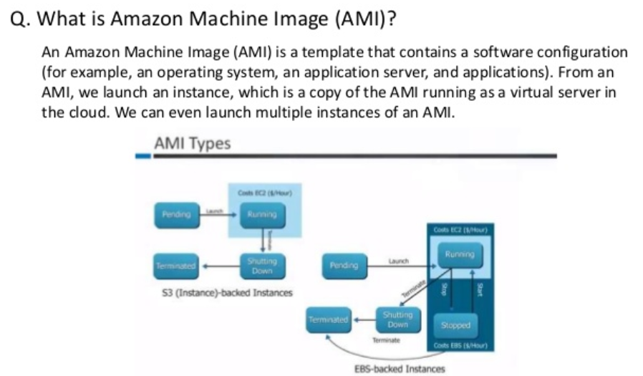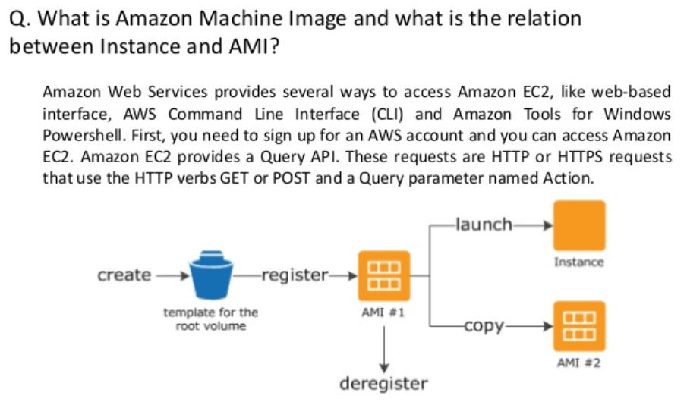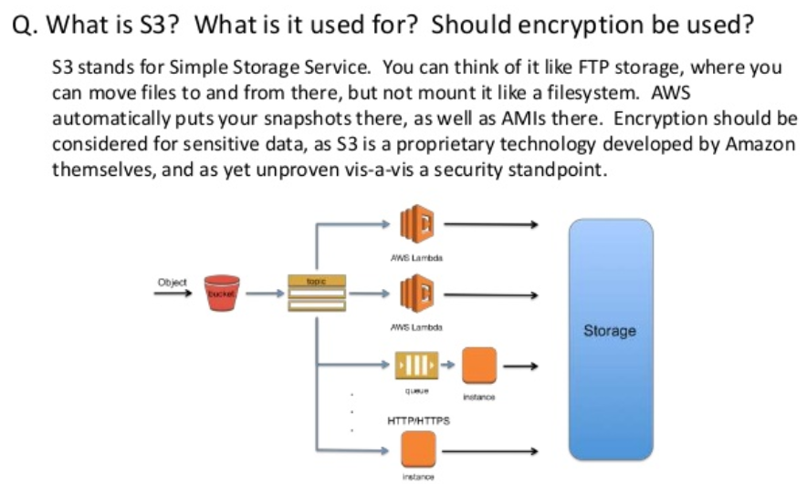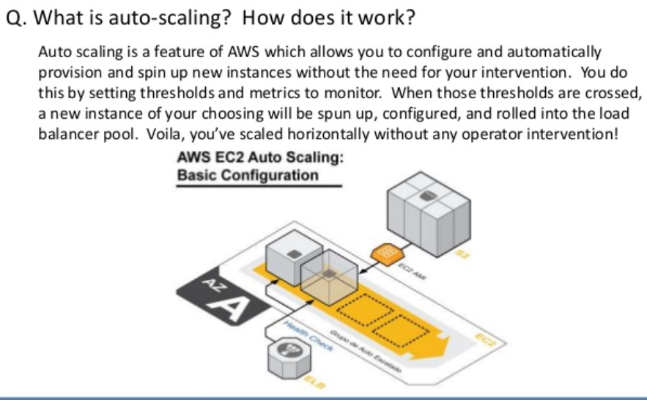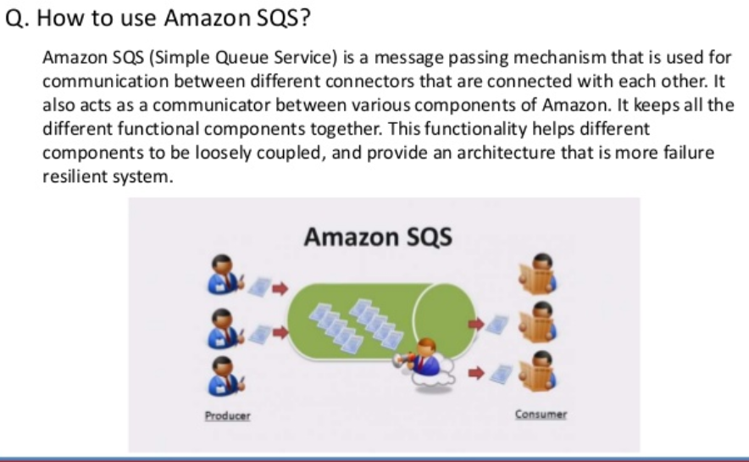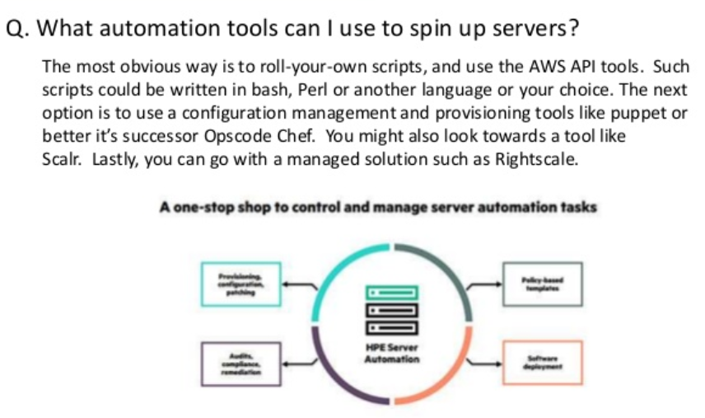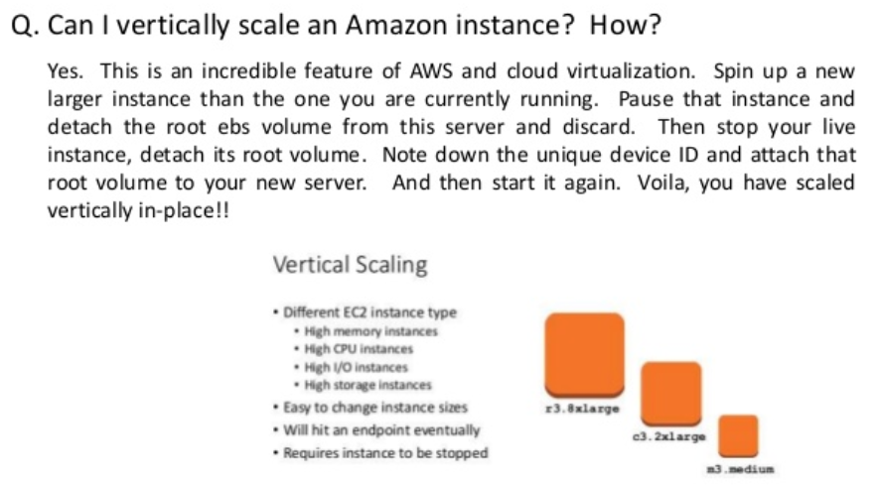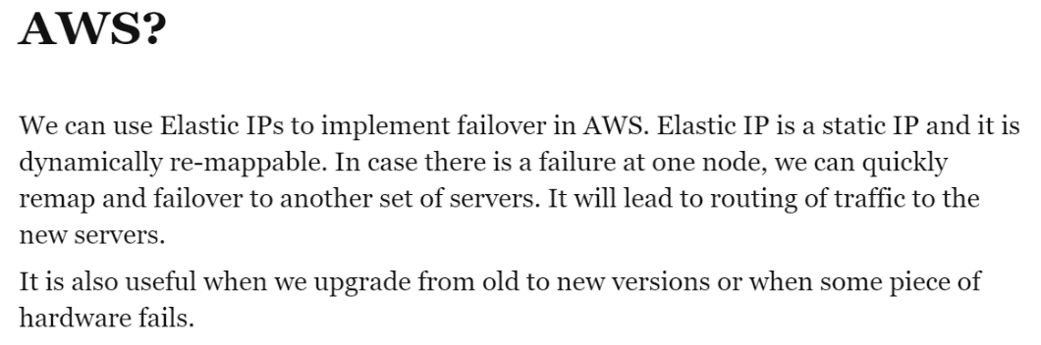

|  |
| --- |
| When it comes to the Internet, keeping your organization's presence online is crucial to the accessibility of resources for customers, potential and existing. At NetWorks Group, we understand that despite the best of intentions and planning, downtime will likely still occur, at least a few minutes per year. Many teams put forth a goal of 100% uptime for their web site, but often get a dose of reality when a [large storm hits their data center](http://bits.blogs.nytimes.com/2012/06/30/amazon-web-services-knocked-offline-by-storms/) or other issues pop-up that may be out of their direct control. To this end, we wanted a way to minimize full-downtime so that our presence on the Internet would only be down as minimally as possible, without going over-the-top on infrastructure to do so.  [Amazon Web Services](http://aws.amazon.com/) provides a plethora of cloud services to help teams do more for their environment with less overhead of capital expenditures. By cherry-picking needed services with AWS, you can find great cost-saving solutions to otherwise expensive — or complicated — problems. In the instance of a web site, the overhead costs and management of a second (or third?) data center to avoid an hour of downtime a year may be overkill for many organizations. For NetWorks Group, our web site being down, while not desirable, is not so critical that it will impede our ability to provide amazing service to our customers. With that in mind, we wanted to take a direction with web site downtime that would be economical, easy to manage, but also give us a minimal downtime of our Internet presence.  By utilizing the AWS services [Route 53](http://aws.amazon.com/route53/) and [S3](http://aws.amazon.com/s3/), we're able to provide a great failover solution when our primary web server is unreachable or down. In February 2013, Route 53 added features to allow for [DNS Failover and S3 Website Hosting](http://aws.typepad.com/aws/2013/02/create-a-backup-website-using-route-53-dns-failover-and-s3-website-hosting.html). The idea is that a simple health check — i.e., AWS verifies it can receive a 200 response code from your web server — will decide whether or not to failover your web site from its regular home to a special S3 bucket with your "downtime" page. By configuring a low DNS Time-to-Live (TTL), your DNS record can be changed to point to this failover end-point within a minute or two.  Through having this S3 bucket at the ready, you can automatically failover to a static-content site to provide critical information to customers such as contact information, expected time-to-recovery, etc.  So the next time your team is considering spending double or triple its budget to handle a few annoying minutes of downtime, think about utilizing Amazon or other cloud service providers to handle the problem gracefully and economically. |

 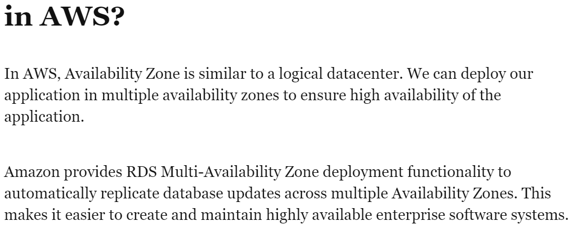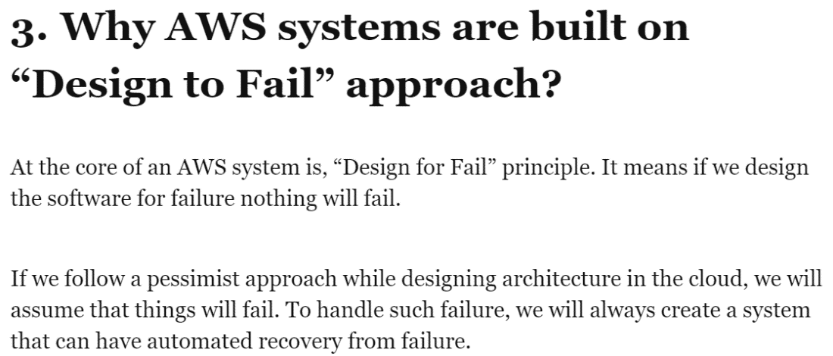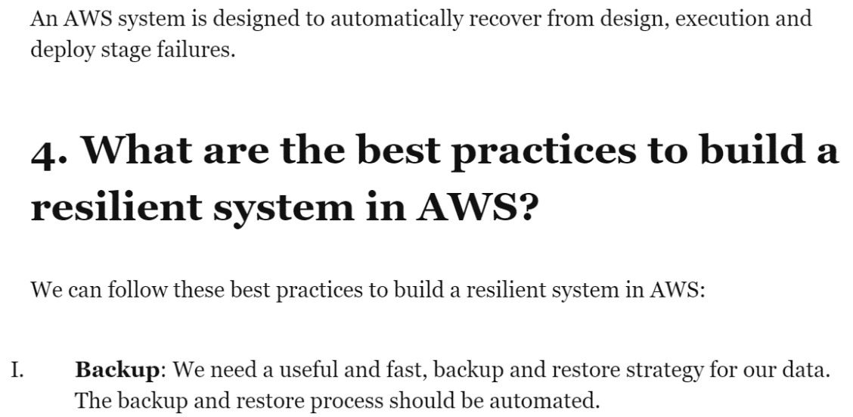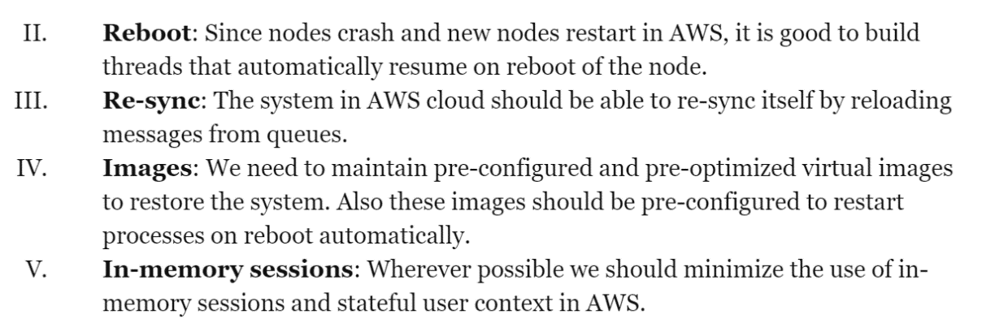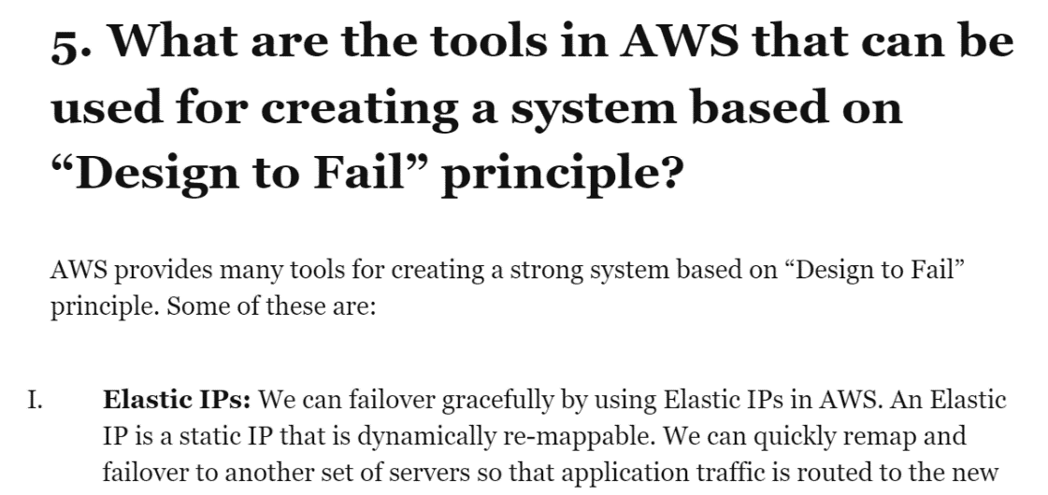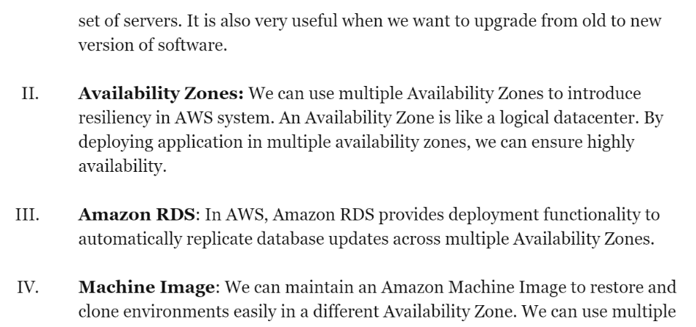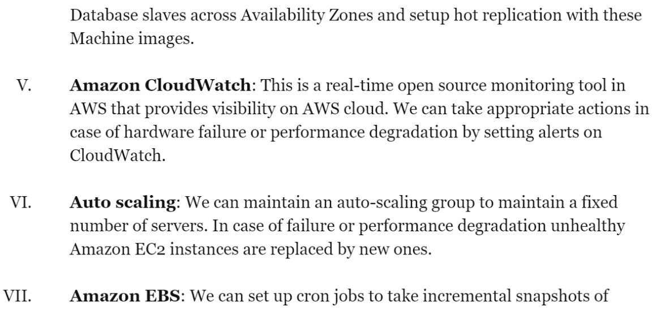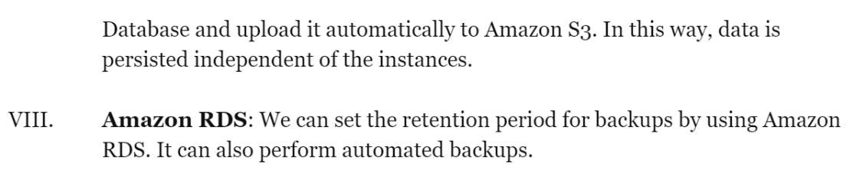

**5. What is AMI (Amazon Machine Image)?**

An Amazon Machine Image, in short term, AMI provides all the information that is required to launch an instance in virtual cloud server. You can launch any number of instances from the AMI as per you need. You can also launch instances from many different AMI’s.

*AN AMI includes the following:*

• A template for root volume for an instance, example it includes, an operating system, set of applications or any virtual application server.

• Launch permissions for controlling which AWS instance can use the AMI at the time of launch.

• A block device that will map the specified volumes to be attached to the instance when it’s launched.

**6. Explain the concept cloud computing?**

Cloud computing refers to that elastic computing platform for enabling simultaneous access to multiple pools of system resources and higher-level web services.

Cloud computing offers wide range of opportunities and capabilities, open a new world covered with flexibility, platforms, services, applications and much more.

*Here is listed some of the uses of cloud computing:*

• Creating new applications and services in virtual server.

• Storage, backup and ensures data recovery.

• Hosting of websites and blogs in global network of virtual servers.

• Audio and video streaming.

• Deliver software’s, resources and services on-demand.

• Data analysing for patterns and broadcasting.

**7. Name the types of cloud services?**

*Cloud Services comprises of 3 types:*

• IaaS

- Infrastructure-as-a-service

• PaaS

- Platform-as-a-service

• SaaS

- Software-as-a-service

**8. Compare the cloud services IaaS, PaaS and SaaS?**

• IaaS(Infrastructure-as-a-service)

Infrastructure-as-a-service facilitates to provide IT infrastructure including virtual servers, virtual machines(VMs), storage, networks, operating systems etc. on cloud provider platform on demand basis and thereby pay-to-pay basis.

• PaaS(Platform-as-a-service)

Platform-as-a-service facilitates to provide on-demand environment for developing, running, executing, testing and managing wide range of software applications. It makes easier and quite convenient for developers to quickly create web or mobile applications without setting up the physical infrastructure.

• SaaS(Software-as-a-service)

Software-as-a-service facilitates to provide on-demand software applications on hosted virtual server on demand basis or either on subscription basis for premium requirements. Users will connect to these virtual applications through web browser on their phone, tablet, PC by connecting the device over the internet.

**9. What are the various layers of the cloud architecture?**

*There are basically 5 layers of the cloud architecture:*

• Cluster Controller(CC)

• Storage Controller(SC)

• Cloud Controller(CLC)

1. **What** **is** **AWS(Amazon** **Web** **Service)?**

AWS stands for Amazon Web Service; it is a collection of remote computing services also known as cloud computing platform. This new realm of cloud computing is also known as IaaS or Infrastructure as a Service.

1. What are the key components of AWS( Amazon Web Service )?

The key components of AWS are :-

► Route 53: A DNS web service

► Simple E-mail Service: It allows sending e-mail using RESTFUL API call or via regular SMTP

► Identity and Access Management: It provides enhanced security and identity management for your AWS account

► Simple Storage Device or (S3): It is a storage device and the most widely used AWS service

► Elastic Compute Cloud (EC2): It provides on-demand computing resources for hosting applications. It is very useful in case of unpredictable workloads

► Elastic Block Store (EBS): It provides persistent storage volumes that attach to EC2 to allow you to persist data past the lifespan of a single EC2

► CloudWatch: To monitor AWS resources, It allows administrators to view and collect key Also, one can set a notification alarm in case of trouble.

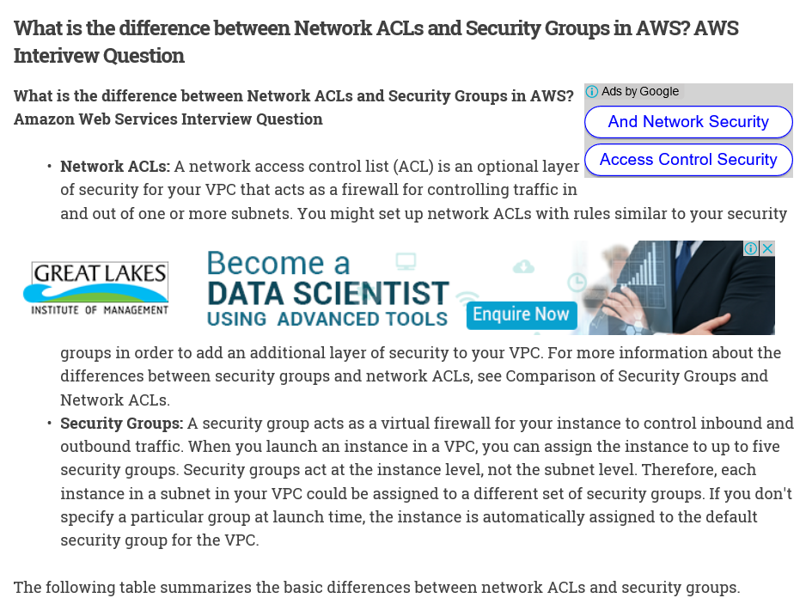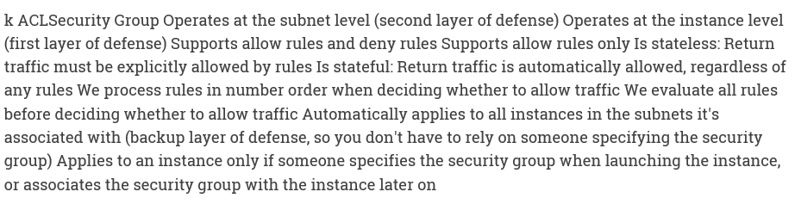

* How will you upload a file greater than 100 megabytes in Amazon S3?
* What happens to an Object when we delete it from Amazon S3?
* What is the use of Amazon Glacier?
* What are the use cases of Cross Region Replication Amazon S3?
* Can we do Cross Region replication in Amazon S3 without enabling versioning on a bucket?
* How do we get higher performance in our application by using Amazon CloudFront?
* What is the mechanism behind Regional Edge Cache in Amazon CloudFront?
* Can we disable versioning on a version-enabled bucket in Amazon S3?
* Can we do Cross Region replication in Amazon S3 without enabling versioning on a bucket?
* How do we get higher performance in our application by using Amazon CloudFront?
* How does AWS Lambda handle failure during event processing?
* How will you manage and run a serverless application in AWS?
* How will you upload a file greater than 100 megabytes in Amazon S3?
* What are Spot instances in Amazon EC2?
* What are the benefits of AWS Storage Gateway?
* What are the benefits of Streaming content?
* What are the benefits of using a Virtual Private Cloud in AWS?
* What are the Consistency levels supported by Amazon S3?
* What are the different APIs available in Amazon DynamoDB?
* What are the different routing policies available in Route 53?
* What are the different tiers in Amazon S3 storage?
* What are the different types of actions in Object Lifecycle Management in Amazon S3?
* What are the different types of events triggered by Amazon CloudFront?
* What are the different types of load balancing options provided by Amazon Elastic Load Balancing (ELB)?
* What are the important components of IAM?
* What are the important features of Amazon S3?
* What are the important points about AWS IAM?
* What are the main benefits of using Amazon DynamoDB?
* What are the main features of Amazon CloudFront?
* What are the main features of Application Load Balancer (ALB) in Amazon EC2?
* What are the main features of Classic Load Balancer in EC2?
* What are the main options available in Amazon CloudWatch?
* What are the main use cases for AWS Lambda?
* What are the main use cases for AWS Storage Gateway?
* What are the security mechanisms available in Amazon S3?
* What are the two main types of Volume provided by Amazon EBS?
* What are the use cases for Amazon Kinesis Streams?
* What are the use cases of Cross Region Replication Amazon S3?
* What do you know about AWS Region?
* What happens to an Object when we delete it from Amazon S3?
* What is a Placement Group in EC2?
* What is a Serverless application in AWS?
* What is an Elastic IP Address?
* What is AWS Lambda?
* What is AWS Snowball?
* What is Geo Targeting in Amazon CloudFront?
* What is Lambda@Edge in AWS?
* What is the basic Data Model in Amazon DynamoDB?
* What is the difference between Amazon SQS and Amazon SNS?
* What is the difference between Instance Store and EBS?
* What is the difference between Spot Instance and On-demand Instance in Amazon EC2?
* What is the difference between Volume and Snapshot in Amazon Web Services?
* What is the mechanism behind Regional Edge Cache in Amazon CloudFront?
* What is the scale of durability in Amazon S3?
* What is the use of Amazon ElastiCache?
* What is the use of Amazon Glacier?
* When should be use Amazon DynamoDB vs. Amazon S3?

1. **What** **is** **IAM** **service?**

AWS Identity and Access Management (IAM) is a web service that helps you securely control access to AWS resources for your users. You use IAM to control who can use your AWS resources (authentication) and what resources they can use and in what ways (authorization).

1. 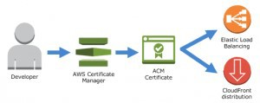**What** **is** **AWS** **Certificate** **Manager?**

AWS Certificate Manager (ACM) handles the complexity of provisioning, deploying, and managing certificates provided by ACM (ACM Certificates) for your AWS-

based websites and applications. You use ACM to request and manage the certificate and then use other AWS services to provision the ACM Certificate for your website or application. As shown by the following illustration, ACM Certificates are currently available for use with only Elastic Load Balancing and Amazon CloudFront. You cannot use ACM Certificates outside of AWS.

1. What is S3?

S3 stands for Simple Storage Service. You can use S3 interface to store and retrieve any amount of data, at any time and from anywhere on the web. Also we can host a website in Amazon S3. most of the companies storing the documents, images and other files to S3. For S3, the payment model is “pay as you go”.

1. **What** **is** **AMI** **(** **Amazon** **Machine** **Image** **)?**

It’s a template that provides the information (an operating system, an application server and applications) required to launch an instance, which is a copy of the AMI running as a virtual server in the cloud. You can launch instances from as many different AMIs as you need.

1. Mention what is the relation between an instance and AMI?

From a single AMI, you can launch multiple types of instances. An instance type defines the hardware of the host computer used for your instance. Each instance type provides different compute and memory capabilities. Once you launch an instance, it looks like a traditional host, and we can interact with it as we would with any computer.

1. What is Redshift?

Redshift is a fast, fully managed, petabyte-scale data warehouse service that makes it simple and cost-effective to efficiently analyze all your data using your existing business intelligence tools.

1. **What** **Is** **Amazon** **EC2?**

Amazon Elastic Compute Cloud (Amazon EC2) provides scalable computing capacity in the Amazon Web Services (AWS) cloud. Using Amazon EC2 eliminates your need to invest in hardware up front, so you can develop and deploy applications faster. You can use Amazon EC2 to launch as many or as few virtual servers as you need, configure security and networking, and manage storage. Amazon EC2 enables you to scale up or down to handle changes in requirements or spikes in popularity, reducing your need to forecast traffic.

1. What Is Amazon EC2 instance?

An EC2 instance is a virtual server in Amazon’s Elastic Compute Cloud (EC2) for running applications on the Amazon Web Services (AWS) infrastructure.

1. **Exmplain some features of Amazon EC2? Amazon EC2 provides the following** **features:**

► Virtual computing environments, known as instances

► Preconfigured templates for your instances, known as Amazon Machine Images (AMIs), that package the bits you need for your server (including the operating system and additional software)

► Various configurations of CPU, memory, storage, and networking capacity for your instances, known as instance types

► Secure login information for your instances using key pairs (AWS stores the public key, and you store the private key in a secure place)

► Storage volumes for temporary data that’s deleted when you stop or terminate your instance, known as instance store volumes

► Persistent storage volumes for your data using Amazon Elastic Block Store (Amazon EBS), known as Amazon EBS volumes

► Multiple physical locations for your resources, such as instances and Amazon EBS volumes, known as regions and Availability Zones

► A firewall that enables you to specify the protocols, ports, and source IP ranges that can reach your instances using security groups

► Static IP addresses for dynamic cloud computing, known as Elastic IP addresses

1. Mention what are the differences between Amazon S3 and EC2 ?

S3: Amazon S3 is just a storage service, typically used to store large binary files. Amazon also has other storage and database services, like RDS for relational databases and DynamoDB for NoSQL.

EC2: An EC2 instance is like a remote computer running Windows or Linux and on which you can install whatever software you want, including a Web server running PHP code and a database server.

1. How many buckets can you create in AWS by default?

By default, you can create upto 100 buckets in each of your AWS accounts.

1. What is T2 instances?

T2 instances are designed to provide moderate baseline performance and the capability to burst to significantly higher performance as required by your workload.

1. What is C4 instances?

C4 instances are ideal for compute-bound applications that benefit from high performance processors.

1. Explain how the buffer is used in Amazon web services?

The buffer is used to make the system more robust to manage traffic or load by synchronizing different component. Usually, components receive and process the requests in an unbalanced way, With the help of buffer, the components will be balanced and will work at the same speed to provide faster services.

1. **What is** **DynamoDB?**

Amazon DynamoDB is a fully managed NoSQL database service that provides fast and predictable performance with seamless scalability. You can use Amazon DynamoDB to create a database table that can store and retrieve any amount of data, and serve any level of request traffic. Amazon DynamoDB automatically spreads the data and traffic for the table over a sufficient number of servers to handle the request capacity specified by the customer and the amount of data stored, while maintaining consistent and fast performance.

1. **What is** **ElastiCache?**

ElastiCache is a web service that makes it easy to set up, manage, and scale distributed in- memory cache environments in the cloud.

1. **What** **is** **the** **AWS** **Key** **Management** **Service?**

The AWS Key Management Service (AWS KMS) is a managed service that makes it easy for you to create and control the encryption keys used to encrypt your data.

1. **What** **is** **AWS** **WAF?** **What** **are** **the** **potential** **benefits** **of** **using** **WAF?**

AWS WAF is a web application firewall that lets you monitor the HTTP and HTTPS requests that are forwarded to Amazon CloudFront and lets you control access to your content. Based on conditions that you specify, such as the IP addresses that requests originate from or the values of query strings, CloudFront responds to requests either with the requested content or with an HTTP 403 status code (Forbidden. You can also configure CloudFront to return a custom error page when a request is blocked.

Benefits of using WAF:

► Additional protection against web attacks using conditions that you specify. You can define

conditions by using characteristics of web requests such as the IP address that the requests originate from, the values in headers, strings that appear in the requests, and the presence of malicious SQL code in the request, which is known as SQL injection.

► Rules that you can reuse for multiple web applications

► Real-time metrics and sampled web requests

► Automated administration using the AWS WAF API

1. **What** **is** **Amazon** **EMR?**

Amazon Elastic MapReduce (Amazon EMR) is a managed cluster platform that simplifies running big data frameworks, such as Apache Hadoop and Apache Spark, on AWS to process and analyze vast amounts of data. By using these frameworks and related open-source projects, such as Apache Hive and Apache Pig, you can process data for analytics purposes and business intelligence workloads. Additionally, you can use Amazon EMR to transform and move large amounts of data into and out of other AWS data stores and databases, such as Amazon Simple Storage Service (Amazon S3) and Amazon DynamoDB.

1. What is AWS Data Pipeline? and what are the components of AWS Data Pipeline?

AWS Data Pipeline is a web service that you can use to automate the movement and transformation of data. With AWS Data Pipeline, you can define data-driven workflows, so that tasks can be dependent on the successful completion of previous tasks.

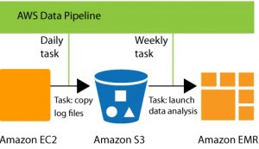

The following components of AWS Data Pipeline work together to manage your data:

► A pipeline definition specifies the business logic of your data management. For more information, see Pipeline Definition File Syntax.

► A pipeline schedules and runs tasks. You upload your pipeline definition to the pipeline, and

then activate the pipeline. You can edit the pipeline definition for a running pipeline and activate the pipeline again for it to take effect. You can deactivate the pipeline, modify a data source, and then activate the pipeline again. When you are finished with your pipeline, you can delete it.

► Task Runner polls for tasks and then performs those tasks. For example, Task Runner could copy log files to Amazon S3 and launch Amazon EMR clusters. Task Runner is installed and runs automatically on resources created by your pipeline definitions. You can write a custom task runner application, or you can use the Task Runner application that is provided by AWS Data Pipeline. For more information, see Task Runners.

1. What is Amazon Kinesis Firehose?

Amazon Kinesis Firehose is a fully managed service for delivering real-time streaming data to destinations such as Amazon Simple Storage Service (Amazon S3) and Amazon Redshift.

1. What Is Amazon CloudSearch and its features?

Amazon CloudSearch is a fully managed service in the cloud that makes it easy to set up, manage, and scale a search solution for your website or application.

You can use Amazon CloudSearch to index and search both structured data and plain text. Amazon CloudSearch features:

► Full text search with language-specific text processing

► Boolean search

► Prefix searches

► Range searches

► Term boosting

► Faceting

► Highlighting

► Autocomplete Suggestions

1. What is Regions and Endpoints in AWS?

To reduce data latency in your applications, most Amazon Web Services products allow you to select a regional endpoint to make your requests. An endpoint is a URL that is the entry point for a web service. For example, https://dynamodb.us-west-2.amazonaws.com is an entry point for the Amazon DynamoDB service.

Some services, such as IAM, do not support regions; their endpoints therefore do not include a

region. A few services, such as Amazon EC2, let you specify an endpoint that does not include a specific region, for example, https://ec2.amazonaws.com. In that case, AWS routes the endpoint to us-east-1.

1. **How** **to** **find** **your** **regions** **and** **Availability** **Zones** **using** **the** **Amazon** **EC2** **CLI?**

Use the ec2-describe-regions command as follows to describe your regions. PROMPT> ec2-describe-regions

REGION us-east-1 ec2.us-east-1.amazonaws.com

REGION ap-northeast-1 ec2.ap-northeast-1.amazonaws.com REGION ap-southeast-1 ec2.ap-southeast-1.amazonaws.com

1. 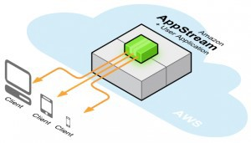What is Amazon AppStream and advantage of using AppStreaming? Amazon AppStream is an application streaming service that lets you stream your existing resource-intensive applications from the cloud without code modifications.

Advantages of Streaming Your Application :

Interactively streaming your application from the cloud provides several benefits:

► Remove Device Constraints – You can leverage the compute power of AWS to deliver experiences that wouldn’t normally be possible due to the GPU, CPU, memory or physical storage constraints of local devices.

► Support Multiple Platforms – You can write your application once and stream it to multiple device platforms. To support a new device, just write a small client to connect to your streaming application.

► Fast and Easy Updates – Because your streaming application is centrally managed by Amazon AppStream, updating your application is as simple as providing a new version of your streaming application to Amazon AppStream. You can immediately upgrade all of your customers without any action on their part.

► Instant On – Streaming your application with Amazon AppStream lets your customers start using your application or game immediately, without the delays associated with large file downloads and time-consuming installations.

► Improve Security – Unlike traditional boxed software and digital downloads, where your application is available for theft or reverse engineering, Amazon AppStream stores your streaming application binary securely in AWS datacenters.

► Automatic Scaling – You can use Amazon AppStream to specify capacity needs, and then the service automatically scales your streamed application and connects customers’ devices to it.

1. Which AWS responsible for managed email and calendaring?

WorkMail is a managed email and calendaring service with strong security controls and support for existing desktop and mobile email clients. You can access their email, contacts, and calendars wherever you use Microsoft Outlook, your browser, or your iOS and Android mobile devices. You can integrate Amazon WorkMail with your existing corporate directory and control both the keys that encrypt your data and the location where your data is stored.

1. What are the benefits of EBS vs. instance-store?

► EBS backed instances can be set so that they cannot be (accidentally) terminated through the API.

► EBS backed instances can be stopped when you’re not using them and resumed when you need them again (like pausing a Virtual PC), at least with my usage patterns saving much more money than I spend on a few dozen GB of EBS storage.

► EBS backed instances don’t lose their instance storage when they crash (not a requirement for all users, but makes recovery much faster)

► You can dynamically resize EBS instance storage.

► You can transfer the EBS instance storage to a brand new instance (useful if the hardware at Amazon you were running on gets flaky or dies, which does happen from time to time)

► It is faster to launch an EBS backed instance because the image does not have to be fetched from S3.

1. How you will find out the instance id from within an ec2 machine?

wget -q -O – <http://instance-data/latest/meta-data/instance-id>

If you need programatic access to the instance ID from within a script die() { status=$1; shift; echo “FATAL: $*”; exit $status; }

EC2_INSTANCE_id=”`wget -q -O – <http://instance-data/latest/meta-data/instance-id> || die

\”wget instance-id has failed: $?\”`”

1. How do you pass custom environment variable on Amazon Elastic Beanstalk (AWS EBS)?

As a heads up to anyone who uses the .ebextensions/*.config way: nowadays you can add, edit and remove environment variables in the Elastic Beanstalk web interface.

The variables are under Configuration ? Software Configuration:

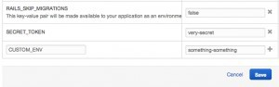

1. Is it possible to use AWS as a web host? What are the way of using AWS as a web host?

Yes it is completely possible to host websites on AWS in 2 ways:

► Easy – S3 (Simple Storage Solution) is a bucket storage solution that lets you serve static content e.g. images but has recently been upgraded so you can use it to host flat .html files and your site will get served by a default Apache installation with very little configuration on your part (but also little control).

► Trickier – You can use EC2 (Elastic Compute Cloud) and create a virtual Linux instance then install Apache/NGinx (or whatever) on that to give you complete control over serving whatever/however you want. You use SecurityGroups to enable/disable ports for individual machines or groups of them.

1. **How** **step** **you** **follow** **to** **make** **10,000** **files** **as** **public** **in** **S3?**

I will generate a bucket policy which gives access to all the files in the bucket. The bucket policy can be added to a bucket through AWS console.

{

“Id”: “…”,

“Statement”: [ {

“Sid”: “…”, “Action”: [ “s3:GetObject”

],

“Effect”: “Allow”,

“Resource”: “arn:aws:s3:::bucket/*”, “Principal”: {

“AWS”: [ “*” ]

}

} ]

}

1. **How** **do** **you** **see** **how** **much** **disk** **space** **is** **using** **by** **S3** **bucket?**

s3cmd can show you this by running s3cmd du, optionally passing the bucket name as an argument.

1. What happens when I reboot an EC2 instance?

Rebooting an instance is like rebooting a PC. The hard disk isn’t affected. You don’t return to the image’s original state, but the contents of the hard disks are those before the reboot.

Rebooting isn’t associated with billing. Billing starts when you instantiate an image and stops when you terminate it. Rebooting in between hasn’t any effect.

1. Write down the command you will use to copy all files from one S3 bucket to another with s3cmd?

s3cmd sync s3://from/this/bucket/ s3://to/this/bucket/

1. **How** **you** **will** **change** **the** **root** **EBS** **device** **of** **my** **amazon** **EC2** **instance?**

► Stop the instance.

► Detach the root EBS volume.

► Attach the alternate EBS volume (as the root e.g. /dev/sda1)

► Start the instance.

► This presupposes that your alternate EBS volume is bootable, of course – it has to contain the bootable OS image.

1. **What** **is** **the** **difference** **between** **Amazon** **SNS** **and** **Amazon** **SQS?**

► Amazon SNS allows applications to send time-critical messages to multiple subscribers through a “push” mechanism, eliminating the need to periodically check or “poll” for updates.

► Amazon SQS is a message queue service used by distributed applications to exchange messages through a polling model, and can be used to decouple sending and receiving components—without requiring each component to be concurrently available.

1. How many objects you can put in a S3 bucket? is there a limit to the number of objects I can put in an S3 bucket?

Write, read, and delete objects containing from 1 byte to 5 terabytes of data each. The number of objects you can store is unlimited.

1. How to delete files recursively from an S3 bucket?

aws s3 rm –recursive s3://your_bucket_name/foo/

Or delete everything under the bucket:

aws s3 rm –recursive s3://your_bucket_name

If what you want is to actually delete the bucket, there is one-step shortcut: aws s3 rb –force s3://your_bucket_name

1. How to access/ping a server located on AWS?

Using UI:

In your security group:

► Click the inbound tab

► Create a custom ICMP rule

► Select echo request

► Use range 0.0.0.0/0 for everyone or lock it down to specific IPs

► Apply the changes

► and you’ll be able to ping.

Using cmd: To do this on the command line you can run:

► ec2-authorize -P icmp -t -1:-1 -s 0.0.0.0/0

1. What is the maximum length of a file-name in S3?

Names are the object keys. The name for a key is a sequence of Unicode characters whose UTF-8 encoding is at most 1024 bytes long.

### **Explain What Is S3?**

**Answer :**

S3 stands for Simple Storage Service. You can use S3 interface to store and retrieve any amount of data, at any time and from anywhere on the web.  For S3, the payment model is “pay as you go”.

09. What are regions and availability zones in Amazon EC2? Explain in brief.

Amazon EC2 is hosted in multiple locations world-wide. These locations are composed of regions and Availability Zones. Each region is a separate geographic area. Each region has multiple, isolated locations known as Availability Zones.

Each region is completely independent. Each Availability Zone is isolated, but the Availability Zones in a region are connected through low-latency links. The following diagram illustrates the relationship between regions and Availability Zones.

10. Explain how to Launch EC2 instance in an Availability Zone?

Each region is completely independent and each Availability Zone is isolated. When you view your resources, you’ll only see the resources tied to the region you have specified.

To launch a EC2 instance, you must select an AMI that’s in the same region (if the AMI is in another region then you can copy the AMI to the region you are using). Now select an  
Availability Zone or let AWS choose for you. After creating the EC2 instance, it will show up in selected Availability Zone.

11. How to Migrate an Instance to another Availability Zone?

You can migrate your EC2 instance from one Availability Zone to another. Following are the steps to migrate an Instance to another Availability Zone.

1. Create an AMI from the running instance
2. Launch an instance from the AMI that you just created, specify the new Availability Zone
3. You can use the same instance type as the original instance, or select a new instance type
4. If the original instance has an associated Elastic IP address, then associate it with the new instance
5. If the original instance is a Reserved Instance, change the Availability Zone for your reservation

12. What is Amazon EC2 Root Device Volume?

When you launch an instance, the Root Device Volume contains the image used to boot the instance.  
You can launch an instance from one of two types of AMIs:

1. Instance store-backed AMI
2. EBS based storage

13. How to persist Root Device Volume in Amazon EC2 Instance?

By default, the root device volume for an AMI backed by Amazon EBS is deleted when the instance terminates. To change the default behavior, set the DeleteOnTermination attribute to false using a block device mapping.

**To change the root device volume of an instance to persist at launch using the console**

1. Open the Amazon EC2 console.
2. From the Amazon EC2 console dashboard, click Launch Instance.
3. On the Choose an Amazon Machine Image (AMI) page, choose the AMI to use and click Select.
4. Follow the wizard to complete the Choose an Instance Type and Configure Instance Details pages.
5. On the Add Storage page, deselect the Delete On Termination check box for the root volume.
6. Complete the remaining wizard pages, and then click Launch.

**Changing the Root Volume of an Instance to Persist Using the AWS CLI**  
Use the run-instances command to preserve the root volume by including a block device mapping that sets its DeleteOnTermination attribute for to false.

$ aws ec2 run-instances –image-id ami-1a2b3c4d –block-device-mappings ‘[{"DeviceName":"/dev/sda1","Ebs":{"DeleteOnTermination":false}}]‘

14. What is Key Pair?

AWS uses public-key cryptography to secure the login information for your instance. A Linux instance has no password; you use a key pair to log in to your instance securely.  
You specify the name of the key pair when you launch your instance, then provide the private key when you log in using SSH.

15. How to create Key Pair?

We can create one using the Amazon EC2 console. To launch instances in multiple regions, we’ll need to create a key pair in each region.  
**Following are the steps to create Key Pair:**

1. Sign in to Amaon Web Service.
2. From the AWS dashboard, choose EC2 to open the Amazon EC2 console.
3. From the navigation bar, select a region for the key pair.
4. In the left navigation pane, under **NETWORK & SECURITY**, click Key **Pairs**.
5. Click Create **Key Pair**.
6. Enter a name for the new key pair in the **Key pair name** field of the **Create Key Pair**dialog box, and then click **Create**.
7. The private key file is automatically downloaded by your browser. The base file name is the name you specified as the name of your key pair, and the file name extension is .pem.

16. What is the use of Key Pair?

Key pair is used to log in to your instance securely. This is public-key cryptography to secure the login information for your instance.

17. What is Security Group in Amazon EC2?

Security groups act as a firewall for associated instances, controlling both inbound and outbound traffic at the instance level.

18. What are the features of Security Group in Amazon EC2?

**Following are the features of the Security Group in Amazon EC2:**

1. We can add rules to a security group that enable us to connect to our instance from our IP address using SSH.
2. We can also add rules that allow inbound and outbound HTTP and HTTPS access from anywhere.

19. How to create Security Group in Amazon EC2?

We can create Security Group in Amazon EC2 using the Amazon EC2 console. To launch instances in multiple regions, we’ll need to create a Security Group in each region.  
**Following are the steps to create Security Group in Amazon EC2:**

1. Open the Amazon EC2 console.
2. From the left navigation bar, select a region for the security group.
3. Click **Security Groups** in the navigation pane.
4. Click **Create Security Group**.
5. Enter a name for the new security group and a description.
6. In the **VPC** list, select your VPC.
7. On the **Inbound** tab, click **Add Rule** for each new rule, and then click **Create**.

20. How to launch an Amazon EC2 Instance?

We can launch Linux/Windows Amazon EC2 instance using AWS Management Console. Following are the steps to create Amazon EC2 instance.

1. Open the Amazon EC2 console.
2. From the console dashboard, choose Launch Instance.
3. Choose an Amazon Machine Image (AMI).
4. Choose an Instance Type.
5. Click on Review and Launch to let the wizard complete the other configuration setting.
6. On the Review Instance Launch page, under Security Groups select a Security Group.
7. Click on Launch on the Review Instance Launch.
8. Select an Existing ket pair when it prompte for key pair.
9. Click on View Instance to return on the console to see instance is launching.

21. How to connect to your Amazon EC2 Instance?

There are several ways to connect to a Linux instance. One of the commonly used method is to connect Linux instance from Windows local machine using PuTTY.

**Following are the steps to connect to a Linux instance.**

1. Install PuTTY on your local machine.
2. Get your instance ID.
3. Get the public DNS name of the instance.
4. Locate the private key.
5. Enable inbound SSH traffic from your IP address to your instance.
6. Converting Your Private Key Using PuTTYgen.
7. Starting a PuTTY Session.
8. Now you are connected to your EC2 instance.

22. How to add a EBS Volume to your Amazon EC2 Instance?

We can attach an EBS volume to one of our instances that is in the same Availability Zone as the Volume.  
**Following are the steps to attache an EBS volumn to an instance using console:**

1. Open the Amazon EC2 console at https://console.aws.amazon.com/ec2/.
2. In the left navigation pane, choose **Volumes**.
3. Select a volume and choose **Attach Volume**.
4. Select the instance to which you want to attach the volume.
5. Click on **Attach**.
6. Now connect to your instance and make the volume available.

23. How to clean up your Amazon EC2 Instance and Volume?

After we are finished with the instance we created, we can clean up by terminating the instance.  
**Following are the steps to terminate the EC2 instance:**

1. In the navigation pane, choose Instances. In the list of instances, select the instance.
2. Choose Actions, then Instance State, and then choose Terminate.
3. Choose Yes,Terminate when prompted for confirmation.

24. What are the best practices for Amazon EC2?

To get the maximum benefit from and satisfaction with Amazon EC2. There are mainly four best practices.

1. **Security and Network Best Practices**
2. **Storage**
3. **Resource Management**
4. **Backup and Recovery**

25. How to create your own Amazon Machine Image (AMI)?

You can customize a instance that is launched from a public AMI and then save that configuration as a custom AMI for your own use.  
Instances that you launch from your AMI use all the customizations that you’ve made.

26. Explain types of storage for the Root Device and difference between them?

There are 2 types of storage for the Root Device, as either **backed by Amazon EBS** or **backed by Instance store**. he former means that the root device for an instance launched from the AMI is an Amazon EBS volume created from an Amazon EBS snapshot.  
This section summarizes the important differences between the two types of AMIs. The following table provides a quick summary of these differences.

|  |  |  |
| --- | --- | --- |
| **Characteristic** | **Amazon EBS-Backed** | **Amazon Instance Store-Backed** |
| Boot time | Usually less than 1 minute | Usually less than 5 minutes |
| Size limit | 16 TiB | 10 GiB |
| Root device volume | Amazon EBS volume | Instance store volume |
| Data persistence | By default, the root volume is deleted when the instance terminates.* Data on any other Amazon EBS volumes persists after instance termination by default. Data on any instance store volumes persists only during the life of the instance. | Data on any instance store volumes persists only during the life of the instance. Data on any Amazon EBS volumes persists after instance termination by default. |
| Upgrading | The instance type, kernel, RAM disk, and user data can be changed while the instance is stopped. | Instance attributes are fixed for the life of an instance. |
| Charges | You’re charged for instance usage, Amazon EBS volume usage, and storing your AMI as an Amazon EBS snapshot. | You’re charged for instance usage and storing your AMI in Amazon S3. |
| AMI creation/bundling | Uses a single command/call | Requires installation and use of AMI tools |
| Stopped state | Can be placed in stopped state where instance is not running, but the root volume is persisted in Amazon EBS | Cannot be in stopped state; instances are running or terminated |

27. How to determine the Root Device type of your AMI?

We can determine the Root Device type of AMI using following 2 methods.  
Method 1: Following are the steps to determine the Root Device type of an AMI using the console  
1. Open the Amazon EC2 console  
2. In the navigation pane, click **AMIs**, and select the AMI  
3. Check the value of **Root Device Type** in the Details tab as follows  
3.1 If the value is **ebs**, this is an Amazon EBS-backed AMI  
3.2 If the value is **instance store**, this is an instance store-backed AMI

Method 2: Following are the steps to determine the root device type of an AMI using the command line  
We can use one of the following commands.  
1. describe-images (AWS CLI)  
2. Get-EC2Image (AWS Tools for Windows PowerShell)

28. What is the size limit for Amazon EC2 instance store-backed AMIs and Amazon EBS-backed AMIs?

All AMIs are categorized as either backed by Amazon EBS or backed by instance store.

**Backed by Amazon EBS** – means that the root device for an instance launched from the AMI is an Amazon EBS volume created from an Amazon EBS snapshot.

**Backed by instance store** – means that the root device for an instance launched from the AMI is an instance store volume created from a template stored in Amazon S3.

**Root device size limit for** –  
Amazon EBS – Backed is 16 TiB  
Amazon Instance Store-Backed is 10 GiB

29. How you’re charged in Amazon EC2? Explain in detail.

Charges varies upon AMIs backed and storage volums.

AMIs backed by instance storage charged for: **AMI storage + Instance usage**  
AMIs backed by Amazon EBS storage charged for: **Volume storage + Usage in addition to the AMI + instance usage**

When an Amazon EBS-backed instance is stopped, you are not charged for instance usage, but you are **still charged for volume storage**.

AWS charges a full instance hour for every transition from a stopped state to a running state, even if we transition the instance multiple times within a single hour.  
For example: if hourly instance charge for your instance is $0.10 and if you were to run that instance for one hour without stopping it, you would be charged $0.10. If you stopped and restarted that instance twice during that hour, then you would be charged $0.30 for that hour of usage (the initial $0.10, plus 2 x $0.10 for each restart).

30. What is shared AMI?

A shared AMI is an AMI that a developer created and made available for other developers to use.  
One of the easiest ways to get started with Amazon EC2 is to use a shared AMI that has the components you need and then add custom content. You can also create your own AMIs and share them with others.

**Note**: Use a shared AMI at your own risk. Amazon can’t vouch for the integrity or security of AMIs shared by other Amazon EC2 users. AWS recommends that you get an AMI from a trusted source.

31. How to update AMI tools at Boot Time?

AWS recommends that your AMIs download and upgrade the Amazon  
EC2 AMI creation tools during startup. This ensures that new AMIs based on your shared AMIs have the latest AMI tools.

For Amazon Linux, add the following to /etc/rc.local:

# Update the Amazon EC2 AMI tools  
echo ” + Updating EC2 AMI tools”  
yum update -y aws-amitools-ec2  
echo ” + Updated EC2 AMI tools”

32. How to disable Password-Based Logins for Root in Amazon EC2 Instance?

Using a fixed root password for a public AMI is a security risk that can quickly become known. Even relying on users to change the password after the first login opens a small window of opportunity for potential abuse.

Following are the steps to disable password-based remote logins for the root user.

1.Open the /etc/ssh/sshd_config file with a text editor and locate the following line:  
#PermitRootLogin yes

2. Change the line to:  
PermitRootLogin without-password

The location of this configuration file might differ for your distribution.

33. What is Public Key Credentials and how to install it?

Amazon EC2 uses public–key cryptography to encrypt and decrypt login information. Public–key cryptography uses a public key to encrypt a piece of data, such as a password, then the recipient uses the private key to decrypt the data. The public and private keys are known as a key pair.

After configuring the AMI to prevent logging in using a password, you must make sure users can log in using another mechanism.

1. **What Is The Relation Between Instance And Ami?**

We can launch different types of instances from a single AMI. An instance type essentially determines the hardware of the host computer used for your instance. Each instance type offers different compute and memory capabilities.

After we launch an instance, it looks like a traditional host, and we can interact with it as we would do with any computer. We have complete control of our instances; we can use sudo to run commands that require root privileges.

1. **Explain Storage For Amazon Ec2 Instance.?**

Amazon EC2 provides many data storage options for your instances. Each option has a unique combination of performance and durability. These storages can be used independently or in combination to suit your requirements.

**There are mainly four types of storages provided by AWS:**

**Amazon EBS:**Its durable, block-level storage volumes  can attached in running Amazon EC2 instance. The Amazon EBS volume persists independently from the running life of an Amazon EC2 instance. After an EBS volume is attached to an instance, you can use it like any other physical hard drive. Amazon EBS encryption feature supports encryption feature.

**Amazon EC2 Instance Store:** Storage disk that is attached to the host computer is referred to as instance store. The instance storage provides temporary block-level storage for Amazon EC2 instances. The data on an instance store volume persists only during the life of the associated Amazon EC2 instance; if you stop or terminate an instance, any data on instance store volumes is lost.

**Amazon S3:** Amazon S3 provides access to reliable and inexpensive data storage infrastructure. It is designed to make web-scale computing easier by enabling you to store and retrieve any amount of data, at any time, from within Amazon EC2 or anywhere on the web.

**Adding Storage:** Every time you launch an instance from an AMI, a root storage device is created for that instance. The root storage device contains all the information necessary to boot the instance. You can specify storage volumes in addition to the root device volume when you create an AMI or launch an instance using block device mapping.

### **Explain What Is Ami?**

**Answer :**

AMI stands for Amazon Machine Image.  It’s a template that provides the information (an operating system, an application server and applications) required to launch an instance, which is a copy of the AMI running as a virtual server in the cloud.  You can launch instances from as many different AMIs as you need.

### **What Does An Ami Include?**

**Answer :**

**An AMI includes the following things:**

* 1. A template for the root volume for the instance
  2. Launch permissions decide which AWS accounts can avail the AMI to launch instances
  3. A block device mapping that determines the volumes to attach to the instance when it is launched.

### **How Can You Send Request To Amazon S3?**

**Answer :**

Amazon S3 is a REST service, you can send request by using the REST API or the AWS SDK wrapper libraries that wrap the underlying Amazon S3 REST API.

### **Mention What Is The Difference Between Amazon S3 And Ec2?**

**Answer :**

**The difference between EC2 and Amazon S3 is that:**

**EC2:**

* 1. It is a cloud web service used for hosting your application
  2. It is like a huge computer machine which can run either Linux or Windows and can handle application like PHP, Python, Apache or any databases.

**S3:**

* 1. It is a data storage system where any amount of data can be stored
  2. It has a REST interface and uses secure HMAC-SHA1 authentication keys.

### **How Many Buckets Can You Create In Aws By Default?**

**Answer :**

By default, you can create upto 100 buckets in each of your AWS accounts.

### **Explain Can You Vertically Scale An Amazon Instance? How?**

**Answer :**

**Yes, you can vertically scale on Amazon instance. For that:**

* 1. Spin up a new larger instance than the one you are currently running
  2. Pause that instance and detach the root webs volume from the server and discard
  3. Then stop your live instance and detach its root volume
  4. Note the unique device ID and attach that root volume to your new server
  5. And start it again

**1. Explain Elastic Block Storage?  What type of performance can you expect?  How do you back it up?  How do you improve performance?**

EBS is a virtualized SAN or storage area network.  That means it is RAID storage to start with so it's redundant and fault tolerant.  If disks die in that RAID you don't lose data.  Great!  It is also virtualized, so you can provision and allocate storage, and attach it to your server with various API calls.  No calling the storage expert and asking him or her to run specialized commands from the hardware vendor.

Performance on EBS can exhibit variability.  That is it can go above the SLA performance level, then drop below it.  The SLA provides you with an average disk I/O rate you can expect.  This can frustrate some folks especially performance experts who expect reliable and consistent disk throughput on a server.  Traditional physically hosted servers behave that way.  Virtual AWS instances do not.

Backup EBS volumes by using the snapshot facility via API call or via a GUI interface like elasticfox.

Improve performance by using Linux software raid and striping across four volumes.

**2. What is S3?  What is it used for?  Should encryption be used?**

S3 stands for Simple Storage Service.  You can think of it like ftp storage, where you can move files to and from there, but not mount it like a filesystem.  AWS automatically puts your snapshots there, as well as AMIs there.  Encryption should be considered for sensitive data, as S3 is a proprietary technology developed by Amazon themselves, and as yet unproven vis-a-vis a security standpoint.

**5. What is auto-scaling?  How does it work?**

Autoscaling is a feature of AWS which allows you to configure and automatically provision and spinup new instances without the need for your intervention.  You do this by setting thresholds and metrics to monitor.  When those thresholds are crossed a new instance of your choosing will be spun up, configured, and rolled into the load balancer pool.  Voila you've scaled horizontally without any operator intervention!

**7. What is configuration management?  Why would I want to use it with cloud provisioning of resources?**

Configuration management has been around for a long time in web operations and systems administration.  Yet the cultural popularity of it has been limited.  Most systems administrators configure machines as software was developed before version control - that is manually making changes on servers.  Each server can then and usually is slightly different.  Troubleshooting though is straightforward as you login to the box and operate on it directly.  Configuration management brings a large automation tool into the picture, managing servers like strings of a puppet.  This forces standardization, best practices, and reproducibility as all configs are versioned and managed.  It also introduces a new way of working which is the biggest hurdle to its adoption.

Enter the cloud, and configuration management becomes even more critical.  That's because virtual servers such as amazons EC2 instances are much less reliable than physical ones.  You absolutely need a mechanism to rebuild them as-is at any moment.  This pushes best practices like automation, reproducibility and disaster recovery into center stage.

**8. Explain how you would simulate perimeter security using Amazon Web Services model?**

Traditional perimeter security that we're already familiar with using firewalls and so forth is not supported in the Amazon EC2 world.  AWS supports security groups.  One can create a security group for a jump box with ssh access - only port 22 open.  From there a webserver group and database group are created.  The webserver group allows 80 and 443 from the world, but port 22 *only* from the jump box group.  Further the database group allows port 3306 from the webserver group and port 22 from the jump box group.  Add any machines to the webserver group and they can all hit the database.  No one from the world can, and no one can directly ssh to any of your boxes.

**1) What is AWS?**

### **Ans:**AWS (Amazon Web Services) is a platform which provides secure cloud services, database storage, offerings to compute power, content delivery among other services to help business level and develop. What is AWS?

Amazon Web Services (AWS) is a cloud services platform.It provides services for different functionalities such as a resources,database,networking.

What are the main components of AWS?

* ***Route53***     Route53 is a feature rich domain name service (DNS) web service
* ***Simple Email Service*** It allows you to send emails without running your own email infrastructure.
* ***Identity and Access Management***provides security and identity management for AWS account.
* ***Simple storage service*** (S3) is a storage device.
* ***Elastic Compute Cloud (EC2)*** provides on demand computing resources.It is the main component of AWS.
* ***Elastic block store (EBS)*** provides persist storage volumes which attach to EC2 instances and allows to persist data after the lifespan of a single EC2
* ***CloudWatch*** provides monitoring for AWS resources and enables to view and collect key metrics and also notifies in case of trouble

What is Amazon EC2?

Amazon Elastic Compute Cloud (Amazon EC2) is a main part of amazon’s cloud computing platform.EC2 provides a web service through which users can configure virtual machine or instance.So EC2 provides an abstraction of resources.

What is Amazon Machine Image or AMI?

Amazon Machine Image is used to launch an instance.It contains information about the instance such as operating system,application server.You can create an AMI or use the default one.

What is a bucket?

Bucket is logical storage unit in Amazon S3 .Every object in Amazon S3 is stored in a bucket. Before data can be stored in S3,bucket must be created.

How do you manage security in AWS?

Security is managed by using the Cloud computing security service.Also you can choose the specific data centers across different geographies.Following are some of the guidelines related to security:

* By restricting access to ports of the instance
* By using AWS Identity and Access Management (IAM)

**2) What is auto-scaling?  How does it work?**

**Ans:**Auto scaling is a feature of AWS which enables you to configure and immediately provision and spin up new situations without any need of intervention. You need to do this by mounting thresholds and metrics to watch.  When individually these thresholds are met, a completely new occasion of a person's selection will most likely be spun up, configured, and folded into the load balancer pool.  Voila, you have scaled horizontally witout any operator intervention!

**3) What is an AMI?  How do I build one?**

**Ans:**AMI denotes Amazon Machine Image.  It is definitely a picture of the source file system. Useful hardware, servers have bios that denote the master boot record from the first slab on a disk.  A disk image, although can sit actually on a disk, Linux can boot from an absolute location on the EBS storage network.

Build a new AMI by first rotating up an example from a trusted AMI then add packages and components required.  Be cautious of placing sensitive data on an AMI. For example, access credentials of yours should be added to an instance after spinup with a database, position an external volume that operates your MySQL data after spinup as well.

**5) What is Amazon S3?**

**Ans:**Amazon S3 (Simple Storage Service) is an object storage with a simple web service interface to store and retrieve any amount of data from anywhere on the web.

**6) What is SimpleDB?**

**Ans:**It is a structured data store that supports indexing and data queries to both EC2 and S3.

**7) What is the type of architecture, where half of the workload is on the public load while the other half is on the local storage?**

**Ans:**Hybrid Cloud Architecture.

**8) How can you send a request to Amazon S3?**

**Ans:** You can send the request by using the REST API or the AWS SDK wrapper libraries that wrap the underlying Amazon S3 REST API.

**9) How many buckets can be created in AWS by default?**

**Ans:**By default, 100 buckets can be created.

**10) Should encryption be used for S3?**

**Ans:**Encryption should be considered for sensitive data as S3 is a proprietary technology.

**11) What are the various AMI design options?**

**Ans:**Fully Baked AMI, JeOS (just enough operating system) AMI, and Hybrid AMI.

**12) What is Geo Restriction in CloudFront?**

**Ans:**Geo-restriction, also known as geoblocking, is used to prevent users in specific geographic locations from accessing content that you’re distributing through a CloudFront web distribution.

**13) Explain T2 instances?**

**Ans:**T2 instances are designed to provide moderate baseline performance and the capability to burst to higher performance as required by workload.

**14) What is AWS Lambda?**

**Ans:** AWS Lambda is a compute service that lets you run code in the AWS Cloud without provisioning or managing servers.

**15) What is a Serverless application in AWS?**

**Ans:**The AWS Serverless Application Model (AWS SAM) extends AWS CloudFormation to provide a simplified way of defining the Amazon API Gateway APIs, AWS Lambda functions, and Amazon DynamoDB tables needed by your serverless application.

**16) What is the use of Amazon ElastiCache?**

**Ans:**Amazon ElastiCache is a web service that makes it easy to deploy, operate, and scale an in-memory data store or cache in the cloud.

**17) Differentiate between stopping and terminating an instance.**

**Ans:**When an instance is stopped, it performs a normal shutdown and then transitions to a paused state. When an instance is terminated, it performs a normal shutdown, then the attached Amazon EBS volumes are deleted unless the volume’s deleteOnTermination attribute is set to false.

**18) Is it possible to change the private IP addresses of an EC2 while it is running/stopped in a VPC?**

**Ans:**The primary private IP address cannot be changed. However, secondary private addresses can be unassigned, assigned or moved between interfaces or instances at any point.

**19) Give one instance where you would prefer Provisioned IOPS over Standard RDS storage?**

**Ans:**This can happen when you have batch-oriented workloads.

**20) What is the importance of buffer in Amazon Web Services?**

**Ans:**An Elastic Load Balancer ensures that the incoming traffic is distributed optimally across various AWS instances.  A buffer will synchronize different components and makes the arrangement additional elastic to a burst of load or traffic. The components are prone to work in an unstable way of receiving and processing the requests. The buffer creates the equilibrium linking various apparatus and crafts them effort at the identical rate to supply more rapid services.

**21) What is the way to secure data for carrying in the cloud?**

**Ans:**One thing must be ensured that no one should seize the information in the cloud while data is moving from point one to another and also there should not be any leakage with the security key from several storerooms in the cloud. Segregation of information from additional companies’ information and then encrypting it by means of approved methods is one of the options.

**22) Name the several layers of Cloud Computing.**

**Ans:**Here is a list of layers of the cloud computing

1) **PaaS** – Platform as a Service

2) **IaaS**– Infrastructure as a Service

3) **SaaS**– Software as a Service

**23) What are the components involved in Amazon Web Services?**

**Ans:**There are 4 components involved, which are as follows.

1) **S3**: with this, one can retrieve the key information which is occupied in creating cloud structural design and amount of produced information also can be stored in this component that is the consequence of the key specified.

2) **Amazon EC2**instance: helpful to run a large distributed system on the Hadoop cluster. Automatic parallelization and job scheduling can be achieved by this component.

3) **Amazon SQS:** this component acts as a mediator between different controllers. Also worn for cushioning requirements those are obtained by the manager of Amazon.

4) **Amazon SimpleDB:** helps in storing the transitional position log and the errands executed by the consumers.

**24) Distinguish between scalability and flexibility?**

**Ans:**The aptitude of any scheme to enhance the tasks on hand to its present hardware resources to grip inconsistency in command is known as scalability. This capability to augment the tasks on hand to its present and supplementary hardware property is recognized as flexibility. This enables the industry to summon command without putting in the infrastructure at all.  AWS has several configuration management solutions for AWS scalability, flexibility, availability and management.

**25) Name the various layers of the cloud architecture?**

**Ans:**The 5 layers of cloud architecture are listed below:-

1) **CC**- Cluster Controller

2) **SC**- Storage Controller

3) **CLC**- Cloud Controller

4) **Walrus**

5) **NC**- Node Controller

**26) Which automation gears can help with spinup services?**

**Ans:**The API tools can be both used for spinup services and the written scripts. These scripts could be coded in Perl, bash or other languages of preference. The other option is that of patterned administration and stipulating tools such as a dummy or improved descendant. A tool called Scalr can also be used and we can go with a controlled explanation like a RightScale.

**27) How do the processes start, stop and terminate works?**

**Ans:**Starting and stopping of an instance: If an instance gets stopped or ended, the instance functions a usual power cut and then changes over to a clogged position. You can establish the case afterward since all the EBS volumes of Amazon remain attached. If an instance is in stopping state, then you will not get charged for additional instance.

Finishing the instance: If an instance gets terminated it tends to perform a typical blackout, so the EBS volumes which are attached will get removed except the volume’s deleteOnTermination characteristic is set to zero. In such cases, the instance will get removed and cannot set it up afterward.

**28) What is Amazon EC2 service?**

**Ans:**Amazon Elastic Compute Cloud (Amazon EC2) is an Amazon Web service that provides resizable (scalable) computing capacity in the cloud. You can configure security and networking as well as manage storage. It also helps in obtaining and configuring capacity using minimal friction. You can use it to launch as many virtual servers as you need.

**29) Compare AWS and OpenStack?**

**Ans:**

|  |  |  |
| --- | --- | --- |
| Criteria | AWS | OpenStack |
| License | Amazon proprietary | Open Source |
| Operating System | Whatever cloud administrator provides | Whatever AMIs provided by AWS |
| Performing repeatable operations | Through templates | Through text files |

**30) What are the features of the Amazon EC2 service?**

**Ans:**Amazon EC2 provides the following features:

a) Virtual computing environment (known as instances)

b) Pre-configured templates for your instances (known as Amazon Machine Images – **AMIs**)

c) Amazon Machine Images **(AMIs)** is a complete package that you need for your server (including the operating system and additional software)

d) It provides various configurations of CPU, memory, storage and networking capacity for your instances (known as instance type)

e) It provides secure login information for your instances using key pairs (AWS stores the public key and you can store the private key in a secure place)

f) Storage volumes of temporary data is deleted when you stop or terminate your instance (known as instance store volumes)

g) It provides persistent storage volumes (using Amazon Elastic Block Store – **EBS**)

h) A firewall that enables you to specify the protocols, ports, and source IP ranges that can reach your instances using security groups

i) Static IP addresses for dynamic cloud computing (known as Elastic IP address)

j) It provides metadata (known as tags)

k) It provides virtual networks that are logically isolated from the rest of the **AWS CLOUD**, and that you can optionally connect to your own network (known as virtual private clouds – **VPCs**)

### **While Connecting To Your Instance What Are The Possible Connection Issues One Might Face?**

**The possible connection errors one might encounter while connecting instances are:**

* Connection timed out
* User key not recognized by the server
* Host key not found, permission denied
* Unprotected private key file
* Server refused our key or No supported authentication method available
* Error using MindTerm on Safari Browser
* Error using Mac OS X RDP Client

**31) What is Amazon Machine Image (AMI)?**

**Ans:**An Amazon Machine Image **(AMI)** is a template that contains a software configuration (for example, an operating system, an application server, and applications). From an **AMI**, we launch an instance, which is a copy of the **AMI** running as a virtual server in the cloud. We can even launch multiple instances of an **AMI.**

**32) What is the relation between Instance and AMI?**

**Ans:**We can launch different types of instances from a single AMI. An instance type essentially determines the hardware of the host computer used for your instance. Each instance type offers different compute and memory capabilities.

After we launch an instance, it looks like a traditional host, and we can interact with it as we would do with any computer. We have complete control of our instances; we can use it to run commands that require root privileges.

**34) What are the Security Best Practices for Amazon EC2?**

There are several best practices for secure Amazon EC2. Following are few of them:-

1) Use AWS Identity and Access Management (IAM) to control access to your AWS resources.

2) Restrict access by only allowing trusted hosts or networks to access ports on your instance.

3) Review the rules in your security groups regularly, and ensure that you apply the principle of least

4) Privilege — only open up permissions that you require.

5) Disable password-based logins for instances launched from your AMI. Passwords can be found or cracked, and are a security risk.

**35) Explain Elastic Block Storage. What type of performance can you expect?  How do you back it up?  How do you improve performance?**

**Ans:**EBS is a virtualized SAN or storage area network.  That means it is RAID storage to start with, so it’s redundant and faults tolerant.  If disks die in that RAID you don’t lose data. It is also virtualized, so you can provision and allocate storage, and attach it to your server with various API calls.  No calling the storage expert and asking him or her to run specialized commands from the hardware vendor.

Performance on EBS can exhibit variability.  That is, it can go above the SLA performance level then, drop below it.  The SLA provides you with an average disk I/O rate you can expect.  This can frustrate some folks, especially performance experts who expect reliable and consistent disk throughout on a server.  Traditional physically hosted servers behave that way.  Virtual AWS instances do not.

Backup EBS volumes by using the snapshot facility via API call or via a GUI interface like elasticfox. Improve performance by using Linux software raid and striping across four volumes.

**36) What is S3?  What is it used for?  Should encryption be used?**

**Ans: S3** stands for Simple Storage Service.  You can think of it like FTP storage, where you can move files to and from there, but not mount it like a filesystem.  AWS automatically puts your snapshots there, as well as AMIs there.  Encryption should be considered for sensitive data, as AWS S3 is a proprietary technology developed by Amazon themselves, and as yet unproven vis-a-vis a security standpoint.

**37)  What automation tools can I use to spin up servers?**

**Ans:**The most obvious way is to roll-your-own scripts and use the AWS API tools.  Such scripts could be written in bash, Perl or another language of preference. The next option is to use a configuration management and provisioning tools like Opscode Chef or Scalr. Lastly, you can go with a managed solution such as RightScale.

**38) What is configuration management?  Why would I want to use it with cloud provisioning of resources?**

**Ans:**Configuration management has been around for a long time in web operations and systems administration. Yet the cultural popularity of it has been limited.  Most systems administrators configure machines as the software was developed before version control – that is manually making changes on servers.  Each server can then and usually is slightly different.  Troubleshooting though is straightforward as you log in to the box and operate on it directly.  Configuration management brings a large automation tool in the picture, managing servers like strings of a puppet.  This forces standardization, best practices, and reproducibility as all configurations are versioned and managed.  It also introduces a new way of working which is the biggest hurdle to its adoption.

Once you enter the cloud, then configuration management becomes even more critical.  That’s because virtual servers such as Amazon's EC2 instances are much less reliable than physical ones.  You absolutely need a mechanism to rebuild them as-is at any moment.  This pushes best practices like automation, reproducibility and disaster recovery into center stage.

**39) Explain how you would simulate perimeter security using the Amazon Web Services model?**

**Ans:**Traditional perimeter security that we’re already familiar with using firewalls and so forth is not supported in the Amazon EC2 world.  AWS supports security groups.  One can create a security group for a jump box with ssh access – only port 22 open.  From there a web server group and database group are created.  The web server group allows 80 and 443 from the world, but port 22 *only* from the jump box group.  Further, the database group allows port 3306 from the web server group and port 22 from the jump box group.  Add any machines to the web server group and they can all hit the database.  No one from the world can, and no one can directly ssh to any of your boxes.

**40) How to use Amazon SQS?**

**Ans:**Amazon SQS (Simple Queue Service) is a message passing mechanism that is used for communication between different connectors that are connected with each other. It also acts as a communicator between various components of Amazon. It keeps all the different functional components together. This functionality helps different components to be loosely coupled, and provide an AWS architecture that is more failure resilient system.

**41) I have some private servers on my premises, also I have distributed some of my workloads on the public cloud, what is this architecture called?**

**Ans: A.** Virtual Private Network

**B.** Private Cloud

**C.** Virtual Private Cloud

**D.** Hybrid Cloud

Answer **D.**

Explanation: This type of architecture would be a hybrid cloud because we are using both, the public cloud and on-premises servers i.e the private cloud. To make this hybrid architecture easy to use, it’d be better if the private and public cloud were all on the same network(virtually). This is established by including your public cloud servers in a virtual private cloud and connecting this virtual cloud with your on-premise servers using a VPN (Virtual Private Network).

**42)  What does the following command do with respect to the Amazon EC2 security groups?**

**Ans:   A.** Groups the user created security groups into a new group for easy access.

**B.** Creates a new security group for use with your account.

**C.** Creates a new group inside the security group.

**D.** Creates a new rule inside the security group.

Answer **B.**

Explanation: A Security group is just like a firewall, it controls the inbound and outbound traffic in and out of your instance. The command mentioned says to create a security group, and its function is the same. Moving along, once your security group is created, you can add different rules to it. For example, you have an RDS instance, to access it, you have to add the public IP address of the machine from which you want to access the instance in its security group.

**43) You have a video transcoding application. The videos are processed according to a queue. If the processing of a video is interrupted in one instance, it is resumed in another instance. Currently, there is a huge back-log of videos which needs to be processed, for this you need to add more instances, but you need these instances only until your backlog is reduced. Which of these would be an efficient way to do it?**

**Ans:**You should be using an On Demand instance for the same. The reasons being, the workload has to be processed now, meaning it is urgent, secondly you don’t need them once your backlog is cleared, therefore Reserved Instance is out of the picture, and since the work is urgent, you cannot stop the work on your instance just because the spot price spiked, therefore Spot Instances shall also not be used. Hence On-Demand instances shall be the right choice in this case.

**44) You have a distributed application that periodically processes large volumes of data across multiple Amazon EC2 Instances. The application is designed to recover gracefully from Amazon EC2 instance failures. You are required to accomplish this task in the most cost-effective way?**

**Which of the following will meet your requirements?**

**Ans:   A.** Spot Instances

**B.** Reserved instances

**C.** Dedicated Instances

**D.** On-Demand Instances

Answer: **A**

Since the work we are addressing here is not continuous, a reserved instance shall be idle at times, same goes with On Demand instances. Also, it does not make sense to launch an On-Demand instance whenever work comes up since it is expensive. Hence Spot Instances will be the right fit because of their low rates and no long-term commitments.

**45) How is stopping and terminating an instance different from each other?**

**Ans:**Starting, stopping and terminating are the three states in an EC2 instance, let’s discuss them in detail:

**a)**Stopping and Starting an instance: When an instance is stopped, the instance performs a normal shutdown and then transitions to a stopped state. All of its Amazon EBS volumes remain attached, and you can start the instance again at a later time. You are not charged for additional instance hours while the instance is in a stopped state.

**b)**Terminating an instance: When an instance is terminated, the instance performs a normal shutdown, then the attached Amazon EBS volumes are deleted unless the volume’s deleteOnTermination attribute is set to false. The instance itself is also deleted, and you can’t start the instance again at a later time.

**46) If I want my instance to run on a single-tenant hardware, which value do I have to set the instance’s tenancy attribute to?**

**Ans:**  **A.** Dedicated

**B.** Isolated

**C.** One

**D.** Reserved

Answer **A.**

The Instance tenancy attribute should be set to Dedicated Instance. The rest of the values are invalid.

**47) When will you incur costs with an Elastic IP address (EIP)?**

**Ans:   A.** When an EIP is allocated.

**B.** When it is allocated and associated with a running instance.

**C.** When it is allocated and associated with a stopped instance.

**D.** Costs are incurred regardless of whether the EIP is associated with a running instance.

Answer **C.**

You are not charged, if only one Elastic IP address is attached to your running instance. But you do get charged under the following conditions:

• When you use more than one Elastic IPs with your instance.

• When your Elastic IP is attached to a stopped instance.

• When your Elastic IP is not attached to any instance.

**48) How is a Spot instance different from an On-Demand instance or Reserved Instance?**

**Ans:**Firstly, Spot Instance, On-Demand instance and Reserved Instances are all models for pricing. Moving along, spot instances provide the ability for customers to purchase compute capacity with no upfront commitment, at hourly rates usually lower than the On-Demand rate in each region. Spot instances are just like bidding, the bidding price is called Spot Price. The Spot Price fluctuates based on supply and demand for instances, but customers will never pay more than the maximum price they have specified. If the Spot Price moves higher than a customer’s maximum price, the customer’s EC2 instance will be shut down automatically. But the reverse is not true, if the Spot prices come down again, your EC2 instance will not be launched automatically, one has to do that manually.  In Spot and On-demand instance, there is no commitment for the duration from the user side, however in reserved instances, one has to stick to the time period that he has chosen.

**49) Are the Reserved Instances available for Multi-AZ Deployments?**

**Ans:   A.** Multi-AZ Deployments are only available for Cluster Compute instances types

**B.** Available for all instance types

**C.** Only available for M3 instance types

**D.** Not Available for Reserved Instances

Answer **B.**

Reserved Instances is a pricing model, which is available for all instance types in EC2.

**50) How to use the processor state control feature available on the c4.8xlarge instance?**

**Ans:**The processor state control consists of 2 states:

**a)**The C state – Sleep state varying from c0 to c6. C6 is the deepest sleep state for a processor

**b)** The P state – Performance state p0 being the highest and p15 being the lowest possible frequency.

The C state and P state are used as Processors have cores; these cores need thermal headroom to boost their performance. Since all the cores are on the processor the temperature should be kept at an optimal state so that all the cores can perform at the highest performance.

Now how will these states help in that? If a core is put into sleep state it will reduce the overall temperature of the processor and hence other cores can perform better. Now the same can be synchronized with other cores so that the processor can boost as many cores it can by timely putting other cores to sleep, and thus get an overall performance boost.

Concluding, the C and P state can be customized in some EC2 instances like the c4.8xlarge instance and thus you can customize the processor according to your workload.

**1. What are the differences among Spot instance, On-Demand instance, and Reserved Instances?**

All these instances are models for pricing. Spot instance powers the customers to acquire compute capacity without having any upfront commitment. The hourly rate of Spot instance is usually higher than the speed of the On-Demand instance. Both in Spot instance and On-Demand instance, the users, do not commit to any particular duration. However, there is a fixed period to which the users have to stick in the Reserved Instance.

**2. What are the network performance parameters that you should be expecting when you launch Instances in a cluster placement group?**

The network performance depends on two elements:-

* Instance type
* Network performance specification

One should expect the following things when instances are launched in a cluster placement group:

* 10 Gbps in a single flow
* 20 Gbps in full duplex
* Outside of the placement unit, the network traffic will be limited to 5 Gbps.

**3. Is it enough to have only one Elastic IP for all the instances that I have been running?**

There is no definite answer to this question because it depends on the instance. The instances have their public and private addresses. Both the private and the public address remains associated with the Amazon EC2 and instance respectively until it is terminated or stopped. These addresses can be replaced with Elastic address, and it remains with the Instance until the user does not manually detach it. If multiple websites are being hosted on EC2 server, more than one Elastic IP will be required.

**4. What are the best practices for Security in Amazon EC2?**

Following are the best practices for security in Amazon EC2:

* Usage of Access Management and AWS Identity to control the access given to the AWS resources.
* Allow only trusted host to access the ports of your instance by restricting access.
* A regular review of the security groups should be done.

**5. How can the data transfer speed up in Snowball?**

One can increase the rate of data transfer in Snowballs by executing the following ways:

* Do multiple copy operations at a single time
* Copy things from multiple workstations to the same snowball
* Transferring of large files should be done by creating small groups of the small file to reduce the encryption overhead
* Elimination of unnecessary hops

**6. Why do you make subnets?**

Subnets are created to utilize the networks efficiently that have a significant number of hosts. Managing a network, which is filled with a large number of hosts is very tedious. When the network is divided into subnets, it becomes easier to manage the hosts.

**7. What are the differences among DynamoDB, Amazon RDS, and Redshift?**

DynamoDB is a NoSQL database, which deals with unstructured data. Amazon RDS is meant to serve the relational databases. It manages the following things:

* + Patching
  + Upgrading
  + Backing up of data

It does the tasks for you with any need of your intervention. It is meant to deal with the structured data only. Redshift, on the other hand, is not a database. It is a data warehouse product, which is used for data analysis.

**8. What is the difference between Elasticity and Scalability?**

Scalability refers to the ability of the system to increase and improve its hardware resources so that it can meet the growth in demand. Scalability can be achieved by increasing:

1. Hardware specifications

2. Processing nodes

Elasticity refers to the ability of the system to manage the growth in workload by increasing the hardware resources when the demands are high. However, when the demand is low, the additional hardware resources have to be rolled back. Elasticity becomes helpful when one is dealing with Cloud environments.

**9. I want to transfer my present domain name registration to the Amazon Route 53 without disturbing or disrupting my current web traffic. What should I do to achieve this?**

Follow the steps given below to transfer your domain name registration to Amazon route 53:

Step 1: Get a list of the DNS record data, which is available for your domain name.

Step 2: Use Route 53 Management Console to create a hosted zone, which will be storing the DNS records of your domain and then start the transfer process.

Step 3: Contact with the registrar with whom you have registered the domain name. Follow the transfer process.

Your DNS queries will be answered when the registrar propagates the requirement of the new name server delegations.

2. What are the different layers of cloud computing?  
The three layers are:  
Infrastructure as a Service (IaaS)  
Platform as a Service (PaaS)  
Software as a Service (SaaS)

3. How to secure your data for transport in cloud?  
Ensure that no one can intercept the data as it moves from point A to point B in the cloud and also check that there are no data leaks with the encryption key from any storage in the cloud. You can also segregate your data from other companies’ data and then encrypt it by using an approved method. In addition you can ensure the security of older data that remains with a cloud vendor after you have no use for it.

4. List out different layers which define cloud architecture?  
There are five layers:  
Cloud Controller (CLC)  
Walrus  
Cluster Controller  
Storage Controller (SC)  
Node Controller (NC)

5. What are the security laws which are implemented to secure data in a cloud?  
The security laws which are implemented to secure data in cloud are:  
Processing  
File  
Output reconciliation  
Input Validation  
Security and Backup

6. What uses do API’s have in cloud services?  
Application Programming Interface (API) has the following uses:  
It eliminates the need to write fully fledged programs  
It provides the instructions to set up communication between one or more applications  
It allows easy creation of applications and links the cloud services with other systems

7. How many data centers are deployed for cloud computing? What are they?  
There are two datacenters in cloud computing:  
Containerized Datacenters  
Low Density Datacenters

8. What is S3? What is it used for? Should encryption be used in S3?  
According to Amazon, S3 is storage for the Internet. They define it as a, “simple storage service that offers software developers a highly-scalable, reliable, and low-latency data storage infrastructure at very low costs”.  
Amazon S3 provides a simple web service interface which you can use to store and retrieve any amount of data, at any time, from anywhere on the web. Using this web service, developers can easily build applications that make use of Internet storage.  
Encryption should be considered for sensitive data, as S3 is a proprietary technology developed by Amazon themselves, and yet to be proven from a security standpoint.

9. What is Amazon EC2 service?  
Amazon describes Elastic Compute Cloud (Amazon EC2) as a web service that provides resizable compute capacity in the cloud. It is designed to make web-scale cloud computing easier for developers. Amazon EC2’s simple web service interface allows developers to obtain and configure capacity with minimal friction.

10. What is an AMI?  
An Amazon Machine Image (AMI) provides the information required to launch an instance, which is a virtual server in the cloud. You specify an AMI when you launch an instance, and you can launch as many instances from the AMI as you need. You can also launch instances from as many different AMIs as you need. Source: http://docs.aws.amazon.com  
An AMI includes the following:  
A template for the root volume for the instance ( such as an operating system, an application server, and applications)  
Launch permissions that control which AWS accounts can use the AMI to launch instances  
A block device mapping that specifies the volumes to attach to the instance when it’s launched

12. What automation tools can you use to spinup servers?  
Any of the following tools can be used:  
Roll-your-own scripts, and use the AWS API tools. Such scripts could be written in bash, perl or other language or your choice.  
Use a configuration management and provisioning tool like puppet or its successor Opscode Chef. You can also use a tool like Scalr.  
Use a managed solution such as Rightscale.

13. What are the different deployment models for Cloud?  
The different models are:  
Private Cloud  
Public Cloud  
Hybrid Clouds

14. What is auto-scaling? How does it work?  
Autoscaling is a feature of AWS which allows you to configure and automatically provision and spinup new instances without the need for your intervention. You can do this by setting thresholds and metrics to monitor. When those thresholds are crossed, a new instance of your choosing will be spun up, configured, and rolled into the load balancer pool.

17. What is the function of Amazon Elastic Compute Cloud?  
Amazon Elastic compute cloud also known as Amazon EC2 is an Amazon web service that provides scalable resources and makes the computing easier for developers. The main functions of Amazon EC2 are:  
It provides easy configurable options and allow user to configure the capacity.  
It provides the complete control of computing resources and let the user run the computing environment according to his requirements.  
It provides a fast way to run the instances and quickly book the system hence reducing the overall time.  
It provides scalability to the resources and changes its environment according to the requirement of the user.  
It provides varieties of tools to the developers to build failure resilient applications.

18. What are the different components used in AWS?  
The components that are used in AWS are:  
Amazon S3: it is used to retrieve input data sets that are involved in making a cloud architecture and also used to store the output data sets that is the result of the input.  
Amazon SQS: it is used for buffering requests that is received by the controller of the Amazon. It is the component that is used for communication between different controllers.  
Amazon SimpleDB: it is used to store intermediate status log and the tasks that are performed by the user/  
Amazon EC2: it is used to run a large distributed processing on the Hadoop cluster. It provides automatic parallelization and job scheduling.

19. Explain Stopping, Starting, and Terminating an Amazon EC2 instance?  
Stopping and Starting an instance: When an instance is stopped, the instance performs a normal shutdown and then transitions to a stopped state. All of its Amazon EBS volumes remain attached, and you can start the instance again at a later time. You are not charged for additional instance hours while the instance is in a stopped state.  
Terminating an instance: When an instance is terminated, the instance performs a normal shutdown, then the attached Amazon EBS volumes are deleted unless the volume’s deleteOnTermination attribute is set to false. The instance itself is also deleted, and you can’t start the instance again at a later time.

20. Explain what is S3?  
S3 stands for Simple Storage Service. You can use S3 interface to store and retrieve any amount of data, at any time and from anywhere on the web. For S3, the payment model is “pay as you go”.

21. Explain what is AMI?  
AMI stands for Amazon Machine Image. It’s a template that provides the information (an operating system, an application server and applications) required to launch an instance, which is a copy of the AMI running as a virtual server in the cloud. You can launch instances from as many different AMIs as you need.

.

24. How can you send request to Amazon S3?  
Amazon S3 is a REST service, you can send request by using the REST API or the AWS SDK wrapper libraries that wrap the underlying Amazon S3 REST API.

25. Explain can you vertically scale an Amazon instance? How?  
Yes, you can vertically scale on Amazon instance. For that  
=> Spin up a new larger instance than the one you are currently running  
=> Pause that instance and detach the root webs volume from the server and discard  
=> Then stop your live instance and detach its root volume  
=> Note the unique device ID and attach that root volume to your new server  
=> And start it again

**9. How many buckets can be create in AWS by default?**

**Ans.** By default, 100 buckets can be created.

**Q10. Should encryption be used for S3?**

**Ans.** Encryption should be considered for sensitive data as S3 is a proprietary technology.

**Q11. What are the various AMI design options?**

**Ans.** Fully Baked AMI, JeOS (just enough operating system) AMI, and Hybrid AMI.

**Q12. What is Geo Restriction in CloudFront?**

**Ans.** Geo restriction, also known as geoblocking, is used to prevent users in specific geographic locations from accessing content that you’re distributing through a CloudFront web distribution.

**Q13. Explain what is T2 instances?**

**Ans.** T2 instances are designed to provide moderate baseline performance and the capability to burst to higher performance as required by workload.

**Q14. What is AWS Lambda?**

**Ans.** AWS Lambda is a compute service that lets you run code in the AWS Cloud without provisioning or managing servers.

**Q15. What is a Serverless application in AWS?**

**Ans.** The AWS Serverless Application Model (AWS SAM) extends AWS CloudFormation to provide a simplified way of defining the Amazon API Gateway APIs, AWS Lambda functions, and Amazon DynamoDB tables needed by your serverless application.

**Q16. What is the use of Amazon ElastiCache?**

**Ans.** Amazon ElastiCache is a web service that makes it easy to deploy, operate, and scale an in-memory data store or cache in the cloud.

**Q17. Explain how the buffer is used in Amazon web services?**

**Ans.** The buffer is used to make the system more robust to manage traffic or load by synchronizing different component.

**Q18. Differentiate between stopping and terminating an instance**

**Ans.** When an instance is stopped, the instance performs a normal shutdown and then transitions to a stopped state.

When an instance is terminated, the instance performs a normal shutdown, then the attached Amazon EBS volumes are deleted unless the volume’s deleteOnTermination attribute is set to false.

**Q19. Is it possible to change the private IP addresses of an EC2 while it is running/stopped in a VPC?**

**Ans.** The primary private IP address cannot be changed. Secondary private addresses can be unassigned, assigned or moved between interfaces or instances at any point.

**Q20. Give one instance where you would prefer Provisioned IOPS over Standard RDS storage?**

**Ans.** When you have batch-oriented workloads.

**In Vpc With Private And Public Subnets, Database Servers Should Ideally Be Launched Into Which Subnet?**

With private and public subnets in VPC, database servers should ideally launch into private subnets.

**Question 1 : What is the difference between public subnet and private subnet ?**

**Answer :**A Public subnet is a subnet to which an internet gateway is attached and that can be accessible over internet. Generally, web servers are hosted behind the public subnet.

A Private subnet is a subnet to which an internet gateway is not attached and has no accessibility over internet. Generally, database servers are hosted behind the private subnet.

**Question 2 : Which service is used not to miss the single write to the database ?**

**Answer :** SQS (Simple Queue Service)

**Question 3 : EBS Snapshots are block level or file systems ?**

**Answer :** EBS Snapshots are the block level. When you create a LUN with the EBS snapshot and use this then you do not need to create the file system on it.

**Question 4 : In same VPC, all the servers are reachable in all subnets – why ?**

**Answer :** All the servers in all subnets is a same VPC are reachable because they share the common route table. That’s why they are able to communicate with each other.

**Question 5 : How we can increase the IOPS of an Amazon EBS volume ?**

**Answer :** For increasing the IOPS of an EBS volume, you first need to take a snapshot of the volume and then you need to re-create the EBS volume from that snapshot and during creation of the EBS volume you will get an option to define the number of IOPS and this is how you can increase the IOPS and just re-attach that new volume with new IOPS values.

**Question 6 : How can we stop the Amazon RDS Instance ?**

**Answer :**Yes, we can stop the RDS Instance now. Earlier, there was no option to stop the RDS Instance in AWS. Earlier, we can only reboot or delete our RDS Instance but now there is an option to stop the RDS Instance. You can simply go to Instance Actions and select stop and your RDS Instance will be stopped.

**Question 7 : What is difference between S3 and Glacier ?**

**Answer :**S3 (Simple Storage Service) is an object based storage where you can upload your objects directly into S3 buckets and you can access these objects from your applications while Glacier is the Archival storage where you can store old data into glacier. In S3 you can keep the recently backup data and in glacier you can keep your old backup data. Glacier is less costly than the S3 storage.

**Question 8 : Can NAT instance be in private subnet ?**

**Answer :**No, NAT Instance can only be in public subnet and must have the public ip or elastic ip attached to it. Because all the private subnet will use the NAT instance as the gateway to get access over internet.

**Question 9 : What is Security Group ?**

**Answer :**A Security Group acts as a firewall and is implemented on instance level. Here, in the security group you can define rules for different protocols and you can control the traffic to reach to your instance.

**Question 10 : What is NACL ?**

**Answer :**NACL (Network Access Control List) is implemented at router level in the VPC. It is a stateless as If you deny SSH rules to reach to instance then it will block the SSH port for everyone and even to the owner of that instance.

**Question 11 : How many types of Load Balancers are there in AWS ?**

**Answer :**There are two types of Load Balancers in AWS :

1. Classic Load Balancer
2. Application Load Balancer

**Question 12 : How you can login to the AWS RDS Instance ?**

**Answer :**RDS Instance have only one port open which is : MYSQL/Aurora (Port No. 3306). So, you will only get the mysql> prompt. First, you need to provide the access to your application server for accessing the RDS instance. Then, from the application server, you can access the RDS Instance with the following command :

**# > mysql -u <user-name> -p -h <RDS Instance endpoint> -P 3306 <Database name>**

Then, you will get the prompt for entering the database password and you will get the access to RDS Instance.

**Question 13 : How to take full database backup on MYSQL ?**

**Answer :**With the following command you can take the full backup of your MYSQL Database :

**#> mysqldump -u <user-name> -p -h <RDS Instance Endpoint / localhost> <database-name> > /tmp/backup.sql**

Now, it will ask for the password and you will get the full backup of your database into file.

**Question 14 : How to restore the MYSQL database from the backup file ?**

**Answer :**With the following command you can restore the database from the backup file :

**#> mysql -u <user-name> -p -h <RDS Instance endpoint name / localhost> <database-name> < /tmp/backup.sql**

It will ask for the database password and it will restore all the database contents from the backup file.

**Question 15 : If you lost the key pair file then how will you manage to login to the EC2 instance ?**

**Answer :**If you lost the key pair file then you need to create the AMI from that EC2 instance and then from that AMI you again need to create a fresh instance and then you need to choose to create a new key pair or you can choose for existing key pair which is available to you.

**Question 16 : What is NAT and how it can be used ?**

**Answer :**NAT stands for (Network Address Translation). In AWS, we can create either NAT Server or we can use the NAT Gateway to provide the access to the internet for the virtual machines which are created in private subnet and has no internet connectivity. NAT helps you to connect to the internet for private subnet instances to download updates, install patches etc..

**Question 17 : NAT Server should be in which subnet ?**

**Answer :**NAT Server should be in public subnet and a public or elastic ip should be attached to it because private subnet instances will use the NAT server as the gateway to connect to the outer world.