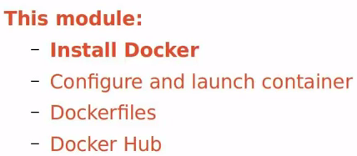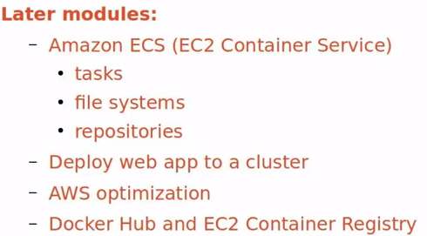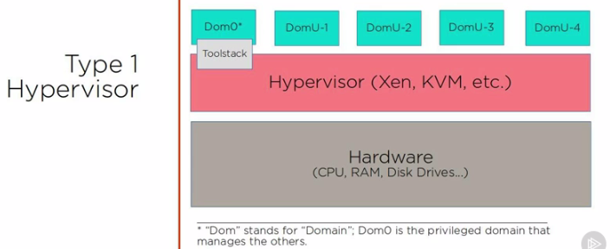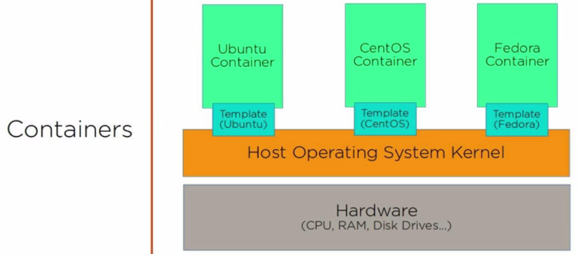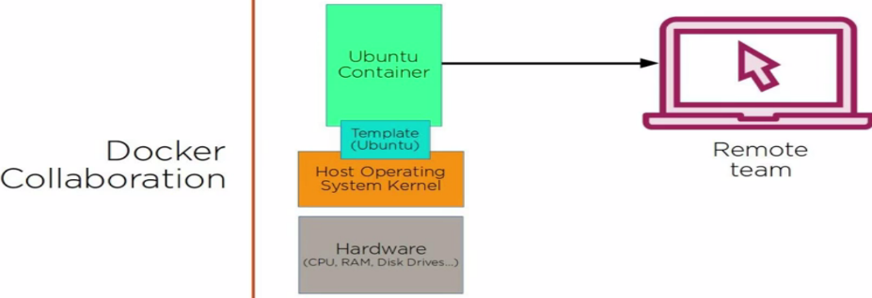

**EBS(ELASTIC BEAN STACK)—**have number of docker options.

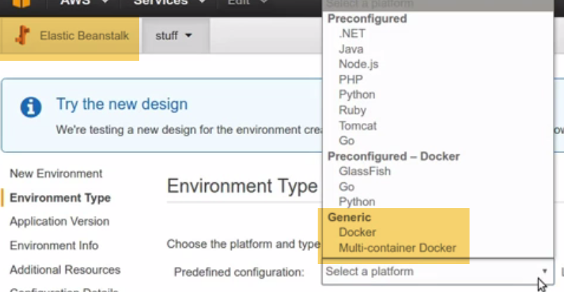

**CloudFormation:** Allows to combine any combination of AWS resources into template, that can be deployed once or more times, with dependencies and custom parameters.

It is scriptable design, and can used be used as natural way for Docker deployment.

--🡪In fact, Docker itself offers Docker for AWS service, that automatically generates CloudFormation template to orchestrate swarm of Docker containers to run on AWS infrastructure.

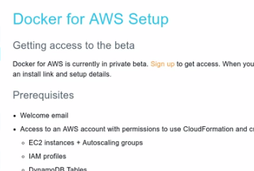

-🡪Docker Datacenter on AWS is a joint Docker-AWS project

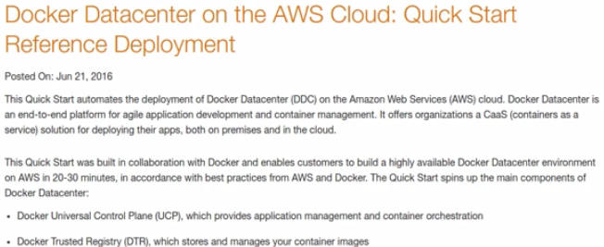

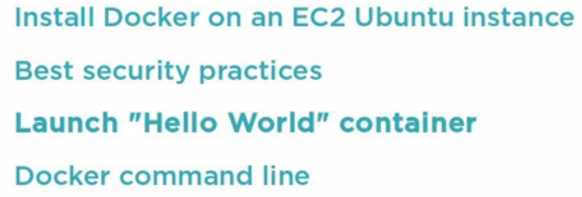

Launch EC2🡪Ubuntu

Install Docker on Ubuntu

Install CA Certificates(encryption certification)🡪To make sure, we are installing from trusted one, not from malware sites.

Followed by gpg-keys

