CentOS box-> install docker-> pull CentOS image

Docker-Compose install

sudo yum update

sudo yum install -y python-pip

**pip** is a package management system used to install and manage software packages written in **Python**.

sudo pip install docker-compose

Now I'll make a directory named it as WordPress, mkdir WordPress ..now i'll enter this WordPress directory

mkdir wordpress

cd wordpress/

create new file-> sudo gedit docker-compose.yml

|  |
| --- |
| wordpress:  images: wordpress  links:  - wordpress_db:mysql  ports:  - 8080:80  wordpress_db:  image: mariadb  environment:  MYSQL_ROOT_PASSWORD: edureka  phpmyadmin:  image: corbinu/docker-phpmyadmin  links:  - wordpress_db:mysql  ports:  - 8181:80  environemnt:  MYSQL_USERNAME: root  MYSQL_ROOT_PASSWORD: edureka |
| wordpress:-🡪 Defined a container, and named it wordpress  images: wordpress🡺 Build from image wordpress, present on dockerhub.  (But this WordPress image does not have a database ..,so for that i have defined one more container and i have named it as WordPress_DB.  It is actually built from the image that is called a Mario DB, which is present in the WordPress  ).  links:  - wordpress_db:mysql🡪 I need to link this WordPress_DB with the WordPress container.So for that , i have written links wordpress_DB:mysql  ports:  - 8080:80 🡪 this port 80 of the docker container will actually be linked to port 8080 of my host machine  wordpress_db:  image: mariadb  environment:  MYSQL_ROOT_PASSWORD: edureka🡪 defined a password here, edureka  phpmyadmin:  image: corbinu/docker-phpmyadmin🡪 I've defined one more container called PHPmyadmin. This container is built from the image corbinu /docker-phpmyadmin, that is present on the docker hub  links:  - wordpress_db:mysql🡪 Again, I need to link this particular container with WordPress_DB container.I have written links wordpress _DB:mysql  ports:  - 8181:80🡪 port 80 of my docker container will actually be linked to put 8181 of the host machine  environemnt:  MYSQL_USERNAME: root🡪 finally i have given a username that is root  MYSQL_ROOT_PASSWORD: edureka🡪 password as Edureka |

1. i have defined a container by the name wordpress, it is built from an image called WordPress that is present in the docker hub
2. This image present in dockerhub does not have a database ..,so i need to define one more container that contains a database.

So WordPress_DB is the name of that container and it is built from an image called Mario DB which is present on the docker hub

1. I need to link this database with WordPress ..So i'll write links wordpress_DB colon:mysql
2. Port section-> the port 80 of the docker container will be linked to port 8080 of the host machine
3. After that, we require one more container and I've named it as PHP myadmin ..it is built from the image called corbinu /docker-PHPmy admin.
4. I need to link this particular container with WordPress_DB :mysql. **Mysql is actually the name that I have given**
5. in the port section, the port 80 of the container is actually linked to put 8181 of the host machine.
6. and finally i have given user name and password.

Sudo Docker-compose up -d

this command will actually pull all the three images and we'll build the three containers ..

open my browser -> IP address /hostname

localhost:8080.., that I have given for WordPress . So it will direct you to a wordpress installation page.

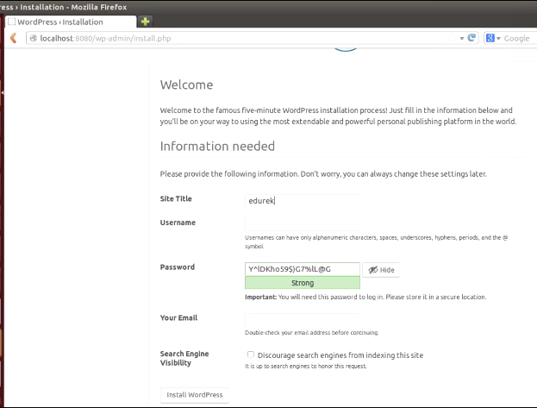 over here, fill this particular form which is asking you for :

site title->Edureka, username ,password,email

wordpress dashboard and wordpress is now successfully installed.

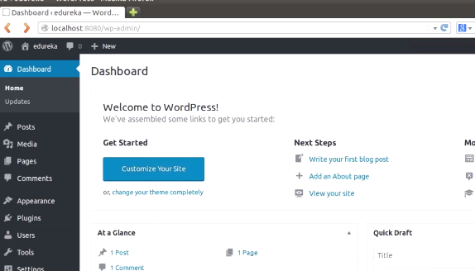 On new tab -> localhost:8181 for PHPmyadmin

Enter user,password..,as given YAML file

PHPmyadmin is successfully installed.

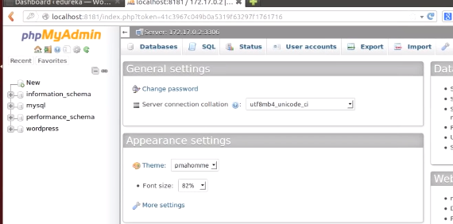

this PHPmyadmin is actually used to access a mysql database.

This mysql database is used as back-end for WordPress.