**How it all began? To**

what cloud is, just think about all your daily activities online, and you will realize that a lot of your work that you do online is based on cloud. Like your social media interactions are all on the cloud, anything that you store online, is again cloud, you paying your electricity bills online, online shopping, everything!

Now **how does it all work,**let’s understand it through *an example*:

So, there is this application called the Customer Relation Manager (CRM) which is based on the cloud. This software is highly used in all the Sales organisations for better agility, enhanced productivity and low costs.

The way it is used is like this; a field sales representative would need an access to a mobile device which is connected to the internet and then he can retrieve the customer information irrespective of his location. Also, he can update the information on the go therefore no need of going back to the office to update the deal information.

The sales managers can also monitor everything on their internet enabled devices, and will know which deals to close or not. It all happens on the go!

The best part? You don’t have to buy any machines or administer any kind of software, it all will be handled by the cloud company which is running this application. Cool right?

**What is Cloud Computing?**

the services it offers has been divided into three different models, let’s discuss each one of them:

* SaaS
* PaaS
* IaaS

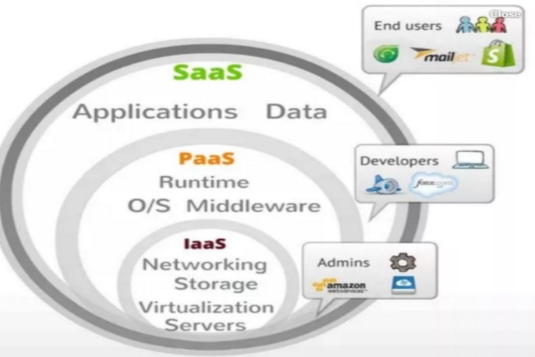 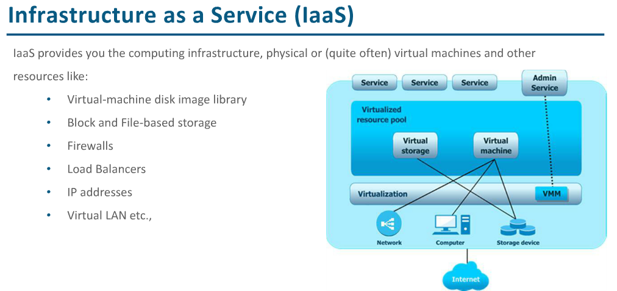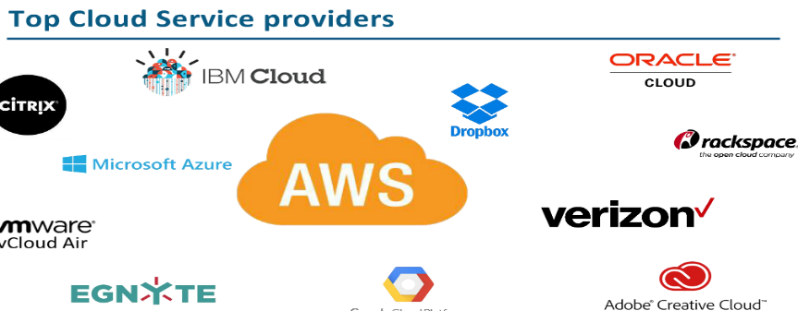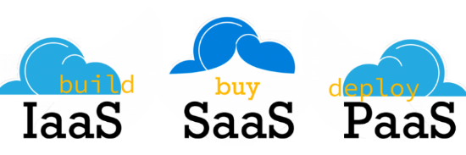

## What is IaaS? (Infra as a service)

IaaS provides the infrastructure such as virtual machines and other resources like virtual-machine disk image library, block and file-based storage, firewalls, load balancers, IP addresses, virtual local area networks etc. **Infrastructure as service** or **IaaS** is the basic layer in cloud computing model.

**More elaborately IaaS** is analogous to buying furniture from Walmart.

You are given all the materials, you need to build it yourself. **ie**, you are given a computer without even an OS on it, and you can install the OS and all the software on top of it as you wish.

Common examples: DigitalOcean, Linode, Rackspace, Amazon Web Services (AWS), Cisco Metapod, Microsoft Azure, Google Compute Engine (GCE) are some popular examples of Iaas.

**For Example**AWS(Amazon Web Services) is IaaS, like [***AWS EC2***](https://www.edureka.co/blog/ec2-aws-tutorial-elastic-compute-cloud/).

## What is PaaS (Platform as a service)

**PaaS** or platform as a service model provides you computing platforms which typically includes operating system, programming language execution environment, database, web server. technically It is a layer on top of IaaS as the second thing you demand after Infrastructure is platform.

**PaaS(Platform as a Service)**

In this service the Cloud Provider gives the ability to the customer to deploy customer created application using programming languages, tools etc that are provided by the Cloud Provider. The customer cannot control the underlying architecture including operating  systems, storage, servers etc.

Cloud platform services, or [Platform as a Service (PaaS)](https://apprenda.com/white-papers/enterprise-paas-for-existing-and-new-apps/?utm_source=library&utm_medium=post&utm_term=saaspaasiaas&utm_campaign=existingandnewapps), are used for applications, and other development, while providing cloud components to software. What developers gain with PaaS is a framework they can build upon to develop or customize applications. PaaS makes the development, testing, and deployment of applications quick, simple, and cost-effective. With this technology, enterprise operations, or a third-party provider, can manage OSes, virtualization, servers, storage, networking, and the PaaS software itself. Developers, however, manage the applications.

**For Example:**This service would make sense to you only if you are a developer, since this service provides you a platform for developing applications, like Google App Engine.

**More elaborately,** This is like ordering in a fast food joint like chipotle. You have your choice of toppings, but there only a few bases for the toppings – a bowl, or burrito, or taco, etc.**ie**,

The computers that you get in an PaaS offering, have a fixed OS and software stack. You can run your software on top of this. Example, you can deploy any code on top of the Google app engine.

examples: AWS Elastic Beanstalk, Windows Azure, Heroku, Force.com, Google App Engine, Apache Stratos.

## What is SaaS (Software as a service)

In a SaaS you are provided access to application services installed at a server. You don’t have to worry about installation, maintenance or coding of that software. You can access and operate the software with just your browser. You don’t have to download or install any kind of setup or OS, the software is just available for you to access and operate. The software maintenance or setup or help will be provided by SaaS provider company and you will only have to pay for your usage.

***More elaborately*** – This is like borrowing a reference book from a library. You go, read the book, return it and come back. **ie,**you use the software available online, and that’s it.

Common examples: Google Apps, Microsoft office365, Google docs, Gmail, WHMCS billing software.

**For Example:** salesforce.com provides the CRM(Customer Relation Manager) on a cloud infrastructure to its client and charges them for it, but the software is owned by the salesforce company only.

## IaaS, PaaS & SaaS with car example

With **IaaS**, it’s like leasing a car. Keeping the car repaired is someone else’s problem, you just need to supply it with fuel (setting it up, maintaining software, etc.) and you get to go pretty much wherever you want to.

**PaaS** is a bit like getting a cab. You get in and choose where you want to go to and how to get there. Keeping the car running and figuring out the details is up to the driver.

**SaaS** is a bit like public transport. Cheap, someone else takes care of pretty much everything, you just get to use it. This comes at the price of not always getting as close as you want (less customizability).

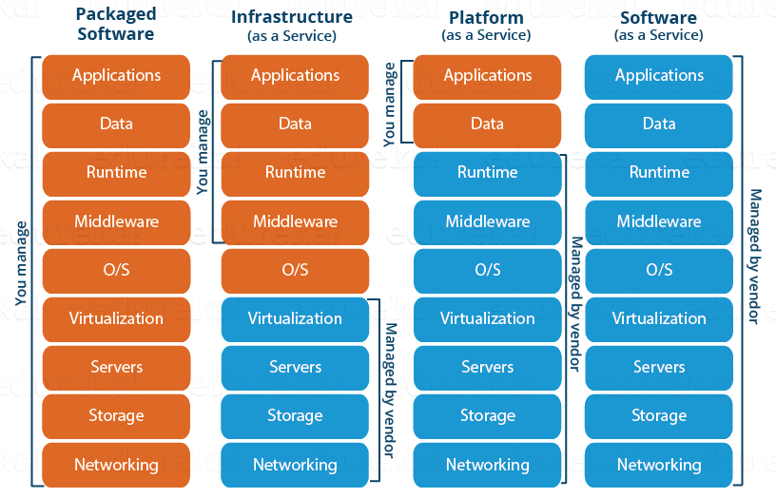

We now know about the service models, once you offer a service next comes deployment, let us now discuss the deployment models:

* **Private Cloud:**the cloud services used by a single organization, which are not exposed to the public. A private cloud resides inside the organization and must be behind a firewall, so only the organization has access to it and can manage it.
* **Public Cloud:** the cloud services are exposed to the public and can be used by anyone. Virtualization is typically used to build the cloud services that are offered to the public. An example of a public cloud is Amazon Web Services (AWS).
* **Hybrid Cloud:** the cloud services can be distributed among public and private clouds, where sensitive applications are kept inside the organization’s network (by using a private cloud), whereas other services can be hosted outside the organization’s network (by using a public cloud). Users can them interchangeably use private as well as public cloud services in every day operations.

|  |  |  |  |
| --- | --- | --- | --- |
| **Difference** | **Private** | **Public** | **Hybrid** |
| **Tenancy** | Single tenancy: there’s only the data of a single organization stored in the cloud. | Multi-tenancy: the data of multiple organizations in stored in a shared environment. | The data stored in the public cloud is usually multi-tenant, which means the data from multiple organizations is stored in a shared environment. The data stored in private cloud is kept private by the organization. |
| **Exposed to the Public** | No: only the organization itself can use the private cloud services. | Yes: anyone can use the public cloud services. | The services running on a private cloud can be accessed only the organization’s users, while the services running on public cloud can be accessed by anyone. |
| **Data Center Location** | Inside the organization’s network. | Anywhere on the Internet where the cloud service provider’s services are located. | Inside the organization’s network for private cloud services as well as anywhere on the Internet for public cloud services. |
| **Cloud Service Management** | The organization must have their own administrators managing their private cloud services. | The cloud service provider manages the services, where the organization merely uses them. | The organization itself must manage the private cloud, while the public cloud is managed by the CSP. |
| **Hardware Components** | Must be provided by the organization itself, which has to buy physical servers to build the private cloud on. | The CSP provides all the hardware and ensures it’s working at all times. | The organization must provide hardware for the private cloud, while the hardware of CSP is used for public cloud services. |
| **Expenses** | Can be quite expensive, since the hardware, applications and network have to be provided and managed by the organization itself. | The CSP has to provide the hardware, set-up the application and provide the network accessibility according to the SLA. | The private cloud services must be provided by the organization, including the hardware, applications and network, while the CSP manages the public cloud services. |

As you can see, the hybrid cloud is a combination of private, as well as public cloud, used together by the same organization to pull the best features from each

Which one should you choose?

It’s important to keep in mind when deciding whether to build a private or public cloud, to properly weigh the differences against each other. In most cases they can be thought of as advantages or disadvantages, depending on the usage required. If we’d like to store our backup data somewhere in the cloud, it’s important to determine the sensitivity of said data.

For example, if we are storing confidential information such as credit card information or medical records we absolutely must store that data in a private cloud but when it comes to non-sensitive info, we can store it in a public cloud if it keeps costs down considerably.

Then, there’s always a choice whether to integrate public or private cloud into our everyday operations. Again, there are advantages and disadvantages that need to be taken into consideration. Whether to compromise the security and keep expenses down or pay a little extra for additional layer of security is a choice you’ll sooner or later have to make; but you should always consider what’s best for your business and move forward from there.

## Hybrid Cloud

A hybrid cloud consists the functionalities of both private and public cloud. How?

**Let’s understand it through an example:** Suppose there is a research company, so they would have some published data and also, data which would still be in research phase. Now any thing which is still in research should be kept confidential right? Though your cloud provider may have state of the art security features but then it is still open to public, therefore prone to cyber attacks.

So to address this risk, you can keep the data still being worked on, in your company’s servers whose access is controlled by the company, and your published data on the public platform, this type of arrangement would be a hybrid cloud.

I think by now you must have a fair idea about what is cloud computing. Let’s go ahead and know the target audience of the cloud, that is YOU,  now you can either be looking at the cloud as an individual or a business, let’s take an insight into both the perspectives.

|  |
| --- |
| How do customers decide between public, private, and hybrid clouds? Well, it depends on the user requirement that is, if the user feels that his information is too sensitive to be on any system rather than their own, they would opt for a private cloud  The best example for this could be DropBox, in their early days they started by using AWS S3 as their backend for storing objects, but now they have created their own storage technology which they monitor themselves.  Why they did this?  Well they got so big, that public cloud pricing didn’t make sense any longer. According to them their software and hardware optimizations are more economically viable than storing their stuff on Amazon S3.  But then if you are not a biggie like DropBox, and you are still on private infrastructure, maybe its time you think, Why not public cloud?  Now why will a customer use public cloud?   * First of all the pricing is pretty less, compared to the investment that a company would need to setup their own servers. * Secondly, when you are linked with a reputed Cloud Provider, the Availability of your files on the Cloud becomes higher.   Still confused whether you want to store your files or data on private or public cloud.  Let me tell you about hybrid cloud, with hybrid cloud you can keep your more “precious” data on your private infrastructure and the rest on the public cloud, this would be a “hybrid cloud” |

## Consumers v/s Business

Let’s talk about consumers here, those of us who work in small to medium offices, use internet on a regular basis, for us cloud would be say Google Drive or maybe DropBox.

But, for organisations and businesses, it is an entirely different scene, for them cloud is SaaS where they might want to use a software on the cloud, or maybe PaaS where they might want to build an app on an environment which is provided by the cloud environment or maybe they want to avail the cloud service as an Infrastructure where in they will rent out entire VMs and configure it their own way, which will be IaaS.

Advantages does Cloud Computing serve:

**Now, how do you get started?**

1. **Fast Implementation**  
   If you’ve been there for a development or implementation of an application, it takes sometimes months or even years to make the application up and running, with cloud you can cut through the time and make things faster.
2. **Instant Scalability**  
   With cloud resources you can always scale up or scale down the no. of resources and users according to your need, the cloud capacity never runs out!
3. **Access Anywhere**  
   Applications built on cloud are designed to be accessed from anywhere, you just need an internet connection on a mobile device.
4. **No Upfront Costs**  
   Earlier to deploy an application you had to purchase the necessary hardware, build the architecture, purchase software licenses etc, but with cloud all those costs are dramatically reduced and in some cases eliminated.
5. **Maintenance Free**  
   Traditionally you would have to patch your software with the latest releases, upgrade your hardware and also troubleshoot faults in your system at the hardware level, but with cloud you don’t have to worry about the maintenance of your hardware, it will all be managed by your cloud provider.
6. **Better Security**  
   An Independent study found that yearly a medium scale company loses around 260 laptops, this is a loss to the company not in monetary terms, but the data that was there on the laptop is valuable, with Cloud you don’t have to worry about that, all your data is stored in a centralized secure location.

There are tons of cloud providers out there to choose from. Let us take the most prominent ones.

* **Azure:** It’s a cloud computing platform by Microsoft founded in 2010.
* **AWS:** Amazon Web Services is a cloud computing platform by Amazon in 2006.

AWS and Microsoft Azure are two major players in the cloud computing industry, but still AWS is bigger than Azure. How much bigger?

Well, the server capacity of AWS is 6 times the size than all of its competitor’s server size combined.

Also AWS started its cloud journey way back in 2006 compared to Microsoft Azure which was launched in 2010, thus in terms of service, AWS’s service model is more mature. Amazon owns the largest data centers in the world, which are strategically placed all around the globe.

When we see Azure, it is nowhere near the capacity that Amazon has, but then Microsoft has been working hard to achieve the kind of services and flexibility that Amazon offers. For example, in 2014, Microsoft launched redundant storage option called *Zone Redundant Storage* which is at par with the services that Amazon offers.

Let’s talk about a more important parameter like **Pricing**.

Amazon bills you for the hour, meaning the no. of hours you will be using your instances, the downside of this can be that if you stop your instance say after 2.5 hours, you will be billed for the whole 3 hours.

For this, Azure has a different scheme which may appeal customers, they bill you on minutes, that is the number of minutes you use your instance, but when you compare AWS and Azure prices in hours AWS is cheaper.

***For example:*** an AWS m3.large instance is 0.133$ for an hour, and the equivalent instance in Azure (a Medium VM) costs 0.45$ for an hour.

Concluding here, Amazon emerges as a winner!

So now look at it this way, if you want to make a *career shift* in the cloud computing industry, which service is more likely to be in demand, AWS right?

Let’s see what Analytics has to say,

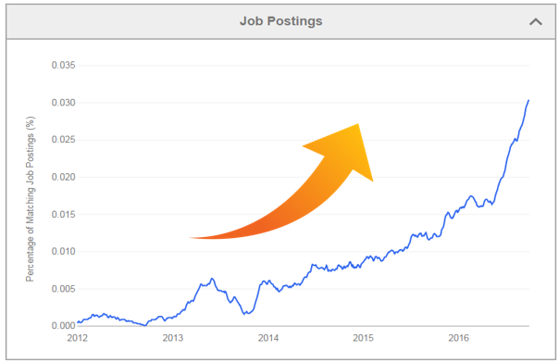

Fig. This graph shows job postings for a AWS Solution Architect from Indeed.com

Let’s hear some **interesting arguments** about Cloud Computing.

Some people say moving your business completely to cloud may not be a good idea. Well, it kind of makes sense, because what if your **Cloud Provider experiences a downtime,** in that case your business will also suffer a loss.

This actually happened with our very own AWS in 2012 when there was a power outage due to an electrical storm in Northern Virginia due to which Amazon servers experienced a downtime, because of that big companies like Instagram, Pinterest and Instagram also experienced a downtime because they host their services on AWS.

Another argument which often comes up when we talk about Cloud Computing is this, **who owns the data on cloud**?

Is it yours or the company who is hosting your data? Some may say that the data that you are putting on cloud is yours, but what about the data which is generated using their tools, who owns it?

So these things are a risk when you are moving to the cloud, but when we compare these cons to the pros, they kind of weigh more, so that’s why there is a major shift onto the cloud.

There are a lot of “risks” that people think cloud computing has, let’s address these risks one by one:

**1. Cloud is insecure**

Most of the times whenever you would talk about cloud, there would be a lot of people saying, the data is more secure on their own infrastructure rather than say some AWS server with AWS security.

Well this might make sense if the company would just focus on their private cloud’s security which obviously is not the case. But if the company does that, when will they focus on their own goals?

Let’s talk about Cloud Providers, say AWS (the largest of them all), don’t you think AWS’s sole purpose is to make your data the most secure? Why, because that is what they are being paid for.

Also a fun fact, Amazon has hosted their own e-commerce website on AWS, which clears the air on whether AWS is reliable.

Cloud providers live, eat and breathe cloud security.

**2. There are more breaches in the cloud**

A study from Spring Alert Logic Report of 2014 shows that the cyber attacks in 2012-2013 were both targeted at private clouds and public clouds, but the private clouds were more susceptible to the attacks. Why? Because companies which setup their own servers are not that equipped compared to AWS or Azure or any other Cloud Provider for that matter.

**3. Single tenant systems are more secure than multi-tenant systems.**

Well if you think logically, don’t you think that with multi-tenant systems you have an additional layer of security attached to it. Why? Because your content will be logically isolated from the rest of the tenants or users on the system, which is not there if you are using single-tenant systems. Therefore, in case a hacker wants to go through your system, he has to go through one additional layer of security.

Concluding, these are all myths and also considering the saving in investments that you will be doing when you move your data to cloud and also the other benefits, it far outweighs the risks involved in cloud security.

Having said that, let’s move on to the focus of today’s discussion, how do your Cloud providers handle security.

So let’s take an example here and assume that you are using an app for social networking. You click on some random link and nothing happens. Later you come to know, that spam messages are being sent from your account to all your contacts that are connected with you on that application.

But then before you could even drop a mail or complain to the app’s support, they would already know the problem and would be up and running to solve it. How? Let’s understand.

So basically Cloud Security has three stages:

* **Monitoring Data**
* **Gaining Visibility**
* **Managing Access**

**What is AWS ? – An Introduction to AWS**

In 2006, **Amazon Web Services (AWS)** started to offer IT services to the market in the form of web services, which is nowadays known as **cloud computing**.

With this cloud, we need not plan for servers and other IT infrastructure which takes up much of time in advance.

Instead, these services can instantly spin up hundreds or thousands of servers in minutes and deliver results faster. We pay only for what we use with no up-front expenses and no long-term commitments, which makes AWS cost efficient.

Back in 2006-2007, companies were using their own private servers to create services like for storage, computing, etc. But now with internet speeds becoming better, companies big or small have started understanding the power of the cloud, therefore they are shifting their data to the cloud for improved performance, so that they can focus on core-competency.

For example, Netflix is a popular video streaming service which the whole world uses today, back in 2008 Netflix suffered a major database corruption, and for three days there operations were halted. The problem was scaling, that is when they realized the need for a highly reliable, horizontally scalable, distributed systems in the cloud. Came in AWS, and since then their growth has been off the charts.

**Gartner says, By 2020, a Corporate “No-Cloud” Policy Will Be as Rare as a “No-Internet” Policy Today. Interesting, isn’t it?**

Amazon Web Services(AWS) is a Amazon.com subsidiary which offers**cloud-computing services**at very affordable rates, **therefore making its customer base strong from small scale companies like Pinterest (which has just 5 employees) to big enterprises like D-Link.**

 let’s move ahead in this AWS Tutorial and explore the different domains in which AWS offer services:

* **Compute**It is used to process data on the cloud by making use of powerful processors which serve multiple instances at a time.
* **Storage and Content Delivery**The storage as the name suggests, is used to store data in the cloud, this data can be stored anywhere but content delivery on the other hand is used to cache data nearer to the user so as to provide low latency.
* **Database**The database domain is used to provide reliable relational and non relational database instances managed by AWS.
* **Networking**It includes services which provide a variety of networking features such as security, faster access etc.
* **Management Tools**It includes services which can be used to manage and monitor your AWS instances.
* **Security and Identity**It includes services for user authentication or limiting access to a certain set of audience on your AWS resources.
* **Application Services**It includes simple services like notifications, emailing and queuing.
* **Compute**
* **AWS EC2**

It is a web service which provides re-sizable compute capacity in the cloud. It is designed to make the web scale computing easier for developers. To know more about the service you can refer to our AWS EC2 blog. To know more, please go through the [AWS EC2 blog](https://www.edureka.co/blog/ec2-aws-tutorial-elastic-compute-cloud/)

* **AWS Elastic Beanstalk**

  
Elastic Beanstalk lets you quickly deploy and manage applications in AWS without worrying about the underlying infrastructure.

* **AWS Elastic Load Balancing**

  
ELB automatically manages the workload on your instances and distributes them to other instances in case of an instance failure.

* **AWS Lambda**

  
AWS Lambda is used to execute backend code without worrying about the underlying architecture, you just upload the code and it runs, it’s that simple! To know more, please go through the[AWS Lambda Blog](https://www.edureka.co/blog/aws-lambda-tutorial)

* **AWS Autoscaling**



The Autoscaling feature is used to scale up and down automatically as and when required. To know more, please go through the [AWS EC2/Autoscaling Blog](https://www.edureka.co/blog/ec2-aws-tutorial-elastic-compute-cloud/)

* **Storage and Content Delivery**
* **S3 AWS**

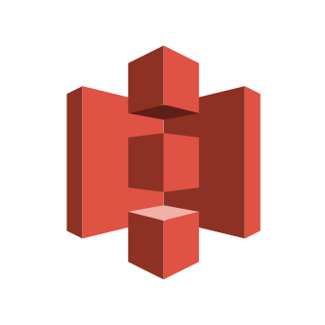  
S3 stands for simple storage service, it is used for storing data in the form of objects in the AWS Cloud. To know more about S3, please go through the [S3 AWS Blog](https://www.edureka.co/blog/s3-aws-amazon-simple-storage-service/)

* **Amazon CloudFront**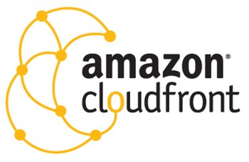  
  CloudFront is a content delivery network which is used to cache data to an edge location which reduces latency. To know more about Amazon Cloudfront, please go through the [S3 AWS/CloudFront Blog](https://www.edureka.co/blog/s3-aws-amazon-simple-storage-service/)
* **Amazon EBS**

[](https://www.edureka.co/blog/ec2-aws-tutorial-elastic-compute-cloud/)

Amazon Elastic Block Storage is a storage service wherein each block of storage acts like a separate hard drive. To know more about EBS, please refer our  [AWS EC2/EBS Blog](https://www.edureka.co/blog/ec2-aws-tutorial-elastic-compute-cloud/)

* **Amazon Glacier**

  
Glacier is an archiving service offered by Amazon, which offers low cost data archiving. To know more about Amazon Glacier, please refer our [S3 AWS/Glacier Blog](https://www.edureka.co/blog/s3-aws-amazon-simple-storage-service/)

* **AWS Import/Export Snowball**

  
It offers physical transfer of data between user’s location and AWS data centers, the device which is used to transfer the data is called Snowball. To know more about AWS Snowball, please refer out [S3 AWS/Snowball Blog.](https://www.edureka.co/blog/s3-aws-amazon-simple-storage-service/)

* **AWS Storage Gateway**

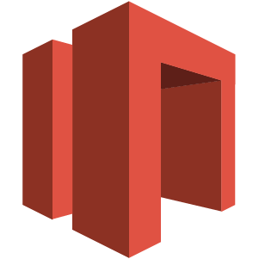  
It is used to provide seamless integration with data security features between your on premise software appliance and AWS Cloud.

* **Database**
* **Amazon Aurora**

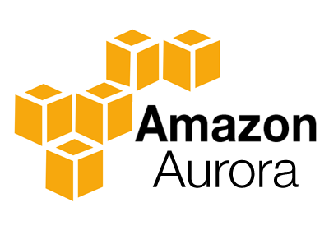

It is a relational database engine that combines the speed and reliability of high-end commercial databases and the cost effectiveness and simplicity of open-source databases.

* **Amazon RDS**

****Amazon RDS is a managed relational database service which does routine database tasks  in 6 familiar databases like  Amazon Aurora, MySQL, MariaDB, Oracle, Microsoft SQL Server, and PostgreSQL. To know more, please refer our [RDS AWS Blog.](https://www.edureka.co/blog/rds-aws-tutorial/)

* **Amazon DynamoDB**
* 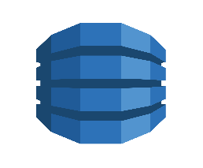

It is a fully managed No-SQL database service. It is known for extremely low latencies and scalability.

* **Amazon ElastiCache**

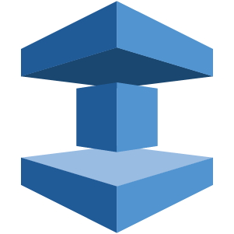It is a web service that makes it easy to set up, manage and scale a distributed cache-in environment in the cloud.

* **Amazon Redshift**

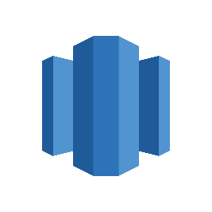

Amazon Redshift is a fully managed petabyte-scale data warehouse service in the cloud.

* **Networking**
* **VPC AWS**

****Amazon VPC lets you launch AWS resources in a virtual network that you define. It closely resembles a traditional network that you’d operate in your data center.

* **AWS Direct Connect**

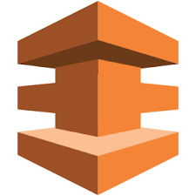

It helps you establish a private connection between your premises and AWS, therefore giving better network performance and throughput than an Internet based connection.

* **Amazon Route 53**

****Route 53 is a highly scalable and highly available Domain Name System by Amazon AWS. The name is in reference to the TCP and UDP’s port 53 where DNS requests are addressed.

* **Management Tools**
* **Amazon CloudWatch**



It is a monitoring tool by AWS which is used to keep a track on the AWS resources and the applications you run on Amazon AWS.

* **AWS CloudFormation**

  
It is a service which helps you setup and model your Amazon AWS resources so that you can spend less time managing these resources and more time focusing on the development.

* **AWS CloudTrail**



AWS CloudTrail is a logging service which records the API calls to your Amazon AWS account and delivers them to you.

* **AWS Command Line Tool**

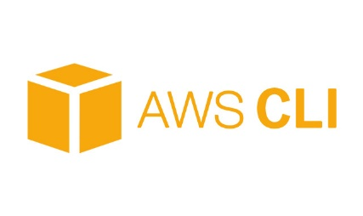It is an all in one tool to manage all your AWS services, by downloading and configuring only one tool you can manage all the AWS services through the command line.

* **AWS OpsWorks**
* 

It is a configuration management tool that helps configure and operate applications of all size and shapes using Chef.

* **Trusted Advisor**
* ****Trusted Advisor is a customized cloud monitoring tool, that analyzes your AWS environment and gives insights on the expense, performance improvement, security gaps and reliability.

* **Security and Identity**
* **AWS Identity and Access Management(IAM)**



It is an AWS service that helps you control access to your AWS resources for your users.

* **AWS Key Management Service**
* ****It is a managed service that helps you create and control encryption keys which is used to encrypt your data, and uses Hardware Security Modules to protect the security of your keys.

* **Application Services**
* **Amazon SES**

It is a cost effective emailing service which is built on the scalable and reliable infrastructure of Amazon.com

**Amazon SNS**  
It is a web service offered by AWS that manages the delivery of messages to subscribed endpoints or clients.

* **Amazon SQS**



It is a fast, reliable and scalable message queuing service, it can be used to transmit any volume of data at any level of throughput, without losing any messages or without the use of any other service.

Each type of service in this “What is AWS” blog, is categorized under a domain, the few domains which are widely used are:

* Compute
* Storage
* Database
* Migration
* Network and Content Delivery
* Management Tools
* Security & Identity Compliance
* Messaging

**The Compute domain includes services related to compute workloads, it includes the following services:**

* EC2 (Elastic Compute Cloud)
* Lambda
* Elastic Beanstalk
* Amazon LightSail

**The Storage domain includes services related data storage, it includes the following services:**

* S3 (Simple Storage Service)
* Elastic Block Store
* Amazon Glacier
* AWS Snowball

**The Database domain is used for database related workloads,**

* Amazon Aurora
* Amazon RDS
* Amazon DynamoDB
* Amazon RedShift

The **Migration** domain is used for transferring data to or from the AWS Infrastructure,

* AWS database Migration Service
* AWS SnowBall

The**Networking and Content Delivery** domain is used for isolating your network infrastructure, and content delivery is used for faster delivery of content. It includes the following services:

* Amazon Route 53
* AWS CloudFront

The **Management Tools** domain consists of services which are used to manage other services in AWS, it includes the following services:

* AWS CloudWatch
* AWS CloudFomation
* AWS CloudTrail

The **Security & Identity, Compliance** domain consist of services which are used to manage to authenticate and provide security to your AWS resources. It consists of the following services:

* AWS IAM
* AWS KMS
* AWS Shield

The **Messaging** domain consists of services which are used for queuing, notifying or emailing messages. It consists of the following domains:

* Amazon SQS
* Amazon SNS
* Amazon SES
* Amazon Pinpoint

## Building Applications

* First and foremost, you should analyze, what is your application about? Is it something that requires you to be worried about the underlying infrastructure? Is it something that requires a database? Is it something which will require monitoring?
* So, once you know all the requirements about your application, you can pick the domain, and hence choose a service.
* **Like for example, you want to deploy an application in AWS, which does not require you to worry about the underlying architecture, which service will you choose?**
* **Well, in the compute section there is this service called Elastic Beanstalk. You just upload your application, and AWS does the rest for you. It’s that simple!**

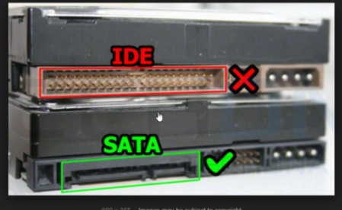(SATA)(SSD)

