AWS CloudWatch Tutorial | What is AWS CloudWatch | AWS Tutorial | AWS Training Videos | Simplilearn

* Amazon CloudWatch is a monitoring service for AWS cloud resources and the applications you run on AWS cloud watch enables monitoring for ec2 and other Amazon cloud services, so you can get alerts when things go wrong.
* You can use Amazon CloudWatch to collect and track metrics. So, you can get system-wide visibility into resource utilization application performance and overall operational health.
* And you can use these insights to react and keep your applications running smoothly.

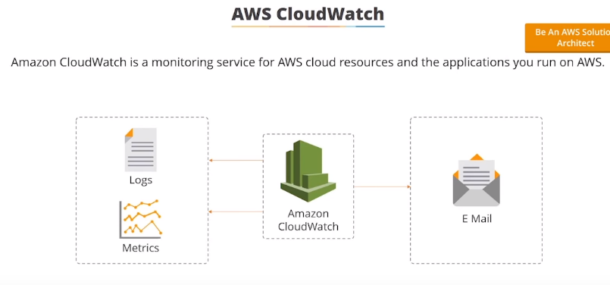

CloudWatch offers two types of monitoring...

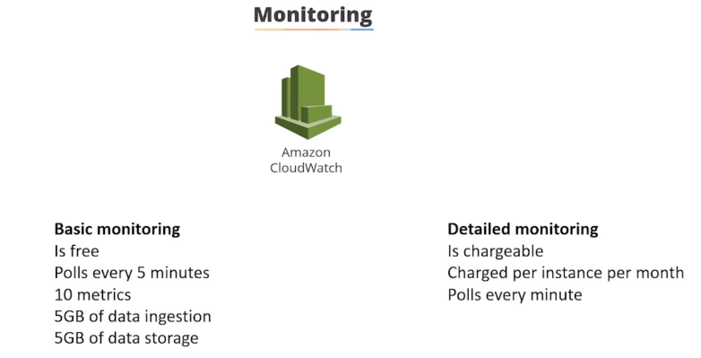

There's **basic monitoring** which is included free of charge and polls every five minutes and gives you ten metrics five gigabytes of data ingestion and five gigabytes of data storage.

**Detailed monitoring** this cost more as a price per instance per month but it pulls every minute. So if you want more detailed monitoring than you can pay for it.

* AWS cloud watch allows you to record metrics for services such as EBS, ec2 elastic load balancer and Amazon s3.

And using these metrics you can add them to dashboards to give visual or text-based notifications of what's going on.

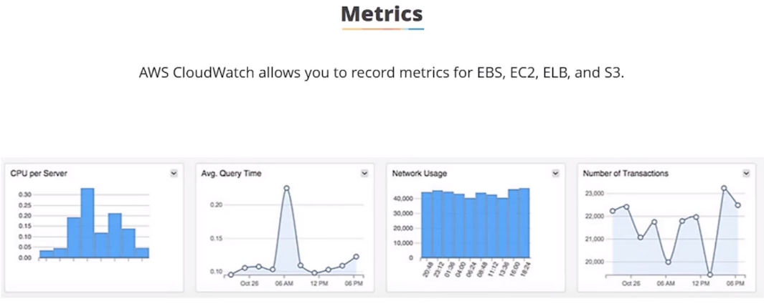

This is a diagram of a dashboard in Amazon CloudWatch metrics are **at the hypervisor level.**

So you can get things like CPU, disk, network. **You cannot see memory usage..** Metrics appear as you add more resources to your AWS account.

you can create events based on your card watch monitoring...

For example: triggering lambda functions.

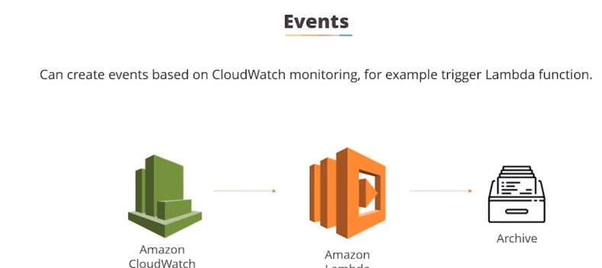

Ex: if you need EBS volume fails up you could trigger an event so that data is removed and archived from the volume or a new volume is created.

* You can install cloud watch agents on ec2 instances and this will send monitoring data about the instance to cloud watch. So, you can monitor things like HTTP response codes Apache or you can count exceptions in application logs.

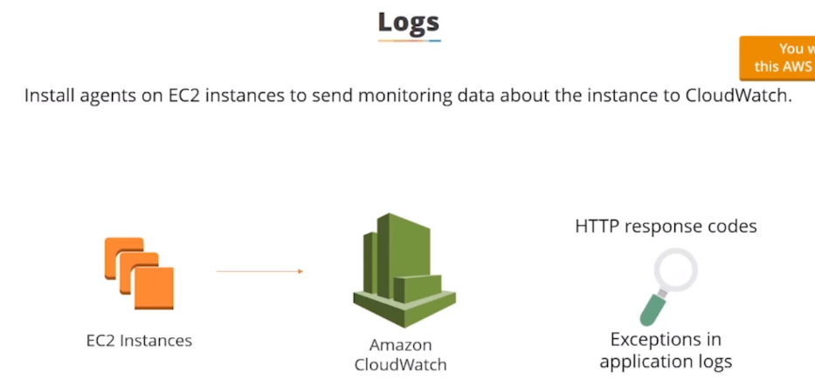

* you can set alarms to warn based on resource usage…

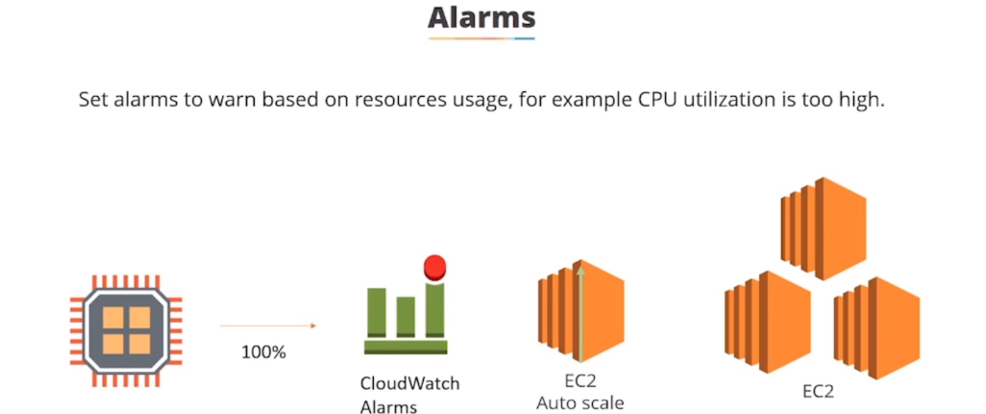

**For example** if CPU utilization is too high then it could send a notification it can also auto scale so if your CPU is maxed out you can get another instance launched to take care of some of the load or you can send cloud watch monitoring alarms to ec2 actions to say recover an instance or reboot an instance if something happens.

you can also use alarms to shut down instances it isn't just used for starting them up so if you have idle instances you can get cloud watch to shut them down for you.

**demonstration** we're going to take a look at AWS cloud watch and how we can use it to shutdown idle instances:

1. I launched an Amazon Linux instance and let it run for 10 minutes just so we'd have some data.

Now go to cloud Watch-🡪Go to Dashboard-🡪create a new dashboard to look at the monitoring statistics.

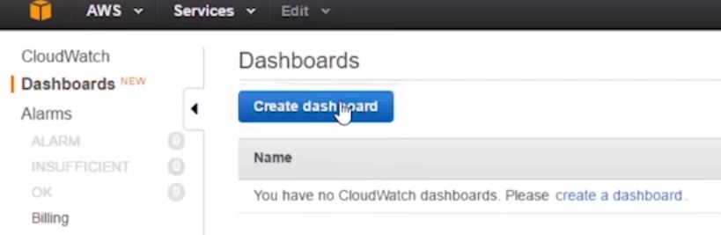

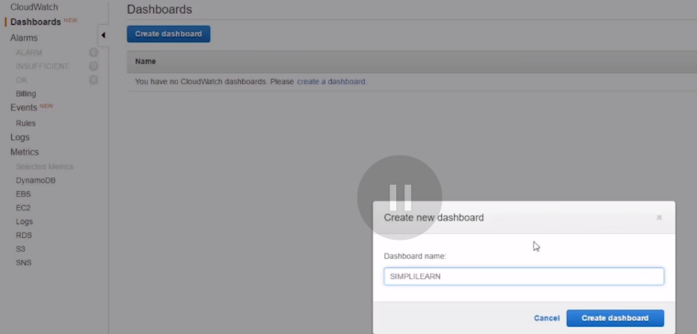

2.) Now we get the option… Do we want to

* text based or
* metric graphs widgets to our dashboard???

and we're going to select metric graphs and we'll click on configure 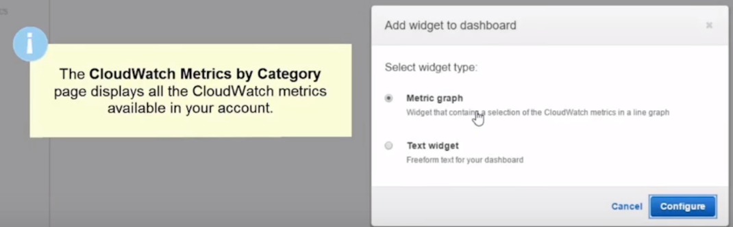

3.) We’re presented with all the cloud box metrics that I have available in my AWS account. 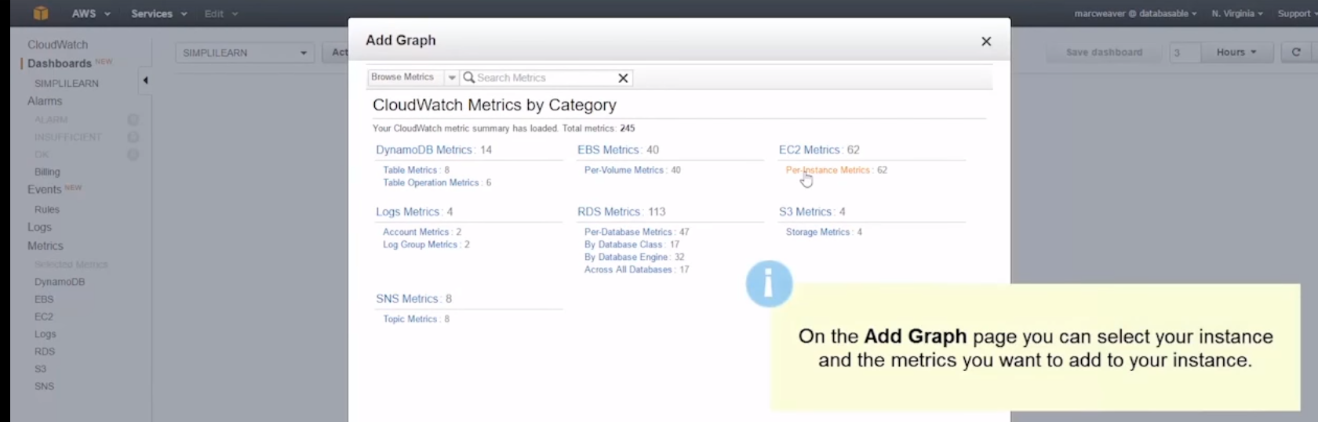

Obviously I've just launched an ec2 instance …So I'm going to click on ec2 metrics.

4.) my new server is called simplycloud watch demo… So I want to add CPU utilization let's click on that

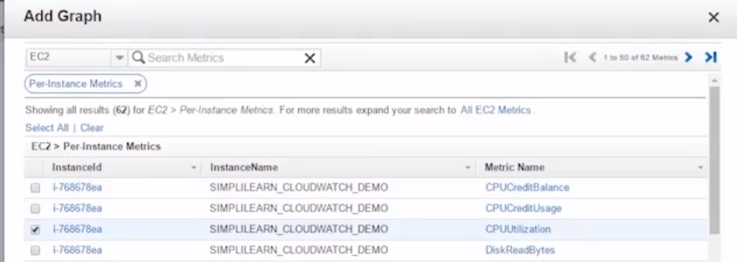

Let me create this widget and then that CPUUtlization appears on our dashboard.

5.) we can add more …So we click on add widget. 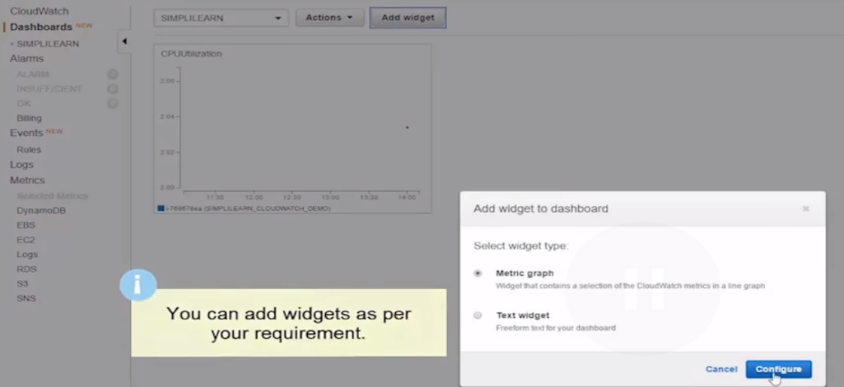 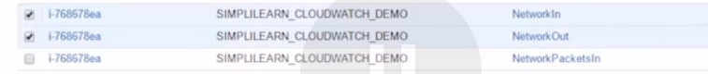

Will do another metric graph -🡪 Ec2 instance metric-🡪 and choose network in and network out.

and we'll create the widget

6.) 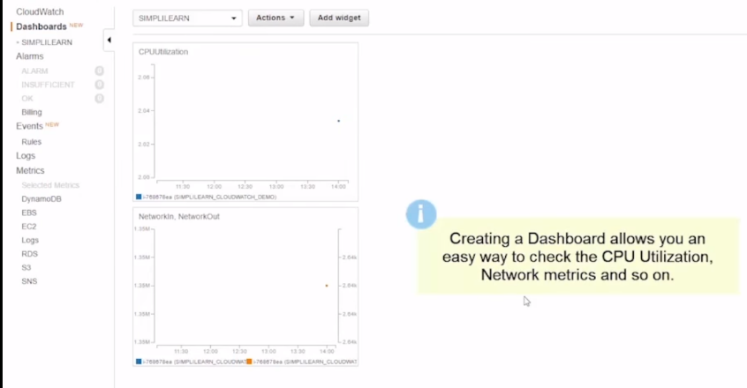

this is how you would create a dashboard …

7.) **Alarms**

We can also set up an alarm.

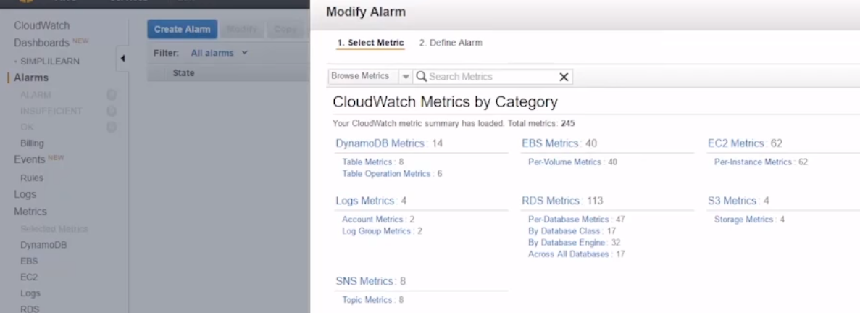

a.) Let's go to alarms…> create alarm

We get to choose the metric to base the alarm on.

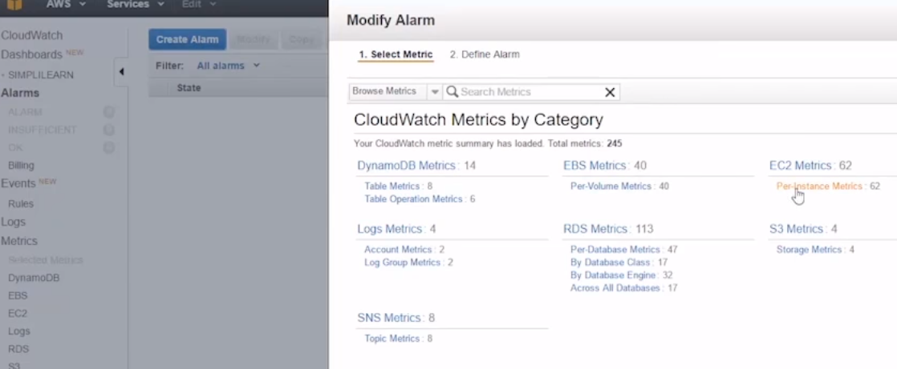

b.)Obviously we have an ec2 instance… So we're going to choose that option **I'm going to do it based on CPU utilization** of our simply learned cloud watch demo instance. 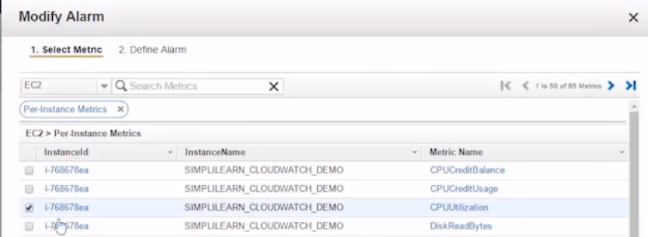

c.) give our alarm a name …simplylearn_underscore_alarm.

Give alarm threshold-🡪whenever CPU utilization is less than or equal to 50% for one consecutive period

( 1 consecutive period = 5 min in basic monitoring) …we want this alarm to fire..

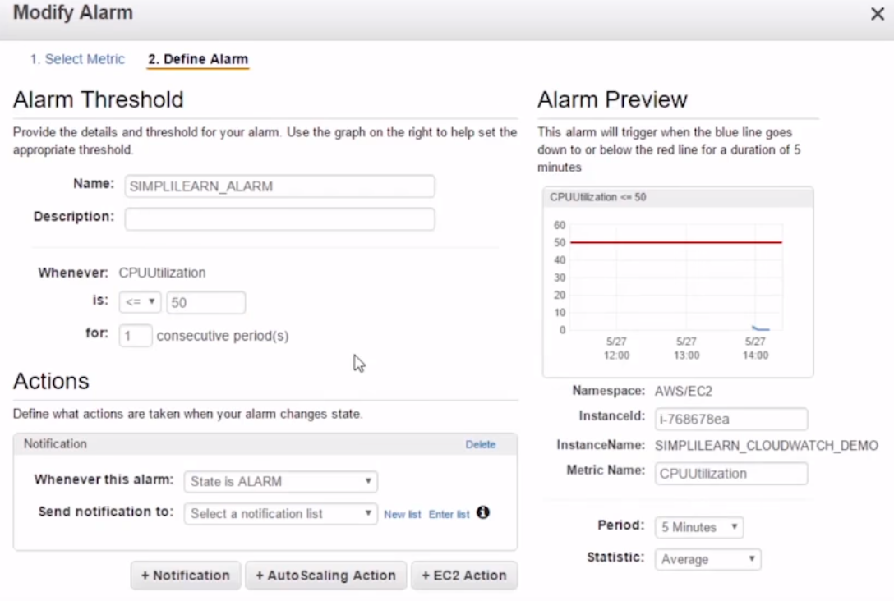

**Why would you do this????**

well imagine if you had a really high-powered server that we're using every night to do some highly intensive compute computations… so you might know that it runs for a couple of hours and it's charging you quite a lot of money per hour to run.

but when the CPU utilization drops below say fifty percent or ten percent you know the job is complete so then you can get an alarm to fire and an action to happen.

So you could set a notification. so we could together to send an email when this alarm fires.

-🡪 we're not going to do that in this demonstration but we can do an ec2 action so whenever this state is in alarm I want it to stop this instance… 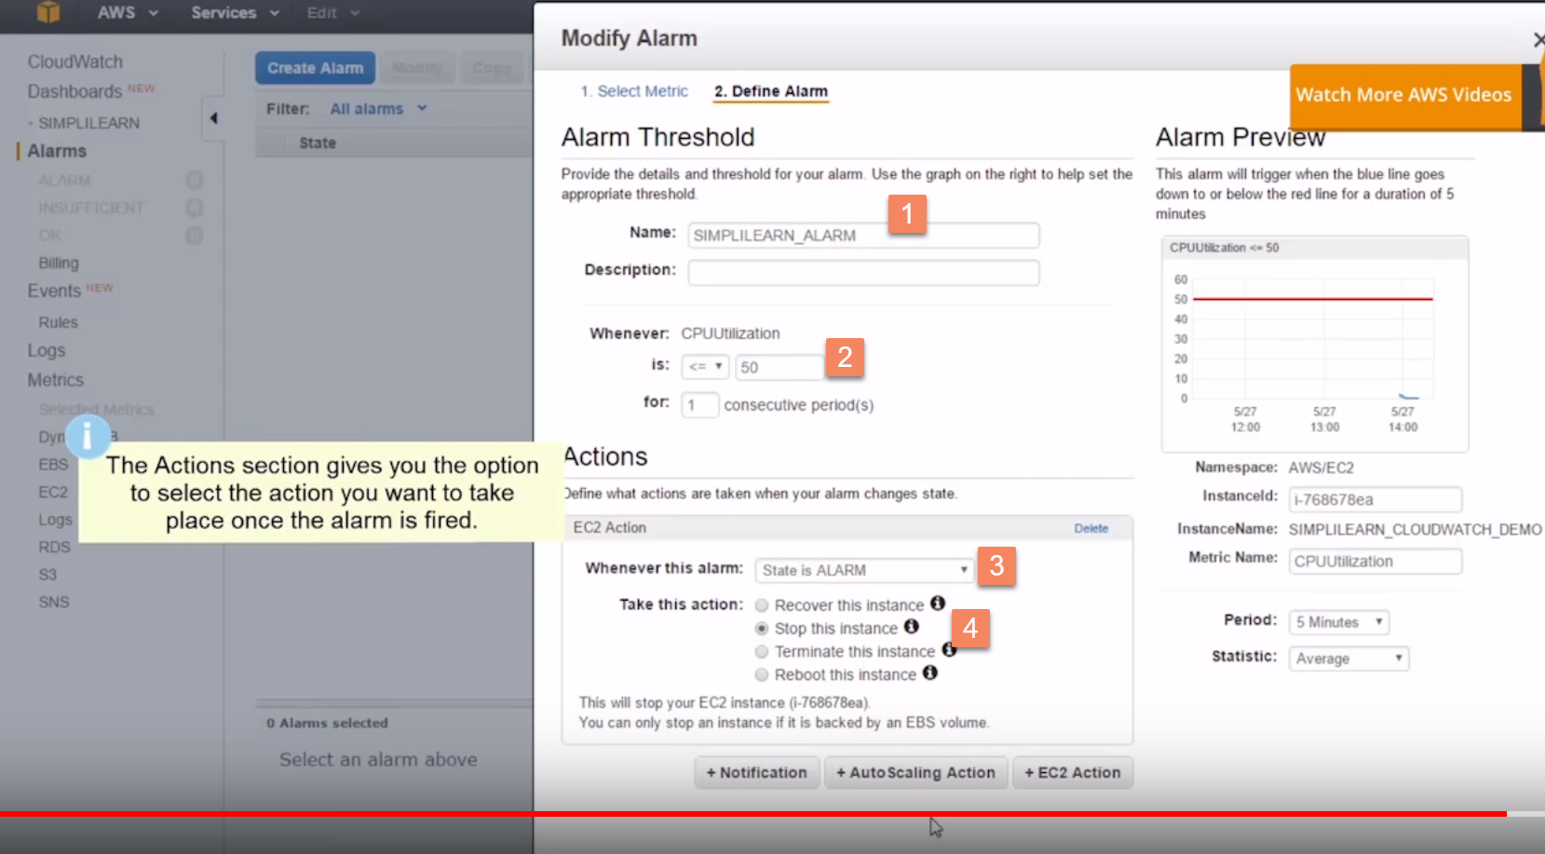

So this instance is going to be stopped whenever the CPU utilization is less than 50% for five minutes

d.)

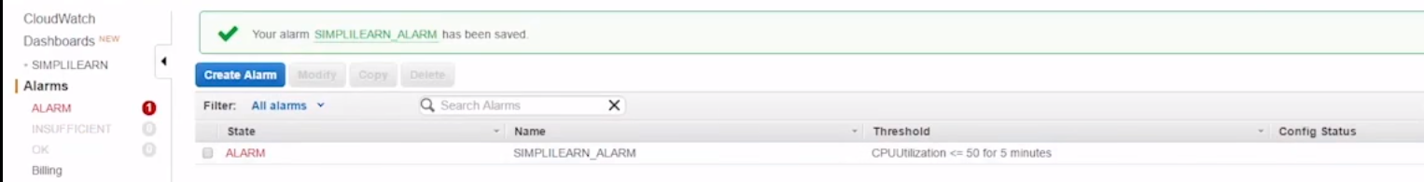

e.) this instance has been up and running it has monitoring data for the last five minutes and it's saying the alarm has fired…

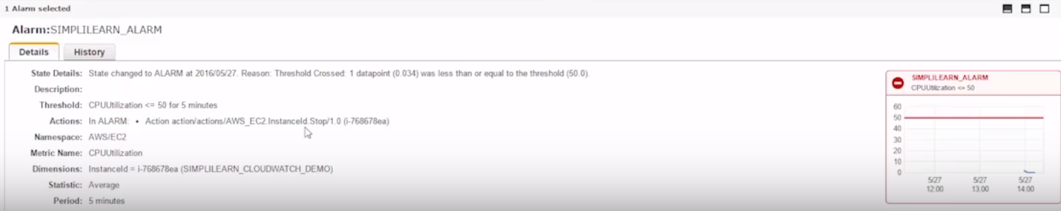 threshold crossed one data point 0.034 was less than equal to the threshold at 50%...

and it says when it's in alarm it's going to stop the instance…

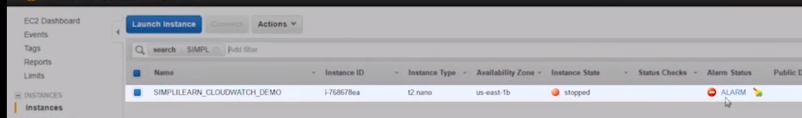

so, if we go to the ec2 dashboard and here we can see that the simply learn cloud works demo instance has been stopped by alarm…