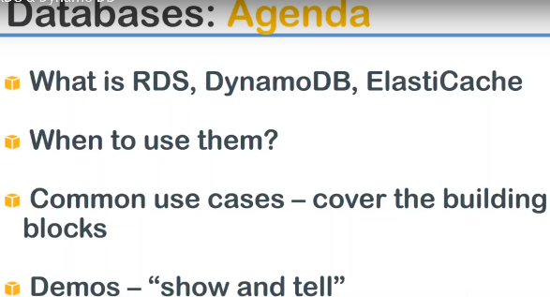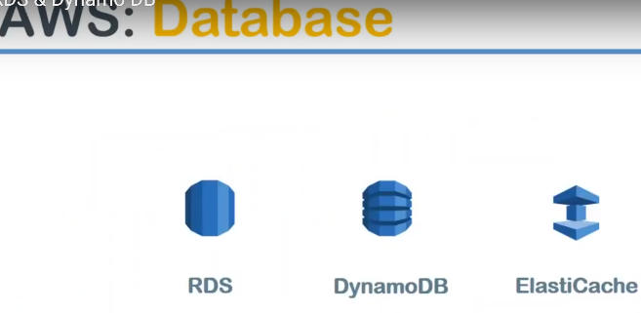

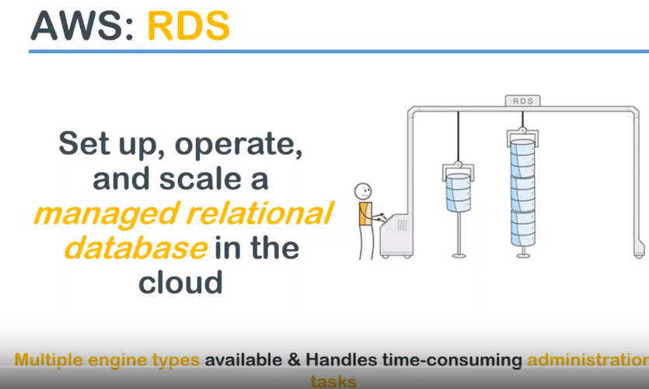

**RDS:** It is part of the database group of services offered by Amazon… and it is a highly managed service provided by Amazon and it is the relational database service provided by Amazon.

When I say relational it is a rows and columns and there is some relationship between all the records or all the records for more similar structure.

**For example:** The table of students in a particular classroom …So the relationship is all of them are students and all of them might be from the same class and

They might be from myself particular school or some kind of relationship will be there and each student will have the name age sex marks and then their preferences hobbies is preferred subjects and so on so forth so that is what a relational database will look like and

That's kind of a database can be run on the cloud without installing without managing without the configuring because all those activities are done by Amazon you just go ahead and start consuming it…

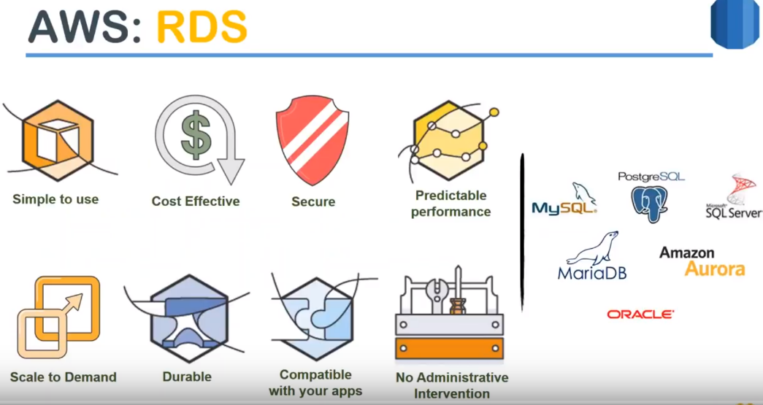

Amazon flavor of database engine Arora..,which is compatible with MySQL. **Arora is binary compatible with MySQL…** What it means is??? any database which is stored in MySQL …you want to migrate because it is finally compatible and all the data will move smoothly or imported without any hiccups..

**Features:**

**Simple to use:** RDS it is very simple to use… I would definitely agree with that when compared to what the database is on-premise..

All i have to do is: choose your subnets where your database needs to be ,customize the locale settings your time settings , parameters that define your database, choose the type of engine and then you select the database type db.t2.micro..>click on create-🡪 Will do all the processing and give you an endpoint which you can start communicating in your applications,

**cost-effective** Absolutely ….because you are not installed in our database ..,you're not setting of the high availability…, automatic patching all of those things are taken care.

So comparatively it is very cost effective.

**security** RDS can have databases encrypted using your own keys because kms service provides you both these options your keys are: Amazon's own keys or any other keys.

**Performance:** it uses EBS volumes underneath …You are not going to choose the EBS volumes but you will be able to choose your provision *IOPS* level. So you can choose my database needs 20,000 IOPS or 40,000 IOPS or 5,000 IOPS.., You can go on dial-up the performance so that way you can clearly predict what is going to be a performance for your database when you choose a provision I office type of service.

**scales to your demand**

For example: if you are not having enough CPU and memory capacity.., all you have to do is just change your instance type or your database and you have a higher instance.. and if you need more performance go ahead and increase your provision IOPS then you can have more IOPS capacity also.

In this way, you can scale up to demand… or you can come back also anytime and literally your database grows vertically upward down as your demand grows .

Nowadays, Amazon introduced some other concepts called as database clusters .

Arora have benefit not RDS itself or ever has this global database that is multi master database in multiple regions you have masters and you will have global rewrites without a conflict possible .

**multiple master databases** but that is what the modern world is moving in you will have a master database in America 11-1 and Europe own in Asia and another one in Australia and all of them will have the data completely synchronized and people can't read and write from at any point in time.

So multi master database is becoming more and more common nowadays.

**compatibility and maintenance:** Almost all the services in Amazon is very nicely integrated.

For example: in this case our RDS integrated with VPC ..

So that you can have security of your VPC layer saying… you want a security group defined for database alone…

you wanted separate subnets defined for your database or let us say you want to connect your day through particular IP addresses only using NACL.

else that way it is more secure and then it is integrated with your kms service so that it can access your keys.

it is integrated with the cloudwatch..so that you can monitor your databases with the different metrics

**automated**

* you don't have to do a lot of administrative stuff for example Amazon takes care of the minor version upgrades of your database…
* Amazon can take snapshots of your database every day regularly without it you doing much work.
* You just have to put in the time stamp saying I want my database to take a backup but every day at 12 o clock and I want this back up to run for half an hour and if it is not completed in half an hour it is going to automatically stop the backup and you can continue with your prod. activities
* you can also decide when your upgrades are going to happen …whether it is going to be on Sunday night or Monday night and how much time window you want to take you to the base offline for your upgrade activities.

**what is an RDS instance** ???

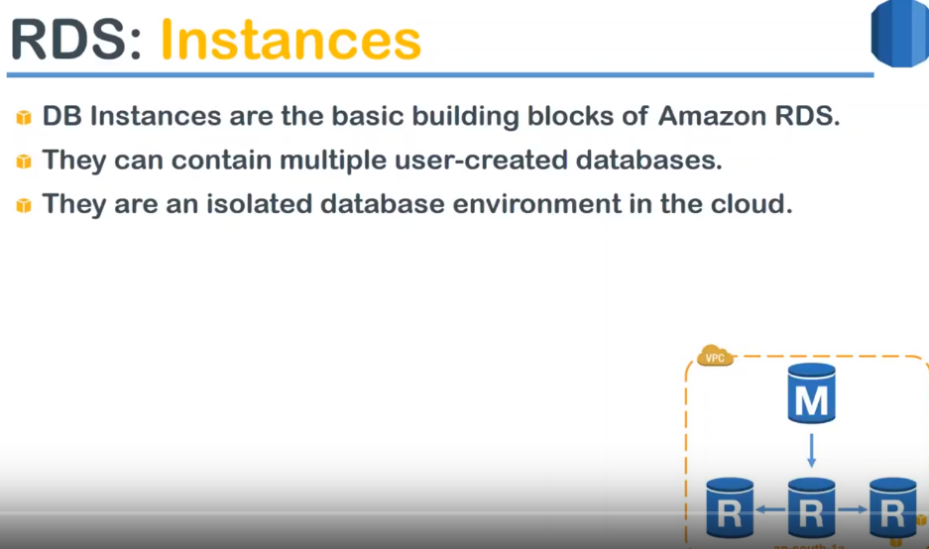

When we are talking about the database.., you need to provision an underlying instance which will provide the compute and memory capacity of the database itself .

So it is the building block or basic building block of RDS instance—

When you say I am creating an RDS instance…, each instance can have multiple database on top of it .

**example** I have a student’s database and you have our staff database …I would have a database for the school itself or I will have another database for parents and teachers always other metadata .

So all these things collectively will be used while it is a school for running their operations.

So one instance will have multiple databases in short… and all of those the databases will run in their own isolated in isolated environment…

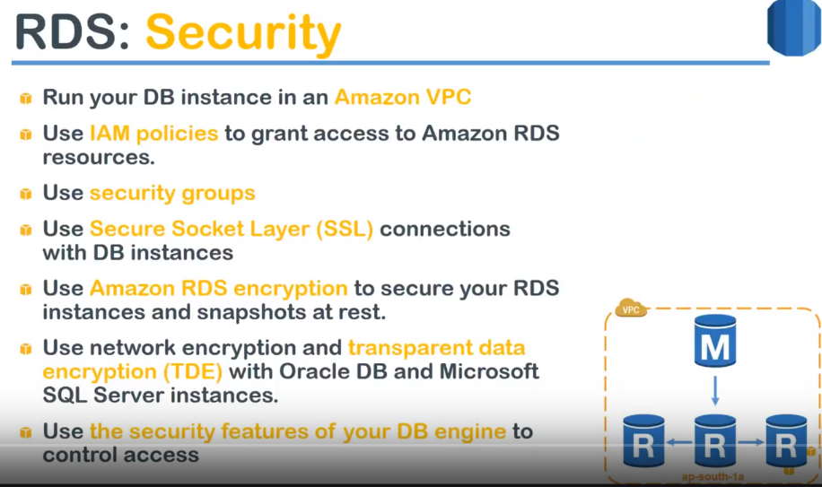

Now that you setup your instance how do I have my security of my instance????

Multiple ways listed here…

1. VPC, which brings in your security group, subnets,,NaCl.
2. We can configure I am policy …who can access your RDS itself and who can manage your RDS.

who can stop them, who can start and who can take a snapshot.., who can restore it.., who can copy to another region through IAM policies.

1. Then you have an SSL connection also you can securely connect your database using your SSL which can be configured with your connection managers
2. encryption through kms service: So that your database and your the snapshots are all encrypted when the data is at rest.
3. if your data is the moving level or if you are talking about a database is particular to Oracle DB of Microsoft they have their own encryption standard called as a TDE.. That encryption standard is also supported in RDS.

6.) Finally, every database engine comes with some other security which is off its own

**for example:** MySQL it will have an admin user and then there will be other users to connect to the database and make some modifications and there are certain ways to tie down the permissions of this user itself.

So you can use those features as well and tie down your database. So it is more secure in the cloud.

**Management/operation**

how do I take backups. There are two different ways 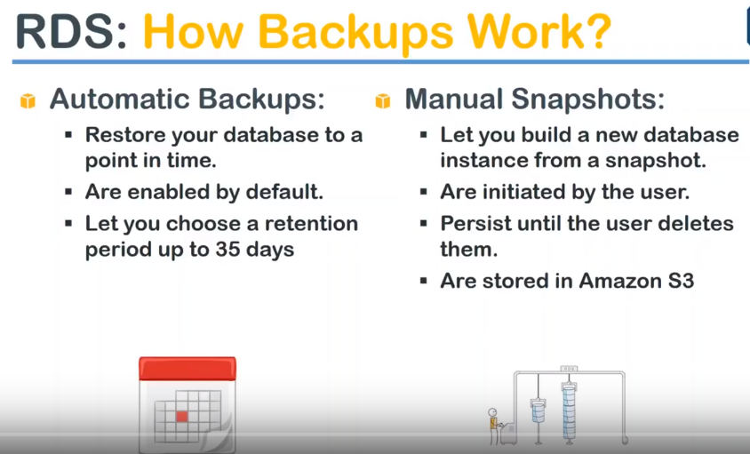

1. automatic backup: all you have to do is choose the time and date and time and it is by default enabled for you.

you will have to manually disable it or you uncheck that feature and the database retains those snapshots for a default retention period of 35 days… if you want you can go ahead and customize it even put it as 0 or 1 or whatever retention days

1. **manual backup** : you can go ahead and take it any time it is always initiated by the user and it is never deleted by Amazon at all…

whereas in automatic backups after 35 days the oldest backup will be deleted… when it comes to manual snapshot nobody will delete it it will still decide in your account and you will have to manually go ahead and clean up your manual snapshots.

**Note:** if you take a lot of manual snapshots, then you need to go ahead and configure your the cleanup activities as part of your process.

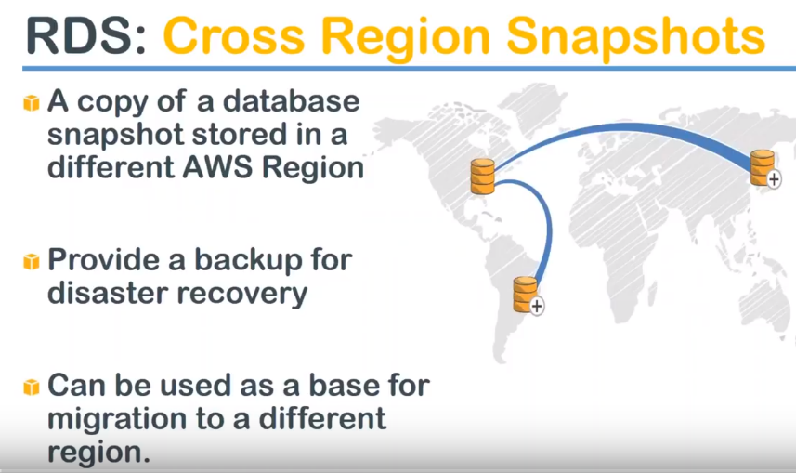

These are the different reasons for having a cross region snapshots

What again I do with my snapshots now???

* **use case-1#** Say my databases is the production master databases in the u.s. region and my developers are in some other country and I need to give them a snapshot of my database so that they can do some development activities…

What can I do with my RDS snapshots first thing is …if your developer is sitting in India and your production is in u.s. …you need to give them a snapshot of your database so that the development activities happen on live data and not some old data.

So most probably what you will do is you take a snapshot you will move it to in a Mumbai region and create another RDS instance using that snapshot. So this way your developers will have lowest latency and they might have also have that latest data also to develop the code or the functionality.

**use case-2#** the next use case is disaster recovery… you wouldn't want to keep your master data in the same location for region software disasters. If your disasters strikes you would want to keep it away so that you can bring up your functionality or your web application in another region…

**use case-3# Finally compliance wise** reasons are also there… which will mandate that you need to move the data to a different region which is a geographically separated.

It doesn't mean that you cannot stay take a snapshot in the same region… that is also possible.. but once you've done that what can you do with that is the question??? and these are the three use cases commonly snap cross region snapshots are used for..

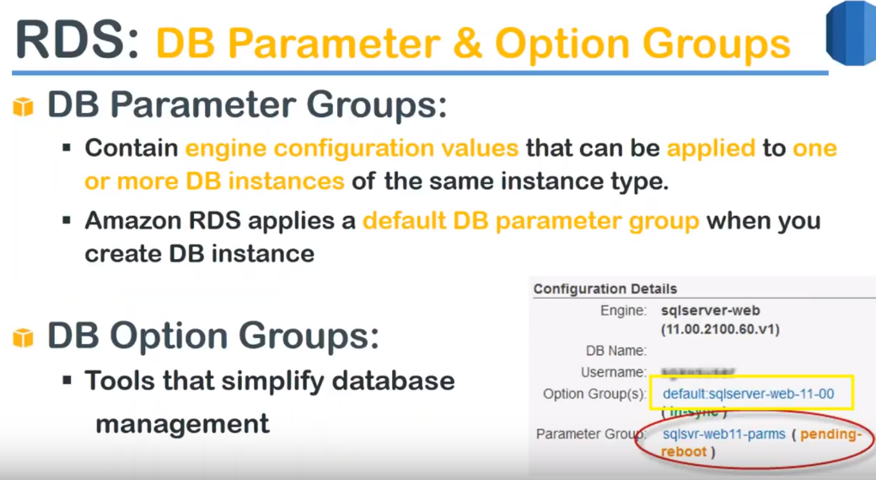

these are the two things Amazon gives you to customize your database… when I talk about the **parameter groups:** this comes from your database engine itself ..

The parameter group for RDS MySQL will be different the parameter group for Oracle will be different and the parameter group for Microsoft will be different..

You don't have to remember all of them Amazon gives you a default customized parameter group for all these engines ..but if you want to further customize it for example a date and timestamp that I spoke about or the local character saying if you want to use more than ASCII characters say so if you see that particular format of font that you want to support you can go ahead and customize that apart from that there are some twenty thirty or more than that you can go ahead and customize any of them depending upon your application use case so this is a data based level at the administrative level you have a DB option groups for example DB option groups gives you the flexibility of choosing when do I want my databases to be taken back up say all your protein databases needs to go offline at Sunday for doing a back up whereas your different tests can have a back up say anytime during the day and the evening so something like that you can configure in your options group so they appear on your database configuration details as the screenshot shows on the right hand side so how do I set up my database now let us think about one imagine a simple web application you have a load balancer at the friend which is accepting traffic and you application servers running in ec2 and they are load balanced with the ELP and those two application servers are in turn connecting to your master database now and this master database is taking snapshots to your s3 bucket everything is fantastic but in my opinion the only problem with this kind of architecture is there is only one database instance and there is a single point of failure here and there is no multi AC or standby server available if something has to happen to your master instance you are going to lose your database connectivity and except all your application will lose its functionality so once again when we talk about high availability we come to the same concept of multi AC deployments and Y and RDS also allows you to do that so what typically when you choose a multi AC option happens is Amazon will automatically create a replica in the other availability zone that you choose or say whatever wherever you have created the subnets it will automatically go ahead and choose one of those subnets and create and replica copy and that replica will be synchronously replicated same you write to one data here and you just go ahead and query the same data in the other database it will be you will be able to read that data immediately because the multi each ACS have a millisecond latency and if you remember regions we talked about the earlier sessions the latency between two edges are really really less and you can literally query them almost instantaneously we saw that in the EF versus session as well you can write it in one easy pick it up with another AC and modify topology so go ahead and use multi AC deployments for your production without a failures even if somebody argues against it it is your responsibility to go ahead and talk to them saying the failover happens automatically to say when AC is gone offline the fellow from master to the replica happens automatically and remember this replica is not something that you can use it from your application and to improve your performance because there is two instances why should i connect on you to the one that is not way I mean the Amazon does not allow you to do that it has the replica but the replica will be promoted to a master only when the master is offline or having some health issues because of unlike hardware or any software about that so that is what a multi AC deployment and how does it look like in an architecture way this is how it is the same architecture we just added a couple of application servers and we also have a master and slave now and both of them are synchronously replicating and snapshots are going to your s3 so this is how your architecture should look like for production databases so we saw what is an RDS itself what is the relational database what are the services offered by Amazon in ideas but there is another type of service or another type of database in G which is getting more and more popular in the world and this is called as the Noyce ql engine there are a lot of open source technologies which tackle this problem the common one is called as a MongoDB and the Facebook version of a nice QL database or columnar database actually speaking is a Cassandra TV and there are some other databases like Coach DB but Amazon variant is called as dynamo DB so whenever somebody says dynamo DB it is no SQL database which has a predictable and scalable performance why I am saying predictable and scalable is no SQL database runs or dynamo DB runs on SSD disks and SSD disks always have a consistent performance and if you said I said that I want to have this many right units of performance and this many units of performance so you will be consistently getting those kind of perform and it is scalable because you are not storing in a relational database like a tables and columns each of the data will be stored in a format called as collections and the collections might might be a group of flat files the best use cases think of you storing your vacation pictures and images you will have a name of the location name say I went in April 4 so on so place and all the photos under that and then you will go to another vacation after six months and you just put a top-level directory name and all the images we need that so you nobody will know how many images will come inside those pictures and think of now uploading all this into Facebook into all the groups are collections so they have distorted somewhere and this is the use case a dynamo TVs all routes because every person will create the different collections and every person who added different types of files into it I will collect my music files you will collect your images somebody will collect their video files and somebody will put some CSV files so what is going inside the collections is absolutely flexible and what is the size of those collections again it is flexible and what is the metadata about those collections you can decide how we want this is at the database level but when you want to store it then a mode TV allows you to have this flexibility of any type of file format it doesn't say I need to have binary format only and need to have CSV format I will have to have ASCII text these are some restrictions that your IDs will bring into picture you cannot directly store your binary objects you will need to create columns and each of this columns you need to decide whether it is string characters or integers or binary columns but in dynamo TV you just create a collection go ahead and do that that is one of a broader level differences between an artist and the dynamo TV again this is a highly scalable because Amazon automatically creates a replica for you and you don't have to do anything there is no concept of multi AC deployments here once you create in dynamo TV and automatically Amazon ensures that you have the necessary replicas in your s3 kind of storage and you don't have to worry about the failures anymore and literally the service takes minutes to get up and running very very simple and I wouldn't say exactly cost-effective but considering the for months it gives and comparing the capabilities it has it is one of the competitive cost in the market because I have seen then I'm going to be cost overshadowing on the other costs sometimes but the performance it gives for mobile applications or print ends which need a lot of i/o and each of those i/o is like in millions then animal TV is a fantastic mute case for you so in short there is summary of all the things that we just now spoke about when you are talking about an SQL database the data itself is stored in rows and columns whereas in Noyce ql it is a key and value in our case let us say it is a vacation name and the value is your all the image names that is stored there and the schema is fixed that is what type of format of data that I need to store is fixer and then it comes to know SQL there is a dynamic you can have a different schema I can have a different kind of first-order Eicher and querying there is an interesting part you need to use the SQL standard coding format for no RDS whereas when it comes to know SQL you can run through your collections using the JSON querying format like you will get at HSN and within the Jason you can use a Java or Python code to traverse how to find out which collection is where and how much data is there scalability is always vertical in RDS if you remember I spoke about increasing the CPU and memory by choosing the instance type and also changing the performance of the disks by using the provision I ops so these are the only way or you can scale your SQL instance whereas when it comes to no SQL it is horizontally scaling because each of them are stored in a separate collection if my first disk running out of space all I have to do is add another disk and I'll continue the collection and add it to my index saying this collection is in this place so depending upon your use case you will choose an SQL or no SQL there is no straightforward access but when you are starting out the Amazon says if you are a new building a new application you have some hundred users or thousand users most probably SQL will be meeting your demand but when you are talking about the globally distributed use cases with a lot of million of eyeballs and small i/o activities like gaming or a Twitter feed processing I am a management of your data then no SQL makes sense but that is also after X number of users when you're starting up SQL makes a fantastic use case for most of the scenarios again use case level is a description between both those databases when you are talking about application type then existing databases or business process centric databases you can do but no SQL when you are talking only about you have scale or large number of reads and writes well the reason I say keep saying about a gaming is infer there is a particular game in the market and say there are certain tools and users are playing it each of them will be at a different level in that game and each of them have a different high scores and at the game overall will have some high scores so constantly this game will be updating to the server to find out where you are say can because for this example it will quickly show who are your friends and then what is their breast score and within the friends who have got the best score and who whatever they are in and you're going to interact with them to get the lives or you can buy some products from the app itself so all of this activity is constantly going to the server and coming back so much web scale applications and the small read rates no SQL is best and the next two thing that you you will choose on deciding is a relational data model is what type of data model that you are using whether it's complex queries or join query sir this is quite interesting part you cannot do something like this in an OTP running a join query in dynamo DB is very very difficult and needs performance however it is is SSD one second so complex queries cannot be done in dynamodb so if you are a database requires or if your application requires you to run complex queries then you need to go with SQL only that is the best performance application for this which case then your if you need is scaling by clustering partitioning and sharding then you can choose ideas but if you want to seamless integration and on-demand scaling then you need to choose with them OTP finally your quality of service if your performance depends on your query say once again going back to here and how often you can do optimize your querying and relay rate availability then you will choose this but if you want all of this to be done by somebody for you that is Amazon or some service provider then you will have to choose with dynamodb because the performance optimization and it's not shorting the replicas high availability everything is taken care by Mysore and no SQL so you can go ahead and choose that so depending upon your use case is no one single straightforward answer like ABC you go ahead and choose this so here is how you choose your performance of your dynamo TV in short what happens is there is a one receive capacity and then the right capacity so if you want to choose the what type of read or write you need to choose that with Amazon in this case read capacity is identified as 4 KB and if you're right capacity is identified as 1 KB so you go to and talk to your obligation themes and see how much read they are going to do and how much concurrent reach they are going to do and the overall in a typical day how much they will do then you go ahead and divide that number say I will do 10,000 reads and each of those the read will be let us say 8 KB then all you're going to do is so you are going to provision with the 20,000 baby units because then they said that 10,000 and it is 8 KB of data they're feeding so for the unit Amazon provides only 4 kv of capacity so if you want 20,000 that amount you need to go ahead and set up 20,000 units likewise you go ahead and choose what is your right capacity unit and per unit capacity is only as large as 1 KP only even if you do say for example 512 bytes Amazon will come to it as 1 KB of all right unit so anything lesser than this or closer to this you will choose only one KB as your right capacity unit and based on this your performance will be allocated and the disks will be optimized the underlying this will be optimized for this kind of performance so this is a simple data model let us try to see how collection will look in reality although when you go to a console you will be asked to the terminology will be used as a database only but underlying this is what happens here is an example of a data model for a music album and let us say each music album to each row that you see there is a single music album and each album will have an artist song title and then you will have album title ear genre and all those fields and you can notice that all the albums are not having on the fields some album is having here and some album is having journal and other album is not having it so this is how a DynamoDB data model will look like in reality and each of them will called as items so the entire thing is in collection and inside that collection you have multiple items and in this case for each item is a music album and to optimize the querying what you are amazon says is you board and create a partition key or some kind of an unique value that will identify each collection so that you can easily retrieve it in this case the artist name is chosen as the partition key so that you can identify it easily then you can go ahead and do one more thing also you can create a short key because each attach will have multiple songs and you can go ahead and sort it and pick them based on that then finally once you do this you can go ahead and query saying that I want it in the table music I want to give list me all the album's written by this particular artist and sort them by song title so I will get a smaller subset of data and again I will write another query finding out saying song title should be so-and-so and give me that value only so that is how you use your table short key and partition key to identify a particular item in your collection this is the think of it as a quick snapshot or a primer into how no SQL query will work like that then to improve the performance Amazon has something like you have a local secondary index and then the global secondary index is also there in addition to your partition key you can go ahead and identify the albums based on your album title also so it allows you to query it based on some more parameters so instead of having let us one as 10,000 songs or just give me all the title starting with a and then all the song title starting with B and combination of this will be lesser so I can have lesser data to process through in my application so let's move forward this simple application architecture for dynamo DB will look like this and you can see here the interesting is the front ends are all shown as different devices mobile tablet and computer and they enter their database through load balancer which is ideal in my opinion always have a load balancer in front of your application servers and which will cascade it to your ec2 fleet of servers or you might have one web app server on the backend level you will have your 10 MOT B so that is all you need to set up an three-tier architecture this is not exactly three tier two tier I would say we're back servers that is why I said but this how you need to do always have to have a load balancer and application servers in auto scaling mode and dynamodb which can also have auto scaling today and then you can go ahead and setup your three two tiers like this on security groups and me PC split on top of them so let us go ahead and see some considerations of when to choose what first and foremost there is no one-size database which everybody you need to decide what you are going to use for your application and what I am going for doing for my application will not suit you even if you are doing the same application also because my user base might be different your user base might be different and my users might be coming from one region that latency requirement will be different and your latency so one size doesn't fit all so after setting that Golden Rule in the beginning so what are the other dimensions that I can choose when I mean when other dimensions that I should carefully look for and choosing a database data format what type of data I am going to store whether it is CSV music files video files HTML files or binary data ASCII data choose all that and then see what is the size of the data is all of the data is going to be one KB 1 MB 1 gigabyte or 10 terabytes what is the size of your data that you are going to store how often you are going to query your data you were wearing all of the data at the same time or some of your data quite often or all the data will be in frequently accessed so data access speed what is your read operation slight operations so based on this then you will have to decide your radar base whether it is noise Kuehl if it is or no SQL then go overhead with a normal TV and if it is SQL then you need to decide which engine that you need to run so when I say engine MySQL Oracle ms SQL Postgres anything so that's all these are two important services amazon offers when you are talking about database itself so the next thing we are going to do is going to the dashboard and start setting up this services and see how we can interact with them so let us go to our dashboard so RDS service and in my opinion the first thing that you need to start is creating an subnet group and then creating an parameter group and then going and starting your instance itself because you need to decide what parameters your database is going to have before you have it although you can go ahead and modify the parameters later but that would require a reboot to get applied so first thing subnet groups next your parameter groups and then go ahead and start your instances so let us Buddha do the first thing subnet groups and as often there are no subnet two groups so let us go ahead and create one I'm just going to say is there more subnet group and which VPC this is the QV PC because I'm going to put my application clients in my QV PC only so I'm going to put it choose this one V PC and which all the subnets I want I want both my subnets one A and one B in one year I will probably have to go to my V PC to find out which is my private subnet here because the description is not appearing so let me open maybe PC dashboard so annemun may be PC dashboard section under the subnets what I am going to do is I'm just going to say Q - is he so it just filters it the based on that so what I am going to first thing that I'm going to do is go and find out what is a private for a c1 that is are usually when I said is e1i you name it for one year availability zone and my subnet in this case is one CA B this is the subnet for me I'm just going to make go back to my artists console and the choose one CA B this is the one so for that easy one I have chosen that and I'm going to click on add subnet it will appear in the bottom so I'm going to do the same thing for AZ B also and let us go ahead and find out what is our subnet ID but changing this one to AC 2 and it says that my subnet is d60 let us go ahead and pick the same thing the 6 0 ok great and click on add subnet and it is go ahead and create our subnet to group now that is how simple you go ahead and create your subnet to group so next thing is parameter groups and by these are the default parameter groups that already amazon has I'm just going to say I am going to create another parameter group and I wanted this parameter group for MySQL because I'm going to start and IDs instance in MySQL and 5.7 so I'm just going to use the same thing I'm going to call this as custom perang group for MySQL 5.7 so go ahead and click on create okay must contain only digits letters digits or hyphens okay the dot was the problem I remove the dot so that worked so option options groups you can go ahead and customize it but nothing much is going to do it is say so we are going to do this for a MySQL go ahead and choose MySQL what is the major version five point seven just going to choose that option as well so we have done all these customizations before starting our instance so let us go ahead and start our instance itself before that let me take you to the dashboard and stuff no there is nothing there if I go to my instances also absolutely no instances running just go ahead and create our first RDS instance you can see here launch DB instance click on that this is where your choices are coming into the picture the different Amazon offered the database engines Aurora MySQL and MariaDB you can go ahead and choose anything anytime the licenses are managed by Amazon itself automatically you is not easy to import your own through mice licenses to this cloud licenses it is recommended that you go over and discuss with your vendor to see whether you can import it otherwise go ahead and choose the default ones and done with it and remember some of them are charged here for example Aurora DB is not a free for our trial purpose that is for a free tier account at the bottom you have enable only the free tier if you choose this you can see automatically the Aurora GB is a disabled I cannot choose that option anymore I mean since I the option of selected already it's the tick was there let me go ahead and choose that now I cannot reduce our or a TB but if I choose that I will be having an additional pricing that we have clickable so you see here there is a friendly warning message that comes up so for the demo purpose go over and choose MySQL and if you want to know the difference between this and this you can see here this abode so at every size of 16 terabytes and then this much memory and there's a limit on the number of reach replicas also whereas if I go ahead and choose Aurora TV you can see here it will go all the way up to 16 terabytes and it has 15 read replicas with something second lag so it's really high performance database that amazon has created in our RDP and if your client says that I want RDS only and I want really high performance you can blindly suggest Aurora TBS one of the options to consider for demo purpose that is go ahead and stick with MySQL click on next and here is the parameters that we are going to choose with so let us go ahead and choose 5.7 what is the latest version 5.19 it is code and choose that an automatic your license gets updated as well and then if you go ahead and uncheck this you will see that my TAC deployment gets enabled if you say I want to only create options the free tier you will not be able to create a multi-tier application so first let us say testing a database in the only one tier and let us go ahead and change the multi tier later and here is the database engine and let me unfreeze this and if I wish that I get all this bigger sized database engines AMA database memory and CPU capacity available for free tier you are allowed only a TB t2 micro only so that is the only option available so let us go ahead and keep this unchecked but let us choose the options carefully and by default SST disks you can want to improve your performance go ahead and choose a provision I ops and you can go ahead and choose how much you want so and if you choose the general purpose the 20 GB is the minimum you cannot go lesser than that earlier it was Phi G B now it has gone up to all the way to 20 T V that is a storage that your database needs so here is the other things that you will need the several custom parameters you can go and choose whichever field you want so I'm going to call my DB instance as DB instance 0 1 and master user is equal to DB the user and then password DB user us I just want to be careful so that they don't lose it typically this is what I am going to put am just going to keep it somewhere else so that doesn't know that so here is the VPC part let me go ahead and choose the QV PC and you can see here by default the subnet group it automatically picks up the one that we created if it is not there it will automatically create the subnet group and give a drop-down with that option on V since we've done that we don't have to worry about it and it's asking whether you want the V P already has to be publicly available no we can make sure that your RDS is not publicly available and all you see is your instances outside of the V PC will be able to connect yes that is what I want I don't want the public access to my V PC and in this case let us make sure that my master that is the single instance is going to be in one year then we'll go ahead and enable multi Izzi and see whether it is starting up in one be also so then we select security groups I want I'm going to select it manually and see here this deep word already chosen let me remove that and I'm going to choose the public security I'm a private security group and remember I need to ensure my private security group is allowing traffic from my public because my client is going to sit in publica so we'll go ahead and edit it in the V PC in a short while after finishing the remaining configurations so because we need this port number you'll use that so what is going to be my database name and I'm going to call my database name as prudence ste u de NT students DB okay let us remember that because we will use this database to connect in a short while and my D me params group is a five point six that is interesting why it is not reflecting there is probably a version confliction because for some reason some of the options that I chose is not allowing me to choose the five point seven DB parameter group and the options group that we created will check that later but anyway you can you will discuss this usually with your the version number especially discuss with your application team on what version of database they need and choose that it is copy the snapshot and it doesn't do not need and I am a sophomore for administering the database itself and for the DB instance class that is T 2 micro encryption is not supported if you go ahead and start a bigger instance you will be able to choose the encryption as well and finally how often your database needs to be done backup for so seven days 35 days whatever you want you can go ahead and choose that and I have no preference of my database called you that if you have preference go ahead and select it and say to your time and then what these times are in UTC so if you are in CET PG or PST whatever time zone you are in converted and update it in UTC monitoring if you want more information about what is happening in your database then go ahead and choose enable enhanced monitoring and what is your frequency one minute level sub-second some one-minute level let us choose default of sitting of one minute that should be fine and do you want to export your logs yes I would like to say I wanted export all my logs and send it to cloud watch finally maintenance part of it the important part whether you want your minor versions to upgrade or not and if you want the preference of time window when you want to do it let us say I want to do it every Sunday at let us say zero-zero hours and 30 minutes or I have to do something like this and I want to happen the updated certificate completed in one hour so I've chosen this option go ahead and launch DB instance okay back up window did me choose a time here okay I'm just going to say the backup is going to start at after the upgrade - so that should not be a problem now click on launch instance so it has taken all the parameters and it is going to launch my instance let us go ahead and see the details that we have done so far and remember we need to update our V PC also while the database is getting booted up we code and do that meanwhile this is my instance and DB instance 0 1 is what I treated and if I scroll down all the parameters all the fields that we have chosen everything is listed out here and that once the database comes online this field will be updated with the domain name through which we will be able to access our obvious instance itself so for now it is still creating if you just look at this option it says that a DB instance it is is getting created I mean getting creating so let us leave that as it is and let us just go and see this is the configuration of the database itself the network part the instance details and the monitoring part of it they just segregated in Nice four columns so that you can focus on which option that you want to modify or anything so I am interested in this security group I am just going to click on that so that we can configure it to enable port 3306 axis it is close this notification so as of now my inbound rules allow port 80 and port ready to only just going to edit it and say already yes or not is my SQL so automatically it chooses my port here and then I am going to save my web security group so my web security group or in other words called as public security group and click on save and if I take you back to my ec2 dashboard remember I have an all Deus client set up in the same me PC and I have put it in the public security group so we should be able to connect to or database from this server as well so let us wait for our RDS to come online it's going to take some time that is wait for that here you can see here my database has been set up and it is still not yet available because it is doing the initial backup and if I go to my snapshots and I should be seeing a snapshot being created here and then there is a create statuses creation in progress and about 1% a richer so any ideas instance that you create for the first time it is going to set up the database and it will do an automatic backup almost instantaneously after the database creation is completed so this is where I have the snapshot section but it is go back to instances and see it is completed its boot up cycle and you can see here there is another interesting thing I am going to show you the connections is as of now zero and if we use our Terminal Server and then we go and connect it then this session will be incrementing by one and we will slowly see how it implements when I start a secondary server as a replica and what happens after that you can see here my endpoint is ready and when so once the backup is completed its process then we should be able to connect to it and write to it in this article we have all this most of the steps or most of the commands that we are going to run for the remaining part of the demo this is the steps written to how to connect to an ec2 instance and this is the syntax for that let us go ahead and plug in our domain I'm in the endpoint and then our master user or password here - hedge and the domain I mean the endpoint I copied from my dashboard so - P that is the port number and then we are going to use the username if you remember I gave the username I said TP user let me go ahead and confirm that if the username that I've used earlier yeah and then the - small P is for the password part of it so I'm just going to copy this and go to my ec2 server which is counter true putti here I'm going to just paste it and if everything is working fine I should be given a password prompt so my security group and my RDAs everything is come online so I'm just going to put in the password now and you see here I am connected to the server and it says gives the my SQL prompt if security group or my IDs has not come online I will not get this prompt so the next is I'm going to ask the Argus data will to show me all your databases so the command for that is something like show databases and it shows me the students DB that we created when we are setting up the RDS itself so I'm going to say use students DB and I'm just going to say show tables so incoming all the tables that is inside your database now for the database students and show me the tables as of now there are no tables so the first thing we are going to do is set up some tables in my RDS copy this command from your article which is going to create our table with a student name I mean the table name is going to be students ID name and city so just copy this back to our terminal paste it and press Enter now it says that query is OK and it is executed so if I go back and execute my show tables and it will show that there is one table called as students and as of now there is nothing in my tables if I say select star from students it will say there are 0 query first of all there are no students in my data in my tables so let us go ahead and insert some students now for that as well I have written the article which will be inserting some students these are the values let us go ahead and insert the first four records into our table now so let us go ahead and paste them and if I go ahead and execute show me all the students from all the records from my students table it is going to show me the four records that we just now inserted and it says that there is a person called Anil from Singapore and there is a person called Sydney from Hyderabad and there is a person called a whale from Chennai so there are four records we have operated and that is how you interact from your application to your alias itself we infected through creating a table we inserted some records if you want to go ahead and retrieve it I just retrieved all the records from my table by using the select star from Honda you can go ahead and we through individual records also safer so here I am going to execute this record which picks up my student ID where the last name is ready so I should be getting these two records actually I should be getting only two nine two three this is go ahead and execute it and see what happens so you see here student ID is two and three likewise you can go ahead and change this value say give me the city and then from where we can also do that so all you have to do is something like this and I should be getting the city s Hyderabad so now that is how you interact with today that is so coming back to aw audience let us see how we can go ahead and create a snapshot and which is a point in time a backup of your data so when I say point in time there are four records and all these four records will be taken or should be taken as a backup now let us go ahead and do that we are back in the RDS console and I'm just going to refresh my screen to see all the values are taken into effect and databases come online and you can see here the number of connections has gone up to one because there is a one client that is interacting with my database now so let us go ahead and ensure that we are selected our instance of a choice and click on actions and you have an option saying take snapshot and remember what the action that we are doing now is a manual snapshot so I'm just going to call it as a manual snap with four records [Music] take snapshot I mean I just gave an expose nap shots because what you are going to do is after the snapshot is triggered we are going to insert some records and we will create a database from this snapshot also and see how many records are there in this snapshot so that is one thing we have what we have done so far is just figure the manual snapshot and you can see here it is in the creating stage now and it is going to complete its processing it's in its own time it is not wait for let us go back to instances and in case if you want to change any parameter or anything for the database itself you can use this instance option and go ahead and change it say for example I want to create a 3d replica that is that is a master where I can read and write data to it but there are certain queries where only the read operations happens and I want to from my application send those queries to a different instance which will only read to improve my application performance I can do that as well so all I have to do is click on create read replica and it is going to ask me some questions like for example what is the DB parameter group and I will abuti shown in this case I'm going to choose ACB and make sure that I am not in public and what is the instance class again I am going to say this is going to be in t2 micro only I don't want the multi is e1 and I am going to go ahead and choose the other settings here as well general-purpose everything is fine default so I'm just going to say a DB instance identifier so give me inst 0 1 so he'd pick ax that is what I'm going to create and popular styles and snapshots yes I am going to leave everything else as default and remember it is going to pick some of the other default values from my instance itself you can see here I mean I my database is still not an available stage it is doing its background processing it's not finished so it's not allowing me to create as either because we have to wait for some more time my database has come online now and you can see here the connection level is at 1 once my replica is comes online we should be able to see this connection level jump to to let us go ahead and see go to a previous a dashboard and see we can complete the process of creating the rate replica for our instance just let me scroll down and click on create if everything else is fine we should be able to trigger the requester to create a vehicle clicker so we have successfully done that and let me find out there will be one section where it will list out all the readers because all the other instances connecting to this database here you can find the outer that the replication status as of now in the replication status that is just one and if you remember we chose availability zone 1b for my replication P I mean the clicker instance it will come up appear here once that request has been completed you can see here it is a modifying my DB instance earlier it was saying backing up now it is a modifying because it is creating a synchronous connection between my master database and my three replicas here so that is the state changes and let me scroll down to the replication segment and here we go there is the master here and my DB instance read replica here and this is in availability zone 1a and this one is in rip other I will have this one 1b and you can see the role of each player this is a muscle and I cannot get it up do anything to this instance itself here you can see is a summary view of my instances there is one master and there is one read replica and my read replica is getting created and after my trip it has created there will be a snapshot for this as well and then this will also come into available state and my connection will change into two and of course this will also this lead instance will also get its own end point once the process of setting it up completes you will get its own end point we should be able to connect it from our server and see whether we can read data from it and we will also try to write to it and see what happens after that okay finally both my instances have come online and the interesting part is if you see the connections my master has two connections now that is because my replica is also talking to the my master so if I connect to my replica and I'm using its end point and the same user name password is sure to work for maybe the biggest well here is the end point for my reader pick up just copy this so we have got the syntax right it is go ahead and connect to or read replica it is good input the password so connected to it let us go ahead and say use to thence DB and this change of Florence TV select okay before okay select star from students I should be able to see all the four records that we created so what I'm going to do now is I'm just going to insert try and insert a recorder from this because this is a read the replica I'm going to do a write operation or insert another record now so I'm just going back to the article pick up the last record and let us go ahead and try and insert it paste it here and press enter and you can see here this server is only in a read-only mode and it cannot accept any statement or not execute this statement whereas if I go to my master server and just go ahead and execute I selected the wrong one I just just go ahead and copy the statement again so my record is executed if I say select star from students I should have fire course now and you can see here there is a Martian record entry that has been done whereas read replica is almost synchronous coffee so let me just execute it and you can see here the data is replicated all ready in my teeth of the cup coffee and this data is there but remember we took a snapshot when there are only four records so let us go ahead and restore the snapshot and see how many records are there in that snapshot Here I am in my snapshot section and you can see this is a manual snapshot that we created and I'm just going to restore this snapshot now under snapshot actions I am going to say restore and we are just going to all the other parameters and he leave the ones which I have already seen as default itself let us not choose multi AC let us go ahead and 230 b2 micro finally me and then DB from snap and QE PC is fine the subnet group that we set up is fine I'm just going to say 1a and leave this as default we don't have to choose any of them just go ahead and and is there a security group option somewhere mentioned here no okay let us see what security group it question to if it is not going into the private security group we'll go ahead and ensure that this instance has a private security group assigned to it so as usual it is going to go into a creating state then if we take a backup and then it will go ahead and give you a end point through which we can connect to it so this is one way of restoring from your snapshot and sometimes what happens is you will need to promote your read repeater to a master also say that I want to create a completely different database from my original server what you would ideally to do is create a read replica first and all the data will be copied between the reader and the master and there are the triplica once you have all the latest data just stop reiterate activity on your master and go to your read replica and then what you have option is a remote read replica so when I promote this what happens is this will become an individual database of its own it will along will have a synchronous connection between that so all you have to do is just go ahead and choose the server and update it as promoter a Tripucka and it is going to ask you the other questions for any master server what is the database what is the retention period just click on continue and it is saying that it will not have connectivity and all those things do you really want to do that or you sure you want to promote in other words yes I want to promote go ahead and do that so it it will say modifying state here and this connections will again come back to one after some time so you can see here my activity of promoting is already taken into effect this is my master server instance you can see here that if the original server that we started and this is my V repeater which is already being promoted to a my master and the connections have already reduced from two to one and the snapshot that he restored is also getting created so all the three databases are individual databases now there is no connection between any of them but this guy will have only four records in this case this snapshot I will have four records and this V the bigger they will have white of course this will also have five records my replica is on it is completing its backup operations meanwhile let us go for it and see the endpoint has come online so we should be able to interact with our server now we are in our replica server I am just going to execute command to say select star from students and five records what I am going to do now is I'm just going to try and insert another record because it is promoted it should work I am just going to edit the student field here to say zero zero six and say Marcion one and let us go ahead and see select star from students and did I not edit it properly okay they donate it to six so at least a much in one eight it has a break it properly so now you can see here earlier when I try to insert a record it was giving me an error saying this is running with a - - bid only option now I promoted that server and I can happily insert records into the server because this is completely separate from my initial configuration of your heater bleaker so that is how you promote your theater behind Oh master we created another database from your snapshot let us go ahead and connect to that one as well so I want to connect to this database now that is a DB from snap and it is an available state good we can go ahead and connect and see how many records are there here is my endpoint let me connect it corrected properly shown and then put in the four three three zero safe and then the username and then the password I think my port is not working my security group is having some problems let me just go ahead and confirm that you can notice here I earlier spoke about this because when you're restoring a snapshot it doesn't exactly allow me to choose the security group that I wanted to be in it is in the default security group and it has its own rules so we have not exactly allowed 3306 in short what happened was my security group was in the default value so it is why not allowing me to connect we have changed it to the private security group where we have ensured the port is allowed and it is secure so that it can connect only from a web server and we are trying to apply it gives you a choice whether you want to operate in the next maintenance window or apply it immediately in this case I want to connect it immediately because there is no way that I'm going to wait until next Sunday just because my port is not working my applications are going to be offline so I immediately click on modify instance and it is going to take that change and it is going to apply that the change to the server now you can see here my security group has changed I'm just going to go ahead and see the rules now what it says it says private security group good I should be able to go ahead and attempt another connection to the server now so you can see here it is say can't connect because there were some problems so yes let us go ahead and attempt another connection TV so there we go once we change our security group straight away we got connected now I'm just going to use the students DB and say [Music] now that is what's wrong so databases [Music] and use students DB and select star from [Music] students we should be able to see only four records now if you remember we inserted five records in my master and then in my read replica also we created another two records but none of them will reflect from the snapshot we created because this snapshot was created when one there were only four records in my data so in the real world database keeps on changing that is why you need to take incremental backup every single day so that when you the point when there is a disaster or failure and you want to restore you will have the latest information to restore all the data so take incremental backups and constantly recycle them so that you don't incur a lot of charges for snapshots also here we are in our dynamodb dashboard all year - the first step is creating the table and it is going to ask me what is the name of the table once again the article that I have written takes care of the enemy t DB as well and I have given the default values that you can fit in there not default customized values because the rest of the commands taken to these values into account so if you change them here make sure that you can go ahead and change them in the commands as well say for example you are creating a new table I'm just going to call this as it abuse students I'm just going to put in the same thing in my DynamoDB as well that is my table name so what is my primary key most probably student ID or student name is for what I am going to use as the primary key so in this case I am going to use it as students ID and I am going to choose the type as string so in case your student ID one needs to be a number you can go ahead and choose that but in this use case I am going to use it as string and I don't want another short key because my database is very simple it's just the students I don't need sort keys and all those things so here is the interesting part if you want to improve your performance more and if you want a better read rate than the default or five reads and the five if you remember each really gives you about 1/4 KB of data and each height will give you about 1 KB of data so by default I am given of 5 read that means the interpreter a 20 KB of rewrite per second and then 5kb overwrite per second for me if I want to change this just uncheck this field and then you can go ahead and edit my capacity index here and then let's say I want to have a minimum capacity of something like 100 units and I just go ahead and modify it here that is on the read level on the right level from usually and I it will be lesser than your visa so you will talk to your application team and see what is the ratio of read write then you can go ahead and cube set and of course the cost is also given to you and if you want to calculate more we can go ahead and choose that calculator then see what is going to be a cost impact for choosing that type of performance for learning purpose definitely default settings is more than enough for you just go ahead and select that click create and it is going to take these parameters and this is going to set up your collections now so once your table or collections is set up on the right hand side you will have all the metrics about your collections so it is sitting it up so my table has been set up that is the amount of time it took to set up my dynamodb table at all literally super fast in my opinion so you can see here the items aschoff now there is nothing in my tables so this this field is completely empty or there is no items and when we go ahead and insert we will go ahead and see how the items list up here these are all the management items matrix alarms how much capacity or provision once again after setting up your database you can come here and go ahead and change it anytime also and you can ask if you remember I said auto scaling is available to anybody v also so you can go ahead and configure certain percentages so this way you can automatically grow your data base and reduce them all so that is where you have a maximum I'm a minimum and then as a maximum and what is the percentage when you want to trigger these thresholds to automatically increase or decrease so that is also possible and remember I o created only one index that is student ID I don't have any robell secondary in Texas created if it is there then it will come up here and do I want workflow created or say my lambda triggers operations in my denim OTP or when an s3 uploader triggers a dynamo DB update so you can configure your triggers to do that again it's an application configuration it's not P you go ahead and set it up for some performance improvement or anything then Modi be yourself is very simple create the table and you will deal with items only so how do I insert items for that then I'm going to me in this case I'm going to write it as adjacent items or some adjacent files so this is how the file will look like I am going to create some these four files now and then I'm going to use the arrows to CLI command to put these items into my dynamo DB itself so let us go ahead and have a server which will have a WCC la access which can interact with the dynamodb can you put it on just going to ensure that root level access okay good I should be able to use this server to insert records let me clean all these files [Music] so we have inserted four records after creating our files though using the article which is use it I would even put item that is good or dynamodb itself and see what is there in the items now so and so now it looks like there's nothing there let me go ahead and refresh the screen and you can see here all the four records that we inserted from our terminal is there and as I said to repeat you will never use a terminal 99 percentage of the times unless you have troubleshooting it you would not go ahead and insert it through that way you'll be doing this from your application so for example let us say I want to hear three record so what I will do is have you sir get item action so here is the command for getting an item so in this case I am going to retrieve the student number three just copy this and then I'm just going to put it here and it is going to retrieve the item and return that JSON object so you can see here it retrieved the item and it says sir on this three and then I find that this value is wrong and this value is empty so I need to correct it so I am going to insert the new record or an update this record so that these values are corrected so let us go ahead and create a collection which is having the proper data I'm just going to enter that so we have created a new file called a store and three and then we are going to use the food item to update that record itself so if I am just going to select this and put it here and I'm not going to retrieve it this time in my console I am going to go to my aw dashboard I'm going to select mic here you can see your 881 is updated here if I click on item number three it is going to give me all the details here of course I can come here or edit it but this is easy when you are having three record strength records but when you have millions of records you cannot literally use the console to make changes and of course you can also go ahead and delete a record from here but typically you won't do that from here and delete item also you can do by using the dynamo DB - delete action if I go to my metrics now there will be some small spikes hopefully from all the food items and get items that we did there you can see the default capacity that is provision for me is mentioned here as five and then I'm literally using nothing here so forth I'm not just literally pushed it up so that I've consumed all the five units if you remember this is for real means that is 20 KB of capacity is provisioned before me and then this is a poor time consuming less than 1 KB that's one unit and right capacity is also 5 and right is like PI tabes for me and I'm using a tiny fraction of it you can see here this it literally a small tiny line there so that is how you set up Dinamo TV in your account if you have any problem with that or any doubts with that let me know I'll try to help you with that