EC2 LAB :  
This lab provides you with a basic overview of **launching, resizing, managing, and monitoring an Amazon EC2 instance.**

**Amazon Elastic Compute Cloud (Amazon EC2)** is a web service that provides resizable compute capacity in the cloud. It is designed to make web-scale cloud computing easier for developers.

Amazon EC2's simple web service interface allows you to obtain and configure capacity with minimal friction. It provides you with complete control of your computing resources and lets you run on Amazon's proven computing environment. Amazon EC2 reduces the time required to obtain and boot new server instances to minutes, allowing you to quickly scale capacity, both up and down, as your computing requirements change.

Amazon EC2 changes the economics of computing by allowing you to pay only for capacity that you actually use. Amazon EC2 provides developers the tools to build failure resilient applications and isolate themselves from common failure scenarios.

TOPICS:

* Launch a web server with termination protection enabled
* Monitor Your EC2 instance
* Modify the security group that your web server is using to allow HTTP access
* Resize your Amazon EC2 instance to scale
* Explore EC2 limits
* Test termination protection
* Terminate your EC2 instance

**Task 1: Launch Your Amazon EC2 Instance**

In this task, you will launch an Amazon EC2 instance with *termination protection*. **Termination protection prevents you from accidentally terminating an EC2 instance.**

**Choose an AMI**

 An **Amazon Machine Image (AMI)** provides the information required to launch an instance, which is a virtual server in the cloud. An AMI includes:

* A template for the root volume for the instance (for example, an operating system or an application server with applications)
* Launch permissions that control which AWS accounts can use the AMI to launch instances
* A block device mapping that specifies the volumes to attach to the instance when it is launched

The **Quick Start** list contains the most commonly-used AMIs. You can also create your own AMI or select an AMI from the AWS Marketplace, an online store where you can sell or buy software that runs on AWS.

**Choose an Instance Type**

 Amazon EC2 provides a wide selection of *instance types* optimized to fit different use cases. Instance types comprise **varying combinations of CPU, memory, storage, and networking capacity** and give you the flexibility to choose the appropriate mix of resources for your applications. **Each instance type includes one or more *instance sizes*, allowing you to scale your resources to the requirements of your target workload.**

You will use a **t2.micro** instance which should be selected  by default. This instance type has 1 virtual CPU and 1 GiB of memory.

**Configure Instance Details**

This page is used to configure the instance to suit your requirements. **This includes networking and monitoring settings.**

The **Network** indicates which Virtual Private Cloud (VPC) you wish to launch the instance into**. You can have multiple networks, such as different ones for development, testing and production.**

1. For **Network**, select **Lab VPC**.

The Lab VPC was created using a CloudFormation template during the setup process of your lab. This VPC includes two public subnets in two different Availability Zones. 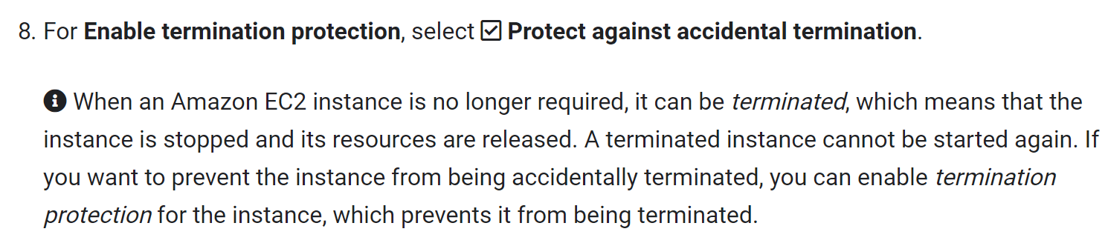

1. Scroll down, then expand  **Advanced Details**.

A field for **User data** will appear.

 When you launch an instance, you can pass *user data* to the instance that can be used to perform common automated configuration tasks and even run scripts after the instance starts.

Your instance is running Amazon Linux, so you will provide a *shell script* that will run when the instance starts.

1. Copy the following commands and paste them into the **User data** field:

#!/bin/bash

yum -y update

yum -y install httpd

chkconfig httpd on

service httpd start

echo "<html><h1>Hello From Your Web Server!</h1></html>" > /var/www/html/index.html

**Add Storage**

**Amazon EC2 stores data on a network-attached virtual disk called *Elastic Block Store*.**

You will launch the Amazon EC2 instance using a default 8 GiB disk volume. This will be your root volume (also known as a 'boot' volume).

**Add Tags**

 Tags enable you to categorize your AWS resources in different ways, for example, **by purpose, owner, or environment.** **This is useful when you have many resources of the same type — you can quickly identify a specific resource based on the tags you have assigned to it.** Each tag consists of a Key and a Value, both of which you define.

Click **Add Tag**, then configure:

* **Key:** 
* **Value:** 

**Configure Security Group:**

 A security group acts as a virtual firewall that controls the traffic for one or more instances. When you launch an instance, you associate one or more security groups with the instance. You add rules to each security group that allow traffic to or from its associated instances. You can modify the rules for a security group at any time; the new rules are automatically applied to all instances that are associated with the security group.

* **Security group name:** 
* **Description:** 

In this lab, you will not log into your instance using SSH. Removing SSH access will improve the security of the instance.

1. Delete  the existing SSH rule.
2. Click **Review and Launch**.

Review

The Review page displays the configuration for the instance you are about to launch.

A **Select an existing key pair or create a new key pair** window will appear.

 Amazon EC2 uses public–key cryptography to encrypt and decrypt login information. To log in to your instance, you must create a key pair, specify the name of the key pair when you launch the instance, and provide the private key when you connect to the instance.

In this lab you will not log into your instance, so you do not require a key pair.

1. Click **View Instances**.

The instance will appear in a *pending* state, which means it is being launched. It will then change to *running*, which indicates that the instance has started booting. There will be a short time before you can access the instance.

The instance receives a *public DNS name* that you can use to contact the instance from the Internet.

Description tab, drag the window divider upwards.

Review the information displayed in the **Description** tab. It includes information about the instance type, security settings and network settings.

1. Wait for your instance to display the following:

* **Instance State:**  running
* **Status Checks:**  2/2 checks passed

**Congratulations!** You have successfully launched your first Amazon EC2 instance.

**Task 2: Monitor Your Instance**

Monitoring is an important part of maintaining the reliability, availability, and performance of your Amazon Elastic Compute Cloud (Amazon EC2) instances and your AWS solutions.

1. Click the **Status Checks** tab.

 With instance status monitoring, you can quickly determine whether Amazon EC2 has detected any problems that might prevent your instances from running applications. Amazon EC2 performs automated checks on every running EC2 instance to identify hardware and software issues.

Notice that both the **System reachability** and **Instance reachability** checks have passed.

1. Click the **Monitoring** tab.

This tab displays CloudWatch metrics for your instance. Currently, there are not many metrics to display because the instance was recently launched.

You can click on a graph to see an expanded view.

 Amazon EC2 sends metrics to Amazon CloudWatch for your EC2 instances. Basic (five-minute) monitoring is enabled by default. You can enable detailed (one-minute) monitoring.

1. In the **Actions** menu, select **Instance Settings**  **Get System Log**.

The System Log displays the console output of the instance, which is a valuable tool for problem diagnosis. It is especially useful for troubleshooting kernel problems and service configuration issues that could cause an instance to terminate or become unreachable before its SSH daemon can be started. If you do not see a system log, wait a few minutes and then try again.

1. Scroll through the output and note that the HTTP package was installed from the **user data** that you added when you created the instance.

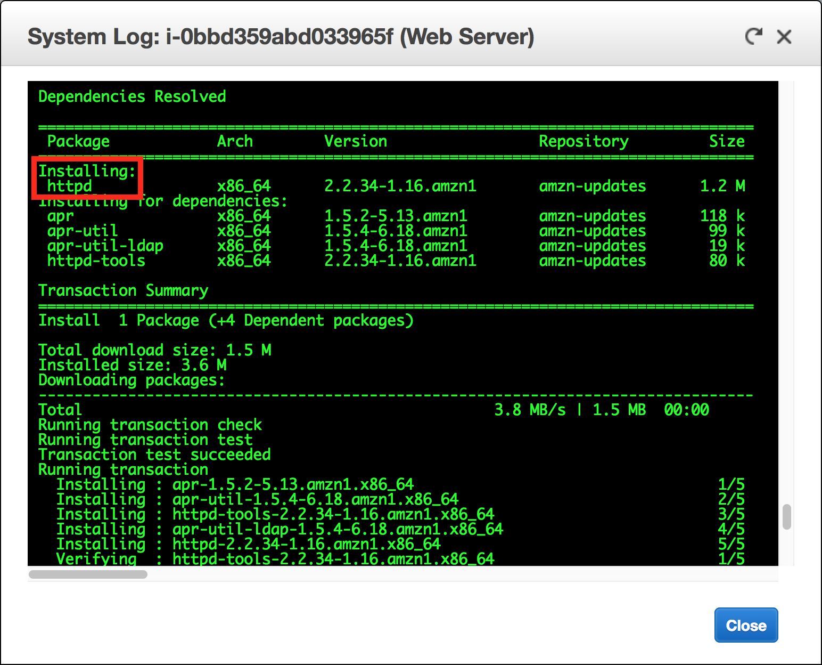

1. Click **Close**.
2. In the **Actions** menu, select **Instance Settings**  **Get Instance Screenshot**.

This shows you what your Amazon EC2 instance console would look like if a screen were attached to it.

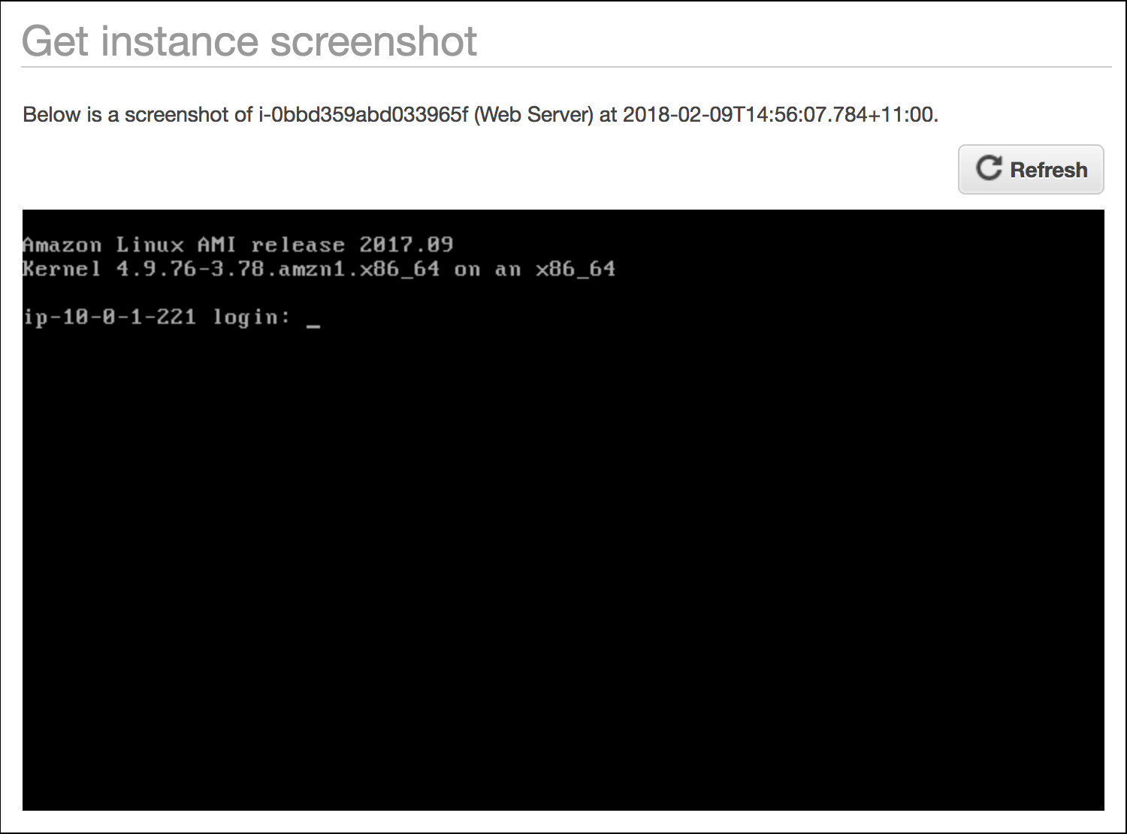

 If you are unable to reach your instance via SSH or RDP, you can capture a screenshot of your instance and view it as an image. This provides visibility as to the status of the instance, and allows for quicker troubleshooting.

1. Click **Close**.

**Congratulations!** You have explored several ways to monitor your instance.

**Task 3: Update Your Security Group and Access the Web Server**

When you launched the EC2 instance, you provided a script that installed a web server and created a simple web page. In this task, you will access content from the web server.

1. Click the **Description** tab.
2. Copy the **IPv4 Public IP** of your instance to your clipboard.
3. Open a new tab in your web browser, paste the IP address you just copied, then press **Enter**.

**Question:** Are you able to access your web server? Why not?

You are **not** currently able to access your web server because the *security group* is not permitting inbound traffic on port 80, which is used for HTTP web requests. This is a demonstration of using a security group as a firewall to restrict the network traffic that is allowed in and out of an instance.

To correct this, you will now update the security group to permit web traffic on port 80.

1. Keep the browser tab open, but return to the **EC2 Management Console** tab.
2. In the left navigation pane, click **Security Groups**.
3. Select  **Web Server security group**.
4. Click the **Inbound** tab.

The security group currently has no rules.

1. Click **Edit**, then configure:

* **Type:** *HTTP*
* **Source:** *Anywhere*
* Click **Save**

1. Return to the web server tab that you previously opened and refresh  the page.

You should see the message *Hello From Your Web Server!*

**Congratulations!** You have successfully modified your security group to permit HTTP traffic into your Amazon EC2 Instance.

**Task 4: Resize Your Instance: Instance Type and EBS Volume**

As your needs change, you might find that your instance is over-utilized (too small) or under-utilized (too large). If so, you can change the *instance type*. For example, if a *t2.micro* instance is too small for its workload, you can change it to an *m5.medium* instance. Similarly, you can change the size of a disk.

Stop Your Instance

Before you can resize an instance, you must *stop* it.

 When you stop an instance, it is shut down. There is no charge for a stopped EC2 instance, but the storage charge for attached Amazon EBS volumes remains.

1. On the **EC2 Management Console**, in the left navigation pane, click **Instances**.

**Web Server** should already be selected.

1. In the **Actions** menu, select **Instance State**  **Stop**.
2. Click **Yes, Stop**.

Your instance will perform a normal shutdown and then will stop running.

1. Wait for the **Instance State** to display:  stopped

Change The Instance Type

1. In the **Actions** menu, select **Instance Settings**  **Change Instance Type**.
2. For **Instance Type**, select **t2.small**.
3. Click **Apply**.

When the instance is started again it will be a *t2.small*, which has twice as much memory as a *t2.micro* instance.

Resize the EBS Volume

1. In the left navigation menu, click **Volumes**.
2. In the **Actions** menu, select **Modify Volume**.

The disk volume currently has a size of 8 GiB. You will now increase the size of this disk.

1. Change the size to: 
2. Click **Modify**.
3. Click **Yes** to confirm and increase the size of the volume.
4. Click **Close**.

Start the Resized Instance

You will now start the instance again, which will now have more memory and more disk space.

1. In left navigation pane, click **Instances**.
2. In the **Actions** menu, select **Instance State**  **Start**.
3. Click **Yes, Start**.

**Congratulations!** You have successfully resized your Amazon EC2 Instance. In this task you changed your instance type from *t2.micro* to *t2.small*. You also modified your root disk volume from 8 GiB to 10 GiB.

**Task 5: Explore EC2 Limits**

Amazon EC2 provides different resources that you can use. These resources include images, instances, volumes, and snapshots. When you create an AWS account, there are default limits on these resources on a per-region basis.

1. In the left navigation pane, click **Limits**.

Note that there is a limit on the number of instances that you can launch in this region. When launching an instance, the request must not cause your usage to exceed the current instance limit in that region.

You can request an increase for many of these limits.

**Task 6: Test Termination Protection**

You can delete your instance when you no longer need it. This is referred to as *terminating* your instance. You cannot connect to or restart an instance after it has been terminated.

In this task, you will learn how to use *termination protection*.

1. In left navigation pane, click **Instances**.
2. In the **Actions** menu, select **Instance State**  **Terminate**.

Note that there is a message that says: *These instances have Termination Protection and will not be terminated. Use the Change Termination Protection option from the Instances screen Actions menu to allow termination of these instances.*

Also, the **Yes, Terminate** button is dimmed and cannot be clicked.

This is a safeguard to prevent the accidental termination of an instance. If you really want to terminate the instance, you will need to disable the termination protection.

1. Click **Cancel**.
2. In the **Actions** menu, select **Instance Settings**  **Change Termination Protection**.
3. Click **Yes, Disable**.

You can now terminate the instance.

1. In the **Actions** menu, select **Instance State**  **Terminate**.
2. Click **Yes, Terminate**.

**Congratulations!** You have successfully tested termination protection and terminated your instance.

**End Lab**

Follow these steps to close the console, end your lab, and evaluate the experience.

1. Return to the AWS Management Console.
2. On the navigation bar, click **<yourusername>@<AccountNumber>**, and then click **Sign out**.
3. Click **END LAB**.
4. Click **OK**.
5. (Optional) Select the applicable number of stars, type a comment, and then click **SUBMIT**.

**Note:** The number of stars indicates the following:

* 1 star = Very dissatisfied
* 2 stars = Dissatisfied
* 3 stars = Neutral
* 4 stars = Satisfied
* 5 stars = Very satisfied

You may close the dialog if you don't want to provide feedback.

For feedback, suggestions, or corrections, please email us at [*aws-course-feedback@amazon.com*](mailto:aws-course-feedback@amazon.com).

**Additional Resources**

* [Launch Your Instance](https://docs.aws.amazon.com/AWSEC2/latest/UserGuide/LaunchingAndUsingInstances.html)
* [Amazon EC2 Instance Types](https://aws.amazon.com/ec2/instance-types)
* [Amazon Machine Images (AMI)](https://docs.aws.amazon.com/AWSEC2/latest/UserGuide/AMIs.html)
* [Amazon EC2 - User Data and Shell Scripts](https://docs.aws.amazon.com/AWSEC2/latest/UserGuide/user-data.html)
* [Amazon EC2 Root Device Volume](https://docs.aws.amazon.com/AWSEC2/latest/UserGuide/RootDeviceStorage.html)
* [Tagging Your Amazon EC2 Resources](https://docs.aws.amazon.com/AWSEC2/latest/UserGuide/Using_Tags.html)
* [Security Groups](https://docs.aws.amazon.com/AWSEC2/latest/UserGuide/using-network-security.html)
* [Amazon EC2 Key Pairs](https://docs.aws.amazon.com/AWSEC2/latest/UserGuide/ec2-key-pairs.html)
* [Status Checks for Your Instances](https://docs.aws.amazon.com/AWSEC2/latest/UserGuide/monitoring-system-instance-status-check.html?icmpid=docs_ec2_console)
* [Getting Console Output and Rebooting Instances](https://docs.aws.amazon.com/AWSEC2/latest/UserGuide/instance-console.html)
* [Amazon EC2 Metrics and Dimensions](https://docs.aws.amazon.com/AmazonCloudWatch/latest/monitoring/ec2-metricscollected.html)
* [Resizing Your Instance](https://docs.aws.amazon.com/AWSEC2/latest/UserGuide/ec2-instance-resize.html)
* [Stop and Start Your Instance](https://docs.aws.amazon.com/AWSEC2/latest/UserGuide/Stop_Start.html)
* [Amazon EC2 Service Limits](https://docs.aws.amazon.com/AWSEC2/latest/UserGuide/ec2-resource-limits.html)
* [Terminate Your Instance](https://docs.aws.amazon.com/AWSEC2/latest/UserGuide/terminating-instances.html)
* [Termination Protection for an Instance](https://docs.aws.amazon.com/AWSEC2/latest/UserGuide/terminating-instances.html)

[**Overview**](https://qwiklab.com/focuses/368?parent=catalog#step1)[Start Lab](https://qwiklab.com/focuses/368?parent=catalog#step2)[Task 1: Launch Your Amazon EC2 Instance](https://qwiklab.com/focuses/368?parent=catalog#step3)[Task 2: Monitor Your Instance](https://qwiklab.com/focuses/368?parent=catalog#step4)[Task 3: Update Your Security Group and Access the Web Server](https://qwiklab.com/focuses/368?parent=catalog#step5)[Task 4: Resize Your Instance: Instance Type and EBS Volume](https://qwiklab.com/focuses/368?parent=catalog#step6)[Task 5: Explore EC2 Limits](https://qwiklab.com/focuses/368?parent=catalog#step7)[Task 6: Test Termination Protection](https://qwiklab.com/focuses/368?parent=catalog#step8)[End Lab](https://qwiklab.com/focuses/368?parent=catalog#step9)[Additional Resources](https://qwiklab.com/focuses/368?parent=catalog#step10)

×

help