**S3 analytics**

Using a little older bucket because it has a lot of files and some analysis has happened on that bucket and we might be able to show better graphs there.

1.)you can also do this in your account also, but you need to have a lot of files. 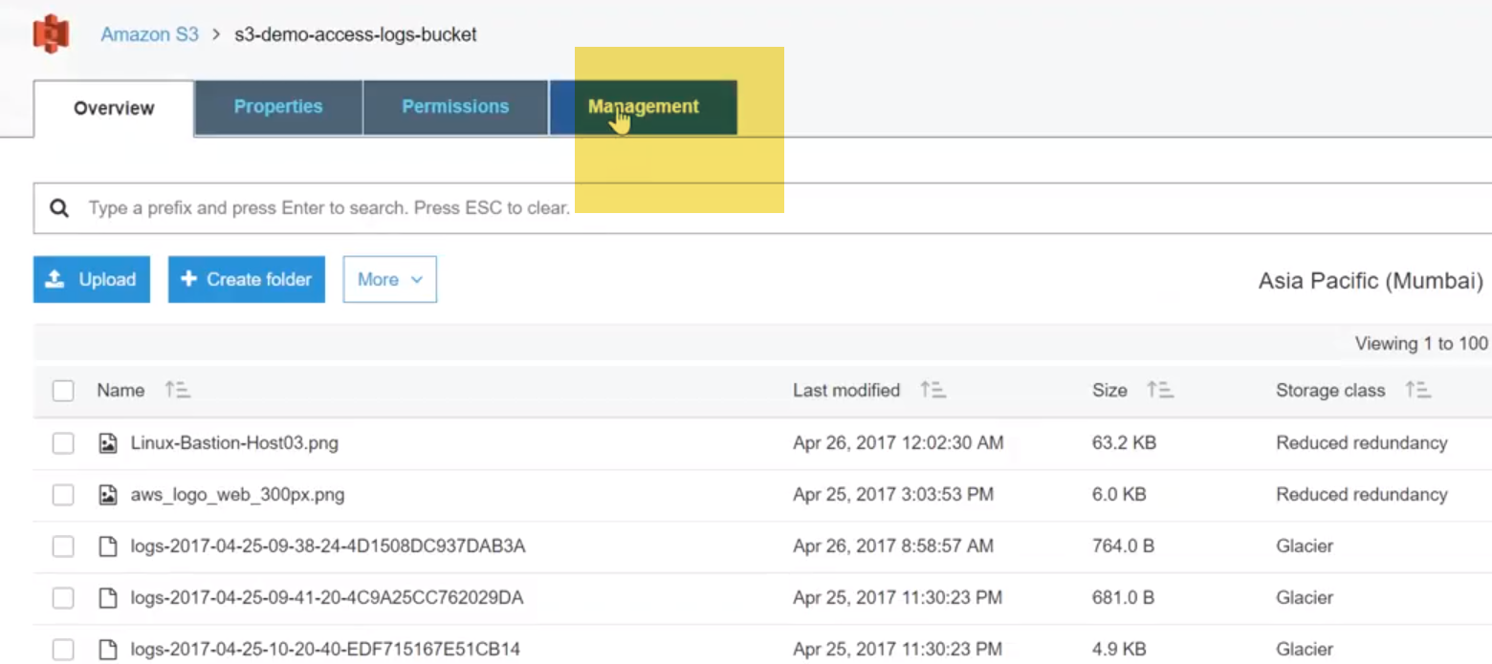

goto management-🡪 analytics

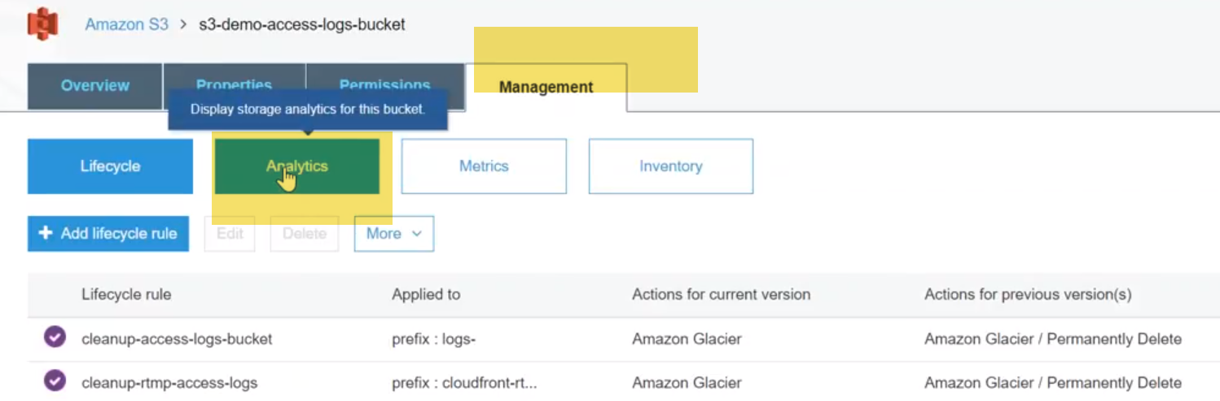

🡪you can see here I have two lexical rules to clean up my bucket.

1. one is for cleaning up my access logs I'm moving it to Amazon Glacier and then I'm making it a permanent delete also .

**analytics typically shows a storage class analysis..** In other words ,it will show you how much of storage that you are using in Galcier,how much of storage you are using in standard and how much you are using reduced redundancy.

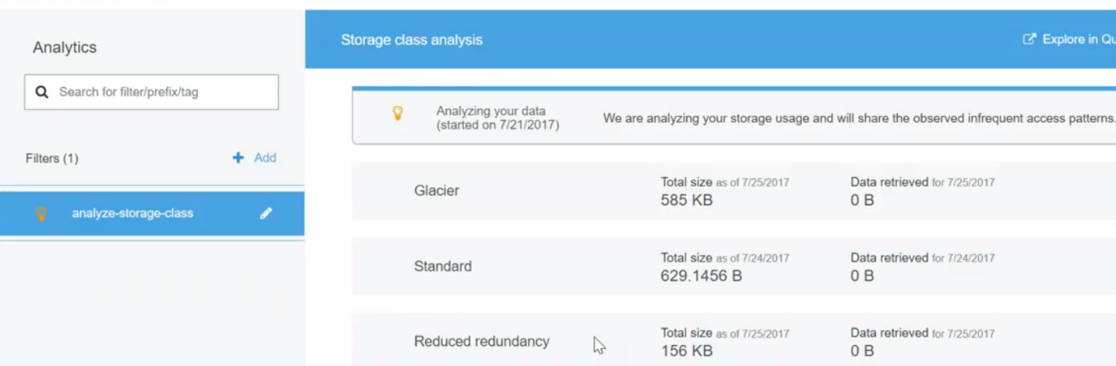 I don't have a lot of files but you can see get a total of mb is here and then another half an MB is here about 200 KBS..

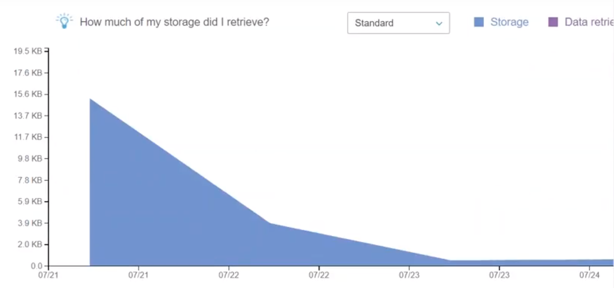

It just gives you a nice chart view of :

what is happening in your account and

how much files you have see

**for example** on the 21st of July I had about the 15 KB of files and then I set up some new rules to clean it up automatically and within a couple of days it got to clean them ..So typically this is like two days and the rule got kicked in and then it's constantly kept cleaning automatically and and by the way I am NOT doing the cleanup manually… it is all lexical rules that I showed you some same track and it automatically removes the older files and it removes some more older files and finally we have here with we are in 27th of July and I am still continuing with the same number of files.

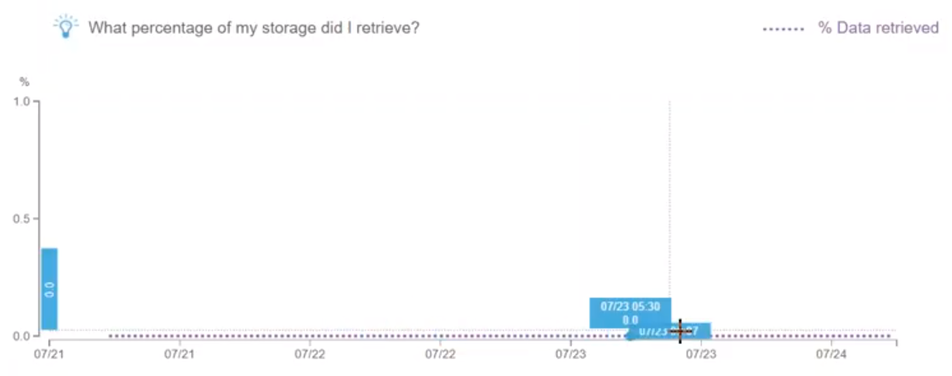

If I hover/put your mouse here it will show you whether I have added the new files where, am i storing and all those things…

On our demo account this might not be useful this might not be really relevant but when you are talking about a company where they are storing a lot of data millions and millions of files and the storage will be huge and there might be easy optimizations here for savings available to your clients …

So it might be very easy for you to just go to this Dashboard and tell them see for example you are in storage and **standard, and**  if we move to Glacier… this much of our savings is there…

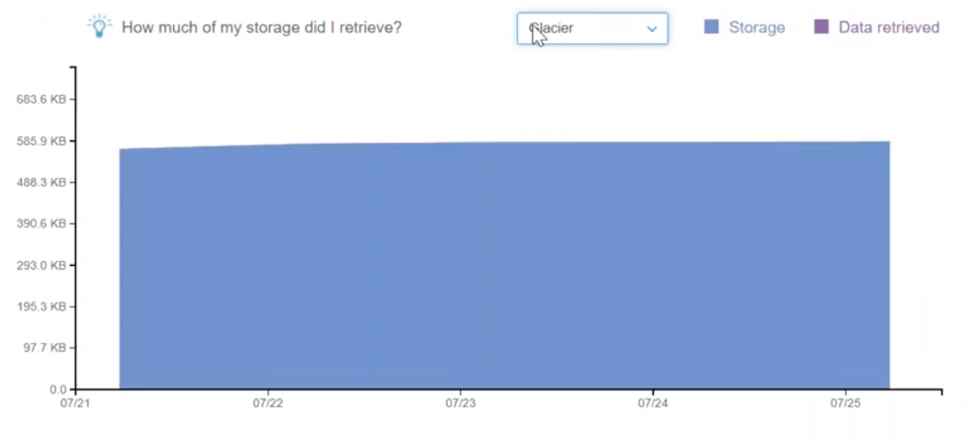

**very simple nice and easy low hanging fruit** ..

you can have filters in other words …

* you if you want to analyze only your access logs or if you want to analyze only your cloudfront logs you can have a combination of those filters …especially if you have tagged them.

you can filter them based on those tags.

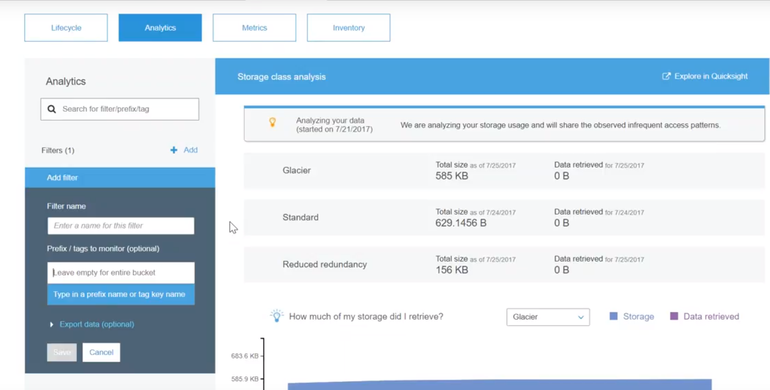

* remember one of the reasons I keep saying tag them tag them because quite a lot of times the filters work on tags that are being used so using those tags able to filter only for certain amount of logs or data and then analyze them.
* it is the quick way of restricting the amount of data you are analyzing.

**Metrics**

it shows how much of Bucket-sized bytes are there and I had about 14k and automatically I have come down to four and then 706 K B's so again.

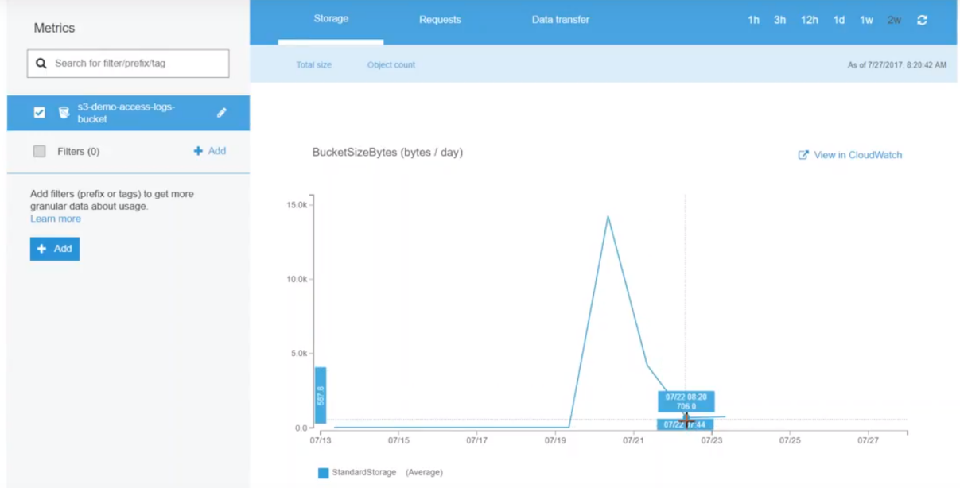

how you can use policies to reduce your cost by using is creating a simple tool and at any point of time it shows you how much data you are consuming in your Bucket.

Here, I have created a filter here which picks up everything( I have not added any specific )..filter. You can notice have more filters complicated.

Ex: if you have a static website you want to see how much of the content is used for storing static content then you can choose that also ..

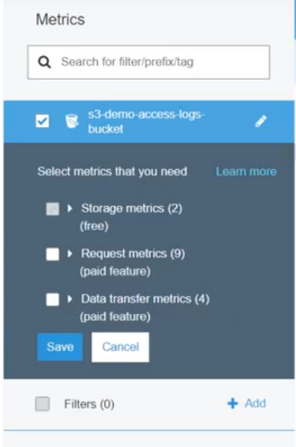

2.)At top there is a data transfer and request …

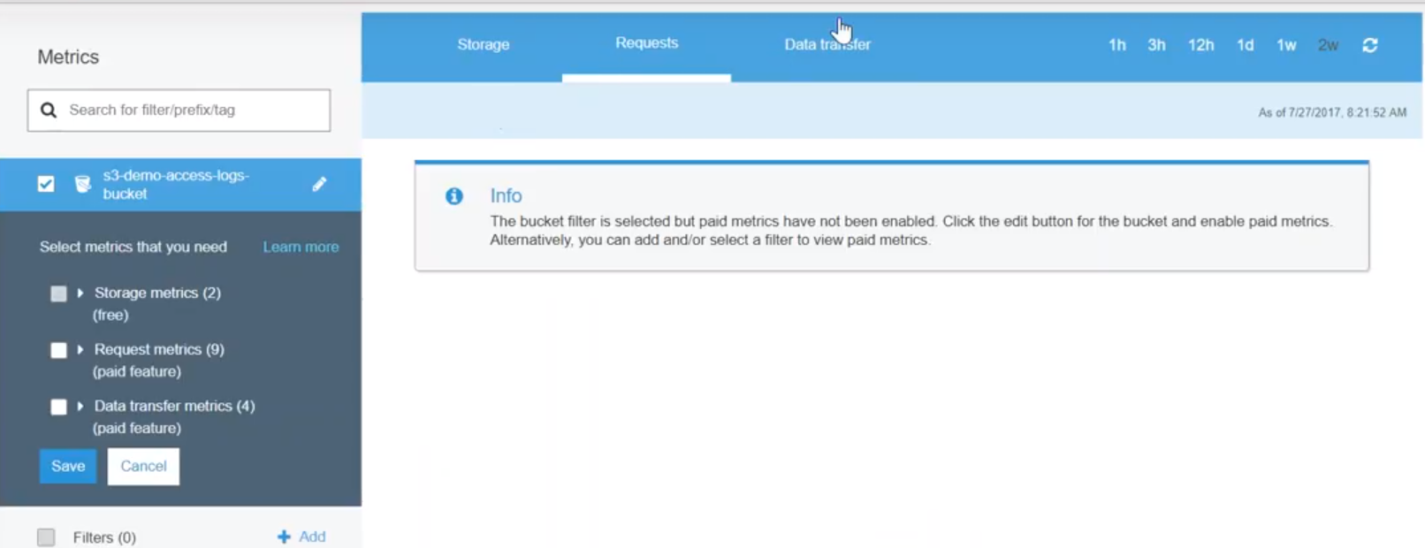

These two are paid services as you can see here the bucket filter is selected but

Paid matrix paid metrics have not been enabled so on the left hand side.

You see here these two options are there if I check them and then click on save my page metrics will enable and I will see data here mostly once again companies with how paid for this if they want to analyze it inside s3 itself and then they will be able to give you another nice graph on what is happening..

so for now you just need to know these options are available to analyze the data which is Stored in s3.

**In other words you are trying to optimize your s3 cost** .

**inventory** :

gives you a list of items that is in your account…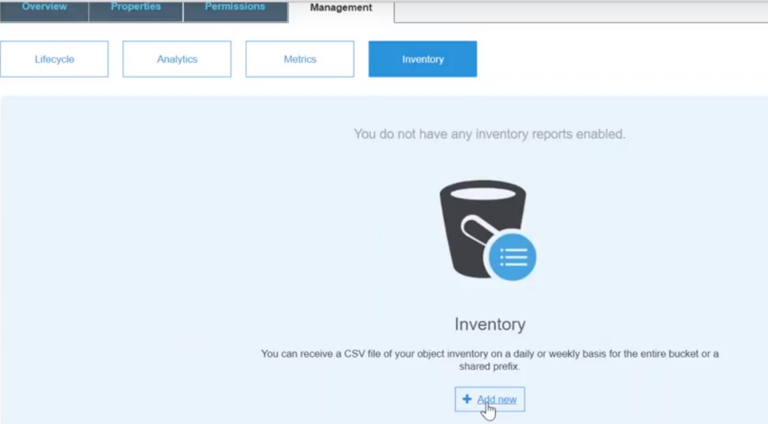

if you click on add new you can see I don't have anything right… Now click on add new and it's asking me: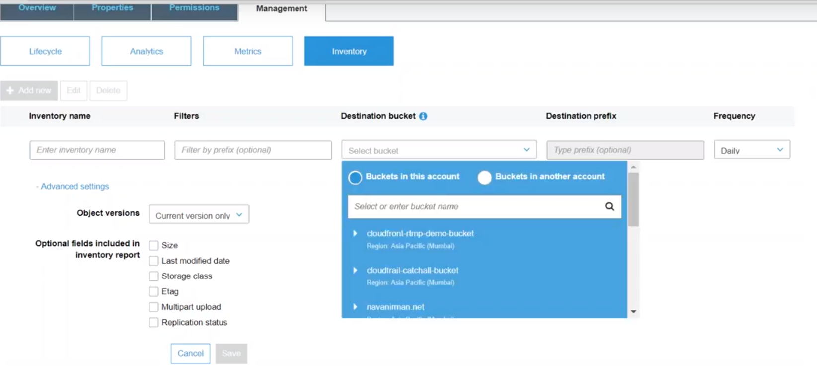

* what is the name of the inventory
* filters
* which Bucket, I want to store it and
* what is the frequency

**it's nothing but it will list all the items in your bucket** ..

It might be ten files… it might be 20 files for a million files Amazon will take a list of all those things and put it in another bucket for you …

It is asking you what are all the details you want:

* you want the size
* you want the last mod date .
* what is the storage class
* is that any other tags and
* this is a multi-part upload
* what is the replication status

using this data you should be able to have a very good picture of what is in your account and how to control the cost for that account or every bucket…

This a new service that Amazon is slowly popularizing everywhere.

It is for analyzing images that you have stored in your account or

You can upload it to this service so that Amazon can recognize it.

* + you can search any image
  + you can identify what is inside that image or
  + you can tag that image with the objects inside that image