**Amazon S3 Website Hosting**

**Module Introduction:** How to leverage Amazon S3 to host a static website.

**Static Website Hosting**

🡪S3 has a ton of use cases. But one that's very popular is to host a static website. So, for instance, because you're able to put all of these objects, and these objects are, again, **non-transactional, there are no open files on this, you're able to put up a static website.**

Maybe it's a photo-sharing website for your family. Maybe it's something else. But if these files are all static, then you can use S3 to host them, and it's a very effective, very easy, very quick way of doing it, and a very cost-effective way of doing that as well

🡪 Now from a DNS perspective, we're going to take a look at how you can associate your domain with your S3 website. 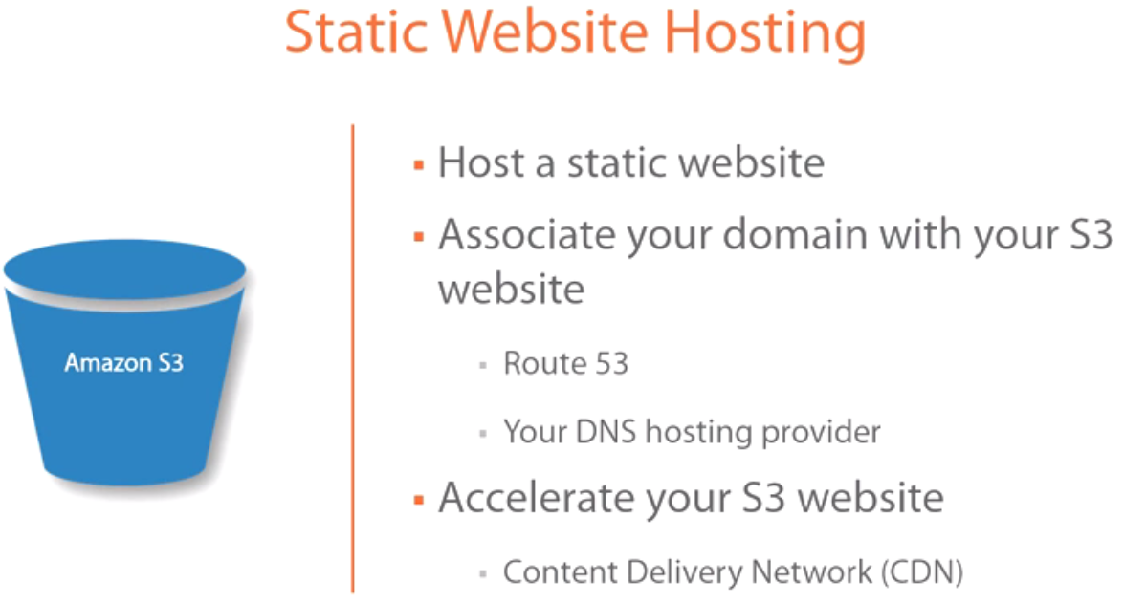

And you can do that in one of two ways--route 53, which is the homegrown AWS DNS, or you can use your DNS provider, whoever you're hosting your website with. For example, I'm hosting it with GoDaddy, so I'll be using GoDaddy to demonstrate how I'm going to associate my website with S3.

🡪Finally, I want to mention that you can accelerate your S3 website also using the CDN or the content delivery network. The CDN is outside the scope of this course, but I wanted to make sure that you are aware that it's there.

content delivery network : leverage the AWS infrastructure. Once you subscribe to CDN using AWS, what it will do is it will spread the content of your website to all of the edge locations that AWS has, which means that depending on where the user is connecting from, if there's an edge location close to them, then AWS will route them to that edge location, to that closest edge location thereby accelerating significantly your website's performance.

So the more you put content out there, that content is going to spread to all of these edge locations. **So essentially what it's doing, it's making copies of your website and storing it on different servers across the world. Depending on where your website is being accessed from, it's going to point them to the closest server to them.**

**Configure Amazon S3 Static Website Hosting**

Without further ado, let's take a look at how we can make some of the content that we put in our S3 bucket public and also how do we host the website and configure our DNS to point to it for a friendlier name. Let's go ahead and get started. 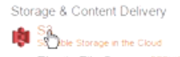

S3 under Storage and Content Delivery. 🡪we only have one bucket..If I select it and go in there, you'll find that we have two objects, two files in there.

The first one, if we click on Properties, you'll see that I have a URL to this particular object, which means I should technically be able to access this from the internet.So let's go ahead and click on it and see what happens. So what it's basically saying is, Listen, you do not have permissions to access this particular object. So while there's a URL for it, that doesn't necessarily mean that you can access that particular object.

🡪Let's go back, and the easiest way to make this particular file internet accessible is if you right-click on it, drag down here to where it says Make Public, click on OK, and as soon as this is done, this is kind of the easy button of making a particular object in your bucket internet accessible. 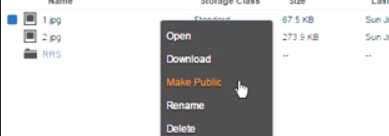So if I go back here, and we refresh this particular page, badabing, badaboom, it's that easy, it's that simple.

🡪Now let's take a look at what happened behind the scenes. If I click on Properties, and we expand Permissions, the only thing that really did is it added another line under the access control list and it gave a view download. 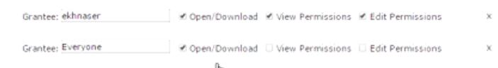It did this to everyone. That's the Everyone group. Remember, the Everyone group means everyone in the world. There's no domain here. There's nothing here. It means anyone with a computer and a browser that points to this URL is going to be able to access it, view it, download it.

🡪Now if we were to do this manually in order to replicate this, let's go to this particular file, and you'll find that right now I'm the only one that has access to it. To modify the access control list, let's click on the drop-down menu here, I'm going to select Everyone.

Again, you have authenticated users. Remember, authenticated users means anyone that has an Amazon account, that's authenticated to that account will be able to access this depending on the permissions that you grant.

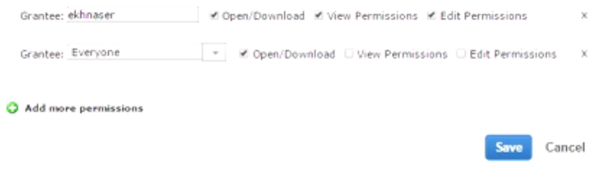So if I click Everyone, and we're also going to do view download, let's go ahead and save this. And if I click on this URL now, voila! Badabing, badaboom, it's that easy, it's that simple. I just gave access to it.

🡪Now this doesn't make sense if you're going to be hosting hundreds and thousands of files. **For example, if you were to host your family's photo album on S3, you're not going to go photo by photo and grant them public access. That just doesn't make sense. It's too time consuming. It doesn't work.**

So the easy way to do this is to make a website out of the bucket. So if we go back to wbcprod here, you'll find that you have access to static website hosting.

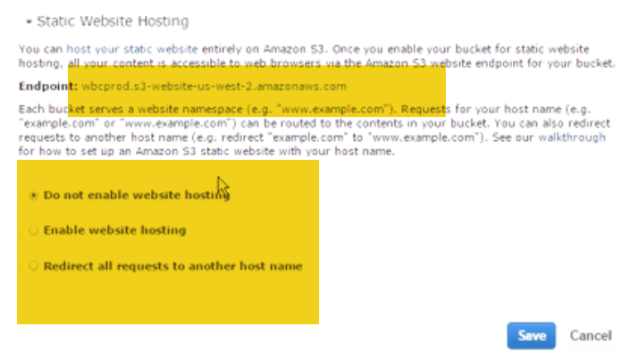

Under static website hosting, well **the first thing you want to note is that you have a long URL name**. This is the last thing that you want to give your friends, your family, and your customers. Nobody's going to remember this, it's too long. So we want to think of ways to shorten that.

So we want to give it a friendly domain name that they can get access to.

The options that you have right now are do not host the website or you're going to enable website hosting, and this is where we're going to be working. But let me talk about the third option for a second. This option allows you to redirect your bucket to an example.com or your domain.com, like a fully qualified domain. You're literally redirecting this. Or you can redirect it to another bucket on AWS. For the purposes of what we're doing, we want to simply redirect this bucket to an alias on an existing domain.

So in my case, we're going to use the domain eliaskhnaser.com. But I'm not pointing this to the root of eliaskhnaser.com. I'm pointing it to a subdomain on eliaskhnaser.com which we're going to call wbc.eliaskhnaser.com.

To do that, the first thing that we want to specify is the index document. Now what the index document means or is is the first page that your users are going to see when they access this redirected page. So in our case, wbc.eliaskhnaser.com. The first document they access is the document we're going to put in here. Now there's one more caveat to make this work--the bucket name has to match the domain name that you're redirecting to. So in my case, I want to redirect my users to wbc.eliaskhnaser.com.

I don't have that bucket created. Therefore, this won't work. If I just put 1.jpg here, for example, and try to use this URL, it won't work.

The way to make this work is we go back to All Buckets, and what we're going to do is we're going to click on Create Bucket. The name of this bucket's going to be wbc.eliaskhnaser.com.

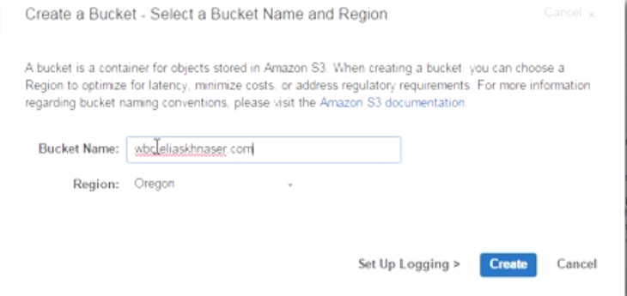 I'm going to keep it in the Oregon region, and we're going to go ahead and click on Create. Once this is created, what we want to do now is we want to upload a file to it. 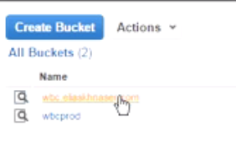So if I click on Upload, Add File, and let's go ahead and select this particular file. Let's start the upload. Now to keep things simple, let's go ahead and rename this file to 1.jpg just so it's easier to remember as we're doing this.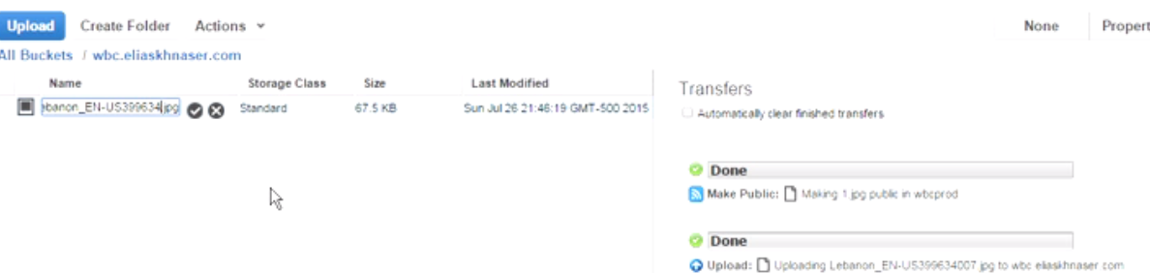

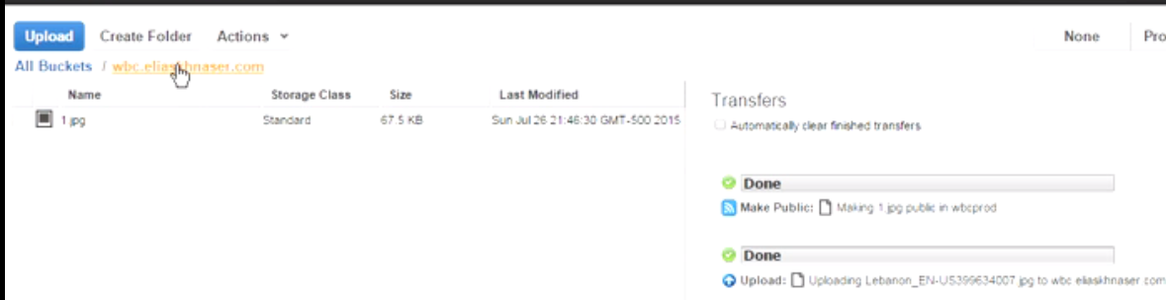 This is a long string of alphanumeric that just won't work. Let's go back into the bucket. So right now we've created this bucket wbc.eliaskhnaser.com. What we want to do now is go to Properties, and we want to enable the static website hosting. Now to do that, we're going to select the second option. And for my index page, I'm going to go with 1.jpg. Now, remember, on your website, this might be index.htm or .html, default.htm or .html. This is the first page that they see. 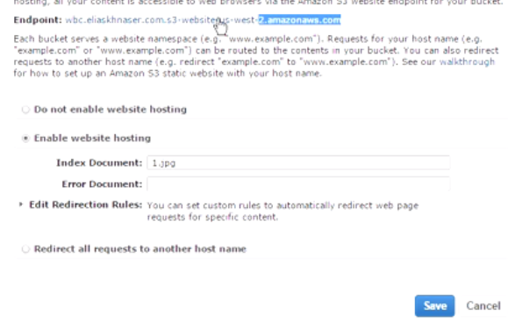

So, for example, if you're hosting a photo album for your family, this would be the website that they would---or the first page that they would access, and this would have links to different albums to make it easier for them to navigate your website. In my case and just to illustrate this and keep things simple, we're going to use an image. But you can replace this with an HTM or HTML file, so on and so forth. Once we do this, we're going to go ahead and click on Save. Now what we want to do is we want to copy this particular URL. This is the URL to our bucket that anybody in the world can access. I'm going to go ahead and click on Copy. And then what you want to do is go to where you're hosting you domain name. In my case, it's GoDaddy. In your case it might be Route 53 or some other DNS hosting company. Once you've opened your domain, what we want to do is we want to add another record. So I'm just going to click on Add Record here, and what I want to do is add a CNAME.

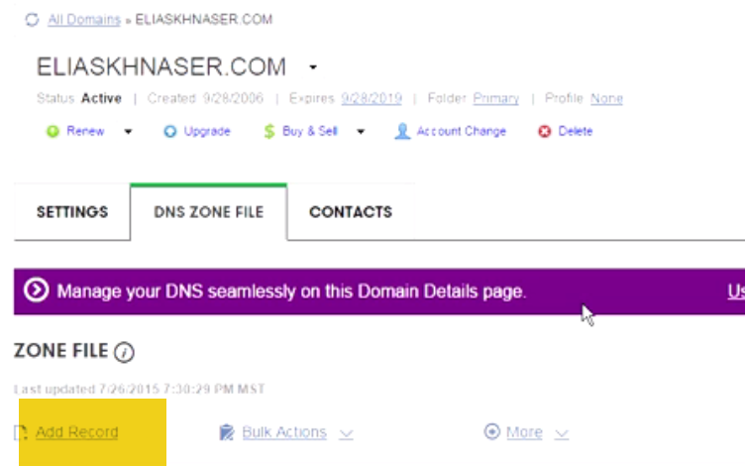

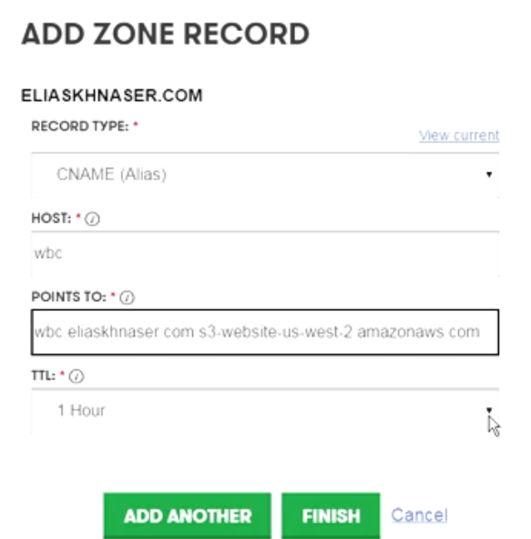

The host is going to be WBC because I want to point to wbc.eliaskhnaser.com, which is the bucket that I just created, and then I want to point to this particular URL. I'm going to shorten the time to live to half an hour so that we don't have to wait. And then I'm going to click on Finish. I'm going to commit my changes. And this is going to take a few seconds here or a few minutes, whatever, in order for it replicate before I can access it, but the record has been added to GoDaddy. So let's give it a few seconds and see if we can access this website. What I want to do now, let's open a new tab and do wbc.eliaskhnaser.com. Badabing, badaboom, would you take a look at that. Now that is beautiful! And it was that simple.

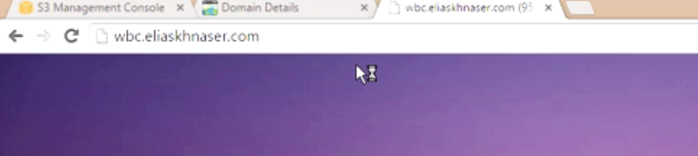 It was that easy, how to host an S3 static website on Amazon.

🡪where to access the content delivery network.:

Under Storage and Content Delivery. **Now the AWS content delivery network is called what? It is called CloudFront,** and you should be aware of this if you've watched the Fundamentals video.

So if you click on CloudFront, you can get going here, and **you can customize, you can add your website so that it's being replicated to all the edge sites that AWS has globally and, thereby, it will route users to the nearest location, thereby giving them faster access to your website**

**Module Summary**

how you can create a website, a static website out of your S3 bucket.

🡪We talked about the fact that if you want to redirect it to an existing website, in our case what we did was did a subdomain on eliaskhnaser.com, I showed you how you would go into your domain and you would redirect to that particular website. Now, remember, in order to do that, the bucket name has to match that subdomain that you're creating. So we created a bucket called wbc.eliaskhnaser.com.

🡪 You can also point to another bucket. You can point to a route domain if you wanted to. But this is an easy way of redirecting content to your website.

🡪We also talked about the fact that you can leverage AWS's CloudFront in order to replicate your website to all the edge locations that AWS has, which will redirect your users to the closest server that's hosting your website.