Flat(single) n/w shared with everyone else using ..

we don’t get different IP address...It is disjoint n/w, open to security issues.

For security groups, we have to apply individually...and then repeat on other systems. Because they are not part of single n/w..

Servers can't communicate privately

VPC allocates part of Cloud as your own private n/w..

Servers can communicate privately…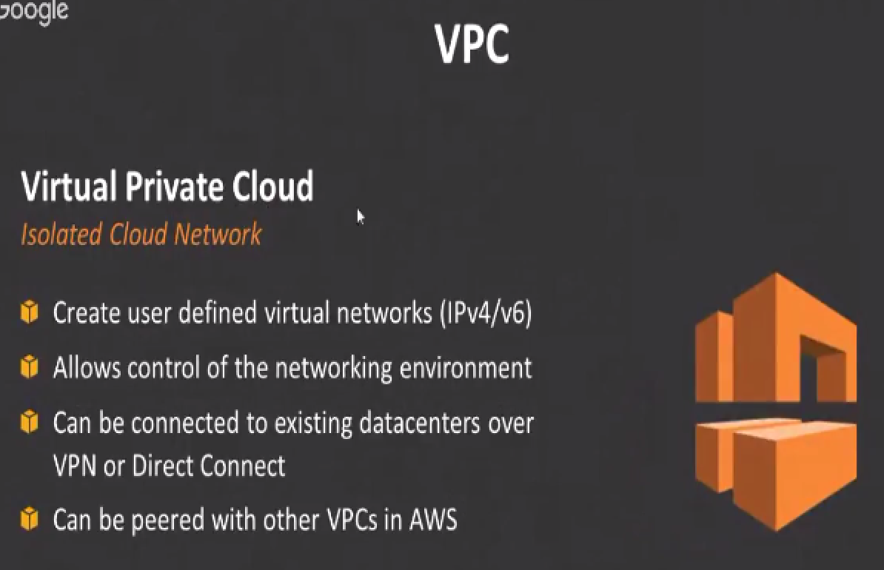

VPC is essentially short for virtual private cloud.

it kind of creates your own network within the AWS network... So instead of having a flat network where everyone else is starting ec2 instances on the same network.

Now you get your own little network within which you can actually control so you kind of get your own network , your own IP addressing, your own systems in that network and you control this network, administrator for this network...

No one else has access to it unless you decide to give them access to it and all of these systems can communicate internally with their private IP addresses you can connect to this network to communicate with the private IP addresses of the instances etc.

