**Amazon Web Services Route 53 Part 1 – Hosted Zones and Record Sets**

Today I will start our AWS DNS service series, Amazon Route 53 . Route 53 is a DNS service for both AWS resources and your on-premise infrastructure. In Route 53 series, first I will configure a hosted zone and records sets. Then I will show how to configure health checks and configuring failover scenairos with route 53 like active-active, active-passive.

Let’s start our demonstration.

First I will create a hosted zone for my wekanban.com. On Route 53 dashboard, I click “Create Hosted Zone” and create my “wekanban.com” domain.

[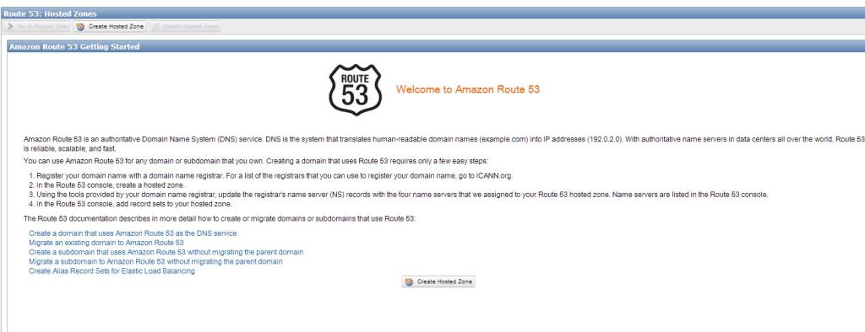](https://i2.wp.com/www.awsomeblog.com/wp-content/uploads/2014/05/route53_dash.jpg)

[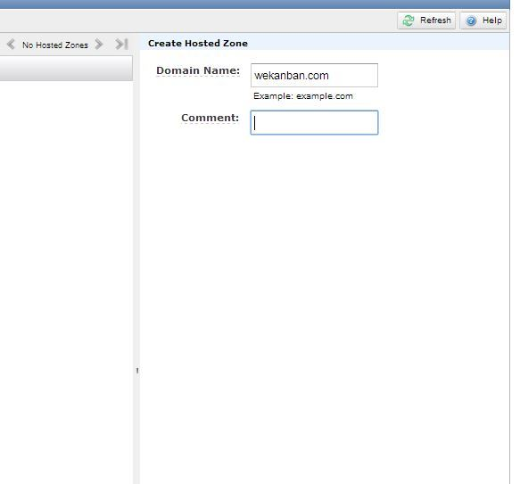](https://i0.wp.com/www.awsomeblog.com/wp-content/uploads/2014/05/create_zone.jpg)

As you see in “Delegation set” there are some DNS servers. We have to update our registrar by providing these DNS servers and then AWS Route 53 will be able to answer our queries for our domain.   
[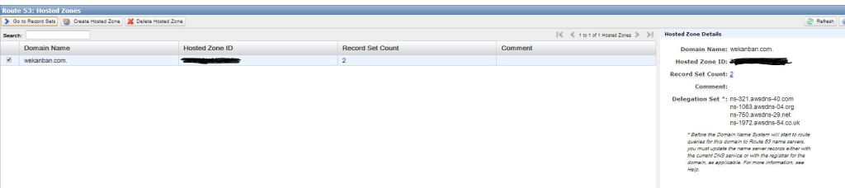](https://i2.wp.com/www.awsomeblog.com/wp-content/uploads/2014/05/created_zone.jpg)

When we create a hosted zone, by default , 2 records are created automatically( NS ve SOA). It is important that we shouldn’t delete or change these records.   
[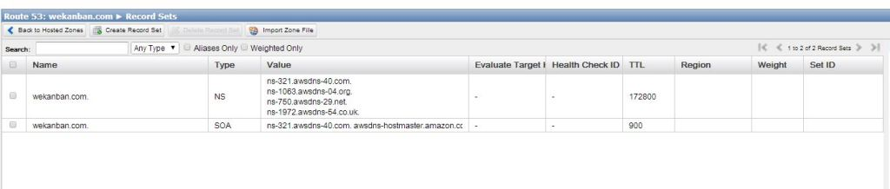](https://i1.wp.com/www.awsomeblog.com/wp-content/uploads/2014/05/default_records.jpg)

We can now create our records for our domain. Route 53 supports different types of records. Refer to this [link](http://docs.aws.amazon.com/Route53/latest/DeveloperGuide/ResourceRecordTypes.html) to view the supported record types. There is an important record type which is “Alias”. Alias is a Route 53 specific record type and is used as a pointer for:

ELB

CloudFront

S3 with a static website

Other Route 53 record set

I will create two different records for my website. First one is an A record and will be for my “test.wekanban.com” website. The other one will be an Alias and I will point it to my ELB and serve my production website “www.wekanban.com”.

[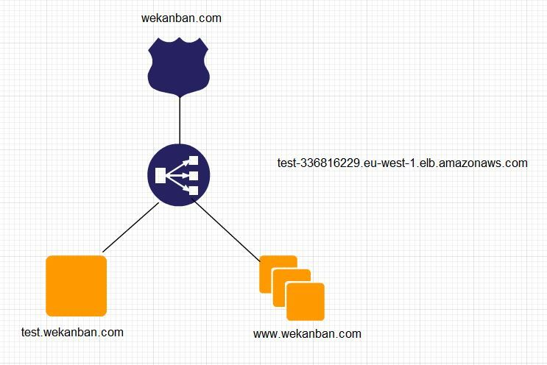](https://i2.wp.com/www.awsomeblog.com/wp-content/uploads/2014/05/diagram.jpg)

I’ve created 3 instances for my website.

For test.wekanban.com I will create an A record and use 54.72.137.212 value.

[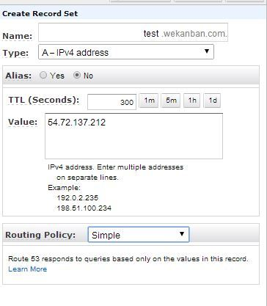](https://i2.wp.com/www.awsomeblog.com/wp-content/uploads/2014/05/54.72.137.212.jpg) 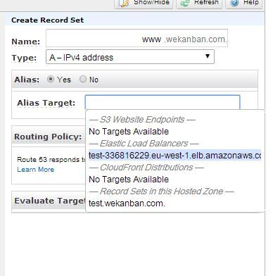

For www.wekanban.com I will create an Alias record and use my ELB as target.

As you see there are other options like routing policy and evaluate target health. I will explain them later.

It is time to test our records now.

[](https://i0.wp.com/www.awsomeblog.com/wp-content/uploads/2014/05/created_records.jpg)

Our test for test.wekanban.com   
[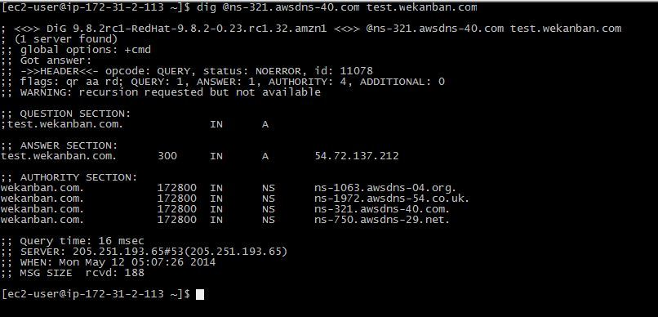](https://i0.wp.com/www.awsomeblog.com/wp-content/uploads/2014/05/dig1.jpg)

Our test for www.wekanban.com.   
As you see my loadbalancer is resolved as 54.246.211.113 and 52.246.211.186. So “www” record should be the one of them.   
[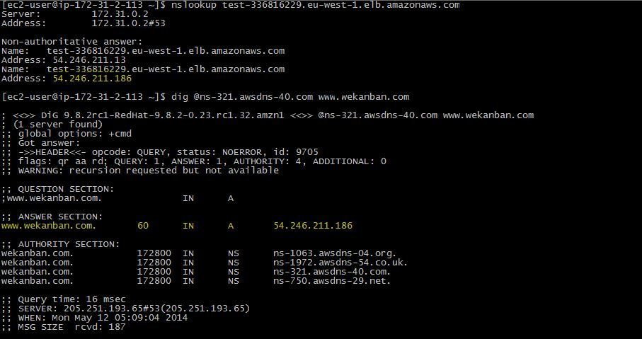](https://i2.wp.com/www.awsomeblog.com/wp-content/uploads/2014/05/dig2.jpg)

If you will migrate your DNS server to AWS Route 53, you can use “import zone file” option. There are some [limitations](http://docs.aws.amazon.com/Route53/latest/DeveloperGuide/rrs-changes-import-console.html) to use this option, like, the hosted zone must be empty and Route 53 ignores the SOA and NS records in the zone file.

Let’s import our sample zone file.

After creating hosted zone, I click “Import Zone File”   
[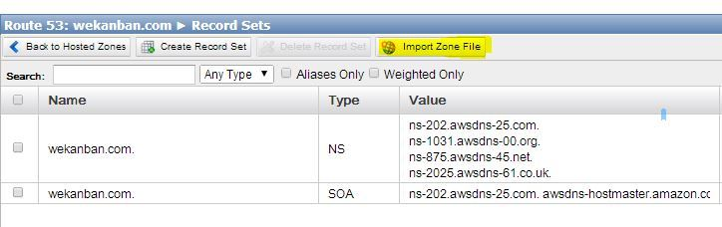](https://i2.wp.com/www.awsomeblog.com/wp-content/uploads/2014/05/import_zone_file.jpg)

I pasted my sample zone file.   
[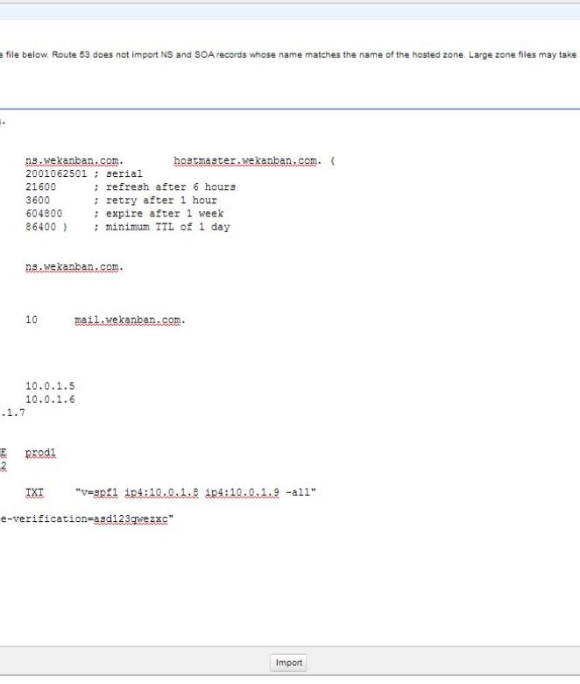](https://i2.wp.com/www.awsomeblog.com/wp-content/uploads/2014/05/zone_file.jpg)

And my zone file is imported successfully.   
[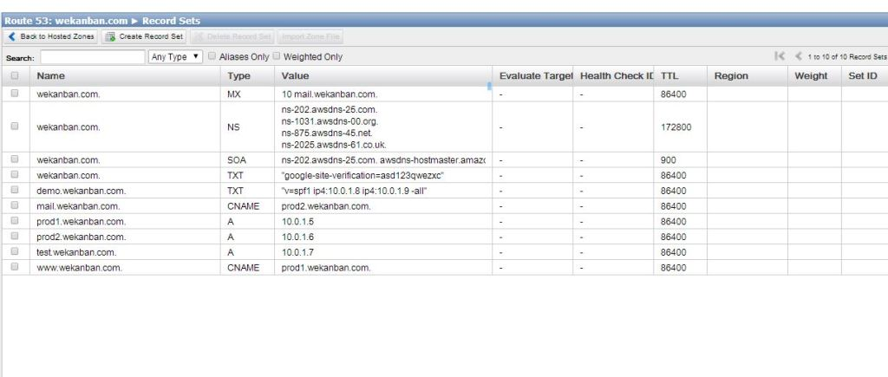](https://i1.wp.com/www.awsomeblog.com/wp-content/uploads/2014/05/imported_zone_file2.jpg)

Finally I check the results.   
[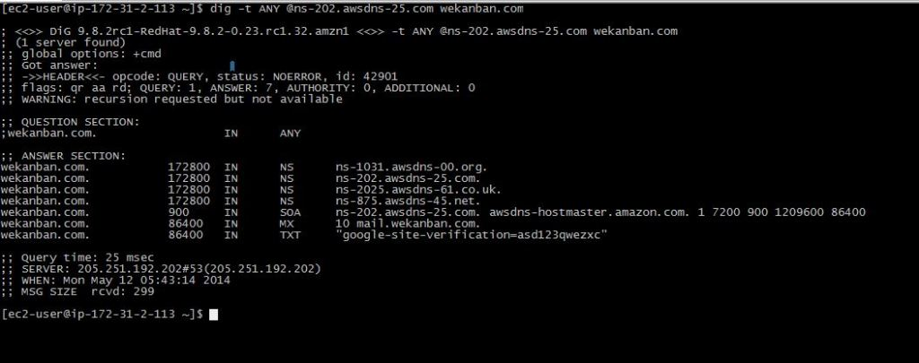](https://i1.wp.com/www.awsomeblog.com/wp-content/uploads/2014/05/import_result.jpg)

That was the fundamentals of Route 53. In my next post I will explain AWS Route 53 routing policies and health checks.