Jenkins

1. Java application.
2. Platform independent, because it is java application.

(We can use Jenkins same way in windows/linux/mac)

1. Used for Continuous integration and C delivery.

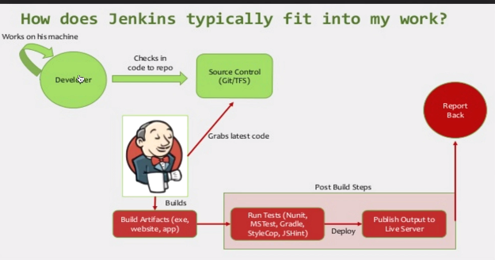

Why Jenkins???????

Developers works on local m/c. Many developers work and checkin to shared repo. Now at end of day, Bug introduced in code…build failed.

Lets say a bug introduced in the code, and build failed.

1. Now what exact code made build fail…
2. What point bug is introduced.

Now we have to check all day code—created that day , where bug introduced.

Here comes Jenkins….

As soon as developer commits code in shared repo…Jenkins takes latest code and triggers build…If any build issues/completed notifications triggered..

1. If any issue in commit, we can revert and Saves time in knowing Which Code Breaks code.
2. If build successful, we can also integrate Performane Test/ Unit/Acceptance test Along with Build....,AS : performance as post build actions in Jenkins
3. As soon as build get deployed, Jenkins triggers test cases(which is automated) and reports back to us….
4. Let’s suppose build was successful and ‘NO ERRORS or exception’ ….But due to changes in code, there was something broke in application.

We can know instantly that due to this code, there is some break---can troubleshoot it

We can see how efficient and powerful system can be………..

1. Summary: We are taking code and doing build,as soon as code gets commit and also performing tests and sending out reports.
2. When change in code, Entire cycle is triggered and we can know any issue with application

Dir:

Plugins:

.jenkins folder -> jobs,plugins,logs

Localhost:8080/restart

Localhost:8080/configure

Localhost:8080/systeminfo

Admin-> Configure->ssh public keys—passphrase

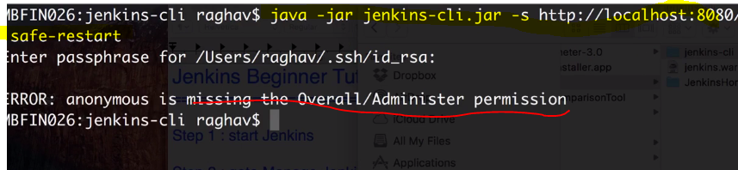

Jenkins-> Manage Jenkins->global security->authorization _>anyone can do anything (for now)

Download:

**Setup Jenkins standalone:**

* Jenkins.io (LTS)..stable ,plugins OR <http://mirrors.jenkins-ci.org/windows/>
* Java –jar Jenkins.war **initialAdminPassword**

|  |
| --- |
| * C:\Users\vebalusu\Downloads>java -jar jenkins.war * webroot: $user.home/.jenkins * Jenkins home directory: C:\Users\vebalusu\.jenkins found at: $user.home/.jenkins * Jenkins initial setup is required. An admin user has been created and a password   C:\Users\vebalusu\.jenkins\secrets\initialAdminPassword |

* Generates admin password…
* **Customize Jenkins (plugins)**: 1.) Select suggested plugins 2.) Install plugins
* Create admin user

## **Jenkins Beginner Tutorial 2 - How to setup Jenkins on Tomcat**

**Setup Jenkins on Tomcat or any other servlet container.**

**We can start all applications on single server—standalone vs tomcat diff**

1. Java 7 or above---Java SE development kit 8---jdk

|  |
| --- |
| You are pointing to a JRE. You need to point to a JDK, which given the location of your JRE might be something like C:\Program Files (x86)\Java\jdk1.6.0_26 or similar. Or, if you only have a JRE installed, you'll need to install a full JDK. Tomcat needs to be able to compile JSPs into .class files, which a JRE can't do.JDK-🡪Java Development Kit |

JAVA_HOME ->C:\Program Files (x86)\Java\jdk

PATH-> ; C:\Program Files (x86)\Java\jdk\bin or ;%JAVA_HOME%\bin

If we change JAVA installation path,no need to change PATH Env variable

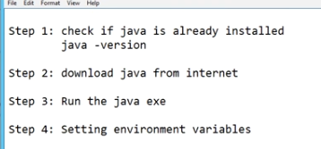

1. Tomcat 5 or above
2. Steps:

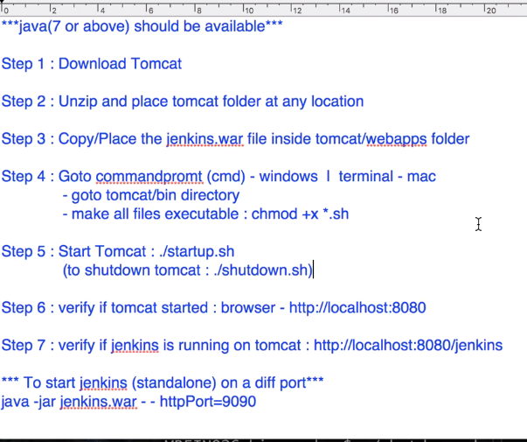

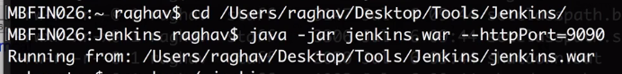

Stop: ctrl +C (or)

Localhost:8080/restart

Both step-7 (tomcat) and step-8(tomcat) created are same.

Create same job on one each of these standalone,tomcat and verify for below screenshot

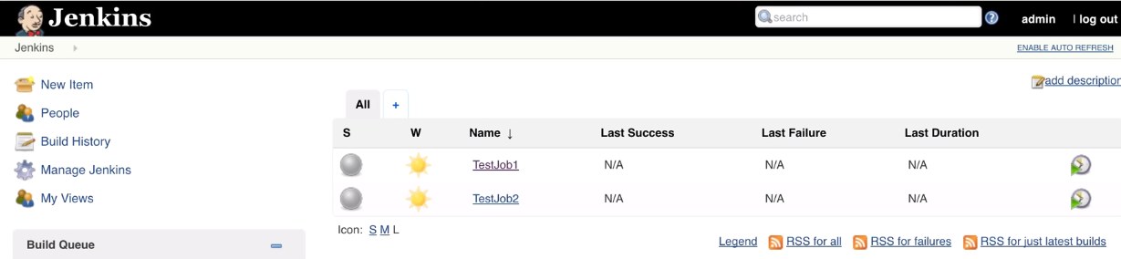

## Jenkins Beginner Tutorial 3 - How to change Home Directory

.jenkins---HOMe dir

* webroot: $user.home/.jenkins
* Jenkins home directory: C:\Users\vebalusu\.jenkins found at: $user.home/.jenkins

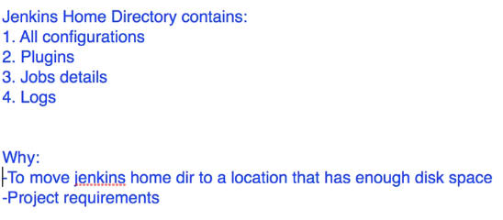

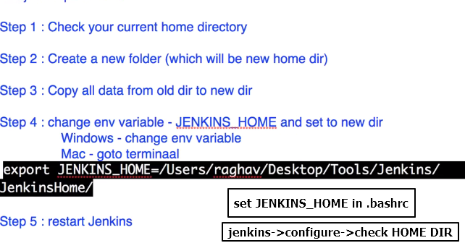

# **Jenkins Beginner Tutorial 4 - How to use CLI (command line interface)**

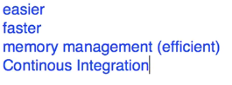

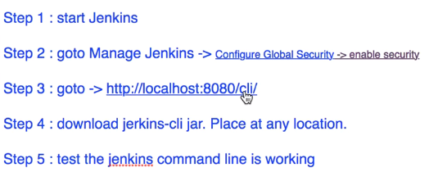

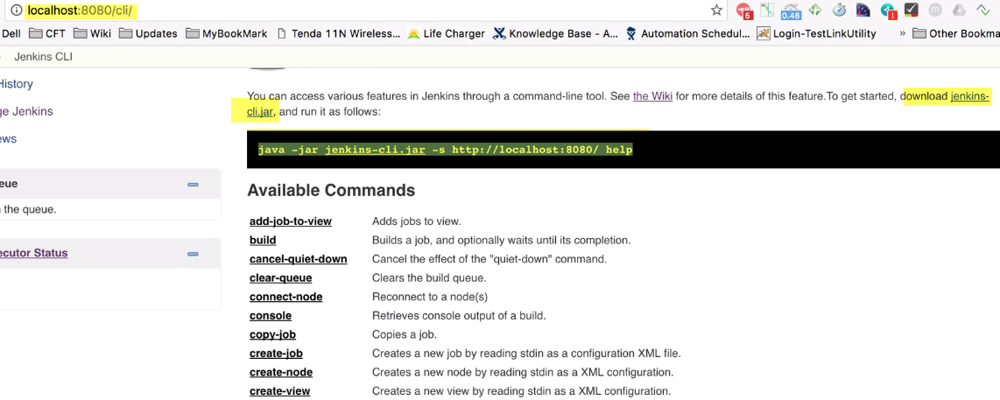

Admin-> Configure->ssh public keys—passphrase



Jenkins-> Manage Jenkins->global security->authorization _>anyone can do anything (for now)

# **Jenkins Beginner Tutorial 5 - How to create Users + Manage + Assign Roles**

