

rhcsa_01_introduction

**With a lot of practice**

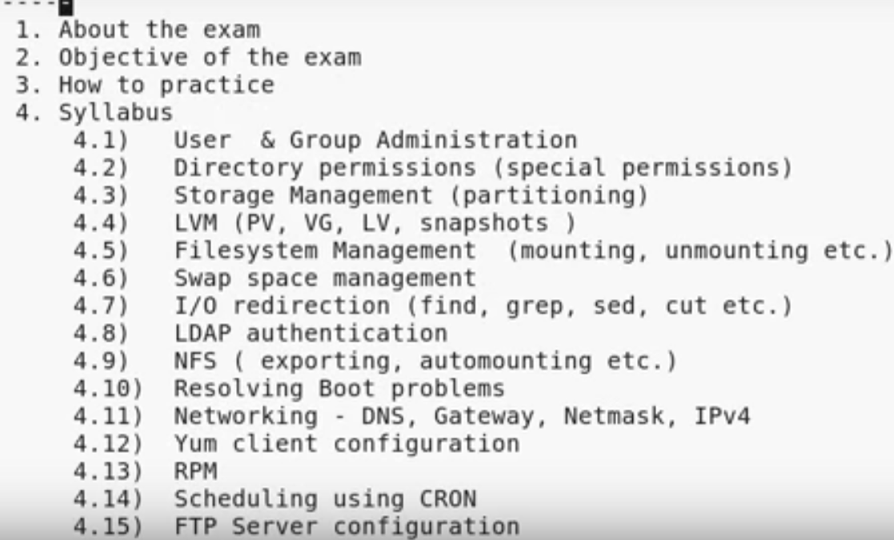

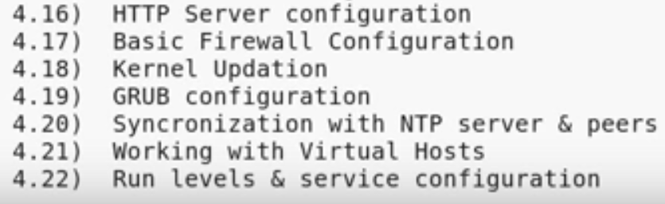

2_about_the_exam

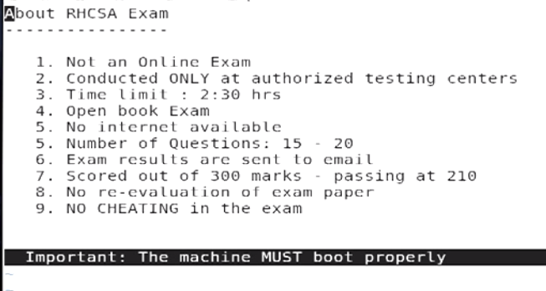

03_objectives_and_assumptions

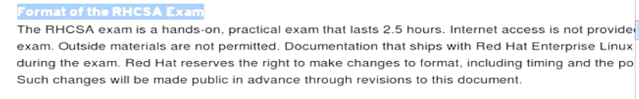

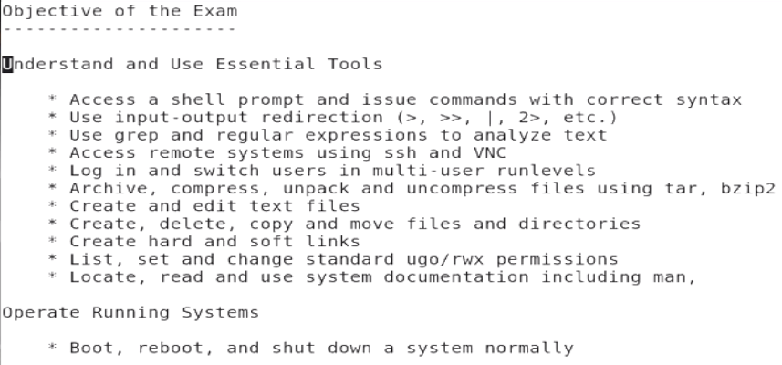

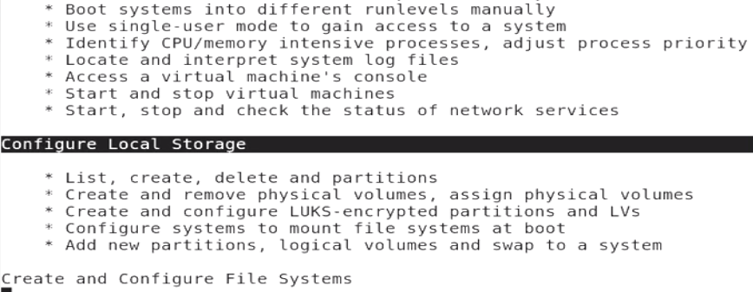

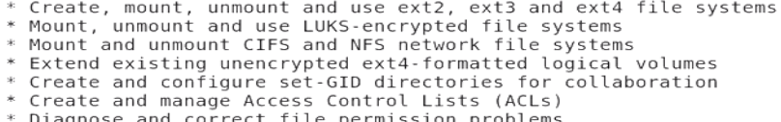

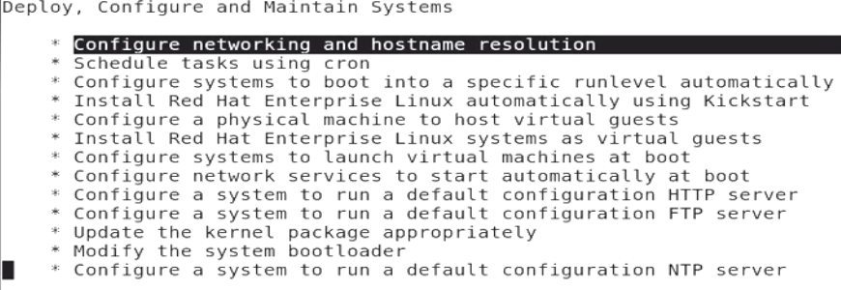

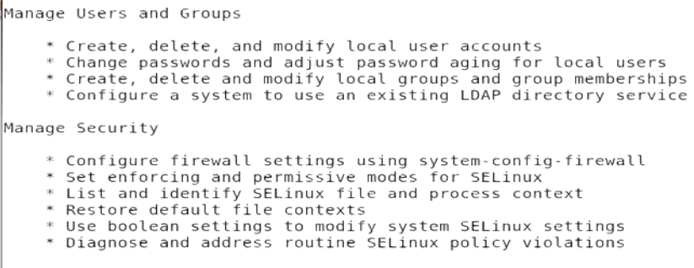

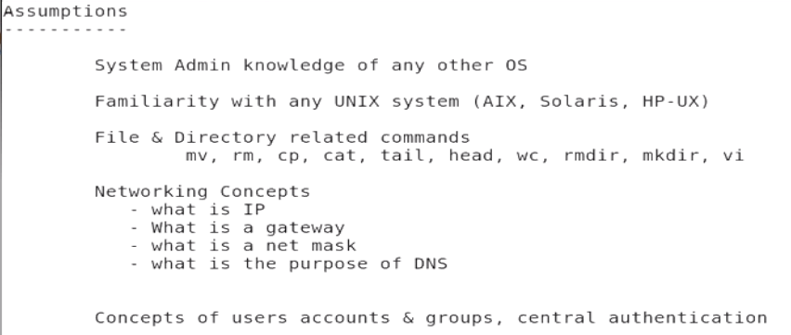

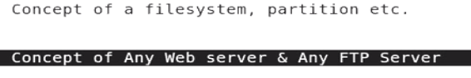

05_user_admin_001

Group is a collection of users.

Main purpose: for the permissions.

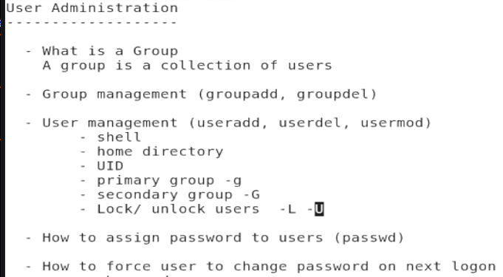

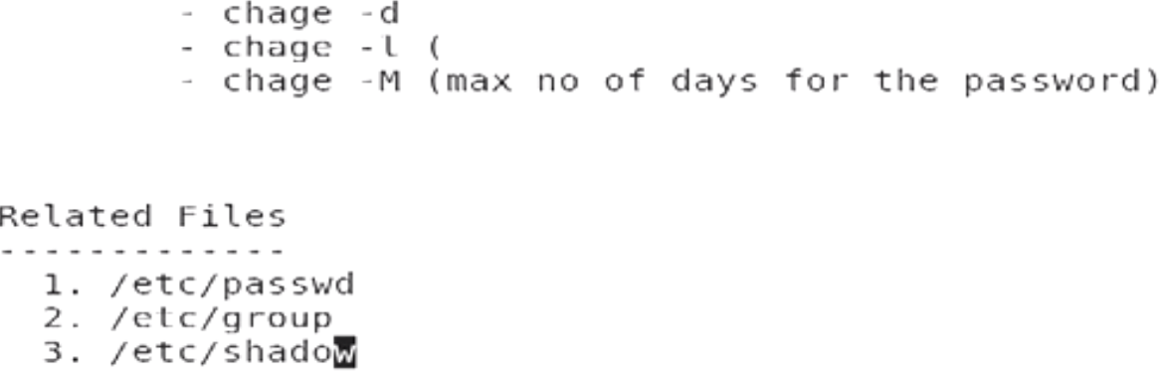

* Group modify
* UID: unique ID
* /etc/password🡪 list of users

/etc/group🡪 group list