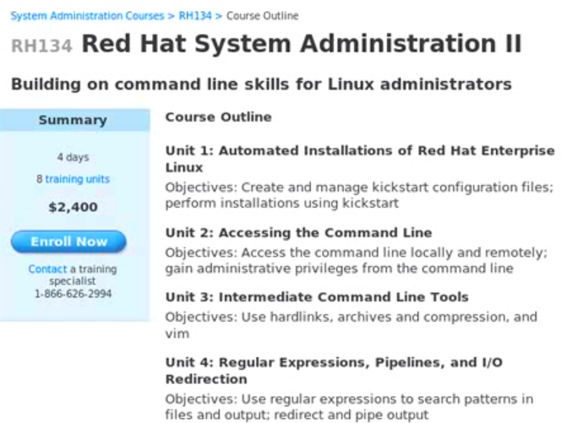

Kickstart Files

Automatic installation with kickstart:

Performed using files that contain ins. And how system should be setup.

A kick start file is automatically get created by anaconda installer at end of RHEL installation 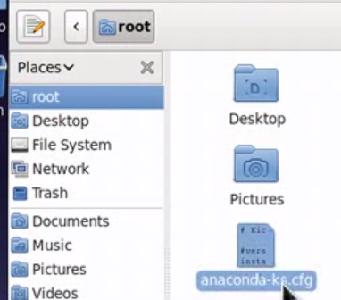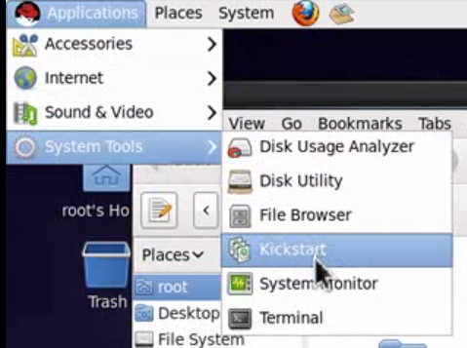

A kick start file cannot create user by default. Need to create it.. 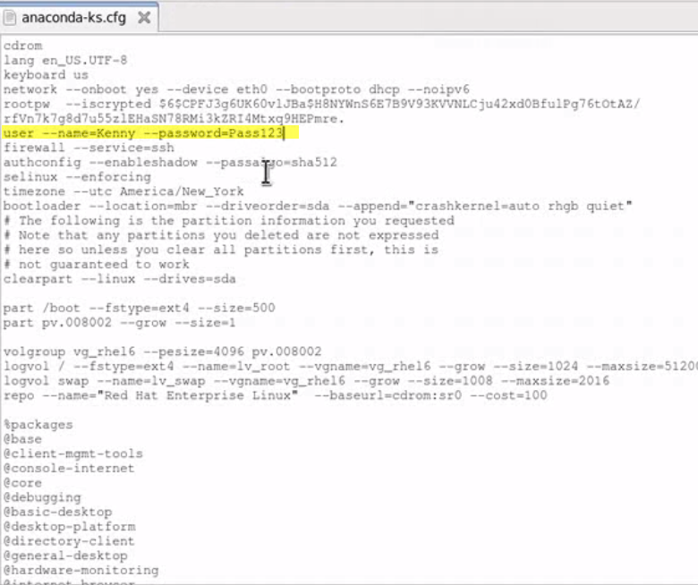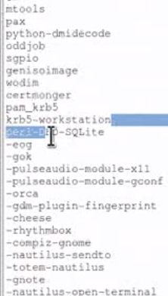

From network location, CD, HDD, web location, ftp server, FS server or USB device..

Syntax: Is only to just modify location of kick start file…

Now doing using NFS

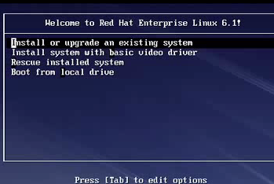Press EScape