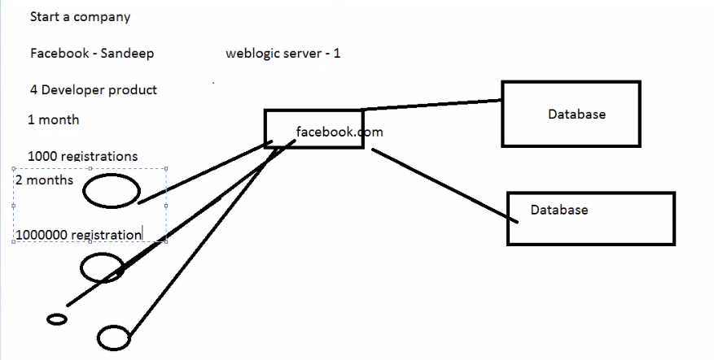

Proxy server/load balancer:

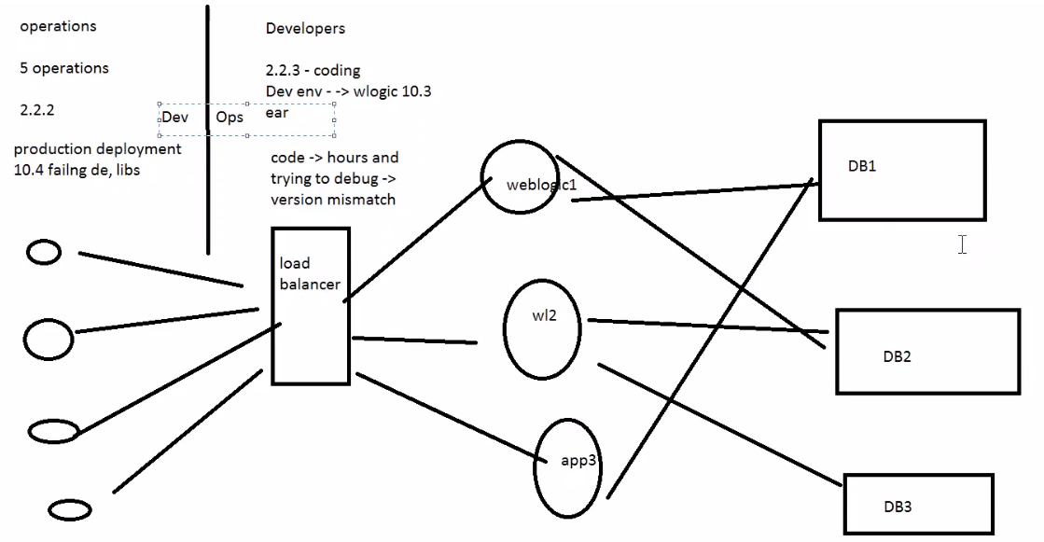

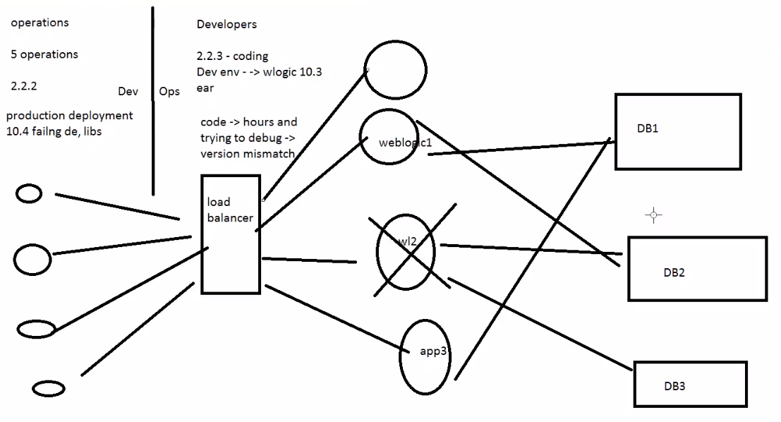

**DB space is 80% used**

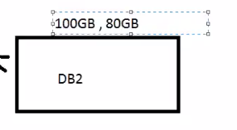



Weblogic Cluster: group of servers, to achieve something.

**Suppose Weblogic server2 is down automaticaaly.**