Installing and configuring Multiple instances of Tomcat8: 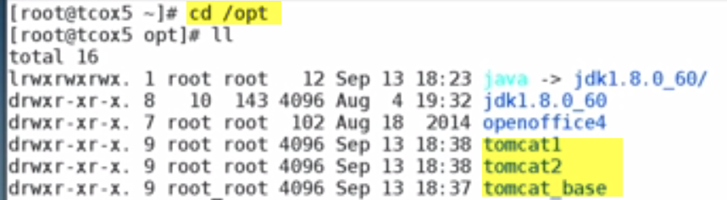

Download tomcat from website.. and make copies of tomcat1 and tomcat2.

We changed permissions around

Group permissions for running as appropriate tomcat user..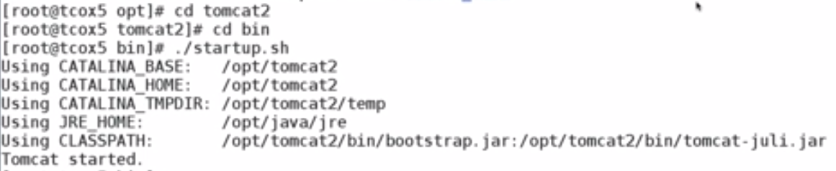 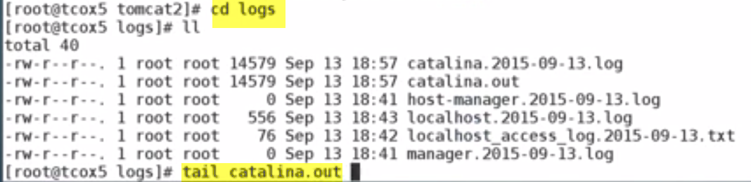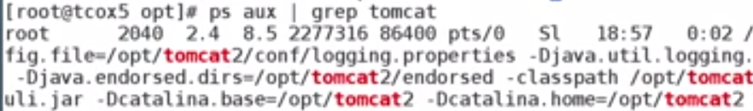C:\Users\vebalusu\AppData\Local\Temp\SNAGHTML33c38a8.PNG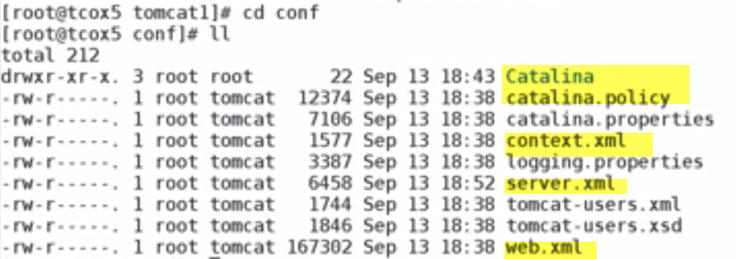

Change this:C:\Users\vebalusu\AppData\Local\Temp\SNAGHTML33e99ba.PNGC:\Users\vebalusu\AppData\Local\Temp\SNAGHTML33ec1c4.PNG 