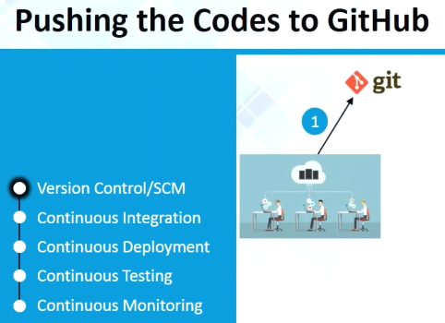

My project is already available on github, whatever developers pushed to github

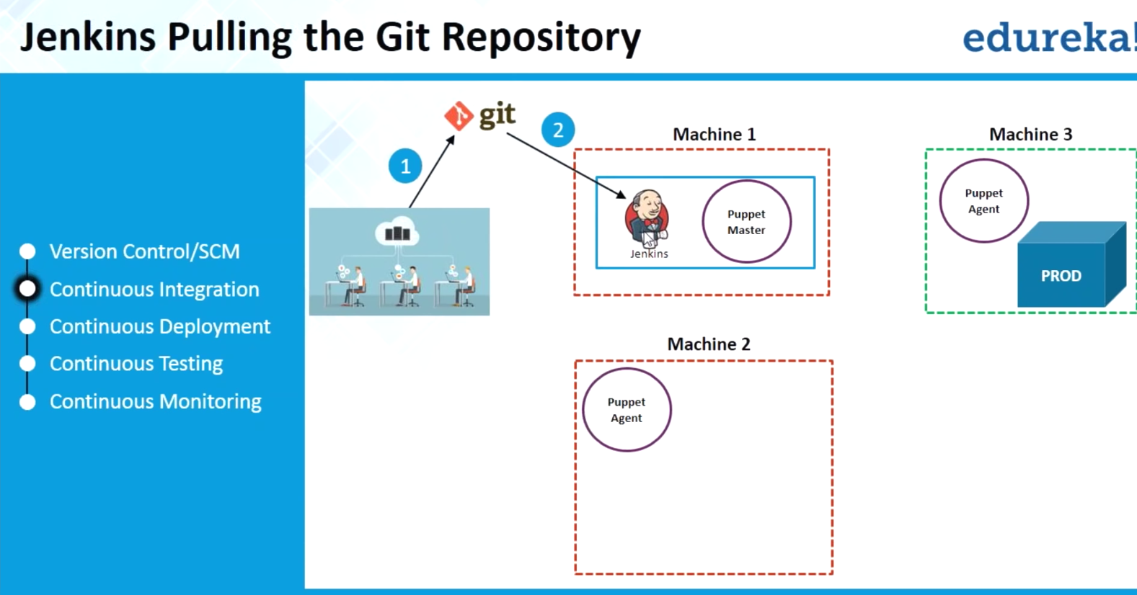

Using Jenkins, I can pull it onto machine1.

I will create a simple Jenkins Job, which will pull this project code from github.

You can see on m/c 1-> Pupper master

2,3-> puppet agent running

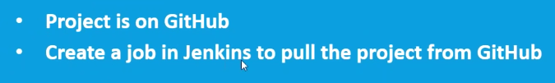

**M1:**

Jenkins-> New project

Give name

Source code mgmt.:

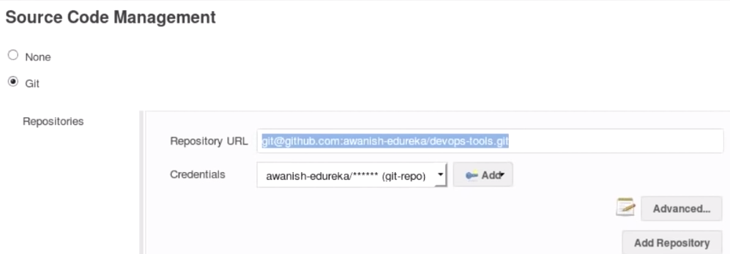

[**https://github.com/awanish-edureka/devops-tools**](https://github.com/awanish-edureka/devops-tools)

This is homepage application..going to deploy today

When we clone/download.., we can get ssh key/https here

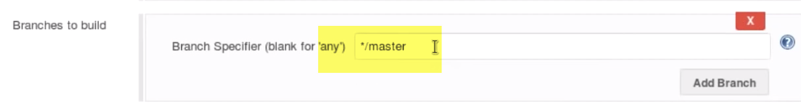

Default branch: master

Build Now.

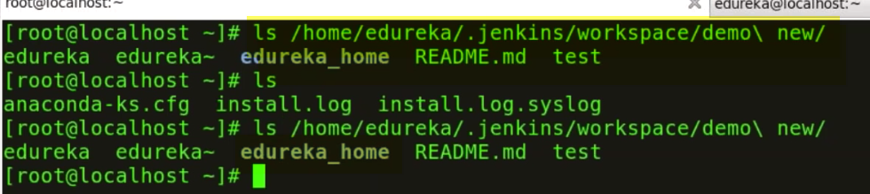

Edureka_home is amy application..Which I pulled toM1

