

AWS(Amazon Web Services)

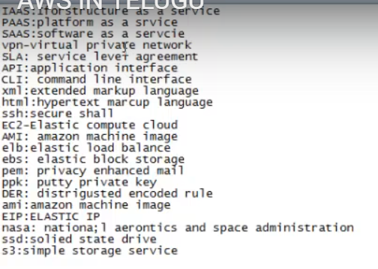

Cloud Computing:

Cloud: Group of servers, connected by network

Server: Which does serving.

**Group of services, by network (located in different counties---Data Center) -🡪 Cloud.**

Types:

Public: All

Private: Only within Org (Complete HCL) ---Ex: VPN

Community: Specific to specific Community. Ex: Bank

Hybrid: Private Public.

I will connect to wifi network (public) and then to private (office network).

* Google Computing Engine
* IBM Blue cloud
* AWS

**Characteristics of Cloud:**

1. On Demand: Whenever we want, we can create instances (servers--iis).
2. Network:
3. Elasticity: We can increase and decrease instances

Auto-scaling ---Scale up & scale down

1. Pool of services used remotely.

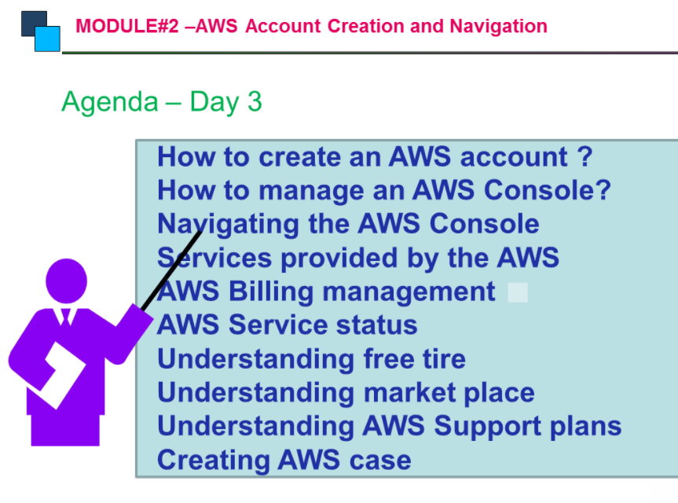

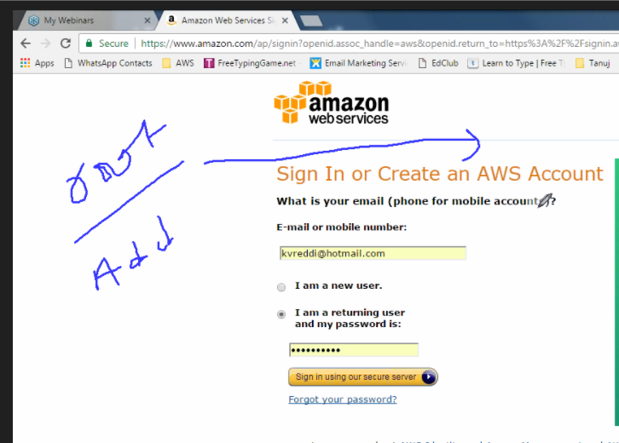

Root-> anything(superuser)

Admin-> except billing

Individual profiles🡪 DB admin-> network admin

We can have read access, by creating policies

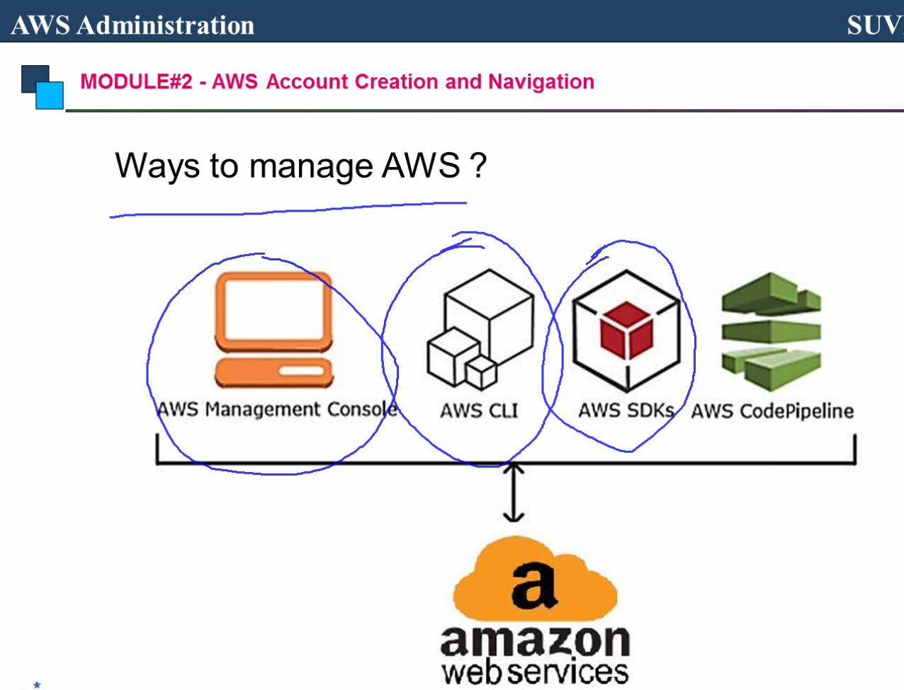

Set up with amazon ec2 virtual machine

how to install:

setup web server

setup database server

Configure it to use PHP

Setup a tomcat server

(If you wanted to use javaserver pages instead of PHP)

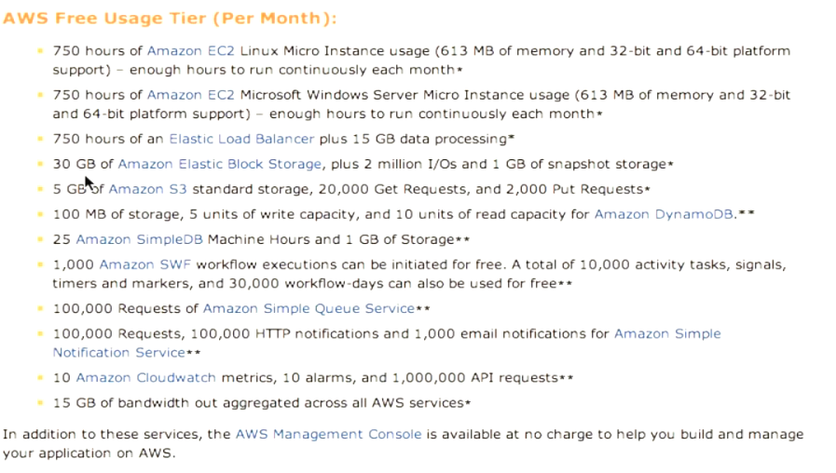

they give you 750 hours per month for 12 months which means basically you can run this virtual machine continuously for an entire year and you won't pay anything now the catches that an AWS account requires a valid credit card and this is going to be a problem for students because some of them might not have credit cards now they don't actually charge you anything because they have this for usage here but if you were to ever go over this then they need to have a credit card on file so that you know they can charge you so the problem here is that again students might not have credit cards so the solution is that they have this AWS Amazon Web Services in education program that you fill out this simple form here and they will give you a teaching grant that will give you a hundred dollars and Amazon credits for each of your students and that will be good for up to a year so you'd have to apply once every summer for the upcoming year and yeah you should be able to get free virtual machines for all of your students so you have to fill out this form requires you to enter your email can be a dot edu or equivalent so this is valid in canada or anywhere else in the world it doesn't have to be an edu account and it does require you to have an amazon web services account already so you will have to sign up and enter a credit card and then give them the email address that you use to sign up for amazon web services if you don't feel comfortable doing that I'm happy to put it on my credit card that's not a problem whatsoever just say the word so it asks you for your course course URL and the number of students so you'd want to give them the number of students that you're expecting to have for the entire year so you know if you get like 50 per semester then put in a hundred here alright so what it says in the faq here is that you apply with this form they review your application and if your grants accepted they'll notify you via email i'll send you a link to a site where you can redeem the credits and get all the accounts setup for your students so I realize this is kind of a pain in the butt but i think that the benefits here really outweigh the disadvantages I think this is going to be this could be i should say a great learning experience for the students so assuming that you have an amazon web services account setup then what you want to do is go to my account click on the AWS management console and simply log in to log in here and we'll go to amazon ec2 that's where you manage your virtual machines and then i click on launch instance i want to start up a new virtual machine i'll click continue and what they give you here is a list of predefined virtual machine images that you can use so I'm going to Community am eyes i'm going to set up a virtual machine using Ubuntu and I just happen to know the am I ID it's the virtual machine ID for this particular image that I want to use so i just type that in and it just takes a minute to pull it up okay there we go so now I'm just going to click on select and i'm going to make sure that micro is selected and you can see here that it's free to your eligible so i'm not going to charge you anything for it so i'm going to click on micro instance leave everything else as is and then I'm going to click this box is prevention against accidental accidental termination what this does ok the default on ec2 is that if you were to shut down your virtual machine then the default on ec2 is that they deleted it goes away it's gone by enabling this termination protection basically if you or to shut it down then it would just be stopped and you could restart it again later if you wanted to so I'll just check that and i'm just going to give it a name here so i'll say CES 2012 server for group 1 continue okay it's gonna ask me to create a key parasol could create a new key pair here i'll call it saves CES 2012 this key pair is what i'm going to use to SSH into my server because they don't use password authentication so i'm gonna click on create and download my key pair and you can see it just downloaded that key pair for me so we'll get to that later and now it's going to ask you to choose a security group this is basically the firewall i created a blank firewall here for this demo just because the existing firewall that i have already has a bunch of settings in it so I just want to start fresh but you would just select default so I'm just going to click this and click continue and everything set to go so i'll click on launch so it says I'm it's now launching i'll click on clothes and go to my instances list and you can see here that my CS 2212 server is starting up its independent state and it just takes a minute for it to start up now while that's going on I'm going to grab Mikey here that i just downloaded and i'm going to ssh i'm going to SCP to obelix so copied up 20 blocks so that it's ready i'm going to do this entire demo from obelix you could certainly do it from your own system on windows you have to use cygwin on linux or mac you just open up a terminal but i'll do it for mobile x because I imagine a lot of students would be doing it for mobile x as well so you can now see that my 2012 servers running so I'm going to SSH into obelix and i'm going to just click on this server here in my console and grab its host name is so there's the hostname and i'm going to try ssh into it now the user that ssh into as is ubuntu so i'll say SH up onto a DC to blah blah and you can see it's not working now the reason is that we have to go into the security group here and we have to allow the ssh port so I'm just going to say inbound ssh a drool and then apply and now I've opened up the ssh port in my security group now you would have clicked on default i created this the CES 2012 security group but you would click on default and add the rule there ok so i'll try that again you can see now it's listening and it gives me permission denied and that's because i have to use that CS 2212 key that i downloaded from them so i'm gonna say sh dash i give it the file name of the key file and then ubuntu at that hostname and you can see that I am now SSH 10 and if i just take a look here d f dash h you can see that it's given me an eight gig partition so there's plenty of space therefore the students now I'm just going to exit out here for a second I don't want to have to type every single time SSH dash I blah blah blah so what I'm going to do is go into my . ssh directory on obelix i'm going to move that key into that directory and i'm going to create a file called con fig and I'm gonna say host now right here i can put whatever alias I want to use for the server so i'm going to use the alias ec2 and the host name is going to be that big long hostname the user is going to be open to and the identity file is going to be tilled slashdot ssh CS 2212 top pattern that at $TIME p.m. file that we downloaded from amazon so now if i save this i can simply type ssh ec2 from the console and I'm in perfect ok so now that we've got the server up and running we need to install some software on it we need to install a web server database server get PHP configured so i'm going to switch to the root user by saying sudo su now I'm route and i'm going to say apt-get install apache2 we need the apache web server we need PHP we need the module the PHP module for apache and then we'll install mysql server as well for the database server so it's going to ask me if I want to do it i say yes hit enter and we'll just let it install for a second okay so it asks me for the root password that i want to use for mysql so I'll just enter something enter it again ok so now that we have everything installed i'm just going to clear the screen here and then I'm going to restart apache just to make sure that PHP is properly enabled by saying service apache2 restart it just restarts the web server and last thing i want to do you don't have to do this but it's good practice to run this mysql underscore secure underscore installation script so it's going to ask you for your root password enter that I don't want to change it so I say no and asked me if I basically I'm just locking down my my database server here so i'm going to remove my anonymous users i'm going to disable root login remotely and i'm going to remove the test database and access to it and reload my privileges table so you don't have to do that but it just locks it down it's just hire security basically ok so now we want to see if this web server is up and running and working so once again I'm just going to grab that hostname for that server and I'm going to go and try and access it but you can see here that it's just sort of doing nothing the reason for that is that we have to open up port 80 so i go into my security groups again you'd be clicking on default i'm clicking on CES 2012 here and i'm going to create a new rule and i want to create one for HTTP i want to allow the HTTP port 80 click on apply rule changes and now let's see if we refresh this page you can see that it's working now it's actually responding perfect ok so we want to quickly create some sort of PHP options to make sure that it's working so i'm going to mysql login as the root user and i'm going to specify a password since I set a root password so much of that and let's create a database here create database CES 2012 use CES 2012 and then I'll just going to create a simple comments forms i'll create a comment stable and it's going to be have an integer ID not know that will be its primary key so we'll have auto increment here and we'll take the user's name which will makes a bar chart 255 characters not know and then the body of the comment will be text not know and then finally primary key will be the ID and that should do it so we've got the comments table created now we have to create a user because we don't want to use our root mysql user in this comments out because that would be insecure so i'll say create user will call it 2012 DB user at localhost identified by and then a password so the password i'll say CS 2212 for life right and then we have to grant all privileges on RCS 2212 database all tables within the CES 2012 database 222 12db user that user we just created 20 multi-user at localhost and then last thing I have to do is just flush the privileges to get them to take effect alright so the database is set up and now we're going to create the actual comments form so by default on ubuntu Apache stores all of its files in / bar / www i'm going to edit this index.html file and i'll just quickly put in a comments form HTML body tag create our form action equals will say it's gonna post to a file called comments that PHP the method is post and then we'll have a name input type equals text name equals name and then we'll have comment that will be a text area with say 10 rows 80 columns and its name will be body and then we just need our submit button input type equals submit all right close out our form close our body was at the HTML page so if I reload that just make sure it works perfect so now we just have to create the comments . PHP file so go in here and create this started off and we're going to have our DB host name is localhost our database username we said was 22 12 DB user our DB password whoops we set to bcs 2012 for life and our database name we created the database at CES 2012 ok so i need to connect to the database so I'm gonna grab a handle to the database mysql connect TV host name pass the DB username pass the DB password and if that doesn't work then we'll die with an error message and we'll get mysql to print out the error message that occurred okay assuming that work then we'll select the database with mysql select DB and I'm going to grab the parameters that have been posted to my forum so post name and the body of the comment body and then finally I'll say try inserting it insert into comments name body values name oops body alright and obviously this is totally insecure i'm not doing any sort of input validation so somebody could totally do an SQL injection attack but it's just for testing so assuming that worked we're going to print out a simple message that says I don't know thank you and your comments was received and if that didn't work then I'm going to print out an error message that just says error we're sorry but your request could not be completed at this time okay and then we'll just close out our PHP block here and we should be good to go so we'll switch back to our web server here Jeff Shantz hello world submit and nothing happens now what happened was there was an error that happened behind the scenes and we can take a look at that by looking up VAR log Apache error dialog and you can see we have this PHP fatal error call to undefined function MySQL connect now I did this intentionally and the reason I did this is I wanted to show you why would one of the benefits of having a virtual machine if they were to be doing the same knoblauch's they would have to be looking at a log that was may be shared with a lot of different users and so all sorts of error messages would be intertwined by having their own server that can look at the logs and they can know that yeah this is an error that came from my script ok so i just think it's it's nice to have their own system that they can play with and and it's understand how things work behind the scenes ok so we have this call to undefined function my school connect and that's because I didn't install the connector that tells PHP how to connect to mysql so I'm gonna say ABT get install PHP five dash minus 2l that will get installed and now I simply have to restart apache service apache2 restart my web service restarted and I should be able to now go back submit my form and you can see I get my thank you and if we just confirmed that in the database UCS 2012 select star from comments you can see that my comments been inserted so PHP is working properly everything's great ok so that's how you set up apache and PHP assuming you wanted to go the route of javaserver pages you would need to use tomcat instead of Apache so I'm going to first just remove Apache I wouldn't have to remove it I could have stopped it I guess ok and instead i'm going to install Tomcat seven so this is an application server there are lots of different JSP application servers like websphere and I don't know j boston and stuff like that but tom cat is free it's pretty lightweight so it's probably the one to use so just take a minute to install it's installing java it's installing tomcat and all the dependencies for it ok by default tomcat runs on port 8080 so if you want to access it you would have to go to port 8080 on this host and again you can see it's not responding and that's because we have to go to our security group here and allow 8080 now 88 is not in this list so I'm just going to create a custom rule type in 84 the range click on ADD and then apply and now when i go back here and i click on reload there we go so now it's working with tomcat now it's not very nice to have it running on port 8080 it would be nicer if it were just running on port 80 so that we could just type in something like this you can change Tomcats run on port 80 but if you want to do that it has to run as the root user and it's not very secure it's not usually recommended so instead what the hack is is that you just redirect port 80 to port 8080 so that Tomcat can be running on port 8080 and any requests that come in on port 80 will be redirected to it so this is just something that the students could just copy and paste they don't really need to understand this I'm just creating a in iptables role to redirect from port 80 to port 8080 alright and then I'm just going to say iptables save to make sure if we were to reboot this virtual machine that rule would still be in effect so now i should be able to go here and and look at that I don't have to specify the port anymore so again tom cat is still running on port 8080 but i'm just using this firewall rule to redirect port 80 to port 8080 ok so what do we want to do next well we want to be able to access our console here so it comes with a manager web app that you can use to deploy . war files to deploy JSP applications to the server but you have to create a user in order to be able to access that so i'm going to edit the file etc' Tomcats and it's tom cat dashed users that XML going to go under this Tomcat users tag and i'm going to create a user will give it the user name of Jeff and password will just say is admin 123 rolls the roles will be manager dash go E and admin dashboard me again this is just something that students could copy and paste into the file ok so we save that up and i just have to restart the tomcat server so say e.t.c entity tomcat seven restart and that restarts it ok and i should be able to you know what I just realized that i forgot to install Tomcat seven dash admin so i have to install the admin site so i just installed that i'm going to restart my tomcat server again sorry about that and once it started up i can now go back click on the manager web app it asked me for the username password i'll put in the one I just created Jeff admin 123 and now i'm into the application manager and so this is where you can see all the applications that are running on the server and you can deploy a new application so the students would compile their JSP application into a war file and they would simply upload the file and deploy it and then it would be listed as one of the applications in this list and they could play with it i'm not going to get into that right now but hopefully you get the picture alright so that's pretty much covers it i'm not sure if I got under my 20 minutes or not but yeah hopefully you can see that this is really not that hard and I think the students could totally handle it and I think it'd be a great learning experience for them all right actually