

Quiz

Live lab ---Notes

Study Guide

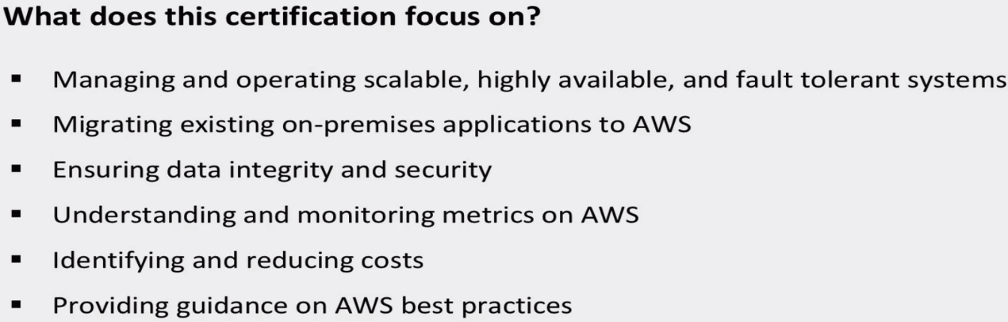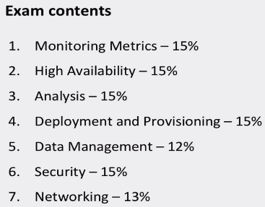

**Understanding AWS Instance Types, Utilization, and Performance**

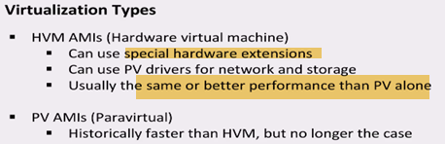

HVM uses special hardware extensions, that increase performance

Instance Families:

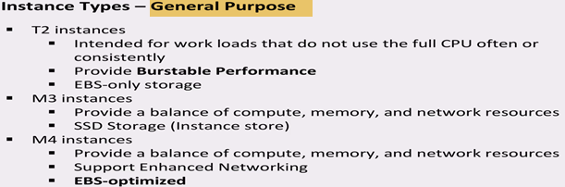

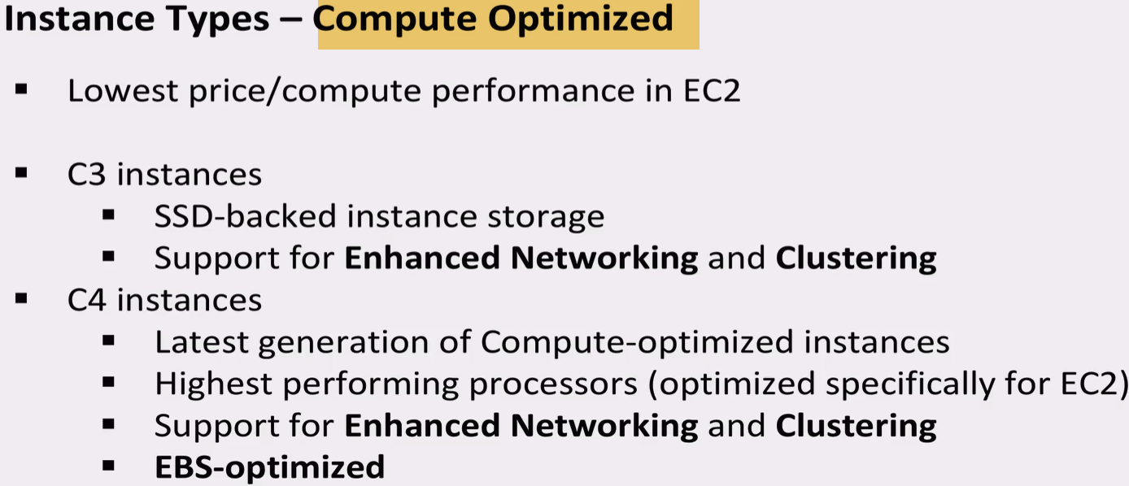

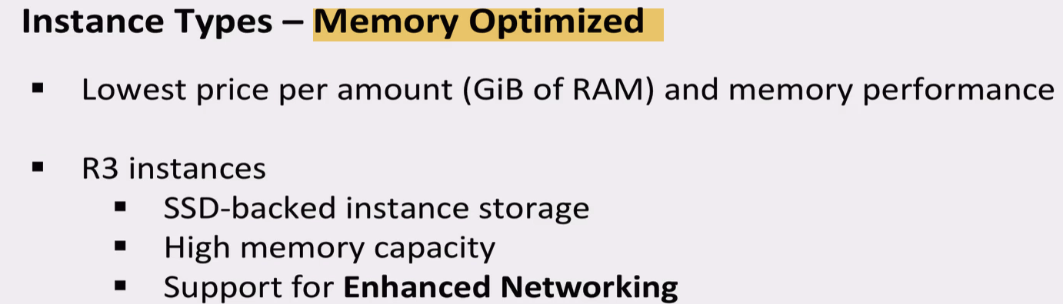

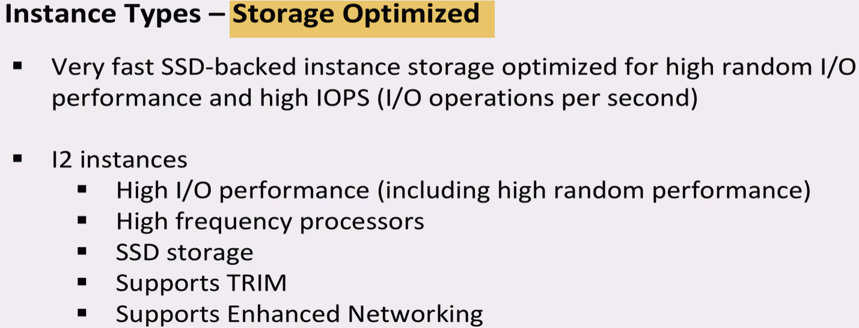

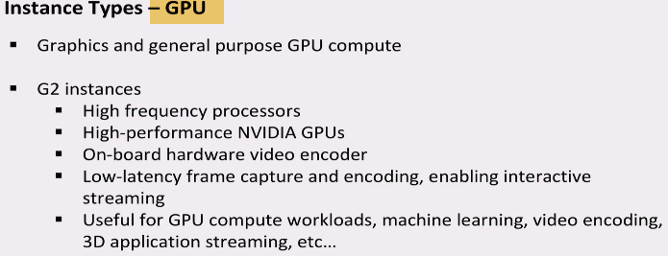

Elastic Compute Cloud (EC2) Instance and System Status Checks

Status checks: 1.) System 2.) EC2

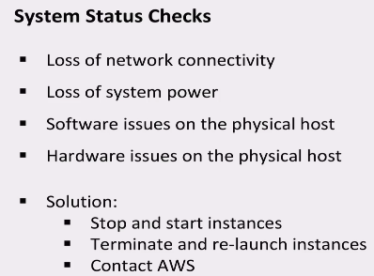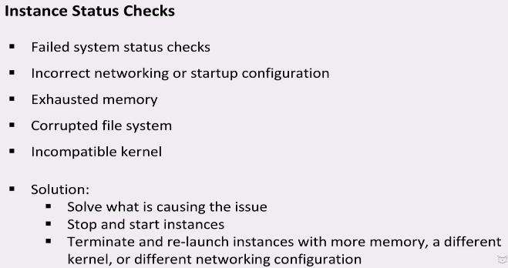



**Creating CloudWatch Alarms**