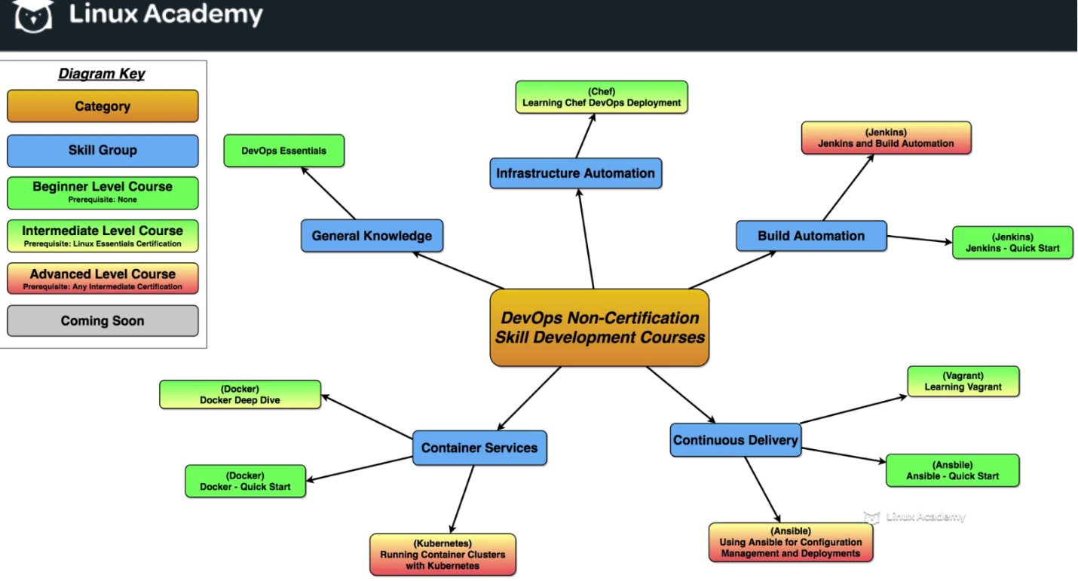

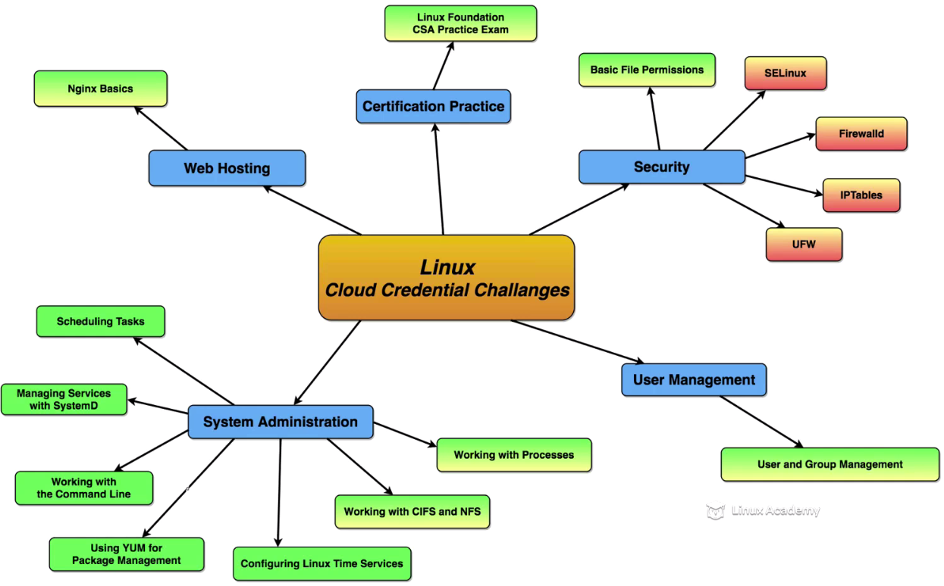

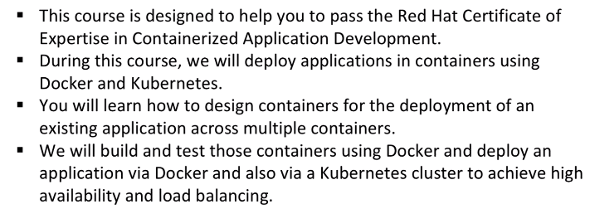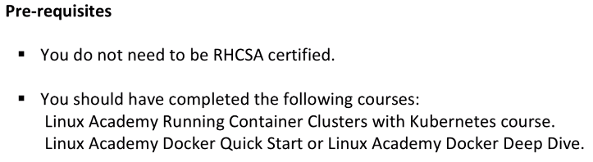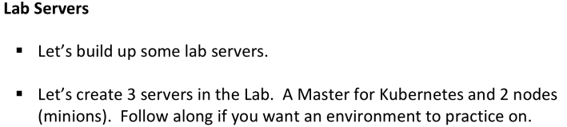

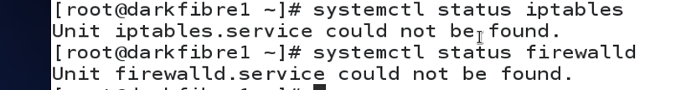

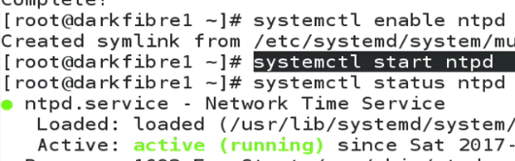

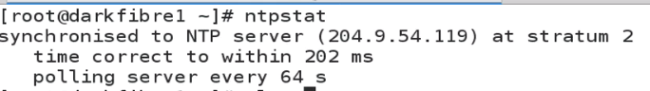

1 MASTER 2 nodes:

Firewall

Iptables

Service status

/etc/hosts

Ping

Yum install –y ntp

**Kubernates master server, 2 Docker minions**

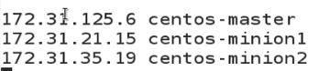

**Do same on server, 2 nodes:**

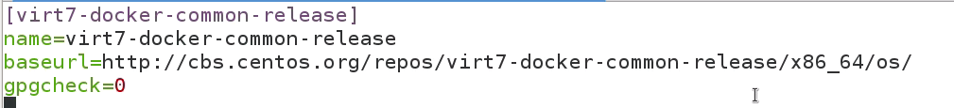

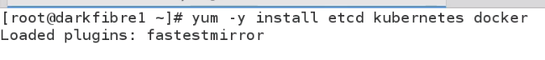

**On SERVER: Change Config file 1.)**

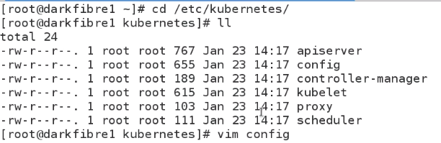

C:\Users\vebalusu\AppData\Local\Temp\SNAGHTML40bbdc7.PNG

NEW:

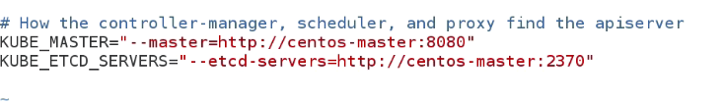

ADD KUBE_ETCD_SERVICES line extra

2.)

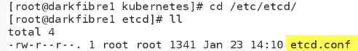

**OLD:**  



**NEW:** 

3.) 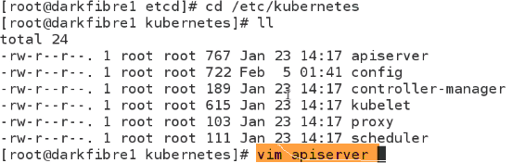

**Old-New:**



**Uncomment:**





**COMMENT**



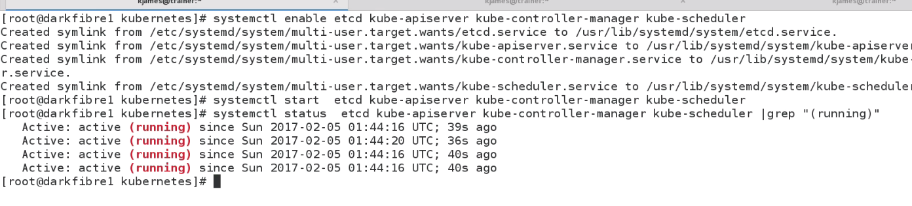

**NODES**

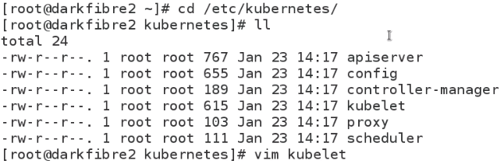



**UNCOMMENT**



Comment



2.)



ADD KUBE_ETCD_SERVICES line extra

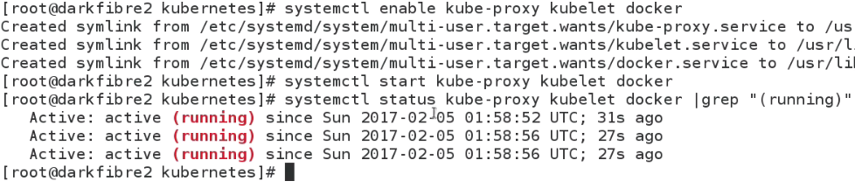

VERIFY EVERYTING IS FINE.

**FROM MASTER:**

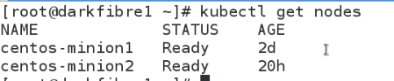

**FROM minion-1, 2 :**



**------------------------------------------------------------------------------------------------------------------------------------------**

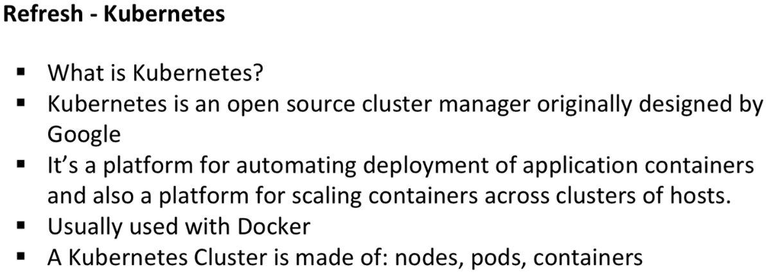

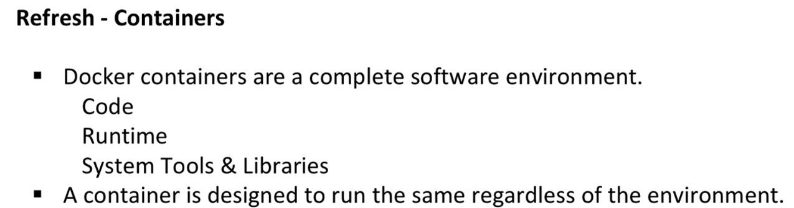

-------------------------------------------------------------------------------------------------------------------------------------

**Provision a Database Server Using Container Technology**

**MINION-1**

1. Give a specific name to docker instance using **–name**

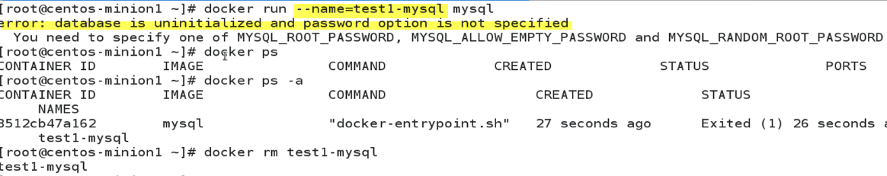

Error bcz mysql is expecting one of these variables..



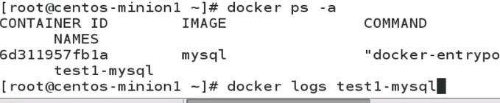

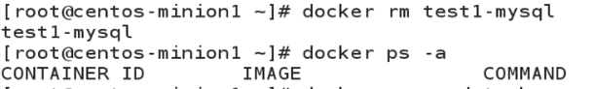

1. Detach mode:

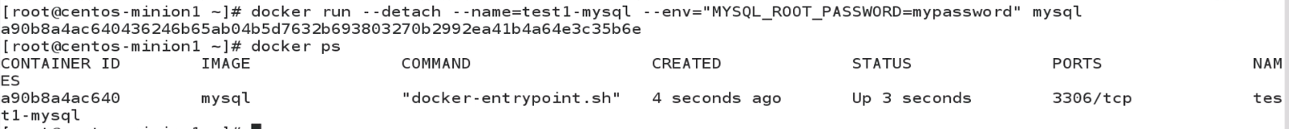

---Get IP address

Connect to mysql of docker

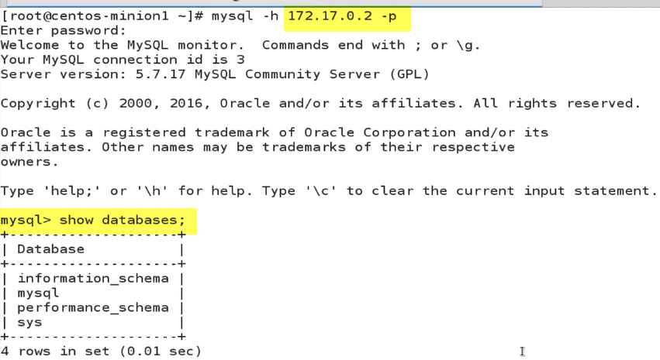

But Ip address can changes.Next we see how to link containers.

Thus we can see how to connect to containers without IP address…

------------------------------------------------------------------------------------------------------------------------

**Link Containers**

