Live sessions: Login on time…N/w, audio connection Sanity check…Q/A

Close to 150+ Devops tools

How to optimize delivery

How to make cost effective to organization

CI, CD, Release and integration---Where does these fit into pipeline..

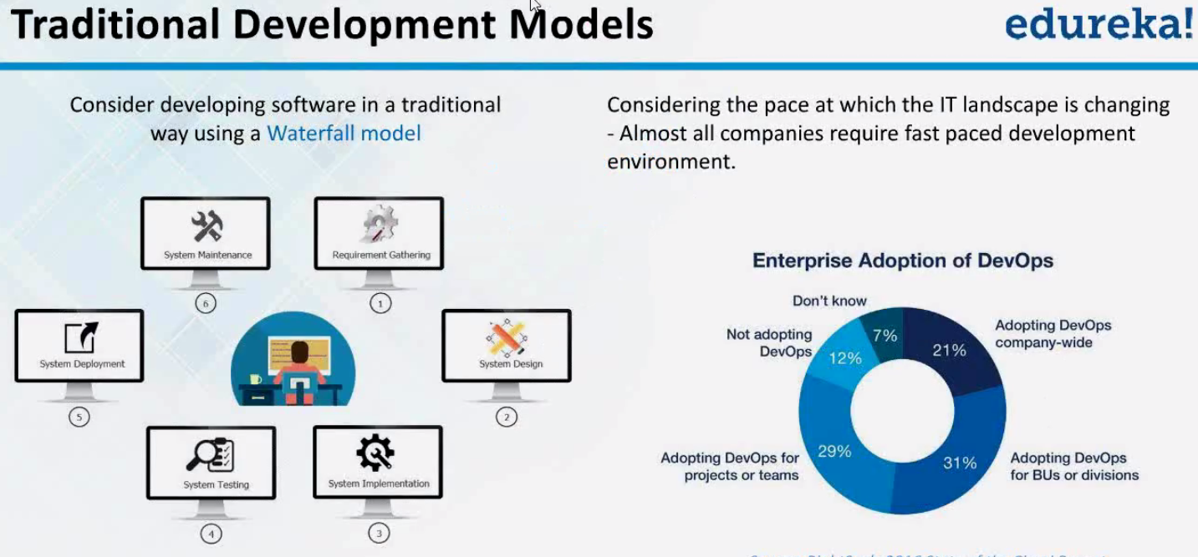

This kind of traditional model never worked. Usually used to 6 mths, 1yr.

By the time, we get req are frozen/deployed, customer might have moved to some other set of req.

Market changed.

Incorrect req🡪 much of failures

Client-> we something-> architect-> developer🡪 something

Cut down/optimize time..> We have agile…Focused on devt only.

It focus on operations..

It applies to all🡪 faster u change, more unstable..

Now Devops🡪 How can I do bring agility to devy, How can I do bring stability to Ops, still going fast

Thus it became Bridge or culture b/w dev & ops..

Devops influenced by agile. It’s not agile

Devops: deliver product rapidly 1day, not 6 mths/yr.

**(Rapid devt. With stability)🡪 devops**

low cost

Customer satisfaction