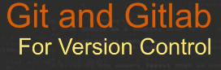

Source/version control:

Able to look back at file and see what happened previously, it’s history in life cycle of S/W devt.

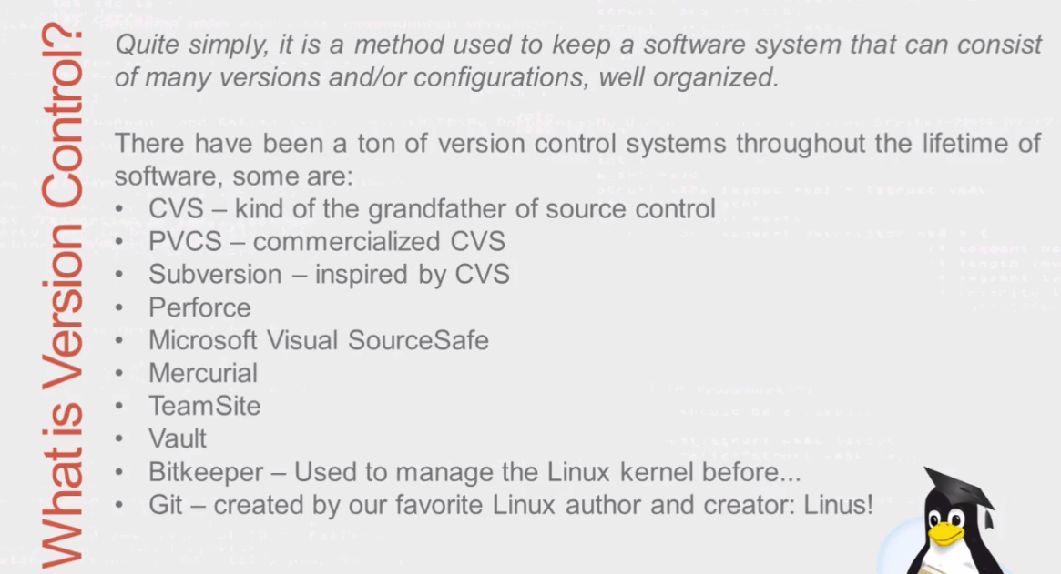

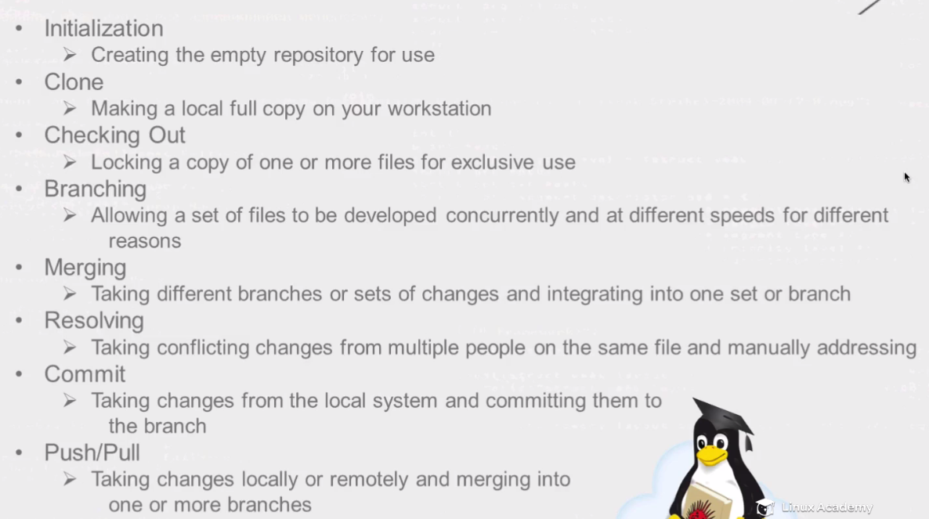

Repository: like repos in Linux, that contains all pkgs. Data +metadata.

Clone: Most common m/d of checkout source from repo.

--------------------------------------------------------------------------**Installing Git-🡪 git installs itself as both client and server**

/etc/issue

Uname –a

100 changes-🡪 1 file and 99 deltas 🡪 Combined make up current version.

Git –version **1.7-🡪 min. needed fot github or bitbucket**

[jenkins@devops1 ~]$ git config --global user.name jenkins

[jenkins@devops1 ~]$ git config --global user.email [jenkins@outlook.com](mailto:jenkins@outlook.com)

[jenkins@devops1 ~]$ cat .gitconfig

[user]

name = jenkins

email = [jenkins@outlook.com](mailto:jenkins@outlook.com) (OR)

[jenkins@devops1 ~]$ git config --list

user.name=jenkins

[user.email=jenkins@outlook.com](mailto:user.email=jenkins@outlook.com)

gitlab is clone of github

----------------------------------------------------------------------------

Basic Configuration ---Config files

1.) system level config---- Applies to entire system ..clients/server ..Every user on it

2.) Global level config: Applies to u for system throughout globally –Client or system-🡪 .gitconfig

3.) local config -🡪 in .git of repo dir

Local config trumphs -> global triumphs system

System config is least specific..because individual users are going to have their own changes/limitation.

**Global config:**

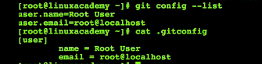



**System:**

