--Private Git server on Windows OS (Git server located on private n/w).

1.) Download git’

2.) Bitwise SSH server

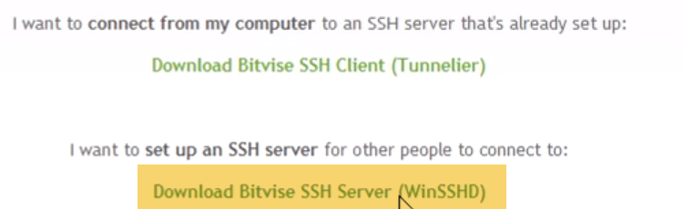

Git by itself is both Server and client.