-Manage Document, Source

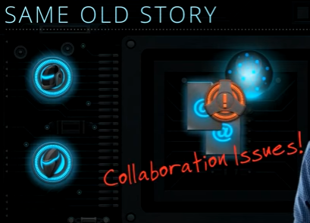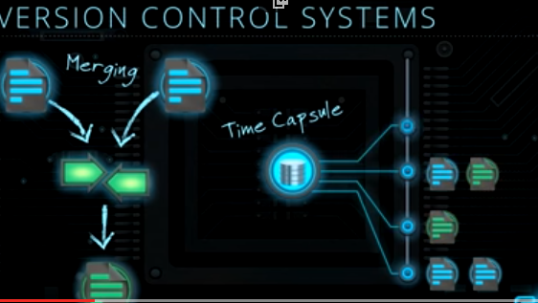

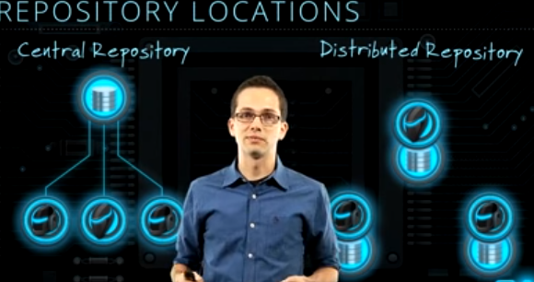

Full copy, Backup…..GIT🡪DVCS

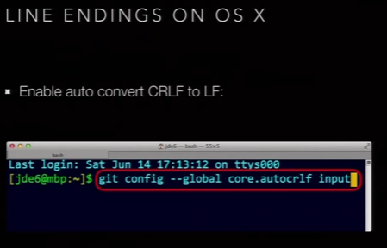

Git config color.ui-🡪true

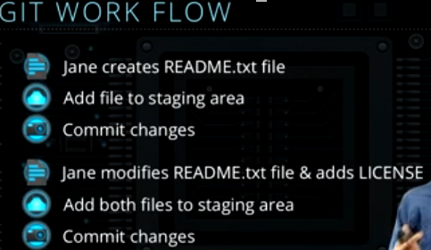

Git status

New file(untracked) -🡪 add (staging) -🡪 local repo(track) commit

Git add –-all

Git add docs/*.txt

Git add docs/

Git add *.txt—Add all text files in current dir

Git add “*.txt”---Whole project

|  |  |
| --- | --- |
|  |  |

|  |  |
| --- | --- |
|  |  |

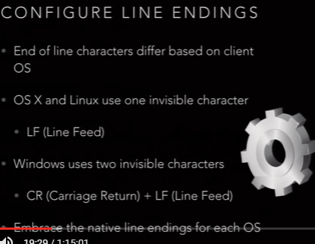

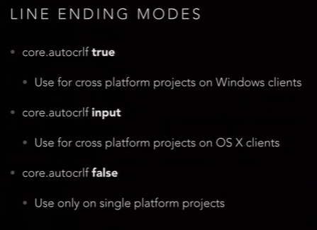

Git status

-Untracked

-Modified

-Stagged

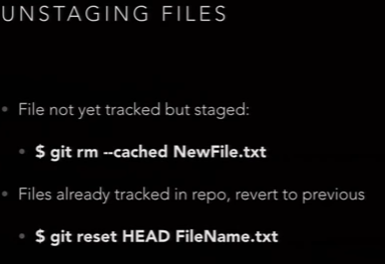

Git log –p 2

