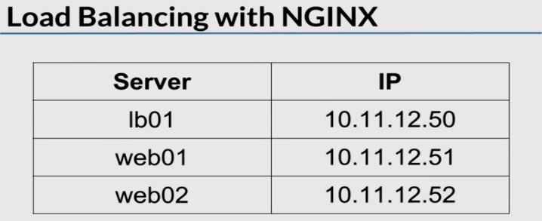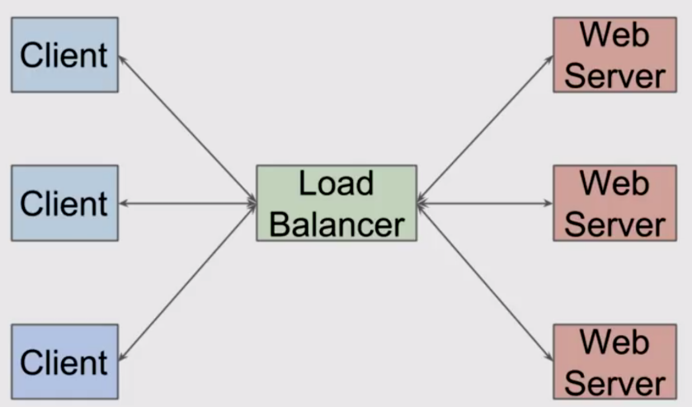

LB accepts request from Clients, route those requests to webservers for processing.. And sends back results to clients.

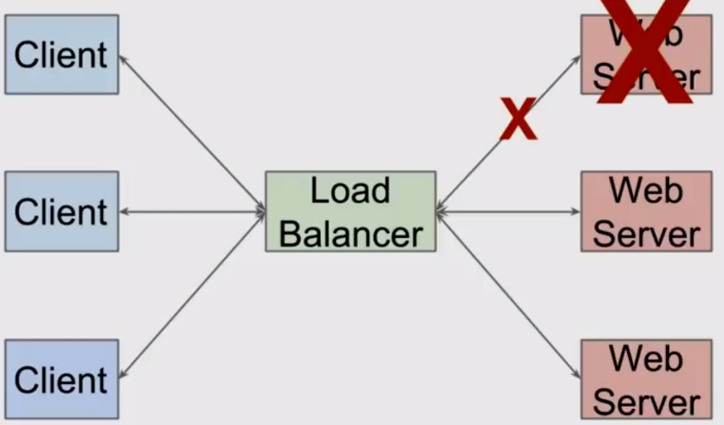

If webserver is unavailable, load balancer sends req. to webserver that is up, and accepts connections.

**On Web01:**

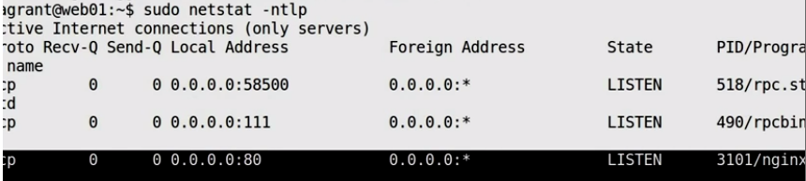

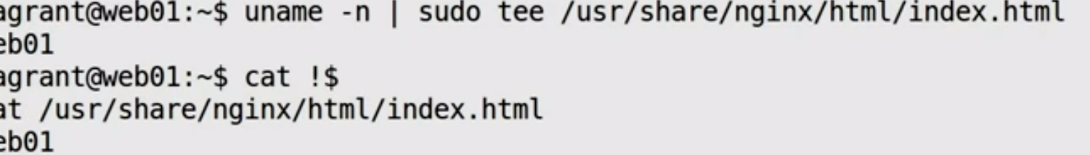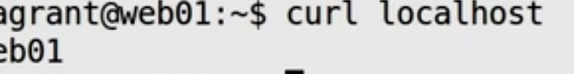

**Web02:** Do same for **Web02**

**LB01:**



**Round-Robin method**

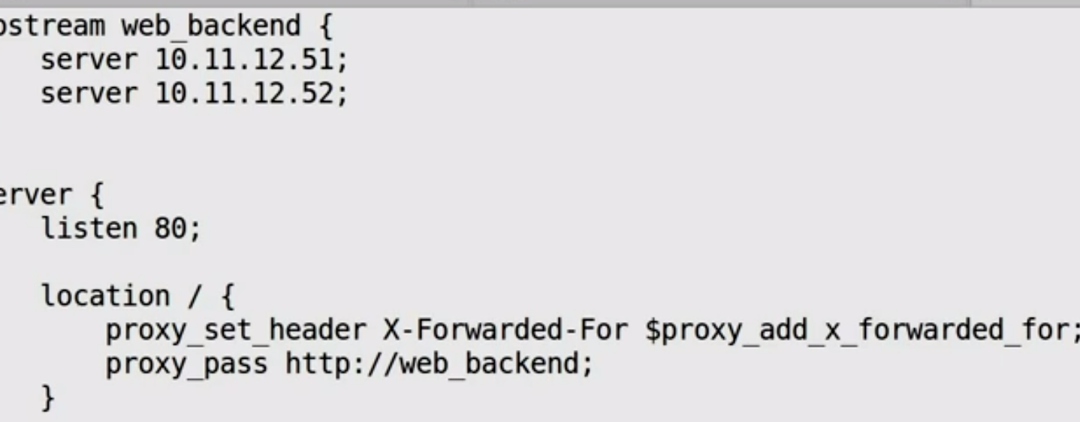

First, we define backend webservers (51, 52)

Then we tell nginx to pass all traffic to those backend webservers

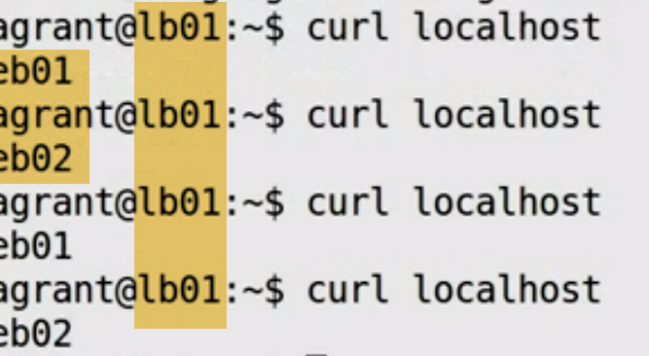



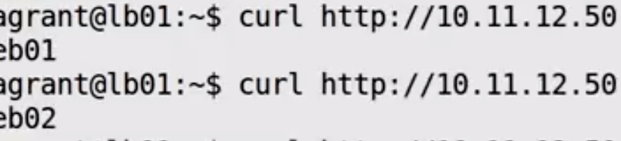---Try with IP of Load balancer---Works

**For Session: ( It will use same webserver ---for a session)**

