Analyzing and Implementing Divide-and-Conquer Algorithms: Merge Sort and Quick Sort

Hareesh Devulapalli
Student ID: 005044231
PhD in Information Technology, University of the Cumberlands
MSCS 532: Algorithms and Data Structures
Michael Solomon
Assignment 2
October 28, 2026

GitHub repository: https://github.com/hareeshdevulapalli/MSCS532_Assignment2

Analyzing and Implementing Divide-and-Conquer Algorithms
For this assignment I picked Merge Sort and Quick Sort. Both sort a list of n numbers into increasing order, and both use divide and conquer, but they put the hard work in different places. I wanted to see if that difference shows up when the code actually runs.

Merge Sort
Merge Sort splits the list in the middle, sorts the left half and the right half with recursive calls, and then merges the two sorted halves back together. The merge just keeps comparing the first items of each half and copying the smaller one over (Knuth, 1998). Splitting takes no real effort, and merging n items takes Θ(n) time. Since the halves are always the same size, the recurrence does not depend on the input at all:
T(n) = 2T(n/2) + Θ(n), T(1) = Θ(1)
Using the master method, a = 2 and b = 2, so n^{log₂ 2} = n. The extra work f(n) is Θ(n), the same rate, which puts us in case 2 and gives T(n) = Θ(n lg n) (Bentley et al., 1980). The recursion tree gives the same answer in a more visual way. The root costs cn, the next level has two nodes costing cn/2 each, and in general level i has 2^{i} nodes costing cn/2^{i}. Every level adds up to cn, and there are lg n + 1 levels, so the total is cn lg n + cn. To check this with substitution, I assumed T(m) ≤ cm lg m for smaller inputs. Plugging in gives T(n) ≤ 2c(n/2) lg(n/2) + dn = cn lg n − (c − d)n, and that is at most cn lg n as long as c ≥ d. The lower bound works out the same way. So Merge Sort is Θ(n lg n), which means it is both O(n lg n) and Ω(n lg n), and this holds for the best, average, and worst cases. The downside is the Θ(n) extra memory for the temporary halves. It is also stable.

Quick Sort
Quick Sort does it the other way around (Sedgewick, 1978). It picks a pivot, which in my version is the last item (the Lomuto partition from Bentley, 2000), and moves everything smaller than or equal to the pivot to its left and everything bigger to its right. Then it sorts the two sides recursively, and there is nothing left to combine. Partitioning is Θ(n), but how evenly it splits depends on the pivot, so there are two recurrences to look at:
Worst: T(n) = T(n − 1) + T(0) + Θ(n) Best: T(n) = 2T(n/2) + Θ(n)
The worst case happens when the pivot is always the smallest or largest item. With a last-item pivot, that is exactly what happens on a list that is already sorted or sorted backwards. Each call only removes one item, so the recursion tree is a long chain with costs cn, c(n − 1), and so on down to c, which adds up to Θ(n²). For substitution, I assumed T(m) ≤ cm² for smaller inputs and got T(n) ≤ c(n − 1)² + dn = cn² − c(2n − 1) + dn, which is at most cn² when c ≥ d. The master method does not work for this case because the subproblem is size n − 1 instead of n/b. When the splits are even, the recurrence is the same as Merge Sort’s, so case 2 gives Θ(n lg n). Even a lopsided split like 9 to 1 still keeps the tree O(log n) deep. With a random pivot, Quick Sort makes about 1.39 n lg n comparisons on average (Sedgewick, 1978). Putting it together, Quick Sort is O(n²) and Ω(n lg n). It is Θ(n²) in the worst case and Θ(n lg n) in the best and expected cases. It sorts in place, uses an O(lg n) stack if the smaller side is sorted first, and is not stable.

Practical Implications
Merge Sort is a good choice when you need a guaranteed running time or a stable sort, for example when sorting records by one field after another. It also reads data in order, which is why it is used for sorting files too big to fit in memory. Python’s own sort, Timsort, is built on merging (Auger et al., 2018). Quick Sort is usually the fastest in memory because it sorts in place with a very simple inner loop. C’s qsort is based on it (Bentley & McIlroy, 1993), and so is C++’s introsort. Library versions choose the pivot more carefully and switch to heapsort if the recursion gets too deep, which rules out the Θ(n²) case (Musser, 1997).

Implementation
I wrote both algorithms in Python, plus a version of Quick Sort with a random pivot, some unit tests, and a benchmark script. All of it is in the GitHub repository. The benchmark sorts sorted, reverse-sorted, and random lists from 500 to 8,000 numbers. For time, I took the median of five runs. For memory, I did a separate run using Python’s memory tracing, since tracing slows the code down (Gorelick & Ozsvald, 2020). I ran everything with Python 3.13 on an Apple Silicon Mac. I only included the partition function here, since it is the part that explains Quick Sort’s worst case. Figure 1 shows the programs running.
def partition(arr, first, last):
pivot = arr[last] # last item is the pivot
small_end = first - 1 # arr[first..small_end] <= pivot
for idx in range(first, last):
if arr[idx] <= pivot:
small_end += 1
arr[small_end], arr[idx] = arr[idx], arr[small_end]
arr[small_end + 1], arr[last] = arr[last], arr[small_end + 1]
return small_end + 1 # pivot's final position
Figure 1
Program Execution: Demo Runs, Unit Tests, and Benchmark Output
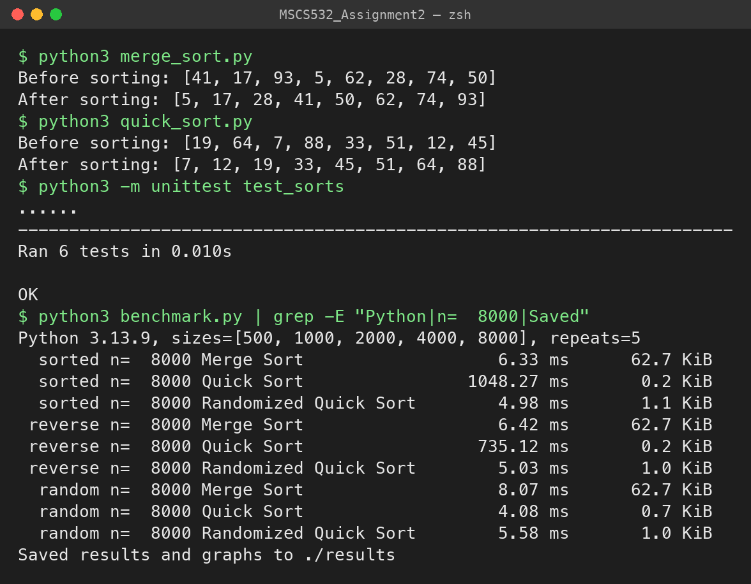
Table 1
Execution Time (ms) and Peak Extra Memory at n = 8,000
Algorithm | Sorted | Reverse | Random | Memory
Merge Sort | 6.3 | 6.4 | 8.1 | 62.7 KiB
Quick Sort (last pivot) | 1,048.3 | 735.1 | 4.1 | 0.2–0.7 KiB
Randomized Quick Sort | 5.0 | 5.0 | 5.6 | 1.0–1.1 KiB

Figure 2
Execution Time Versus Input Size (log–log scale)
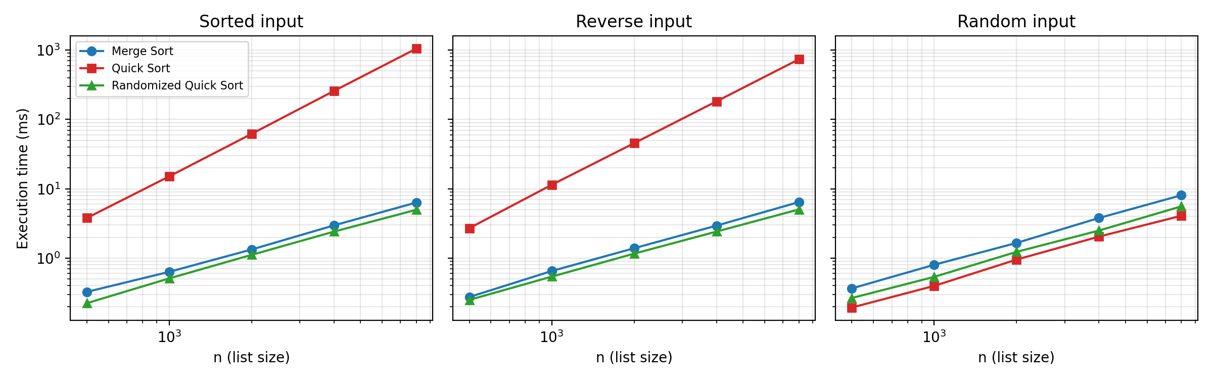

Results and Discussion
Most of the results matched what I expected from the analysis. On sorted and reverse-sorted lists, Quick Sort got about four times slower every time I doubled n. On sorted input it went from 15.1 ms to 61.9, 257.3, and finally 1,048.3 ms, which is what Θ(n²) looks like. In Figure 2 its line has a slope of about 2, while the other lines are just above 1, which fits n lg n. Merge Sort took about the same time no matter how the input was ordered, and its memory grew in a straight line, roughly 8 bytes per item for the copies in the merge step. The random pivot fixed Quick Sort’s problem with sorted input completely.
A few results surprised me at first. On random data, Quick Sort was about twice as fast as Merge Sort, even though both are Θ(n lg n). Big-O notation leaves out constant factors, and Merge Sort spends a lot of time creating new lists and copying items at every level, while Quick Sort only swaps items inside the same list. I also did not expect Quick Sort to be about 40% slower on sorted input than on reverse-sorted input, since both make the same n(n − 1)/2 comparisons. Looking at the partition code explained it. On sorted input every comparison is true and leads to a swap, but on reverse-sorted input almost none are. Merge Sort was about 20% faster on sorted input, because one half runs out early and the rest is copied without comparing. Finally, the random-pivot version was a little slower than the normal one on random data. Picking a random number at every step costs time, and it does not help when the data is already random. Python’s overhead slows all three versions about equally, so the comparison is still fair. My takeaway is that Merge Sort is the safer choice when you need predictable time and can spare the memory, while Quick Sort is usually faster but only if the pivot is chosen well.

References
Auger, N., Jugé, V., Nicaud, C., & Pivoteau, C. (2018). On the worst-case complexity of TimSort. In 26th Annual European Symposium on Algorithms (ESA 2018) (Vol. 112, pp. 4:1–4:13). Schloss Dagstuhl–Leibniz-Zentrum für Informatik. https://doi.org/10.4230/LIPIcs.ESA.2018.4
Bentley, J. (2000). Programming pearls (2nd ed.). Addison-Wesley.
Bentley, J. L., Haken, D., & Saxe, J. B. (1980). A general method for solving divide-and-conquer recurrences. ACM SIGACT News, 12(3), 36–44. https://doi.org/10.1145/1008861.1008865
Bentley, J. L., & McIlroy, M. D. (1993). Engineering a sort function. Software: Practice and Experience, 23(11), 1249–1265. https://doi.org/10.1002/spe.4380231105
Gorelick, M., & Ozsvald, I. (2020). High performance Python: Practical performant programming for humans (2nd ed.). O’Reilly Media.
Knuth, D. E. (1998). The art of computer programming: Vol. 3. Sorting and searching (2nd ed.). Addison-Wesley.
Musser, D. R. (1997). Introspective sorting and selection algorithms. Software: Practice and Experience, 27(8), 983–993. https://doi.org/10.1002/(SICI)1097-024X(199708)27:8<983::AID-SPE117>3.0.CO;2-%23
Sedgewick, R. (1978). Implementing Quicksort programs. Communications of the ACM, 21(10), 847–857. https://doi.org/10.1145/359619.359631

