Understanding Algorithm Efficiency and Scalability: Randomized Quicksort and Hashing with Chaining

Hareesh Devulapalli
Student ID: 005044231
PhD in Information Technology, University of the Cumberlands
MSCS 532: Algorithms and Data Structures
Michael Solomon
Assignment 3

GitHub repository: https://github.com/hareeshdevulapalli/MSCS532_Assignment3

Understanding Algorithm Efficiency and Scalability
In this assignment I studied two algorithms that depend on randomness to run fast: Quicksort with a randomly chosen pivot, and a hash table that handles collisions with chaining. Each of them has a slow worst case. Quicksort can take Θ(n²) time, and a hash table lookup can take Θ(n) time. Randomness does not remove these cases, but it makes them very unlikely, so the expected cost is what shows up in practice. For both algorithms I wrote a Python version, worked out the expected running time, and ran experiments to see how closely the real times follow the math. The code, the raw data, and the graphs are all in the GitHub repository on the title page.

Part 1: Randomized Quicksort

Implementation
Quicksort chooses one item as the pivot, moves the smaller items to its left and the larger items to its right, and then sorts each side the same way (Hoare, 1962). In my randomized version, the pivot is picked with random.randint(lo, hi), so every position in the current subarray has the same chance. The pivot is swapped to the front and then the partition runs. The deterministic version that I compare it with is the same code, except that it always takes the first item as the pivot. Because everything else is shared, any difference in the results comes from the pivot choice alone.
Instead of the two-way Lomuto PARTITION in Cormen et al. (2022), I used a three-way partition. It divides the subarray into three groups: items less than the pivot, items equal to it, and items greater than it. Only the first and last groups are sorted further. This is the usual way to deal with duplicate values (Bentley & McIlroy, 1993; Dijkstra, 1976), because all copies of the pivot are placed in one pass. My scan only moves forward through the array, the same as Lomuto’s, so items greater than the pivot stay where they are. I found out that this matters. My first attempt used Dijkstra’s version, which swaps items in from the end of the array. One of my unit tests showed that this mixed up sorted input, and the first-element Quicksort then no longer showed its worst case. Here is the main part of the partition:
def three_way_split(nums, lo, hi):
pivot = nums[lo]
eq_start = lo
eq_stop = lo
for pos in range(lo + 1, hi + 1):
val = nums[pos]
if val < pivot:
# 3-way rotate so val ends up just before the equal block
nums[pos] = nums[eq_stop + 1]
nums[eq_stop + 1] = nums[eq_start]
nums[eq_start] = val
eq_start += 1
eq_stop += 1
elif val == pivot:
eq_stop += 1
nums[pos], nums[eq_stop] = nums[eq_stop], val
return eq_start, eq_stop

I handled the edge cases from the assignment like this. For an empty list or a list with one item, the condition lo < hi is false, so the list comes back unchanged. Duplicate values are taken care of by the three-way partition. Sorted input is not a problem for the randomized version, since the pivot does not depend on the order of the items. The deterministic version can still get very uneven splits, so to stay under Python’s recursion limit the code makes a recursive call only on the smaller side and handles the larger side with a loop. That keeps the stack depth at O(lg n) and does not change how many comparisons are made. The tests in test_assignment3.py cover all of these cases, as well as negative numbers, floats, and strings, and compare every result with Python’s sorted().

Average-Case Analysis
Most of Quicksort’s time is spent comparing items with the pivot during partitioning. Each partition call does a constant amount of work for every item it compares, and there are at most n partition calls, so the total time is O(n + X), where X is the number of comparisons with a pivot (Cormen et al., 2022, Section 7.4). That means I need E[X]. Like the textbook, I first assume that all the keys are different, and I deal with duplicate keys at the end.
Call the keys in sorted order z₁ < z₂ < … < zₙ, and let Zᵢⱼ = {zᵢ, zᵢ₊₁, …, zⱼ}. For each pair i < j, let the indicator random variable Xᵢⱼ be 1 if zᵢ and zⱼ are ever compared and 0 if they are not. A comparison always involves the current pivot, and once an item has been a pivot it is left out of all later subproblems. So any pair is compared at most one time, and
X = Σᵢ₌₁ⁿ⁻¹ Σⱼ₌ᵢ₊₁ⁿ Xᵢⱼ so, by linearity of expectation, E[X] = Σᵢ Σⱼ Pr{zᵢ is compared with zⱼ}.
Look at the keys in Zᵢⱼ. Until one of them is picked as a pivot, they all stay together in the same subarray, since any pivot smaller than zᵢ or larger than zⱼ sends all of them to the same side. When a key from Zᵢⱼ is picked as a pivot for the first time, there are two possibilities. If it is zᵢ or zⱼ, the two keys get compared. If it is any key between them, zᵢ and zⱼ end up on opposite sides and are never compared. The pivot is chosen uniformly from a subarray that contains all j − i + 1 keys of Zᵢⱼ, so each of them is equally likely to be that first pivot. This gives
Pr{zᵢ is compared with zⱼ} = 2 / (j − i + 1).
Now let k = j − i and use the harmonic number Hₙ = 1 + 1/2 + … + 1/n = ln n + O(1):
E[X] = Σᵢ₌₁ⁿ⁻¹ Σₖ₌₁ⁿ⁻ⁱ 2/(k + 1) < Σᵢ₌₁ⁿ⁻¹ Σₖ₌₁ⁿ 2/k = Σᵢ₌₁ⁿ⁻¹ 2Hₙ = O(n lg n).
If the double sum is calculated exactly, the result is E[X] = 2(n + 1)Hₙ − 4n, which is about 2n ln n, or roughly 1.39 n lg n (Knuth, 1998). Since any comparison sort needs Ω(n lg n) comparisons, this bound is tight, and the expected running time of Randomized Quicksort is Θ(n lg n).
A recurrence leads to the same result. The pivot’s rank q is equally likely to be any value from 1 to n, and the two parts then have q − 1 and n − q items. So the expected number of comparisons C(n) is
C(n) = (n − 1) + (1/n) Σ_q [C(q − 1) + C(n − q)] = (n − 1) + (2/n) Σₖ₌₀ⁿ⁻¹ C(k).
If both sides are multiplied by n, the same equation for n − 1 is subtracted, and the result is divided by n(n + 1), we get C(n)/(n + 1) = C(n − 1)/n + 2(n − 1)/(n(n + 1)). Adding these terms up gives the same 2(n + 1)Hₙ − 4n. An easier way to see why the answer is n lg n: half of the time, a random pivot falls in the middle half of the keys. A pivot like that leaves at most 3/4 of the items on the bigger side, so only about log₄/₃ n of these good splits are needed before the parts become trivial.
Two things are important about this result. The first is that the expectation comes from the random choices the algorithm makes, not from assuming the input is random. It is true for every input, including sorted and reverse-sorted lists, so there is no particular input that always makes it slow. The Θ(n²) worst case can still happen, but it needs many bad pivots in a row, and the chance of taking more than c · n lg n time drops very fast as c gets larger (Motwani & Raghavan, 1995). The second is that the deterministic version behaves very differently on sorted input. Every pivot is the smallest key, so the split is always 0 and n − 1, and
T(n) = T(n − 1) + Θ(n) ⟹ T(n) = Θ(n²), with exactly n(n − 1)/2 comparisons.
Reverse-sorted input is the same situation with the largest key as the pivot every time. On random input all orderings are equally likely, so the first item is as good a pivot as a randomly chosen one, and the deterministic version also takes Θ(n lg n) time on average.
Duplicate keys. The proof above assumed that no two keys are equal. With a two-way partition this assumption is important. If all keys are the same, Lomuto’s partition puts every one of them on the same side, each split is n − 1 and 0, and the time is Θ(n²) no matter how the pivot is chosen. With a three-way partition, all keys equal to the pivot are finished in the same pass, so duplicates can only lower the number of comparisons. When there are only d different values, the recursion is at most d levels deep, and the expected work is O(n · min(d, lg n)).

Empirical Comparison
My benchmark.py script sorts four types of input with sizes from 1,000 to 64,000: random integers, a list that is already sorted, a list sorted in reverse, and a list of random values that uses only 10 different keys. Every time I report is the median of five runs, each on a fresh copy of the data, timed with time.perf_counter using Python 3.13 on an Apple Silicon Mac. The comparisons are counted in a separate run. I also added a third sort, randomized Quicksort with the textbook two-way Lomuto partition, so I could see the effect of duplicate keys by itself. If one run took more than a second, the script stopped trying larger sizes for that case, which is why some lines in Figure 1 are shorter.
Table 1
Running Time in Milliseconds at n = 8,000 (Median of 5 Runs)
Algorithm | Random | Sorted | Reverse | Repeated
Randomized Quicksort | 7.85 | 7.28 | 7.38 | 1.30
Deterministic Quicksort (first pivot) | 6.70 | 715.0 | 1,967.2 | 1.33
Randomized, two-way Lomuto | 5.54 | 5.16 | 5.09 | 105.6
Note. Repeated means values drawn from only 10 distinct keys.

Table 2
Pivot Comparisons: Measured Versus Theory
n | Randomized, random | Randomized, sorted | 2(n+1)Hₙ − 4n | Deterministic, sorted | n(n − 1)/2
1,000 | 10,714 | 11,232 | 10,986 | 499,500 | 499,500
2,000 | 24,609 | 23,679 | 24,730 | 1,999,000 | 1,999,000
4,000 | 55,669 | 52,357 | 54,989 | 7,998,000 | 7,998,000
8,000 | 122,807 | 126,845 | 121,051 | 31,996,000 | 31,996,000
16,000 | 270,954 | 262,585 | 264,263 | 127,992,000 | 127,992,000
32,000 | 563,977 | 572,773 | 572,868 | — | 511,984,000
64,000 | 1,241,900 | 1,250,937 | 1,234,438 | — | 2,047,968,000
Note. Each randomized count is from a single run; the deterministic count on sorted input is exact.

Figure 1
Running Time Versus Input Size for Each Input Distribution (log–log scale)
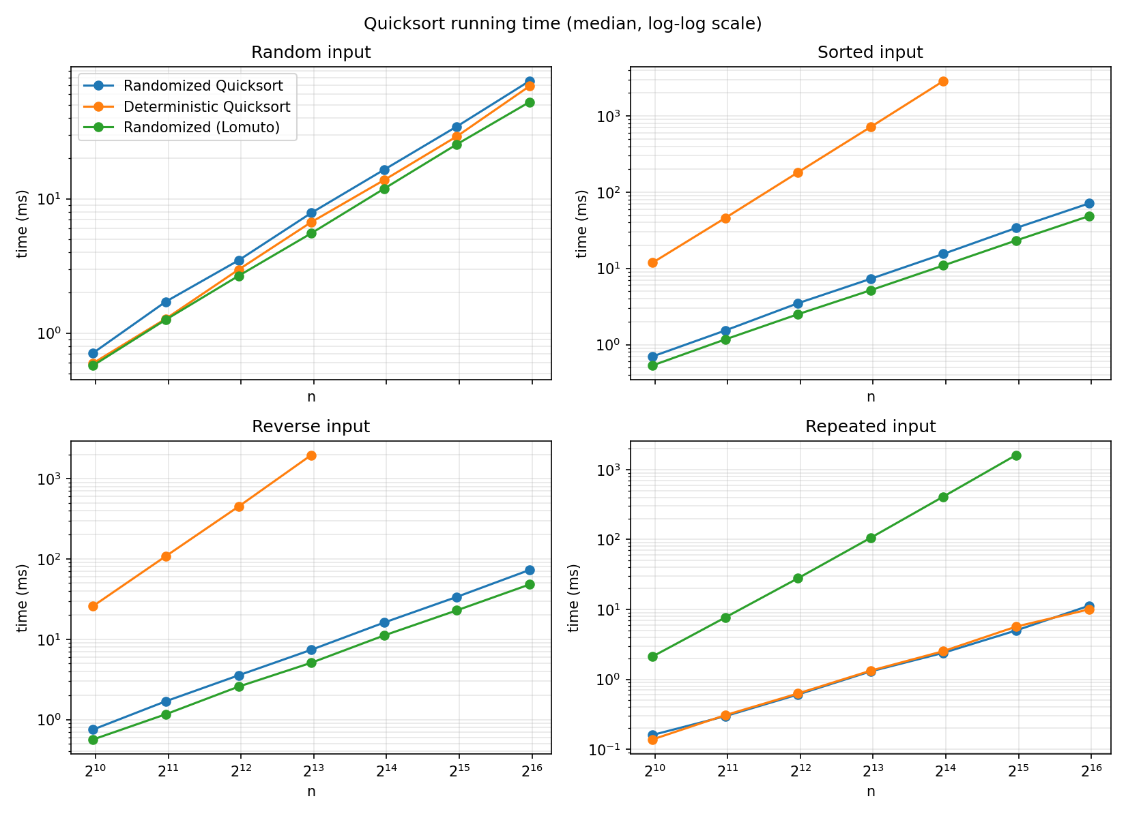

Figure 2
Pivot Comparisons Divided by n lg n
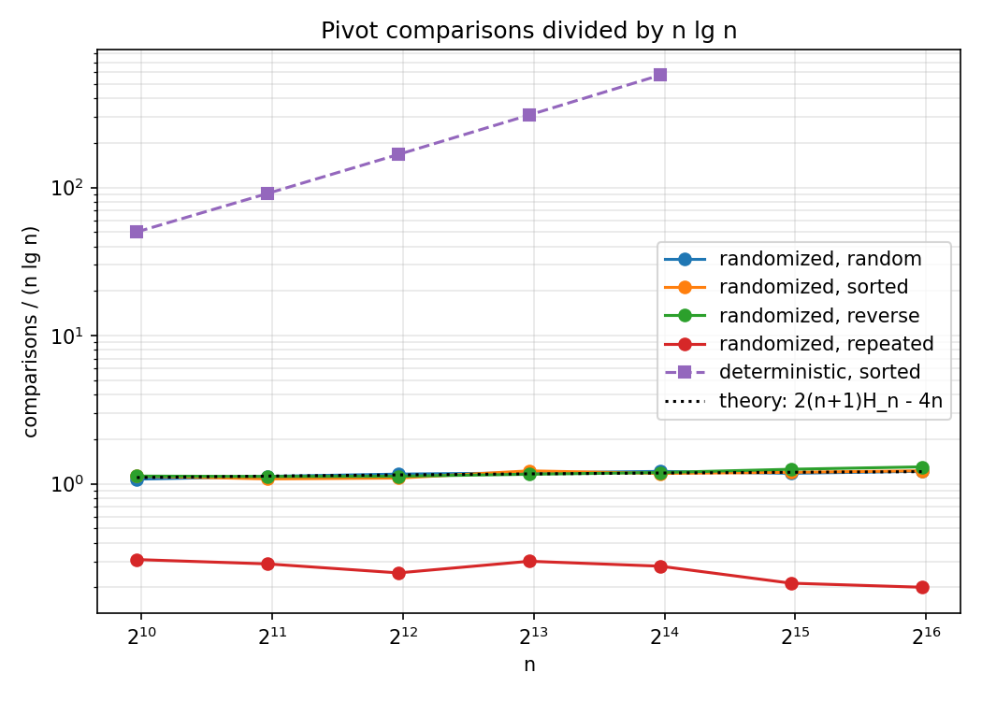

Discussion of Results
For the most part, the measurements agree with the analysis. Deterministic Quicksort was quadratic on sorted and reverse-sorted lists. Each time n doubled its time went up about four times, from 11.8 ms at n = 1,000 to 2,865.7 ms at n = 16,000, and it made exactly n(n − 1)/2 comparisons at every size (Table 2). Randomized Quicksort sorted those same lists in about the same time it needed for random data, 7.28 ms compared with 7.85 ms at n = 8,000. That is exactly what a random pivot is for: the order of the input no longer matters. On the log–log graphs, the randomized lines have a slope a little above 1, which fits n lg n, and the deterministic lines for sorted and reverse input have a slope of 2, which fits n². In Figure 2 the comparison counts for random, sorted, and reverse-sorted input all follow the 2(n + 1)Hₙ − 4n curve. At n = 64,000 the measured count was less than one percent away from the formula. When the count is divided by n lg n, the ratio grows slowly toward 2 ln 2 ≈ 1.39, just as the exact formula says it should.
Some results looked odd at first, and I want to explain them. The first is that on random input the deterministic version was a bit faster than the randomized one (6.70 ms against 7.85 ms at n = 8,000). Their comparison counts are about the same, since in a random list the first item is already a random pivot. The extra time comes from calling random.randint once for every partition, which is slow in Python compared with the rest of the loop. Big-O notation does not show constant costs like this. The second is that the deterministic version took almost three times as long on reverse-sorted input as on sorted input (1,967.2 ms against 715.0 ms), even though it made the same number of comparisons. With sorted input every item is bigger than the pivot, and my partition leaves those items alone. With reverse-sorted input every item is smaller, and each one needs a rotation with three writes. Counting comparisons treats the two cases the same, but the actual work is different. The third is that the two-way Lomuto version was the fastest of the three when the keys were all different, because its loop does less per item, but it became very slow with duplicate keys: 105.6 ms at n = 8,000 compared with 1.30 ms for the three-way version, and its growth was clearly quadratic. This does not go against the O(n lg n) result, because that proof assumes different keys. With only 10 values, each Lomuto partition puts about one tenth of the items on one side and the rest, including all copies of the pivot, on the other side. It acts like a bad fixed pivot, however the pivot is picked. The three-way partition turns duplicate input into the easiest case: both three-way sorts took about 1.30 ms, and their comparison counts grew almost linearly because the recursion cannot go more than about 10 levels deep.
Lastly, the time divided by n lg n is not completely flat and goes up a little for the biggest lists. I believe this comes from memory, not from the algorithm. Once a list is too big for the faster CPU caches, each access takes a bit longer. The comparison counts do not depend on the hardware, and they do not show this extra increase beyond what the formula predicts.

Part 2: Hashing with Chaining

Implementation
The HashTable class in hash_table.py keeps an array of m slots. Every slot has a chain, which is a Python list of [key, value] pairs for the keys that hash to that slot. The table supports insert, search, and delete. Insert adds a new pair, or changes the value if the key is already stored. Search returns the value for a key, or a default value if the key is missing. Delete removes the pair and returns its value, or raises KeyError if the key is not there. The class also works with normal dictionary syntax: table[key], key in table, and del table[key].
The hash function comes from the universal family of Carter and Wegman (1979), as described in Cormen et al. (2022, Section 11.3):
hₐ,ᵦ(k) = ((a · k + b) mod p) mod m, with p = 2⁶¹ − 1, 1 ≤ a < p, 0 ≤ b < p.
Here p is a Mersenne prime that is bigger than the integer keys I use. The values a and b are chosen at random when the table is created, and chosen again each time the table is resized. Integer keys go straight into the formula. Other keys, such as strings or tuples, are first turned into integers with Python’s hash(). What makes this family useful is that for any two different keys, the chance that they end up in the same slot is at most 1/m, taken over the random choice of a and b. This is true for any set of keys, so it does not rely on the keys themselves being random. A fixed function like k mod m cannot give that guarantee.
To keep the load factor small, the table doubles the number of slots when n would go above m (α > 1), and cuts it in half when n falls below m/4 (α < 0.25), but it never goes under 8 slots. Each resize picks a new hash function and puts every pair back in. When a pair is deleted, the last pair in the chain is moved into its place and the end of the list is removed, so the other pairs do not have to shift.

Expected Time Under Simple Uniform Hashing
Simple uniform hashing means each key is equally likely to go to any of the m slots, independently of where the other keys go. With n keys in the table, the expected length of a chain is then the load factor α = n/m (Cormen et al., 2022, Section 11.2). The cost of each operation is as follows.
Unsuccessful search. Finding the slot takes O(1) time, and then every key in that slot’s chain is checked. The chain has α keys on average, so the expected time is Θ(1 + α). The 1 stands for computing the hash and getting to the slot, which is the main cost when α is small.
Successful search. The search stops when it finds the key, so it checks that key and every key before it in the chain. Since my insert adds new pairs to the end of the chain, the keys before the i-th inserted key are the earlier keys that went to the same slot. Each of those i − 1 keys is in that slot with probability 1/m. Averaging over all n keys in the table gives
E[keys examined] = (1/n) Σᵢ₌₁ⁿ (1 + (i − 1)/m) = 1 + α/2 − α/(2n) = Θ(1 + α).
Insert. Adding a pair at the end of a list takes O(1) time. If duplicate keys were allowed, insert would always be O(1), as in Cormen et al. My insert updates the value when the key already exists, so it has to search the chain first, and its expected time is Θ(1 + α), the same as a search. Resizing adds only O(1) amortized time, which I explain below.
Delete. Delete first has to find the key, so its expected time is Θ(1 + α). After the key is found, removing it is O(1) because of the swap with the last pair. (The textbook version with a doubly linked list can delete a node in O(1) if it already has a pointer to it, but deleting by key still needs a search.)
Universal hashing gives the same bounds without any assumption about the keys. For any key k, the expected number of other keys in its slot is at most α, where the expectation is over the random hash function (Cormen et al., 2022, Section 11.3). So all operations take O(1 + α) expected time for any input.

How the Load Factor Affects Performance
The cost of every operation grows in a straight line with α. If the number of slots grows at the same rate as the number of keys, α stays constant and each operation is O(1) on average. If the table size stays fixed while more keys are added, α keeps growing with n. A table with m slots then turns into m linked lists of about n/m keys each, and a search takes Θ(n/m) = Θ(n) time. A smaller α is faster but leaves more slots empty. At α = 1 about e⁻¹ ≈ 37% of the slots are empty, and at α = 0.25 nearly 78% are. So choosing α means trading speed against memory. The average also does not tell the whole story. Even with an ideal random hash, the longest chain at α = 1 slowly gets longer as n grows, about Θ(lg n / lg lg n) (Gonnet, 1981), so a few lookups will take longer than the average.

Strategies for a Low Load Factor and Few Collisions
Dynamic resizing. The most common approach, and the one I used, is to double the number of slots when α goes past a limit and rebuild the table. One rebuild costs Θ(n), but because the size doubles, rebuilds do not happen often. Starting with 8 slots, after n inserts the rebuilds have moved at most 8 + 16 + … + n < 2n keys altogether. So n inserts cost O(n) in total, and each insert is O(1) amortized. I shrink the table when α goes under 1/4 rather than 1/2, so there is a gap between the grow and shrink limits. Without that gap, inserting and deleting back and forth right at a limit could cause a Θ(n) resize on every operation (Cormen et al., 2022, Section 16.4). The downside of resizing is that the cost comes all at once, and one insert pays for the whole rebuild. Systems that cannot accept these pauses use incremental rehashing, where the old and new tables are kept together for a while and a few chains are moved during each operation.
A good hash function. Resizing keeps chains short on average only if the keys are really spread across the slots. A fixed function like k mod m can break down with regular key patterns. For example, if m is a power of two and every key is a multiple of 64, only m/64 of the slots are ever used. Picking the function at random from a universal family means key patterns no longer matter, and picking a new one at each resize means an unlucky choice does not stay for long. If the keys can come from an attacker, such as parameters in web requests, a predictable hash lets the attacker send keys that all collide and slow down the server (Crosby & Wallach, 2003). Hash functions with a random seed protect against this, which is why Python randomizes the hashing of strings.
Other ideas. If the table has to stay a fixed size and use the division method, making m a prime number that is not close to a power of two avoids the most common patterns. Some libraries also limit the harm of a long chain by changing it into a balanced search tree once it gets too long. Java’s HashMap does this, which makes the worst-case lookup O(lg n) instead of O(n).

Empirical Results
I ran three experiments for the hash table. In the first, I used a table with a fixed m = 2,000 slots and no resizing, filled it to load factors between 0.25 and 16, and measured the time for each operation. I also calculated, from the actual chain lengths, how many keys a successful and an unsuccessful search check on average. In the second, I inserted and searched from 2¹⁰ to 2¹⁹ keys, once in a table with resizing and once in a fixed table with 1,024 slots. In the third, I compared the chain lengths at α = 1 for the universal hash and for k mod m.
Table 3
Hash Table With m = 2,000 Fixed Slots at Increasing Load Factors
α | Keys examined (hit) | 1 + α/2 − α/2n | Keys examined (miss) | Longest chain | Hit (µs) | Miss (µs) | Insert (µs) | Delete (µs)
0.25 | 1.11 | 1.12 | 0.25 | 3 | 0.208 | 0.192 | 0.365 | 0.289
0.5 | 1.25 | 1.25 | 0.50 | 5 | 0.218 | 0.204 | 0.323 | 0.292
1 | 1.48 | 1.50 | 1.00 | 7 | 0.221 | 0.212 | 0.287 | 0.299
2 | 2.00 | 2.00 | 2.00 | 9 | 0.236 | 0.239 | 0.297 | 0.312
4 | 3.01 | 3.00 | 4.00 | 12 | 0.261 | 0.287 | 0.317 | 0.344
8 | 5.03 | 5.00 | 8.00 | 21 | 0.297 | 0.355 | 0.365 | 0.360
16 | 8.99 | 9.00 | 16.00 | 30 | 0.385 | 0.510 | 0.425 | 0.395
Note. Times are per operation, median of 5 runs. The miss column of keys examined equals α exactly because it is the average chain length.

Figure 3
Time per Operation and Keys Examined per Search Versus Load Factor (m = 2,000)
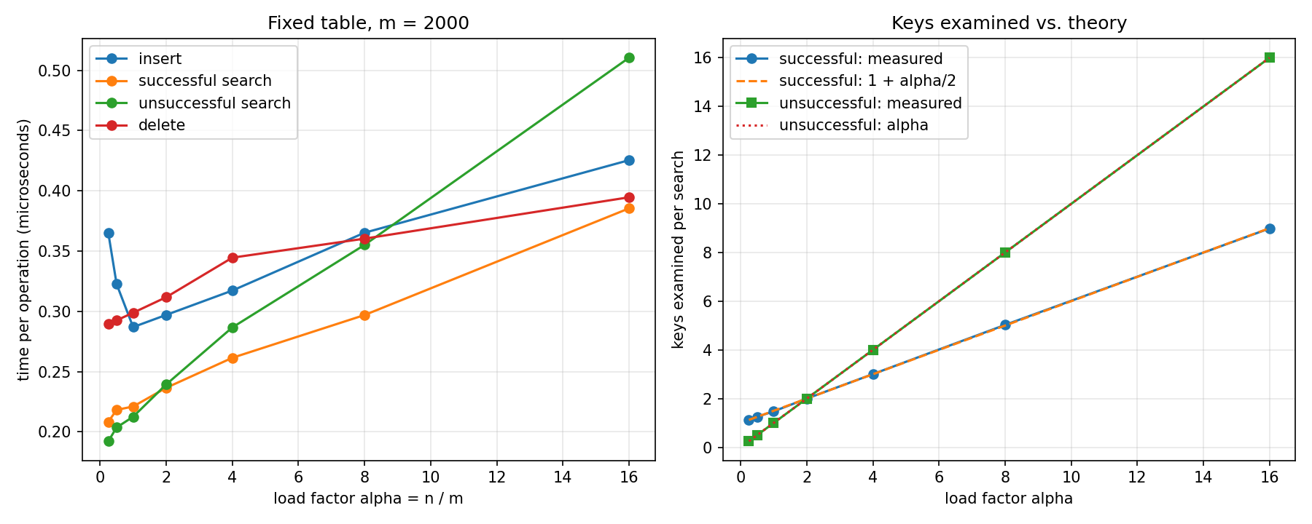

Figure 4
Time per Operation as n Grows, With Resizing and With a Fixed Table of 1,024 Slots
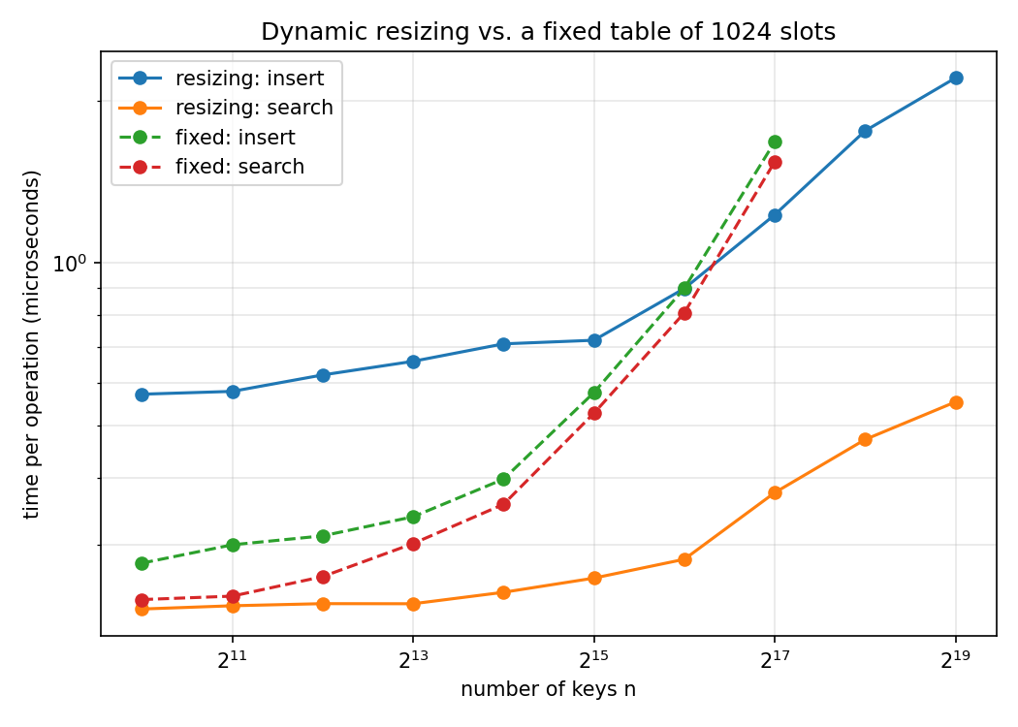

Figure 5
Chain Lengths at α = 1 Compared With a Poisson(1) Distribution
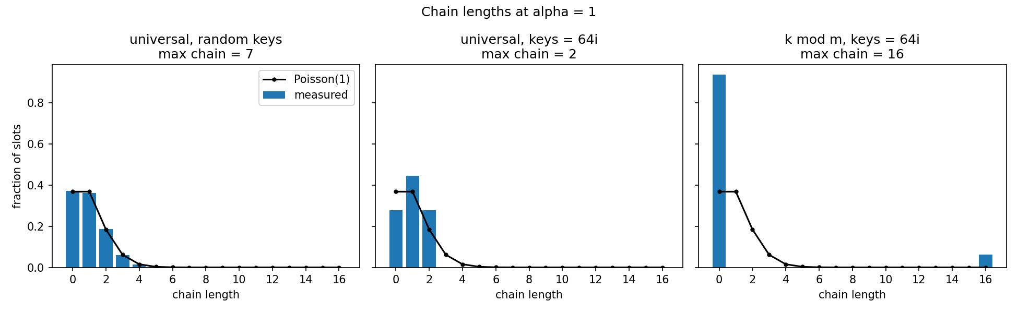

The number of keys checked per search agrees with the simple uniform hashing analysis almost perfectly (Table 3 and the right side of Figure 3). A successful search checked 1.11 keys at α = 0.25 and 8.99 keys at α = 16, while the formula predicts 1.12 and 9.00. An unsuccessful search checks exactly α keys on average. Figure 5 shows that with random keys, the fraction of slots holding 0, 1, 2, and more keys follows the Poisson(1) distribution that uniform hashing predicts. About 37% of the slots were empty, and the longest of the 10,000 chains had 7 keys.
The times also go up with α, but much more slowly than the number of keys checked. An unsuccessful search took 0.192 µs at α = 0.25 and 0.510 µs at α = 16, which is about 2.7 times slower, while the keys checked went up 64 times. This is the Θ(1 + α) bound with a large constant in front of the 1. In Python, working out the universal hash with large integers, calling the method, and finding the slot cost much more than comparing one extra key in a short list, so this fixed cost is most of the time until the chains get long. The part that grows with α is still easy to see. In the fixed 1,024-slot table in Figure 4, search time went from 0.237 µs at α = 1 to 1.542 µs at α = 128. Insert looks slower at α = 0.25 than at α = 1 only because my insert timing includes creating the 2,000 empty slots, and at α = 0.25 that cost is divided among just 500 keys.
Resizing worked as intended. With doubling, α never went above 1, and search time stayed between 0.228 and 0.552 µs while n became 512 times larger. With small n, insert with resizing took about twice as long as insert into a fixed table (0.571 against 0.277 µs). This is the amortized cost of rehashing, since on average each key gets moved about one extra time. When the fixed table became crowded, the resizing table was faster for both insert and search. The resizing curves still rise by about 2.4 times over the whole range, but this is a memory effect and not a failure of the O(1) bound. Half a million keys stored in half a million separate Python lists do not fit in the CPU caches, so almost every lookup has to read from main memory.
The chain-length experiment shows why the choice of hash function matters. When every key was a multiple of 64 and m = 10,000, k mod m put keys in only 625 slots (because gcd(64, 10,000) = 16). That left 94% of the table empty and gave every used slot a chain of 16 keys, so a successful search checked 8.5 keys on average instead of 1.5. The universal hash spread the same keys out evenly. It actually spread them more evenly than random keys, and the longest chain had only 2 keys. The reason is that a linear function turns evenly spaced keys into evenly spaced values modulo p, and those fall into the slots more regularly than random keys do. This is still within what the universal guarantee allows, just on the good side of it.

Conclusion
Both parts of this assignment showed the same idea. A randomized algorithm has an expected bound that is true for every input, and my experiments supported this. Randomized Quicksort made very close to 2(n + 1)Hₙ − 4n comparisons on random, sorted, and reverse-sorted input. With the first item as the pivot, Quicksort made n(n − 1)/2 comparisons on sorted input and needed seconds where the randomized version needed milliseconds. The hash table with a universal hash checked very close to 1 + α/2 keys per successful search, and doubling the table kept α near 1 so that operations stayed O(1). The experiments also showed where the models stop. Counting comparisons ignores the cost of moving data and of calling a random number generator. The O(1) bound for hash tables ignores cache misses. And the Quicksort proof only covers duplicate keys if the partition is designed for them. In my own work, I would use Randomized Quicksort with a three-way partition when I do not know the order of the input, and a chained hash table with a randomly chosen hash function and doubling when I need fast lookups by key.

References
Bentley, J. L., & McIlroy, M. D. (1993). Engineering a sort function. Software: Practice and Experience, 23(11), 1249–1265. https://doi.org/10.1002/spe.4380231105
Carter, J. L., & Wegman, M. N. (1979). Universal classes of hash functions. Journal of Computer and System Sciences, 18(2), 143–154. https://doi.org/10.1016/0022-0000(79)90044-8
Cormen, T. H., Leiserson, C. E., Rivest, R. L., & Stein, C. (2022). Introduction to algorithms (4th ed.). MIT Press.
Crosby, S. A., & Wallach, D. S. (2003). Denial of service via algorithmic complexity attacks. In Proceedings of the 12th USENIX Security Symposium (pp. 29–44). USENIX Association.
Dijkstra, E. W. (1976). A discipline of programming. Prentice-Hall.
Gonnet, G. H. (1981). Expected length of the longest probe sequence in hash code searching. Journal of the ACM, 28(2), 289–304. https://doi.org/10.1145/322248.322254
Hoare, C. A. R. (1962). Quicksort. The Computer Journal, 5(1), 10–16. https://doi.org/10.1093/comjnl/5.1.10
Knuth, D. E. (1998). The art of computer programming: Vol. 3. Sorting and searching (2nd ed.). Addison-Wesley.
Motwani, R., & Raghavan, P. (1995). Randomized algorithms. Cambridge University Press.

