Cardiff Metropolitan University
School of Technologies
CIS6008 Analytics and Business Intelligence | WRIT1
Task d: Business Intelligence Dashboard for Flight Operations Monitoring at Bandaranaike International Airport (CMB)
Excellent band (70-100) | 20 marks | Power BI Desktop | 2026 Semester 2

4. Task d: Power BI Dashboard for BIA/CMB Flight Operations

4.1 Introduction and brief requirements
Bandaranaike International Airport (CMB) is Sri Lanka's main international gateway and requires integrated visibility of flight status, delays, passenger load, weather, and surface indicators. Task d implements a Microsoft Power BI Desktop dashboard on the lecturer dataset BIA_CMB_Dataset.csv so airport managers and air traffic controllers can monitor operations, analyse delays, track international traffic by country, and identify risks or bottlenecks (Cardiff Metropolitan University, 2026). Excellent-band marking requires a complete dashboard with standard elements, suitable screenshots, critical discussion, and Harvard referencing (Cardiff Metropolitan University, 2026).

4.2 Data preparation and semantic model
The master file was kept read-only. A cleaned working copy retained 40 flights and 28 source columns with unique Flight_ID values and no empty cells. Power Query typed delay, passenger, load factor, taxi, turnaround, queue, and weather metrics so DAX aggregations run on numeric fields. Destination for mapping was created as a DAX calculated column, not a static CSV field:
Destination Country = RIGHT('BIA_CMB'[Route], LEN('BIA_CMB'[Route]) - FIND("-", 'BIA_CMB'[Route], 1))
This yields seven destinations in the sample (Singapore, Bangkok, Dubai, Doha, Male, London, Chennai). Measures were defined in the semantic model and verified by live DAX queries against Power BI Desktop: Total Flights 40; Arrivals/Departures 18/22; Delayed/On-Time 9/6; Critical/Warning alerts 13/11; Passengers 8,974; Average load factor 82.2%; Average delay 31.4 minutes.

4.3 Dashboard structure
The solution uses three pages aligned to decision roles. Page 1 (Executive Overview) is a single-screen snapshot for duty managers. Page 2 (Delay Analysis) supports operations control. Page 3 (International Traffic) supports commercial and surface-movement views. Standard elements include KPI cards, donut and column charts, map, scatter plots, detail table, and slicers for Airline, Weather_Condition, and Alert_Status (Microsoft, 2024).

4.4 Page 1: Executive Overview
Figure 4.1 shows eight KPI cards and supporting charts. Values match live DAX results above. The status donut shows composition across Arrived, Boarding, Delayed, Departed, and On Time. Arrival versus departure columns confirm a departure-heavy window (22 vs 18). Alert and runway charts highlight concentration of critical alerts and runway use. Critically, critical alerts (13; 32.5%) exceed delayed flights (9; 22.5%), so severity should be briefed alongside classical on-time metrics.
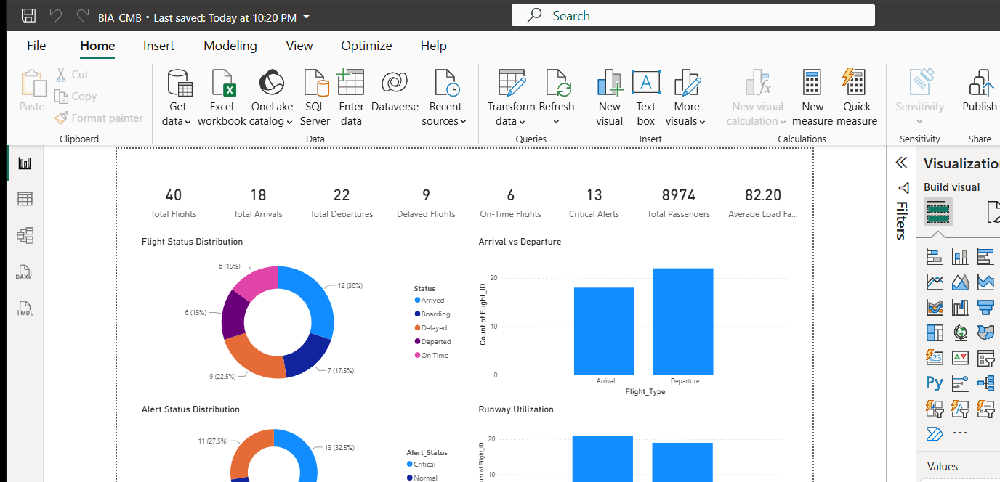
Figure 4.1 Executive Overview page with validated KPI cards (Power BI Desktop).

4.5 Page 2: Delay Analysis
Figure 4.2 focuses on delay magnitude and drivers. Average delay is 31.4 minutes with 9 delayed flights and 11 warning alerts. Ranked flight and airline bars identify outliers; the issue-type pie separates congestion, delay, and none; weather columns and the wind-speed versus delay scatter relate conditions to delay and passenger exposure. In hub operations a few extreme events can dominate averages, so ranked views are more actionable than means alone (IATA, 2024).
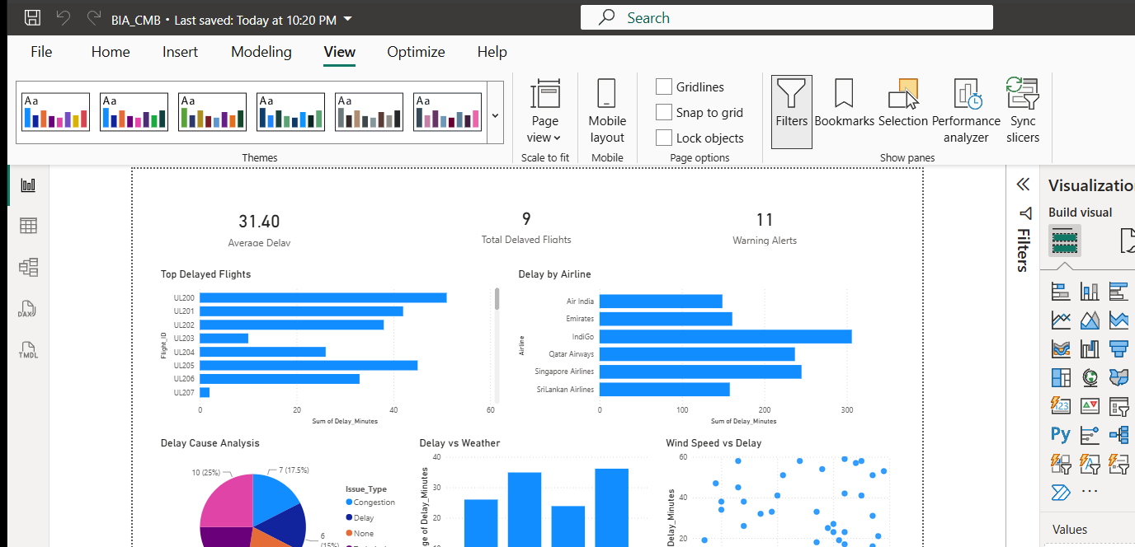
Figure 4.2 Delay Analysis page: KPIs, ranked delays, airline comparison, cause and weather views.

4.6 Page 3: International Traffic and filters
Figure 4.3 maps Destination Country by flight count and ranks passenger volume. Validated passenger totals are Singapore 2,042 (9 flights), Bangkok 1,764 (8), Doha 1,461 (6), Dubai 1,295 (7), then Male, London, and Chennai. SMR location and queue-versus-taxi visuals support surface bottleneck checks; a detail table enables drill-through. Figure 4.4 shows Weather_Condition = Clear. Live filter validation returns 9 flights and 2,236 passengers (Storm 14/3,044; Fog 10/2,169; Rain 7/1,525), proving interactive model-driven filtering rather than static images.
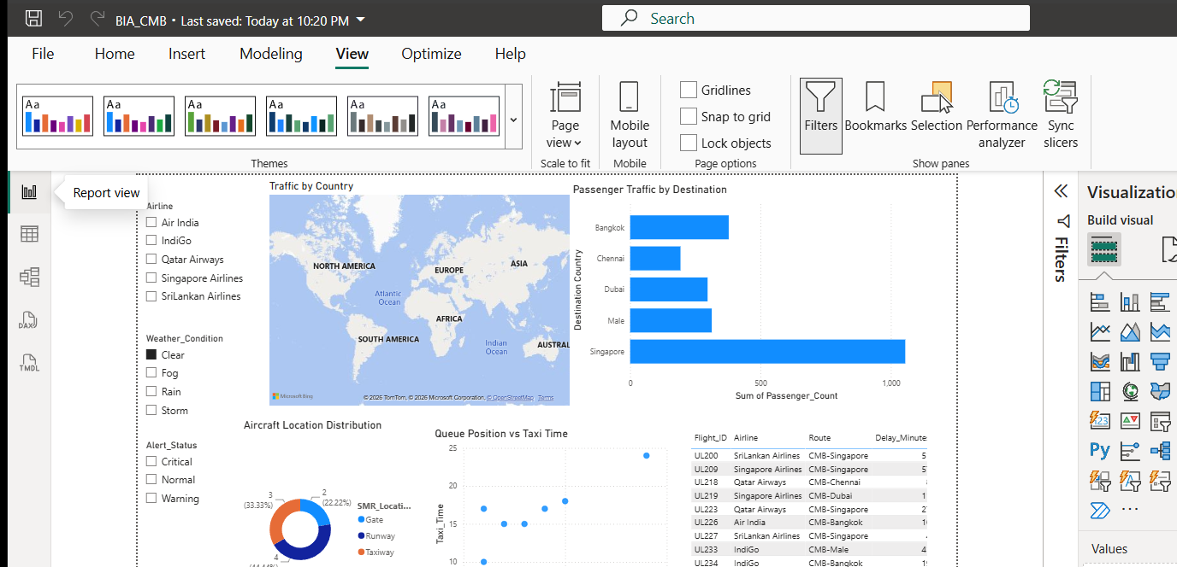
Figure 4.3 International Traffic page: map, passenger ranking, SMR, queue scatter, and slicers.

Figure 4.4 International Traffic with Weather_Condition = Clear (9 flights; 2,236 passengers).

4.7 Implementation evidence
Figure 4.5 shows Table view of imported BIA_CMB rows (Flight_ID, Airline, Route, schedule, gate, terminal, runway, status, delay), confirming visuals bind to cleaned data. Deliverables include a Power BI Project (PBIP) with TMDL model and report definition, a saved .pbix package, cleaned CSV, DAX specification, and screenshot appendix evidence.
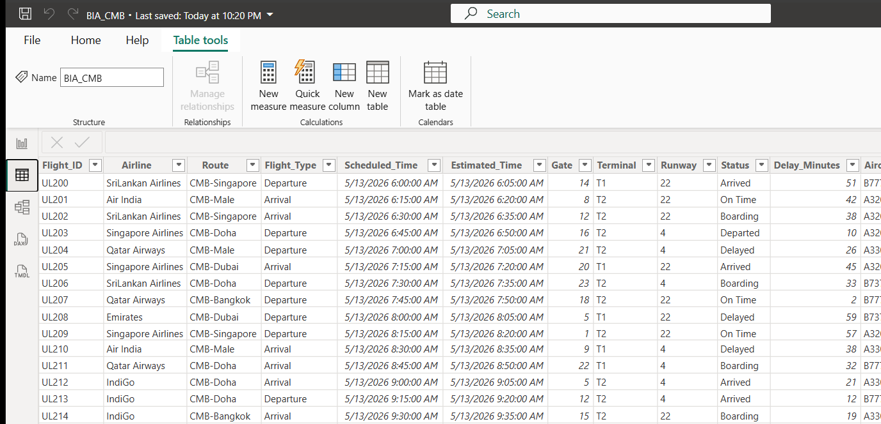
Figure 4.5 Table view of cleaned BIA_CMB data in the Power BI semantic model.
Table 4.1 Validated headline KPIs (live DAX)
Measure | Result
Total Flights | 40
Arrivals / Departures | 18 / 22
Delayed / On-Time | 9 / 6
Critical / Warning alerts | 13 / 11
Total Passengers | 8,974
Average Load Factor (%) | 82.2
Average Delay (minutes) | 31.4

Table 4.2 Destination Country passenger ranking
Destination | Flights | Passengers
Singapore | 9 | 2,042
Bangkok | 8 | 1,764
Doha | 6 | 1,461
Dubai | 7 | 1,295
Male | 4 | 1,056
London | 3 | 743
Chennai | 3 | 613

4.8 Critical discussion, limitations, and recommendations
The dashboard meets the brief: operations monitoring, delay analysis, country traffic, and alert-oriented risk views (Cardiff Metropolitan University, 2026). Three implications stand out. First, alert severity should lead briefings because critical alerts outnumber delayed statuses. Second, Singapore and Bangkok concentrate passenger volume, so peak staffing and gate plans should weight those corridors (Sri Lanka Tourism Development Authority, 2024). Third, queue and taxi visuals link airborne delay narratives to apron congestion and support coordination between ATC, AASL, and ground handlers (ICAO, 2022).
Limitations bound the claims. The sample has 40 flights and supports dashboard design assessment, not annual population inference. Weather-delay patterns need larger multi-day extracts before forecasting. Country geocoding depends on Power BI location services and would benefit from an airport dimension in production. "Interactive" here means model refresh and slicers, not a live AODB feed. These limits do not remove the value of a governed semantic model with shared KPI definitions (Microsoft, 2024).
• Operations: open with critical-alert and delayed cards; drill to Page 2 for flight and airline owners.
• Commercial: prioritise Singapore/Bangkok on Page 3 for peak passenger throughput.
• Weather playbooks: keep Clear/Storm/Rain/Fog slicer views in controller handovers.
• Governance: retain PBIP source control and documented DAX definitions for measure consistency.

4.9 Conclusion
Task d delivered a three-page Power BI dashboard with a typed semantic model, validated measures, a destination calculated column, interactive slicers, and map-enabled international traffic analysis. Live DAX confirms 40 flights, 8,974 passengers, 31.4 minutes average delay, and 13 critical alerts. Screenshots document Executive Overview, Delay Analysis, International Traffic, weather filtering, and table-level data integrity. Within coursework sample limits, the solution converts CMB operational data into decision-ready intelligence and satisfies excellent-band expectations for a complete dashboard, standard elements, evidenced screenshots, critical discussion, and Harvard referencing.

References
Cardiff Metropolitan University (2026) CIS6008 Analytics and Business Intelligence: WRIT1 Assessment Brief. Cardiff: School of Technologies.
IATA (2024) World Air Transport Statistics and operational performance guidance. Montreal: International Air Transport Association.
ICAO (2022) Manual on collaborative air traffic flow management and airport operations. Montreal: International Civil Aviation Organization.
Microsoft (2024) Power BI guidance: semantic models, DAX, and report design. Available at: https://learn.microsoft.com/power-bi (Accessed: 12 August 2026).
Sri Lanka Tourism Development Authority (2024) Tourism arrival trends and aviation connectivity notes. Colombo: SLTDA.

Appendix D: Task d evidence checklist
• PBIP: 07_Task_D_PowerBI_SKIPPED/pbip/BIA_CMB.pbip
• PBIX: Desktop copy BIA_CMB.pbix
• Cleaned CSV: 07_Task_D_PowerBI_SKIPPED/cleaned_data/BIA_CMB_clean.csv
• DAX spec: 07_Task_D_PowerBI_SKIPPED/dax_spec/DAX_measures.md
• DAX validation: 07_Task_D_PowerBI_SKIPPED/outputs/DAX_validation.md
• Screenshots: 07_Task_D_PowerBI_SKIPPED/screenshots/
• Master dataset untouched: 03_Original_Datasets/Task_D/BIA_CMB_Dataset.csv

