The dataset contains operational, traffic, radar, weather, delay, and alert information suitable for air traffic management.

Open Power BI Desktop
After installing Power BI Desktop:
- Open Power BI Desktop.
- Click Get Data.
- Choose Text/CSV.
- Select BIA_CMB_Dataset.csv.
- Click Load.

- Dashboard Objective
airport managers and air traffic controllers to

monitor flight operations,
analyze delays,
track international traffic by country,
identify potential risks or bottlenecks

Sample Dash board overview
2. Dashboard Pages
Page 1: Executive Overview-Airport Managers KPI Cards
Eg: Create KPI cards for
KPI | Calculation | Sample code
Total Flights | Count(Flight_ID) | Total Flights =  COUNT('BIA_CMB_Dataset'[Flight_ID])
Total Arrivals | Count where Flight_Type = Arrival | Total Arrivals =  CALCULATE(  COUNT('BIA_CMB_Dataset'[Flight_ID]),  'BIA_CMB_Dataset'[Flight_Type]="Arrival"  )
Total Departures | Count where Flight_Type = Departure | Total Departures =  CALCULATE(  COUNT('BIA_CMB_Dataset'[Flight_ID]),  'BIA_CMB_Dataset'[Flight_Type] = "Departure"  )
Delayed Flights | Status = Delayed | Delayed Flights =  CALCULATE(  COUNT('BIA_CMB_Dataset'[Flight_ID]),  'BIA_CMB_Dataset'[Status] = "Delayed"  )
On-Time Flights | Status = On Time | On-Time Flights =  CALCULATE(  COUNT('BIA_CMB_Dataset'[Flight_ID]),  'BIA_CMB_Dataset'[Status] = "On Time"  )
Critical Alerts | Alert_Status = Critical | Critical Alerts =  CALCULATE(  COUNT('BIA_CMB_Dataset'[Flight_ID]),  'BIA_CMB_Dataset'[Alert_Status] = "Critical"  )
Total Passengers | Sum(Passenger_Count) | Total Passengers =  SUM('BIA_CMB_Dataset'[Passenger_Count])
Average Load Factor | Average(Load_Factor_%) | Average Load Factor =  AVERAGE('BIA_CMB_Dataset'[Load_Factor_%])

Add KPI Cards
- In the Visualizations pane select Card.-123 icon
- Drag the measure Total Flights into the card.
- Resize and place it.
Eg:
Modeling → New Measure
A formula bar appears near the top.

Replace the above with:
Total Flights =
COUNT('BIA_CMB_Dataset'[Flight_ID])
A new field called Total Flights appears in the Fields pane.

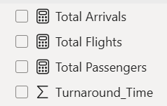
Total Passengers =
SUM('BIA_CMB_Dataset'[Passenger_Count])

Where do I see the output?
Add KPI Cards
- In the Visualizations pane select Card.-123 icon
- Drag the measure Total Flights into the card.
- Resize and place it.

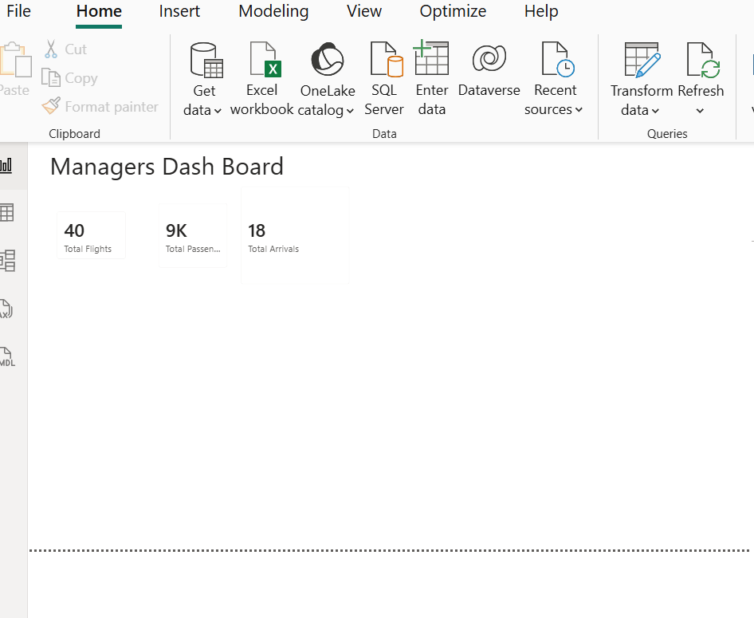

-Create All KPI Cards

Flight Status Distribution
Visual:
- Donut Chart
Field:
- Status
Values:
- Count of Flight_ID
Possible statuses available in dataset:
- Arrived
- Departed
- Delayed
- Boarding
- On Time

Create Flight Status Distribution Donut Chart
Insert Visual
- Select Donut Chart.
Configure Fields

Legend
Status
Values
Flight_ID
Set aggregation:

In the Visualizations pane:
- Look for the Donut Chart icon.
- Click it once.
A blank donut chart will appear on the report canvas.
Drag Status field into the chart's Legend field.
This tells Power BI to create one slice for each status:
- Arrived
- Departed
- Delayed
- Boarding
- On Time
Drag Status field into the chart's Legend field and Drag Flight_ID into values.
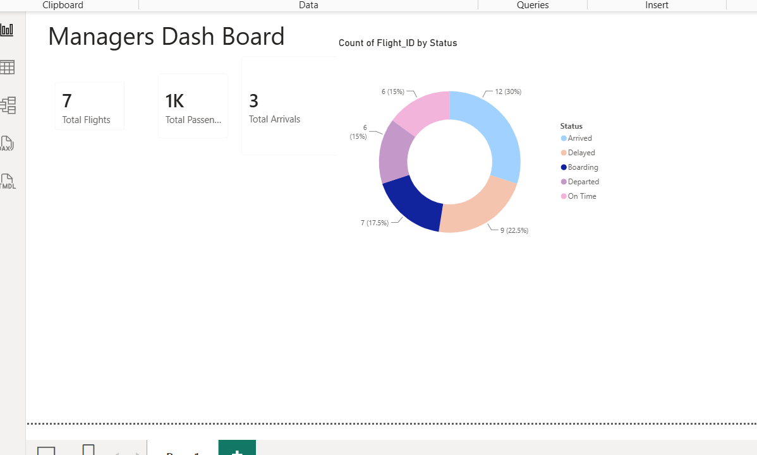

Create Arrival vs Departure Chart
Visual: Clustered Column Chart
Axis: Flight_Type
Value: Count(Flight_ID)

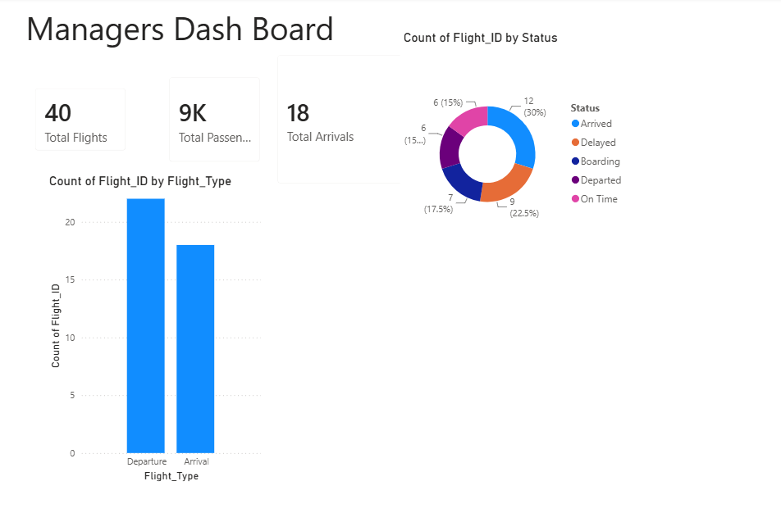

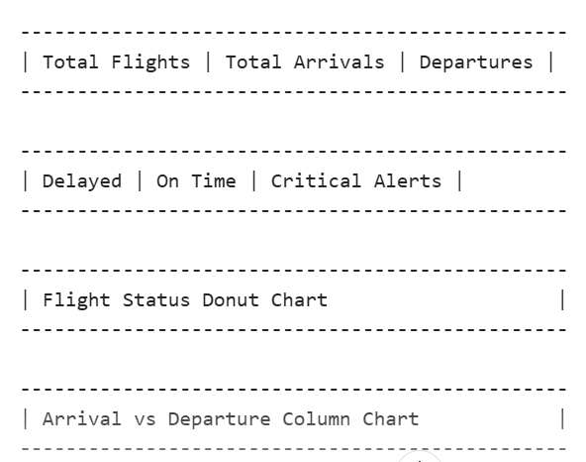

Page 2: Delay Analysis Dashboard
Help airport managers identify:
- Which flights are delayed most
- Which airlines cause most delays
- Main reasons for delays
- Overall delay performance

Dataset fields;
- Delay_Minutes
- Airline
- Flight_ID
- Issue_Type
- Status

Visual 1: Average Delay KPI Card
Create Measure
Average Delay =
AVERAGE('BIA_CMB_Dataset'[Delay_Minutes])

Visual 2: Total Delayed Flights KPI
Total Delayed Flights =
CALCULATE(
COUNT('BIA_CMB_Dataset'[Flight_ID]),
'BIA_CMB_Dataset'[Status] = "Delayed"
)

Visual 3: Top Delayed Flights
Insert Bar Chart
- Click Clustered Bar Chart
Y-Axis; Flight_ID
X-Axis; Delay_Minutes

Aggregation: Sum

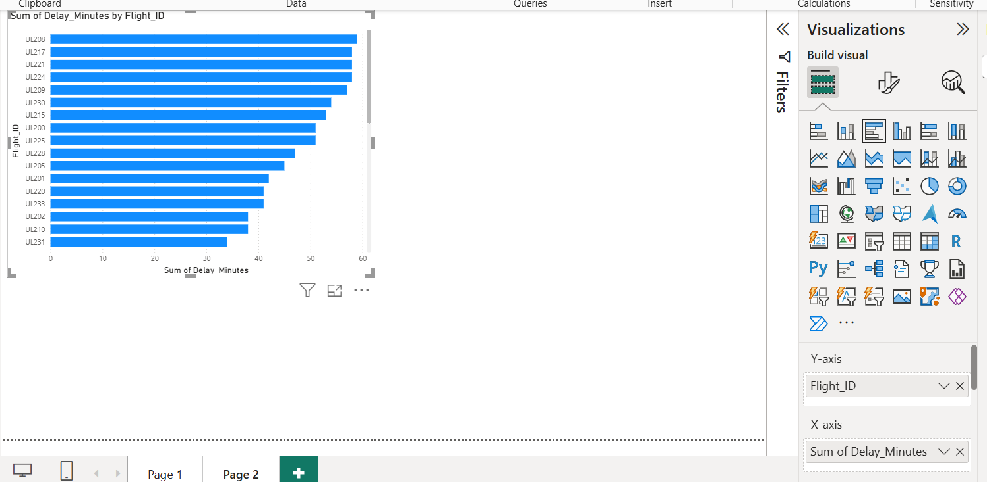
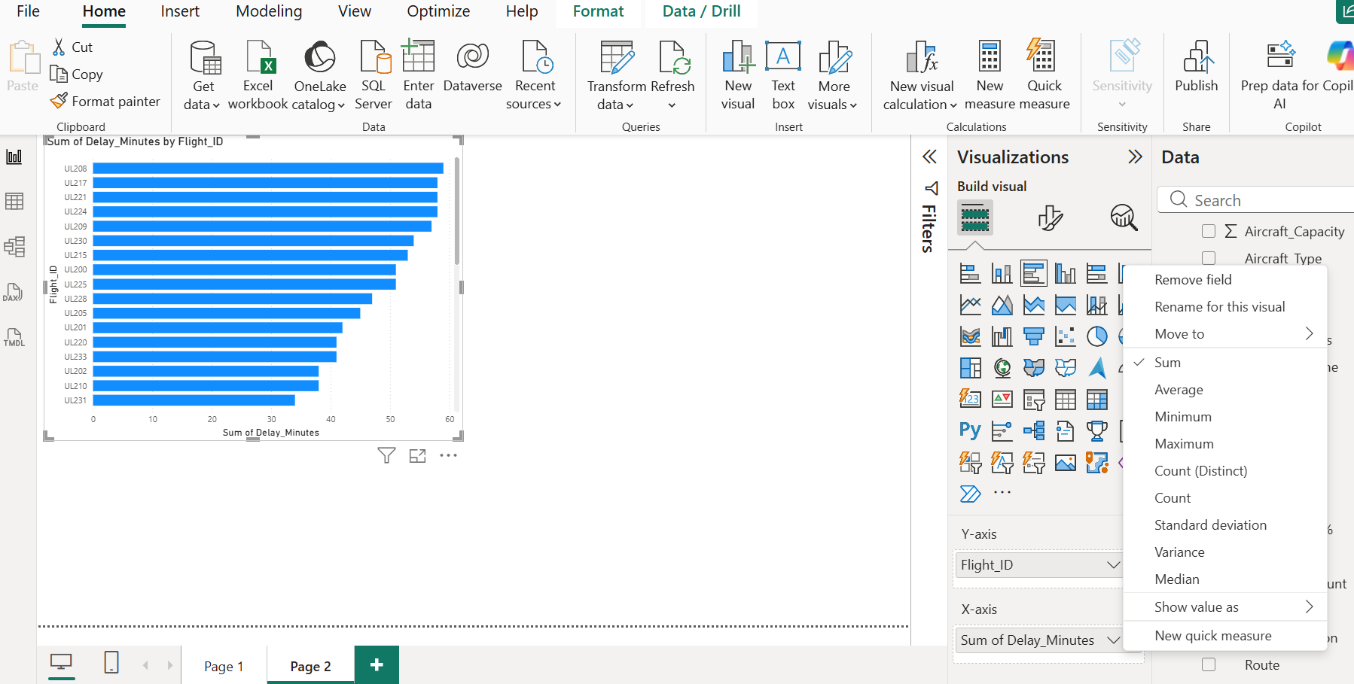

Sort by Delay
Move your mouse to the top-right corner of the chart click on …
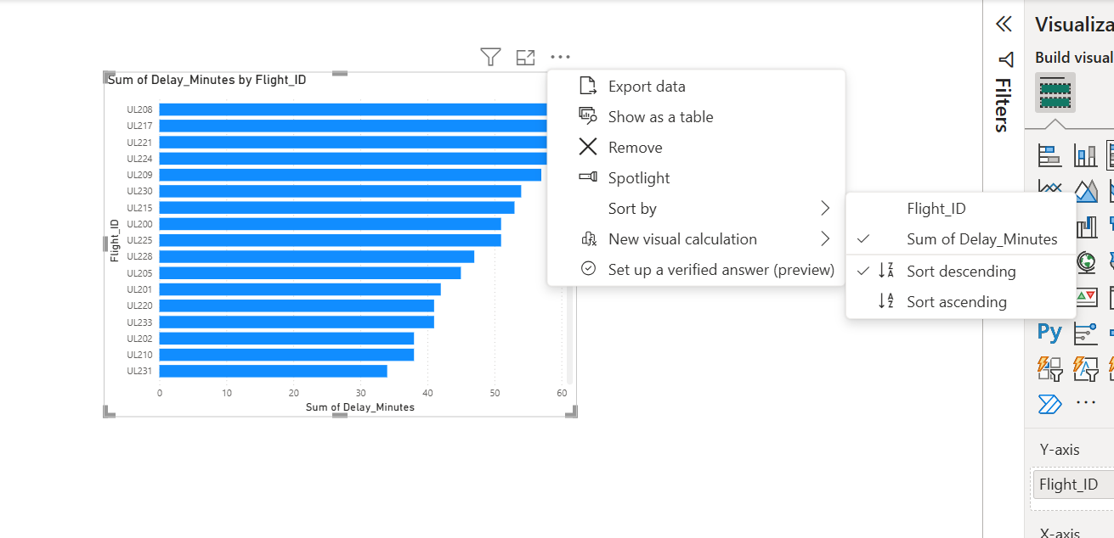
Click on chart and get format visual to do formatting on the visual -paint brush icon
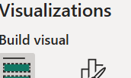

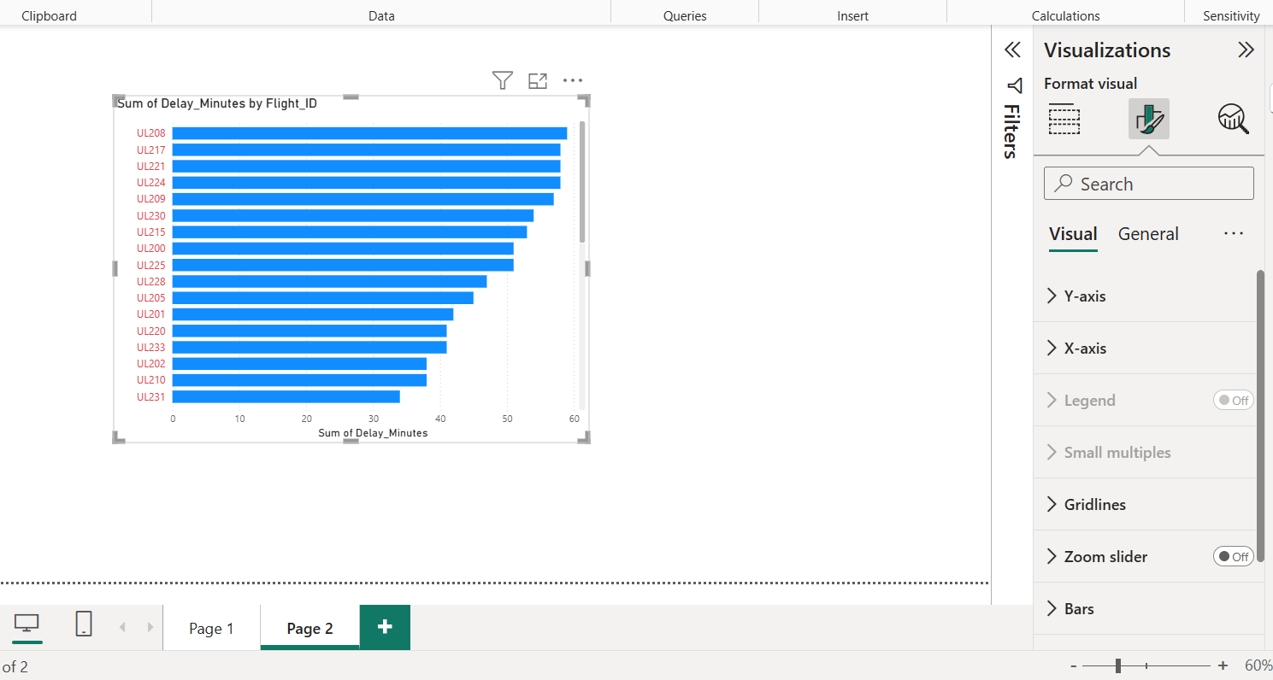

Average Delay

Delay by Airline
Delay Cause Analysis
Visual:Pie Chart
Legend:Issue_Type
Values:Count of flights
Categories:
- Weather
- Technical
- Congestion
- Delay
- None

Page 3: International Traffic Analysis
Extract Country
From Route column:
Examples:
CMB-Singapore
CMB-Dubai
CMB-Doha
CMB-London
CMB-Bangkok
CMB-Male

Traffic by Country
Visual: Map
Location:
- Destination Country
Values:
- Number of Flights

For Traffic by Country, your dataset does not have a separate "Country" column. You need to create one from the Route field.
Step 1: Create Destination Country Column
Modeling → New Column
Destination Country =
RIGHT(
'BIA_CMB_Dataset'[Route],
LEN('BIA_CMB_Dataset'[Route]) -
FIND("-", 'BIA_CMB_Dataset'[Route],1)
)
New column will contain values like Singapore, Dubai, Doha, London, Bangkok, Male, and Chennai
Step 2: Create Number of Flights Measure
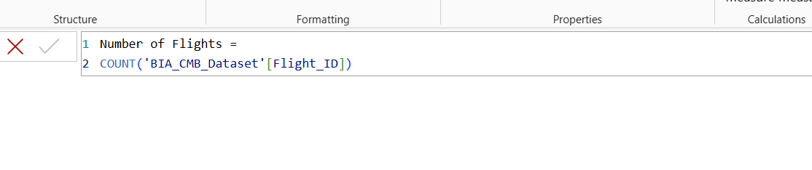
Step 3: Insert a Map Visual
- Go to a new report page.
- Click an empty area.
- In Visualizations, select Map (globe icon).
Step 4: Add Country Locations
Drag Destination country field into locations.
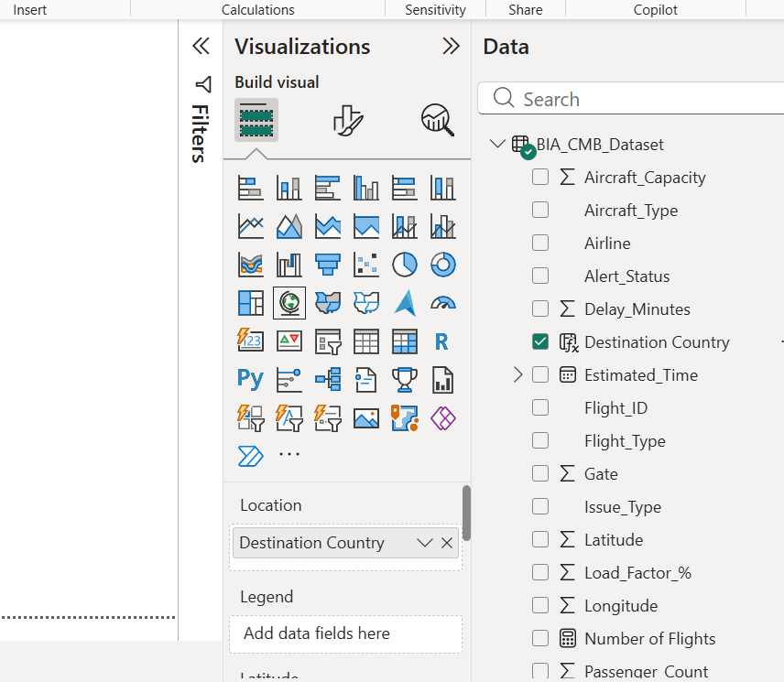

Power BI will place markers on countries/cities.
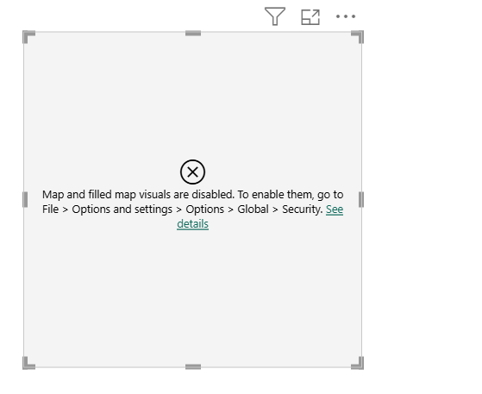
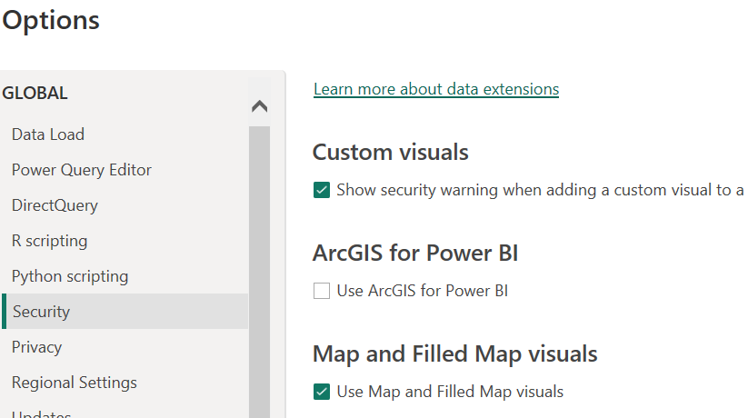

Step 5: Add Flight Counts
Drag no of flights into size/bubble size
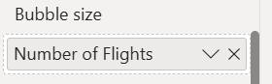

Step 6: Set Data Category (Important)

Passenger Traffic by Country
Visual: Bar Chart
Axis: Destination
Values: Sum(Passenger_Count)
Longitude: Longitude
Size: Passenger_Count
Fields available:
- Latitude
- Longitude

Aircraft Location Distribution
Visual: Donut Chart
Field: SMR_Location
Locations:
- Gate
- Runway
- Taxiway

Runway Utilization
Visual: Column Chart
Axis: Runway
Values: Count Flights
Available runways:
- Runway 22
- Runway 04

Queue Position Monitoring
Visual: Scatter Plot
X Axis: Queue_Position
Y Axis: Taxi_Time
Bubble Size: Passenger_Count
Values: Count
Categories:
- Normal
- Warning
- Critical

Critical Flights Table
Filter: Alert_Status = Critical
Show:
- Flight_ID
- Airline
- Route
- Delay_Minutes
- Issue_Type
- Weather_Condition

Alert Cause Analysis
Visual: Stacked Bar
Axis: Issue_Type
Legend: Alert_Status
Values: Count
Conditions:
- Rain
- Fog
- Storm
- Clear

Delay vs Weather
Visual: Column Chart
Axis: Weather_Condition
Value: Average Delay_Minutes

Wind Speed Analysis
Visual: Scatter Plot
X: Wind_Speed_kmh
Y: Delay_Minutes
Size: passenger_Count

OR
Delay_Minutes > 45

Yellow Alert
Alert_Status = Warning
OR
Delay_Minutes between 20 and 45

Green Alert
Alert_Status = Normal

Suggested Dashboard Filters (Slicers)
Add slicers for:
- Airline
- Flight Type
- Destination Country
- Weather Condition
- Status
- Alert Status
- Runway
- Terminal
- Aircraft Type

Expected Insights
The dashboard should answer:
- Which airline experiences the highest delays?
- Which destinations generate the highest traffic?
- Which weather conditions contribute most to delays?
- How many critical alerts require immediate attention?
- Which runway is most utilized?
- Where are aircraft concentrated (gate, taxiway, runway)?
- Which countries generate the largest passenger traffic?
- What operational bottlenecks exist in taxiing, turnaround, and queue management?
Your structure must address flight operations monitoring, delay analysis, country-based traffic analysis, radar-based visualization, bottleneck detection, and critical-event alerting using the provided dataset.

