Main Agile Methodologies:

1. Scrum

Scrum is, undoubtedly, the most used of the many frameworks underpinning Agile methodology. **Scrum is characterised by cycles or stages of development, known as sprints**, and by the maximisation of development time for a software product towards a goal, the Product Goal. This Product Goal is a larger value objective, in which sprints bring the scrum team product a step closer.

It is usually used in the management of the development of software products but can be used successfully in a business-related context.

Every day starts with a small 15-minute meeting, the **daily Scrum**, which takes the role of synchronising activities and finding the best way to plan out the working day, allowing for a check on sprint “health” and product progress.

Advantages:

* Team motivation is good because programmers want to meet the deadline for every sprint;
* Transparency allows the project to be followed by all the members in a team or even throughout the organisation;
* A simple “definition of done” is used for validating requirements
* Focus on quality is a constant with the scrum method, resulting in fewer mistakes;
* The dynamics of this method allow developers to reorganise priorities, ensuring that sprints that have not yet been completed get more attention;
* Good sprint planning is prioritised, so that the whole scrum team understands the “why, what and how” of allocated tasks.

Disadvantages:

* The segmentation of the project and the search for the agility of development can sometimes lead the team to lose track of the project as a whole, focusing on a single part;
* Every developer role may not be well defined, resulting in some confusion amongst team members.

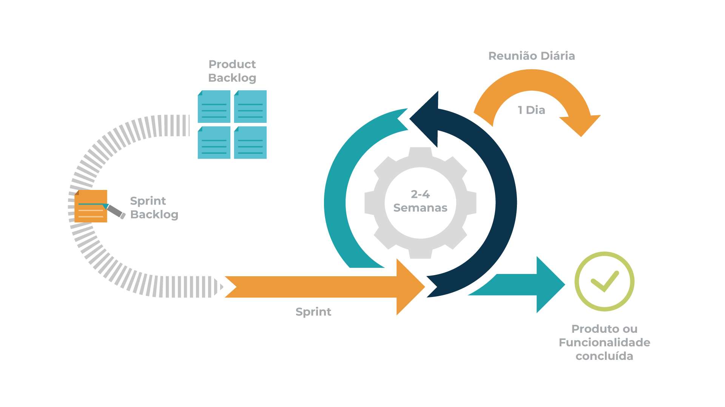

1. Kanban

The word **Kanban** is of Japanese origin and its meaning is linked to the concept of “just in time”. In practice, the Kanban method is organised on a board or table (Kanban board), divided into columns, showing every flow within the software production project. As the development evolves, the information contained in the table changes, and whenever a new task comes into play, a new “card” is created.

This methodology is also useful in individual business departments, such as HR, marketing, etc., bringing the desired visibility over all the team’s tasks.

The Kanban method **requires communication and transparency** so that the members of any team all know exactly what stage development is at and can see the status of a project at any time. It primarily focused on team capacity and is best for processes that undergo small changes.

A Kanban card **represents an individual work item, which allows teams to view important work information**. A Kanban card is a sticky note on that board. Each Kanban card, or sticky note, represents one work item.

Advantages:

* Ability to view all the tasks under a single project (by Completed, In Progress or In testing, for example) using the simple concept of “Cards”;
* You can limit the number of running tasks (that is, the amount of work, bearing its resolution or deliverability in mind);
* Focuses on the duration of a cycle – how long it takes a task to go from backlog to final stage;
* Allows continuous deliveries;
* Probably one of the simplest methodologies to implement outside the “IT world”.

Disadvantages:

* It’s possible for team members to misinterpret the information shown on the Kanban Board, especially when it is shown as outdated;
* Since there are no timeframes in Kanban, you can face time-related problems, such as delays, at each and every stage.

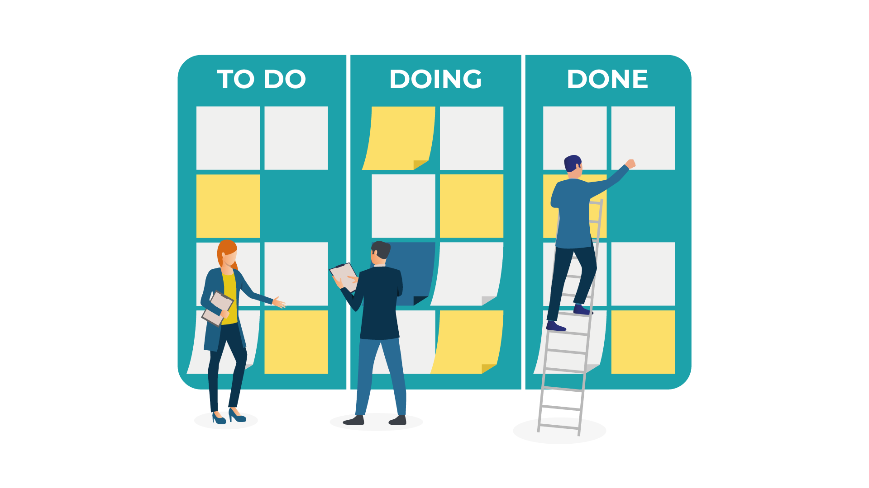

Kanban boards use Card, Column, Swimlanes, and WIP Limits to enable teams to visualize and manage their workflows effectively. Let us introduce you to the main components more closely: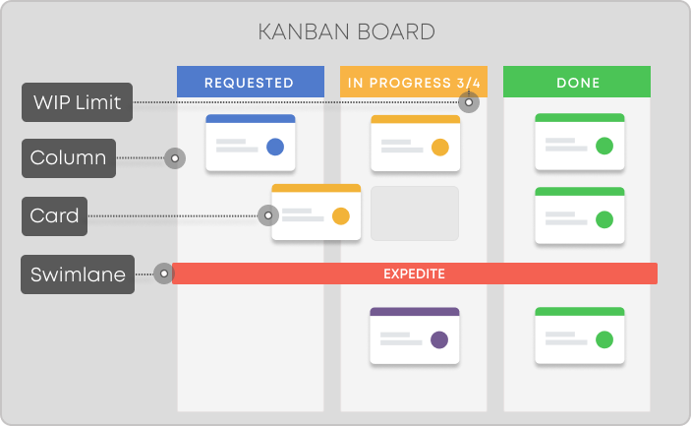

*Kanban board components*

**Kanban Cards** – This is the visual representation of tasks. Each card contains information about the task and its status, such as deadline, assignee, description, etc.

**Kanban Columns** – Each column on the board represents a different stage of your workflow. The cards go through the workflow until their full completion.

**Work-in-Progress Limits** – They restrict the maximum amount of tasks in the different stages of the workflow. Limiting WIP allows you to finish work items faster by helping your team focus only on current tasks.

**Kanban Swimlanes** – These are horizontal lanes you can use to separate different activities, teams, classes of service, and more.

**Commitment Point** – A commitment marks a point in the work process where a work item is ready to be pulled into the system.

**Delivery Point** – The point in the workflow where work items are considered finished.

1. Extreme Programming (XP)

This is a typical Agile development framework, developed by Kent Beck, and can be adapted to development companies of various dimensions.

**Extreme Programming (“XP”)** methodology is based around the idea of discovering “the simplest thing that will work” without putting too much weight on the long-term product view.

It is a methodology that emphasises values such as **Communication, Simplicity, Feedback, Courage and Respect**, and prioritises customer satisfaction over everything else. This methodology encourages trust by motivating developers to accept changes in customer requirements, even if they arrive during the latter stages of the development cycle.

Teamwork is extremely important in XP, since, when there is a problem, it is solved by the whole team of managers, developers or customers, bringing them together to promote conversation and engagement and break down barriers to communication. They all become essential pieces of the same puzzle, creating a fertile environment for high productivity and efficiency within teams. In Extreme Programming, the software is tested from day one, collecting feedback to improve development. XP promotes activities such as pair programming, and with a strong testing component, it’s an excellent engineering methodology.

Advantages:

* The simplicity of the written code is an advantage since it allows for improvement at any given time;
* The whole process and the XP development cycle is visible, creating goals for developers along with relatively rapid results;
* Software development is more agile than when using other methodologies, due to constant testing;
* Promotes a highly energising way of working;
* XP also contributes to uplifting and maintaining team talent.

Disadvantages:

* The extreme focus on code can lead to less importance being paid to design, meaning that it has to get extra attention later;
* This framework may not work at its best if all the team members are not situated in the same geographical area;
* In XP projects, a registry of possible errors is not always maintained, and this lack of monitoring can lead to similar bugs in the future.

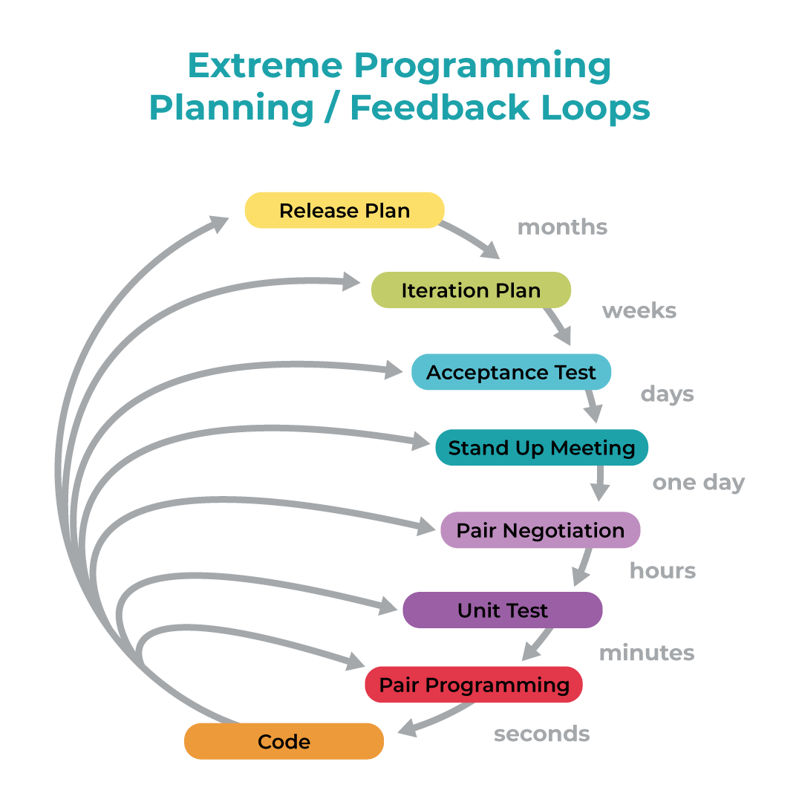

4. Lean Development

Lean development is a methodology that comes directly from Lean Manufacturing, created by Toyota, and applied to software development. This method offers a conceptual framework and follows values, principles and good development practices that can be applied to an Agile development approach.

**Lean development forces the team to ruthlessly remove any activity that does not bring ultimate value to the product.**

There are seven essential principles: deleting things that do not matter (anything that does not bring effective value to the customer project); quality development (creating quality in development requires discipline and control of the number of residuals created); creating knowledge (the team is motivated to document the whole infrastructure to later retain that value); differing commitments (this point encourages the team not to focus too much on planning and anticipating ideas without having a complete prior understanding of the requirements of the business); fast delivery (getting value to the customer as soon as possible); respecting the team (communication and managing conflicts are two essential points); optimise the whole (the development sequence has to be perfected enough to be able to delete errors in the code, in order to create a flow of true value).

Works on building simple solutions and presenting them to customers using their feedback on the “product” to incrementally enhance it. The “minimum viable product” concept is also often associated with “Lean”.

Advantages:

* Allows the team to delete superfluous activity, therefore saving time and money;
* Decreases the time needed to deliver functionalities, since it prepares the development team during the decision-making process, hence increasing general motivation;
* Easily scalable methodology, easily adaptable to projects of any dimension;
* Does not over-engineer solutions or business requirements.

Disadvantages:

* Dependent on the development team’s ability and on following “Lean principles”, which requires extremely dedicated and talented developers;
* It is easier to lose focus since various tasks are divided into a number of elements;
* Requires some documents, in particular on the characteristics of the business that is the subject of the work. Otherwise, there is a risk that the development may be carried out incorrectly and present errors.

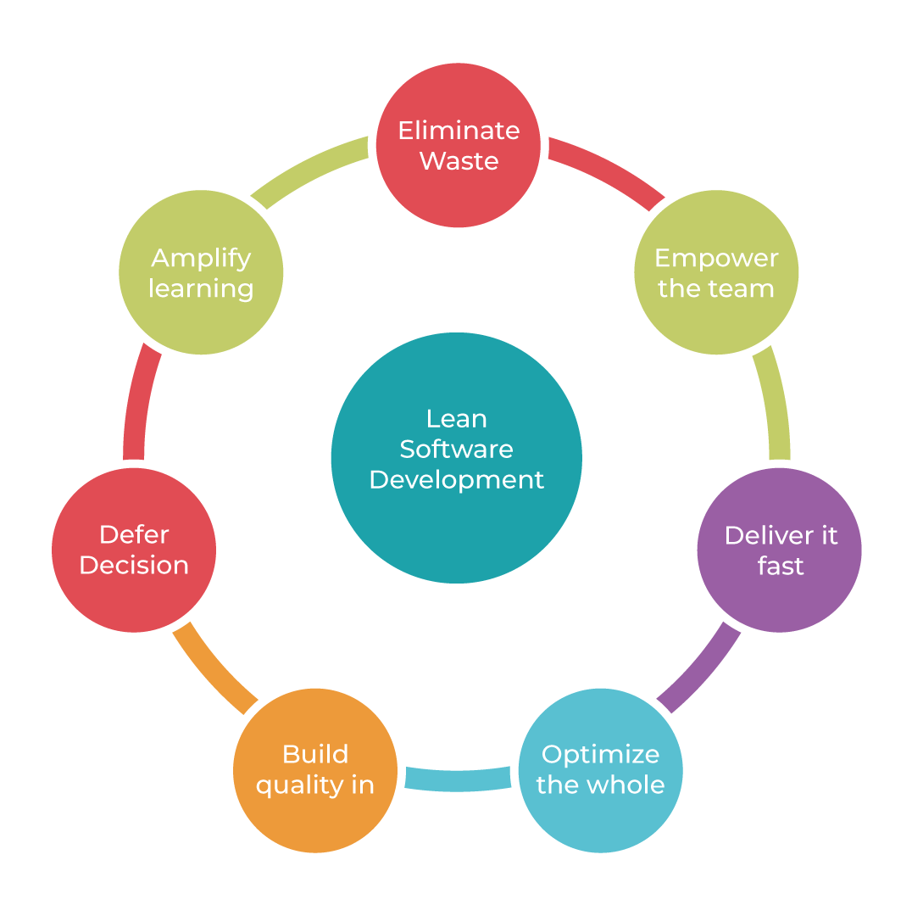

5. Crystal

This is a family of Agile methodologies, and **Crystal is one of the most flexible frameworks, giving tremendous freedom to the team to develop their own processes.** It focuses way more on individuals and how they interact rather than on the process or the tools – so communication is an essential key aspect.

Crystal has variants such as **Crystal Clear** (up to an 8-person team), **Crystal Yellow** (up to a 10 to 20-person team), **Crystal Orange** (up to a 20 to 50-person team) and **Crystal Red** (for big teams with 50 to 1000 people). Crystal focuses on principles such as People, Interactions, Community, Skills, Talent and Communication, aiming to deliver the best possible software development process. The core of this development process is interaction and symbiosis, which have to exist between the people allocated to the projects and processes in order to bring efficiency to the project.

Each project is unique and undergoes frequent changes, so the team must find their own ways to bring it to its conclusion using the best decisions.

According to its founder, Alistair Cockburn, “Crystal is a family of software development methodologies, which works with the power invested by people, and is extremely light and stretch-to-fit”. Basically, Cockburn believes that **talent and the way team members interact brings benefits for the whole project.**

It’s a light methodology in terms of documentation, where teams can find their own ways over preferred work modalities, removing management overheads and creating a “free” process.

Advantages:

* Crystal requires frequent deliveries, in order to identify eventual problems at every stage;
* There is always space to improve characteristics, taking some time from software development and allowing for discussions about how to perfect processes;
* Facilitates closer communication within teams and promotes interaction and knowledge-sharing between team members;
* Requires a technical environment with automated tests, configuration management and frequent integration.

Disadvantages:

* The fact that there are variants in the methodology family means that the principles might vary with the size of the team and the size of the project, resulting in projects that might not be so straightforward;
* It might not work best for geographically scattered teams, because of the constant need to communicate and reflect;
* Planning and development are not dependent on requirements;
* It is ideal for experienced, autonomous teams.

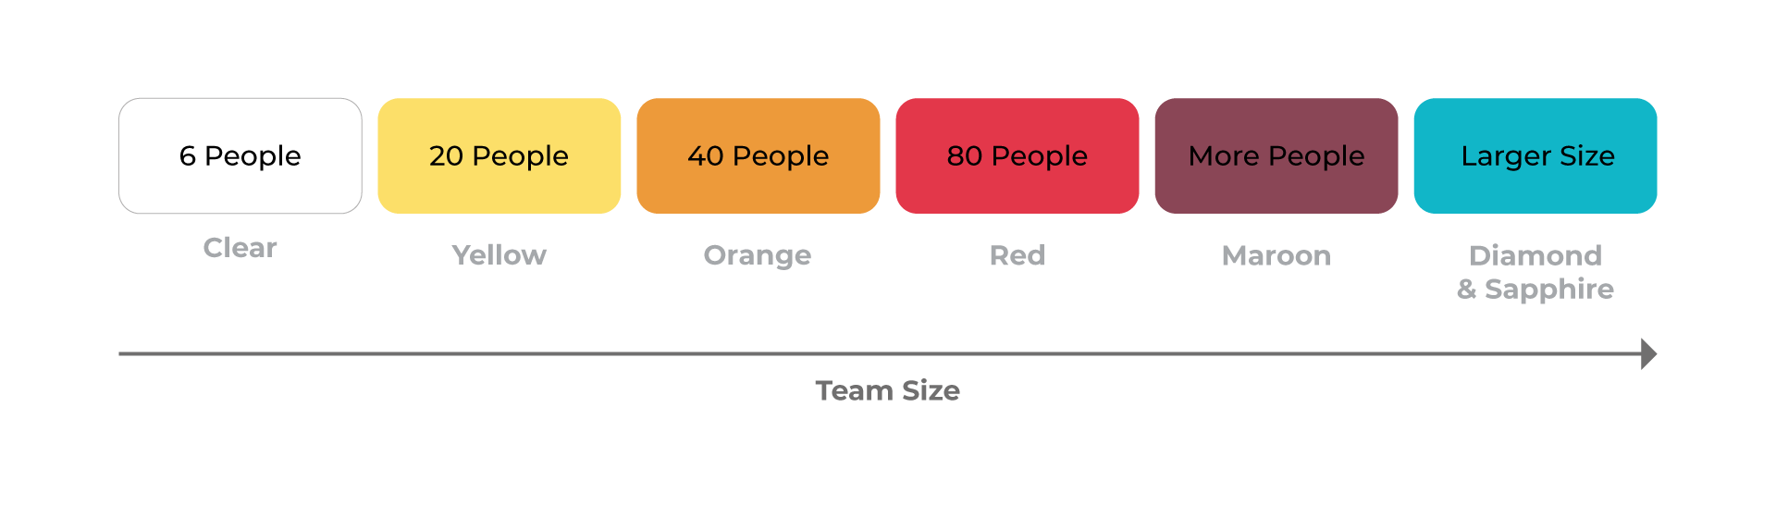

SCRUM Vs Kanban

* Scrum sprints have start and stop dates whereas Kanban is an ongoing process.
* Team roles are clearly defined in scrum (product owner, dev team, and scrum master), while Kanban has no formal roles. Both teams are self-organized.
* A Kanban board is used throughout the lifecycle of a project whereas a scrum board is cleared and recycled after each sprint.
* A Scrum board has a set number of tasks and strict deadline to complete them.
* Kanban boards are more flexible with regards to tasks and timing. Tasks can be reprioritized, reassigned, or updated as needed.
* The whole team owns the Kanban board. Some teams enlist an agile coach but, unlike scrum, there is no single “Kanban master” who keeps everything running smoothly. It’s the collective responsibility of the entire team to collaborate on and deliver the tasks on the board.